Impact of Copper Doping on the Anatase to Rutile Transition of TiO₂ Photocatalysts
Ciara Byrne ^{a,b}, Lorraine Moran ^{c}, Daphne Hermosilla ^{d}, Noemí Merayo ^{e}, Ángeles Blanco ^{e}, Stephen Rhatigan^{f}, Michael Nolan ^{f}, Steven Hinder ^{g}, Priyanka Ganguly ^{a,b} and Suresh C. Pillai ^{a,b}†
ª Nanotechnology and Bio-engineering Research Group, Department of Environmental Science, Institute of Technology Sligo, Sligo, Ireland
^{b} Centre for Precision Engineering, Materials and Manufacturing Research (PEM), Institute of Technology Sligo, Sligo, Ireland.
^{c} Department of Life Sciences, Institute of Technology Sligo, Sligo, Ireland
^{d} University of Valladolid, E.U. Ingenierías Agrarias de Soria, Campus Duques de Soria, 42005 Soria, Spain.
^{e} Complutense University of Madrid, FCC Químicas, Ciudad Universitaria s/n, 28040 Madrid, Spain.
^{f} Tyndall National Institute, University College Cork, Lee Maltings, Dyke Parade, Cork, Ireland
^{g} The Surface Analysis Laboratory, Faculty of Engineering and Physical Sciences, University of Surrey, Guildford, Surrey, GU2 7XH, United Kingdom
† Corresponding author. E-mail address: pillai.suresh@itsligo.ie

Supplementary Information

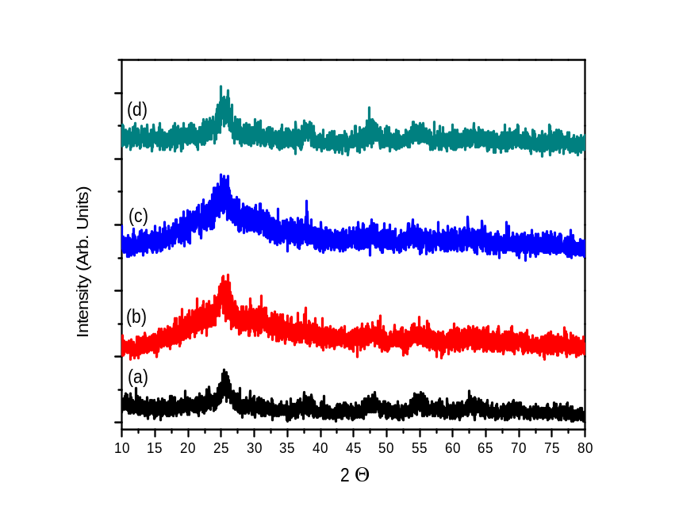
Figure S1: XRD of all uncalcined samples. (a) 0% copper (b) 2% copper (c) 4% copper and (d) 8% copper, where A= anatase and R = Rutile.

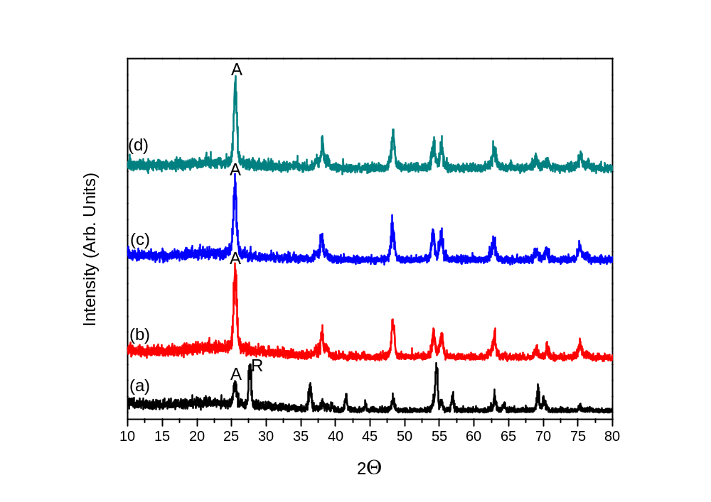
Figure S2: XRD of all samples calcined at 600°C. (a) 0% copper (b) 2% copper (c) 4% copper and (d) 8% copper, where A= anatase and R = Rutile.

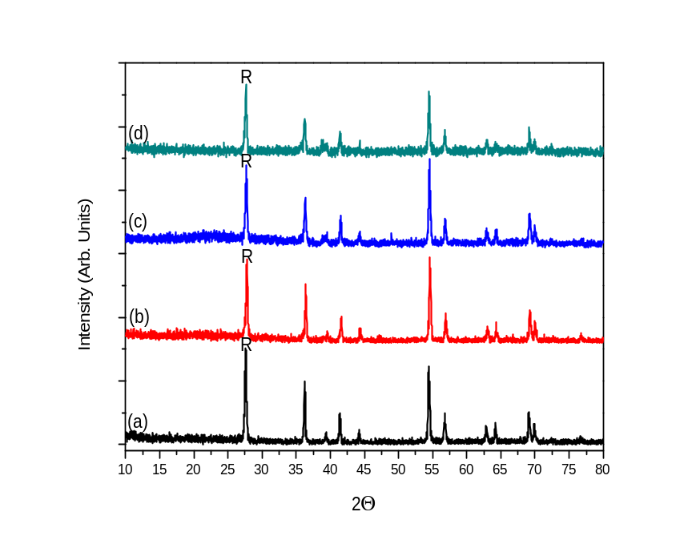
Figure S3: XRD of all samples calcined at 700°C. (a) 0% copper (b) 2% copper (c) 4% copper and (d) 8% copper, where A= anatase and R = Rutile.
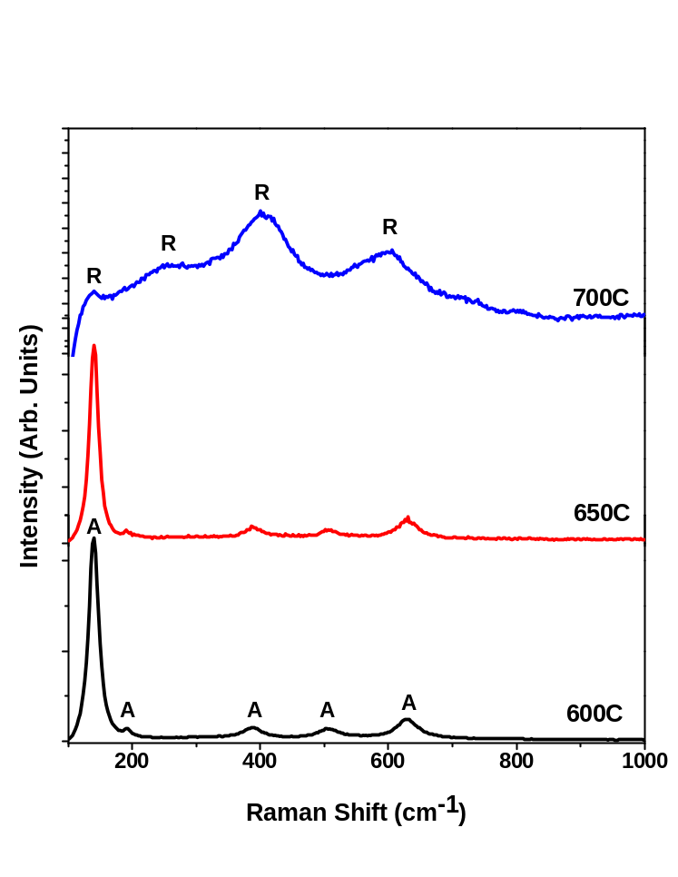
Figure S4: Raman spectra of 8% Cu-TiO₂ calcined at 600 °C, 650 °C and 700 °C.

Table S1: The elemental composition (in atomic %) of the elements present which have been derived from XPS data.
 | 0% Cu | 2% Cu | 4% Cu | 8% Cu
C_{1s} | 600 °C – 17.90%  650 °C – 24.81%  700 °C –26.76% | 600 °C – 13.64%  650 °C – 22.15%  700 °C –10.48% | 600 °C – 12.37%  650 °C – 25.80%  700 °C – 12.89% | 600 °C – 14.92%  650 °C – 24.89%  700 °C – 26.83%
O_{1s} | 600 °C – 58.42%  650 °C – 53.90%  700 °C – 52.59% | 600 °C – 61.82%  650 °C – 53.53%  700 °C – 61.20% | 600 °C – 62.47%  650 °C – 51.12%  700 °C – 59.78% | 600 °C – 58.26%  650 °C – 51.98%  700 °C – 49.80%
Ti_{2p} | 600 °C – 23.67%  650 °C – 21.29%  700 °C – 20.56% | 600 °C – 21.03%  650 °C – 19.49%  700 °C – 21.02% | 600 °C – 21.72%  650 °C – 18.51%  700 °C – 20.27% | 600 °C – 15.45%  650 °C – 18.05%  700 °C – 17.58%
S_{2p} | N/A | 600 °C – 1.58%  650 °C – 1.02%  700 °C – 0.90% | 600 °C – 1.45%  650 °C – 0.79%  700 °C – 1.07% | 600 °C – 4.42%  650 °C – 1.51%  700 °C – 0.94%
Cu_{2p3} | N/A | 600 °C – 1.94%  650 °C – 3.82%  700 °C – 6.40% | 600 °C – 1.99%  650 °C – 3.60%  700 °C – 5.98% | 600 °C – 6.94%  650 °C – 3.58%  700 °C – 4.85%

Table S2: XPS binding energy (eV) data for samples calcined at 600, 650 and 700°C
 | 0% Cu | 2% Cu | 4% Cu | 8% Cu
C_{1s} | 600 °C – 284.9  650 °C – 284.9  700 °C – 284.9 | 600 °C – 284.9  650 °C – 284.9  700 °C – 284.9 | 600 °C – 285.0  650 °C – 284.9  700 °C – 285.0 | 600 °C – 285.0  650 °C – 284.9  700 °C – 284.9
O_{1s} | 600 °C – 530.2  650 °C – 530.0  700 °C – 530.1 | 600 °C – 530.5  650 °C – 530.2  700 °C – 529.2 | 600 °C – 530.4  650 °C – 530.1  700 °C – 530.3 | 600 °C – 530.5  650 °C – 530.3  700 °C – 530.1
Ti_{2p} | 600 °C – 459.0  650 °C – 458.8  700 °C – 458.9 | 600 °C – 459.2  650 °C – 458.9  700 °C – 458.9 | 600 °C – 459.1  650 °C – 458.9  700 °C – 458.9 | 600 °C – 459.0  650 °C – 459.0  700 °C – 458.8
S_{2p} | N/A | 600 °C – 169.5  650 °C – 168.9  700 °C – 168.9 | 600 °C – 169.2  650 °C – 168.9  700 °C – 169.3 | 600 °C – 169.6  650 °C – 169.1  700 °C – 168.9
Cu_{2p3} | N/A | 600 °C – 933.0  650 °C – 932.8  700 °C – 933.2 | 600 °C – 932.9  650 °C – 932.8  700 °C – 933.3 | 600 °C – 934.0  650 °C – 932.9  700 °C – 933.9

Table S3: Deconvoluted XPS data (binding energy (eV)) for O_{1s}, S_{2p} and Cu_{2p3} for the 8% Cu-TiO₂ samples
 | 600 °C | 650 °C | 700 °C
O_{1s} | 530.4  532.6 | 530.2  532.0 | 530.1  531.7
S_{2p} | 169.2  170.4 | 168.8  170.1 | 168.7  170.0
Cu_{2p3} | 933.1  936.1  941.8  944.9 | 932.6  935.1  941.1  943.5 | 932.6  934.6  941.8  944.1

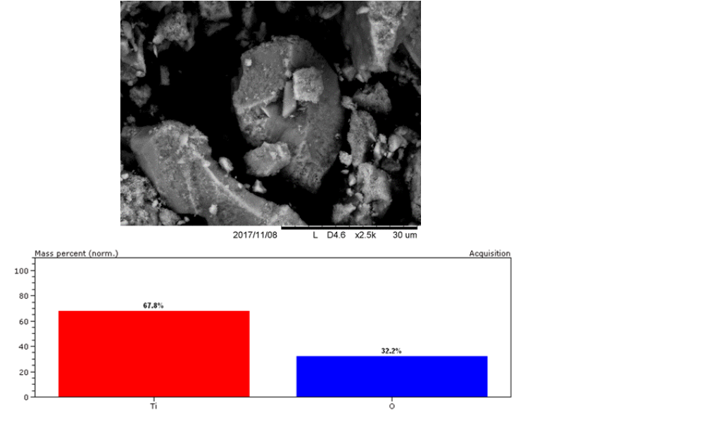
Figure S5: SEM image and EDX composition results of 0% Cu-TiO₂ @ 500°C.
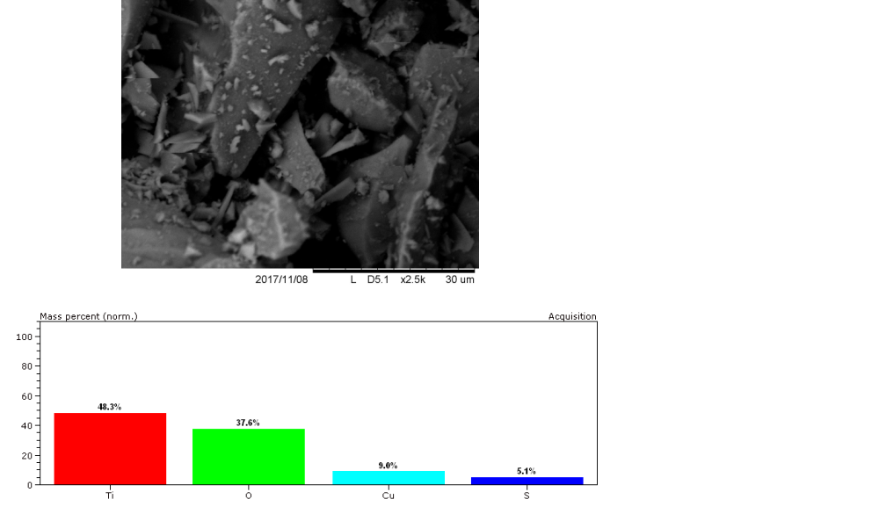
Figure S6: SEM image and EDX composition results of 8% Cu-TiO₂ @ 500°C.

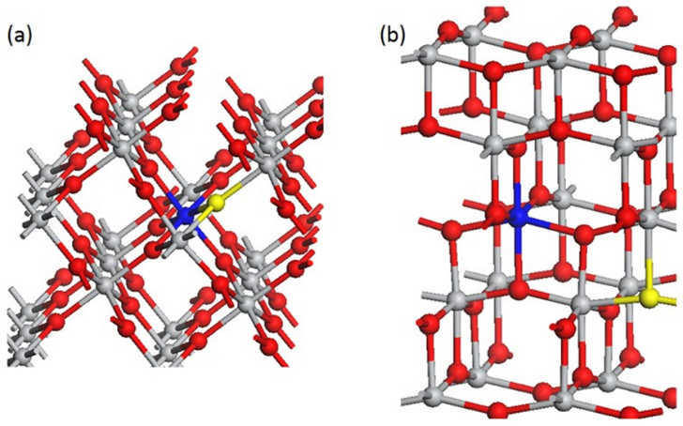
Figure S7: Local atomic structure in the vicinity of the dopant for (a) rutile and (b) anatase. Copper is represented by a blue sphere, titanium is grey and oxygen is red. The yellow sphere marks the location of the oxygen hole polaron.

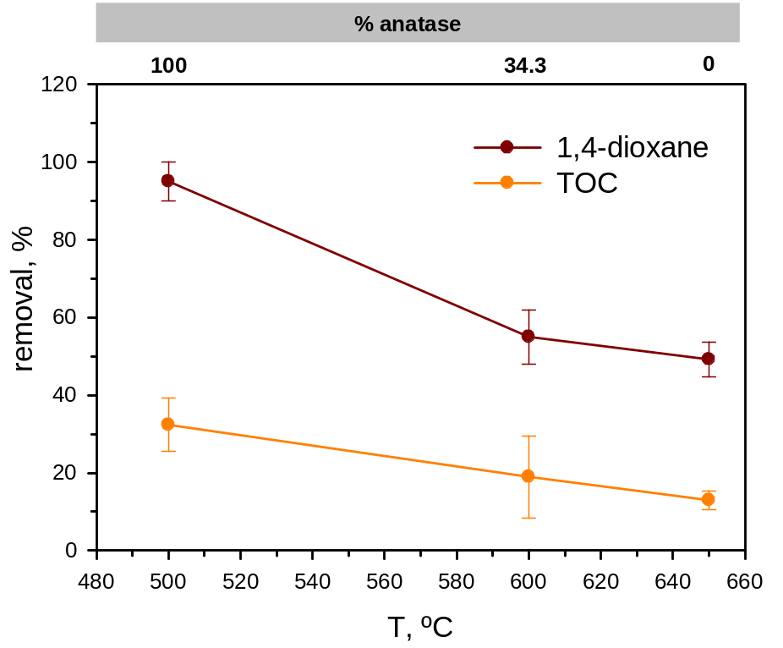
Figure S8: Effect of T of the catalyst on both 1,4-dioxane and TOC removals.
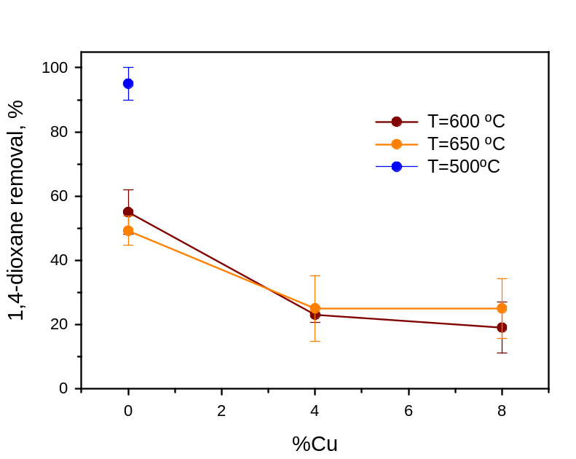
Figure S9: Effect of Cu percentage in the removal efficiency of 1,4 dioxane.

