Supplementary Material

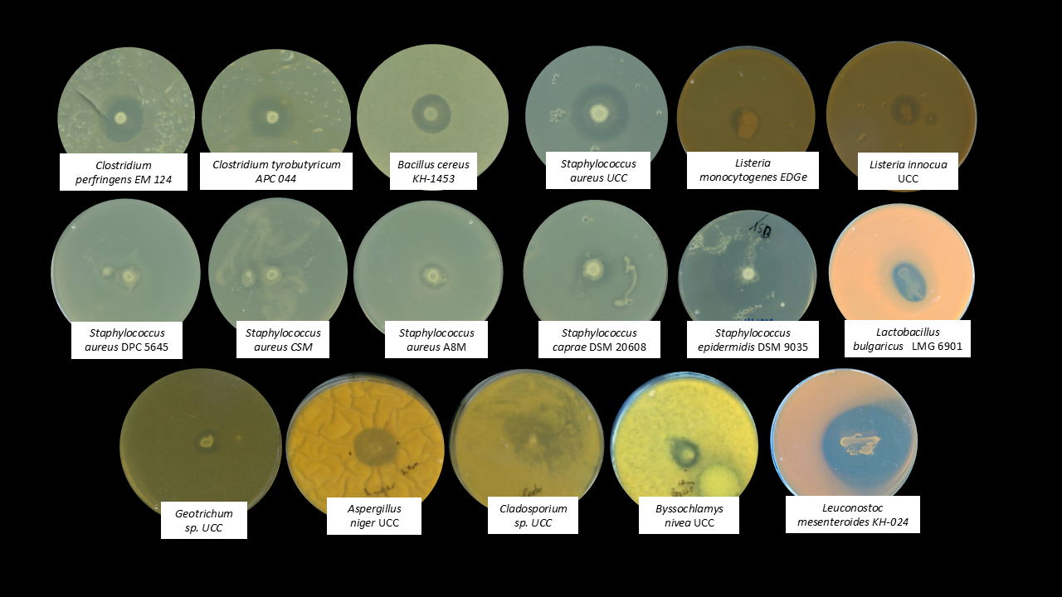
Supplementary Figure S1. Agar spot assay of B. safensis APC 4099 against a selection of bacterial and fungal indicators strains.
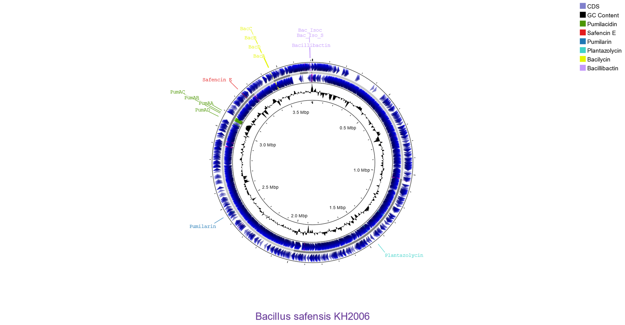
Supplementary Figure S2. Map of the gene sequences coding for the detected bacteriocins and non-ribosomally synthesized peptides across the circular genome of B. safensis APC 4099.
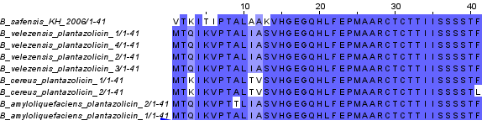
Supplementary Figure S3. Sequence alignment among plantazolicins identified from B. safensis (present study), and other Bacilli closest hinds identified following NCBI Blast, including B. velezensis, B. cereus, and B. amyloliquefaciens, including B. amyloliquefaciens FZB42 (41), highlighting with blue color the conserved amino acids.
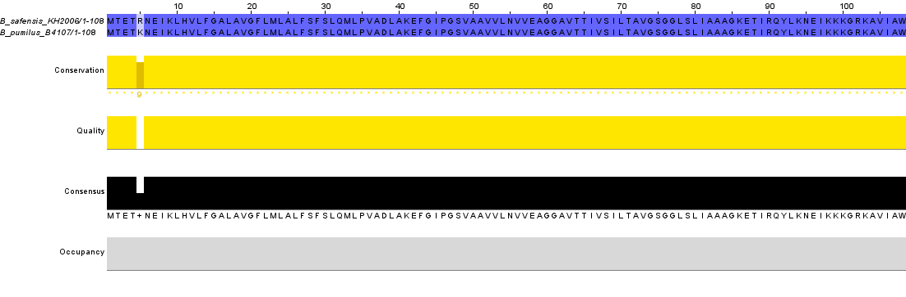
Supplementary Figure S4. Sequence alignment between pumilarin identified from B. safensis (present study), and B. pumilus B4107, highlighting with blue color the conserved amino acids.

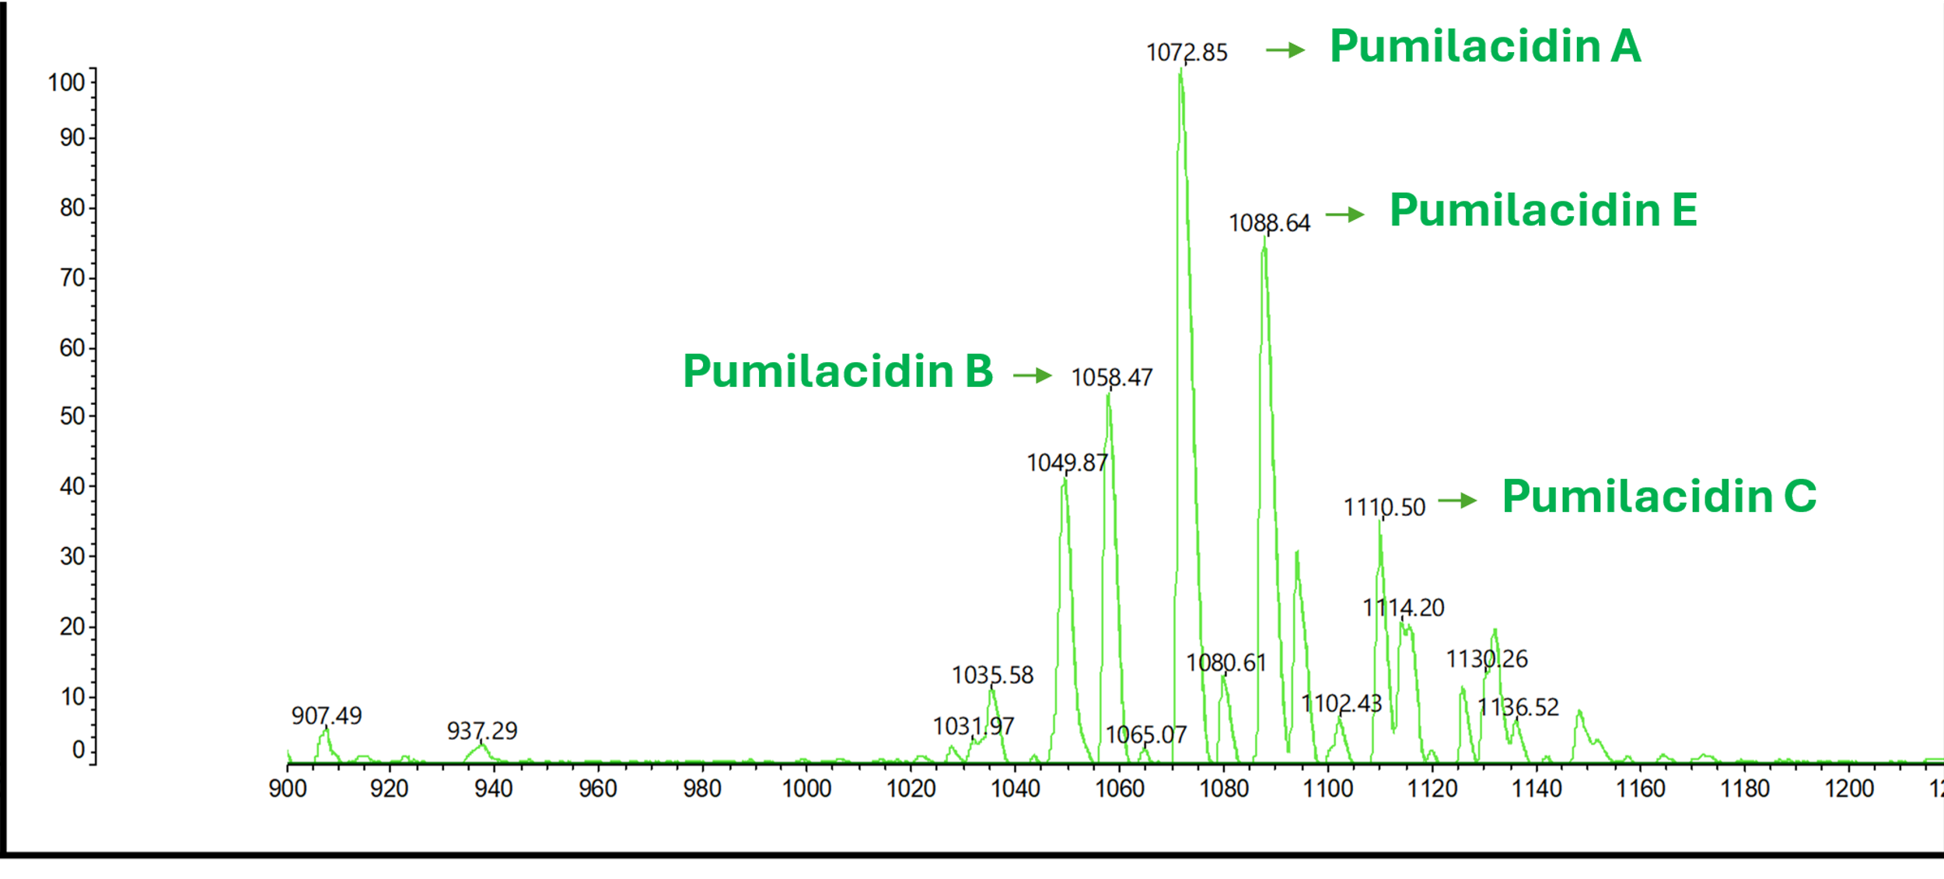
Supplementary Figure S5. MALDI TOF MS of HPLC fractions showing the molecular mass for lipopeptide isoforms ions.

Supplementary Table 1. Evaluation of the ability of the CFS to inhibit the growth of tested indicators in concentrations 5%, 10%, 25%, and 50% compared to control, based on LSD test.
Microorganism | Time point | CFS concentration | Mean Difference (I-J) | Std. Error | Significant difference compared to control | 95% Confidence Interval
 |  |  |  |  |  | Lower Bound | Upper Bound
B. cereus KH-1453 | 12 hours | 5% | 0.5236 | 0.01775 | <.001 | 0.484 | 0.5632
B. cereus KH-1453 | 12 hours | 10% | 0.5248 | 0.01775 | <.001 | 0.4852 | 0.5644
B. cereus KH-1453 | 12 hours | 25% | 0.52477 | 0.01775 | <.001 | 0.4852 | 0.5643
B. cereus KH-1453 | 12 hours | 50% | 0.52467 | 0.01775 | <.001 | 0.4851 | 0.5642
B. cereus KH-1453 | 24 hours | 5% | 0.6463 | 0.00942 | <.001 | 0.6253 | 0.6673
B. cereus KH-1453 | 24 hours | 10% | 0.64743 | 0.00942 | <.001 | 0.6264 | 0.6684
B. cereus KH-1453 | 24 hours | 25% | 0.64727 | 0.00942 | <.001 | 0.6263 | 0.6683
B. cereus KH-1453 | 24 hours | 50% | 0.6471 | 0.00942 | <.001 | 0.6261 | 0.6681
B. cereus KH-1453 | 48 hours | 5% | 0.5924 | 0.02544 | <.001 | 0.5357 | 0.6491
B. cereus KH-1453 | 48 hours | 10% | 0.63647 | 0.02544 | <.001 | 0.5798 | 0.6932
B. cereus KH-1453 | 48 hours | 25% | 0.63717 | 0.02544 | <.001 | 0.5805 | 0.6939
B. cereus KH-1453 | 48 hours | 50% | 0.6373 | 0.02544 | <.001 | 0.5806 | 0.694
L. innocua UCC | 12 hours | 5% | -0.12667 | 0.04232 | 0.014 | -0.221 | -0.0324
L. innocua UCC | 12 hours | 10% | 0.58333 | 0.04232 | <.001 | 0.489 | 0.6776
L. innocua UCC | 12 hours | 25% | 0.64333 | 0.04232 | <.001 | 0.549 | 0.7376
L. innocua UCC | 12 hours | 50% | 0.66333 | 0.04232 | <.001 | 0.569 | 0.7576
L. innocua UCC | 24 hours | 5% | -0.04667 | 0.08817 | 0.608 | -0.2431 | 0.1498
L. innocua UCC | 24 hours | 10% | 0.33 | 0.08817 | 0.004 | 0.1336 | 0.5264
L. innocua UCC | 24 hours | 25% | 0.56 | 0.08817 | <.001 | 0.3636 | 0.7564
L. innocua UCC | 24 hours | 50% | 0.61333 | 0.08817 | <.001 | 0.4169 | 0.8098
L. innocua UCC | 48 hours | 5% | -0.06 | 0.02556 | 0.041 | -0.117 | -0.003
L. innocua UCC | 48 hours | 10% | 0.17667 | 0.02556 | <.001 | 0.1197 | 0.2336
L. innocua UCC | 48 hours | 25% | 0.55333 | 0.02556 | <.001 | 0.4964 | 0.6103
L. innocua UCC | 48 hours | 50% | 0.57333 | 0.02556 | <.001 | 0.5164 | 0.6303
L. monocytogenes EDGe | 12 hours | 5% | 0.36667 | 0.05203 | <.001 | 0.2507 | 0.4826
L. monocytogenes EDGe | 12 hours | 10% | 0.42667 | 0.05203 | <.001 | 0.3107 | 0.5426
L. monocytogenes EDGe | 12 hours | 25% | 0.453 | 0.05203 | <.001 | 0.3371 | 0.5689
L. monocytogenes EDGe | 12 hours | 50% | 0.45333 | 0.05203 | <.001 | 0.3374 | 0.5693
L. monocytogenes EDGe | 24 hours | 5% | 0.34333 | 0.06096 | <.001 | 0.2075 | 0.4792
L. monocytogenes EDGe | 24 hours | 10% | 0.16667 | 0.06096 | 0.021 | 0.0308 | 0.3025
L. monocytogenes EDGe | 24 hours | 25% | 0.47633 | 0.06096 | <.001 | 0.3405 | 0.6122
L. monocytogenes EDGe | 24 hours | 50% | 0.47667 | 0.06096 | <.001 | 0.3408 | 0.6125
L. monocytogenes EDGe | 48 hours | 5% | 0.02 | 0.05645 | 0.73 | -0.1058 | 0.1458
L. monocytogenes EDGe | 48 hours | 10% | 0.20333 | 0.05645 | 0.005 | 0.0776 | 0.3291
L. monocytogenes EDGe | 48 hours | 25% | 0.40667 | 0.05645 | <.001 | 0.2809 | 0.5324
L. monocytogenes EDGe | 48 hours | 50% | 0.41333 | 0.05645 | <.001 | 0.2876 | 0.5391
L.mesenteroides KH-024 | 12 hours | 5% | 0.67 | 0.09437 | <.001 | 0.4597 | 0.8803
L.mesenteroides KH-024 | 12 hours | 10% | 0.74333 | 0.09437 | <.001 | 0.5331 | 0.9536
L.mesenteroides KH-024 | 12 hours | 25% | 0.72313 | 0.09437 | <.001 | 0.5129 | 0.9334
L.mesenteroides KH-024 | 12 hours | 50% | 0.78397 | 0.09437 | <.001 | 0.5737 | 0.9942
L.mesenteroides KH-024 | 24 hours | 5% | 1.14667 | 0.05522 | <.001 | 1.0236 | 1.2697
L.mesenteroides KH-024 | 24 hours | 10% | 1.26 | 0.05522 | <.001 | 1.137 | 1.383
L.mesenteroides KH-024 | 24 hours | 25% | 1.27 | 0.05522 | <.001 | 1.147 | 1.393
L.mesenteroides KH-024 | 24 hours | 50% | 1.26667 | 0.05522 | <.001 | 1.1436 | 1.3897
L.mesenteroides KH-024 | 48 hours | 5% | 0.56667 | 0.10433 | <.001 | 0.3342 | 0.7991
L.mesenteroides KH-024 | 48 hours | 10% | 1.74 | 0.10433 | <.001 | 1.5075 | 1.9725
L.mesenteroides KH-024 | 48 hours | 25% | 1.74333 | 0.10433 | <.001 | 1.5109 | 1.9758
L.mesenteroides KH-024 | 48 hours | 50% | 1.74333 | 0.10433 | <.001 | 1.5109 | 1.9758
S. epidermitis KM 1928 | 12 hours | 5% | 0.02583 | 0.00895 | 0.016 | 0.0059 | 0.0458
S. epidermitis KM 1928 | 12 hours | 10% | 0.0263 | 0.00895 | 0.015 | 0.0064 | 0.0462
S. epidermitis KM 1928 | 12 hours | 25% | 0.02583 | 0.00895 | 0.016 | 0.0059 | 0.0458
S. epidermitis KM 1928 | 12 hours | 50% | 0.01707 | 0.00895 | 0.086 | -0.0029 | 0.037
S. epidermitis KM 1928 | 24 hours | 5% | 0.17453 | 0.03503 | <.001 | 0.0965 | 0.2526
S. epidermitis KM 1928 | 24 hours | 10% | 0.18023 | 0.03503 | <.001 | 0.1022 | 0.2583
S. epidermitis KM 1928 | 24 hours | 25% | 0.18053 | 0.03503 | <.001 | 0.1025 | 0.2586
S. epidermitis KM 1928 | 24 hours | 50% | 0.1738 | 0.03503 | <.001 | 0.0957 | 0.2519
S. epidermitis KM 1928 | 48 hours | 5% | 0.30997 | 0.0332 | <.001 | 0.236 | 0.3839
S. epidermitis KM 1928 | 48 hours | 10% | 0.38983 | 0.0332 | <.001 | 0.3159 | 0.4638
S. epidermitis KM 1928 | 48 hours | 25% | 0.39733 | 0.0332 | <.001 | 0.3234 | 0.4713
S. epidermitis KM 1928 | 48 hours | 50% | 0.39143 | 0.0332 | <.001 | 0.3175 | 0.4654
S. aureus CSM | 12 hours | 5% | 0.09887 | 0.0247 | 0.003 | 0.0438 | 0.1539
S. aureus CSM | 12 hours | 10% | 0.11087 | 0.0247 | 0.001 | 0.0558 | 0.1659
S. aureus CSM | 12 hours | 25% | 0.11437 | 0.0247 | <.001 | 0.0593 | 0.1694
S. aureus CSM | 12 hours | 50% | 0.1356 | 0.0247 | <.001 | 0.0806 | 0.1906
S. aureus CSM | 24 hours | 5% | 0.11617 | 0.04056 | 0.017 | 0.0258 | 0.2065
S. aureus CSM | 24 hours | 10% | 0.17723 | 0.04056 | 0.001 | 0.0869 | 0.2676
S. aureus CSM | 24 hours | 25% | 0.22957 | 0.04056 | <.001 | 0.1392 | 0.3199
S. aureus CSM | 24 hours | 50% | 0.2559 | 0.04056 | <.001 | 0.1655 | 0.3463
S. aureus CSM | 48 hours | 5% | 0.15963 | 0.03631 | 0.001 | 0.0787 | 0.2405
S. aureus CSM | 48 hours | 10% | 0.32483 | 0.03631 | <.001 | 0.2439 | 0.4057
S. aureus CSM | 48 hours | 25% | 0.44877 | 0.03631 | <.001 | 0.3679 | 0.5297
S. aureus CSM | 48 hours | 50% | 0.4793 | 0.03631 | <.001 | 0.3984 | 0.5602
S. aureus A8M | 12 hours | 5% | 0.1343 | 0.02351 | <.001 | 0.0819 | 0.1867
S. aureus A8M | 12 hours | 10% | 0.1472 | 0.02351 | <.001 | 0.0948 | 0.1996
S. aureus A8M | 12 hours | 25% | 0.14793 | 0.02351 | <.001 | 0.0956 | 0.2003
S. aureus A8M | 12 hours | 50% | 0.14737 | 0.02351 | <.001 | 0.095 | 0.1997
S. aureus A8M | 24 hours | 5% | 0.18787 | 0.04687 | 0.002 | 0.0834 | 0.2923
S. aureus A8M | 24 hours | 10% | 0.2608 | 0.04687 | <.001 | 0.1564 | 0.3652
S. aureus A8M | 24 hours | 25% | 0.2824 | 0.04687 | <.001 | 0.178 | 0.3868
S. aureus A8M | 24 hours | 50% | 0.2828 | 0.04687 | <.001 | 0.1784 | 0.3872
S. aureus A8M | 48 hours | 5% | 0.11423 | 0.05187 | 0.052 | -0.0014 | 0.2298
S. aureus A8M | 48 hours | 10% | 0.35513 | 0.05187 | <.001 | 0.2395 | 0.4707
S. aureus A8M | 48 hours | 25% | 0.46487 | 0.05187 | <.001 | 0.3493 | 0.5805
S. aureus A8M | 48 hours | 50% | 0.46607 | 0.05187 | <.001 | 0.3505 | 0.5817
S. aureus UCC | 12 hours | 5% | 0.0008 | 0.10041 | 0.994 | -0.2229 | 0.2245
S. aureus UCC | 12 hours | 10% | 0.20303 | 0.10041 | 0.071 | -0.0207 | 0.4268
S. aureus UCC | 12 hours | 25% | 0.2022 | 0.10041 | 0.072 | -0.0215 | 0.4259
S. aureus UCC | 12 hours | 50% | 0.20263 | 0.10041 | 0.071 | -0.0211 | 0.4264
S. aureus UCC | 24 hours | 5% | -0.0532 | 0.0371 | 0.182 | -0.1359 | 0.0295
S. aureus UCC | 24 hours | 10% | 0.33777 | 0.0371 | <.001 | 0.2551 | 0.4204
S. aureus UCC | 24 hours | 25% | 0.3394 | 0.0371 | <.001 | 0.2567 | 0.4221
S. aureus UCC | 24 hours | 50% | 0.33977 | 0.0371 | <.001 | 0.2571 | 0.4224
S. aureus UCC | 48 hours | 5% | -0.02993 | 0.06945 | 0.676 | -0.1847 | 0.1248
S. aureus UCC | 48 hours | 10% | 0.30053 | 0.06945 | 0.001 | 0.1458 | 0.4553
S. aureus UCC | 48 hours | 25% | 0.4563 | 0.06945 | <.001 | 0.3015 | 0.6111
S. aureus UCC | 48 hours | 50% | 0.423 | 0.06945 | <.001 | 0.2682 | 0.5778
Cladiosporium sp UCC | 24 hours | 5% | 0.03717 | 0.01295 | 0.017 | 0.0083 | 0.066
Cladiosporium sp UCC | 24 hours | 10% | 0.11437 | 0.01295 | <.001 | 0.0855 | 0.1432
Cladiosporium sp UCC | 24 hours | 25% | 0.1115 | 0.01295 | <.001 | 0.0826 | 0.1404
Cladiosporium sp UCC | 24 hours | 50% | 0.11553 | 0.01295 | <.001 | 0.0867 | 0.1444
Cladiosporium sp UCC | 48 hours | 5% | 0.0173 | 0.02026 | 0.413 | -0.0278 | 0.0624
Cladiosporium sp UCC | 48 hours | 10% | 0.066 | 0.02026 | 0.009 | 0.0209 | 0.1111
Cladiosporium sp UCC | 48 hours | 25% | 0.0765 | 0.02026 | 0.004 | 0.0314 | 0.1216
Cladiosporium sp UCC | 48 hours | 50% | 0.0609 | 0.02026 | 0.013 | 0.0158 | 0.106
Geotrichum sp UCC | 24 hours | 5% | -0.0942 | 0.06235 | 0.162 | -0.2331 | 0.0447
Geotrichum sp UCC | 24 hours | 10% | 0.04853 | 0.06235 | 0.454 | -0.0904 | 0.1875
Geotrichum sp UCC | 24 hours | 25% | 0.20413 | 0.06235 | 0.008 | 0.0652 | 0.3431
Geotrichum sp UCC | 24 hours | 50% | 0.27353 | 0.06235 | 0.001 | 0.1346 | 0.4125
Geotrichum sp UCC | 48 hours | 5% | 0.24143 | 0.2163 | 0.29 | -0.2405 | 0.7234
Geotrichum sp UCC | 48 hours | 10% | 0.59143 | 0.2163 | 0.021 | 0.1095 | 1.0734
Geotrichum sp UCC | 48 hours | 25% | 0.81047 | 0.2163 | 0.004 | 0.3285 | 1.2924
Geotrichum sp UCC | 48 hours | 50% | 0.97143 | 0.2163 | 0.001 | 0.4895 | 1.4534
P. variottii UCC | 36 hours | 5% | 0.18793 | 0.02431 | <.001 | 0.1338 | 0.2421
P. variottii UCC | 36 hours | 10% | 0.32827 | 0.02431 | <.001 | 0.2741 | 0.3824
P. variottii UCC | 36 hours | 25% | 0.36343 | 0.02431 | <.001 | 0.3093 | 0.4176
P. variottii UCC | 36 hours | 50% | 0.36493 | 0.02431 | <.001 | 0.3108 | 0.4191
P. variottii UCC | 48 hours | 5% | 0.20453 | 0.05391 | 0.004 | 0.0844 | 0.3246
P. variottii UCC | 48 hours | 10% | 0.34963 | 0.05391 | <.001 | 0.2295 | 0.4697
P. variottii UCC | 48 hours | 25% | 0.4903 | 0.05391 | <.001 | 0.3702 | 0.6104
P. variottii UCC | 48 hours | 50% | 0.48873 | 0.05391 | <.001 | 0.3686 | 0.6088
A. niger UCC | 24 hours | 5% | -0.0381 | 0.10789 | 0.731 | -0.2785 | 0.2023
A. niger UCC | 24 hours | 10% | -0.7572 | 0.10789 | <.001 | -0.9976 | -0.5168
A. niger UCC | 24 hours | 25% | 0.2282 | 0.10789 | 0.061 | -0.0122 | 0.4686
A. niger UCC | 24 hours | 50% | 0.2513 | 0.10789 | 0.042 | 0.0109 | 0.4917
A. niger UCC | 48 hours | 5% | -0.12557 | 0.12971 | 0.356 | -0.4146 | 0.1634
A. niger UCC | 48 hours | 10% | -0.8761 | 0.12971 | <.001 | -1.1651 | -0.5871
A. niger UCC | 48 hours | 25% | 0.1618 | 0.12971 | 0.241 | -0.1272 | 0.4508
A. niger UCC | 48 hours | 50% | 0.30577 | 0.12971 | 0.04 | 0.0168 | 0.5948
P. variottii UCC | 36 hours | 5% | -0.06137 | 0.08885 | 0.505 | -0.2593 | 0.1366
P. variottii UCC | 36 hours | 10% | -0.1042 | 0.08885 | 0.268 | -0.3022 | 0.0938
P. variottii UCC | 36 hours | 25% | 0.24103 | 0.08885 | 0.022 | 0.0431 | 0.439
P. variottii UCC | 36 hours | 50% | 0.24463 | 0.08885 | 0.02 | 0.0467 | 0.4426
P. variottii UCC | 48 hours | 5% | -0.15337 | 0.07738 | 0.076 | -0.3258 | 0.019
P. variottii UCC | 48 hours | 10% | -0.3548 | 0.07738 | 0.001 | -0.5272 | -0.1824
P. variottii UCC | 48 hours | 25% | 0.3301 | 0.07738 | 0.002 | 0.1577 | 0.5025
P. variottii UCC | 48 hours | 50% | 0.3463 | 0.07738 | 0.001 | 0.1739 | 0.5187
B. nivea UCC | 36 hours | 5% | -0.06137 | 0.08885 | 0.505 | -0.2593 | 0.1366
B. nivea UCC | 36 hours | 10% | -0.1042 | 0.08885 | 0.268 | -0.3022 | 0.0938
B. nivea UCC | 36 hours | 25% | 0.24103 | 0.08885 | 0.022 | 0.0431 | 0.439
B. nivea UCC | 36 hours | 50% | 0.24463 | 0.08885 | 0.02 | 0.0467 | 0.4426
B. nivea UCC | 48 hours | 5% | -0.15337 | 0.07738 | 0.076 | -0.3258 | 0.019
B. nivea UCC | 48 hours | 10% | -0.3548 | 0.07738 | 0.001 | -0.5272 | -0.1824
B. nivea UCC | 48 hours | 25% | 0.3301 | 0.07738 | 0.002 | 0.1577 | 0.5025
B. nivea UCC | 48 hours | 50% | 0.3463 | 0.07738 | 0.001 | 0.1739 | 0.5187

Supplementary Table 2. Comparison of the whole genome of B. safensis APC 4099 against other 10 B. safensis complete circular genomes
Column1 | B. safensis_AHB11 | B. safensis_H31R-08 | B. safensis_BRM1 | B. safensis_LG01 | B. safensis_F6 | B. safensis_BS-10L | B. safensis_APC_4099 | B. safensis_PgKB20 | B. safensis_ZK-1 | B. safensis_SRCM125915 | B. safensis_KCTC
B. safensis_AHB11 | 1 | 0.97609 | 0.9868 | 0.985 | 0.9657 | 0.976 | 0.987503 | 0.976734 | 0.9767 | 0.96586 | 0.9760827
B. safensis_H31R-08 | 0.9761 | 1 | 0.9749 | 0.976 | 0.967 | 0.986 | 0.974627 | 0.987193 | 0.98722 | 0.96726 | 0.9856386
B. safensis_BRM1 | 0.9868 | 0.97494 | 1 | 0.988 | 0.9659 | 0.975 | 0.990647 | 0.975382 | 0.97553 | 0.96616 | 0.9751614
B. safensis_LG01 | 0.9854 | 0.97617 | 0.9882 | 1 | 0.9659 | 0.976 | 0.988162 | 0.976865 | 0.97692 | 0.96602 | 0.976164
B. safensis_F6 | 0.9657 | 0.96696 | 0.9659 | 0.966 | 1 | 0.967 | 0.965418 | 0.966207 | 0.96674 | 0.98984 | 0.9666697
B. safensis_BS-10L | 0.9764 | 0.98571 | 0.9753 | 0.976 | 0.9666 | 1 | 0.974912 | 0.985934 | 0.9873 | 0.96679 | 0.9881202
B. safensis_ APC_4099 | 0.9875 | 0.97463 | 0.9906 | 0.988 | 0.9654 | 0.975 | 1 | 0.975361 | 0.97528 | 0.96558 | 0.9740364
B. safensis_PgKB20 | 0.9767 | 0.98719 | 0.9754 | 0.977 | 0.9662 | 0.986 | 0.975361 | 1 | 0.98841 | 0.96642 | 0.9858055
B. safensis_ZK-1 | 0.9767 | 0.98722 | 0.9755 | 0.977 | 0.9667 | 0.987 | 0.975282 | 0.988413 | 1 | 0.96686 | 0.9870227
B. safensis_SRCM125915 | 0.9659 | 0.96726 | 0.9662 | 0.966 | 0.9898 | 0.967 | 0.965582 | 0.966419 | 0.96686 | 1 | 0.9667215
B. safensis_KCTC | 0.9761 | 0.98564 | 0.9752 | 0.976 | 0.9667 | 0.988 | 0.974036 | 0.985805 | 0.98702 | 0.96672 | 1

Supplementary Table 3. Similarity among genes of the gene cluster coding for Bacillus safensis APC 4099 lipopeptide compared to the gene cluster coding for pumilacidin, produced by B. safensis CCMA-560, B. safensis VK, B. pumilus SAFR-032, and B. pumilus ATCC 7061.

Gene product | B. safensis CCMA-560 (pumilacidin) | B. safensis VK  (pumilacidin) | B. pumilus SAFR-032  (pumilacidin) | B. pumilus ATCC 7061 (pumilacidin)
NRP synthetase | 98% | 97% | 90% | 90%
NRP synthetase 2 | 98% | 97.5% | 90% | 90%
NRP synthetase 3 | 98% | 98% | 91% | 92%
NRP synthetase 4 | 97% | 96% | 90% | 90%
NRP synthetase 5 | 97% | 97% | 90% | 90%

