Supporting Information

Improved robustness of ex-situ biological methanation for electro-fuel production through the addition of graphene

Benteng Wu ^{1, 2}, Richen Lin ^{1, 2,} , Xihui Kang ^{1, 2}, Chen Deng ^{1, 2}, Alan D.W. Dobson ^{1,} ³, Jerry D. Murphy ^{1, 2}
¹ MaREI Centre, Environmental Research Institute, University College Cork, Cork T23 XE10, Ireland
² Civil, Structural and Environmental Engineering, School of Engineering and Architecture, University College Cork, Cork, T12 YN60, Ireland
³ School of Microbiology, University College Cork, Cork T12 K8AF, Ireland

Number of pages: 6
Number of figures: 2
Number of tables: 1

Materials and methods
Gas volume measurement
Different methods were adopted to measure the volume of output gas in gas bags. When the gas volume was below 300 mL, only the syringe was used to measure the gas volume. When the gas volume was more than 300 mL, a 300 mL syringe, a 3-way stopcock and an empty gas bag were used (Fig. S2). The 3-way stopcock, which enables the switch of the direction of gas flow, was used to connect the syringe with the empty gas bag and prevent gas leakage during operation. By turning the 3-way stopcock, gases in the syringe could be transferred to the empty gas bag to temporarily preserve the gas mixture without leakage. After measuring the gas volume, the preserved gas was re-introduced into the system. During measurement, the peristaltic pump was turned off and the reactor was isolated by the 3-way stopcock. The output gas volume was the sum of the gas volume in the gas bag and the reactor headspace.

Biogas composition and VFA content analysis
The concentration of CO₂, H₂ and CH₄ in the gas mixture was analysed using a gas chromatograph system (GC, Agilent 7890B, USA) equipped with a thermal conductivity detector and two fused silica capillary columns. A CP-Molsieve 5A column (25 m × 0.32 mm × 30 µm film thickness, Agilent, USA) was used to detect H₂ and CH₄ whilst a GS-CarbonPLOT column (30 m × 0.32 mm × 3 µm film thickness, Agilent, USA) was used to determine CO₂. A gastight syringe (1725SL, Hamilton, USA) was used to collect 200 µL gas samples for GC injection. The temperature of the injector and detector was 150 °C and 300 °C, respectively. The column temperature was initially set at 50°C for 5 min, then increased to 200 °C at a heating rate of 30 °C/min. Argon was used as the carrier gas at a flow rate of 30 mL/min. N₂ was used as the makeup gas at a flow rate of 5 mL/min. The split ratio was set at 10:1 with a split flow of 40 mL/min. Gas compositions were identified according to their retention times whilst their concentrations were calculated against the standards.
A 1.5 mL liquid sample was taken from each reactor at the end of each cycle using a syringe with the help of 3-way stopcock and then centrifuged at 10,000 rpm for 10 mins (Eppendorf Centrifuge 5424, Germany). The 3-way stopcock was used to present gas leakage during collection. Before analysis, the supernatant was acidized by H₃PO₄ to pH 2.0. The VFA contents (acetic acid, propionic acid, isobutyric acid, isovaleric acid, isocaproic acid and caproic acid) were quantified using a gas chromatograph (Agilent 7890B, USA) equipped with a flame ionization detector and a capillary column (Nukol, fused silica capillary column, 30 m × 0.25 mm × 0.25 µm film thickness, Supelco, USA). The inlet and detector temperatures were both set at 250 °C. The column temperature was initially maintained at 75 °C, then increased to 185 °C at a heating ramp of 16 °C/min, and finally held for 1.15 min. H₂ was used as the fuel gas at a flow rate of 30 mL/min whilst air was used as the oxidant gas at a flow rate of 400 mL/min. N₂ was used as the makeup gas at a flow rate of 25 mL/min. The split ratio was set at 5: 1 with a split flow of 25 mL/min. Peaks corresponding to those of VFAs were confirmed by the retention time compared with those of standards. VFAs concentrations were calculated against the standards.
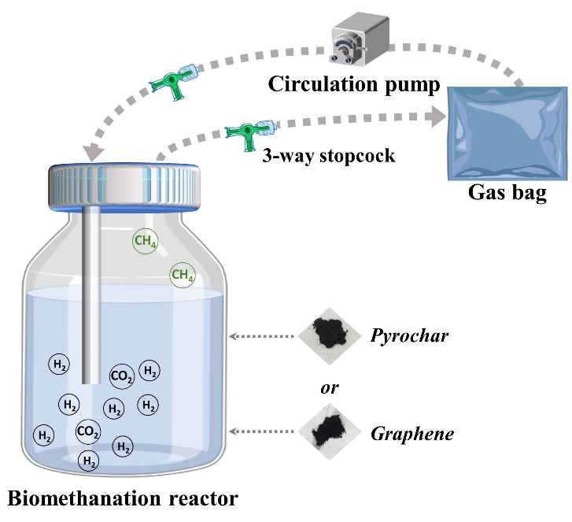
Fig. S1. Schematic diagram of the ex-situ biomethanation system.

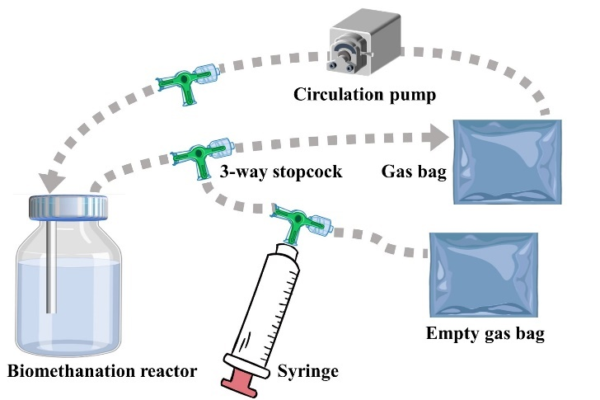
Fig. S2. Schematic diagram of the gas measurement unit.

Table S1 pH and the electrical conductivity of the anaerobic sludge in different groups at the end of the experiment.
Group | pH | Electrical conductivity (µS/cm)
Control | 8.05 ± 0.06 | 10.10 ± 2.17
Graphene | 8.02 ± 0.08 | 36.83 ± 13.59
Pyrochar | 8.04 ± 0.01 | 18.55 ± 6.65

Corresponding author: Dr Richen Lin, MaREI Centre, Environmental Research Institute, University College Cork, Ireland. Tel.: +353 (0)21 490 1948. Email: richen.lin@ucc.ie

