Supplementary feeding can attract red squirrels (Sciurus vulgaris) to optimal environments

Anna Starkey, Javier delBarco-Trillo

Supplementary Figures

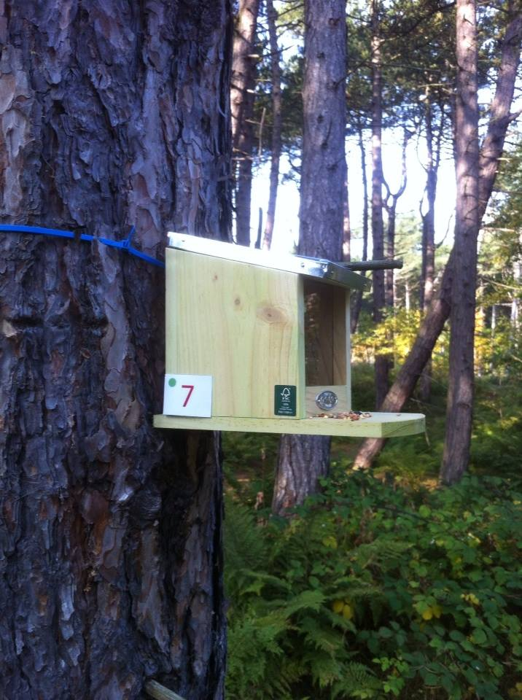

Figure S1. Feeding box used in the study. Feeding boxes were positioned at head height and attached to a tree using cable ties. Dimensions of the feeding boxes were 23 cm x 18 cm x 12 cm.

