Article Title: Manipulation of sward diversity is a more effective management strategy than addition of microbial inoculants in intensively managed grassland
Journal name: Plant and Soil
Author names: Israel Ikoyi^{1,2*}, Aoife M. Duff¹, John A. Finn¹, David P. Wall¹, Tanja Kostic³, Eva Lucic-Mercy⁴, Angela Sessitsch³, Fiona Brennan¹
Addresses:
¹Environment, Soils and Land-Use Department, Teagasc, Johnstown Castle, Wexford, Ireland
²School of Biological, Earth and Environmental Sciences, University College Cork, Distillery Fields, North Mall, Cork, Ireland; and Environmental Research Institute, University College Cork, Ireland
³AIT Austrian Institute of Technology GmbH, Bioresources Unit, Tulln, Austria
⁴Inoq GmbH, Schnega, Germany

*Corresponding author: israelikoyi@ucc.ie

Table S1: Primers used in this study

Target | Primers & probe | Conditions | Reference
P. phytofirmans PsJN | Bphyt_1824F: AAAAACGAGCCAAAACGGGC | Denaturation 95°C for 2 min  40 cycles denaturation at  95°C for 5 s and annealing and elongation for 20 s at 59°C. | Sheibani-Tezerji et al., 2015
P. phytofirmans PsJN | Bphyt_1824R: CACCAGCGCGAAATAACG |  | Sheibani-Tezerji et al., 2015
P. phytofirmans PsJN | Probe: FAM- AAACCTCGTACCTCGCCAGCBHQ |  | Sheibani-Tezerji et al., 2015
Bacillus sp. P5 | P5F: TGAGGGAACCGTTAACCTTG | Denaturation 98°C for 3 min  40 cycles denaturation at  95°C for 15 s, annealing at 56°C for 30 s and elongation at 72°C for 25 s plate read at 75°C for 2 s followed by melt curve analysis 65°C to 95°C, increment 0.5°C, 0:05+ plate read | This study
Bacillus sp. P5 | P5R: GCATCTTGCTGCTTGGAATC |  | This study
Bacterial 16S rRNA | 515F_Y: GTGYCAGCMGCCGCGGTAA  926R: CCGYCAATTYMTTTRAGTTT | PCR1:  Denaturation 94°C for 3 min  25 cycles denaturation at  94°C for 45s, annealing 50°C for 45s, elongation at 72°C for 1 min & a final elongation at 72°C for 5 min  PCR2 (for indexing):  Denaturation 95°C for 3 min  7 cycle denaturation at  95°C for 30s, annealing at 55°C for 30s, elongation at 72°C for 30s & a final elongation at 72°C for 5 min | Parada et al., 2016
Fungal ITS | ITS86F: GTGAATCATCGAATCTTTGAA  ITS4R: TCCTCCGCTTATTGATATGC | Denaturation 95°C for 3 min  25 cycles denaturation at  95°C for 45s, annealing at 54°C for 45s, elongation at 72°C for 1 min & a final elongation at 72°C for 5 min | De Beeck et al., 2014

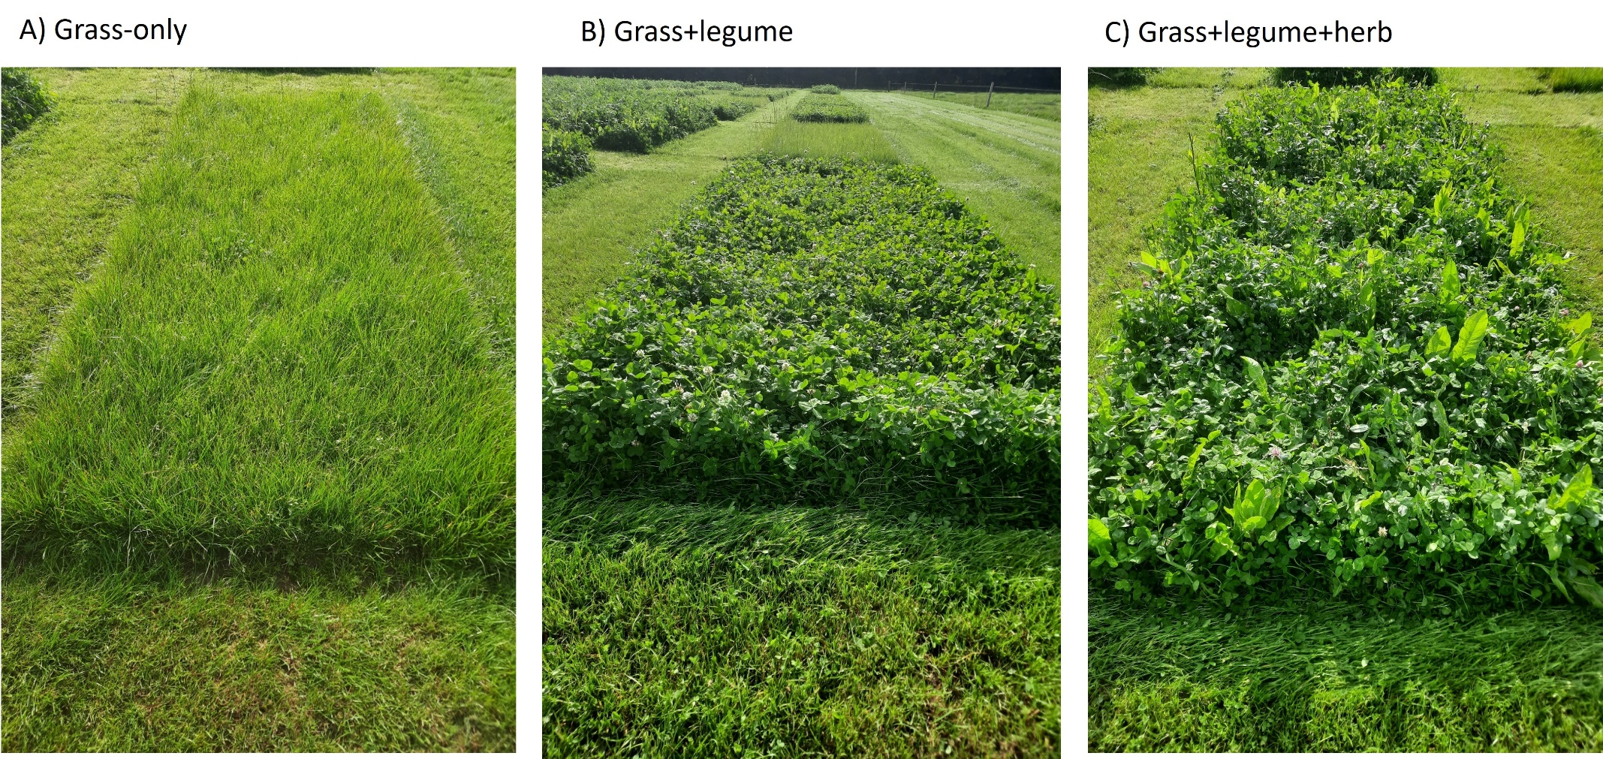
Figure S1: Established botanical composition of the three sward types.
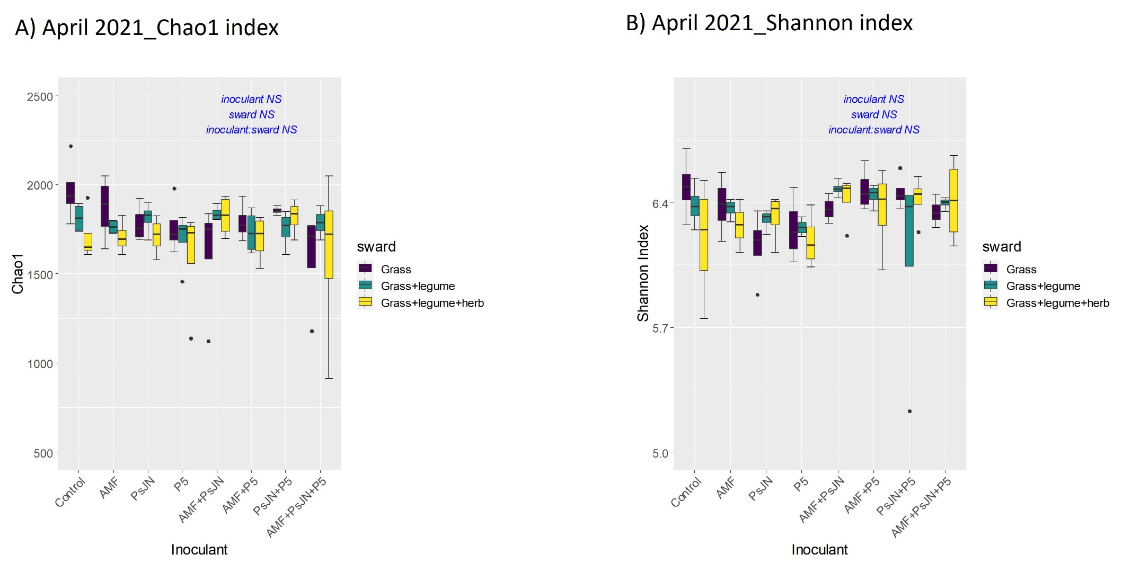
Figure S2: April 2021 Prokaryotic α-diversity

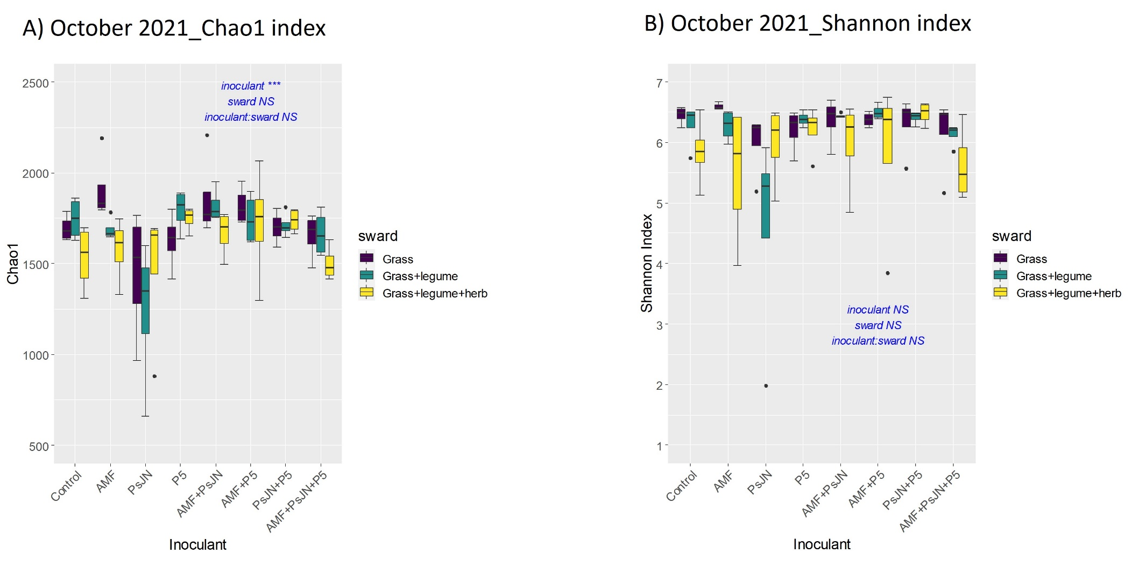
Figure S3 October 2021 prokaryotic α-diversity

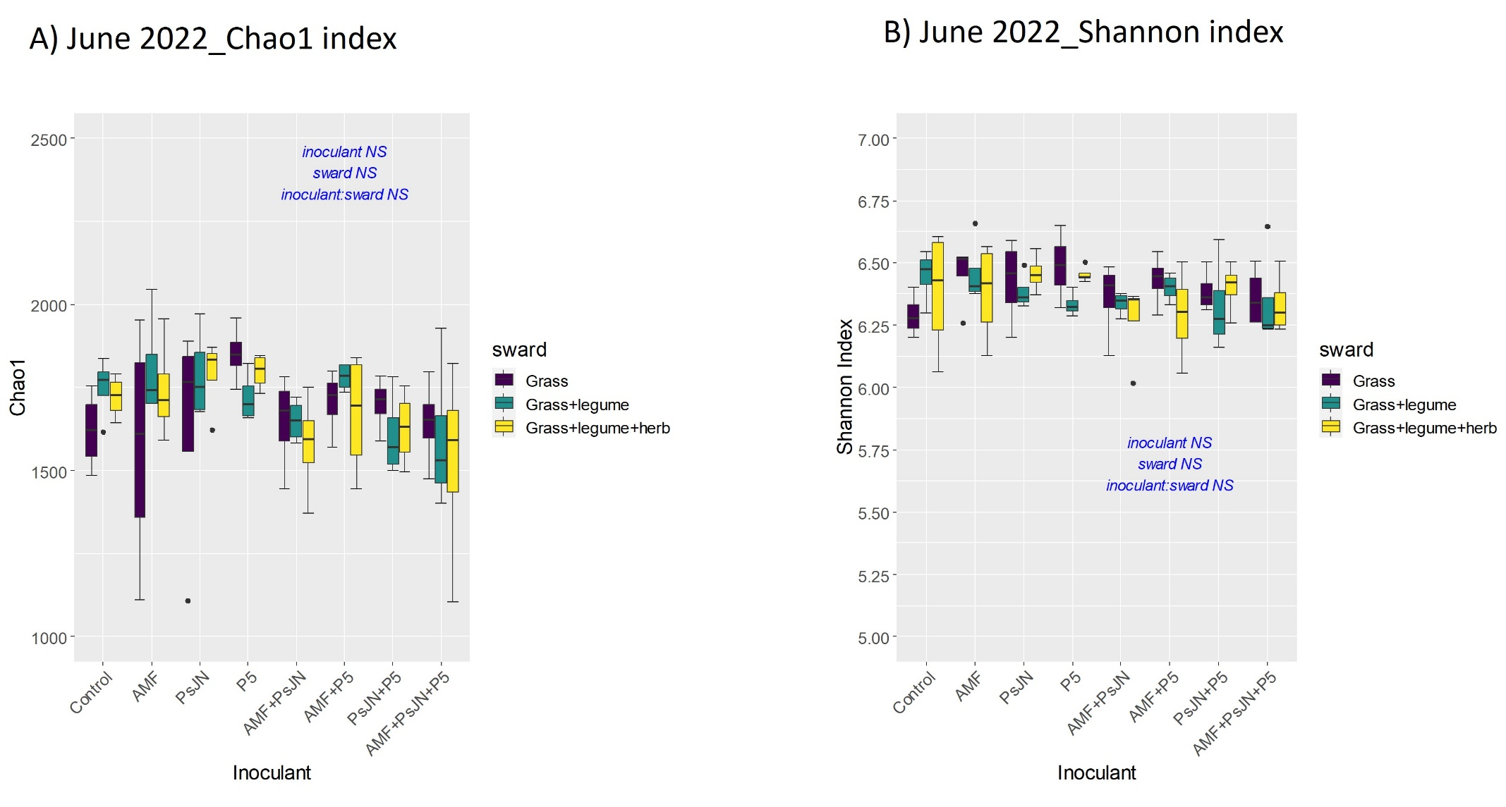
Figure S4 June 2022 prokaryotic α-diversity
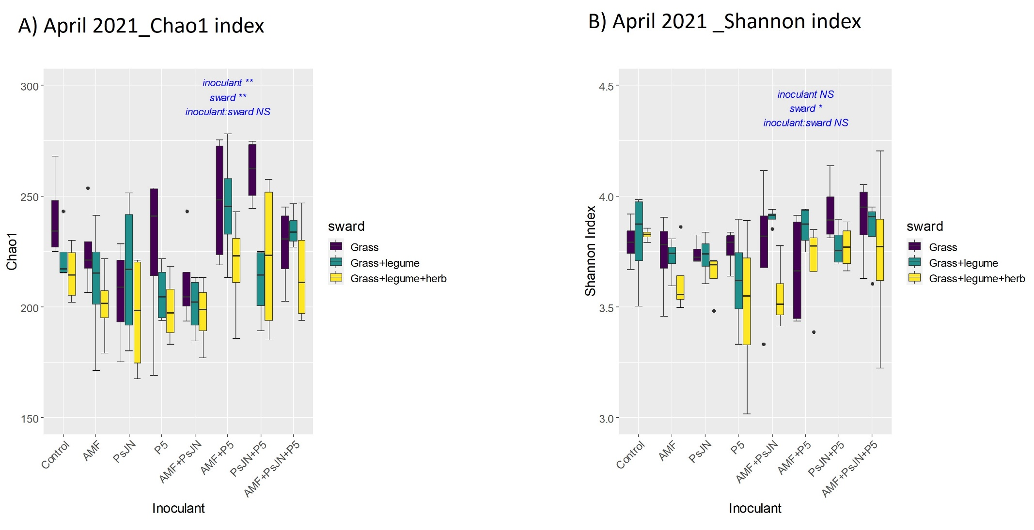
Figure S5 April 2021 fungal α-diversity
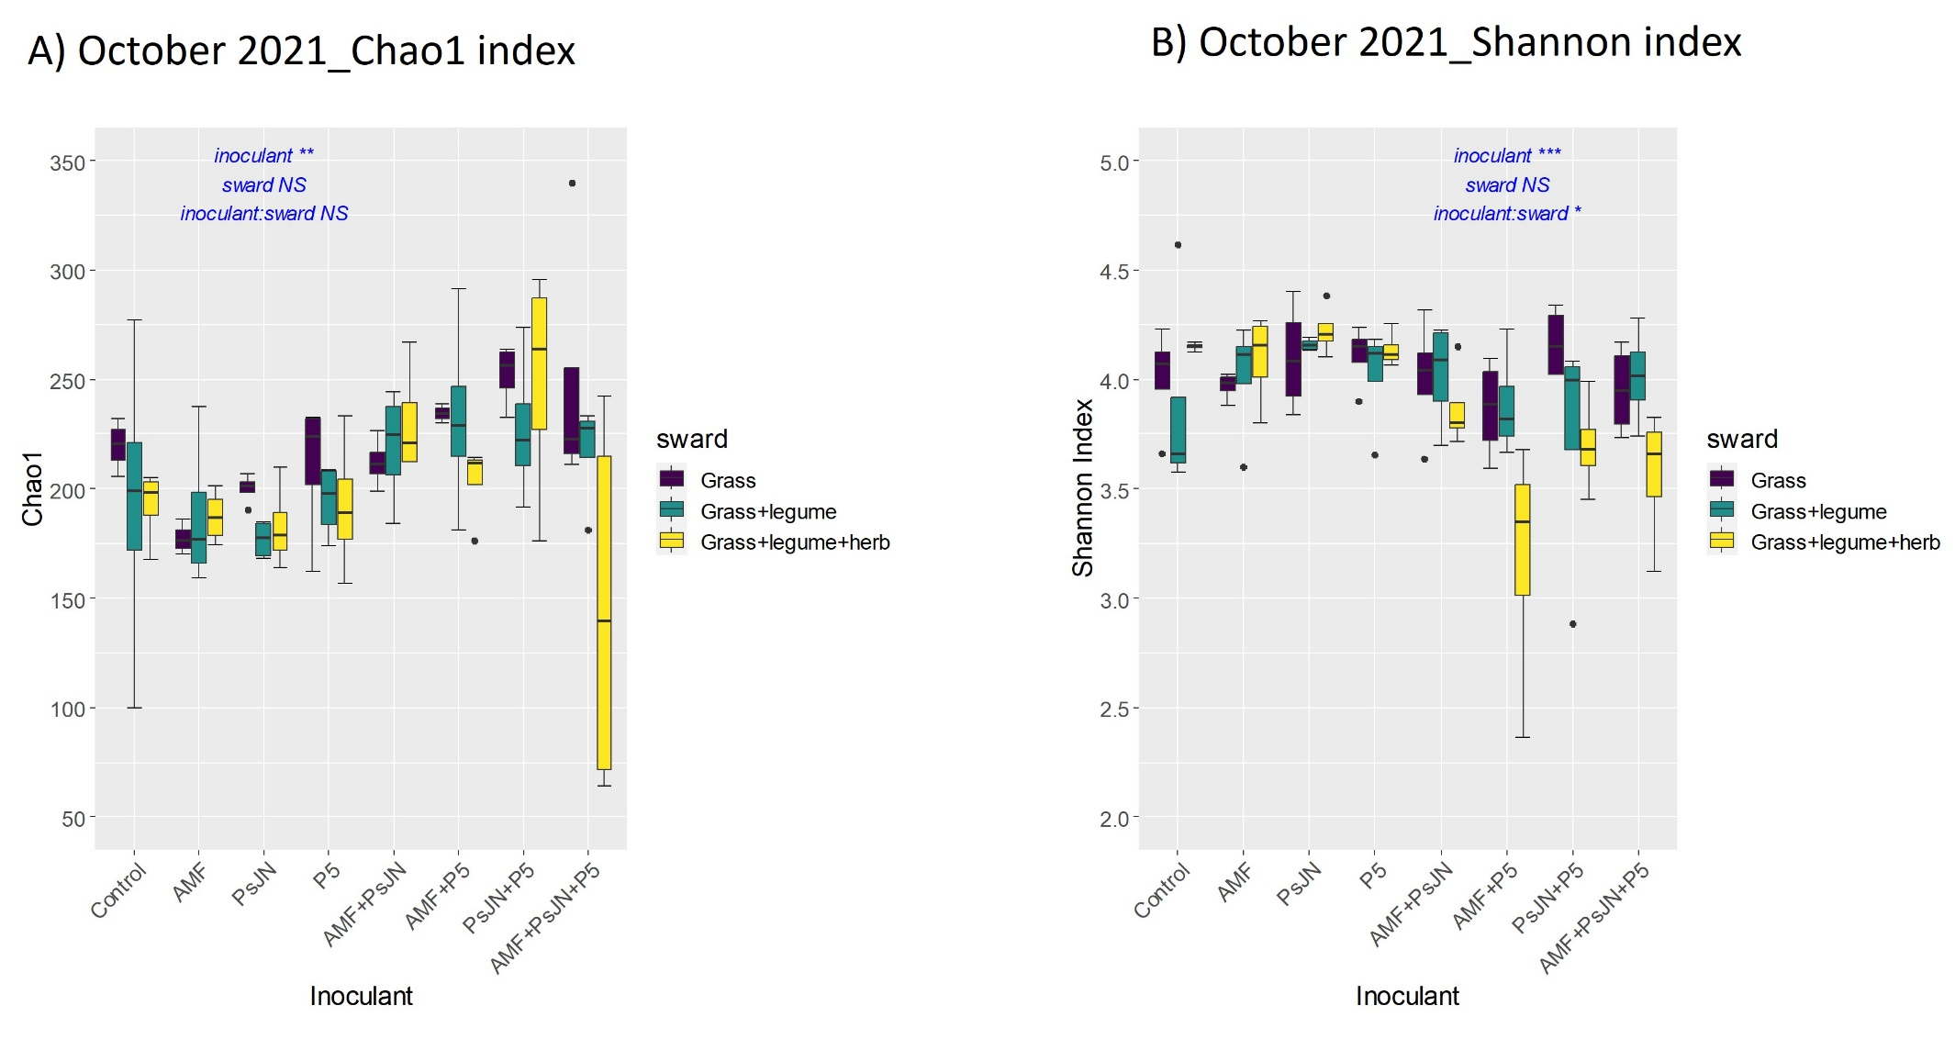
Figure S6 October 2021 fungal α-diversity
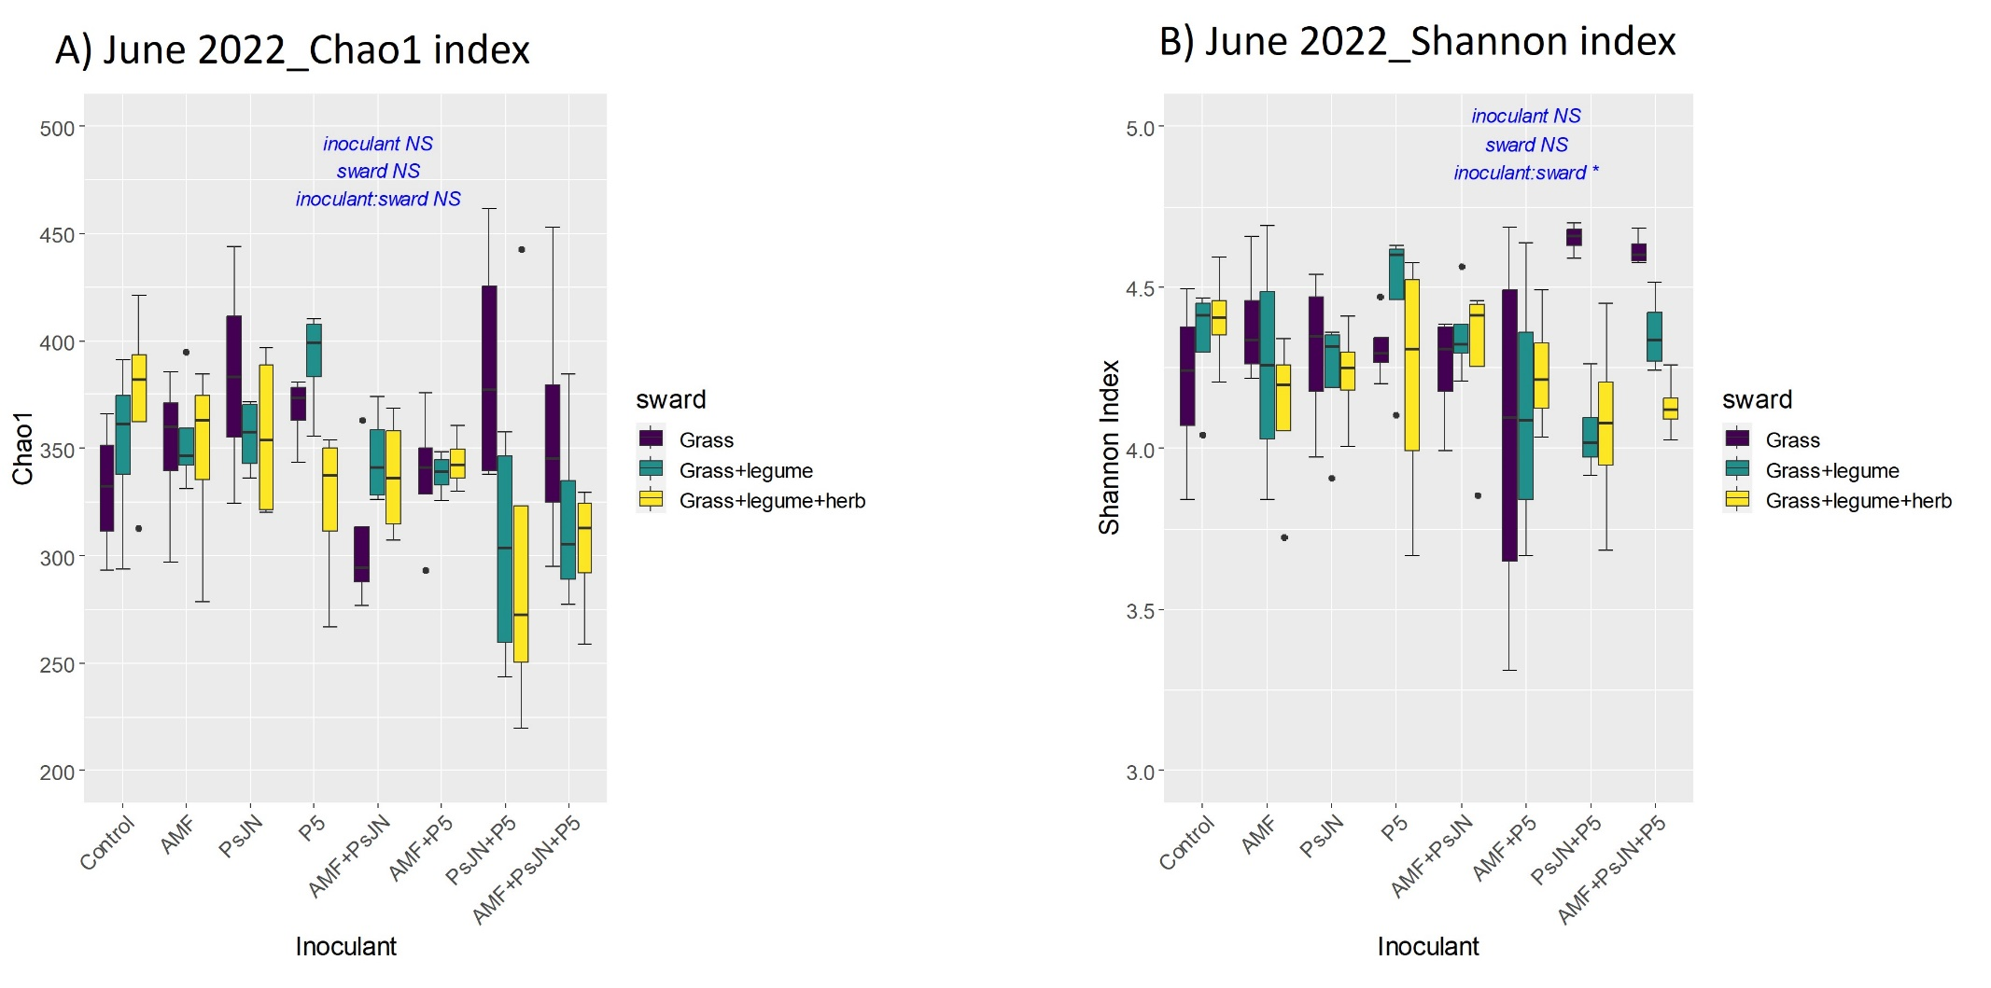
Figure S7 June 2022 fungal α-diversity

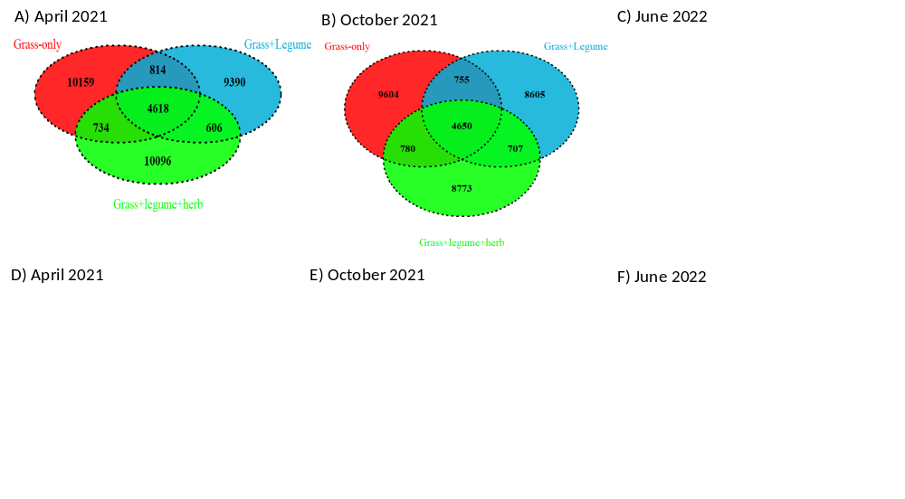
Figure S8 Abundance of ASVs in the swards for prokaryotic community (A-C) and fungal community (D-F)

