Electrochemical sensors

Interferent Free Electrochemical Detection of Nitrate in Water Using Copper–Cobalt based Sensor

Daisy Das, Alan O’Riordan, Han Shao*
Precision Electrochemical Nano sensor Group, Tyndall National Institute University College Cork, Dyke Parade, Cork, Ireland. T12 R5CP
han.shao@tyndall.ie

Abstract—Nitrate contamination in water is a significant global concern, prompting regulatory bodies such as the European Union to set a maximum permissible limit of 44 mg/L in drinking water. However, conventional laboratory-based detection methods are time-consuming and require specialized expertise, while chemical electrode systems often suffer from drawbacks such as frequent recalibration and ion cross-sensitivity, limiting their suitability for long-term and on-site monitoring. In response to these challenges, we present a novel and cost-effective electrochemical sensor based on a copper–cobalt based electrochemical sensor for reliable nitrate detection. The sensor exhibits a remarkable true detection limit of 0.19 µM and limit of quantification of 4.41 µM and demonstrates high selectivity even in the presence of commonly interfering ions such as Mg²⁺, SO₄²⁻, Zn²⁺, K⁺, NH₄⁺, Fe²⁺, and Na⁺. Owing to its sensitivity, selectivity, and portability, the developed sensor offers a promising solution for real-time, on-site monitoring of nitrate concentrations in both water and soil samples.

Keywords—Electrochemical sensors; Nitrate detection; Water contamination, Nanomaterial; Real-time monitoring

INTRODUCTION
Nitrate contamination in water has become a major concern, mainly due to agricultural and livestock activities [1]. Overuse of nitrogen-based fertilizers leads to groundwater pollution, impacting the food chain. High nitrate levels cause eutrophication, harming aquatic life, and pose health risks as they convert into harmful compounds linked to diseases like cancer, Parkinson’s, and gastritis [2,3]. Regulatory bodies, including the Environmental Protection Agency (EPA), have established a nitrate limit of 44 mg/L (0.7 mM) in drinking water to mitigate contamination risks [4]. Detecting nitrates accurately is essential for environmental and food safety. While spectroscopic techniques offer excellent precision, they demand specialized tools and expertise. In this regard, creating a rapid, user-friendly, and portable technology for detecting nitrate ions is essential for the continuous monitoring of natural water contamination. In contrast, electrochemical sensors, improved by nanomaterials, offer a more efficient, user-friendly solution for real-time monitoring. Various types of electrode materials have been investigated for electrochemical detection of analyte, but transition metal oxide nanoparticles have gained widespread attraction due to their higher conductivity and redox properties, stability, abundance and compatibility with other nanoparticles [5].
Cobalt-based metal oxides (MxCoyOz, with M = Mn, Cu, or Ni) are multifunctional materials widely used across various advanced technologies, such as electrochemical systems, energy storage devices, solid oxide fuel cells, electronic components, and solar energy applications [6]. Despite their broad utility, the structural features and design aspects of copper-cobalt oxide, specifically for enhancing electrochemical sensor performance, have not been thoroughly investigated yet. Among the various techniques [7,8] for synthesizing and depositing metal oxides, metallic films, composites, and microstructures, electrodeposition is a flexible approach. It allows precise control over the properties of the final deposit by modifying factors such as the type of reactant or electrolyte, concentration, pH of the solution, additives, and electrochemical parameters like applied potential, current, charge, deposition time, and signal type [9].
In this work, we developed a copper-cobalt (Cu/Co) based electrochemical sensor for nitrate detection, with performance evaluated in controlled standard solutions containing common environmental interferent. While several electrochemical sensors for nitrate detection exist, many suffer from complex fabrication steps or limited sensitivity. To address these challenges, we propose a novel Cu/Co co-electrodeposition approach on platinum microband electrodes, resulting in a sensor with high reproducibility and a low detection limit. This methodological innovation represents the primary contribution of our work and offers a scalable and efficient pathway for environmental nitrate monitoring. The structural and surface properties of the modified sensor were characterized using scanning electron microscopy (SEM) and atomic force microscopy (AFM). Square wave voltammetry (SWV) was employed for nitrate detection across a broad concentration range (0–2500 µM), and selectivity was evaluated in the presence of common interferents including phosphate, ammonium, potassium, sodium, iron, magnesium, sulfate, and zinc. The sensor achieved a detection limit in accordance with U.S. EPA standards. Overall, this study demonstrates a high-performance, Cu/Co-based nitrate sensor and provides valuable insights for advancing electrochemical sensing.

EXPERIMENTAL
A. Materials and Methods
Copper sulphate pentahydrate (CuSO4·5H2O), Cobalt acetate (Co(CH₃Co₂)₂·4H₂O), Boric acid powder (H₃BO₃), Ferrocene carboxylic acid (FCA), Sodium nitrate (NaNO₃), phosphoric acid (H₃PO₄) and Acetic acid (CH₃COOH); pyrrole (Py), Poly(vinyl chloride) (PVC), , Phosphate buffered saline tablets, were procured from Merck Life Science Ltd. Britton Robinson (BR) buffer was prepared by mixing 0.04 mol/L each of H₃BO₃, CH₃COOH, and H₃PO4 in ultrapure water, and pH adjusted using 2 M NaOH solution. Py and PVC solution was used for modification of reference electrode. Electrochemical measurements were performed using a MULTI AUTOLAB M101 potentiostat (Metrohm, Netherlands), with on-chip counter (CE) and reference electrodes (RE), or an external Ag/AgCl RE. Surface morphology and composition were analyzed using a Zeiss-Supra 40 SEM with EDX. AFM (Bruker, Scanasyst-air mode) with a silicon nitride cantilever with aluminum refractive layer was used for nanoscale characterization. AFM data were processed using Gwyddion v2.61. The schematic representation of the modification of the WE, sensing application is presented in Fig.1

Fabrication of electrode
Silicon based chips with platinum interdigitated microelectrode array as WE length 45 µm and width 1 µm with 2 µm gap on chip CE and RE with interconnecting tracks and connecting pinouts were fabricated using photolithography, metal deposition, lift-off, and etching techniques. Before use, the sensors were cleaned by ultrasonication in acetone, IPA, and DI water for 5–7 minutes each to remove the protective photoresist Electrochemical cleaning of the WE were performed by Cyclic Voltammetry (CV) at potential range of -1 to 1 V, 20 number of scans and at a scan rate of 100mV/s in 10 mM phosphate buffer solution. The modification of the WE were done by electrodeposition technique using chronoamperometry (CA) at potential of -0.82 V for 5 sec, followed by -0.25 V for 10 sec using external Ag/AgCl RE and Pt CE. The deposition buffer consists of 1:1 ratio of 0.01M CuSO4 and 0.001 M Co acetate in 0.5M Boric acid solution at pH 2. The on chip RE was modified by electrodeposited pyrrole (Py) and followed by drop casting with the PVC solution and left overnight in room temperature.

Electrochemical measurements
Electrochemical measurements were conducted using a 5 mL beaker containing 2 mL of sample with the chip connected vertically with a connector as shown in Fig1. Each chip contained eight sensors, Pt CE, and a modified RE. Square wave voltammetry (SWV) tests were conducted using the modified Cu/Co electrode in 0.4 M BR buffer. The potential range was adjusted between -0.4 and -1.0 V vs. on-chip RE and CE, with a step potential of -0.002 V and a modulation amplitude of 0.025 V. A frequency of 10 Hz was used at a scan rate of 40 mV/s. The SWV parameters were chosen based on prior literature [15]. To create a calibration curve, the analyte's concentration varied from 0 to 2500 μM. All these electrochemical analyses were carried out at room temperature. Electrochemical measurements were performed in triplicate using three deiffernt on-chip sensors, with minimal variations observed under identical conditions.
The limit of detection (LOD) of nitrate at the Cu/Co electrode was determined as in [10]:
LOD=(3.3*σ)/S (1)

Where σ is the standard deviation of a blank buffer solution and S is the slope of the corresponding calibration curve.
Fig.1: Schematic diagram of the experimental setup, including microchip, deposition of sensing layer and electrochemical applications. [WE: working electrodes; CE: counter electrodes; RE: Reference electrode].

RESULTS AND DISSCUSION

Electrochemical characterization
Electrochemical Impedance study (EIS) in 1 mM FCA in 10 mM PB was undertaken after each surface modification to study charge transfer at the electrode–solution interface. Fig. 2a presents the CV at 50 mV/s in 1 mM FCA for bare Pt electrode. Furthermore, Nyquist plots were fitted using a Randles circuit (Fig. 2b, inset) to determine the charge-transfer resistance (R_{p}). The bare Pt electrode showed high R_{p} (87.1 MΩ) and solution resistance (R_{s}) (271 kΩ), while the Cu/Co-modified electrode had much lower values (R_{p}: 3.28 MΩ, R_{s}: 12.5 kΩ), indicating improved conductivity and reduced resistance after modification.
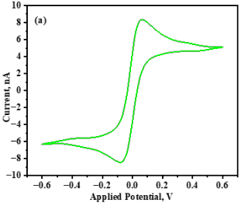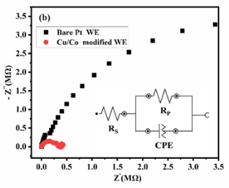
Fig.2. (a) CV in 1mM FCA at 50 mV/s for the bare Pt WE. (b). Nyquist plot of corresponding EIS measuring the impedance within a frequency range of 10⁻² to 10⁵ Hz, at room temperature. Inset is the Randles equivalent circuit.

Morphology study
The surface morphology and composition of the modified electrode was investigated using SEM and presented in Fig.2a. It confirms the homogeneous electrodeposition of the Cu/Co nanostructures over the Pt interdigitated microband electrode.Fig.2b confirms nanoparticles growth in roughly rounded and agglomerated structures at the edges of the electrode surface which may be due to co-deposition of the Cu and Co. Furthermore, the EDX analysis (Fig.2c) confirms the presence of Cu in higher percentage compared to Co as concentration of Co was ten times less than Cu in the deposition buffer. Along with Cu and Co, O, C, and Pt were also noticed. The presence of O may be due to the formation of copper oxide or cobalt oxide or formation of a complex structure with copper-cobalt oxide [5].
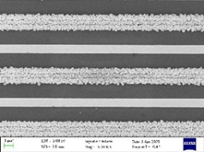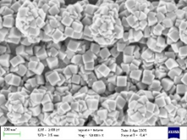
Cu
(b)
(a)
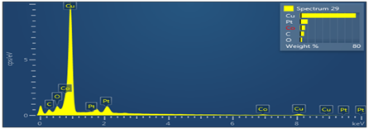
O
C
Pt
Cu
Cu
Co
Pt
Pt
Pt
Co
(c)
Fig.3. FESEM image of modified electrode surface at magnifications (a) 5.0 kX (b). 50 kX. (c). EDX spectrum

AFM analysis
AFM was employed to assess the surface topography, using standard tapping mode at a scan rate of 0.8 Hz over an area measuring 6 µm × 6 µm, with 256 lines captured per second. This technique was specifically applied to analyze the surface morphology of the electrode following the sensor modification process. Notably, the resulting images provided the root mean square (RMS) roughness value, a key indicator of surface characteristics. Fig.4. presents representative three-dimensional AFM images of the scanned electrode regions, along with corresponding cropped views of the top surface. Fig. 4a illustrates the surface of the bare Pt electrode, revealing a thickness of 0.14 µm and an RMS roughness of 6.55 nm. In contrast, Fig. 4b displays the Cu/Co-modified electrode, which shows a significantly increased thickness of 0.62 µm along with a higher RMS roughness of 73.72 nm. The AFM images clearly demonstrate a substantial enhancement in electrode thickness, confirming the successful electrodeposition of the Cu/Co layer onto the sensor surface. Overall, the morphological and compositional analyses carried out using SEM, EDX, and AFM show strong agreement and collectively confirm the successful surface modification of the electrode at each experimental stage, thereby supporting the sensor's functional viability.
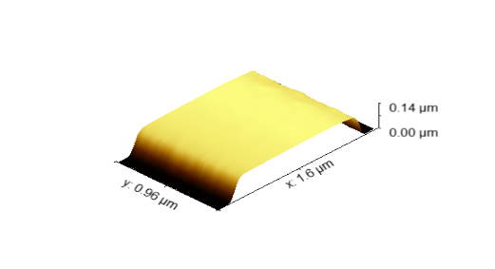
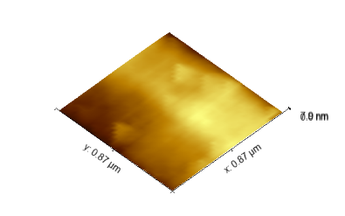
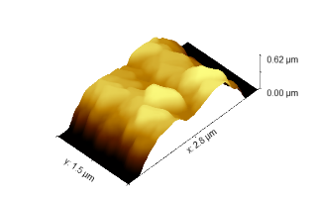
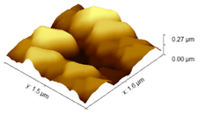
(a)
(b)

Fig.4. 3D AFM images taken at: (a) Bare Pt WE. (b) Cu/Co modified electrode surface and the corresponding cropped images of each surface.

Sensor performance analysis
The nitrate sensor performance was investigated employing a wide range of nitrate concentration. Fig.5a. shows the nitrate sensing response of the modified sensor using SWV with nitrate concentration range varied from 0 to 2500 µM in 0.4 M BR buffer solution. All the experiments were conducted at pH 2 as the use of acidic media is strongly recommended for nitrate reduction in reported literature [1,11-13]. From Fig.5a, a distinct peak at -0.55 V was observed for nitrate reduction. This aligns with reported work [14-18]. A slight shift in the peak potential toward more negative values was noted as the concentration increased beyond 100 µM. This can be attributed to the fact that at higher concentrations, mass transport becomes limited or disrupted, requiring the system to apply a greater potential to overcome this interference [10,19]. The electrochemical reduction of nitrate ions proceeds through multiple redox processes. This observation has been corroborated by other researchers [20,21].
Nitrate is believed to undergo reduction under suitably acidic conditions, leading to its conversion into nitrite [1]. This transformation can be represented by the following overall reaction equation:
${NO}_{3}^{-}$ + ${2H}^{+}$ +${2e}^{-}$ $↔$ ${NO}_{2}^{-}$ +$H_{2}O$ (2)
In Fig. 5b, two linear ranges of sensor performance were observed one at low concentrations (0–100 µM) which is referred as true LOD and one at higher concentrations (100–2500 µM) which is referred as limit of quantification (LOQ) and are represented by Eq.3 and Eq.4, respectively. Here ‘y’ refers to the peak current in nA.
$y \left(nA\right)=-0.0552 C_{Nitrate \left(µM\right)}-0.2904 ; R^{2} 0.9846$(3)
$y \left(nA\right)=-0.0022 C_{Nitrate \left(µM\right)}-5.4619 ; R^{2} 0.9858$(4)
The true LOD was determined using Eq.1 and found to be 0.19 µM and the LOQ was found to be 4.41 µM respectively. An interference study was conducted using common water ions like Mg²⁺, SO₄⁻, Zn²⁺, K⁺, NH₄⁺, Fe²⁺ and Na⁺. The concentration of these ions tested was 1000 µM in presence of 500 µM nitrate and the percentage change in peak current is presented in Fig.5c. Nitrite was excluded, as its reduction occurs at less negative potentials and does not interfere under acidic conditions [1]. The interfering ions showed a minimal impact on current response. Peak current measurements varied by less than ±10% compared to the nitrate-only blank test. This indicates a high selectivity of the sensor toward nitrate detection. The enhanced sensitivity and lower limit of detection (LOD) of the Cu/Co-based sensor can be attributed to two synergistic mechanisms. First, the nanoscale/microband electrode geometry—previously demonstrated by our group to enhance mass transport via radial diffusion—contributes to improved detection limits, higher sensitivity, and faster response times while operating at reduced sample volumes. Second, the co-deposition of Cu and Co generates a uniformly distributed nanostructured surface, as evidenced by FESEM and EDX analysis. This unique morphology not only increases the electroactive surface area but also promotes faster electron transfer kinetics, thereby improving the efficiency of nitrate reduction. Furthermore, the complementary electrocatalytic interaction between Cu and Co species enhances the overall reaction kinetics, consistent with prior reports [15]. By optimizing the Cu/Co complex coating on these microband electrodes, we further leverage these inherent advantages, resulting in the observed analytical performance improvements. Together, these material and geometric effects provide a comprehensive explanation for the sensor’s superior performance.

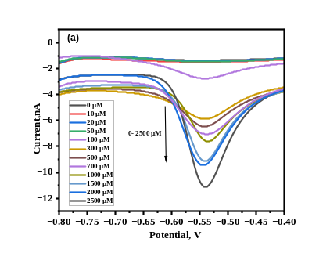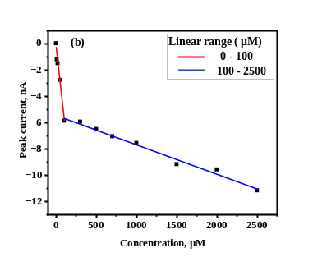
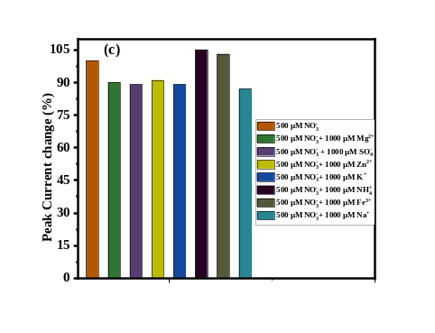

Fig.5: (a) SWV response of the Cu/Co sensor from nitrate concentrations (0 -2500 µM). (b) Calibration curve for nitrate sensing between the peak current vs. nitrate concentration (0- 2500 μM). (d) Peak current changes with interference of Mg²⁺, SO₄⁻, Zn²⁺, K⁺, NH₄⁺, Fe²⁺, Na⁺ for detection of nitrate at concentration of 500 µM.

Table 1: Performance comparison of various nitrate sensors.
Sensor Type | Detection technique | Range (µM) | pH | LOD(µM) | Ref
Cu NW | LSV | 0-50 | 2.5 | 10 | [1]
Cu NW | CV | 0-16000 | 4 | 250- 16000 | [4]
Chit/TsCuPc | SWV | 1-10 | 2 | 0.05 | [15]
Cu | LSV | 10-200 | 3 | - | [17]
Cu | LSV | 5-2000 | 2 | 1.99 | [18]
Ni₂O₃/rGO | CV | 16-3226 | 7 | 380 | [20]
MWCNTs | DPV | 50-1000 | 7 | 20 | [21]
Cu | DPV | 8-5860 | 2 | 1.35 | [11]
Cu/Co | SWV | 0-100 | 2 | 0.19 | This work

IV. CONCLUSION

Copper-Cobalt based sensors were developed through electrodeposition and showed effective performance for nitrate detection. The galvanic deposition method enabled a fast, cost-effective, reproducible, and simple approach for electrode fabrication, making it highly suitable for large-scale production. The sensor demonstrated two linear response ranges: 0–100 μM with true LOD 0.19 μM and 100–2500 μM, with LOQ of 4.41 µM. Selectivity analysis indicated excellent specificity toward common ions typically found in real water samples. These results confirm the sensor’s effectiveness for monitoring nitrates in various real water sources, including, river water, and drinking water.

ACKNOWLEDGMENT

This work was supported by funding from the Irish Department of Agriculture, Food and the Marine through the EJP-SOIL external FAMOSOS project (Grant No. 2022EJPSOIL202) and the CirCoVal project (Grant No. 2023RP1040) and financial support of Research Ireland and the Department of Agriculture, Food and Marine on behalf of the Government of Ireland under Grant Number [21/RC/10303_P2] – VistaMilk.
REFERENCES

[1] Patella B, Russo R R, Riordan A O, Aiello G, Sunseri C, Inguanta R (2021), “Copper nanowire array as highly selective electrochemical sensor of nitrate ions in water”, Talanta, vol. 221, pp. 121643. https://doi.org/10.1016/j.talanta.2020.121643
[2] Alahi M E E, Mukhopadhyay S C (2018), “Detection methods of nitrate in water: A review”, Sensors and Actuators A: Physical, vol.280, pp. 210-221. https://doi.org/10.1016/j.sna.2018.07.026
[3] Öznülüer T, Özdurak B, Doğan H Ö (2013), “Electrochemical reduction of nitrate on graphene modified copper electrodes in alkaline media”, J. of Electroanalytical Chemistry, vol. 699, pp. 1-5. https://doi.org/10.1016/j.jelechem.2013.04.001
[4] Yang Z, Li C, Luo D, Wei J, Che F, Gu Z (2024), “Electrodeposition of Cu-based nanoarrays with tailored hierarchical nanostructure and their application for electrochemical nitrate sensing”, J. of Electroanalytical Chemistry, vol. 974, pp.118744. https://doi.org/10.1016/j.jelechem.2024.118744
[5] Noormohammadi E, Sanjabi S, Soavi F, Poli F (2023), “Electrodeposited Cobalt–Copper mixed oxides for supercapacitor electrodes and investigation of the Co/Cu ratio on the electrochemical performance,” Materials for Renewable and Sustainable Energy, vol. 12(1), pp. 53-61. https://doi.org/10.1007/s40243-023-00229-4
[6] Bahar J, Lghazi Y, Youbi B, Ait Himi M, El Haimer C, Ezaier Y, Bimaghra I (2023), “Electrochemical deposition and characterization of copper-cobalt oxide layers by electrodeposition,” J. of the Indian Chemical Society, vol. 100(2), pp. 100914. https://doi.org/10.1016/j.jics.2023.100914
[7] Narayan T, Reidy M K, Heelan S, Riordan A, Shao H (2023), "Real-Time Electrochemical Sensor for Phosphate Sensing in Water." In 2023 IEEE SENSORS, pp. 1-4. IEEE, 2023.
[8] Gomez E, Pane S, Valles E (2005), “Magnetic composites CoNi–barium ferrite prepared by electrodeposition”, Electrochemistry communications, vol. 7(12), pp. 1225-1231. https://doi.org/10.1016/j.elecom.2005.08.016
[9] Landa-Castro M, Sebastián P, Giannotti M I, Serrà A, Gómez E (2020), “Electrodeposition of nanostructured cobalt films from a deep eutectic solvent: Influence of the substrate and deposition potential range”, Electrochimica Acta, vol. 359, pp. 136928. https://doi.org/10.1016/j.electacta.2020.136928
[10] Das D, Bhan C, Mukherjee C, Golder A K (2024), “Improved selectivity of electrochemical aniline sensing using one-dimensional silver nanorods with high aspect ratio synthesized by ascorbic acid assisted method”, Analytica Chimica Acta, vol. 1310, pp. 342697. https://doi.org/10.1016/j.aca.2024.342697
[11] Liang J, Zheng Y, Liu Z (2016), “Nanowire-based Cu electrode as electrochemical sensor for detection of nitrate in water”, Sensors and Actuators B: Chemical, vol. 232, pp. 336-344. https://doi.org/10.1016/j.snb.2016.03.145
[13] Pletcher D, Poorabedi Z (1979), “The reduction of nitrate at a copper in aqueous acid”, Electrochima Acta, vol. 24, pp. 1253-1256. https://doi.org/10.1016/0013-4686(79)87081-4
[14] Wei S, Xiao D, Bian C, Li Y (2024), “Phosphate and nitrate electrochemical sensor based on a bifunctional boron-doped diamond electrode” ACS omega, vol. 9(18), pp. 20293-20303. https://doi.org/10.1021/acsomega.4c00717
[15] Talbi M, Anurag A, Tegenkamp C, Ali M B, Kanoun O (2024), “Enhanced electrochemical detection of nitrite and nitrate in water using Chitosan-Copper phthalocyanine nanocomposite”, Measurement, vol. 238, pp. 115395. https://doi.org/10.1016/j.measurement.2024.115395
[16] Hyusein, C, Tsakova V (2023) “Nitrate detection at Pd-Cu-modified carbon screen printed electrodes”, J. of Electroanalytical Chemistry, vol. 930, pp. 117172. https://doi.org/10.1016/j.jelechem.2023.117172
[17] Davis J, Moorcroft M J, Wilkins S J, Compton R G, Cardosi M F (2000), “Electrochemical detection of nitrate and nitrite at a copper modified electrode”, Analyst, vol. 125(4), pp. 737-742. DOI: 10.1039/A909762G
[18] Siddiqui H, Singh N, Chauhan V, Sathish N, Kumar S (2021), “Electrochemical 3D printed copper garden for nitrate detection”, Materials Letters, vol. 305, pp. 130795. https://doi.org/10.1016/j.matlet.2021.130795
[19] Dawson K, Baudequin M, O'Riordan A (2011), “Single on-chip gold nanowires for electrochemical biosensing of glucose”, Analyst, vol. 136 (21), pp. 4507-4513. DOI: 10.1039/C1AN15279C
[20] Percy S J, Tharini C, Sachdev A, Manikandan E (2024), “An efficient sensing system using Ion-Selective Membrane on Ni₂O₃/rGO nanocomposite for electrochemical detection of nitrate ions”, J. of Alloys and Compounds, vol. 980, pp. 173414. https://doi.org/10.1016/j.jallcom.2023.173414
[21] Kusonpan P, Kunpatee K, Chailapakul O, Kalcher K, Ortner A, Chaiyo S, Samphao A (2025) “A simple manually rotated paper-based analytical device with electrochemical sensors for the determination of nitrite and nitrate” Talanta, vol.292, pp.127919. https://doi.org/10.1016/j.talanta.2025.127919

