Supplementary Materials for

A novel comparative study for simultaneous determination of Cd (II) and Pb (II) based on Ruthenium Complex-Nanoparticles-Nafion modified screen-printed gold electrode.
Ibtihaj Albalawi, Anna Hogan, Hanan Alatawi, Samia Alsefri, Eric Moore *

*Corresponding author: Dr. Eric Moore
E-mail: e.moore@ucc.ie

Sensing and Separation Group, School of Chemistry,
University College Cork,
Cork, Ireland

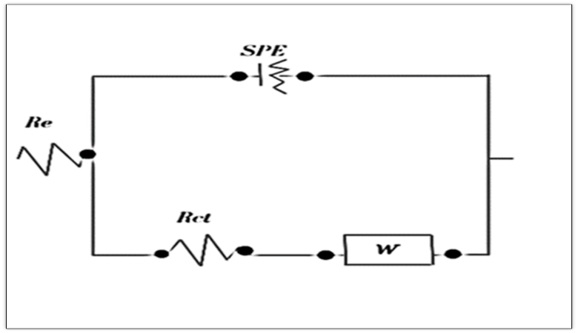

Fig. S1. The equivalent circuit model used to fit the EIS data

Optimization studies

Stripping time, potential, and stirring speed at Au-Ru/ /NA/ SPGE

Square wave anodic stripping voltammetry was conducted to investigate the effect of stripping time and potential on the metal’s detection using Au-Ru/ /NA/ SPGE in 0.1 M acetate buffer (pH 5.0). As seen in Fig.S2. a, the lead stripping current increased gradually with an increase in potential from −1.0 V to −1.6 V, reaching the maximum at −1.6 V. However, the stripping potential has no significant effect on the cadmium peak current, which peaked at −1.6 V. Therefore, −1.6 V was selected for further observation. Furthermore, the stripping time was studied from the 30 s to 300 s while the potential was kept constant at −1.6 V. It was observed that the lead peak current raised linearity with time and reached its maximum at 240 s; after this time, there was no significant improvement (Fig.S2. b). Cadmium current started to appear at 90 s and showed a slight improvement with an increase in time. Taking into consideration the cost factor, 120 s was selected for further studies. The influence of stirring speed on the peak current of the metals was also examined. As seen in Fig.S2.c, the effect of speed is meaningful on lead current, reaching the highest current at 600 rpm. However, the cadmium current has less response toward the stripping speed. Obviously, the metal’s current is almost similar at 300 rpm and 600 rpm. Therefore, 300 rpm was selected.

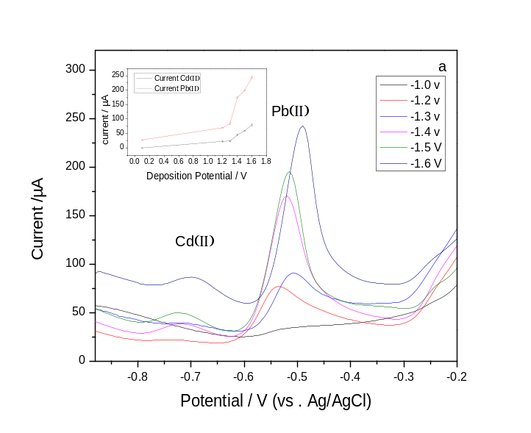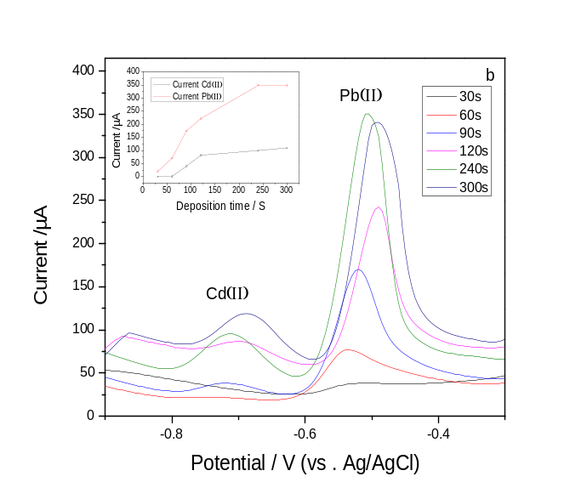
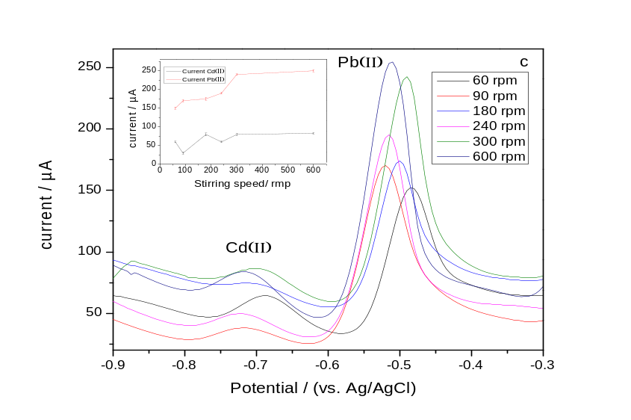
Fig. S2. SWASV of 200 ppb Cd (II) and Pb (II) in 0.1 M acetate buffer (pH 5.0) at Au-Ru/NA/SPGE with a deposition potential ranging from −1.0 V to −1.6 V (a), with a deposition time ranging from 30 s to 300 s (b) and stirring speed ranging from 60 rpm to 600 rpm (c); plot of peak currents vs. deposition potentials (a) (inset), vs. deposition times (b) (inset), and vs. stirring speeds (c) (inset).

Repeatability and reproducibility of [Ru(bpy)₃]²⁺- GO/NA and [Ru(bpy)₃]²⁺- Au/NA- SPGEs.

The repeatability of the hybrid nanocomposite [Ru(bpy)₃]²⁺- GO/NA sensor was examined in the presence of 200 ppb cadmium and lead in 0.1 M acetate buffer (pH 5.0) using SWASV for 30 continuous readings. The relative standard deviation (RSD) values were calculated to be 3.46 % for Cd (II) and 4.06 % for Pb (II), indicating a very high degree of repeatability. Additionally, SWASV was also used to test the repeatability of the modified [Ru(bpy)₃]²⁺- Au/NA nanocomposite sensor. The RSD values were calculated to be 6.52 % for Cd (II) and 2.67 % for Pb (II)

The reproducibility of the [Ru(bpy)₃]²⁺- GO/NA/ SPGE was also tested. Several prepared electrodes were evaluated in acetate buffer (pH 5.0) containing 200 ppb Cd (II) and Pb (II). The RSD values were measured for Cd (II) to be 1.3 % and for Pb (II) to be 1.5 %, suggesting acceptable reproducibility of the sensor. The relative standard deviation (RSD) values of reproducibility were calculated for [Ru(bpy)₃]²⁺- Au/NA to be 3.17 % for Cd (II) and 2.19 % for Pb (II), indicating a very good degree of reproducibility of the present sensor.

