Supplementary
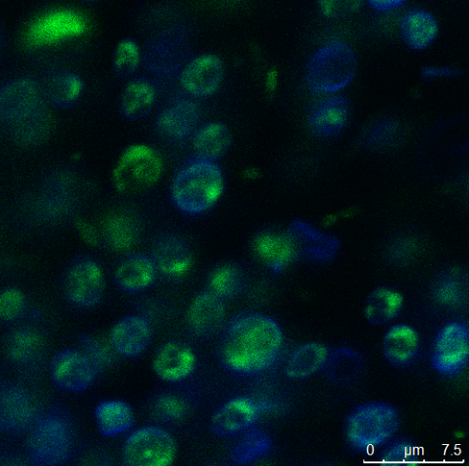
Figure S1. Microstructure image of C. vulgaris cell suspension. Proteins were dyed with 1 % fast green FCF (w/v) shown in green; lipids were dyed with 0.02 % Nile red shown in red; Cellulose (cell wall) was dyed with Calcofluor white 1:20 water shown in blue. The scale bar of the micrographs is 7.5 μm.
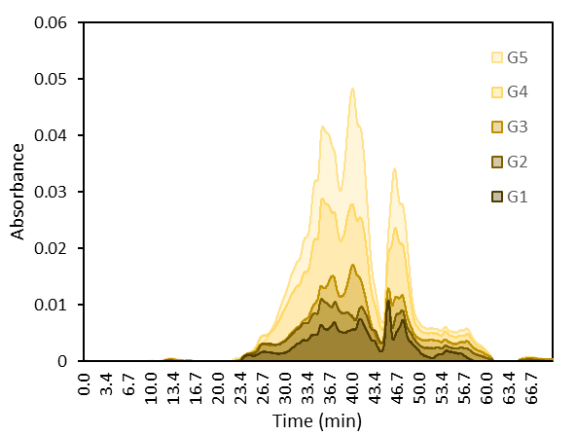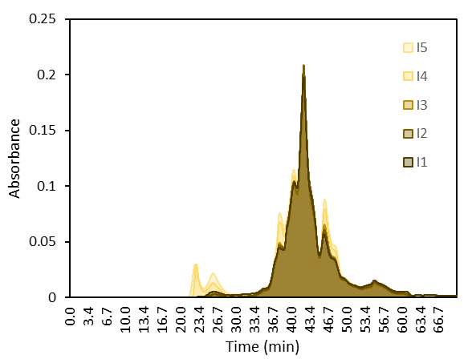
A
B
Figure S2. Size Exclusion Chromatography (SEC) chromatogram showing the peptide profile of gastric digesta (A) and intestinal digesta (B). G1-5 correspond to the gastric emptying time of 13.5, 27.0, 40.5, 54.0, and 67.5 min, respectively. I1-5 correspond to the individual 2h intestinal digestion performed on the G1-5 digesta.

Table S1. Free amino acid profile of undigested sample (U) and digesta (G1-5, I-1) during semi-dynamic in vitro digestion of C.vulgaris suspension (4 % protein, w/w). Results are shown in mean ± Standard deviation. G1-5 correspond to the gastric emptying time of 13.5, 27.0, 40.5, 54.0, and 67.5 min, respectively. I1-5 correspond to the individual 2h intestinal digestion performed on the G1-5 digesta.
 | U | G1 | G2 | G3 | G4 | G5 | I1 | I2 | I3 | I4 | I5
Aspartic Acid | 0.25 ± 0.02 | 0.27 ± 0.03 | 0.18 ± 0.02 | 0.23 ± 0.01 | 0.30 ± 0.00 | 0.35 ± 0.02 | 8.24 ± 0.00 | 9.25 ± 0.00 | 10.09 ± 0.00 | 12.37 ± 0.00 | 14.00 ± 0.00
Threonine | 1.02 ± 0.11 | 1.05 ± 0.06 | 0.80 ± 0.01 | 0.91 ± 0.07 | 1.23 ± 0.08 | 1.34 ± 0.10 | 27.50 ± 0.99 | 32.13 ± 0.33 | 32.03 ± 0.56 | 28.03 ± 0.90 | 30.72 ± 0.86
Serine | 1.62 ± 0.18 | 1.60 ± 0.10 | 1.32 ± 0.04 | 1.60 ± 0.02 | 2.14 ± 0.15 | 2.47 ± 0.16 | 17.95 ± 1.02 | 19.88 ± 4.82 | 20.24 ± 2.41 | 22.77 ± 0.74 | 24.40 ± 2.72
Glutamic Acid | 7.97 ± 0.86 | 7.17 ± 0.35 | 6.06 ± 0.13 | 7.16 ± 0.32 | 10.20 ± 0.70 | 11.52 ± 0.63 | 33.51 ± 1.14 | 35.87 ± 0.49 | 36.22 ± 1.01 | 38.84 ± 1.19 | 40.03 ± 1.33
Glycine | 0.37 ± 0.04 | 0.36 ± 0.01 | 0.31 ± 0.01 | 0.39 ± 0.02 | 0.52 ± 0.02 | 0.58 ± 0.03 | 8.85 ± 2.25 | 9.90 ± 0.88 | 10.20 ± 1.80 | 11.53 ± 1.76 | 12.54 ± 2.17
Alanine | 8.65 ± 0.97 | 8.27 ± 0.44 | 6.91 ± 0.23 | 8.07 ± 0.42 | 11.40 ± 0.82 | 12.99 ± 0.78 | 31.76 ± 0.57 | 33.15 ± 0.24 | 30.61 ± 0.50 | 28.85 ± 0.23 | 27.36 ± 1.12
Cysteine | 3.30 ± 0.08 | 2.07 ± 0.08 | 2.29 ± 0.07 | 3.16 ± 0.34 | 5.51 ± 0.83 | 7.83 ± 1.83 | 11.73 ± 0.51 | 12.47 ± 0.35 | 13.29 ± 0.61 | 16.75 ± 0.97 | 18.78 ± 0.82
Valine | 2.45 ± 0.21 | 2.02 ± 0.11 | 1.82 ± 0.04 | 2.09 ± 0.11 | 3.19 ± 0.31 | 3.90 ± 0.38 | 25.36 ± 0.52 | 26.91 ± 0.27 | 25.54 ± 0.44 | 26.20 ± 0.94 | 26.54 ± 1.02
Methionine | 0.13 ± 0.01 | 0.12 ± 0.06 | 0.12 ± 0.07 | 0.11 ± 0.04 | 0.24 ± 0.11 | 0.33 ± 0.04 | 6.50 ± 0.30 | 6.50 ± 0.57 | 6.22 ± 1.57 | 6.35 ± 0.58 | 6.97 ± 1.43
Isoleucine | 0.33 ± 0.04 | 0.31 ± 0.02 | 0.26 ± 0.02 | 0.31 ± 0.01 | 0.40 ± 0.01 | 0.44 ± 0.01 | 15.70 ± 0.28 | 17.17 ± 0.30 | 16.18 ± 0.58 | 16.47 ± 0.23 | 15.72 ± 0.60
Leucine | 0.36 ± 0.04 | 0.40 ± 0.01 | 0.33 ± 0.01 | 0.40 ± 0.01 | 0.56 ± 0.03 | 0.66 ± 0.04 | 39.81 ± 0.15 | 41.72 ± 0.36 | 36.63 ± 0.78 | 32.15 ± 0.31 | 28.86 ± 1.06
Tyrosine | 0.30 ± 0.03 | 0.32 ± 0.01 | 0.37 ± 0.00 | 0.55 ± 0.11 | 0.77 ± 0.10 | 1.40 ± 0.33 | 19.09 ± 0.32 | 19.19 ± 0.85 | 15.55 ± 2.89 | 11.30 ± 0.83 | 10.87 ± 1.83
Phenylalanine | 0.22 ± 0.01 | 0.83 ± 0.01 | 0.79 ± 0.01 | 1.09 ± 0.00 | 1.77 ± 0.20 | 2.28 ± 0.23 | 25.89 ± 0.38 | 26.79 ± 0.65 | 23.67 ± 1.90 | 21.86 ± 0.81 | 21.61 ± 2.37
Histidine | 1.09 ± 0.07 | 1.07 ± 0.07 | 1.07 ± 0.11 | 1.53 ± 0.11 | 2.30 ± 0.09 | 2.84 ± 0.06 | 13.17 ± 0.24 | 13.39 ± 0.21 | 12.59 ± 0.16 | 12.80 ± 0.08 | 13.42 ± 0.21
Lysine | 0.77 ± 0.19 | 1.10 ± 0.23 | 1.19 ± 0.16 | 1.20 ± 0.03 | 1.33 ± 0.05 | 1.89 ± 0.59 | 39.55 ± 0.19 | 41.92 ± 0.41 | 39.60 ± 1.01 | 39.96 ± 0.30 | 41.22 ± 1.06
Tryptophan | 0.00 ± 0.00 | 0.00 ± 0.00 | 0.00 ± 0.00 | 0.00 ± 0.00 | 0.00 ± 0.00 | 0.00 ± 0.00 | 18.36 ± 0.03 | 19.77 ± 0.01 | 21.00 ± 0.02 | 24.74 ± 0.06 | 27.49 ± 0.08
Arginine | 3.43 ± 0.36 | 3.25 ± 0.15 | 2.61 ± 0.14 | 2.92 ± 0.14 | 3.98 ± 0.08 | 4.28 ± 0.26 | 84.68 ± 2.64 | 83.46 ± 1.83 | 72.79 ± 6.27 | 64.32 ± 1.38 | 59.25 ± 2.13
Proline | 6.17 ± 0.60 | 5.65 ± 0.35 | 4.67 ± 0.10 | 5.50 ± 0.42 | 7.85 ± 0.94 | 8.31 ± 0.60 | 8.03 ± 0.19 | 7.85 ± 0.53 | 8.27 ± 0.95 | 8.06 ± 0.82 | 7.59 ± 1.45

