RGS4 negatively modulates Nociceptin/Orphanin FQ opioid receptor signaling: implication for L-Dopa induced dyskinesia.
¹Pisanò CA, ¹Mercatelli D, ²Mazzocchi M, ¹Brugnoli A, ³Morella I, ³Fasano S, ⁵Zaveri NT, ³Brambilla R, ²O’Keeffe GW, ⁴Neubig RR, ¹Morari M.

Corresponding author: Michele Morari, PhD, Department of Neuroscience and Rehabilitation, Section of Pharmacology, University of Ferrara, via Fossato di Mortara 17-19, 44121 Ferrara (Italy), email: m.morari@unife.it.

Supplementary Material
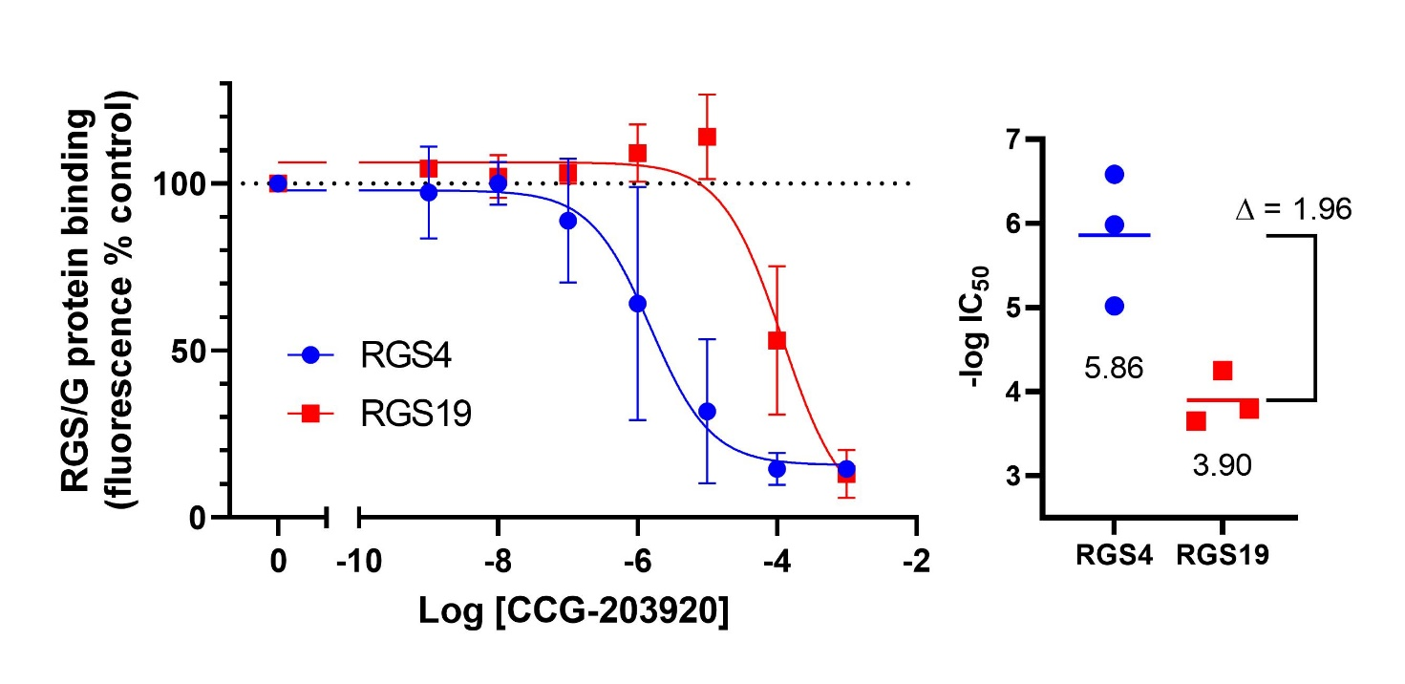
Figure S1. Potency of CCG-203920 for inhibition of binding of RGS4 and RGS19 to the Gα_{o} subunit. Binding of fluorescently-tagged Gα_{o} protein to RGS4 or RGS19 was determined by use of the flow-cytometry protein interaction assay described previously (Turner et al, 2012; Blazer et al 2015). The experimental RGS4 chemical probe CCG-203920 was previously shown to exhibit >600-fold selectivity for RGS4 over RGS8 (Turner et al, 2012). In the current result in three independent studies, the mean log IC₅₀ value for RGS4 is -5.86 (IC₅₀ 1.4 μM) while that for RGS19 is -3.90 (IC₅₀ 126 μM) with a selectivity ratio of 91-fold.

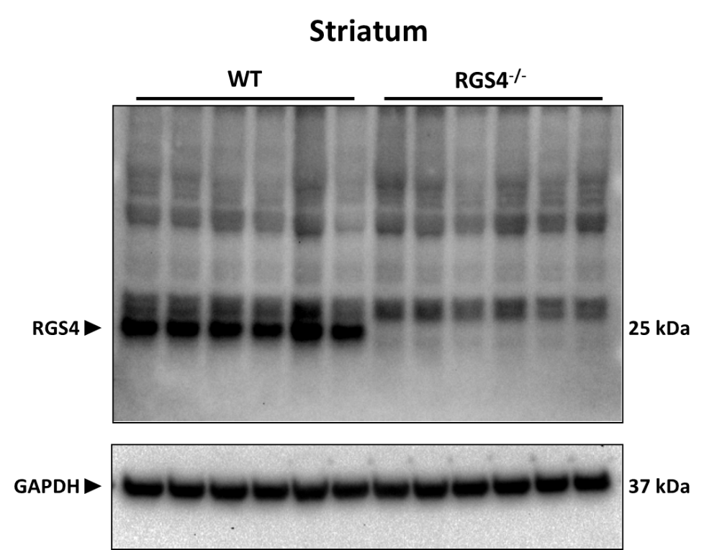

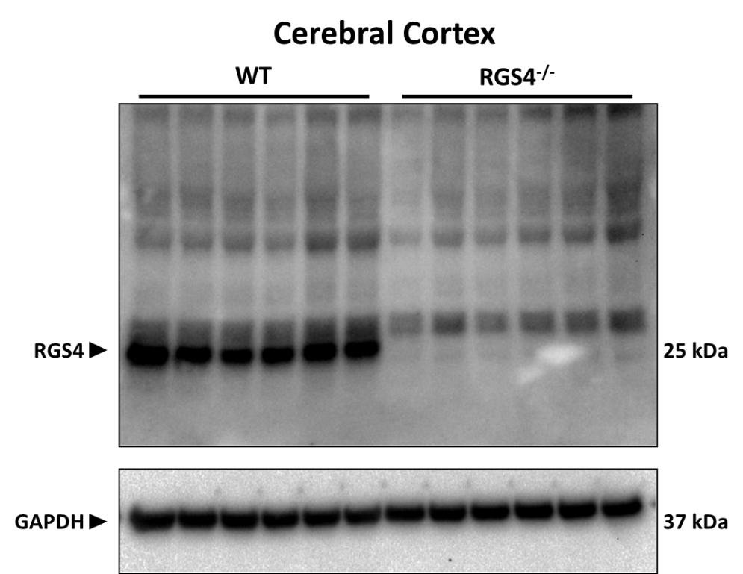

Figure S2. Specificity of RGS4 antibody. Western blot analysis of lysates from the striatum and cerebral cortex of n=6 wild-type (WT) and n=6 RGS4 knockout (RGS4^{-/-}) mice loaded with an RGS4 antibody. Note the absence of RGS4 signal in RGS4^{-/-} mice indicating the specificity of the antibody. GAPDH was used as equal protein loading control.

