Supporting information
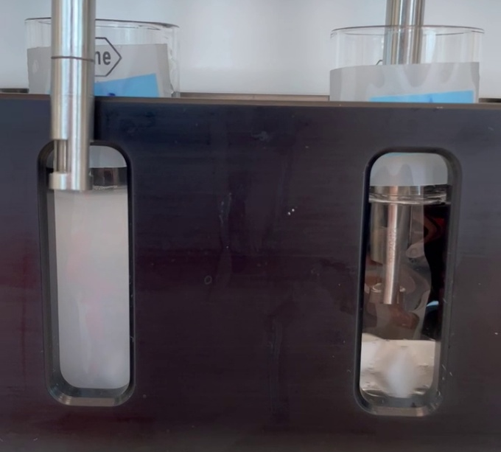
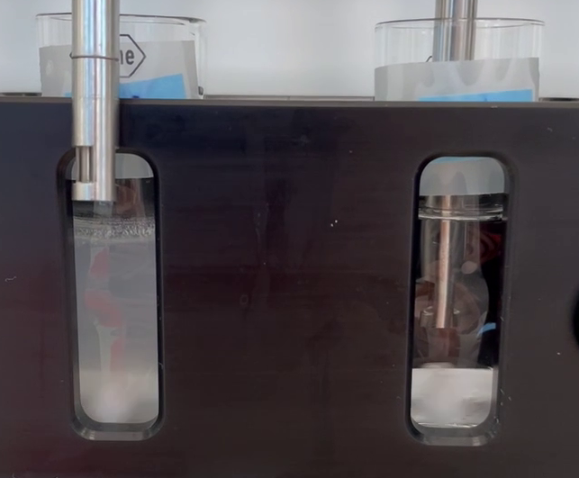
(a)
(b)

Figure S1. Donor and acceptor compartments of the µFLUX setup (a) 90 seconds and (b) 4 hours after initiating the dissolution/permeation test. Donor compartment is seen on the left and acceptor on the right. A decrease in turbidity of the donor medium was observed over time.

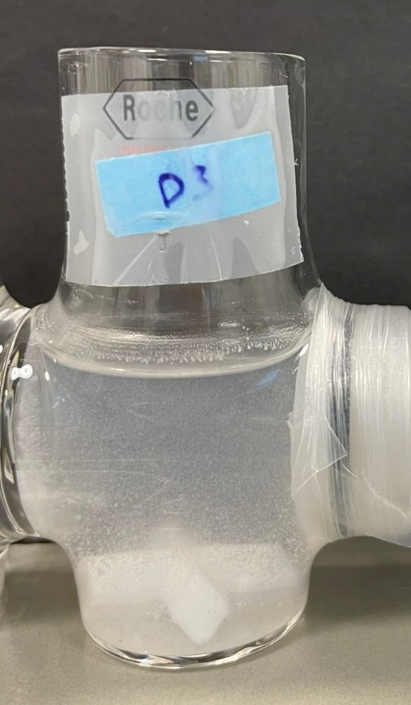
Figure S2. Sedimentation of precipitated solids on the bottom of the donor vial after end of µFLUX dissolution/permeation test using a solvent shift approach with a neat DMSO stock of RO6897779 in FaSSIF-V1 at 37 °C.

