Supplementary figures:

Figure S1:

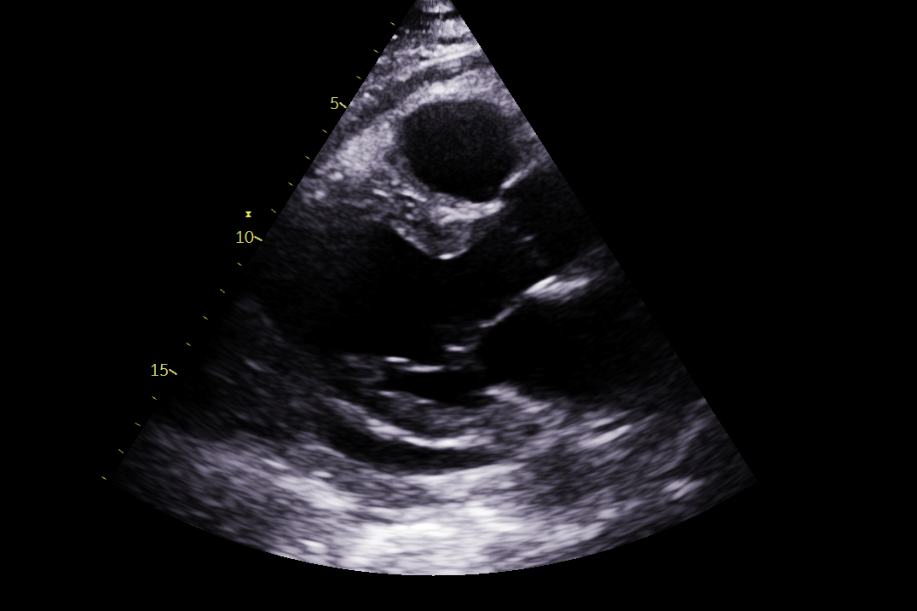
Echocardiogram post-pericardiocentesis:
Post-pericardiocentesis

Figure S2:

Cardiac MRI before the steroid treatment:
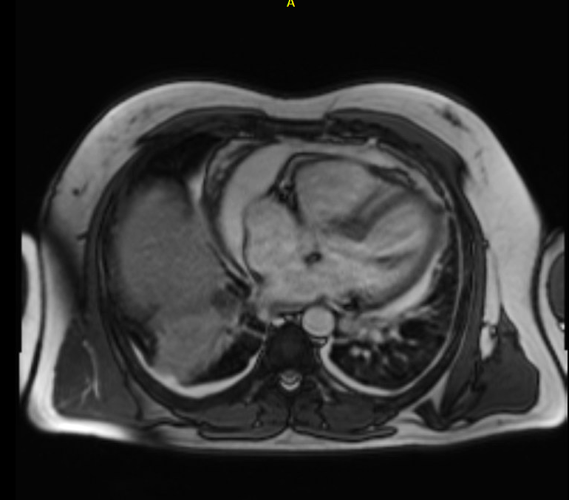

Figure S3:

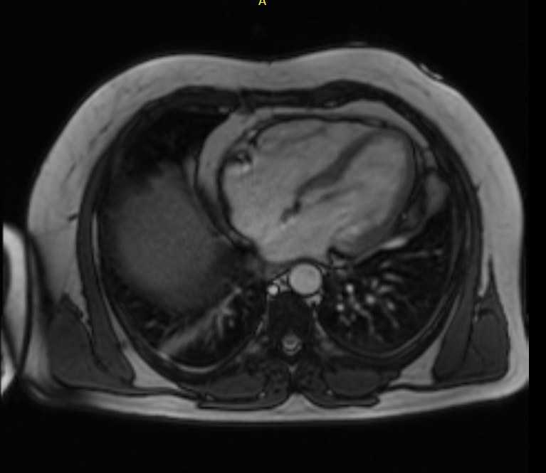
Cardiac MRI after steroid treatment:

Figure. S4:

Inflammatory markers (WCC and CRP) trends with each admission:

 | Admission | During admission | Discharge bloods
First presentation | WCC 11.2 × 10^9/L  CRP 227 mg/L | 8.6 × 10^9/L  212 mg/L | 6.7 × 10^9/L  55 mg/L
Second presentation | WCC. 17.5 × 10^9/L  CRP 216 mg/L | 14.7× 10^9/L  13 mg/L | 9.1 × 10^9/L  4 mg/L
Third presentation | WCC10.9 × 10^9/L  CRP 80 mg/L | 9.5 × 10^9/L  177 mg/L | 8.8 × 10^9/L  8 mg/L
Around pericardiectomy presentation | WCC 12.2 × 10^9/L  CRP 131 mg/L | 10.1× 10^9/L  15.1 mg/L | 24 × 10^9/L  5.2 mg/L

