Supplementary Information for

Synchrotron-X-ray absorption spectroscopy of melanosomes in vertebrates and cephalopods: implications for the affinity of Tullimonstrum
Christopher S. Rogers, Timothy I. Astrop, Samuel M. Webb, Shosuke Ito, Kazumasa Wakamatsu, Maria E. McNamara
Christopher S. Rogers, Maria E. McNamara
Email: christopher.rogers@ucc.ie; maria.mcnamara@ucc.ie

This PDF file includes:

Figures S1 to S3
Tables S1 to S4

Figure S1. Carbon film in fossil eyespots. Photographs (a,b), backscatter electron micrograph (c) and EDS elemental map for C (d) of fossil Gilpicthys greenei (FMNH P F8474) showing enrichment of C in the eyespots. Delineated region in (a) is that imaged shown in (b–d). Arrows indicate position of eyespots in (d).

Figure S2. Histological sections of eyes in extant cephalopods (L. vulgaris, O. vulgaris, S. officialis) and vertebrates (P. marinus, D. labrax). Sections are stained with Warthin-Starry; melanin appears black. Delineated regions are those shown in figure 1b.
Figure S3. Fossil eyespots. Photographs (i-ii) and scanning electron micrographs (iii-iv) of fossils (a) NHMD 199838 (Acanthopterygii: Tetradontiformes), (b) UGF-2015-16 (Clupeomorpha: Knightia), (c) CKGM F 6426 (Tullimonstrum), (d) NHMUK PICC651A (Octopodiformes: Keuppia), (e) FMNH PF5668 B (Petromyzodontiformes: Mayomyzon), (f), FMNH PF 8474 A (Cyclostomata: Gilpichthys), and (g) FMNH PE 51727 (Cirroctopoda: Pohlsepia) showing details of fossil eyespots and melanosome-like microbodies (a-f) and the absence of melanosome-like microbodies (g). Delineated regions in (i) are those mapped using synchrotron-XRF.

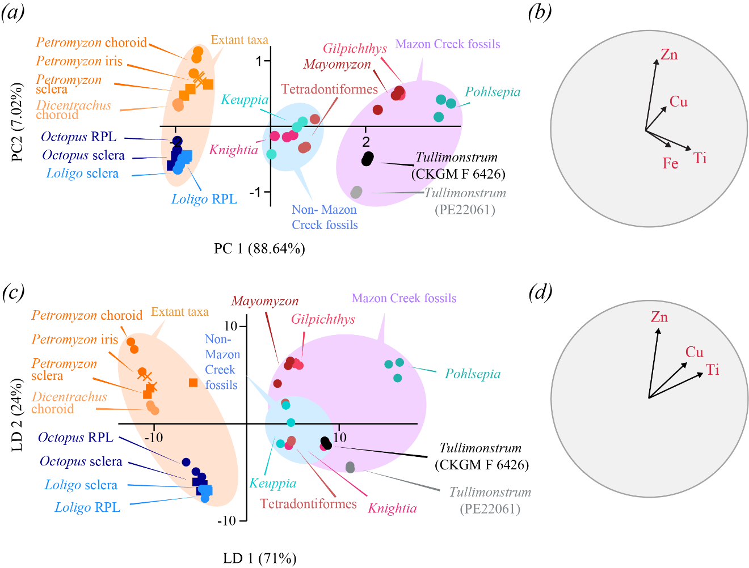
Figure S4. Variation in key elements (Ti, Fe, Cu and Zn) in extant and fossil cephalopods and vertebrates. Principal Component Analysis based on measured concentrations of Ti, Fe, Cu and Zn showing a near identical distribution of data points relative to those in figure 4a (a). Biplot of key elements contributing to variation in (b). Linear discriminate analysis data of measured concentrations of Ti, Cu and Zn with the major rock-forming element Fe (which is responsible for most variation in LD2 in figure 4a) removed (c). Biplot of key elements contributing to variation in (d).

Table S1. Details of fossil specimens used in this study.

taxon | specimen number | locality | age
Gilpichthys greenei (Cyclostomata) | FMNH PF 8474 A | Mazon Creek | Middle-Upper Carboniferous
Keuppia sp. (Octopoda: Palaeoctopodidae) | NHMUK PICC651A | Hâkel and Hâdjoula | Upper Cretaceous
Knightia sp. (Actinopterygii: Clupeomorpha) | FOBU 17591 | Green River Formation | Lower-Middle Eocene
Mayomyzon pieckoensis (Cyclostomata: Petromyzodontiformes) | FMNH PF 5668 B | Mazon Creek | Middle-Upper Carboniferous
Pohlsepia mazonensis (Coleoidea: Ciroctopoda)  Tetradontiformes indet. (Actinopterygii) | FMNH PE 51727  NHMD 199838 | Mazon Creek  Fur Formation | Middle-Upper Carboniferous  Lower Eocene
Tullimonstrum gregarium | CKGM F 6426 | Mazon Creek | Middle-Upper Late Carboniferous
Tullimonstrum gregarium | FMNH PE 22061 | Mazon Creek | Middle-Upper Carboniferous

Table S2. Analysis of melanin content in tissues from eyes of extant cephalopods and extant vertebrates. PTCA and 4-AHP are markers for eumelanin and pheomelanin, respectively. Reported weights of PTCA and 4-AHP represent ~0.3% and ~15% respectively of the total weight of eumelanin and phaeomelanin present in the sample [9, 10]. Therefore, an equal value of PTCA and 4-AHP implies that eumelanin content is 50 times greater than phaeomelanin content. Choroid and RPE could not be separated and were treated as a single tissue for this analysis.
 | PTCA (ng/mg) |  |  |  | 4-AHP (ng/mg)
taxon | iris | RPL | SCL |  | iris | RPL | SCL
Loligo vulgaris | 3.0 | 4.1 | - |  | 9.5 | 0.9 | -
Octopus vulgaris | 4.0 | 3.4 | - |  | 3.1 | 2.1 | -
Sepia officianalis | 6.2 | 3.4 | 7.4 |  | 24.3 | 8.1 | 18.3
 | iris |  | choroid and RPE |  | iris |  | choroid & RPE
Petromyzon marinus | 1771 |  | 1791 |  | 4.5 |  | 2.0
Dicentrachus labrax | - |  | 10.2 |  | - |  | 5.5

Table S3. Geometry of melanosomes in extant cephalopods and lamprey. Values cited are mean ± standard deviation. Full taxon names are reported in table S2.

 | iris |  |  | RPL |  |  | SCL
taxon | length (µm) | aspect ratio |  | length (µm) | aspect ratio |  | length (µm) | aspect ratio
Loligo vulgaris | 1.345  ± 0.5 | 2.776  ± 0.735 |  | 0.799  ± 0.336 | 3.381  ± 1.303 |  | - | -
Octopus vulgaris | 0.773  ± 0.186 | 1.993  ± 0.576 |  | 0.725  ± 0.238 | 1.975  ± 0.975 |  | 0.988  ± 0.310 | 3.391  ± 1.010
Spia officianalis | 1.130  ± 0.302 | 2.776  ± 0.735 |  | 0.799  ± 0.335 | 3.381  ± 1.303 |  | - | -
Petromyzon marinus | choroid |  |  | iris |  |  | RPE |  |  | sclera
Petromyzon marinus | length (µm) | aspect ratio |  | length (µm) | aspect ratio |  | length (µm) | aspect ratio |  | length (µm) | aspect ratio
Petromyzon marinus | 0.740  ± 0.110 | 1.294  ± 0.177 |  | 0.913  ± 0.153 | 1.353  ± 0.240 |  | 1.120  ± 0.325 | 2.107  ± 0.945 |  | 0.682  ± 0.120 | 1.350  ± 0.240

Table S4. Statistical analyses of melanosome geometry. (a) Results of ANOVA. Asterisk indicates use of the non-parametric Welch’s F-test. (b) Post-hoc analyses for ANOVA (Tukey’s pairwise) and Welch F test (Dunn’s post hoc). † indicates geometry data that were log-transformed prior to statistical testing due to non-normality. Full taxon names are reported in table S2.
(a) |  | length (µm) |  |  |  |  |  | aspect ratio
taxon |  | df | F | p |  |  | df |  | F | p
Loligo vulgaris |  | (1,90) | 65.89 | 2.34e⁻¹² |  |  | (1,90) |  | 7.275 | 8.35e⁻³
Octopus vulgaris |  | 93.14* | 11.8* | 2.70e⁻⁵* |  |  | 98.39* |  | 34.02* | 5.87e⁻¹²*
Sepia officianalis |  | (1,48)† | 1.154† | 2.55e^{-1†} |  |  | 1, 48† |  | 10.94† | 1.79e^{-3†}
Petromyzon marinus |  | 114.4* | 57.95* | 7.38e⁻²³ |  |  | 108.7* |  | 15.64* | 1.586e⁻⁸*
(b)
   | iris | RPL
  iris | - | 4.00e⁻¹¹
  RPL | 4.00E⁻¹¹ | -
   | iris | RPL
  iris | - | 2.23e⁻²
  RPL | 2.23e⁻² | -
Loligo vulgaris
   | iris | RPL | SCL
  iris | - | 3.90e⁻² | 6.27e⁻⁴
  RPL | 3.90e⁻² | - | 1.48e⁻⁸
  SCL | 6.27e⁻⁴ | 1.48e⁻⁸ | -
   | iris | RPL | SCL
  iris | - | 0.3072 | 6.44e⁻⁹
  RPL | 0.3072 | - | 1.09e⁻¹³
  SCL | 6.44e⁻⁹ | 1.09e⁻¹³ | -
Octopus vulgaris
   | iris† | RPL†
  iris† | - | 0.3901
  RPL† | 0.3901 | -
   | iris† | RPL†
  iris† | - | 0.0023
  RPL† | 0.0023 | -
Sepia officianalis
   | choroid | iris | RPE | sclera
  choroid | - | 3.86e⁻¹¹ | 1.25e⁻¹⁶ | 7.78e⁻²
  iris | 3.86e⁻¹¹ | - | 0.01191 | 7.06e⁻¹¹
  RPE | 1.25e⁻¹⁶ | 0.01191 | - | 1.62e⁻¹⁵
  sclera | 7.78e⁻² | 7.06e⁻¹¹ | 1.62e⁻¹⁵ | -
   | choroid | iris | RPE | sclera
  choroid | - | 2.24e⁻¹ | 1.83e⁻⁹ | 1.70e⁻¹
  iris | 2.24e⁻¹ | - | 1.83e⁻⁹ | 6.17e⁻¹
  RPE | 1.83e⁻⁹ | 1.83e⁻⁹ | - | 3.72e⁻⁵
  sclera | 1.70e⁻¹ | 6.17e⁻¹ | 3.72e⁻⁵ | -
Petromyzon. marinus

Table S5. Maximum concentration values for key elements (Ti, Fe, Cu and Zn) in XRF maps presented in Figure 3. Values cited are μg/cm².

taxon/ specimen no. | Ti | Fe | Cu | Zn
Dicentrachus labrax | 10.695 | 20.432 | 0.774 | 10.268
Keuppia sp. / NHMUK PICC651A | 32.069 | 138.6 | 45.354 | 5.734
Knightia sp. / FOBU 17591 | 100.698 | 953.843 | 11.281 | 470.210
Loligo vulgaris | 114.231 | 414.166 | 1.5 | 9.449
Octopus vulgaris | 10.915 | 40.657 | 1.000 | 5.000
Petromyzon marinus | 259.221 | 29.324 | 1.120 | 20.118
Tetradontiformes indet. / NHMD 199838 | 60 | 1298.405 | 4 | 15.817
Tullimonstrum gregarium / CKGM F 6426 | 150.430 | 12000.845 | 4.0827 | 1.321

