Supplementary information
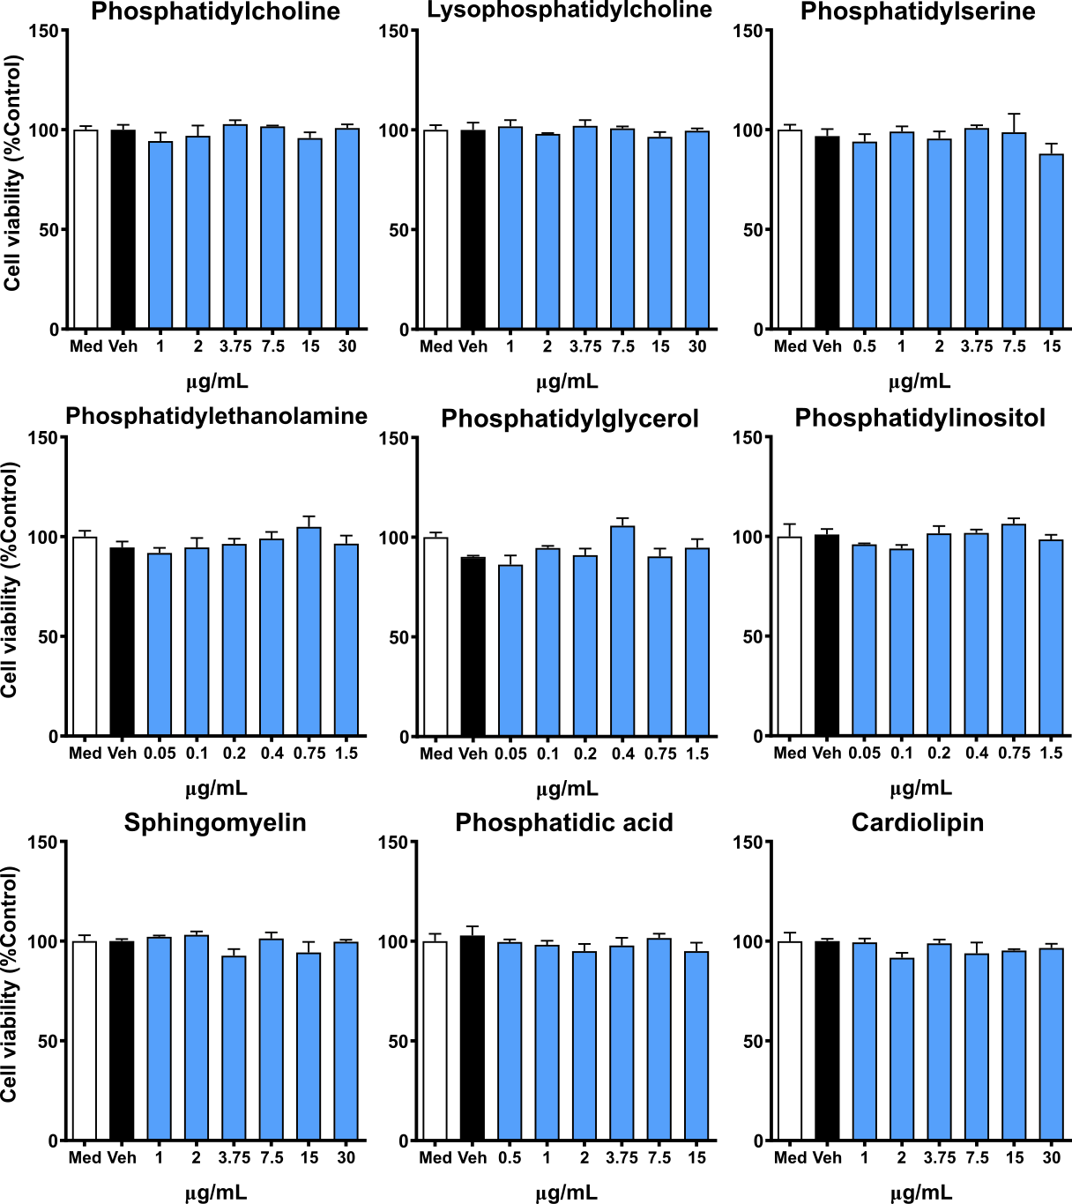
Figure S1 Phospholipids do not exert cytotoxic effects on cortical cells. Cortical cells were incubated with various concentrations of phospholipids for 24 hours. Different concentration ranges were tested for each phospholipid considering their solubility. Cell viability was measured by MTT assay. Results are expressed as the mean ± SEM of three independent experiments performed in triplicate. Medium = Med; Vehicle = Veh

