TABLE A1
Example Patient Diary Entry

Hour | Medication | Asleep | OFF | Dyskinesia | Tremor | Slowness of movement | Freezing of gait | Notes
 |  | (✘) | (✘) | (0, 1, 2, 3, 4) | (0, 1, 2, 3, 4) | (0, 1, 2, 3, 4) | (0, 1, 2, 3, 4)
12:00:00 | 1 | 0 | 0 | 1 | 2 | 2 | 0 | 11:50:00
12:30:00 |  | 0 | 0 | 1 | 2 | 2 | 0 | "DRIVING HOME"
13:00:00 |  | 0 | 0 | 2 | 2 | 2 | 0 | "DRIVING HOME"
13:30:00 |  | 0 | 0 | 2 | 3 | 2 | 0 | "HOME FROM TYNDALL"
14:00:00 |  | 0 | 0 | 1 | 3 | 2 | 0
14:30:00 |  | 0 | 0 | 0 | 0 | 2 | 0 | "SLEEP"
15:00:00 |  | 0 | 0 | 0 | 0 | 2 | 0 | "SLEEP"
15:30:00 |  | 0 | 0 | 0 | 0 | 2 | 0 | "SLEEP"
16:00:00 |  | 0 | 1 | 2 | 2 | 3 | 0 | "SLEEP"
16:30:00 |  | 0 | 1 | 2 | 3 | 3 | 0
17:00:00 |  | 0 | 1 | 2 | 3 | 3 | 0
17:30:00 |  | 0 | 1 | 1 | 2 | 2 | 0
18:00:00 | 1 | 0 | 0 | 1 | 2 | 2 | 0
18:30:00 |  | 0 | 0 | 1 | 2 | 2 | 0
19:00:00 |  | 0 | 0 | 2 | 2 | 2 | 0
19:30:00 |  | 0 | 0 | 2 | 2 | 2 | 0
20:00:00 |  | 0 | 0 | 2 | 3 | 2 | 0
20:30:00 |  | 0 | 0 | 1 | 3 | 2 | 0
21:00:00 | 1 | 0 | 1 | 2 | 3 | 2 | 0
21:30:00 |  | 0 | 1 | 2 | 3 | 2 | 0
22:00:00 |  | 0 | 1 | 2 | 3 | 2 | 0
22:30:00 | 1 | 0 | 0 | 0 | 2 | 2 | 0
23:00:00 |  | 0 | 0 | 0 | 0 | 2 | 0
23:30:00 |  | 0 | 0 | 0 | 0 | 2 | 0
00:00:00 |  | 1 | 0 | 0 | 0 | 0 | 0
00:30:00 |  | 1 | 0 | 0 | 0 | 0 | 0
01:00:00 |  | 1 | 0 | 0 | 0 | 0 | 0
01:30:00 |  | 1 | 0 | 0 | 0 | 0 | 0
02:00:00 |  | 1 | 0 | 0 | 0 | 0 | 0
02:30:00 |  | 0 | 0 | 1 | 3 | 2 | 0 | "WIDE AWAKE"
03:00:00 |  | 0 | 0 | 1 | 3 | 2 | 0 | "EMPTYING DISHWASHER”
03:30:00 |  | 0 | 0 | 1 | 2 | 2 | 0
04:00:00 |  | 0 | 0 | 1 | 2 | 2 | 0
04:30:00 |  | 0 | 0 | 1 | 2 | 0 | 0 | "BACK TO BED"
05:00:00 |  | 1 | 0 | 0 | 1 | 0 | 0 | "HALF ASLEEP"
05:30:00 |  | 1 | 0 | 0 | 1 | 0 | 0 | "HALF ASLEEP"
06:00:00 | 1 | 1 | 0 | 0 | 1 | 0 | 0 | "HALF ASLEEP"
06:30:00 |  | 1 | 0 | 0 | 1 | 0 | 0 | "HALF ASLEEP"
07:00:00 |  | 1 | 0 | 0 | 3 | 0 | 0 | "HALF ASLEEP"
07:30:00 |  | 1 | 0 | 0 | 3 | 0 | 0 | "HALF ASLEEP"
08:00:00 |  | 0 | 0 | 0 | 2 | 0 | 0 | "AWAKE"
08:30:00 |  | 0 | 0 | 1 | 2 | 2 | 0
09:00:00 |  | 0 | 0 | 2 | 2 | 2 | 0
09:30:00 |  | 0 | 0 | 2 | 3 | 3 | 0
10:00:00 |  | 0 | 0 | 2 | 3 | 3 | 0
10:30:00 |  | 0 | 0 | 0 | 0 | 0 | 0
11:00:00 |  | 0 | 0 | 0 | 0 | 0 | 0
11:30:00 |  | 0 | 0 | 0 | 0 | 0 | 0
12:00:00 |  | 0 | 0 | 0 | 0 | 0 | 0

TABLE A2
Laboratory data collection tasks

Task | Description | Repetitions
1 - resting | sitting still with arms on armrest | once
2 - postural | sitting still with arms outstretched | once
3 - updrs | rapid alternating hand movements with both arms (pronation-supination, open hand fully / make a tight fist, finger tapping) | once
4 - kinetic | finger-to-object with most affected arm (five times) | once
5 - water | opening a bottle/pouring water into a cup (three times) | once
6 - orgpa | placing a sheet in a binder (three times) | once
7 - ntblt | assembling 3 nuts and bolts | once
8 - typng | typing on a keyboard | once
9 - fldng | folding a sheet on a table while standing (twice times) | once
10 - stairs | walking up and down stairs (three times) | once
11/12 - tug | 3 meter TUG (Timed Up and Go) test – standing from a chair, walking, turning, walking back, and sitting down again | twice

TABLE A3
Summary breakdown of data collected during laboratory trial tasks

Task | Labeled tasks | Labeled [seconds] | % Tremor | % Bradykinesia | % Dyskinesia
1 | 21 | 1,646 | 29% | n/a | 10%
2 | 21 | 1,641 | 48% | n/a | 10%
3 | 21 | 1,149 | 19% | 71% | 5%
4 | 21 | 755 | 38% | 24% | 5%
5 | 21 | 1,643 | 52% | 62% | 10%
6 | 21 | 1,984 | 48% | 67% | 10%
7 | 21 | 2,658 | 24% | 86% | 5%
8 | 19 | 1,567 | 26% | 58% | 16%
9 | 20 | 2,047 | 25% | 35% | 15%
10 | 13 | 1,127 | 23% | 46% | 8%
11 | 40 | 1,531 | 25% | 85% | 10%
Total | 239 | 17,746 | 32% | 51% | 9%
 |  | 295,8 (minutes)
 |  | 4,9 (hours)

TABLE A4
Summary breakdown of data collected in laboratory trial by subject

Subject | Labeled tasks | Labeled [seconds] | % Tremor | % Bradykinesia | % Dyskinesia
1 | 12 | 763 | 0% | 42% | 0%
2 | 12 | 1073 | 83% | 83% | 0%
3 | 12 | 782 | 8% | 58% | 75%
4 | 12 | 1142 | 100% | 75% | 0%
5 | 12 | 692 | 0% | 25% | 0%
6 | 12 | 856 | 50% | 67% | 0%
7 | 12 | 1039 | 58% | 83% | 0%
8 | 12 | 1214 | 83% | 83% | 0%
9 | 12 | 719 | 17% | 0% | 0%
10 | 12 | 887 | 8% | 58% | 0%
11 | 11 | 818 | 36% | 73% | 9%
12 | 12 | 728 | 0% | 25% | 0%
13 | 11 | 1170 | 36% | 82% | 0%
14 | 10 | 697 | 0% | 60% | 80%
15 | 11 | 686 | 45% | 55% | 0%
16 | 11 | 634 | 0% | 18% | 0%
17 | 10 | 872 | 30% | 60% | 0%
18 | 12 | 761 | 0% | 17% | 8%
19 | 9 | 714 | 0% | 22% | 0%
20 | 11 | 793 | 18% | 64% | 0%
21 | 11 | 706 | 91% | 27% | 27%
Total | 239 | 17746 | 32% | 51% | 9%
 |  | 295.8 (minutes)
 |  | 4.9 (hours)

TABLE A5
Bradykinesia features

Feature name | Description | #
rms | root mean square of signal | 3
range | peak to peak range of signal | 3
mean | mean of signal | 3
stddev | standard deviation of signal | 3
skewness | skewness of signal | 3
kurtosis | kurtosis of signal | 3
xy_corr_peak | max of the cross-correlation between the x-axis and y-axis signal | 1
xy_corr_lag | the relative time shift (as a fraction of the total length of the cross-correlation sequence) required for the x-axis signal to best align with the y-axis signal, based on where the peak cross-correlation occurs | 1
yz_corr_peak | max of the cross-correlation between the y-axis and z-axis signal | 1
yz_corr_lag | the relative time shift (as a fraction of the total length of the cross-correlation sequence) required for the y-axis signal to best align with the z-axis signal, based on where the peak cross-correlation occurs | 1
zx_corr_peak | max of the cross-correlation between the z-axis and x-axis signal | 1
zx_corr_lag | the relative time shift (as a fraction of the total length of the cross-correlation sequence) required for the z-axis signal to best align with the x-axis signal, based on where the peak cross-correlation occurs | 1
dom_freq | frequency corresponding to max of PSD 3.5-12 Hz | 1
dom_freq_power_rel | max / sum of PSD 3.5-12 Hz | 1
psd_mean | mean of PSD 3.5-12 Hz | 1
jerk_mean | mean of jerk | 1
psd_std | standard deviation of PSD 3.5-12 Hz | 1
jerk_std | standard deviation of jerk | 1
psd_skewness | skewness of PSD 3.5-12 Hz | 1
jerk_skewness | skewness of jerk | 1
psd_kurtosis | kurtosis of PSD 3.5-12 Hz | 1
jerk_kurtosis | kurtosis of jerk | 1
sample_entropy | sample entropy of signal | 3
psd_sample_entropy | sample entropy of PSD | 3
lf_dom_freq_magnitude | max of FFT (Fast Fourier Transforms) 0.25-3 Hz | 3
lf_dom_freq | frequency corresponding to lf_dom_freq_magnitude | 3
lf_dom_freq_energy | sum of FFT around lf_dom_freq | 3
lf_dom_freq_ratio | sum of FFT around lf_dom_freq / sum of FFT 0.25-3 Hz | 3
hf_dom_freq_magnitude | max of FFT 3-8 Hz | 3
hf_dom_freq | frequency corresponding to hf_dom_freq_magnitude | 3
hf_dom_freq_energy | sum of FFT around hf_dom_freq | 3
hf_dom_freq_ratio | sum of FFT around hf_dom_freq / sum of FFT 3-8 Hz | 3
bradykinesia_amplitude | root mean square of SVM | 1
Jerk | mean squared jerk of signal | 1
 | Total | 66

TABLE A6
Dyskinesia features

Feature name | Description | #
Stddev | standard deviation of signal | 3
Skewness | skewness of signal | 3
Kurtosis | kurtosis of signal | 3
gini_index | Gini index of signal | 3
Range | peak to peak range of signal | 3
shannon_entropy | Shannon entropy of signal | 3
spectral_entropy | Shannon entropy of PSD | 3
signal_power | sum of PSD 0.5-15 Hz | 3
power_dyskinesia_band | sum of PSD 1-4 Hz | 3
dom_freq | frequency corresponding to max of PSD | 3
dom_freq _power | max of PSD | 3
second_freq | frequency corresponding to 2nd peak of PSD | 3
second_freq_power | 2nd peak of PSD | 3
 | Total | 39

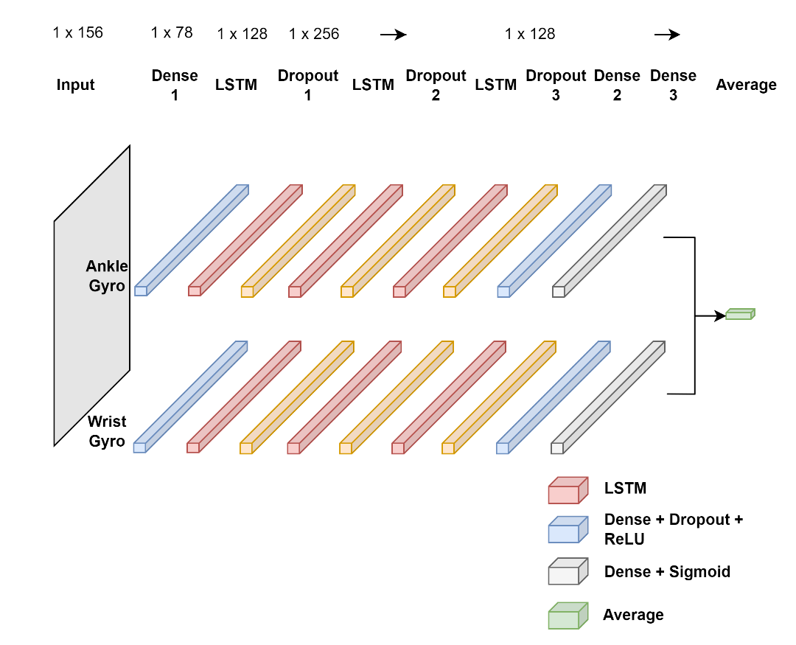
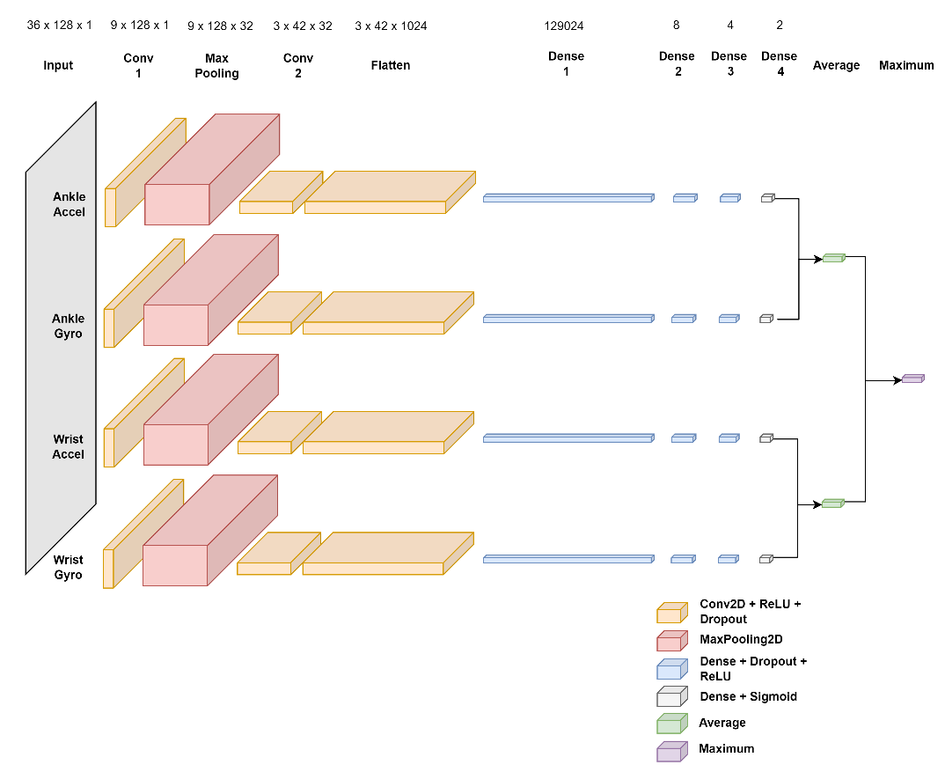
Fig. A1. Tremor CNN Model (most affected wrist and ankle accelerometer and gyroscope).
Fig. A2. Dyskinesia LSTM Model (most affected wrist and ankle accelerometer and gyroscope).

TABLE A7
Comparison of wrist and ankle sensor vs wrist sensor only

Metric | Tremor Model  (ankle + wrist accelerometer + gyroscope) | Tremor Model  (wrist accelerometer + gyroscope) | Bradykinesia Model  (ankle + wrist accelerometer + gyroscope) | Bradykinesia Model  (wrist accelerometer + gyroscope) | Dyskinesia Model  (ankle + wrist accelerometer + gyroscope) | Dyskinesia Model  (wrist accelerometer + gyroscope)
Accuracy | 0.86 | 0.85 | 0.75 | 0.75 | 0.77 | 0.69
Balanced Accuracy | 0.85 | 0.85 | 0.75 | 0.75 | 0.85 | 0.82
Recall Score | 0.86 | 0.85 | 0.75 | 0.75 | 0.77 | 0.69
Precision Score | 0.86 | 0.85 | 0.77 | 0.76 | 0.97 | 0.97
F1 Score_{weighted} | 0.84 | 0.84 | 0.78 | 0.77 | 0.21 | 0.17
True Positives | 624 | 690 | 173 | 172 | 26 | 27
False Positives | 69 | 151 | 75 | 77 | 189 | 257
True Negatives | 846 | 764 | 131 | 129 | 615 | 547
False Negatives | 176 | 110 | 25 | 26 | 2 | 1
# Negative | 915 | 915 | 206 | 206 | 804 | 804
# Positive | 800 | 800 | 198 | 198 | 28 | 28
# Predicted Negative | 1022 | 874 | 156 | 155 | 617 | 548
# Predicted Positive | 693 | 841 | 248 | 249 | 215 | 284

For an individual class “i”, the F1 score is calculated as:
$$F1 Score_{i}=\frac{\left.2×\left(Precision_{i}× Recall_{i}\right)\right.}{\left.\left(Precision_{i}+ Recall_{i}\right)\right.}$$
However, in the context of Table A7, we are using the weighted F1 score which takes into account the support (number of true instances) for each class. The weighted F1 score is calculated as:
$$F1 Score_{weighted}=\frac{\left.Σ_{i} \left(F1 Score_{i}× Support_{i}\right)\right.}{\left.Σ_{i} Support_{i}\right.}$$

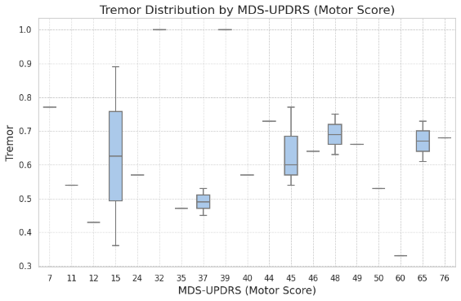
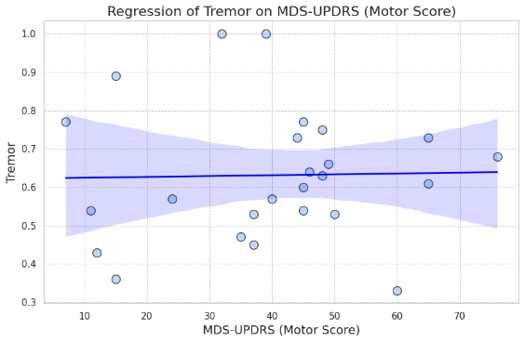
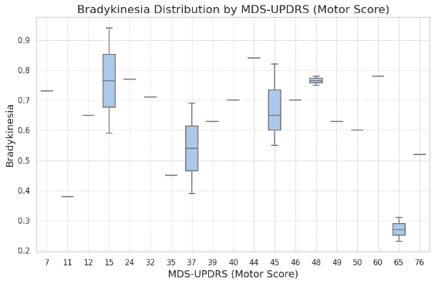
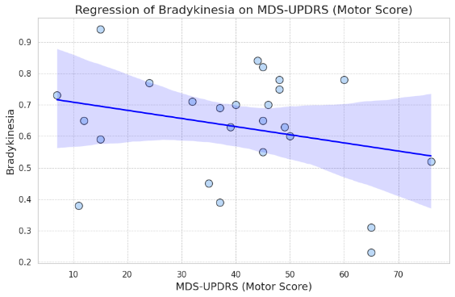
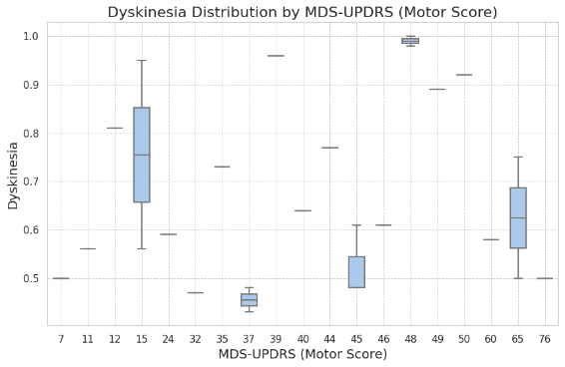
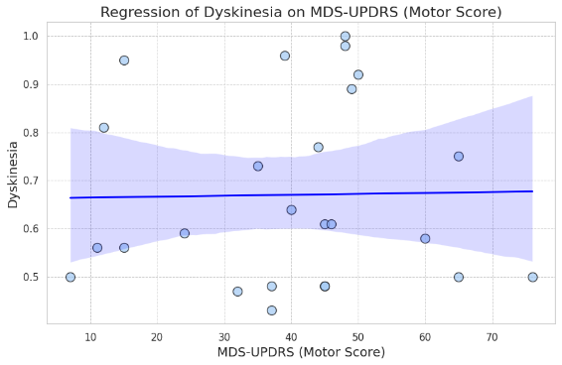
Fig. A3. Relationship Between MDS-UPDRS Motor Scores and PD Symptom Detection Performance - scatter plots with regression lines show the relationship between the MDS-UPDRS motor score and the reported balanced accuracy of the detection algorithm for tremor (top), bradykinesia (middle), and dyskinesia (bottom). Detection accuracy remains consistent across all levels of impairment for tremor and dyskinesia (correlation not statistically significant, r = 0.02). A slight negative correlation with detection accuracy (r = -0.27) is shown for bradykinesia. Box plots on the right of each scatter plot also show the distribution of detection accuracy in relation to MDS-UPDRS motor scores.

