Supplementary Materials

Chronic Kidney Disease and Adverse Pregnancy Outcomes: A Systematic Review and Meta-analysis
Sukainah Y. Al Khalaf^{1,2}, Elizabeth Bodunde¹, Gillian M. Maher^{1,2}, Éilis J. O'Reilly^{1,3}, Fergus P. McCarthy^{2,4}, Michelle M. O'Shaughnessy⁵, Sinéad M. O'Neill⁶, Ali S. Khashan^{1, 2}

¹ School of Public Health, University College Cork, Cork, Ireland
² INFANT Research Centre, University College Cork, Ireland
³ Department of Nutrition, Harvard T.H. Chan School of Public Health, Boston, MA, USA
⁴ Department of Obstetrics and Gynaecology, Cork University Hospital, Cork, Ireland
⁵ Department of Renal Medicine, Cork University Hospital, Cork, Ireland
⁶ School of Public Health Alumna, Cork, Ireland

Supplementary methods

- Search strategy for Web of Science
- Pregnancy outcome* OR obstetric outcome* OR birth outcome* OR pregnancy complication* OR gestational complication*or obstetric complication OR birth complication* OR labor complication* OR pre-term deliver* OR preterm deliver* OR pre-term birth*or preterm birth* OR preterm labor* OR pre-term labor* OR premature deliver* OR premature birth* OR premature labor* OR prematurity OR cesarean* OR cesarean section* OR csection* OR c section* OR spontaneous abortion* abortion OR pregnancy loss OR miscarriage* OR miscarry OR stillbirth* OR still birth* OR intrauterine death* OR intra-uterine death* OR fetal death* OR fetal mortalit* OR neonatal mortalit* OR neonatal death* OR newborn death* OR newborn mortalit* OR new born death* OR new born mortalit* OR perinatal mortalit* OR perinatal death* OR infant mortalit* OR infant death* preeclampsia OR preeclampsia OR pre eclampsia OR preeclamptic OR pre eclamptic OR pre-eclamptic toxemia* OR preeclamptic toxemia* OR PET OR pregnancy toxemia* OR toxemia* OR eclampsia/ OR eclamptic OR HELLP OR hemolysis elevated liver enzymes low platelet count OR hemolysis-elevated liver enzymes-low platelet count OR fetal outcome* OR fetal complication* OR neonate complication* OR neonatal complication*or newborn complication* gestational age* OR special care baby unit admission* OR SCBU admission* OR NICU admission* OR neonatal intensive care unit admission* OR small for gestational age* OR SGA* OR IUGR* OR intrauterine growth restriction* OR LBW*or low birth weight* OR VLBW* OR very low birth weight*

- Chronic Kidney Insufficien* OR CKD OR Chronic Kidney disease OR Chronic renal disease OR Chronic renal Insufficien* OR dialysis OR kidney failure OR renal failure OR diabetic kidney disease OR diabetic chronic kidney disease OR diabetic nephropathy* OR diabetic renal disease OR congenital renal disease OR congenital kidney disease OR polycystic kidney disease OR PKD OR CAKUT OR congenital anomalies of kidney and urinary tract OR Tubulointerstitial CKD OR Glomerular CKD OR proteinuric CKD Hypertensive CKD OR hypertensive kidney disease OR renovascular disease

- Searches 1 and 2 were then combined (1 ‘AND’ 2)

- Search strategy for Embase
- 'pregnancy outcome' OR 'pregnancy complications' OR 'high risk pregnancy' OR 'labor' OR 'delivery' OR 'fetus outcome' OR 'parameters concerning fetus newborn pregnancy' OR 'premature labor' OR 'immature and premature labor' OR 'prematurity' OR 'cesarean section' OR 'spontaneous abortion' OR 'stillbirth' OR 'fetus death' OR 'infant mortality' OR 'fetus mortality' OR 'maternal mortality' OR 'perinatal mortality' OR 'preeclampsia' OR 'eclampsia' OR 'eclampsia and preeclampsia' OR 'hellp' OR 'disseminated intravascular coagulation' OR 'newborn death' OR 'gestational age' OR 'infant low birth weight' OR 'low birth weight' OR 'very low birth weight' OR 'extremely low birth weight' OR 'newborn intensive care' OR 'small for date infant' OR 'pregnancy outcome*' OR 'maternal outcome*' OR 'pregnancy complication*' OR 'high risk pregnanc*' OR 'obstetric outcome*' OR 'obstetric complication*' OR 'normal birth*' OR 'live birth*' OR 'premature birth*' OR 'preterm birth*' OR 'preterm deliver*' OR 'born preterm' OR 'cesarean*' OR 'csection*' OR 'miscarriage*' OR 'stillbirth*' OR 'intrauterine death*' OR 'special care baby unit admission*' OR 'scbu admission*' OR 'neonatal intensive care unit admission*' OR 'nicu admission*' OR 'sga' OR 'iugr' OR 'neonatal intraventricular haemorrhage' OR 'neonatal intraventricular hemorrhage' OR 'apgar score' OR 'lbw' OR 'vlbw'

- 'chronic Kidney Insufficien*' OR 'CKD' OR 'Chronic Kidney disease' OR 'Chronic renal disease' OR 'Chronic renal Insufficien*' OR 'dialysis or kidney failure' OR 'renal failure' OR 'diabetic kidney disease' OR 'diabetic chronic kidney disease' OR 'diabetic nephropathy' or 'diabetic renal disease' OR 'congenital renal disease' OR 'congenital kidney disease' OR 'polycystic kidney disease' OR 'PKD' OR 'CAKUT' OR 'congenital anomalies of kidney and urinary tract' OR 'Tubulointerstitial CKD' OR 'Glomerular CKD' OR 'proteinuric CKD' OR 'Hypertensive CKD' OR 'hypertensive kidney disease' OR 'renovascular disease')

- Pregnan*

- Searches 1, 2 and 3 were then combined (1 ‘AND’ 2 ‘AND’ 3)

Search strategy for PubMed using MeSH term
- "Pregnancy OR "pregnancy, high risk" OR "pregnancy complications, OR "infant, low birth weight" OR "infant, extremely low birth weight" OR "infant, very low birth weight" OR "infant, small for gestational age” OR "obstetric labor, premature" OR "infant, premature" OR "infant, extremely premature" OR "Stillbirth" OR "Stillbirth" OR "abortion, spontaneous" OR "Pre-Eclampsia" OR "Eclampsia" OR "HELLP Syndrome" OR "Cesarean Section" OR "Fetal Death" OR "Pregnancy Outcome" OR "Pregnancy Complications" OR "Perinatal Mortality" OR "Infant Death" OR "Infant Mortality" OR "intensive care units, neonatal" OR "infant, newborn" OR "Intensive Care Units" OR "Fetal Growth Retardation" OR "abortion, induced"

- "Diabetic Nephropathies" OR "Fused Kidney" OR "Cakut" OR "Polycystic Kidney" OR "Renal Insufficiency, Chronic" OR "Hypertension, Renovascular" OR "Nephropathy, Chronic Tubulointerstitial"

- Searches 1 and 2 were then combined (1 ‘AND’ 2)

Table S1. Study characteristics (studies reported the adverse pregnancy outcomes in women with chronic kidney disease (CKD) vs those without)
Study, Year | Country | Study design | Sample size | Definition of Chronic Kidney Disease | Study Year | Defined maternal outcomes | Defined fetal outcomes | Variable accounted for | Quality Assessment
Kimmerle R, 1995 | Germany | Prospective cohort | 46 | DN defined as Proteinuria >400 mg/day, creatinine clearance <80 ml/min and hypertension in the first trimester. | 1982 – 1992 | Preeclampsia defined as acute worsening hypertension (>15% diastolic BP) in the presence of proteinuria, CS (not defined). | SGA defined as birth weight lower than 10th percentile, intrauterine/ perinatal deaths (not defined) | None | 5*
Holley J, 1996 | USA | Prospective cohort | 86 | Proteinuria ≥150 mg/24 h, or 1st trimester Sr Cr. 0.8 mg/dl in the first trimester, or proteinuria≥300 mg/24 h, with known kidney disease. | 1991-1993 | Spontaneous abortion not defined. | Preterm birth defined as birth ≤ 36wks of gestation. IUGR, Neonatal death, Intrauterine fetal death (Not reported) | Maternal age, parity, race, and insulin dependent DM | 4*
Miodovnik M, 1996 | USA | Prospective cohort | 182 | DN defined as total protein excretion rate: >500 mg/day, or persistent positive albuminuria (dipstick ≥2) in the absence of bacteriuria. | 1978 -1991 | Preeclampsia defined as pregnancy-induced hypertension with proteinuria >500mg/ in patient without nephropathy | Preterm birth defined as delivery before 37 complete weeks of gestation, IUGR/SGA defined as birth weight <10th percentile, Stillbirth and Neonatal mortality | None | 5-6*
Fink C, 1998 | USA | Retrospective cohort | 675 | CKD defined according to ICD-9 codes including diabetic and hypertensive nephropathy, acute and chronic glomerulonephritis, nephrotic syndrome, acute and chronic renal failure, disorders with impaired renal function, small kidneys of unknown cause, renal agenesis, and cystic diseases. | 1987 – 1993 | Preeclampsia, CS (outcomes not defined) | Neonatal mortality (defined as infant death within 28 days of birth), Preterm birth, SGA, Preterm birth, IUGR | Maternal age, trimester of first prenatal visit, parity, smoking and chronic hypertension | 8*
Biensanbach G, 2000 | Austria | Prospective cohort | 40 | Preconceptional persistent macroproteinuria (>0.5g protein/24h urine) without UTI and other renal diseases. | 1985 -1993 | CS, Preeclampsia (outcomes not defined) | Preterm birth defined as premature delivery (<34 week of gestation), SGA (2400g birth weight). | None | 6*
Ekbom P, 2001 | Denmark | Prospective cohort | 240 | Micro-albuminuria: 30-300mg/24h; or diabetic nephropathy: >300mg/ 24h. | 1996 -1999 | Miscarriage < 22wks., Preeclampsia defined BP > 140/90mmHg accompanied by proteinuria. | Preterm delivery (<37 wks. Of gestation) SGA < 10th percentile Perinatal mortality defined fetal death later than 22wks. | None | 7*
Trevisan G, 2004 | Brazil | Retrospective cohort | 75 | CRI defined as Sr. Cr >1.5mg/dL | 1989-1999 | Preeclampsia, CS. | Preterm birth; delivery for 28-36wks., Stillbirth (abortion; pregnancy that last for 20-28wks.) | Maternal and gestational age, time of delivery | 5*
Jensen D, 2010 | Denmark | Prospective Cohort | 846 | Microalbumin in early pregnancy defined as UAER between 30 and 300mg/24h or between 20 and 200ug/min | 1993 - 1999 | Preeclampsia defined as BP >140/90mmHg. | Preterm birth defined as delivery before 37 gestational wks., SGA, Birth weight. | Age, BMI, duration of diabetes, parity, pre-pregnancy insulin dose, blood pressure ≥140/90 mmHg at ﬁrst visit, proliferative retinopathy, 1st/3rd trimester A1C. | 8*
Young E, 2011 | Brazil | Prospective cohort | 43 | DN defined as by the criteria of NKF | 2010 - 2011 | Preeclampsia (not defined) | Preterm birth defined as prematurity <37wks, LBW defined as <2500g or 10th percentile for gestational age, Fetal death defined as death after 22wks, Stillbirth defined as expulsion of fetus less than 500g. | None | 6*
Davidson N, 2015 | Australia | Retrospective cohort | 62357 | CKD deﬁned using the KDOQI guidelines. | 2003-2010 | Preeclampsia and Hypertension in pregnancy were defined according to both SOMANZ and ISSHP guidelines | Preterm birth defined as birth in which a child is delivered before it reached the full of gestation (37 wks.). SGA defined as birth weight, length, or head circumference below the 10th percentile for gestational age. IUGR defined as birth weight below the 10th percentile for gestational age. | None | 5-6*
Kendrick J, 2015 | USA | Retrospective cohort | 1156 | ICD-P Code/ NKF-KDOQI, GFR <60 ml/min / 1.73 m2 for >3 months or Sr. Cr >1.2 mg/dL in first trimester | 2000-2013 | CS, Preeclampsia/, Maternal death defined as death occurring at any time. | Preterm birth defined as <37wks’ gestation, LBW defined as <2500, SGA defined as <10th percentile of birth weight, NICU admission and Fetal death defined as death during hospitalization. | Age, race, history of diabetes, chronic hypertension, liver disease, connective tissue disease to women without CKD. | 8*
Patel E, 2015 | USA | Prospective cohort | 12,524,119 | ICD-9 coding | 2000-2010 | Maternal outcomes definition not reported | Fetal outcomes definition not reported. | Age, race/ethnicity, insurance, multiple gestation, diabetes, chronic hypertension, diabetes with chronic hypertension, cardiomyopathy, congenital heart disease, cardiac conduction disorders, systemic lupus erythematous, collagen vascular disease, HIV, thrombophilia/APS, sickle cell disease/trait, drug use, alcohol use, tobacco use, gestational diabetes, preeclampsia/eclampsia, fetal growth restriction, placental abruption | 8*
Wiles K, 2015 | United Kingdom | Retrospective cohort | 312 | CKD definition not reported | 2003-2011 | Preeclampsia not defined; documented diagnosis in the hospital database. | Fetal growth restriction <10th percentile for gestational age. Preterm birth delivery defined as birth <37 wks. of gestation. Intrauterine death defined as death >24 wks. of gestation. Pregnancy loss defined as 2nd trimester miscarriage or intrauterine death. | None | 5*
Wu M, 2016 | USA | Cohort study | 146 | Diagnosis of ADPKD was determined by ultrasound using the following criteria: patients younger than 30 years: at least two cysts in one kidney or one cyst in each kidney; patients aged 30–59 years: at least two cysts in each kidney and patients aged 60 years or older: at least four cysts in each kidney | 1975-2010 | Preeclampsia defined as new onset hypertension sBP 140 mmHg or dBP 90 mmHg measured on two occasions, 6h apart) and proteinuria 300 mg in a 24-h urine specimen after 20wks. of gestation | SGA/IUGR defined as weight > 10th percentile for gestational age, Premature delivery (delivery before the 37th gestational week or 259 days from the first day of the last menstrual period). Neonatal death (death within the first month of life). Abortion defined as elective, therapeutic or spontaneous fetal loss before 20 weeks of gestation. Stillborn defined as birth of a nonviable fetus after 20 weeks of gestation. | None | 7*
Piccoli G, 2017 | Italy | Prospective cohort | 1544 | GN defined according to K-DOQI guidelines (CKD-EPI formula) | Not Reported | CS, Preeclampsia defined as hypertension accompanied by proteinuria after 20 wk. gestational in a  previously normotensive, non-proteinuric woman. | Preterm birth defined as birth <37 wks., very preterm birth defined as birth <34 wks., SGA defined as birth weight below the 10th percentile. | CKD stage, age, nulliparous race, referral proteinuria, hypertension | 6-7*
Tsuchiyama F, 2017 | Japan | Retrospective cohort | 3206 | CKD was diagnosed. based on the K-DOQI definition of CKD | 2001-2010 | Preeclampsia defined as hypertension >140/90mmHg accompanied by proteinuria after the 20th wks. of gestation | Threatened preterm labor defined as progressive dilation of the cervix combined with regular uterine contractions that occurred between 22 and 36 wks. of gestation. SGA (below the 10th birth weight percentile for the infant’s gestational age). Neonatal death defined as death within 28 days of birth. | None | 7*
Li Y, 2018 | China | Retrospective cohort | 114 | CGN defined according to K-DOQI guidelines. Urine protein >0.5g/d | 2018 | Preeclampsia defined by onset of BP >110mmHg | Preterm birth defined as Premature, SGA defined as birth weight below 10th percentile, LBW <2500g, IUGR fetal growth curve below 10th percentile, Fetal loss defined as abortion due to the disease. | None | 5*
Harel, 2020 | Canada | Population- cohort based | 55 964 | serum creatinine above the 95th percentile (i.e., > 77 μmol/L) | 2007-2016 | None | Preterm birth defined as gestational age <37 wks., very defined as gestational age <32 wks., stillbirth≥ 20 weeks’ gestation. | Maternal age, rural or urban residence, residential income, region of origin, diabetes mellitus, chronic hypertension, and illicit drug or tobacco use within 4 years before the index conception date. | 8*
Madej A, 2020 | Poland | Retrospective cohort | 387 | Biopsy-proven GN. CKD stage was classified as follows: CKD1: eGFR >90; CKD2: eGFR 89–60; CKD3: eGFR 59–30, and CKD4: eGFR 15–29 mL/min/1.73 m2, according to the KDIGO | 2013-2018 | Preeclampsia defined as new-onset hypertension and proteinuria with protein excretion >0.3 g/day after 20 weeks of gestation in women without underlying hypertension and proteinuria, new onset hypertension and doubling of daily proteinuria after 20 wks. of gestation in women without hypertension but with proteinuria (with protein excretion >0.3 g/24 h at baseline), and either worsening hypertension or doubling of proteinuria in women with both hypertension and proteinuria (with protein excretion >0.3 g/24 h at baseline). | Preterm birth defined as gestational age <37 wks. Stillbirth defined as death after 21 wks. Of gestation, Neonatal death defined as live born infant dying within 28 days of delivery. | None | 7*
Seah J, 2020 | Australia | Prospective cohort | 144 | eGFR was calculated based on the CKD-EPI formula. Stages of diabetic kidney disease was defined according to the KDIGO guidelines and hyperfiltration define as an eGFR > 120 mL/min/1.73m², microalbuminuria was defined as urinary albumin excretion of 30-300 mg/day or urinary ACR of 3.5 to 35.0 mg/mmol. Macroalbuminuria was defined as urinary albumin excretion > 300 mg/day or urinary ACR > 35.0 mg/mmol. | 2004-2014 | Preeclampsia defined as the development of sBP >140mmHg ± dBP >90mmHg, and proteinuria > 300mg/24h after 20wks gestation as well as clinical diagnosis. | Preterm birth defined as delivery < 37 weeks of gestation with no separation made between iatrogenic and spontaneous. NICU (no definition reported). | None | 6*
Al Khalaf, 2021 | Sweden | Retrospective cohort | 2 784 490 | ICD8-ICD10 codes | 1982-2012 | Preeclampsia defined as at least 2 dBP≥90  mm Hg, combined with proteinuria (≥0.3 g/day or ≥1+ on a urine dipstick), CS. | Preterm birth defined as gestational age <37 wks., very defined as gestational age <32 wks., stillbirth defined as fetal loss >28 wk. (until June 2008) or > 22 wk. (since July 2008), SGA defied as a birthweight below 2 SDs of the mean birthweight. | Adjusted for maternal age, educational level, smoking, BMI, country of origin, parity, other co-morbidities (diabetes mellitus, cardiovascular disease, asthma), birth year, and child’s sex. | 8*
Abbreviations: BMI: Body Mass Index, CGN: Chronic Glomerular-nephritides, CKD: Chronic Kidney Disease, CRI: Chronic Renal Insufficiency, CKD- EPI: Chronic Kidney Disease Epidemiology Collaboration, DM: Diabetes Mellitus, DN: Diabetic Nephropathy, GFR: Glomerular Filtration Rate, eGFR: Estimated Glomerular Filtration Rate, HCPA: Hospital the Clinicas of Porto Alegre-Brazil, IUGR: Intrauterine Growth Retardation/Restriction, KDIGO: Kidney Disease: Improving Global Outcomes, KDOQI: Kidney Disease Outcomes Quality Initiative, LBW: Low Birthweight, SGA: small for gestational age, SD:standard deviation NICU: Neonatal Intensive Care Unit/ Need for Intensive Care Unit.

Table S2. Study characteristics (studies reported the adverse pregnancy outcomes in women with late stages compared to early stages of CKD)
Study, Year | Country | Study design | Sample size | Definition of Chronic Kidney Disease | Study Year | Defined maternal outcomes | Defined fetal outcomes | Variable accounted for | Quality Assessment
Reece E, 1988 | USA | Retrospective cohort | 31 | DN defined as urinary protein level was ≥300 mg/24hr before the third trimester. The severity of the proteinuria was categorized as mild (300 to 499 mg/24 hr), moderate (500 to 3000 mg/24 hr), and severe or nephrotic syndrome (>3 gm/24 hr). | 1975-1984 | Preeclampsia defined acute worsening of BP (> 15% increase in sBP or dBP or deterioration of renal function associated with multisystemic involvement, result-ting in abnormal liver function and coagulation studies, particularly elevation in the fibrin split products and thrombocytopenia. | Not reported | None | 5-6*
Imbasciaati E, 2007 | Italy | Cohort study | 49 | GFR was estimated using the Modification of Diet in Renal Disease 4-variable equation (based on serum creatinine level, age, sex, and race) and expressed in mm per minute per 1.73 m2 of body surface area. | 1977-2004  . | CS (not reported) | Preterm delivery defined as (live birth before the 37th week), stillbirth (intrauterine death after 24 wks. of gestation), neonatal death (live infant dying within 28 days after delivery), and perinatal death (obtained as the sum of stillbirths and neonatal deaths). SGA ( infants with birth weight > the 10th percentile of the Italian population according to gestational week at delivery. LBW (live-born infant  weighing less than 2,500g. | None | 7*
Bramham, 2011 | United Kingdom & Netherlands | Prospective cohort | 36 | Mild CKD and moderate/ severe CKD were defined as pre-pregnancy Cr < 125 mmol/L and Cr > 125 mmol/L, respectively. | 2003-2005 | Preeclampsia was defined as the new development of proteinuria in accordance with the ISSHP | SGA defined as birth weight less than 10th percentile. Preterm birth (37 wks. and <34 wks. gestation). Perinatal death (intrauterine >24wks.gestation or postnatal by 7 days). NICU (not defined). | None | 6*
Davidson N, 2015 | Australia | Retrospective cohort | 55 | CKD deﬁned using the KDOQI guidelines. | 2003-2010 | Preeclampsia and Hypertension in pregnancy were defined according to both SOMANZ and ISSHP guidelines | Preterm birth defined as birth in which a child is delivered before it reached the full of gestation (37 wks.). SGA defined as birth weight, length, or head circumference below the 10th percentile for gestational age. IUGR defined as birth weight below the 10th percentile for gestational age. | None | 5-6*
Feng Z, 2015 | USA | Retrospective cohort | 41 | Severe CKD defined as estimated GFR (eGFR) < 30 mL/min within the first three months of pregnancy. Mild CKD defined as estimated GFR (eGFR) 45 – 100 mL/min | 2000-2012 | Pre-eclampsia defined as blood pressure > 140/90 mmHg and 2+ proteinuria on dipstick after second trimester. | Prematurity was defined as birth before 37 weeks of gestation. Perinatal death was defined as new-born death < 4 weeks of age. Low birth weight was defined as < 2,500 grams. | None | 6-7*
Singh N, 2015 | India | Retrospective cohort | 51 | CKD defined by K-DOQI guidelines abnormality. | 2009-2012 | Not reported | Not reported | None | 7*
Wiles K, 2015 | United Kingdom | Retrospective cohort | 35 | CKD definition not reported | 2003-2011 | Preeclampsia not defined; documented diagnosis in the hospital database. | Fetal growth restriction <10th percentile for gestational age. Preterm birth delivery defined as birth <37 wks. of gestation. Intrauterine death defined as death >24 wks. of gestation. Pregnancy loss defined as 2nd trimester miscarriage or intrauterine death. | None | 5*
Bharti J, 2016 | India | Retrospective cohort | 80 | CKD is defined as either kidney damage or GFR <60ml/min/1.73 m2 for ≥3 months (CKD definition according to NKF-KDOQI guidelines.) | 2005 - 2015 | Preeclampsia defined as new onset hypertension after 20 wks. Of pregnancy associated with proteinuria, CS (not defined). | SGA defined as infants < 10th percentile, Preterm birth (<37 weeks gestation), NICU, Stillbirths, | None | 7*
Piccoli G, 2017 | Italy | Prospective cohort | 126 | GN defined according to K-DOQI guidelines (CKD-EPI formula). | Not Reported | CS, Preeclampsia. | Preterm birth, very preterm birth, SGA, | CKD stage, age, nulliparous race, referral proteinuria, hypertension | 6-7*
He Y, 2018 | China | Retrospective cohort | 293 | CKD defined based on a history of CKD, clinical examination, renal function tests, 24-h urinary protein excretion, renal ultrasound, and renal biopsy. The staging of kidney diseases was based on the eGFR level. | 2005-2016 | Preeclampsia defined based on 2013 Hypertension in Pregnancy Guidelines of ACOG | Preterm birth defined as  gestational age at birth of less than 34 weeks. LBW defined as neonatal birth weight ≤1500 g. | None | 6-7*
Leaños- Miranda A, 2019 | Mexico | Cohort study | 167 | CKD stage was defined according to KDIGO guidelines. GFR was calculated using the CKD-EPI formula based on preconception data or serum creatinine measured at first control in pregnancy. | 2011-2017 | Preeclampsia defined according to The American College of Obstetricians and Gynecology criteria | Preterm delivery (< 34 weeks of gestational age). Stillbirths defined as death of a fetus. Neonatal death defined as death of a new-born until hospital discharge and SGA defined as an infant whose birth weight was below the 10th percentile. | Proteinuria, urinary IgM, CKD stages, and chronic hypertension | 8*
Madej A, 2020 | Poland | Retrospective cohort | 72 | Biopsy-proven GN. CKD stage was classified as follows: CKD1: eGFR >90; CKD2: eGFR 89–60; CKD3: eGFR 59–30, and CKD4: eGFR 15–29 mL/min/1.73 m2, according to the KDIGO | 2013-2018 | Preeclampsia defined as new-onset hypertension and proteinuria with protein excretion >0.3 g/day after 20 weeks of gestation in women without underlying hypertension and proteinuria, new onset hypertension and doubling of daily proteinuria after 20 wks. of gestation in women without hypertension but with proteinuria (with protein excretion >0.3 g/24 h at baseline), and either worsening hypertension or doubling of proteinuria in women with both hypertension and proteinuria (with protein excretion >0.3 g/24 h at baseline). | Preterm birth defined as gestational age <37 wks. Stillbirth defined as death after 21 wks. Of gestation, Neonatal death defined as live born infant dying within 28 days of delivery. | None | 7*
Wile  s K, 2020 | United Kingdom | Retrospective cohort | 178 | eGFR<60 mL/min/1.73 m2, calculated by the Chronic Kidney Disease Epidemiology Collaboration (CKD-EPI) equation. OR a creatinine >125 mmol/L prior to 20 weeks’ gestation in the absence of a precipitant for kidney injury. | 2003 and 2017 | CS. | SGA defined as birthweight< 10th percentile, preterm birth (<37 weeks gestation), very preterm birth (<34 wk.) and NICU admission. | None | 6*
Madazli, 2021 | Turkey | Retrospective cohort | 101 | CKD defined as kidney damage (albumin-to-creatinine ratio >30 mg/ 24h two of three urine specimens, urine sediment abnormalities, tubular disorders, histologically diagnosed abnormalities, structural abnormalities detected by scanning) OR GFR<60ml/min/1.73 m2 for three months based on KDIGO guidelines | 2009 and 2019 | Preeclampsia defined according to ACOG guidelines; superimposed preeclampsia was defined as CKD with hypertension with new onset or sudden increase in proteinuria, sudden increase in BP, thrombocytopenia or deranged liver or kidney function. | stillbirth defined as fetal death after 22 wk., neonatal death that occurred < 28 days after birth, perinatal death (stillbirth + neonatal death), SGA defined as slowing of fetal growth velocity during ≥2 consecutive ultrasound with measurements ≥3 wk. apart and fetal abdominal circumference < 2 SD for gestational age) | None | 7*
Abbreviations: ACOG: American College of Obstetricians and Gynecologists, BP: Blood Pressure, CKD: Chronic Kidney Disease, CS: Cesarean section, DN: Diabetic Nephropathy, GFR: Glomerular Filtration Rate, eGFR: Estimated Glomerular Filtration Rate, ISSSP: International Society of Study of Hypertension in Pregnancy, IUGR: Intrauterine Growth Retardation/Restriction, KDIGO Kidney Disease: Improving Global Outcomes, KDOQI: Kidney Disease Outcomes Quality Initiative, LBW: Low Birthweight, MAP:Mean Arterial Pressure, MDRD: Modification of Diet in Renal Disease, NICU: Neonatal Intensive Care Unit/ Need for Intensive Care Unit, NKF: National Kidney Foundation, PCR: Protein Creatine Ratio, PE: Preeclampsia, SGA: Small for Gestational Age, SD: standard deviation, SOMANZ: Society of Obstetric Medicine of Australia and New Zealand, TOCOS: Torino Cagliari Observational study.

Table S3. Sensitivity analyses of the associations between CKD and adverse pregnancy outcomes (by location and decade of publication)
 |  | Crude estimates |  |  |  | Adjusted estimates*
Outcomes | Subgroup | No of Studies | OR 95% CI | I² (%) | Test for subgroup differences (P-value) | No of Studies | OR 95% CI | I² (%) | Test for subgroup differences (P- value)
Pre-eclampsia
Location | Asia | 2 | 7.61 [4.86, 11.9] | 0 | 0.63 | - | - | -
Location | Australia | 1 | 5.56 [2.95, 10.5] | - | 0.63 | - | - | -
Location | Europe | 7 | 6.70 [2.80, 16.0] | 93 | 0.63 | 2 | 2.41 [0.99, 5.85] | 89 | 0.88
Location | North America | 3 | 9.33 [4.49, 19.4] | 57 | 0.63 | 2 | 2.83 [0.46, 17.5] | 97
Location | South America | 2 | 14.6 [4.69, 45.2] | 0 | 0.63 | - | - | -
Year of Publication | Publication ≤2010 | 6 | 9.69 [5.90, 15.9] | 55 | 0.42 | 2 | 5.45 [3.05, 9.76] | 52
Year of Publication | Publication >2010 | 9 | 6.63 [3.07, 14.32] | 92 | 0.42 | 2 | 1.43 [1.03, 1.98] | 66 | <0.0001
Caesarean Section
Location | Asia | 1 | 2.04 [1.47, 2.82] | - | 0.19 | - | - | - | 0.002
Location | Australia | - | - | - | 0.19 | - | - | - | 0.002
Location | Europe | 5 | 1.43 [1.24, 1.64] | 11 | 0.19 | 1 | 1.40 [1.34, 1.46] | - | 0.002
Location | North America | 3 | 1.86 [1.06, 3.27] | 63 | 0.19 | 2 | 1.99 [0.87, 4.55] | 91 | 0.002
Location | South America | 1 | 2.08 [0.78, 5.50] | - | 0.19 | - | - | - | 0.002
Year of Publication | Publication ≤2010 | 5 | 2.33 [1.65, 3.30] | 10 | 0.02 | 1 | 3.10 [2.00, 4.80] | - | 0.0004
Year of Publication | Publication >2010 | 5 | 1.48 [1.26, 1.73] | 31 | 0.02 | 2 | 1.40 [1.34, 1.46] | 0 | 0.0004
Preterm birth (<37 wk.) |  |  |  |  | 0.45
Location | Asia | 2 | 4.33 [0.71, 26.31] | 69 | 0.45 | - | - | - | 0.44
Location | Australia | 1 | 3.67 [2.01, 6.69] | - | 0.45 | - | - | - | 0.44
Location | Europe | 6 | 3.58 [1.63, 7.85] | 96 | 0.45 | 1 | 1.62 [1.54, 1.70] | - | 0.44
Location | North America | 5 | 2.32 [1.14, 4.71] | 88 | 0.45 | 3 | 2.04 [1.14, 3.65] | 92 | 0.44
Location | South America | 1 | 12.25 [2.44, 61.57] | - | 0.45 | - | - | - | 0.44
Year of Publication | Publication ≤2010 | 5 | 2.77 [1.25, 6.18] | 86 | 0.74 | 1 | 6.10 [3.30, 11.28] | - | <0.0001
Year of Publication | Publication >2010 | 10 | 3.21 [2.25, 4.60] | 92 | 0.74 | 3 | 1.44 [1.17, 1.78] | 88 | <0.0001
Very preterm birth (<34 wk.)
Location | Asia | - | - | - | 0.02 | - | - | - | -
Location | Australia | 1 | 4.18 [2.03, 8.61] | - | 0.02 | - | - | - | -
Location | Europe | 7 | 7.05 [2.87, 17.36] | 91 | 0.02 | 2 | 1.86 [1.66, 2.08] | 0 | 0.27
Location | North America | 2 | 2.19 [1.69, 2.83] | 0 | 0.02 | 2 | 4.76 [2.53, 8.97] | - | 0.27
Location | South America | - | - | - | 0.02 | - | - | -
Year of Publication | Publication ≤2010 | 4 | 4.49 [2.09, 9.62] | 63 | 0.80 | 1 | 1.60 [0.64, 4.00] | - | 0.48
Year of Publication | Publication >2010 | 6 | 5.09 [2.76, 9.37] | 91 | 0.80 | 3 | 2.28 [1.62, 3.21] | 76 | 0.48
Small for gestational age
Location | Asia | 1 | 2.24 [1.28, 3.92] | - | 0.65 | - | - | - | 0.29
Location | Australia | - | - | - | 0.65 | - | - | - | 0.29
Location | Europe | 5 | 2.69 [1.37, 5.28] | 79 | 0.65 | 1 | 1.29 [1.19, 1.40] | - | 0.29
Location | North America | 4 | 3.25 [1.87, 5.65] | 22 | 0.65 | 2 | 2.63 [0.70, 9.88] | 92 | 0.29
Location | South America | - | - | - | 0.65 | - | - | - | 0.29
Year of Publication | Publication ≤2010 | 5 | 5.37 [3.07, 9.39]  1.53 [1.25, 1.87] | 17 | <0.0001 | 1 | 5.30 [2.80, 10.03] | - | <0.0001
Year of Publication | Publication >2010 | 5 | 5.37 [3.07, 9.39]  1.53 [1.25, 1.87] | 18 | <0.0001 | 2 | 1.29 [1.20, 1.40] | 0 | <0.0001
*For adjusted estimates we followed the author’s definitions

Supplementary Figures

Forest plots and funnel plots of the association between CKD and adverse pregnancy outcomes (CKD vs no CKD comparison)

Figure S1. Funnel plot of pre-eclampsia (crude estimates)
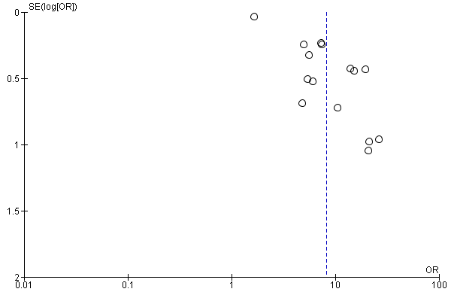

Figure S2. Funnel plots of Caesarean section (crude estimates)
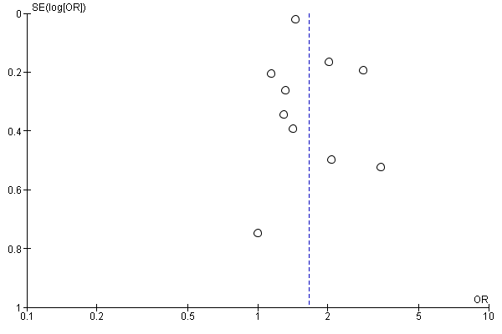

Figure S3. Funnel plot of preterm birth (crude estimates)

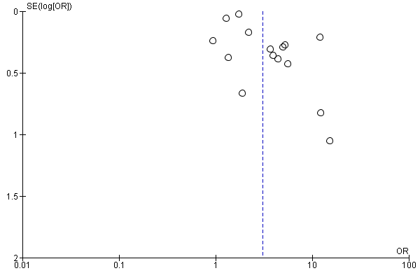

Figure S4a. Forest plot of crude estimates for very preterm birth (<34 wk. gestation)
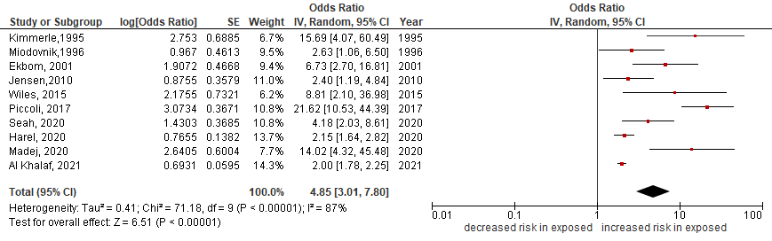

Figure S4b. Forest plot of adjusted estimates for very preterm birth (<34 wk. gestation)
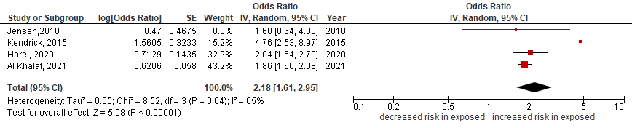

Figure S4c. Funnel plot of very preterm birth (crude estimates)
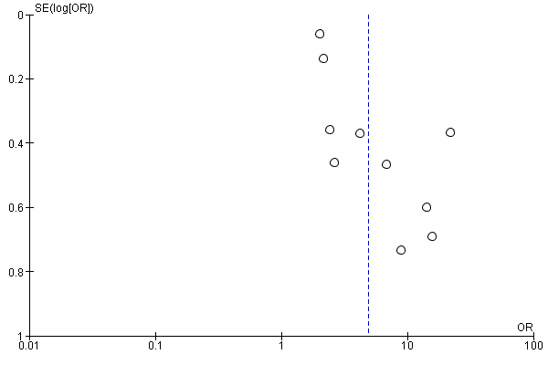

Figure S5. Funnel plots of small for gestational age (crude estimates)

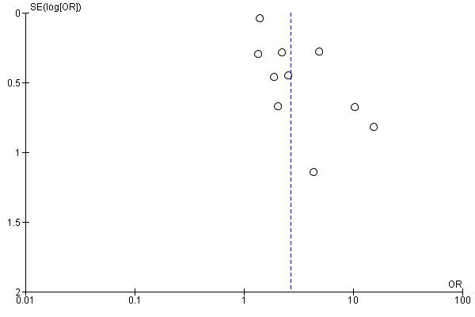

Figure S6. Forest plot of crude estimates for miscarriage
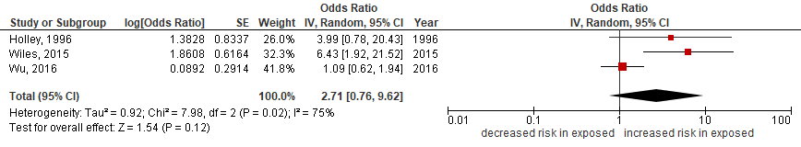

Figure S7a. Forest plot of crude estimates for stillbirth death
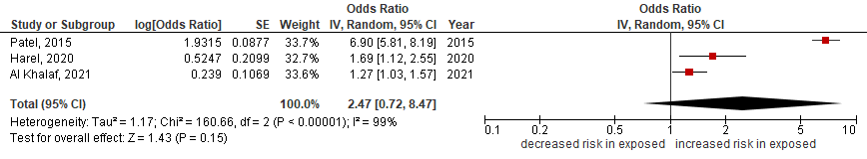

Figure S7b. Forest plot of adjusted estimates for stillbirth death
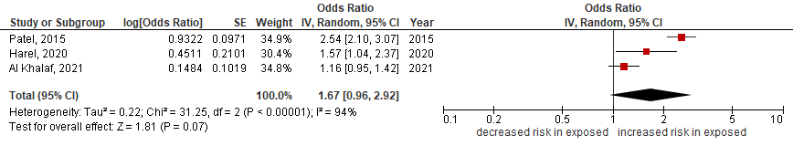

Figure S8. Forest plot of crude estimates for perinatal death
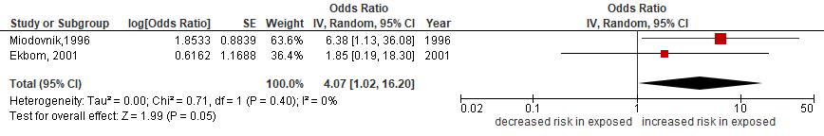

Forest plots of the association between CKD and adverse pregnancy outcomes (late vs early stages of CKD)

Figure S9a. Forest plot of crude estimates for pre-eclampsia
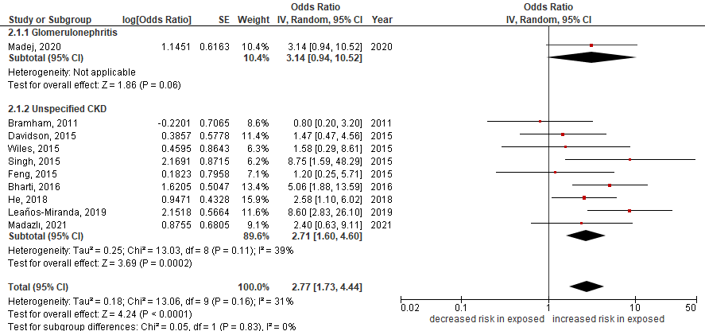

Figure S9b. Funnel plot of pre-eclampsia (crude estimates)
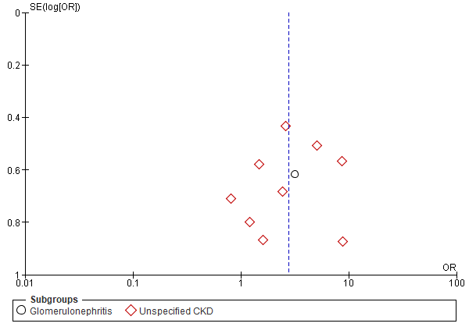

Figure S10a. Forest plot of crude estimates Cesarean section
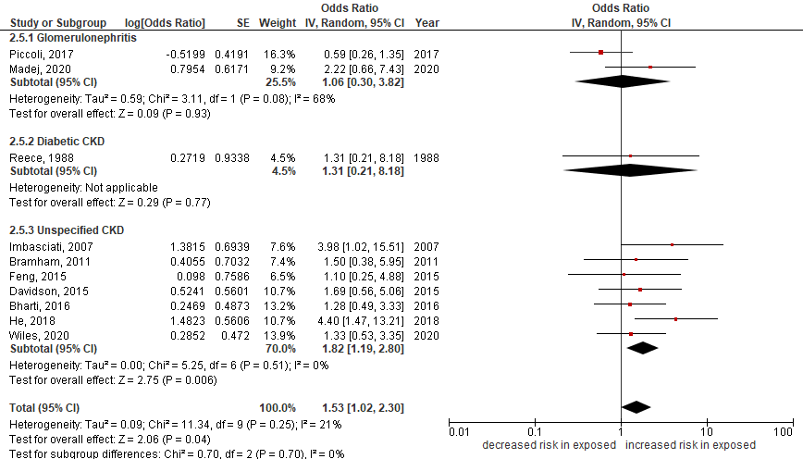

Figure S10b. Funnel plot of Cesarean section (crude estimates)
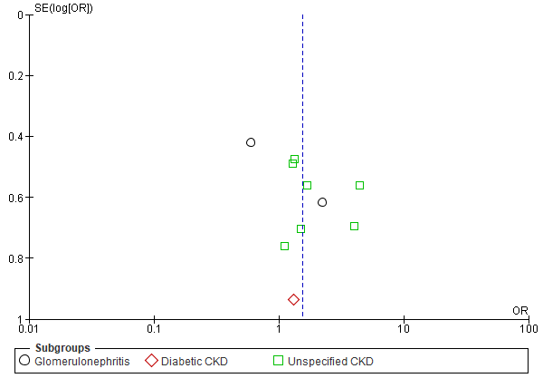

Figure S11a. Forest plot of crude estimates for preterm birth (<37 wk. gestation)
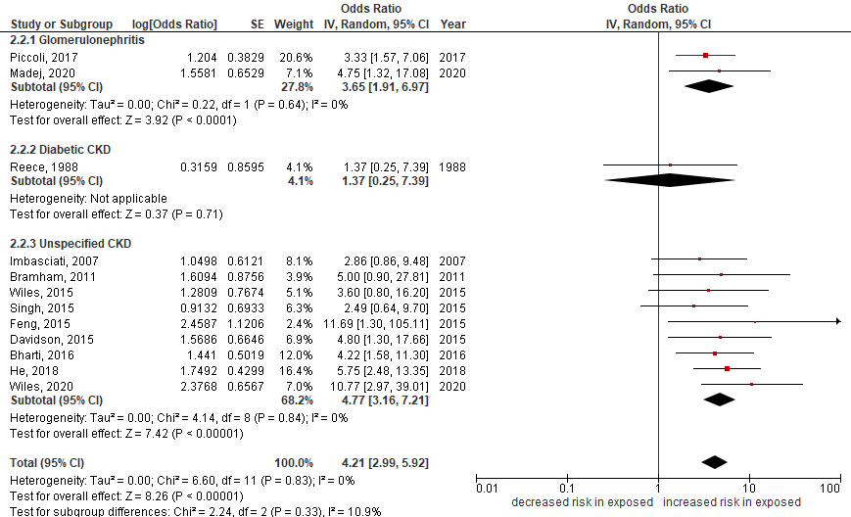

Figure S11b. Funnel plot of preterm birth (<37 wk. gestation)
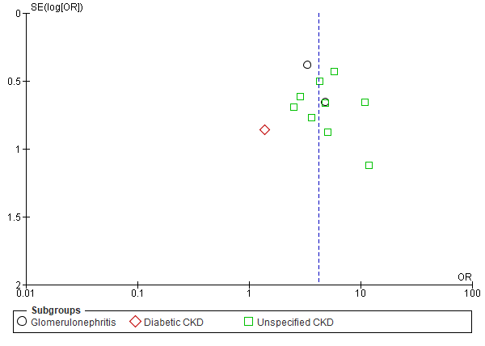

Figure S12a. Forest plot of crude estimates for very preterm birth (<34 wk. gestation)
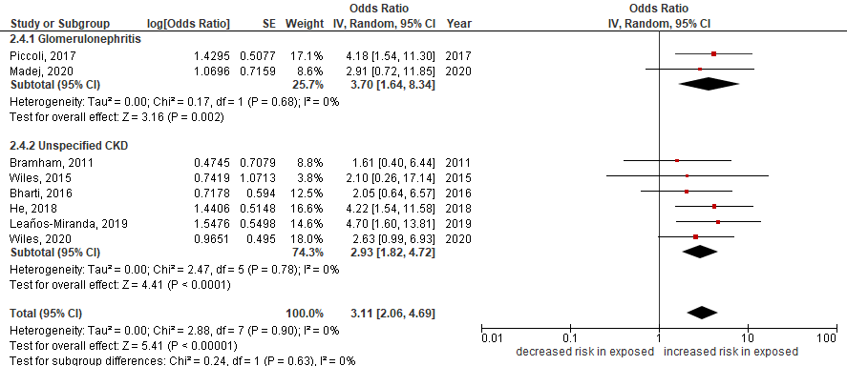

Figure S12b. Forest plot of adjusted estimates for very preterm birth (<34 wk. gestation)
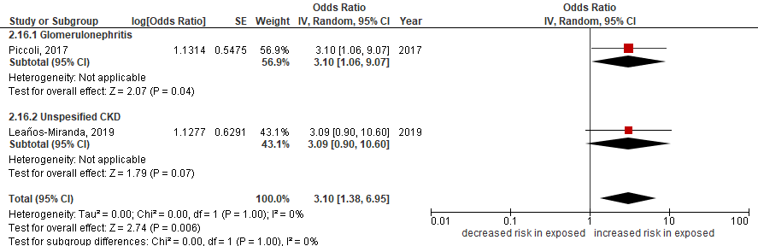

Figure S13a. Forest plot of crude estimates for small for gestational age
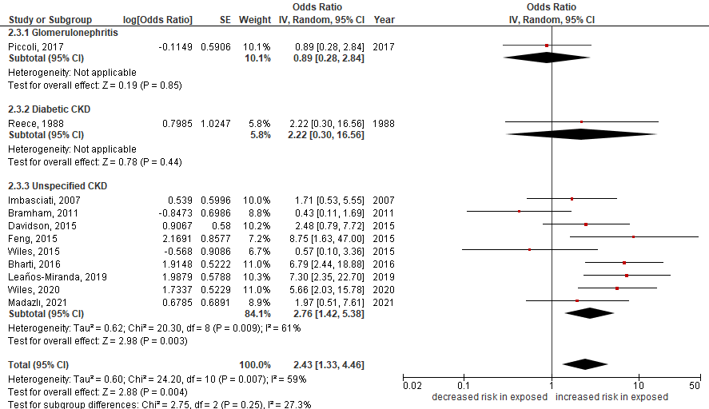

Figure S13b. Forest plot of adjusted estimates for small for gestational age
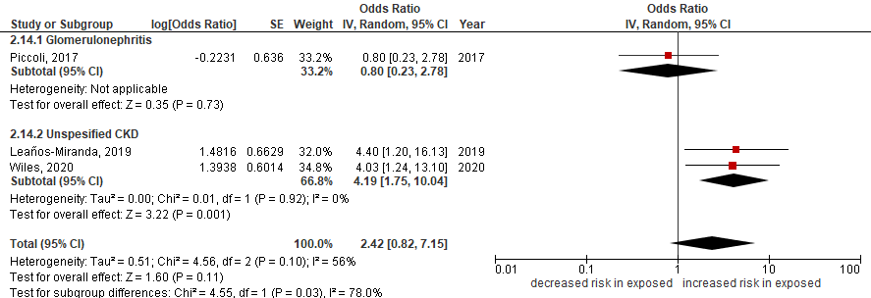

Figure S13c. Funnel plots of small for gestational age

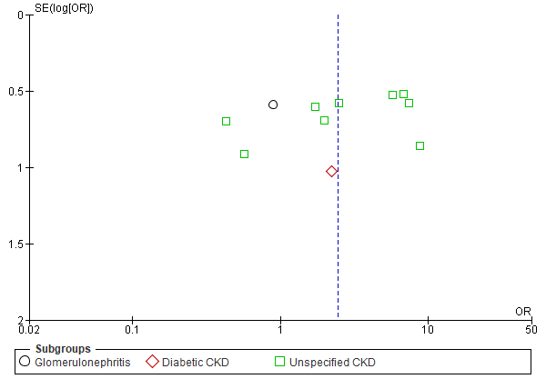

Figure S14. Forest plot of crude estimates for low birthweight
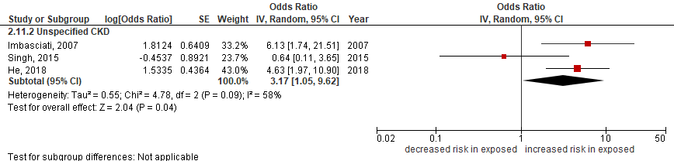

Figure S15. Forest plot of crude estimates for neonatal intensive care unit admission
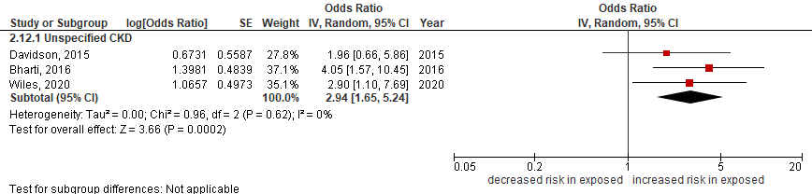

Figure S16. Forest plot of crude estimates for stillbirth
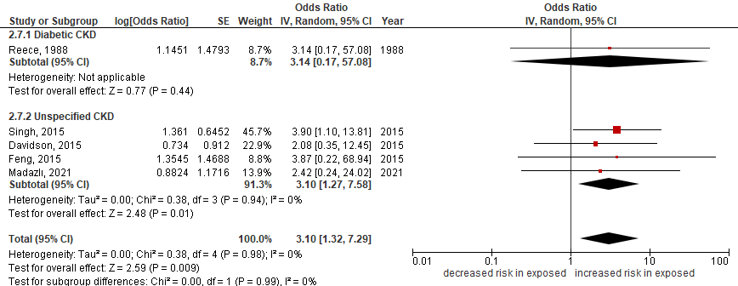

Figure S17. Forest plot of crude estimates for neonatal death
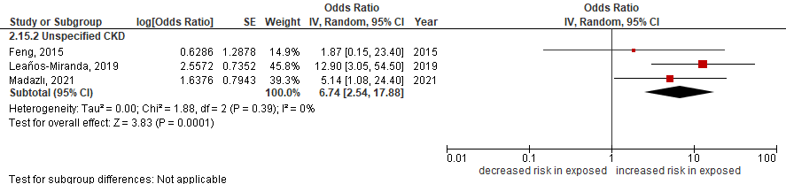

Figure S18. Forest plot of crude estimates for perinatal death
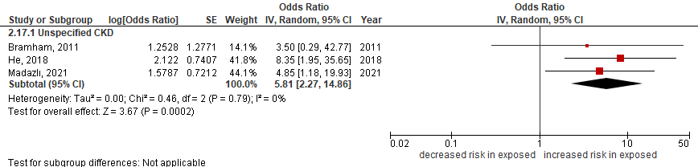

Forest plots of the effect of the cause of CKD on adverse pregnancy outcomes (compared to no CKD)

Figure S19a. Forest plot of crude estimates for pre-eclampsia
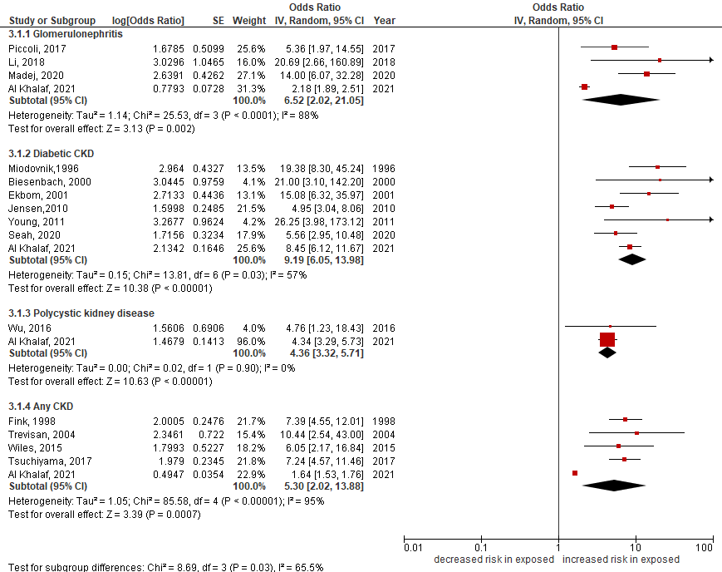

Figure 19b. Forest plot of adjusted estimates for pre-eclampsia
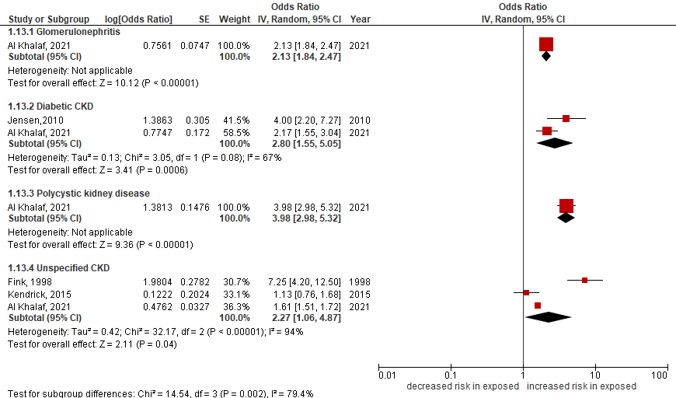

Figure S20a. Forest plot of crude estimates for Caesarean section
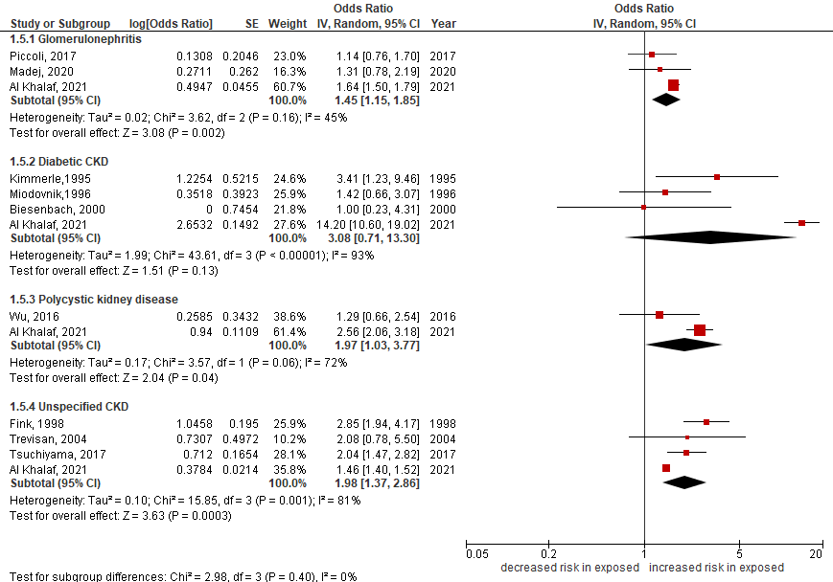

Figure S20b. Forest plot of adjusted estimates for Caesarean section
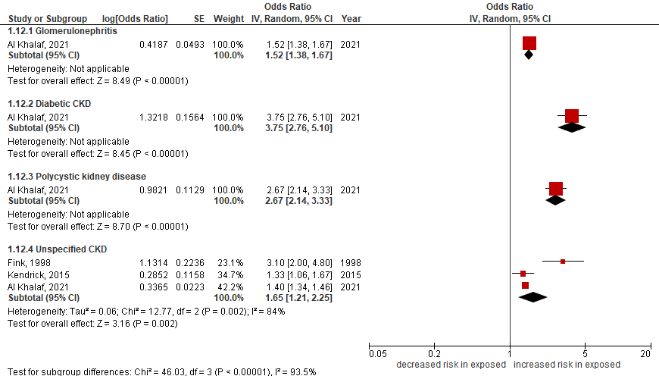

Figure S21a. Forest plot of crude estimates for preterm birth (<37 wk. gestation)
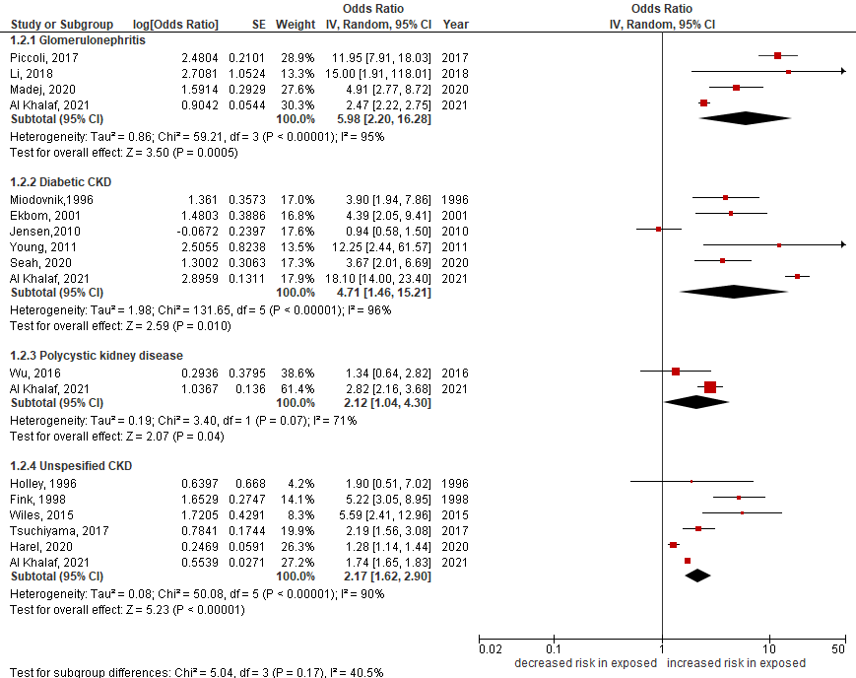

Figure S21b. Forest plot of adjusted estimates for preterm birth (<37 wk. gestation)
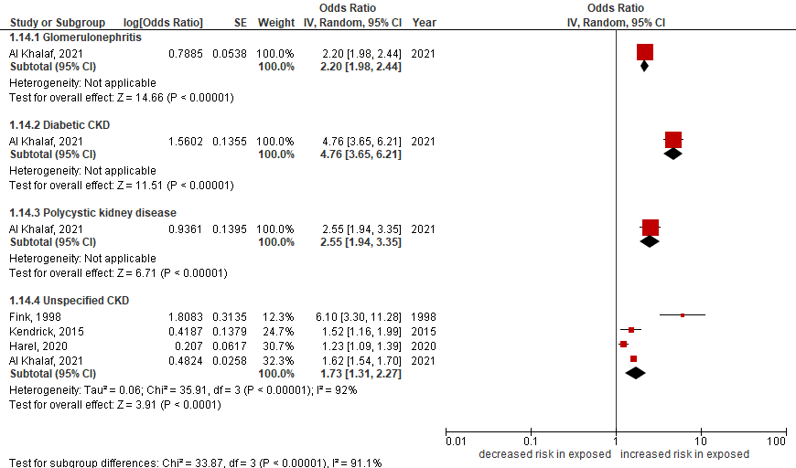

Figure S22a Forest plot of crude estimates for very preterm birth (<34 wk. gestation)
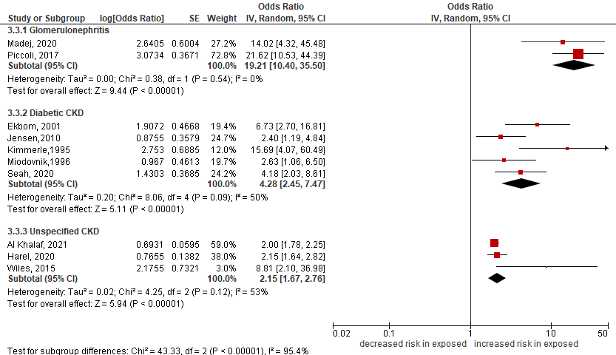

Figure S22b Forest plot of adjusted estimates for very preterm birth (<34 wk. gestation)
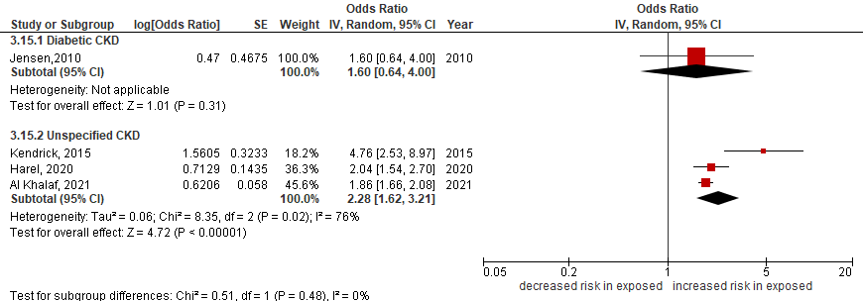

Figure S23a. Forest plot of crude estimates for small for gestational age
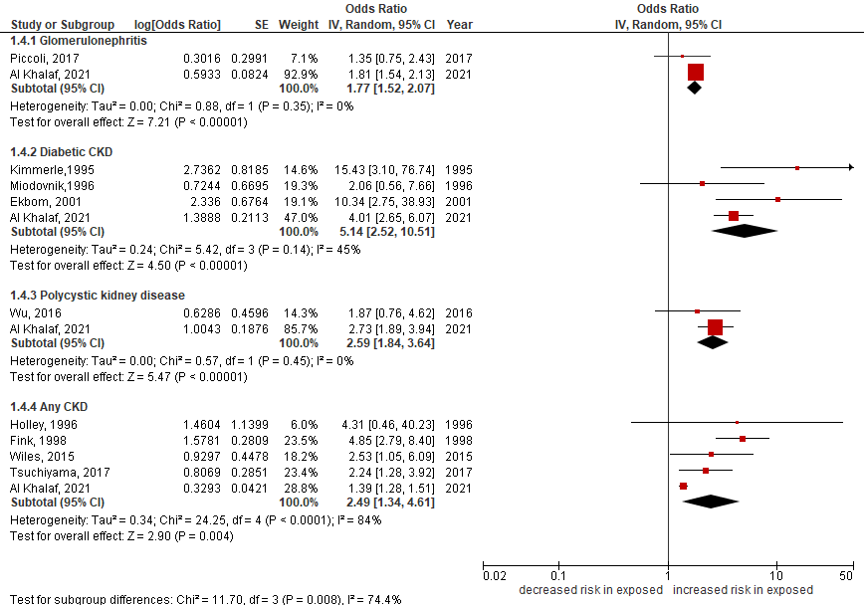

Figure S23b. Forest plot of adjusted estimates for small for gestational age
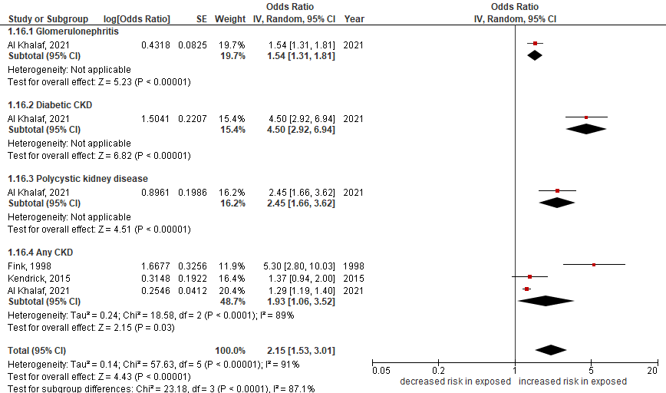

Figure S24a. Forest plot of crude estimates for stillbirth
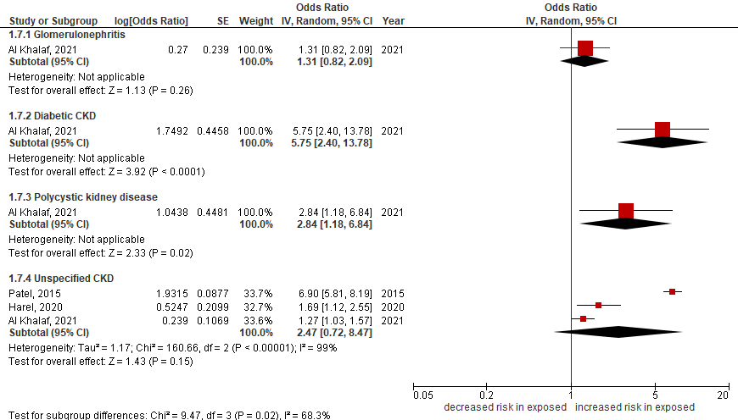

Figure S24b. Forest plot of adjusted estimates for stillbirth
