SUPPLEMENTAL FIGURES
Figure S1. Improvements in rectal bleeding with upadacitinib
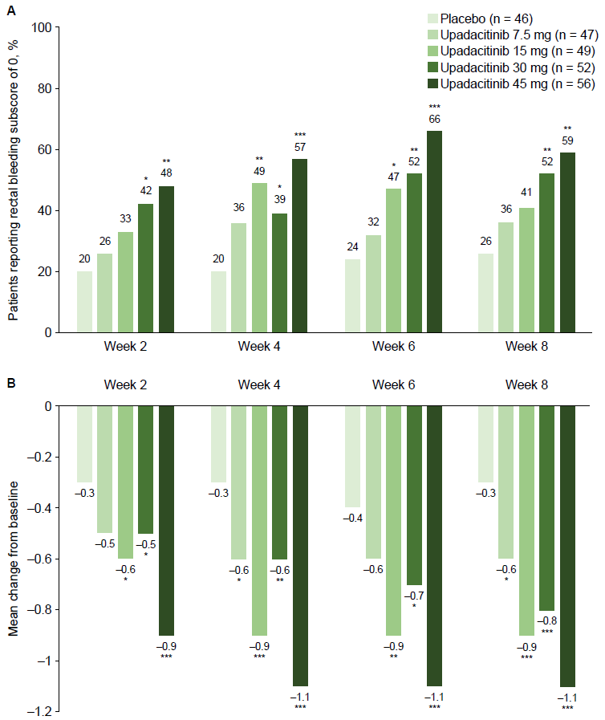

A. Percentage of patients reporting a Mayo rectal bleeding subscore of 0 from Weeks 2–8.
B. Reduction in mean Mayo rectal bleeding subscore from Weeks 2 to 8.
*P ≤0.05, **P ≤0.01, ***P ≤0.001 compared with placebo. Panel A is analysed NRI. Panel B is analysed LOCF. ITT population.
ITT, intent-to-treat; LOCF, last observation carried forward; NRI, non-responder imputation.

Figure S2. Improvements in stool frequency changes with upadacitinib
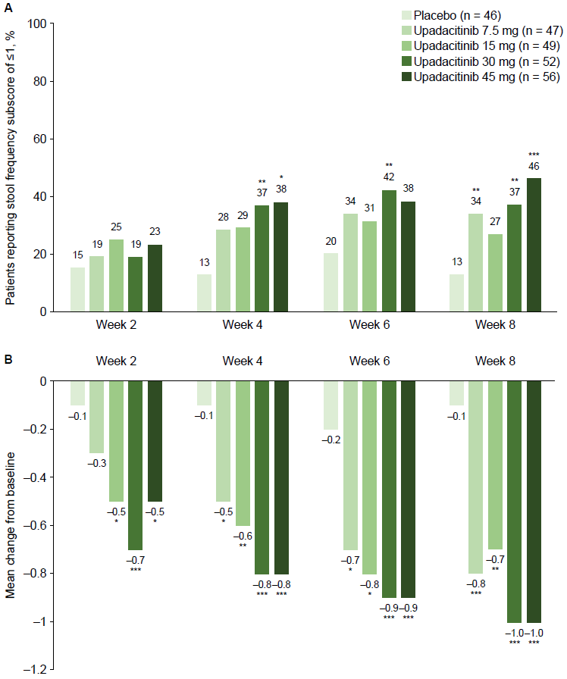

A. Percentage of patients reporting a Mayo stool frequency subscore of ≤1 from Weeks 2–8.
B. Reduction in mean Mayo stool frequency subscore from Weeks 2 to 8.
*P ≤0.05, **P ≤0.01, ***P ≤0.001 compared with placebo. Panel A is analysed NRI. Panel B is analysed LOCF. ITT population.
ITT, intent-to-treat; LOCF, last observation carried forward; NRI, non-responder imputation.
Figure S3. Percentage of patients with an IBDQ remission and response over time with upadacitinib
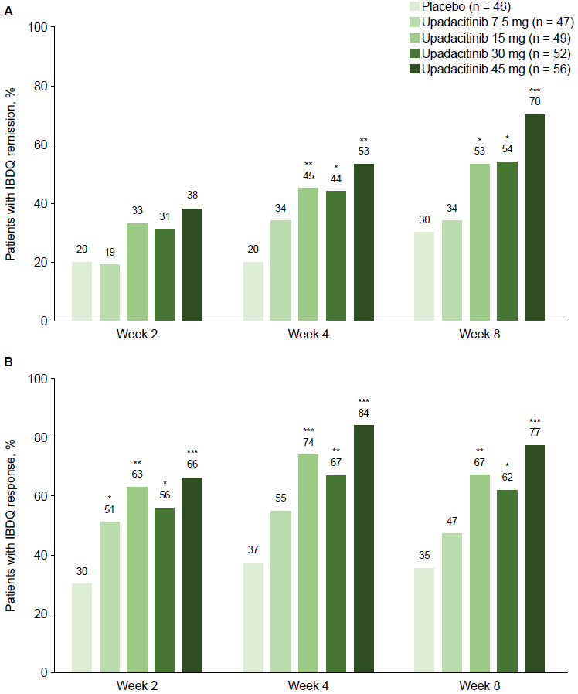
Percentage of patients with an IBDQ remission (A) and response (B) Weeks 2–8.
*P ≤0.05, **P ≤0.01, ***P ≤0.001.
IBDQ remission was defined as IBDQ score ≥170 points. IBDQ response was defined as an increase of ≥16 points from baseline. Missing data were reported with NRI. ITT population.
IBDQ, Inflammatory Bowel Disease Questionnaire; ITT, intent-to-treat; NRI, non-responder imputation.

