The Oxygen Reduction Reaction
To understand the sensing approach taken in this work, it is first necessary to explain the Oxygen Reduction Reaction (ORR). Eq.1 in the main text shows the summarised one-step pathway for reduction of oxygen. This is just one pathway for the ORR however, which has been studied extensively with respect to fuel cell technology. The proton exchange membrane fuel cell uses hydrogen as a fuel but is limited by the large overpotential associated with oxygen reduction.[1] The one step pathway involves four electrons per molecule of oxygen, resulting in a high current flow. The alternative to this is the two-step pathway, wherein hydrogen peroxide is produced as an intermediate and is subsequently reduced to water. This pathway is shown by SEq. 1 and SEq.2: [2], [3]
$$O_{2}+ {2H}^{+}+ {2e}^{-} ⇌ H_{2}O_{2}$$ | SEq. 1
$$H_{2}O_{2}+ {2H}^{+}+ {2e}^{-} ⇌ {2H}_{2}O$$ | SEq. 2
In this work, the production of hydrogen peroxide is vital to the sensor performance, for which materials and conditions that promote the two-step pathway are required. Two common materials employed for probing the ORR are gold and platinum. The consensus in the literature is that gold electrodes facilitate the two-step pathway, while platinum electrodes facilitate the one-step pathway. Sarapuu et al have shown that the reaction pathway for gold, for both bulk and ultra-thin film electrodes favours the two step pathway.[4] Similarly Tammeveski et al have shown that bulk and ultra-thin film platinum electrodes favour the one-step pathway.[5] To understand why this is the case, a more detailed explanation of the oxygen reduction reaction is required. The mechanism for the two step reaction is typically referred to as the peroxo mechanism, while the one step reaction is referred to as the metal oxide mechanism.[6] The peroxo mechanism is shown in SEq. 3 - 6.[7] In this mechanism, the bond between the oxygen atoms is not broken until both atoms have been protonated, therefore hydrogen peroxide exists as an intermediate species.

 | $$O_{2}+ e^{-}→ O_{2}^{-}$$ | SEq. 3
 | $$O_{2(ads)}^{-}+ {2H}^{+}+ e^{-}→ H_{2}O_{2(ads)}⇌H_{2}O_{2}$$ | SEq. 4
 | $$H_{2}O_{2(ads)}+ H^{+}+ e^{-}→ H_{2}O+{OH}_{(ads)}$$ | SEq. 5
 | $${OH}_{(ads)}+ H^{+}+ e^{-}→ H_{2}O$$ | SEq. 6

The subscript (ads) means that the species is adsorbed on the electrode surface wherein the reaction takes place. The production of the superoxide anion, shown in SEq. 3 is the subject of some debate, as it may occur by either an inner-sphere or outer-sphere mechanism. An outer-sphere mechanism involves electron transfer from a species that may not directly interact with the electrode surface. By contrast, an inner-sphere mechanism requires adsorption of some component of the electroactive species. [8]
The metal oxide mechanism differs from the peroxo mechanism, in that the bond between the oxygen atoms is broken before both oxygen atoms have been protonated, therefore hydrogen peroxide typically is not produced as an intermediate species. This mechanism can be further subdivided into associative and dissociative oxygen reduction, depending on when the oxygen bond cleavage occurs. The associative mechanism is: [9], [10]
 | $$O_{2(ads)}+ H^{+}+ e^{-}→ {HO}_{2(ads)}$$ | SEq. 7
 | $${HO}_{2(ads)}+ H^{+}+ e^{-}→ H_{2}O+ O_{(ads)}$$ | SEq. 8
 | $$O_{(ads)}+ H^{+}+ e^{-}→ {OH}_{(ads)}$$ | SEq. 9
 | $${OH}_{(ads)}+ H^{+}+ e^{-}→ H_{2}O$$ | SEq. 10
While the dissociative mechanism is:[9], [10]
 | $$O_{2(ads)}→ {2O}_{(ads)}$$ | SEq. 11
 | $${2O}_{(ads)}+ {2H}^{+}+ {2e}^{-}→ {2OH}_{(ads)}$$ | SEq. 12
 | $${2OH}_{(ads)}+ {2H}^{+}+ {2e}^{-}→ {2H}_{2}O$$ |  | SEq. 13

While matrix effects, such as pH and temperature can impact which mechanism is observed, the electrode effects will be focused on solely the peroxo mechanism. In this case, the interaction between oxygen and the electrode will determine how the reaction progresses. The peroxo pathway typically occurs when there is weak interaction between the electrode and oxygen. Therefore, peroxide is measurable in the solution as it is weakly bound to the electrode surface. Gold typically shows this behaviour as it is known for its weak adsorption ability.[11] Weak surface adsorption means that the cleavage of the oxygen bonds is energetically unfavourable, as the surface does not provide an adequate catalytic site. Thus, the oxygen bonds are not broken until both oxygen sites have been protonated. The metal oxide pathway is characteristic of electrode materials that show strong adsorption ability for oxygen. In such cases, little to no peroxide is observed as the surface binding is strong, so dissociation is unfavourable. Platinum typically shows this behaviour, as it catalyses the cleavage of the oxygen bonds.

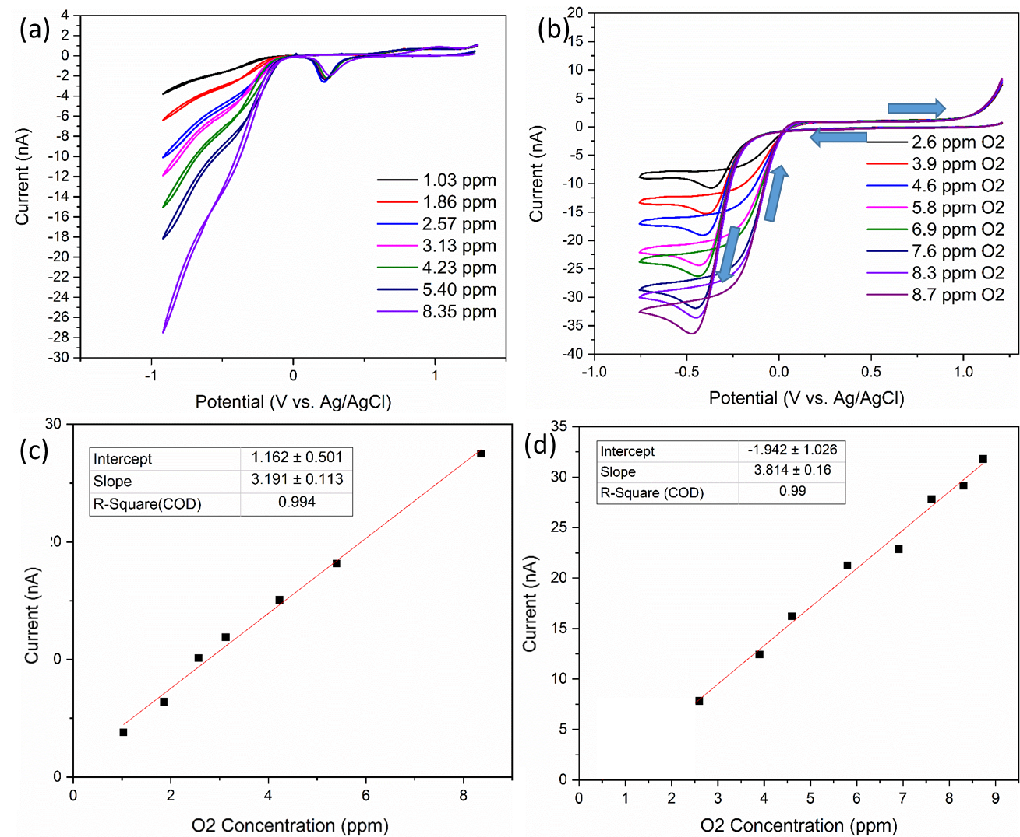
SI Fig. 1: (a) CVs of various concentrations of DO on a gold IDE comb from 1.2 V to -0.8V at 50 mV/s. (b) CVs of various concentrations of DO on a platinum IDE comb from 1.2 V to -0.8V at 50 mV/s. (c) – (D0 corresponding calibration plots for gold and platinum respectively.
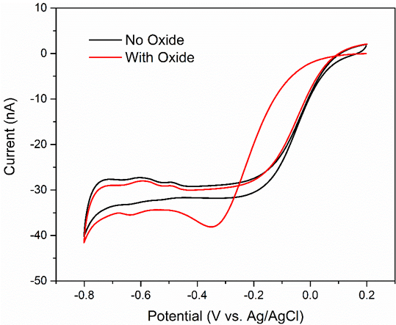
SI Fig. 2: Comparison of oxygen reduction on platinum with (red) and without (black) a pre-grown platinum oxide.
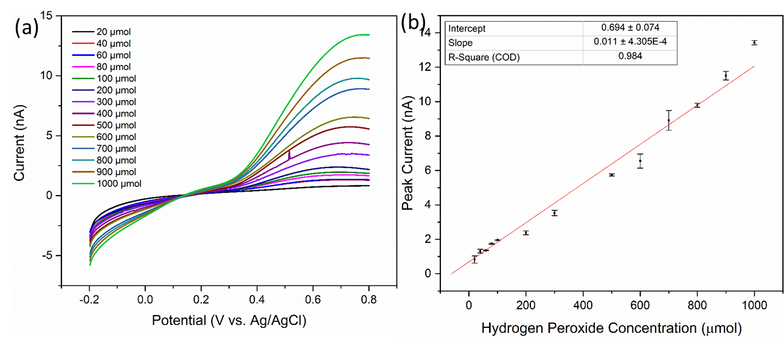
SI Fig. 3: (a) LSVs of a platinum IDE comb in various concentrations of H₂O₂ from -0.2 V to 0.8 V at 50 mV/s. (b) Calibration of the LSVs shown in (a).
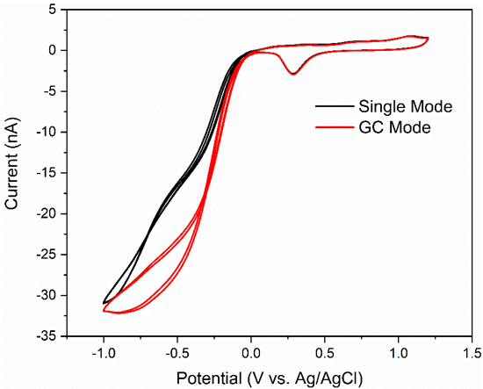
SI Fig. 4: Comparison of oxygen reduction on gold without (black) and with (red) a sufficient collector bias that enables H₂O₂ oxidation and thus redox cycling.

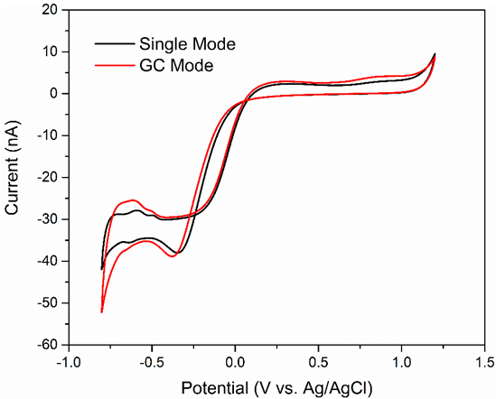
SI Fig. 5: Comparison of oxygen reduction on platinum without (black) and with (red) a sufficient collector bias in GC mode.

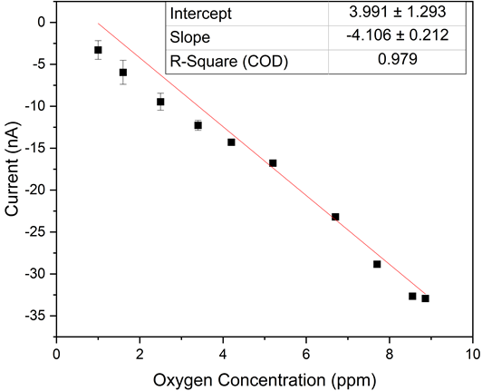
SI Fig. 6: Calibration plot for the generator data shown in Figure 7(a) main paper.

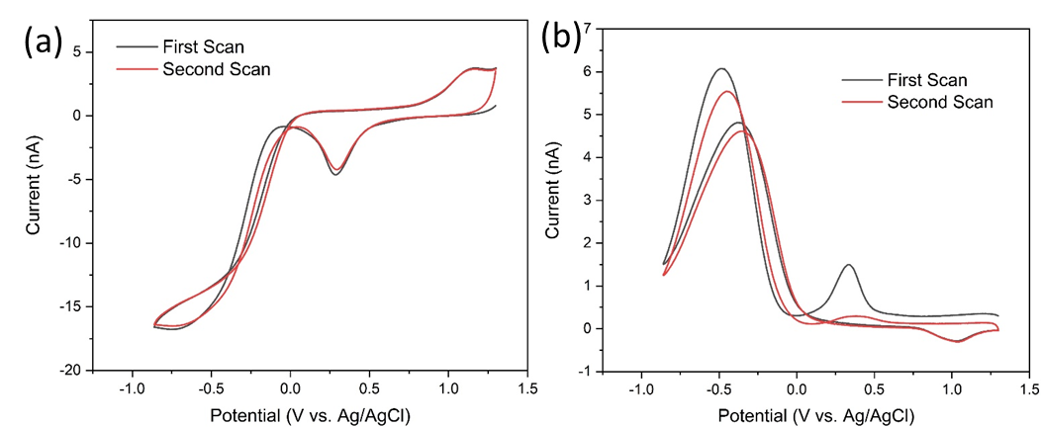
SI Fig. 7: Comparison of the first and second sweep in ADW for the generator (a) and collector (b) electrodes.
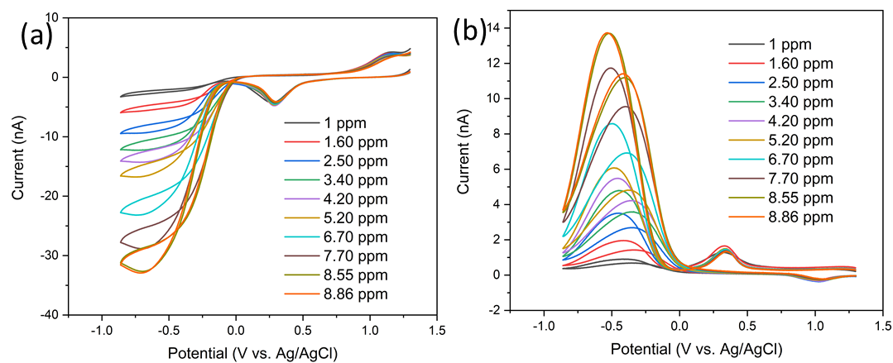
SI Fig. 8: Full CVs of the scans shown in Figure 7 (a) and (b) in the main text.
[1] P. Quaino, N. B. Luque, R. Nazmutdinov, E. Santos, and W. Schmickler, “Why is Gold such a Good Catalyst for Oxygen Reduction in Alkaline Media?,” Angew. Chemie Int. Ed., vol. 51, no. 52, pp. 12997–13000, 2012, doi: 10.1002/anie.201205902.
[2] Y. Zheng, W. Chen, X.-Q. Zuo, J. Cai, and Y.-X. Chen, “The kinetics of the oxidation and reduction of H2O2 at a Pt electrode: A differential electrochemical mass spectrometric study,” Electrochem. commun., vol. 73, pp. 38–41, 2016, doi: https://doi.org/10.1016/j.elecom.2016.10.012.
[3] Y. L. Zheng, D. Mei, Y.-X. Chen, and S. Ye, “The redox reaction of hydrogen peroxide at an Au(100) electrode: Implications for oxygen reduction kinetics,” Electrochem. commun., vol. 39, pp. 19–21, 2014, doi: https://doi.org/10.1016/j.elecom.2013.12.005.
[4] A. Sarapuu, K. Tammeveski, T. T. Tenno, V. Sammelselg, K. Kontturi, and D. J. Schiffrin, “Electrochemical reduction of oxygen on thin-film Au electrodes in acid solution,” Electrochem. commun., vol. 3, no. 8, pp. 446–450, 2001, doi: 10.1016/s1388-2481(01)00198-9.
[5] K. Tammeveski, T. Tenno, J. Claret, and C. Ferrater, “Electrochemical reduction of oxygen on thin-film Pt electrodes in 0.1 M KOH,” Electrochim. Acta, vol. 42, no. 5, pp. 893–897, 1997, doi: 10.1016/s0013-4686(96)00325-8.
[6] C. M. Sánchez-Sánchez and A. J. Bard, “Hydrogen Peroxide Production in the Oxygen Reduction Reaction at Different Electrocatalysts as Quantified by Scanning Electrochemical Microscopy,” Anal. Chem., vol. 81, no. 19, pp. 8094–8100, 2009, doi: 10.1021/ac901291v.
[7] A. Ignaczak, E. Santos, and W. Schmickler, “Oxygen reduction reaction on gold in alkaline solutions – The inner or outer sphere mechanisms in the light of recent achievements,” Curr. Opin. Electrochem., vol. 14, pp. 180–185, 2019, doi: 10.1016/j.coelec.2018.07.011.
[8] S. Tanimoto and A. Ichimura, “Discrimination of Inner- and Outer-Sphere Electrode Reactions by Cyclic Voltammetry Experiments,” J. Chem. Educ., vol. 90, no. 6, pp. 778–781, 2013, doi: 10.1021/ed200604m.
[9] Z. Tang, W. Wu, and K. Wang, “Oxygen Reduction Reaction Catalyzed by Noble Metal Clusters,” Catalysts, vol. 8, no. 2, p. 65, 2018, doi: 10.3390/catal8020065.
[10] B. Jayasankar and K. Karan, “O2 electrochemistry on Pt: A unified multi-step model for oxygen reduction and oxide growth,” Electrochim. Acta, vol. 273, pp. 367–378, 2018, doi: 10.1016/j.electacta.2018.03.191.
[11] V. M. Andoralov, M. R. Tarasevich, and O. V Tripachev, “Oxygen reduction reaction on polycrystalline gold. Pathways of hydrogen peroxide transformation in the acidic medium,” Russ. J. Electrochem., vol. 47, no. 12, pp. 1327–1336, 2011, doi: 10.1134/s1023193511120020.

