
This article is licensed under CC-BY 4.0
http://pubs.acs.org/journal/acsodf
Article

Pen-on-Paper Label-Free Surface-Enhanced Raman Scattering (SERS) Detection of Tetracycline in Milk
Alida Russo,# Martina Piletti,# Aidan J. Quinn, and Daniela Iacopino*


Cite This: ACS Omega 2025, 10, 24710−24719
Read Online

ACCESS Metrics & More Article Recommendations *sı Supporting Information
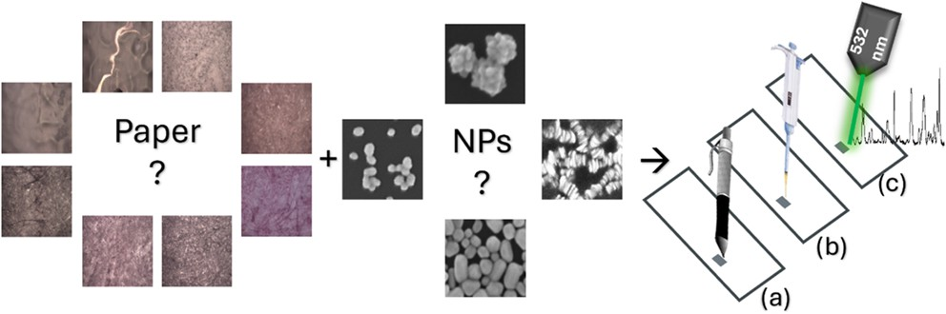
ABSTRACT: Monitoring food quality requires the development of low-cost and sensitive analytical tools with label-free and point- of-site detection capabilities. Surface-enhanced Raman scattering (SERS) is a powerful analytical technique that combines fingerprint detection capabilities with high sensitivity. In this paper, we present the pen-on-paper fabrication of SERS substrates, whereby plasmonic nanoinks were written on a paper substrate and used for the detection of food contaminant residues. To construct
sensitive and robust SERS sensors, four different nanoinks with different plasmonic properties were synthesized and tested on eight papers of different weights, textures, and hydrophilicities. The combination of silver nanoink and Bristol printing paper resulted in the strongest SERS substrate, which was used for crystal violet (CV) and tetracycline detection. Concentrations as low as 10⁻¹² M were obtained for CV and 2.5 ppm of tetracycline in milk, showing the application potential of these paper-based SERS sensors for label-free detection of residuals in complex food matrices.

INTRODUCTION
Downloaded via UNIV COLG CORK on January 20, 2026 at 11:34:22 (UTC).
See https://pubs.acs.org/sharingguidelines for options on how to legitimately share published articles.
The demand for dairy products has increased in recent years due to their nutritional value and population growth, necessitating the implementation of practices to ensure product quality and safety.¹ Milk, especially cow’s milk, is one of the main products of the dairy industry. Poor agricultural, veterinary, and hygienic practices can lead to milk adulteration and the unacceptable presence of chemical residues. For example, antibiotic residues can be found in milk due to their widespread use in the treatment of bacterial infections in dairy cows, such as mastitis. The presence of antibiotic residues in milk is associated with many health issues, including allergic reactions (especially in hypersensitive people), disruption of Ca²⁺ metabolism (problematic for teeth and bone formation in children), photosensitivity, and increased hypersensitivity to light.² Furthermore, residual antibiotics can accumulate long-term in the human body with consequent harmful effects, such as hepatotoxicity, nephrotoxicity, cytotoxicity, and potential carcinogenicity.³ In addition to the above health issues, the inappropriate and widespread use of antibiotics in food animals (about 73% of worldwide used antimicrobials⁴) contributes to the increase of antimicrobial resistance (AMR), which has been declared by the World Health Organization (WHO) as one of the top health challenges facing humanity in the 21st century.^{5,6} To address all these issues, as part of the Farm to Fork Strategy, the European Commission has targeted a 50% reduction in the overall sales of antibiotics for farmed animals and aquaculture by 2030 (compared to 2018).⁷ In parallel, for all antibiotics permitted for animal use, the European Commission has set

© 2025 The Authors. Published by American Chemical Society
maximum residue limits (MRLs) for animal-derived foods, such as milk,⁸ to ensure safe consumption.
Among antibiotics, tetracyclines are widely used to treat different bovine bacterial infections, accounting for 23.5% of the overall sales of antibiotics in Europe.⁹ Tetracyclines work through inhibition of protein synthesis in bacteria.¹⁰ Following a parenteral dose, tetracyclines are eliminated in milk, with traces present up to 48 h after administration. For this reason, the MRL for tetracyclines has been set to 100 μg kg⁻¹ (0.1 ppm = 100 ppb).^{8,11} Considering the widespread use of tetracyclines, it is imperative to develop fast and low-cost technologies to efficiently monitor their trace presence in milk. Conventional analytical approaches, such as liquid chromatog- raphy,^{12,13} liquid chromatography-tandem mass spectrome- try,^{14,15} or gas chromatography,¹⁶ have been widely used in the past decades to detect tetracycline residues. Despite their high reliability, these methods are tedious and require expensive instruments, complex sample preparation, and trained person-
nel. Other simpler methodologies have also been used, such as microbial inhibition assays,¹⁷ aptasensors,¹⁸ and immuno- assays, both enzyme-linked immunosorbent assays (ELISA) and immunochromatographic strips.^{19,20} Although some of these methods allow on-site detection, it would be desirable,

Received: February 21, 2025
Revised: April 29, 2025
Accepted: May 30, 2025
Published: June 6, 2025

https://doi.org/10.1021/acsomega.5c01637

convenient, and lower cost to use a label-free analytical approach.
Surface-enhanced Raman scattering (SERS) is a powerful label-free analytical tool that combines the fingerprinting capabilities of Raman spectroscopy with the high sensitivity offered by the incorporation of noble metal nanostructures. In SERS, the close assembly of noble metal nanoparticles (NPs) on a substrate is engineered to create so-called hotspot areas.²¹ The Raman response of analytes deposited in close proximity to the hotspots is enhanced by a factor of up to 10⁸−10¹² due to a combination of two mechanisms: electromagnetic (EM) and chemical (CE) enhancement.²² Indeed, these unique characteristics have made SERS a technique that has been widely used in different fields, from the biomedical to pharmaceutical sectors, as well as in food safety for the authentication of contaminants and microorganisms.²³ The effectiveness of SERS depends on the type of metal nanoparticles used, their size, shape, and assembly, as well as on the substrate choice.²⁴ Recent research has focused on the development of substrates featuring flexibility, low cost, and environmental friendliness, combining a good level of SERS sensitivity and selectivity with fast and low-cost fabrication.²⁵
Among the various substrates, paper has been identified as a good candidate for point-of-care testing, and it has been shown to be a desirable substrate for different SERS applications, including food safety.^{2,26,27} Recently, a convenient pen direct- writing approach has been developed for the fabrication of paper-based substrates, as demonstrated by Polavarapu et al.²⁸ This approach is based on the development of nanoinks (metallic nanoparticle inks) that are “written” on a paper substrate using a commercially available fountain pen. The simplicity, versatility, and intrinsic do-it-yourself (DIY) applicability of this method have the potential to expand the usability of SERS paper strips in many settings and to resource resource-limited laboratories.
In this paper, a pen-on-paper SERS approach was used to
demonstrate the detection of residual tetracycline in milk matrices. A careful investigation and selection of different paper substrates and nanoinks with different spectroscopic properties were carried out to select the best paper−ink combination for this purpose. Mechanically robust Bristol paper and silver nanoparticle inks were identified as the best combination for the developed paper-based label-free SERS sensor. This study highlights the applicability of SERS for the analysis of milk contaminants, with its low cost, simplicity, and minimal sample preparation. The DIY application of nanoinks allows the fabrication and use of such diagnostic strips in third- world countries or locations with limited availability of expensive fabrication equipment and trained personnel, and opens the possibility to analyze different contaminants in complex matrices.

EXPERIMENTAL SECTION
  - Chemicals and Materials. Tetrachloroauric(III) acid (HAuCl₄, ≥99.9% trace metals basis), silver nitrate (AgNO₃, ACS reagent, ≥99.0%), trisodium citrate dihydrate (ACS reagent, ≥ 99.0%), hydroquinone (Reagent Plus(R), ≥99%), poly(vinylpyrrolidone) (PVP, weight-average molecular weight M_{w} ≈ 29 000 g mol⁻¹), sodium borohydride (NaBH₄,
≥98.0%), and hydrogen peroxide (30% w/w) (H₂O₂, puriss.
P.a., reag. ISO, reag. Ph. Eur.) were purchased from Sigma- Aldrich (Arklow, Ireland). All solutions were prepared using Milli-Q water (resistivity of 18.2 MΩ·cm). All glassware used
for the synthesis of the nanoparticles was cleaned thoroughly with aqua regia and finally rinsed with Milli-Q water. The two analytes, crystal violet (CV, dye content ≥90%) and tetracycline hydrochloride (European Pharmacopoeia, high- performance liquid chromatography (HPLC) assay, ≥95%), were also bought from Sigma-Aldrich (Arklow, Ireland). Dawn Fresh Milk was purchased from a local store and produced in Ireland by Clona Dairy Products Ltd. (Clonakilty, Co. Cork). The Parker fountain pens (Vector model, fine nib) and their standard ink cartridges were acquired at the “Cork Art Supplies” shop (Cork, Ireland). Similarly, the paper substrate Strathmore-Bristol 270 g m⁻² (Wisconsin, USA) was
purchased in the same shop.
  - Synthesis of Colloidal Solutions of Gold and Silver Nanoparticles. Following the Turkevich−Frens method,^{29,30} spherical gold nanoparticles (Au NPs) with a localized surface plasmon resonance (LSPR) at about 527 nm were synthesized by citrate reduction of tetrachloroauric(III) acid. Specifically, 100 mL of 0.01% w/v tetrachloroauric acid solution was boiled under vigorous stirring. As soon as boiling was reached, 1 mL of 1% w/v sodium citrate was added to the solution. The boiling temperature and stirring conditions were maintained until the desired color transition from pale yellow to brilliant red was obtained (ca. 10 min). After cooling to room temperature, the colloidal solution was stored at 4 °C for further use.
A blue colloidal solution of flower-shaped gold nanoparticles (F-Au NPs) with an LSPR of ca. 618 nm was synthesized by a seeding growth approach, following a method reported by Di Nardo et al.³¹ Initially, spherical Au NP seeds (LSPR at about 518 nm) were synthesized by the citrate reduction method, adding 750 μL of sodium citrate 1% w/v to boiling and stirring 30 mL of solution 0.01% w/v of HAuCl₄. Then, 10 mL of Milli-Q water was stirred in a 250 mL flask together with 75 μL of 1% w/v tetrachloroauric acid, 22 μL of 1% w/v sodium citrate, and 84 μL of gold seeds (with an optical density (OD)
= 1). After 2 min of stirring, 1 mL of 30 mM hydroquinone was rapidly added to the solution, causing a color change to blue. The solution was mixed for 20 min at room temperature and then stored at 4 °C until further use.
Silver nanoparticles (Ag NPs) with an LSPR at about 407
nm were synthesized according to the Lee and Maisel citrate reduction method.³² Briefly, 1.7 mL of a solution of 1% w/v silver nitrate was added to 100 mL of Milli-Q water, and the mix was boiled under vigorous stirring. Once boiling was reached, 2 mL of 1% w/v trisodium citrate was added to the reaction solution, which was stirred and boiled for about 1 h, until the solution changed its color from transparent to gray/ silver. After cooling to room temperature, the colloidal solution was stored at 4 °C until further use.
Silver nanoprisms (Ag NPrs) were obtained through a
thermal process by following the methods reported in the literature with minor modifications.³³ In particular, the following reagents were added to a 250 mL flask containing 50 mL of Milli-Q water in the following order: 250 μL of 20 mM silver nitrate, 3 mL of 30 mM trisodium citrate, 3 mL of a solution of 0.7 mM PVP, 120 μL of 30% w/w H₂O₂. These were maintained under vigorous stirring at room temperature, when 500 mL of a freshly prepared solution of 100 mM NaBH₄ was rapidly added to the mix, resulting in an initial pale yellow color. The colloidal solution was stirred in the dark for
2 h until the color changed from yellow to vibrant blue,

Scheme 1. Schematic Representation of the Preparation of the Paper-Based SERS Sensor
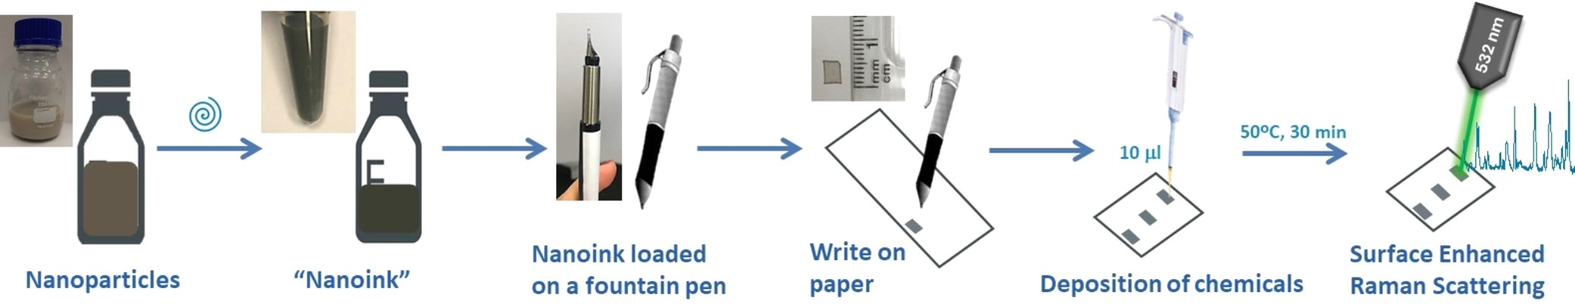
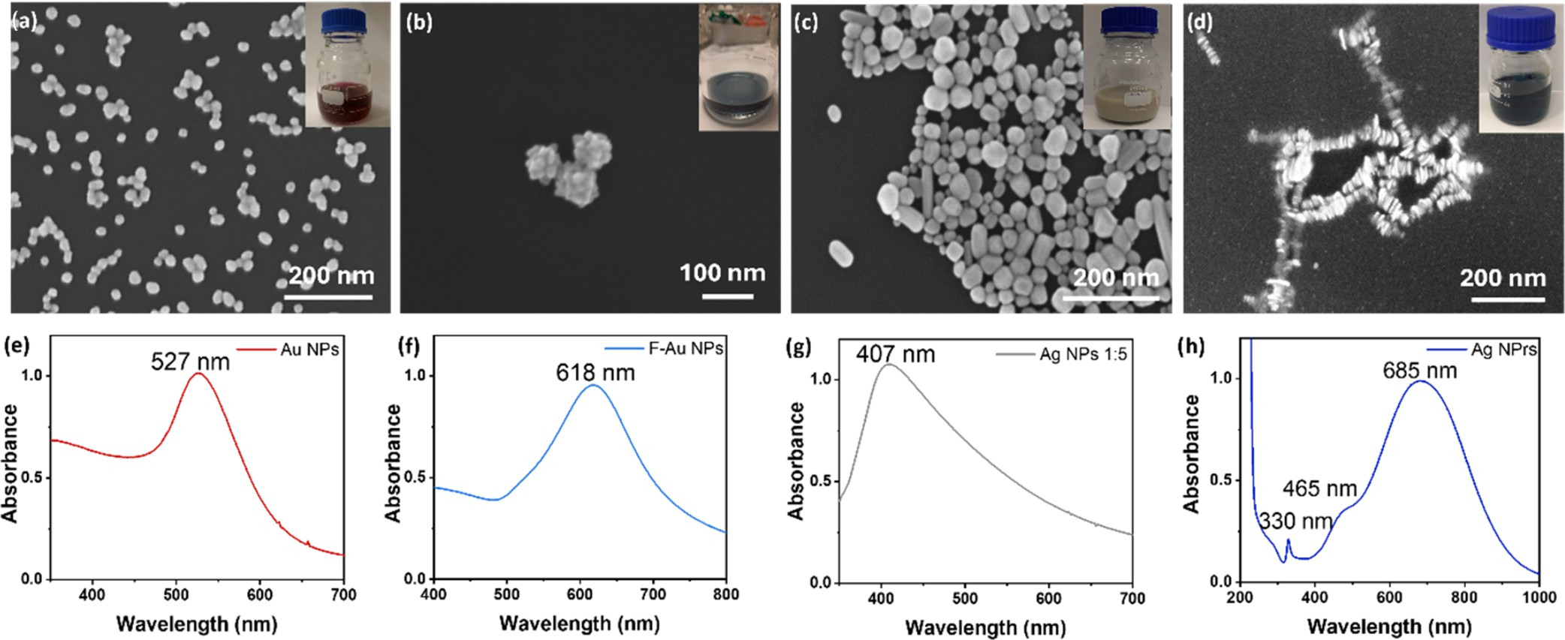

Figure 1. Characterization of the synthesized metallic nanoparticles. SEM images of (a) Au NPs (voltage: 5 kV; magnification: 40k×); (b) F-Au NPs (voltage: 8 kV; magnification: 100k×); (c) Ag NPs (voltage: 8 kV; magnification: 50k×); and (d) Ag NPrs (voltage: 10 kV; magnification: 80k×). Insets: digital pictures of the NP solutions. (e−h) UV−vis spectra of (a)−(d).

confirming the change in the shape of the colloidal particles. The solution was stored at 4 °C until further use.
  - Characterization. A Carl Zeiss Supra scanning
electron microscope (SEM) was used to obtain scanning electron microscopy images (accelerating voltages in the range of 5−10 kV). The SEM was connected to an Oxford Instruments X-Max 50 for energy-dispersive X-ray (EDX) spectroscopy, which was recorded at 10 kV.
To obtain nanoparticle SEM images, diluted solutions were deposited on n-doped Si wafers. Instead, prior to SEM imaging of the paper samples, they were coated with a ∼10 nm film of AuPd (90% Au, 10% Pd).
UV−vis spectra were acquired using an Agilent/HP 8453 UV−vis spectrophotometer (190-1100 nm, spectral bandwidth 1 nm).
The polydispersity index (PDI), hydrodynamic diameters, and ζ potential of the nanoparticle aqueous solutions were obtained using a Zetasizer Instrument (Zetasizer Nano-ZS, Malvern Instruments, Malvern Panalytical, U.K.) based on dynamic light scattering (DLS) and electrophoretic light scattering (ELS).
A Horiba XploRA PLUS Raman Microscope equipped with a 70 mW 532 nm laser was utilized for acquiring Raman spectra (1−10% laser power, 10−50× objectives, 10−60 s). The software was used to process the acquired Raman spectra. Origin 2022 was used for data analysis and scientific plotting.
  - Nanoink Preparation. From each nanoparticle colloidal solution, ink was prepared to write the metallic
SERS substrate on paper using a fountain pen. The inks were obtained through a process involving centrifugation and purification of the specific colloidal solution, resulting in a high-concentration nanoparticle solution. Hence, the term “nanoink” will be used in this work. Au NPs were centrifuged at 10 000 rpm for 20 min, while Ag NPs were centrifuged at 13 200 rpm for 30 min at room temperature. For instance, 2 mL of colloidal solutions was centrifuged, and the pellet obtained was washed with 2 mL of Milli-Q water and recentrifuged, finally obtaining around 150 μL, ensuring that no aggregates were formed on the bottom of the centrifuge tube, indicating instability of the NPs. The final nanoinks were kept in the fridge in the dark to preserve their stability since no additives were added to the mixture.
  - Preparation of the Paper-Based SERS Sensor. The following commercial papers with different textures and weights were tested as potential SERS substrates: (a) Kodak photo paper 180 GSM (Eastman Kodak Company, Rochester, NY, USA), (b) Ilford pearl photo paper 270 GSM (Harman Technology, Ilford Photo, Knutsford, Cheshire, U.K.), (c) Whatman membrane filter mixed cellulose ester (Whatman, Cytiva, Little Chalfont, Buckinghamshire, U.K.), (d) Whatman qualitative filter paper grade 1 (Whatman, Cytiva, Little Chalfont, Buckinghamshire, U.K.), (e) Daler-Rowney acrylic paper 180 GSM (Daler-Rowney Ltd., Bracknell, U.K.); (f) Xerox 90 GSM (Xerox Corporation, Norwalk, Connecticut, USA), (g) Premier stationery white card 160 GSM (Premier Stationery, Stereame, Nenagh, Co. Tipperary, Ireland), and (h)

Bristol smooth surface 270 GSM (Strathmore Artists Papers, Appleton, Wisconsin, USA).
To fabricate the SERS sensor, the synthesized nanoinks were used to fill the cartridges of the fountain pens. SERS substrates were generated by drawing squares (about 0.25 cm²) on clean paper. A double-layer approach was used to write the nanoink squares, whereby squares were drawn in the horizontal and vertical directions to ensure high coverage of NPs in the analytical area. The paper with the deposited nanoink was left to dry at room temperature before drop-casting a small volume of the analyte onto a square (10 μL). Then, the deposited sample was dried at 50 °C for 30 min prior to Raman analysis. To summarize, Scheme 1 reports the preparation process of the label-free, paper-based SERS sensor.
To perform SERS analyses, a solution of 0.01 M (4100 ppm) of CV (in ethanol 96%) was used to prepare all further dilutions. Instead, fresh milk was diluted 1:10 in deionized water and spiked with standard solutions of tetracycline hydrochloride at decreasing concentrations.

RESULTS AND DISCUSSION
  - Characterization of the Metallic Nanoparticles. Figure 1a−d shows the SEM images of all synthesized NPs. The Au NPs, synthesized by citrate reduction of tetrachloroauric(III) acid, showed spherical homogeneous shape with an average diameter size of 26.9 ± 3.4 nm (Figure 1a). The F-Au NPs were synthesized by a seeding growth approach, through a two-step reduction: (1) a weak reduction at room temperature by citrate (Au^{III} to Au^{I}) and (2) a preferential reduction on the gold seed surface by hydro- quinone (Au^{I} to Au⁰).³⁴ The SEM image (Figures 1b and S1a) showed a flower shape, containing numerous branches (petals). The average diameter dimension was calculated as
88.5 ± 8.4 nm; the variability is mostly due to the different lengths of the petals. The formation of the petals seemed to be related to the random attachment of small Au NPs, which
started during the process, on the seed surface, and it did not seem to be dominated by an epitaxial mechanism.³⁵ Ag NPs, synthesized through a reduction method of the silver nitrate,
wavelength optical wavelength
solution density nanoink optical density
showed a quasi-spherical shape (Figure 1c). The average | material | (λ, nm) | (OD) | (λ, nm) | nanoink (OD)
dimension for Ag NPs was 78.9 ± 16.1 nm. While the majority | Au NPs | 527 | 1 | 527 | 42
of particles were spherical, other shapes, including ellipsoids | F-Au NPs | 618 | 1 | 616 | 14
and rods, were formed. A simple, one-flask thermal process was | Ag NPs | 407 | 5 | 407 | 68
used to synthesize Ag NPrs. In this process, the concentration | Ag NPrs | 685, 465, 330 | 1 | 625, 330 | 14
of the reducing agent NaBH₄ influenced the conversion of

plasmon resonance, a weaker band at 465 nm corresponding to the in-plane quadrupolar resonance, and a sharp but small peak at 330 nm related to the out-of-plane quadrupole reso- nance.^{36,37}
Together with SEM and UV−vis spectroscopy, the nano- particles were characterized using DLS and ELS, carrying out measurements at 25 °C after 120 s of equilibration time between each sample. The data are reported in Table S1, obtained by analyzing 3 samples per material, and, for each
sample, 3 measurements (12 runs each) were recorded. The solutions were analyzed as freshly prepared and without any pretreatment, except for the Ag NP solution, which was diluted 1:5 prior to measurement.
  - Nanoink Preparation. To obtain a SERS substrate, it was necessary to prepare an “ink” for each synthesized nanoparticle solution. The use of an ink was key to obtain a controlled deposition of NPs on the paper, avoiding the spreading of the solution during pen writing, and to obtain a high concentration of nanoparticles on the paper, leading to SERS functionality. Usually, an ink is a liquid, semiliquid, or solid composed of different components: a colorant (dye or pigment), a vehicle (water or organic solvent), and other additives (resins, polymers, stabilizers, etc.).³⁸ In this work, the nanoink was a liquid composed of highly concentrated nanoparticles, as a colorant, in an aqueous vehicle. No other additives were included in the mixture, except for stabilizing molecules present on the surface of the NPs. The concentration of the initial NP solution was increased through a series of centrifugations, whereby it was ensured that no aggregates were formed at the bottom of the centrifuge tube, indicating the instability of the NPs. Through centrifugation, the concentration (optical density, OD) of all the colloidal solutions increased, as shown in Table 1. In general, an

Table 1. LSPR Maximum and Optical Density for All the Nanoparticles Synthesized, before (As-Synthesized) and after the Centrifugation Process (Nanoinks)

small nanoparticles (indicated by the initial pale yellow color of the solution) to NPrs. Triangular NPrs were formed, as shown in the SEM images in Figures 1d and S1b, and tended to arrange themselves in stacks. Ag NPrs had an average edge length of 32.1 ± 7.9 nm, with a more homogeneous thickness
(average 6.9 ± 1.3 nm). Insets of Figure 1a−d show
photographs of the colloidal solutions obtained, showing intense red (Au NPs), blue (F-Au NPs, Ag NPrs), and gray colorations (Ag NPs). Figure 1e−g shows the UV vis spectra of the synthesized particles. Au NPs showed a UV−vis spectrum characterized by LSPR centered at 527 nm (Figure 1e). The UV−vis spectrum of the F-Au NPs (Figure 1f) presented a broad LSPR centered at 618 nm. The UV−vis spectrum of Ag NPs (Figure 1g) was characterized by a broadband LSPR centered at 407 nm, confirming the heterogeneity in the size of the synthesized particles. Finally, Figure 1h shows the UV−vis spectrum obtained for Ag NPrs, characterized by a main absorption band at 685 nm, corresponding to in-plane dipole
increase of about 14 times in concentration was obtained, with the exception of spherical Au NPs, which could be concentrated 42 times, probably owing to their spherical shape and size homogeneity, which allowed tight compacting. UV−vis spectra were recorded for all nanoinks and are reported in Figure S2.
  - Evaluation of Substrates for the Paper-Based SERS Sensor. Considering the characteristics of the chosen technique (SERS) and the objective of developing a sensor using a flexible, environmentally friendly, and low-cost substrate, paper was selected as the substrate. To select the optimal paper for this purpose, eight types of paper were investigated, focusing on the ease of pen writing and on their spectral response in the analyte spectral region of interest (300−1800 cm⁻¹). Figure 2 displays microscope images of the different paper substrates analyzed, together with digital pictures of the squares written with a fountain pen loaded with Au NP nanoink. Figure 2 also shows the blank SERS

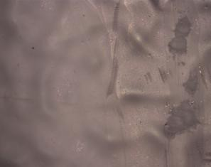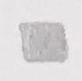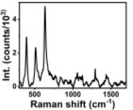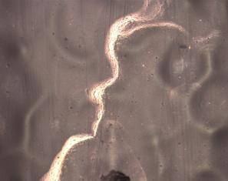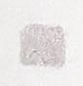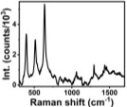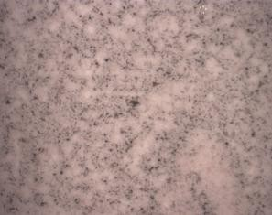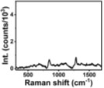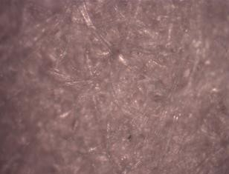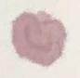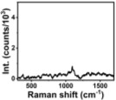

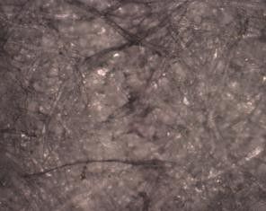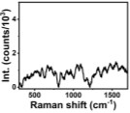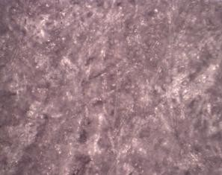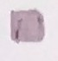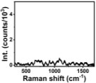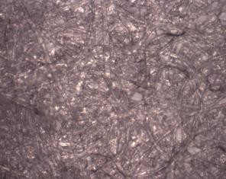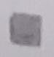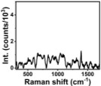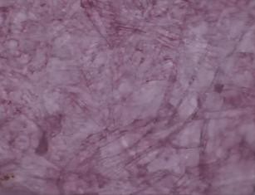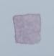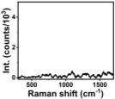
Figure 2. Different paper materials were studied to find the best substrate for our paper-based SERS sensor. Microscope images (10× objective) are shown for: (a) Kodak photo paper 180 GSM; (b) Ilford photo paper 270 GSM; (c) Whatman mixed cellulose ester membrane filter; (d) Whatman qualitative filter paper, grade 1; (e) acrylic paper 180 GSM; (f) Xerox Printer paper 90 GSM; (g) premier stationery white card 160 GSM; and (h) Bristol paper 270 GSM. For all the materials, are also reported, as insets, the SERS spectra obtained (532 nm laser, 10× objective, laser power 0.7 mW, 40−60 s acquisition) and the digital photographs of drawn squares with the Au NP nanoink.

response of the written papers, which must be minimal to avoid interference during analyte detection. The fluorescence response was minimized by adjusting the laser power and acquisition time. Specifically, Figure 2a,b shows data related to two photographic papers, Kodak photo paper 180 GSM and Ilford pearl photo paper 270 GSM. Both papers presented a smooth surface, which made pen writing easy and produced smooth colored squares. However, both papers had a glossy texture, probably due to the use of additives, such as resins, minerals, or optical brightening agents, added during the production process.^{39,40} Therefore, their SERS spectral response (insets) was characterized by intense peaks in the fingerprint region, which was the reason why these two substrates were not considered suitable for further use. Figure 2c,d displays the results obtained for two types of filter paper: Whatman membrane filter mixed with cellulose ester, and Whatman qualitative filter paper grade 1. While it was easy to write on the former filter paper, it was not easy to write on the latter since the nanoink spread unevenly, as observed in the written square shown in the inset of Figure 2d. Both Whatman papers were characterized by SERS spectra with no peaks in the region of interest (see the inset images). However, these two substrates were discarded because, upon deposition of an aqueous solution mimicking the deposition of analytes, they wrinkled with the solution spreading beyond the nanoink written area. Figure 2e shows the data related to the Daler- Rowney acrylic paper 180 GSM. This substrate was not suitable, as the writing was not smooth, and the SERS spectrum presented some interfering response in the region of interest. Finally, Figure 2f−h shows the characterization of
three printer papers with different surface textures and weights: Xerox 90 GSM, Premier stationery white card 160 GSM, and Bristol smooth surface 270 GSM. These printing papers were considered suitable substrates as fountain pen writing was easy and, mimicking the sample addition, the aqueous solution was confined to the area of interest, owing to their hydrophobicity. Also, the blank SERS spectra for these papers did not show characteristic peaks or high noise in the region of interest. Among the three analyzed printer papers, Bristol was selected
for further use, being the smoothest (easy nanoink flow) and heaviest (mechanically robust) of all, while also maintaining good flexibility. A summary of the characteristics of all of the analyzed paper substrates is reported in Table S2.
Prior to the use of Bristol paper as a SERS substrate, the stability of the substrate written with nanoinks was tested by scotch tape and water stability tests (Figure S3a−c), further showing suitability for SERS diagnostic applications.
  - Characterization and Optimization of the Paper- Based SERS Sensor. Considering that the SERS effect is stronger in the gaps between plasmon-coupled metal nano- particles,⁴¹ to increase the probability of so-called “hotspots” formation, the nanoink was deposited on the substrate using a double-layer writing strategy. Specifically, the first layer was written by drawing vertical lanes into a square shape. Once this layer dried, a second layer was written, drawing horizontal lines on top of the vertical features and ensuring that all empty areas were covered. In Figure S4, it is possible to observe the visual difference between a single-layer and a double-layer written nanoink, noticing an intensification of the nanoink color intensity. At the same time, Figure 3a shows why the presence of a hotspot can make a difference in residual detection. In fact, Figure 3a displays the actual enhancement obtained by analyzing 10⁻¹⁰ M CV in the presence (red line) vs absence
(black line) of a hotspot (the intensity of the peak at 1175
cm⁻¹, often used as reference for CV, was 4.5 times more intense in the presence of a hotspot).
To further optimize the sensitivity of the sensor, four nanoinks made from the 4 synthesized metallic nanoparticles were investigated with the Raman model molecule CV to investigate their SERS effect. To this end, a 10⁻⁴ M CV solution was used to compare the SERS response of the different nanoinks. Figure 3b displays the SERS spectra obtained with a laser excitation of 532 nm, showing that the Ag nanoinks (NPs and NPrs) produced greater signal enhancement than the other nanoinks. Therefore, the two Ag nanoinks were further investigated at different CV concentrations.

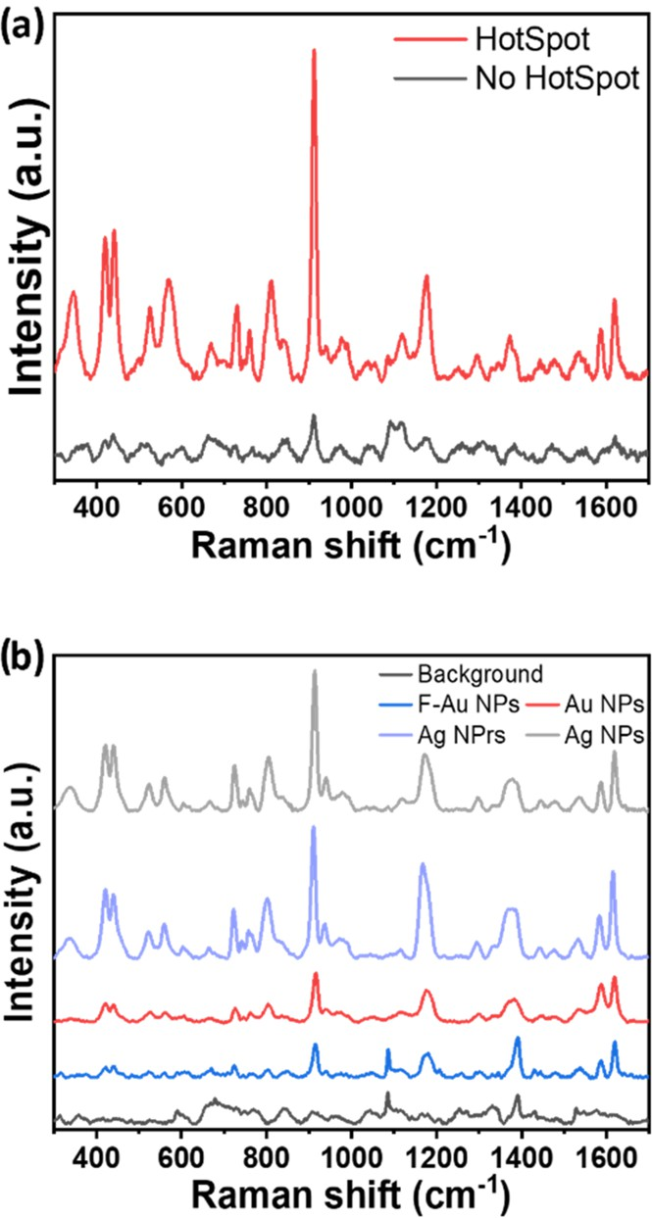
Figure 3. (a) SERS spectra recorded in a hotspot (red line) vs in a no- hotspot area (black line) of 10⁻¹⁰ M crystal violet deposited on the nanoink square (laser 532 nm, objective 50×, laser power 0.25%, acquisition time 80 s). (b) SERS spectra of 10⁻⁴ M crystal violet (CV) on different nanoinks (laser 532 nm, objective 50×, laser power 0.175−0.35 mV, 30−80 s); from the bottom to the top: background spectra (black); F-Au NPs (blue); Au NPs (red); Ag NPrs (indigo);
Ag NPs (gray).

Prior to starting the analysis, the density of NPs deposited on the paper substrate following pen writing was investigated by SEM. Figure S5 shows the images of the chosen substrate before and after pen writing, making evident the differentiation between the two; in fact, in Figure S5b, the fibers are filled with nanoparticles. In Figure S5a, some structures are also visible, which, according to the analysis through SEM and energy- dispersive X-ray spectroscopy (SEM/EDX) reported in Figure S6, should be calcium carbonate (CaCO₃), often used as a filler during paper production.
  - Crystal Violet Case Study: Ag NPs vs Ag NPrs. CV was chosen as a Raman probe owing to its spectroscopic properties and fingerprint spectrum as well as its use, together with its derivatives, in many industrial applications and as a veterinary drug for the treatment of ornamental fish infections. CV use is actually illegal and strictly controlled in fish destined for human consume since its residues are toxic for humans once absorbed by the animal.⁴² Since laborious techniques (mostly liquid chromatography) are usually used for detecting CV and its derivatives, there is a great interest in finding alternative detection methodologies to simplify and accelerate CV analysis.⁴³ The UV−vis spectroscopy characterization, the Raman characterization of the powder, and the characteristic peaks are reported in Figure S7a,b and Table S3, respectively. Among different techniques, SERS has been used for
determining the presence of CV in different platforms using different metallic nanostructures.⁴⁴⁻⁴⁶
Figure 4 shows the SERS spectra obtained with both Ag
nanoinks (Ag NPs (a), Ag NPrs (b)) at different
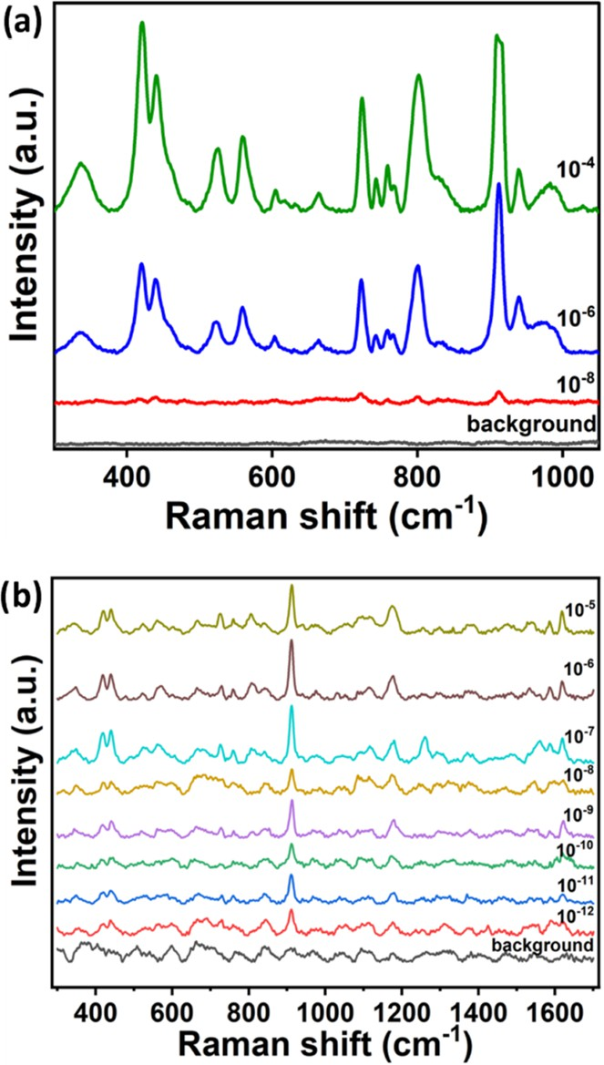

Figure 4. (a) SERS spectra of CV at three different concentrations (10⁻⁴, 10⁻⁶, 10⁻⁸ M in EtOH) obtained on the Ag NP nanoink sensors in comparison with the background spectrum. All spectra were collected at 532 nm, objective of 10×, an acquisition time of 30 s, and a laser power of 0.7 mV. (b) SERS spectra of CV in EtOH at diluting concentrations (from 10⁻⁵ to 10⁻¹² M) obtained on the Ag NPrs nanoink sensors. All spectra were collected at 532 nm, objective of 50×, an acquisition time of 80 s, and a laser power of 0.175 mV.

concentrations of CV. Specifically, 10⁻⁸ M CV (4.1 × 10⁻³ ppm = 4.1 ppb) was the lowest concentration detectable with the Ag NP nanoink, where all of the characteristic peaks of the molecule were still visible. Ag NPrs nanoinks demonstrated a
higher sensitivity, and detected CV at a concentration of 10⁻¹² M (4.1 × 10⁻⁷ ppm = 0.00041 ppb).
Considering the possibility of detecting 8 concentrations
using the paper-based sensor with Ag NPrs nanoink, a calibration curve was built for the detection of CV. In particular, five different spectra per concentration were collected at different points on the square of the paper-based sensor, and the intensities of the characteristic peak at 1175 cm⁻¹ were analyzed in order to obtain the mean intensity and its relative error. Decreasing the concentration of CV also decreased the signal of the diagnostic peak; in particular, the curve in Figure S8 was obtained through a nonlinear regression analysis of the data using a four-parameter logistic equation, with a correlation coefficient R² = 0.978.
Both the Ag nanoinks were proven to be suitable for SERS
investigations. However, stability analyses conducted on both suspensions showed that Ag NPrs were unstable after 21 days (Figure S9a), showing a shift in the wavelength of maximum absorbance, while Ag NPs remained stable. Furthermore, the

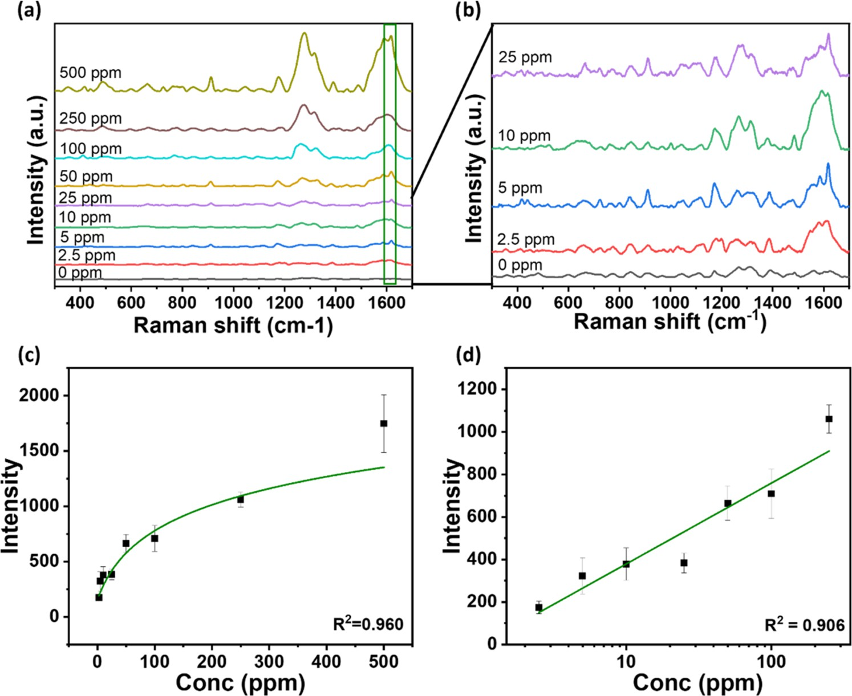
Figure 5. (a) SERS analysis of different concentrations (0−500 ppm) of tetracycline in milk. (b) Zoom-in of the 5 lowest concentrations (0−25 ppm) in milk. (c) SERS intensity 1620 cm⁻¹ vs concentration of tetracycline. (d) Calibration curve obtained through linear fitting of the SERS intensity at 1620 cm⁻¹ vs log of tetracycline concentration. The error bars refer to 4 measurements.

synthesis of Ag NPrs showed poor reproducibility, with batch- to-batch variability of the maximum absorbance wavelength, as observed in the UV−vis spectra shown in Figure S9b and Table S4. This reproducibility problem was not observed for the quasi-spherical Ag NPs, which were chosen for the analysis of antibiotic residues in milk samples.
  - Tetracycline Detection. Tetracycline hydrochloride is one of the most commonly used antibiotics in veterinary medicine. To find a fast, simple, and low-cost method to detect it, it is necessary to monitor its residual presence in foods destined for consumers. The Raman spectrum of tetracycline powder is shown in Figure S10a, while Table S5 shows Raman assignments, in agreement with the literature, with some minor shifts due to the laser used.⁴⁷ Figure S10b shows the SERS spectrum of tetracycline solution deposited on an Ag NP nanoink square, where the enhancement in tetracycline Raman signals can be observed, with a minor shift for some peaks compared to the Raman spectrum. For quantitative analysis of tetracycline in DI water, antibiotic solutions at different concentrations (1000, 500, 100, 50, 20, 10, 5, 2, 1, 0 ppm) were prepared. 10 μL of each solution was deposited on different paper-based SERS sensors written with Ag NP nanoinks and measured under 532 nm laser excitation. The analysis was carried out through a mapping process, choosing nine different points across the nanoink square, and the results obtained for this analysis are shown in Figure S11.
For milk analysis of tetracycline residues, it is necessary to consider the complexity of the matrix. It is composed of about 87% water, ∼3% protein, ∼4% fat, ∼5% lactose, and ∼1% vitamins and minerals. Raman spectroscopy has been recently used to investigate milk quality and composition since fats,
proteins, and lactose (milk solids) are all Raman-active molecules. In fact, in the literature, it is reported how the change in milk solids could affect the Raman signals.⁴⁸ Instead of using milk with a lower amount of fats, for instance, light milk (usually containing around 1 g of fat in 100 mL) or fat free milk (containing around 0.1 g of fat in 100 mL), we analyzed whole milk and diluted it to diminish all solid contributions on the SERS analysis.
Specifically, milk was diluted 1:10 in water and spiked with different concentrations of the antibiotic. 10 μL of each sample (500, 250, 100, 50, 25, 10, 5, 2.5, 0 ppm tetracycline in milk) was deposited on the paper-based sensors and dried before SERS analysis. The peaks obtained are in accordance with those reported in the literature, slightly shifted due to the interactions of the antibiotic with the milk matrix.²
Figure 5a,b shows representative SERS spectra obtained at different concentrations of tetracycline in milk, with a zoom-in at lower concentrations (from 25 to 0 ppm). The SERS analysis was carried out using 4 different points on the Ag NP nanoink square written with a pen-on-paper approach, using the following parameters: laser 532 nm, objective 10×, laser power 0.7 mW, and acquisition time 30 s. As observed for the molecular probe, decreasing the concentration of the antibiotic reduced the intensity of the SERS peaks. Specifically, as shown in Figure 5c, there was a logarithmic correlation between the intensity of the chosen peak of interest for tetracycline (1617 cm⁻¹) and the concentration of the antibiotic (correlation coefficient R² = 0.960). At the same time, a linear dependence of the SERS intensity of the peak at 1617 cm⁻¹ vs the log of the
concentration was found for the range 250−2.5 ppm, with a
correlation coefficient R² = 0.906 (Figure 5d). The limit of

detection (LOD) and the limit of quantification (LOQ) of our method were calculated as (3 × σ)/s and (10 × σ)/s, respectively, with σ as the standard deviation of 4 blank measurements and s as the slope of the calibration curve (Figure 5d). The LOD calculated is 0.07 ppm, while the LOQ is 0.23 ppm. Moreover, for the lowest measurable concen- tration (2.5 ppm), the signal-to-noise ratio (S/N) was also calculated, obtaining a value higher than 3, thereby meeting the LOD criteria (S/N = 20.15). For this calculation, we used the following formula:
S/N = peak intensity (S) , using for both standard deviation of noise (_{noise})
terms the average of 4 measurements
A comparison between our paper-based SERS sensor and other detection methods reported in the literature for tetracycline in milk is presented in Table S6.

CONCLUSIONS
In this work, the combination of Bristol paper and Ag NP nanoinks has allowed us to obtain simple, low-cost fabrication label-free paper-based SERS sensors. The Ag NP nanoinks were readily prepared and placed on paper through a simple, DIY pen-on-paper process. The mechanical and diagnostic properties of the SERS sensor were successfully assessed by using CV as a SERS probe. The ease of fabrication and the demonstrated capability of the sensor to detect low concentrations of tetracycline in a complex matrix such as milk point to the possible use of such disposable label-free SERS sensors in third-world countries or locations with limited access to trained personnel and expensive analytical instru- ments. Moreover, this opens the possibility of detecting different contaminants in food matrices as well as different analytes in diverse complex matrices, possibly in a point-of-site scenario, in combination with portable Raman instrumenta- tion.
▪

ASSOCIATED CONTENT
*sı Supporting Information
The Supporting Information is available free of charge at https://pubs.acs.org/doi/10.1021/acsomega.5c01637.
SEM images of F-Au NPs and Ag NPrs; PDI, hydrodynamic diameters, and ζ potentials of the diverse synthesized nanoparticle solutions; characterization of nanoinks (UV−vis spectroscopy); evaluation and characterization of paper substrates (mechanical stabil- ity, deposition strategy, SEM images, and EDX); characterization of CV (UV−vis and Raman spectros- copy, calibration curve obtained); stability and reprodu- cibility of Ag NPrs; and characterization of tetracycline (Raman vs SERS) and analysis of tetracycline in water (PDF)
▪

AUTHOR INFORMATION
Corresponding Author
Daniela Iacopino − Tyndall National Institute, University College Cork, T12R5CP Cork, Ireland; orcid.org/0000- 0003-2301-9401; Email: daniela.iacopino@tyndall.ie
Authors
Alida Russo − Tyndall National Institute, University College Cork, T12R5CP Cork, Ireland
Martina Piletti − Tyndall National Institute, University College Cork, T12R5CP Cork, Ireland
Aidan J. Quinn − Tyndall National Institute, University College Cork, T12R5CP Cork, Ireland; orcid.org/0000- 0003-4021-9990
Complete contact information is available at: https://pubs.acs.org/10.1021/acsomega.5c01637
Author Contributions
#Alida Russo and Martina Piletti have contributed equally to this work. A.R.: conceptualization, formal analysis, method- ology, visualization, validation, and writing (original draft- review editing); M.P.: formal analysis, methodology, visual- ization, validation, and writing (review, editing); A.J.Q.: funding acquisition, supervision, and writing (review, editing); and D.I.: funding acquisition, supervision, conceptualization, and writing (review, editing). All authors have given approval to the final version of the manuscript.
Funding
This publication has emanated from research conducted with the financial support of Research Ireland (RI) under the Department of Agriculture, Food and Marine on behalf of the Government of Ireland under Grant Numbers 16/RC/3835 (VISTAMILK) and 13/RC/2077-P2 (CONNECT).
Notes
The authors declare no competing financial interest.
▪

ACKNOWLEDGMENTS
The authors wish to thank Therese Uniacke-Lowe from the School of Food and Nutritional Sciences, University College Cork (UCC), for their guidance in ζ potential and DLS measurements.
▪

ABBREVIATIONS
Ag NPrs:silver nanoprisms Ag NPs:silver nanoparticles Au NPs:gold nanoparticles CE:chemical enhancement CV:crystal violet
DIY:do-it-yourself
EDX:energy-dispersive X-ray spectroscopy ELISA:enzyme-linked immunosorbent assay EM:electromagnetic enhancement
F-Au NPs:flower-shape gold nanoparticles
LOD:limit of detection
LOQ:limit of quantification
LSPR:localized surface plasmonic resonance
MRLs:maximum residue limits
OD:optical density
SEM:scanning electron microscopy
SERS:surface-enhanced Raman spectroscopy
▪

REFERENCES
- Dairy Market Review. Overview of Global Market Developments in 2024, 2025. https://openknowledge.fao.org/items/3be6263e-
6d0b-42ee-bce4-97663f2cd905 (accessed April 28, 2025).
- Marques, A.; Veigas, B.; Araújo, A.; Pagará, B.; Baptista, P. V.; Águas, H.; Martins, R.; Fortunato, E. Paper-Based SERS Platform for

One-Step Screening of Tetracycline in Milk. Sci. Rep. 2019, 9 (1), No. 17922.
- Conzuelo, F.; Campuzano, S.; Gamella, M.; Pinacho, D. G.; Reviejo, A. J.; Marco, M. P.; Pingarrón, J. M. Integrated Disposable Electrochemical Immunosensors for the Simultaneous Determination of Sulfonamide and Tetracycline Antibiotics Residues in Milk. Biosens. Bioelectron. 2013, 50, 100−105.
- Van Boeckel, T. P.; Glennon, E. E.; Chen, D.; Gilbert, M.;
Robinson, T. P.; Grenfell, B. T.; Levin, S. A.; Bonhoeffer, S.; Laxminarayan, R. Reducing Antimicrobial Use in Food Animals. Science 2017, 357 (6358), 1350−1352.
- Antimicrobial Resistance. https://www.who.int/news-room/fact-
sheets/detail/antimicrobial-resistance.
- Marshall, B. M.; Levy, S. B. Food Animals and Antimicrobials: Impacts on Human Health. Clin. Microbiol. Rev. 2011, 24 (4), 718−
733.
- A Farm to Fork Strategy for a Fair, Healthy and Environ- mentally-Friendly Food System, 2020. https://eur-lex.europa.eu/ legal-content/EN/TXT/?uri=CELEX:52020DC0381 (accessed Jan 07, 2025).
- Codex Alimentarius—Maximum Residue Limits (MRLs) and Risk Management Recommendations (RMRs) for Residues of Veterinary Drugs in Foods, 2024. https://www.fao.org/fao-who- codexalimentarius/codex-texts/maximum-residue-limits/en/ (ac- cessed July 23, 2024).
- Sales of Veterinary Antimicrobial Agents in 31 European Countries in 2022—Trends from 2010 to 2022—Thirteenth ESVAC Report, 2023. https://www.ema.europa.eu/en/documents/report/ sales-veterinary-antimicrobial-agents-31-european-countries-2022- trends-2010-2022-thirteenth-esvac-report_en.pdf (accessed Jan 07, 2025).
- HPRA—Use of Antibiotics in Dairy Cows; Health Products Regulatory Authority, 2025. https://www.hpra.ie/homepage/ veterinary/special-topics/use-of-veterinary-medicines-in-food- producing-animals/article---use-of-antibiotics-in-dairy-cows (accessed Jan 07, 2025).
- Commission Regulation (EC) No 508/ of 4 March 1999 Amending Annexes I to IV to Council Regulation (EEC) No 2377/90 Laying down a Community Procedure for the Establishment of Maximum Residue Limits of Veterinary Medicinal Products in Foodstuffs of Animal Origin, 1999. http://data.europa.eu/eli/reg/ 1999/508/oj/eng (accessed May 26, 2023).
- Ali, S. K.; Salihu, S.; Olaleye, A. A. Development and Validation of Reverse - Phase HPLC Method for Detection of Tetracycline Residue in Fresh Milk Samples. Dutse J. Pure Appl. Sci. 2023, 9 (3a), 41−48.
- Zergiebel, S.; Ueberschaar, N.; Seeling, A. Development and
Optimization of an Ultra-Fast Microextraction Followed by HPLC- UV of Tetracycline Residues in Milk Products. Food Chem. 2023, 402, No. 134270.
- De Ruyck, H.; De Ridder, H. Determination of Tetracycline Antibiotics in Cow’s Milk by Liquid Chromatography/Tandem Mass Spectrometry. Rapid Commun. Mass Spectrom. 2007, 21 (9), 1511−
1520.
- Ferreira, R. G.; Pereira, M. U.; Da Silva Rio, A.; Spisso, B. F. Determination of Tetracyclines and Their 4-Epimers in Milk by Solid- Phase Extraction (SPE) and Liquid Chromatography Tandem Mass Spectrometry (LC-MS/MS). In Chemical Food Contaminants Analysis; Hoff, R.; Molognoni, L., Eds.; Methods and Protocols in Food Science; Springer US: New York, NY, 2024; pp 135−146.
- Jadhav, M. R.; Pudale, A.; Raut, P.; Utture, S.; Ahammed
Shabeer, T. P.; Banerjee, K. A Unified Approach for High- Throughput Quantitative Analysis of the Residues of Multi-Class Veterinary Drugs and Pesticides in Bovine Milk Using LC-MS/MS and GC−MS/MS. Food Chem. 2019, 272, 292−305.
- Kurittu, J.; Lönnberg, S.; Virta, M.; Karp, M. Qualitative
Detection of Tetracycline Residues in Milk with a Luminescence- Based Microbial Method: The Effect of Milk Composition and Assay
Performance in Relation to an Immunoassay and a Microbial Inhibition Assay. J. Food Prot. 2000, 63 (7), 953−957.
- Luo, Y.; Xu, J.; Li, Y.; Gao, H.; Guo, J.; Shen, F.; Sun, C. A
Novel Colorimetric Aptasensor Using Cysteamine-Stabilized Gold Nanoparticles as Probe for Rapid and Specific Detection of Tetracycline in Raw Milk. Food Control 2015, 54, 7−15.
- Fodor, A.; Cseppento, D. C. N.; Badea, G. E.; Petrehele, A. I.;
Groze, A.; Tit, D. M.; Bungau, S. G. Colloidal Gold Immunochro- matography and ELISA Traceability of Tetracycline Residues from Raw Milk to Its Dairy Products. In Vivo 2023, 37 (4), 1619−1627.
- Han, S.; Zhou, T.; Yin, B.; He, P. A Sensitive and Semi-
Quantitative Method for Determination of Multi-Drug Residues in Animal Body Fluids Using Multiplex Dipstick Immunoassay. Anal. Chim. Acta 2016, 927, 64−71.
- Tim, B.; Błaszkiewicz, P.; Kotkowiak, M. Recent Advances in
Metallic Nanoparticle Assemblies for Surface-Enhanced Spectroscopy.
Int. J. Mol. Sci. 2022, 23 (1), No. 291.
- Zong, C.; Xu, M.; Xu, L.-J.; Wei, T.; Ma, X.; Zheng, X.-S.; Hu,
R.; Ren, B. Surface-Enhanced Raman Spectroscopy for Bioanalysis: Reliability and Challenges. Chem. Rev. 2018, 118 (10), 4946−4980.
- Dhakal, S.; Chao, K.; Huang, Q.; Kim, M.; Schmidt, W.; Qin, J.;
Broadhurst, C. L. A Simple Surface-Enhanced Raman Spectroscopic Method for on-Site Screening of Tetracycline Residue in Whole Milk. Sensors 2018, 18 (2), No. 424.
- Haynes, C. L.; McFarland, A. D.; Van Duyne, R. P. Surface- Enhanced Raman Spectroscopy. Anal. Chem. 2005, 77 (17), 338A− 346A.
- Giuffrida, D.; Spadaro, D.; Strano, V.; Trusso, S.; Saladino, M. L.; Armetta, F.; Ponterio, R. C. Eco-Sustainable and Flexible SERS Platform Based on Waste Cellulose Decorated by Ag Nanoparticles. Mater. Chem. Phys. 2025, 329, No. 130061.
- Siebe, H. S.; Chen, Q.; Li, X.; Xu, Y.; Browne, W. R.; Bell, S. E.
J. Filter Paper Based SERS Substrate for the Direct Detection of Analytes in Complex Matrices. Analyst 2021, 146 (4), 1281−1288.
- Zeng, F.; Duan, W.; Zhu, B.; Mu, T.; Zhu, L.; Guo, J.; Ma, X.
Paper-Based Versatile Surface-Enhanced Raman Spectroscopy Chip with Smartphone-Based Raman Analyzer for Point-of-Care Applica- tion. Anal. Chem. 2019, 91 (1), 1064−1070.
- Polavarapu, L.; Porta, A. L.; Novikov, S. M.; Coronado-Puchau,
M.; Liz-Marzán, L. M. Pen-on-Paper Approach Toward the Design of Universal Surface Enhanced Raman Scattering Substrates. Small 2014, 10 (15), 3065−3071.
- Turkevich, J.; Stevenson, P. C.; Hillier, J. A Study of the
Nucleation and Growth Processes in the Synthesis of Colloidal Gold.
Discuss. Faraday Soc. 1951, 11, 55.
- Frens, G. Controlled Nucleation for the Regulation of the Particle Size in Monodisperse Gold Suspensions. Nat. Phys. Sci. 1973, 241 (105), 20−22.
- Di Nardo, F.; Baggiani, C.; Giovannoli, C.; Spano, G.; Anfossi,
L. Multicolor Immunochromatographic Strip Test Based on Gold Nanoparticles for the Determination of Aflatoxin B1 and Fumonisins. Microchim. Acta 2017, 184 (5), 1295−1304.
- Lee, P. C.; Meisel, D. Adsorption and Surface-Enhanced Raman
of Dyes on Silver and Gold Sols. J. Phys. Chem. A 1982, 86 (17), 3391−3395.
- Métraux, G.; Mirkin, C. A. Rapid Thermal Synthesis of Silver
Nanoprisms with Chemically Tailorable Thickness. Adv. Mater. 2005,
17 (4), 412−415.
- Li, J.; Wu, J.; Zhang, X.; Liu, Y.; Zhou, D.; Sun, H.; Zhang, H.; Yang, B. Controllable Synthesis of Stable Urchin-like Gold Nano- particles Using Hydroquinone to Tune the Reactivity of Gold Chloride. J. Phys. Chem. C 2011, 115 (9), 3630−3637.
- Zhao, L.; Ji, X.; Sun, X.; Li, J.; Yang, W.; Peng, X. Formation
and Stability of Gold Nanoflowers by the Seeding Approach: The Effect of Intraparticle Ripening. J. Phys. Chem. C 2009, 113 (38), 16645−16651.
- Pastoriza-Santos, I.; Liz-Marzán, L. M. Colloidal Silver
Nanoplates. State of the Art and Future Challenges. J. Mater. Chem.
2008, 18 (15), 1724.

- Kelly, K. L.; Coronado, E.; Zhao, L. L.; Schatz, G. C. The Optical Properties of Metal Nanoparticles: The Influence of Size, Shape, and Dielectric Environment. J. Phys. Chem. B 2003, 107 (3), 668−677.
- Sharma, N.; Agarwal, D. A.; Negi, D. Y. S.; Bhardwaj, H.;
Jaiswal, J. History and Chemistry of Ink—A Review. World J. Pharm. Res. 2014, 3 (4), 2096.
- Messier, P.; Baas, V.; Tafilowski, D.; Varga, L. Optical Brightening Agents in Photographic Paper. J. Am. Inst. Conserv. 2005, 44 (1), 1−12.
- Santos, N. F.; Velho, J. L. Coating Structure with Calcium
Carbonate Pigments and Its Influence on Paper and Print Gloss. Pulp Paper Canada—Ontario, 2004.
- Chen, G.; Wang, Y.; Yang, M.; Xu, J.; Goh, S. J.; Pan, M.; Chen,
H. Measuring Ensemble-Averaged Surface-Enhanced Raman Scatter- ing in the Hotspots of Colloidal Nanoparticle Dimers and Trimers. J. Am. Chem. Soc. 2010, 132 (11), 3644−3645.
- Shen, Y.-D.; Deng, X.-F.; Xu, Z.-L.; Wang, Y.; Lei, H.-T.; Wang,
H.; Yang, J.-Y.; Xiao, Z.-L.; Sun, Y.-M. Simultaneous Determination of Malachite Green, Brilliant Green and Crystal Violet in Grass Carp Tissues by a Broad-Specificity Indirect Competitive Enzyme-Linked Immunosorbent Assay. Anal. Chim. Acta 2011, 707 (1), 148−154.
- Andersen, W. C.; Turnipseed, S. B.; Karbiwnyk, C. M.; Lee, R.
H.; Clark, S. B.; Rowe, W. D.; Madson, M. R.; Miller, K. E. Multiresidue Method for the Triphenylmethane Dyes in Fish: Malachite Green, Crystal (Gentian) Violet, and Brilliant Green. Anal. Chim. Acta 2009, 637 (1), 279−289.
- Fateixa, S.; Nogueira, H. I. S.; Trindade, T. Surface-Enhanced
Raman Scattering Spectral Imaging for the Attomolar Range Detection of Crystal Violet in Contaminated Water. ACS Omega 2018, 3 (4), 4331−4341.
- Lai, K.; Zhang, Y.; Du, R.; Zhai, F.; Rasco, B. A.; Huang, Y.
Determination of Chloramphenicol and Crystal Violet with Surface Enhanced Raman Spectroscopy. Sens. Instrum. Food Qual. Saf. 2011, 5 (1), 19−24.
- Shi, G.; Wang, M.; Zhu, Y.; Wang, Y.; Xu, H. A Novel Natural

SERS System for Crystal Violet Detection Based on Graphene Oxide Wrapped Ag Micro-Islands Substrate Fabricated from Lotus Leaf as a Template. Appl. Surf. Sci. 2018, 459, 802−811.
- Muhammad, M.; Yan, B.; Yao, G.; Chao, K.; Zhu, C.; Huang,
Q. Surface-Enhanced Raman Spectroscopy for Trace Detection of Tetracycline and Dicyandiamide in Milk Using Transparent Substrate of Ag Nanoparticle Arrays. ACS Appl. Nano Mater. 2020, 3 (7), 7066−7075, DOI: 10.1021/acsanm.0c01389.
- Silva, M. G.; De Paula, I. L.; Stephani, R.; Edwards, H. G. M.;
De Oliveira, L. F. C. Raman Spectroscopy in the Quality Analysis of Dairy Products: A Literature Review. J. Raman Spectrosc. 2021, 52 (12), 2444−2478.

