Table S1 Experimental conditions of syntheses using PC and soybean oil, and SL. Replicated in triplicate and data combined
 | SO  (mL) | SS  (µL) | PC  (mg) | PC  (mg L⁻¹) |  | Acetate Buffer  (mL) | SS  (µL) | SL  (mg) | SL  (mg L⁻¹)
PC1 | 50 | 500 | 1 | 20 | SL1 | 50 | 820 | 0.2 | 4
PC2 | 50 | 500 | 5 | 100 | SL2 | 50 | 820 | 2 | 40
PC3 | 50 | 500 | 10 | 200 | SL3 | 50 | 820 | 4 | 80
PC4 | 50 | 500 | 20 | 400 | SL4 | 50 | 820 | 100 | 1800
SO; Soybean oil, SS; sodium silicate, Acetate buffer: 0.05 mol L⁻¹

Fig. S1 Base structure of lecithin (top left) and the major components of soy lecithin (right column). R₁ and R₂ = fatty acid residues. CTAB is shown for comparison. Long carbon chains and quaternary ammonium headgroups are the key similarities

Table S2 DLS data of PC and SL at various concentrations. Structure size represented by peak means along with polydispersity index (PDI)
PC in acetate buffer (0.05 mol L⁻¹, pH 5.92)
Concentration  (mg L⁻¹) | Peak 1 mean  (nm) | Peak 2 mean  (nm) | PDI
10 | 150 | 3790 | 0.342
20 | 129 | 4915 | 0.357
30 | 128 | 4804 | 0.349
40 | 123 | 4587 | 0.349
50 | 124 | 4199 | 0.351
60 | 127 | 4726 | 0.328
70 | 116 | 4716 | 0.303
80 | 119 | 4747 | 0.349
90 | 132 | 4656 | 0.339
100 | 165 | 4427 | 0.394
SL in acetate buffer (0.05 mol L⁻¹, pH 5.92)
Concentration  (mg L⁻¹) | Peak 1 mean  (nm) | Peak 2 mean  (nm) | Peak 3 mean  (nm) | PDI
10 | 89 | 360 | 4459 | 0.401
20 | 110 | 475 | 4714 | 0.414
30 | 97 | 376 | 4500 | 0.415
40 | 406 | - | - | 0.418
50 | 101 | 370 | 4923 | 0.404
60 | 105 | 479 | 4672 | 0.418
70 | 332 | 4511 | - | 0.424
80 | 302 | 3811 |  | 0.431
90 | 123 | 640 | - | 0.449
100 | 338 | 4545 | - | 0.430

Fig. S2 shows SEM images of structurally undirected, crystalline monoliths of widely varying sizes and shapes that formed in the absence of PC or SL. These monoliths were formed when using acetate buffer (0.05 mol L⁻¹, pH 5.92) and sodium silicate. There are three possible explanations for what these monoliths are: (1) sodium metal from the reduction of Na⁺, (2) Na₂O from the sodium silicate, and (3) SiO₂. The formed solids were a white powder. This observation, along with the high reduction potential required to reduce Na⁺, means these solids are highly unlikely to be sodium metal. Thus, these white solids are either Na₂O or SiO₂. SiO₂ can be formed because sodium silicate slowly hydrolyses under acidic conditions, such as seen here. However, without any SDA the subsequent silica polymerisation is uncontrolled. These white solids are likely are a mixture of Na₂O and SiO₂. However, no spherical particles are formed. Thus, we conclude that the conditions of our silica synthesis require the presence of an SDA to form spherical silica particles.
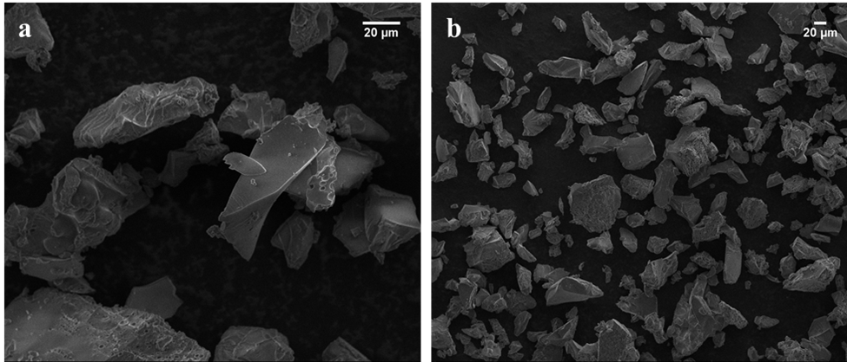Fig. S2 Monoliths formed when (a) no PC and (b) no SL is present in the synthesis
Fig. S3 Z-average for PC in acetate buffer (0.05 mol L⁻¹, pH 5.92) over a wider concentration range. PC1, PC2, PC3, and PC4 are marked with (*)

Fig. S4 PDI for PC (■) and SL (▲) in acetate buffer (0.05 mol L⁻¹, pH 5.92) at various concentrations (from DLS data)

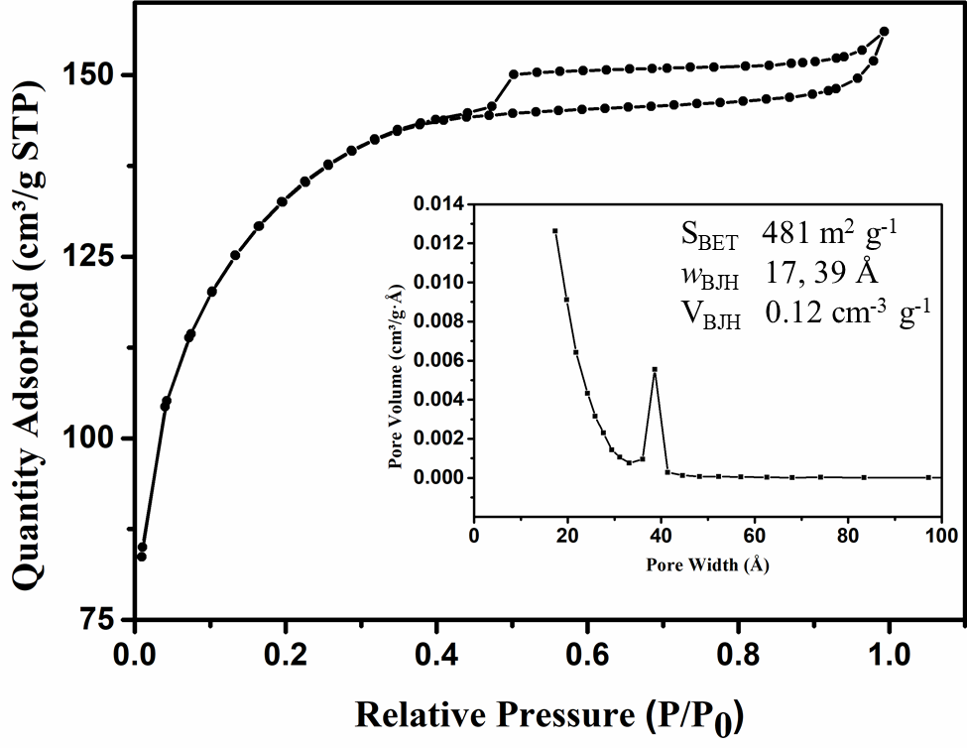Fig. S5 N₂ sorption isotherm and pore size distribution (inset) of silica particles produced with 80 mg L⁻¹ SL (SL3)

Fig. S6 Temporal evolution of Z-average (■) and PDI (▲) of 100 mg L⁻¹ SL in acetate buffer (0.05 mol L⁻¹, pH 5.92) with 10 µL sodium silicate

Fig. S7 Temporal PSD data from DLS measurements of 100 mg L⁻¹ soy lecithin in acetate buffer (0.05 mol L⁻¹, pH 5.92) with 10 µL sodium silicate. As time increases, the distribution becomes unimodal, showing the effect that added sodium silicate has on the structure stability

