Supplementary material

A1. Family labour force and farms in mountain areas as proxies of the prevalence of small farms at NUTS-3 level
Considering the spatial distribution of the family labour force (Figure A1), it is evident that the large majority of the regions at NUTS-3 level are covered by family farms. Given this spatial homogeneity and the low coefficient of variance (~0.33), this indicator may be misleading and not suitable to be used as proxy of the prevalence of small farms as also pointed out by van Vliet et al. (2015). In fact, many larger farms fall in the category of family farms.

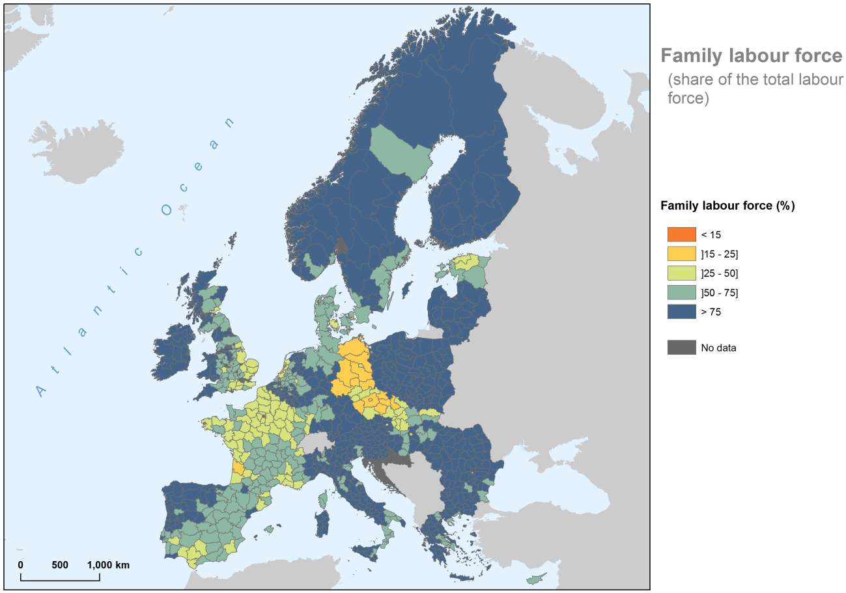
Figure A1. Family labor force (share of the total labor force)

Different patterns and relations between the distribution of farms in mountain areas (Figure A2) (and respective area used for farming) and the distribution of small farms mandates parsimony in the use of these variables. For example, large Slovenian grassland farms are often located in mountain areas and are specialised in livestock breeding with an additional farm income coming from forest production (Bojnec and Latruffe, 2013). Niedermayr et al. (2015) also have observed different development paths in the Alpine farm structures, while Marini et al. (2011) reported changes in these mountain areas related with the decrease of the traditional small farming systems and the increase of larger and more specialized farming systems. In the Italian Alps, from 1990 to 2010, while the number of cattle farms decreased by more than 50%, the heads per farm increased by 76%; similar and even more pronounced trends were observed for sheep and goat farms (ISTAT, 2013; Battaglini et al., 2014).

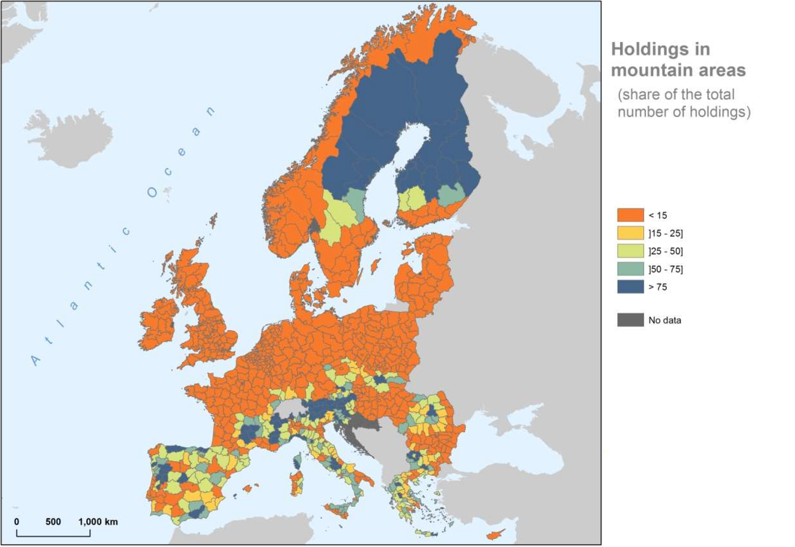
Figure A2. Distribution of farms in mountains ranges

A2. Selection of the cluster algorithm, cluster plot and mean values of each variables for each cluster
The clValid package for R (Brock et al., 2008) was used to select the clustering algorithm, based on the Dunn index (Dunn, 1974), silhouette width (Rousseeuw, 1987) and connectivity (Handl and Knowles, 2005). Connectivity should be minimized, while both the Dunn index and the silhouette width should be maximized (Brock et al., 2008). These measures allow assessing the compactness, connectedness, and separation of the cluster partitions (Brock et al., 2008). Five clustering methods were assessed: divisive analysis (DIANA; Macnaughton-Smith et al., 1964), partition around medoids (PAM; Kaufman and Rousseeuw, 1987), clustering large applications (CLARA; Kaufman and Rousseeuw, 1986), self-organizing tree algorithm (SOTA; Dopazo and Carazo, 1997; Herrero et al., 2001) and model-based clustering (MODEL; Fraley and Raftery, 2001).
The results have showed that an 8-cluster solution (based on Gap statistics) using partition around the medoids (PAM) was the best solution for our data. The medoid-based clustering algorithm (PAM) is more robust than other cluster profiles due to its less sensitiveness to noisy data and outliers (Kaufman and Rousseeuw, 1987; Brock et al., 2008; Barbakh et al., 2009).
As a supplement to Table 2 and Figure 5 that appear in the main text of the paper we also include the cluster plot (Figure A2) and the distribution of the mean values and standard deviation of the variables throughout the clusters (Table A1).

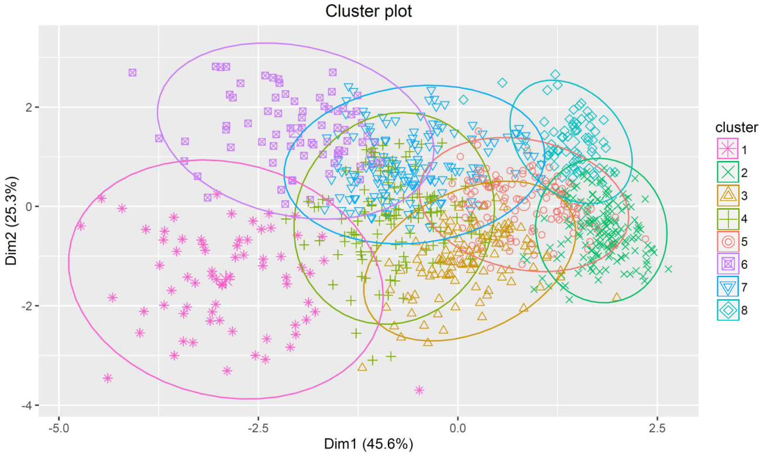
Figure A3. Cluster plot resulting from the PAM for 8 clusters

Table A1.
Mean and standard deviation of each variable used in cluster analysis for each cluster
 |  | Cl. 1 | Cl. 2 | Cl. 3 | Cl. 4 | Cl. 5 | Cl. 6 | Cl. 7 | Cl. 8
pUAA | Mean | 54.86 | 59.26 | 66.94 | 46.92 | 41.14 | 16.51 | 23.79 | 14.94
pUAA | St. Deviation | 12.86 | 10.91 | 8.527 | 9.525 | 8.335 | 9.04 | 9.621 | 9.952
pUAA_{structural} | Mean | 42.39 | 1.431 | 3.493 | 10.41 | 3.308 | 45.81 | 14.28 | 2.233
pUAA_{structural} | St. Deviation | 14.65 | 1.64 | 4.188 | 7.721 | 3.532 | 14.86 | 10.02 | 3.639
prUAA_{economic} | Mean | 33.35 | 2.537 | 12.83 | 13.85 | 6.364 | 9.055 | 8.641 | 1.265
prUAA_{economic} | St. Deviation | 7.859 | 2.958 | 7.64 | 7.992 | 4.568 | 4.883 | 5.174 | 1.028
pSF_{economic} | Mean | 96.19 | 24.5 | 66.35 | 87.67 | 52.54 | 87.9 | 80.9 | 31.68
pSF_{economic} | St. Deviation | 5.165 | 9.973 | 9.783 | 8.378 | 9.765 | 9.063 | 10.61 | 14.92
MSSF | Mean | 1.683 | 2.31 | 1.798 | 1.565 | 2.27 | 1.286 | 1.825 | 2.273
MSSF | St. Deviation | 1.445 | 2.23 | 1.47 | 1.545 | 2.25 | 1.44 | 1.82 | 2.27
pUAA: percentage of utilized agricultural area; pUAA_{structural}: percentage of UAA covered by small farms in terms of structural size (< 5 ha of UAA); prUAA_{economic}: percentage of the region covered by small farms in terms of economic size (< 8 ESU); pSF_{economic}: percentage of small farms in terms of economic size (< 8 ESU); MSSF: mean size of small farms in terms of structural size (<5 ha)

References
Barbakh, W.A., Wu, Y., Fyfe, C., 2009. Non-standard parameter adaptation for exploratory data analysis. Springer, Berlin. doi:10.1007/978-3-642-04005-4
Battaglini, L., Bovolenta, S., Gusmeroli, F., Salvador, S., Sturaro, E., 2014. Environmental sustainability of Alpine livestock farms. Ital. J. Anim. Sci. 13, 431–443. doi:10.4081/ijas.2014.3155
Bojnec, Š., Latruffe, L., 2013. Farm size, agricultural subsidies and farm performance in Slovenia. Land Use Policy 32, 207–217. doi:10.1016/j.landusepol.2012.09.016
Brock, G., Pihur, V., Datta, S., Datta, S., 2008. clValid, an R package for cluster validation. J. Stat. Softw. 25(4), 22p. doi:10.18637/jss.v025.i04
Dopazo, J., Carazo, J.M., 1997. Phylogenetic reconstruction using a growing neural network that adopts the topology of a phylogenetic tree. J. Mol. Evol. 44, 226–233. doi:10.1007/PL00006139
Dunn, J.C., 1974. Well separated clusters and fuzzy partitions. J. Cybernetics 4(1), 95–104. doi:10.1080/01969727408546059
Fraley, C., Raftery, A.E., 2001. Model-based clustering, discriminant analysis, and density estimation. J. Am. Stat. Assoc. 97, 126–136. doi:10.1198/016214502760047131
Handl, J., Knowles, J., 2005. Exploiting the trade-off – the benefits of multiple objectives in data clustering. In: Coello, L.A., Aguirre, A.H., Zitzler, E. (Eds.), Proceedings of the third international conference on evolutionary multicriterion optimization. Springer, Berlin, pp. 547–560. doi:10.1007/978-3-540-31880-4_38
Herrero, J., Valencia, A., Dopazo, J., 2001. A hierarchical unsupervised growing neural network for clustering gene expression patterns. Bioinformatics 17(2), 126–136. doi:10.1093/bioinformatics/17.2.126
ISTAT, 2013. Agricultural census at a glance. Available from: http://censimentoagricoltura. istat.it/
Kaufman, L., Rousseeuw, P.J., 1986. Clustering large data sets. In: Gelsema E.S., Kanal, L.N. (Eds.), Pattern recognition in practice II – Proceedings of an International Workshop held in Amsterdam, June 19-21, 1985. Elsevier, Amsterdam, pp. 425–437.
Kaufman, L., Rousseeuw, P.J., 1987. Clustering by means of medoids. In: Dodge, Y. (Eds.) Statistical data analysis based on the L₁-Norm. Elsevier, Amsterdam, pp. 405–416
Macnaughton-Smith, P., Williams, W.T., Dale, M.B., Mockett, L.G., 1964. Dissimilarity analysis: a new technique of hierarchical sub-division. Nature 202, 1034–1035. doi:10.1038/2021034a0
Marini, L., Klimek, S., Battisti, A., 2011. Mitigating the impacts of the decline of traditional farming on mountain landscapes and biodiversity: a case study in the European Alps. Environ. Sci. Policy 14, 258–267. doi:10.1016/j.envsci.2010.12.003
Niedermayr, J., Hoffmann, C., Stawinoga, A., Streifeneder, T., 2015. Agro-structural patterns in the Alps 2000–2010. Jahrbuch der Österreichischen Gesellschaft für Agrarökonomie 24, 275–284.
Rousseeuw, P.J., 1987. Silhouettes: a graphical aid to the interpretation and validation of cluster analysis. J. Comput. Appl. Math. 20, 53–65. doi:10.1016/0377-0427(87)90125-7
van Vliet, J.A., Schut, A.G., Reidsma, P., Descheemaeker, K., Slingerland, M., van de Ven, G.W., Giller, K.E., 2015. De-mystifying family farming: features, diversity and trends across the globe. Glob. Food Secur. 5, 11–18. doi:10.1016/j.gfs.2015.03.001

