Appendix

Impact of the LSTM and max pooling layers
In this study, the proposed AENet is designed to capture the spatiotemporal characteristics of the AE map. The second component of AENet, the Long Short-Term Memory (LSTM) module, plays a crucial role in extracting the temporal features of the AE time-series data. To quantitatively evaluate the specific contribution of the LSTM module, it is removed from the AENet architecture, and the performance of the modified model - AENet without LSTM, denoted as AENet (No LSTM) - is compared with that of the benchmark model, i.e., the original AENet. In addition, the influence of the pooling strategy is investigated by replacing the max pooling layers in the original AENet with average pooling layers, resulting in another variant referred to as AENet with average pooling (AENet- Ave-pooling).
The ablation study is conducted based on the following model configurations and datasets:
- Model architecture:
- LSTM module: The revised AENet (No LSTM) has two components: a CNN module and fully connected (FC) layers. As described in Section 4.1, after the down-sampling operation of the CNN module, a complete time sequence with a size of (L+1) ×32×8 is obtained. In the revised AENet (No LSTM), this spatiotemporal feature sequence is flattened and directly fed into the FC layers to predict IFL/INB.
- Max pooling: In the revised AENet (Ave-pooling), the architecture remains identical to the original model, with the only modification where the max pooling layers are replaced with average pooling layers.
- The training and test datasets introduced in Sections 5.1 and 5.2 are adopted in this ablation study. The data are prepared using a 15 s historical time window (L = 15 s) and a 1-second inference timestep (Δt =1.0 s). The training data are constructed from two out of the three experimental datasets, while the remaining dataset is used for testing. Moreover, 20% of the training data are randomly selected as the validation set for hyperparameter optimization.
- The AENet (No LSTM) model is trained using the datasets (‘30°’ and ‘45°’) and then evaluated on the test dataset (‘60°’). The same training and testing procedure is repeated 10 times to ensure reliable performance assessment.

Performance of AENet (No LSTM)
Two AENet (No LSTM) models (L = 15 s, ∆t = 1.0 s), one for IFL inference and the other for INB inference, are trained following the same procedure described in Section 4.2. The DL models are trained for 20 epochs with an initial learning rate of 0.00005 and a batch size of 32. All models are trained using the Adam optimizer with L2 regularization and a weight decay of 0.0008 until convergence is achieved. The two models for predicting IFL and INB are trained using their corresponding training datasets, during which both training and validation losses are continuously monitored. Figure 23 illustrates the evolution of the training and validation losses over the 20 training epochs. The AENet (No LSTM) models exhibit convergence after approximately 15 epochs. After 20 epochs, the training loss of the AENet (No LSTM) models reaches about 0.003 for both IFL and INB prediction. In contrast, the revised AENet model without the LSTM component exhibits significantly higher loss values compared with the benchmark AENet, which achieves a lower loss of 0.0002.
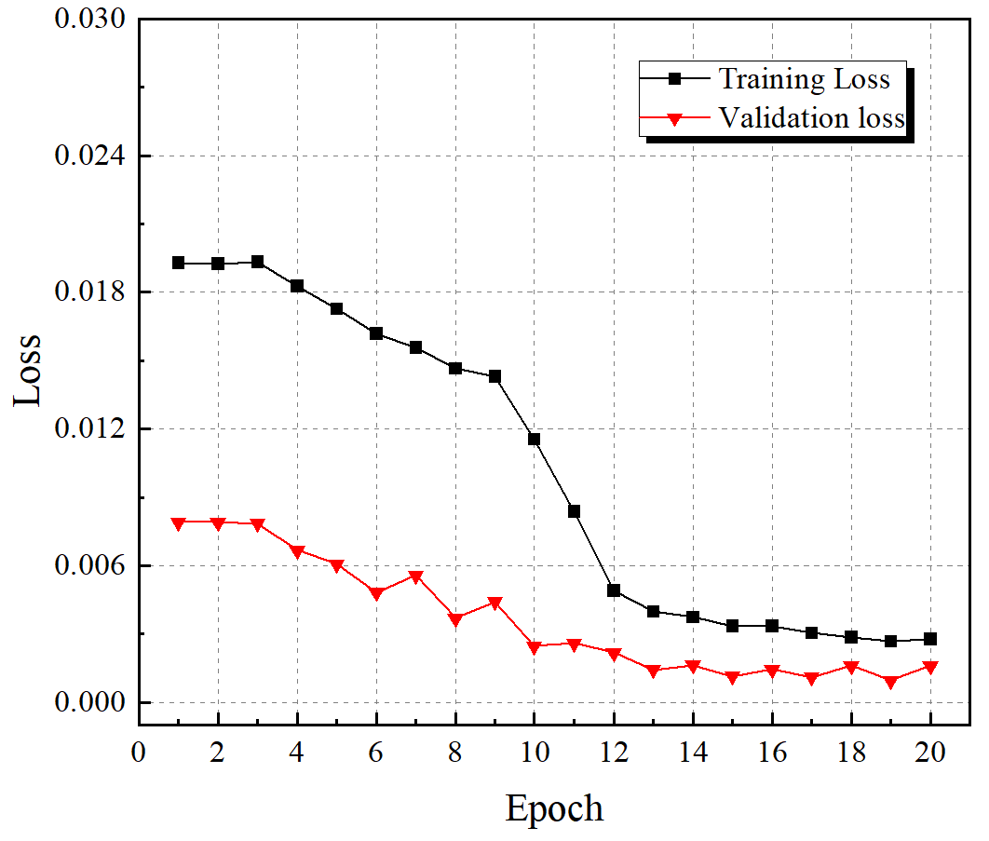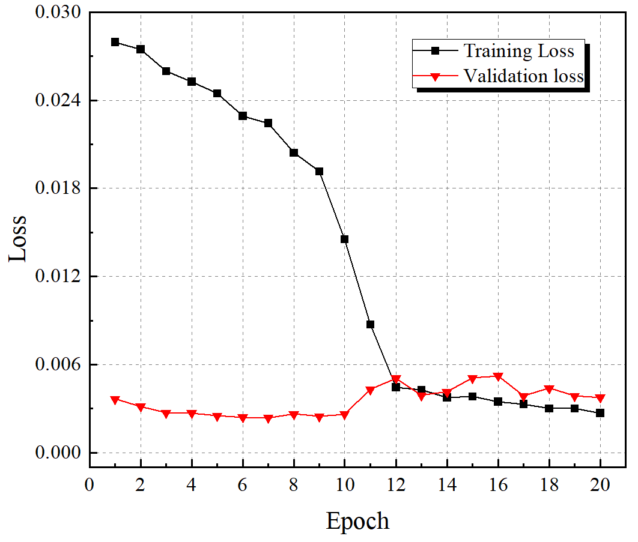
(a) IFL as target (b) INB as target
Figure 23. Training loss and validation loss of AENet (No LSTM) models
The trained DL models are employed to predict the temporal evolution of IFL and INB for the three experimental datasets. The predicted IFL and INB are subsequently integrated with respect to time to obtain CFL and CNB, respectively. Figures 24, 25, and 26 present the CFL/CNB results obtained from the benchmark AENet, the revised AENet (No LSTM), and the ground-truth experimental data for the three datasets, respectively. The results clearly indicate that the revised AENet (No LSTM) exhibits inferior performance compared with the benchmark AENet model. As shown in Figures 24 and 25, the AENet (No LSTM) fails to accurately capture fracture evolution after the fracturing peak and shows pronounced deviation from the experimental results. Moreover, its performance on the test dataset is also unsatisfactory. As illustrated in Figure 26, the AENet (No LSTM) is unable to properly predict the increase in fracture length and the number of branches when AE activity is sparse both before and after the fracturing peak. Table 4 summarizes the MREs and R² values of the inference results obtained using the AENet (No LSTM) model. The MREs across all three datasets are consistently higher and the R² values are lower than those of the benchmark AENet model, further confirming the degraded predictive performance of the revised AENet without the LSTM component.
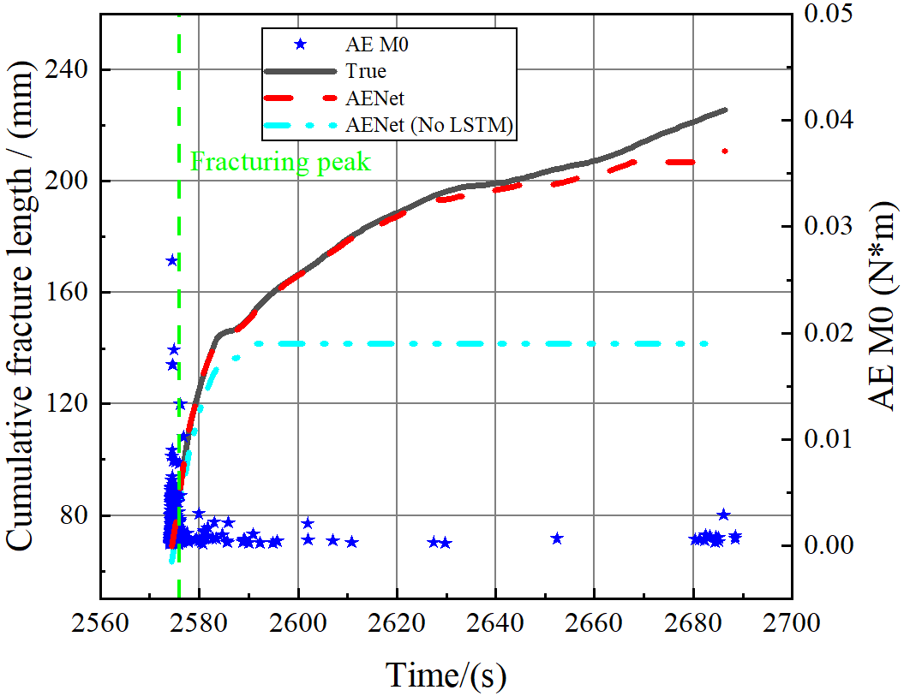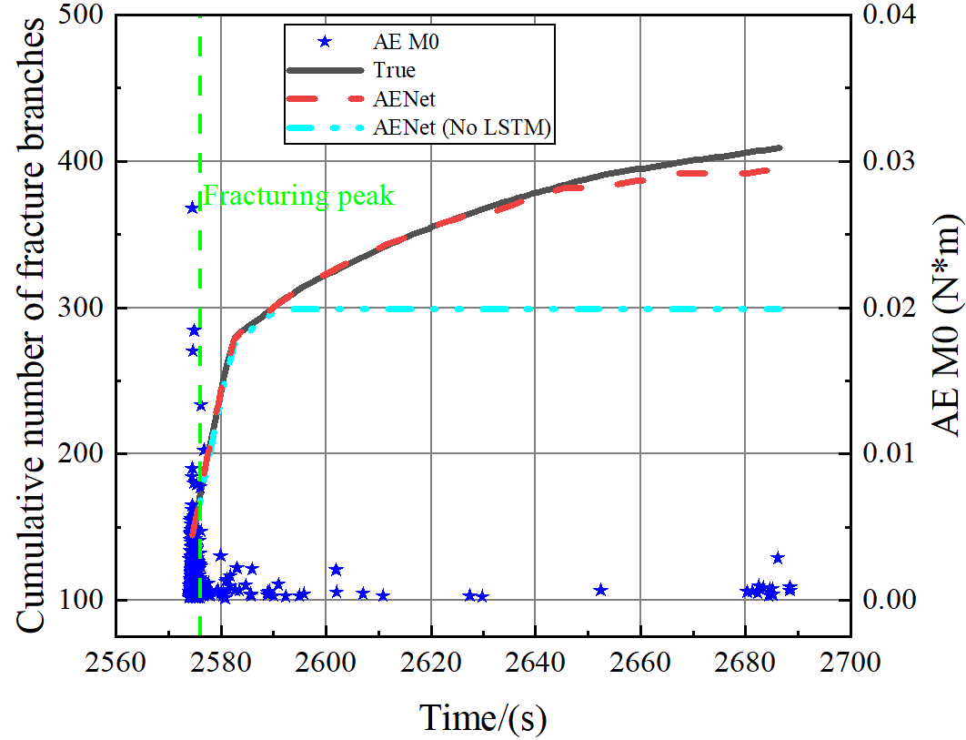
(a) CFL (b) CNB
Figure 24 Comparison of CFL/CNB results between AENet, AENet (No LSTM) and ground-truth experimental data (train data ‘30°’)
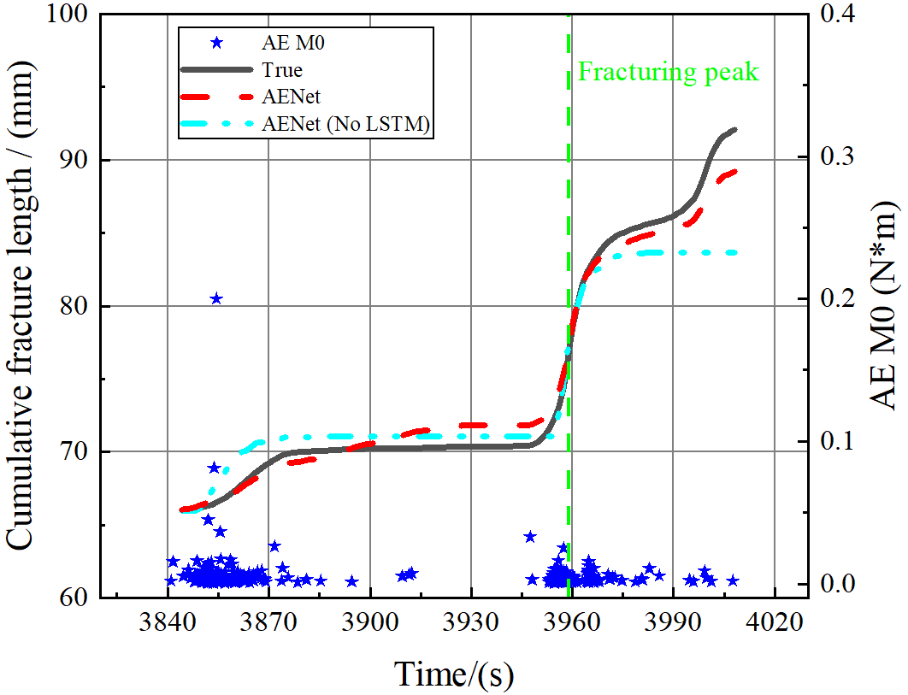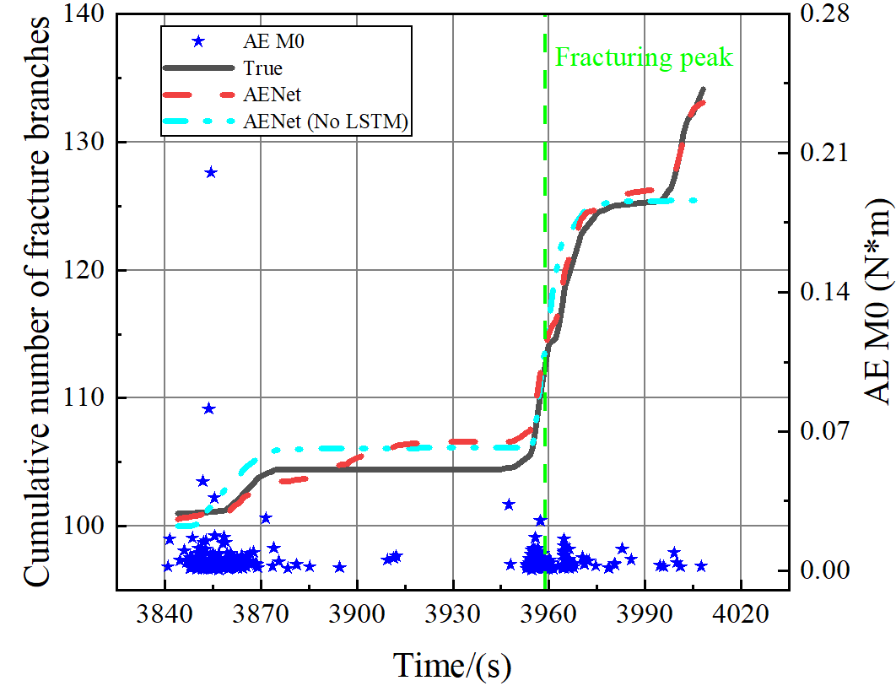
(a) CFL (b) CNB
Figure 25 Comparison of CFL/CNB results between AENet, AENet (No LSTM) and ground-truth experimental data (train data ‘45°’)
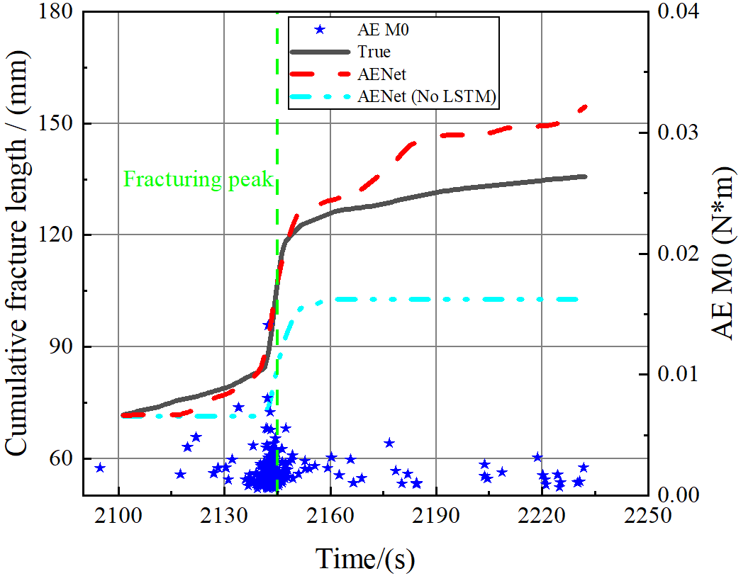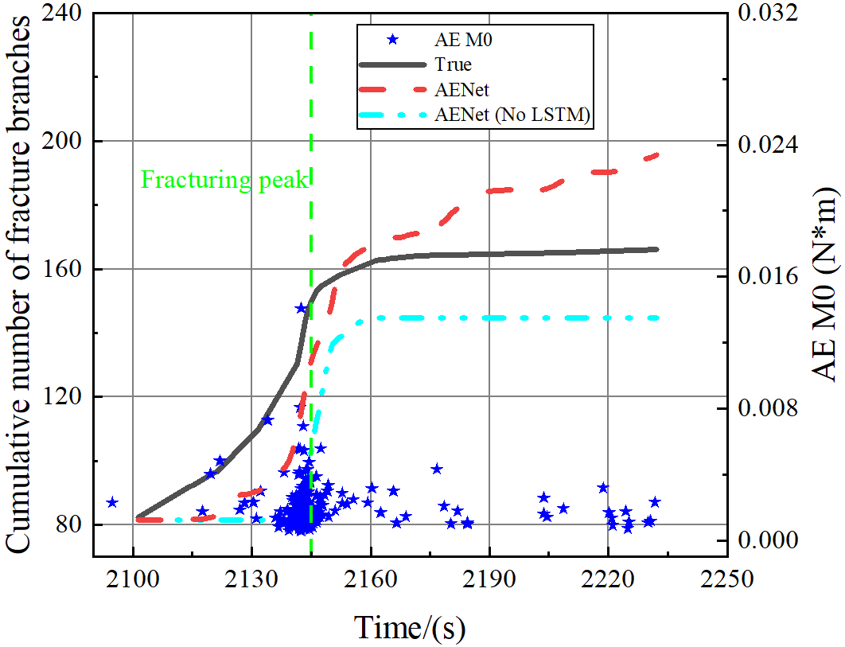
(a) CFL (b) CNB
Figure 26 Comparison of CFL/CNB results between AENet, AENet (No LSTM) and ground-truth experimental data (test data ‘60°’)
Table 4 MREs and R² values of inference results by AENet (No LSTM) model (L = 15 s, ∆t = 1.0 s)
Datasets | Mean Relative Error (MRE) |  | Coefficient of determination (R²)
Datasets | CFL | CNB | CFL | CNB
Dataset ‘30°’ (Train) | 0.6017 | 0.5733 | -0.8592 | -0.6801
Dataset ‘45°’ (Train) | 0.3494 | 0.4098 | 0.9245 | 0.9543
Dataset ‘60°’ (Test) | 0.7098 | 0.6329 | 0.1885 | 0.0853

Performance of AENet (Ave-pooling)
Similarly, two AENet (Ave-pooling) models (L = 15 s, ∆t = 1.0 s), one for IFL inference and the other for INB inference, are trained and optimized. The DL models are trained for 20 epochs with an initial learning rate of 0.00006 and a batch size of 32. All models are trained using the same Adam optimizer and L2 regularization with a weight decay of 0.0008 until convergence is achieved. During the training process, both the training and validation losses of the two models are continuously monitored. As shown in Figure 27, after 20 epochs, the training losses of the AENet (Ave-pooling) models reach approximately 0.004 when predicting IFL and INB as the target. Compared with the benchmark AENet that reaches training loss of 0.0002, the AENet (Ave-pooling) models exhibit significantly higher loss values. Although the AENet (Ave-pooling) models show signs of overfitting on the training data, the training losses remain stable at a relatively high level. This indicates that the AENet models with average pooling lack sufficient fitting capability for the training data.
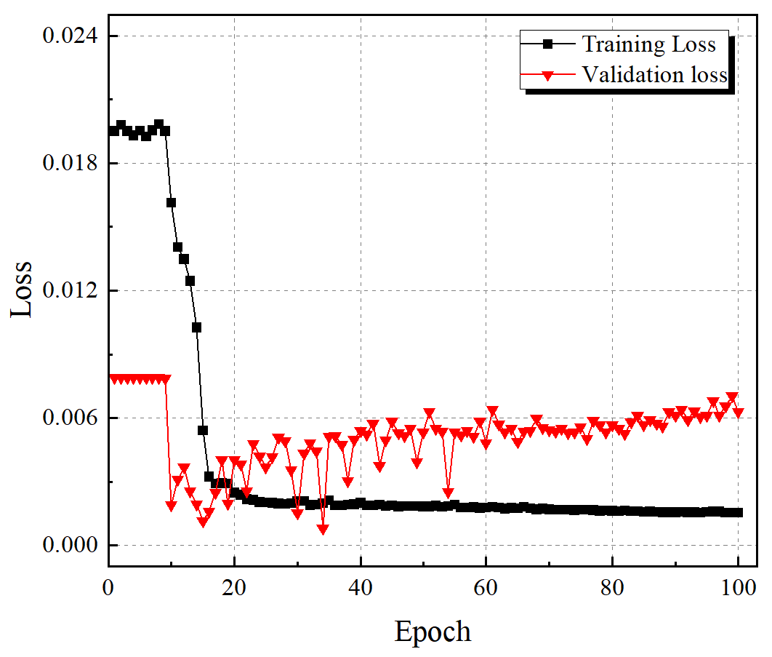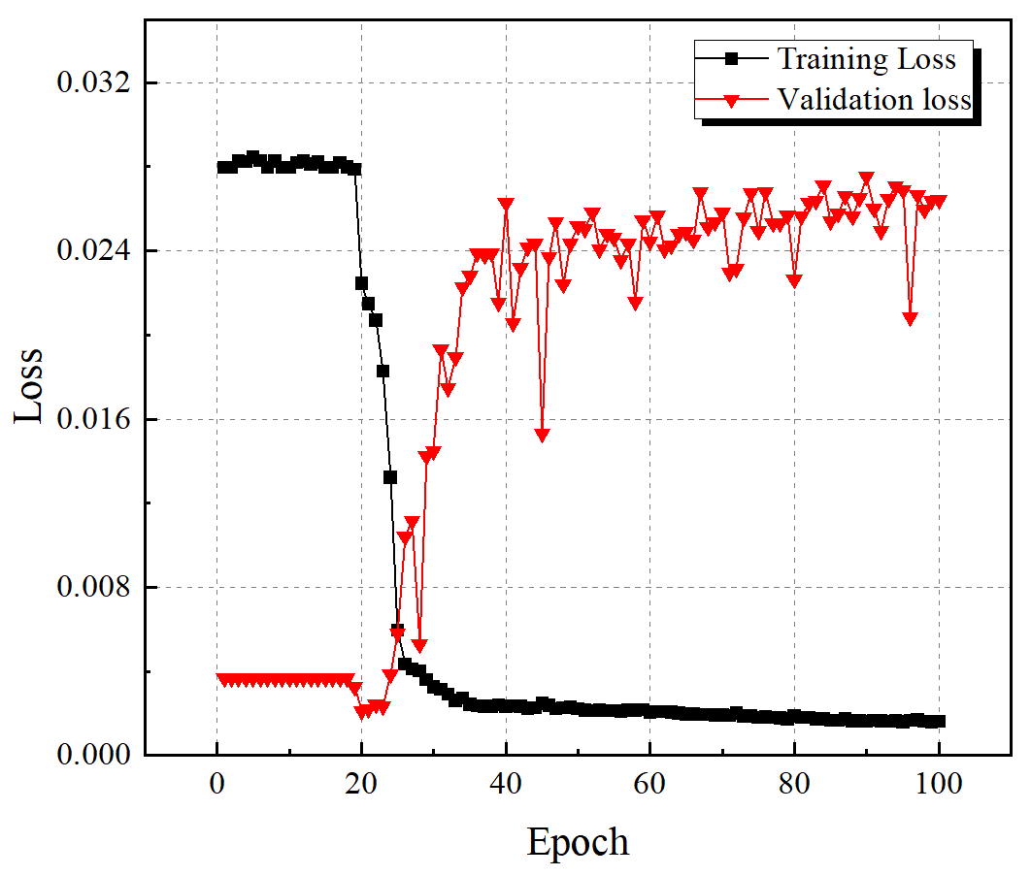
(a) IFL as target (b) INB as target
Figure 27. Training loss and validation loss of AENet (Ave-pooling) models trained for 100 epochs
Figures 28, 29, and 30 present the CFL/CNB results obtained from the benchmark AENet, the revised AENet (Ave-pooling), and the ground-truth experimental data for the three experimental datasets, respectively. The results demonstrate that the AENet (Ave-pooling) exhibits substantially inferior performance compared with the benchmark AENet model. Specifically, the AENet (Ave-pooling) fails to accurately predict the increase in fracture length and the number of branches when AE activity is sparse both before and after the fracturing peak. As shown in Figures 29 and 30, the revised AENet (Ave-pooling) is unable to accurately fit the fracture evolution after fracturing peak. Moreover, Figure 28 indicates that the AENet (Ave-pooling) can hardly predict the fracture length and the number of branches throughout the cracking process. Table 5 lists the mean relative errors (MREs) and R² values of the inference results obtained using the AENet (Ave-pooling) model. Compared with the benchmark AENet, the revised AENet (Ave-pooling) yields consistently higher MREs across all three datasets and lower R² values, further confirming its degraded predictive performance.
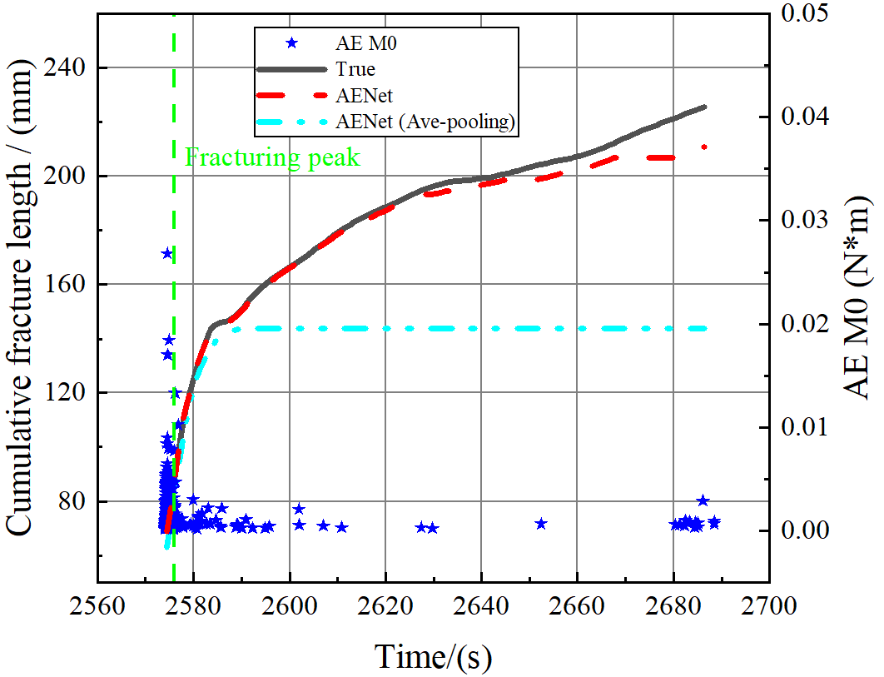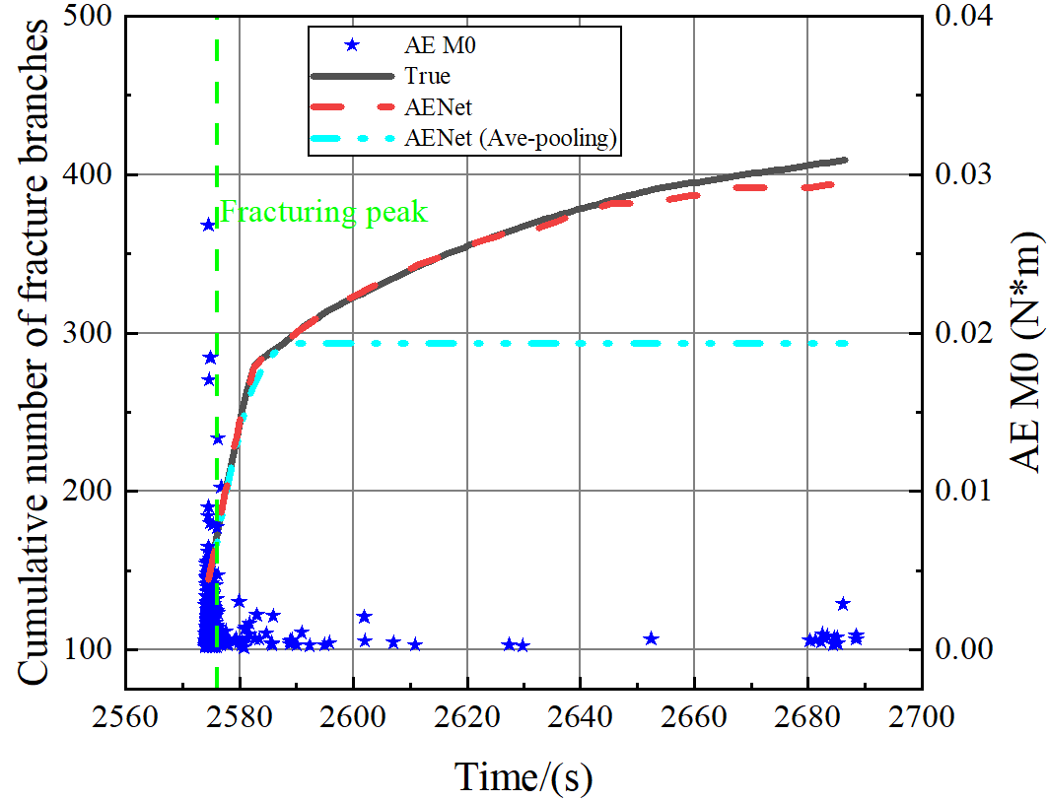
(a) CFL (b) CNB
Figure 28 Comparison of CFL/CNB results between AENet, AENet (Ave-pooling) and ground-truth experimental data (train data ‘30°’)
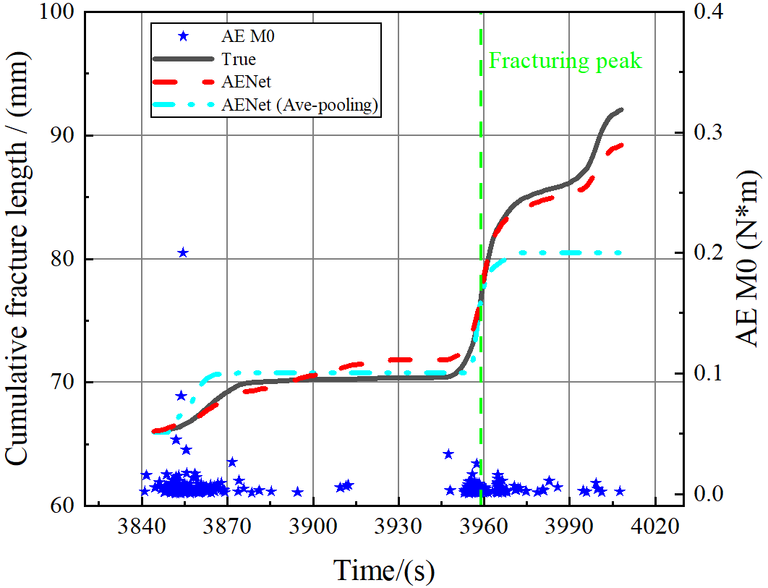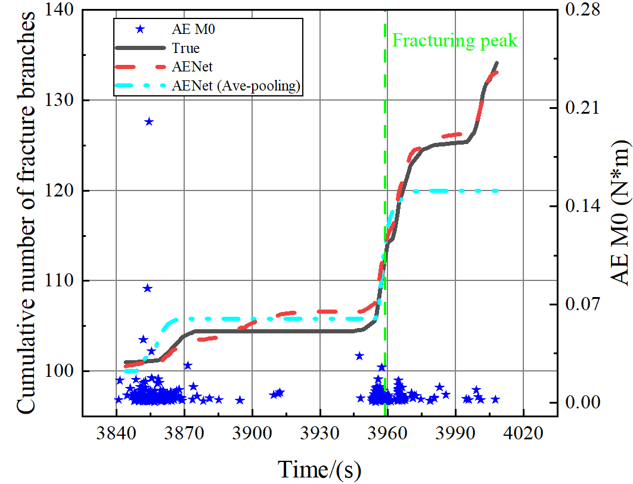
(a) CFL (b) CNB
Figure 29 Comparison of CFL/CNB results between AENet, AENet (Ave-pooling) and ground-truth experimental data (train data ‘45°’)
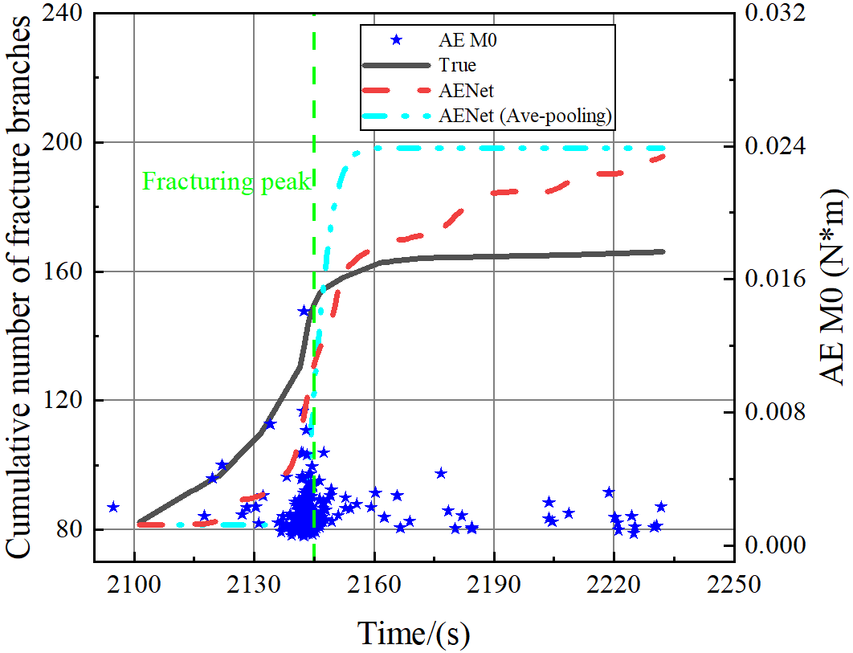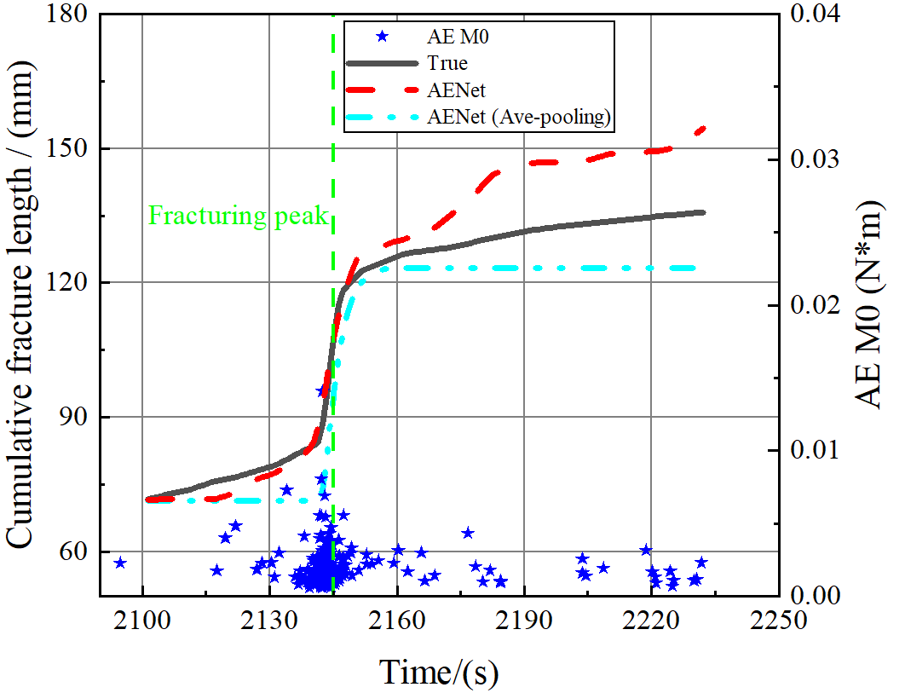
(a) CFL (b) CNB
Figure 30 Comparison of CFL/CNB results between AENet, AENet (Ave-pooling) and ground-truth experimental data (test data ‘60°’)
Table 5 MREs and R² values of inference results by AENet (Ave-pooling) model (L = 15 s, ∆t = 1.0 s)
Datasets | Mean Relative Error (MRE) |  | Coefficient of determination (R²)
Datasets | CFL | CNB | CFL | CNB
Dataset ‘30°’ (Train) | 0.3263 | 0.2697 | -1.6449 | -0.9439
Dataset ‘45°’ (Train) | 0.3309 | 1.6906 | 0.7890 | 0.8586
Dataset ‘60°’ (Test) | 0.411 | 0.5899 | 0.8957 | -0.0391

