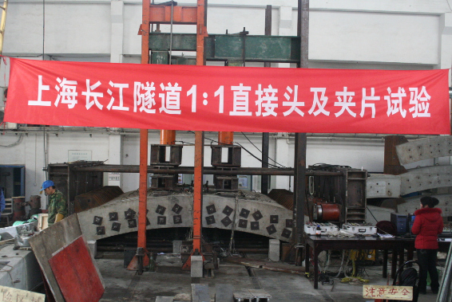
- Bending test on segmental joint

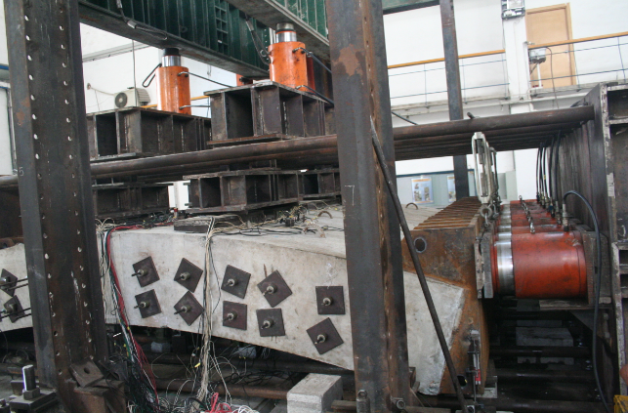
- Rigid steel support at the end of tunnel segment
Figure 1 Photos of concrete tunnel segmental joint bending test (courtesy Chen et al., 2010)

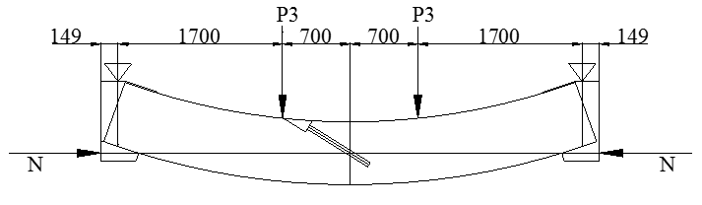
- Negative bending moment test
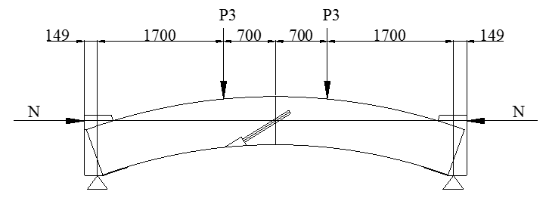
- Positive bending moment test

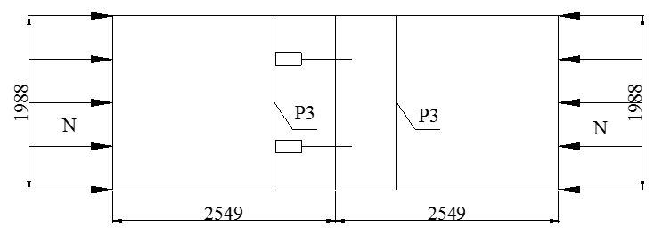
- Top view of the bending moment test

Figure 2 schematic of the bending moment tests (unit mm) (Chen et al., 2010)

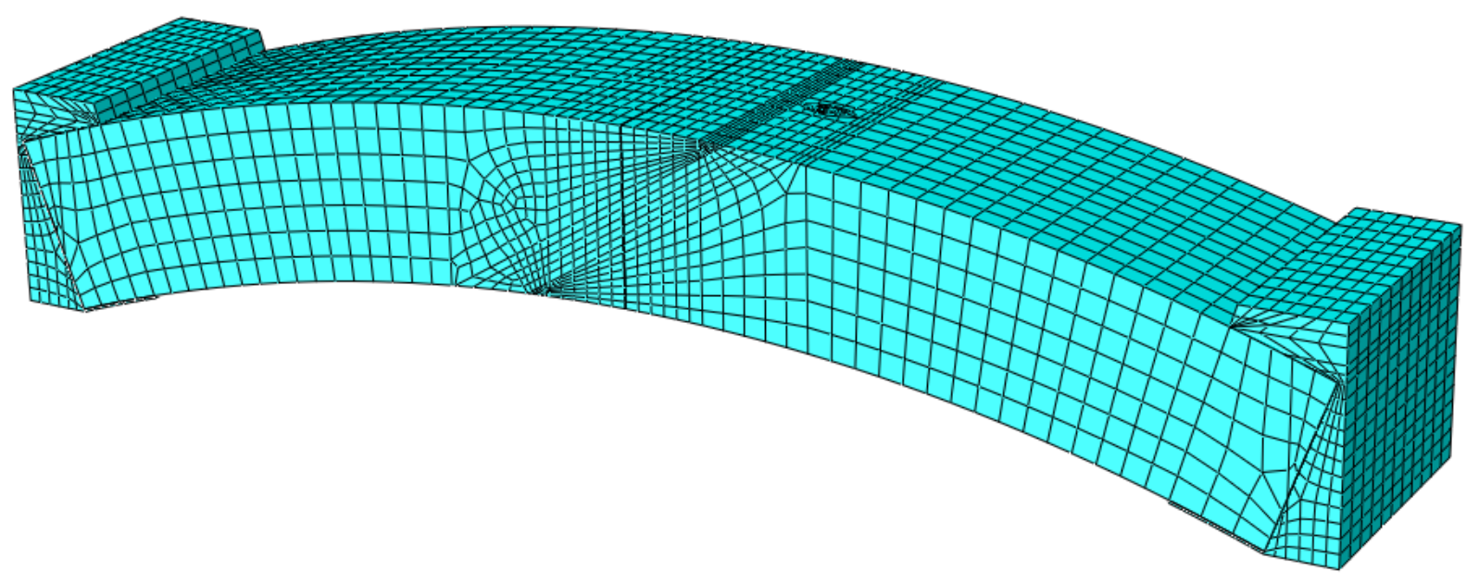
- Oblique view of the segmental joint

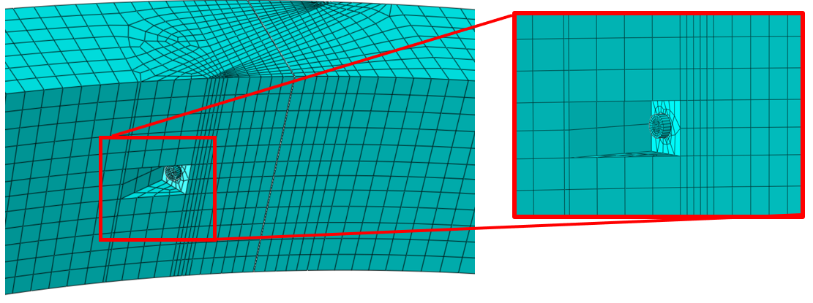
- Bottom view of the bolt hole
Figure 3 Finite element model for the segmental joint bending tests

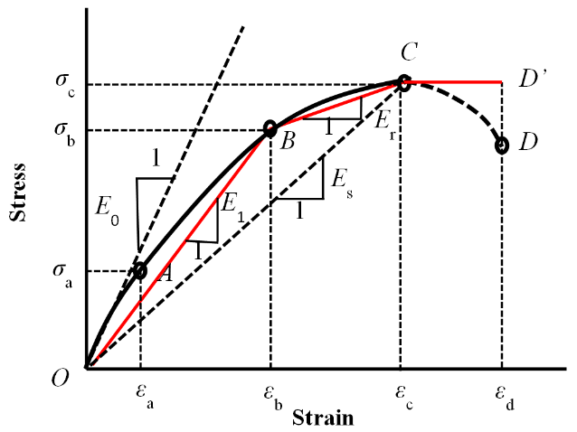

Figure 4 Schematic stress-strain diagram for concrete (Zhang et al., 2003)

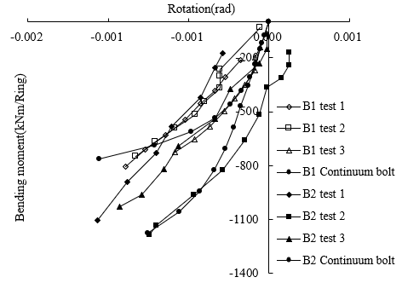

- The development of rotational angle under negative bending moment

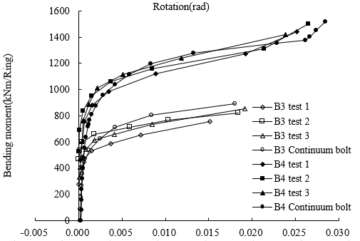
- The development of rotational angle under positive bending moment
Figure 5 Comparison between computed joint bending behaviour and the experimental data

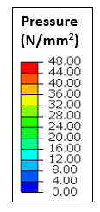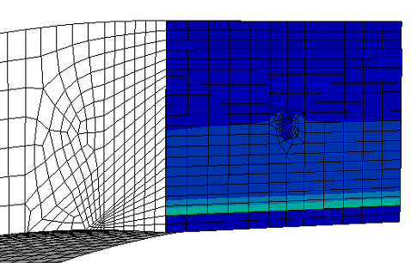
(a) under 0 bending moment
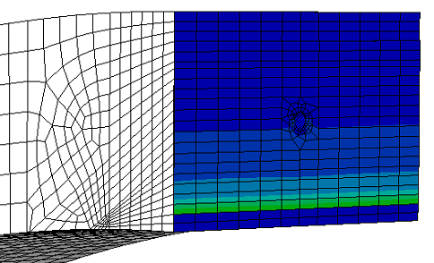
(b) under -191 kNm/m bending moment
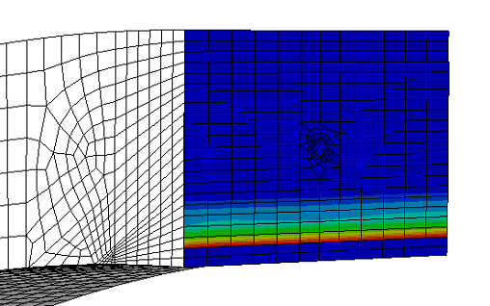

(c) under -382 kNm/m bending moment
Figure 6 Contact pressure contours of the segment under axial load and bending moment

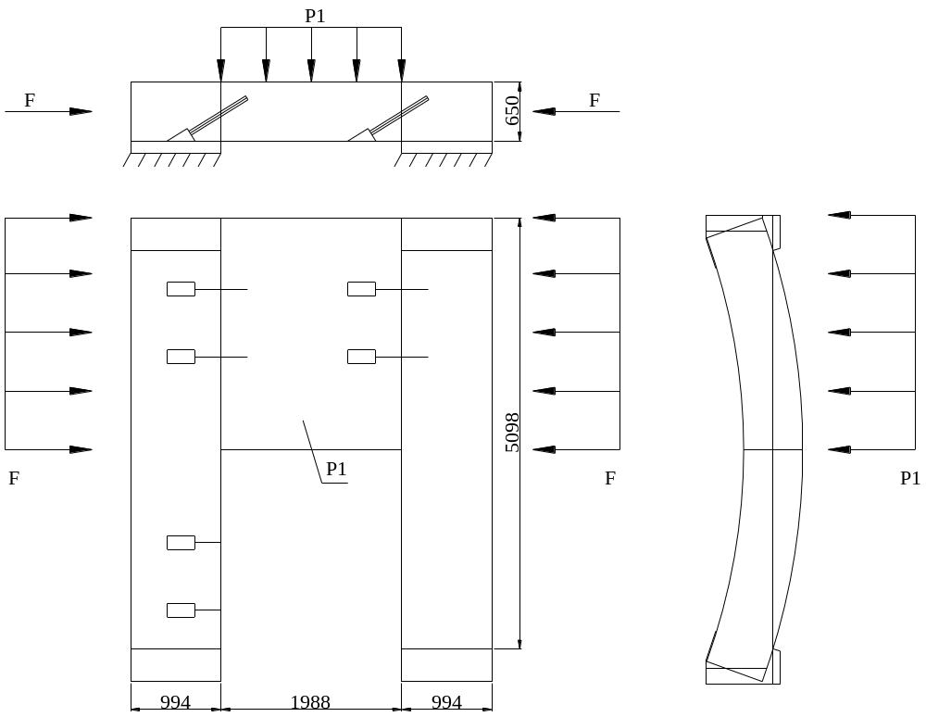
- shear test between segments in longitudinal direction along the railway track
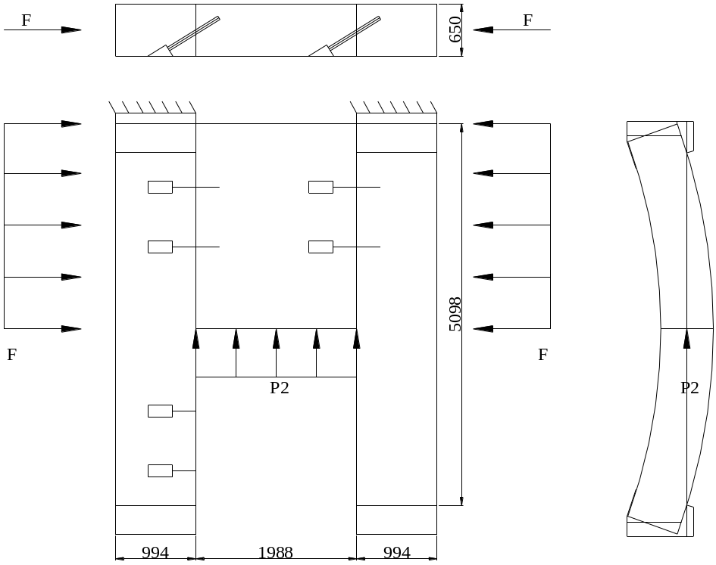
- shear test between segments in radial direction within a ring

Figure 7 schematic of the shear tests (unit mm) (Li et al., 2011)
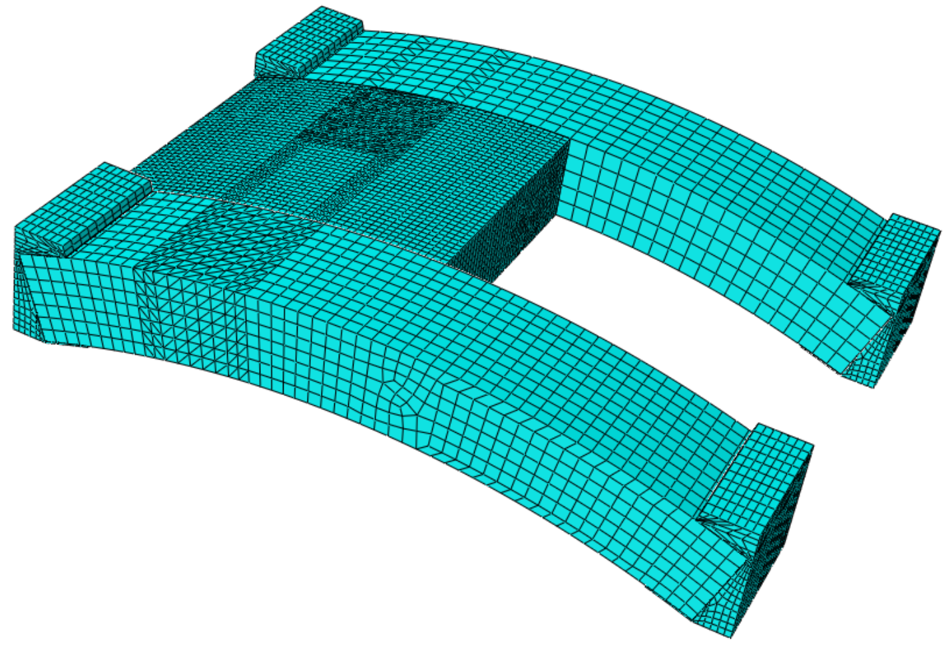
- Oblique view of segmental joint

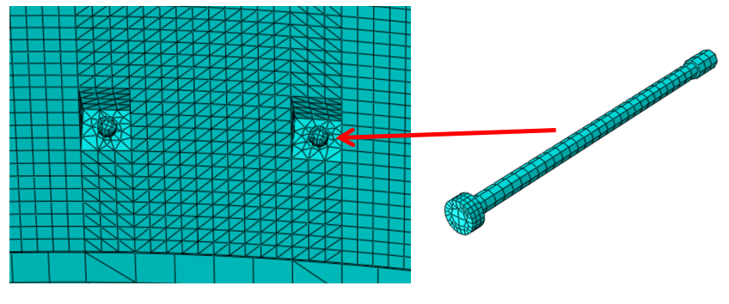
- Close up view of the bolt hole

Figure 8 Finite element model for the segmental joint shear tests

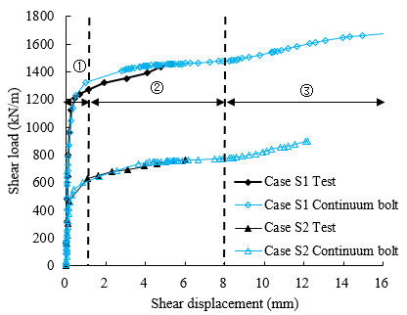
- Shear behaviour in longitudinal direction

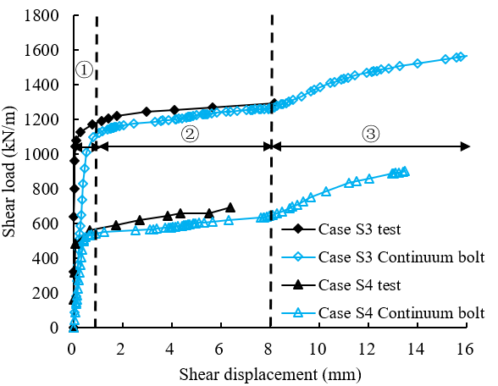
- Shear behaviour in radial direction
Figure 9 Comparison between computed joint shear behaviour and the experimental data

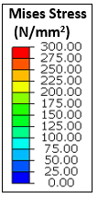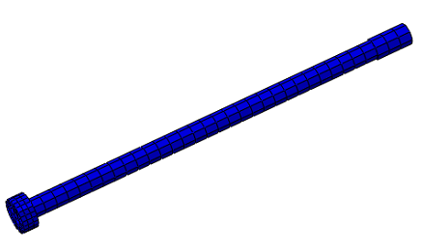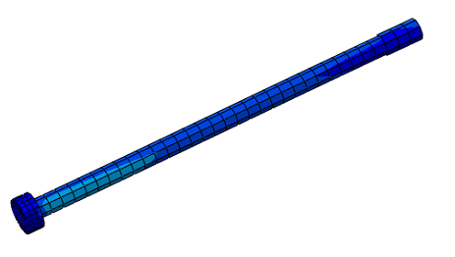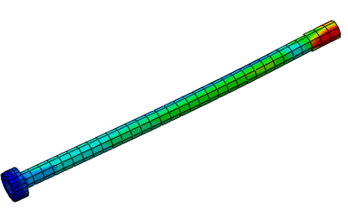
(a) 0 mm (b) 2 mm (c) 4 mm
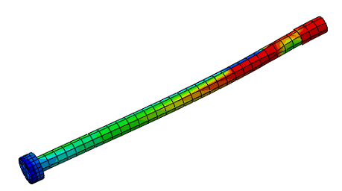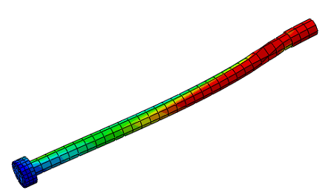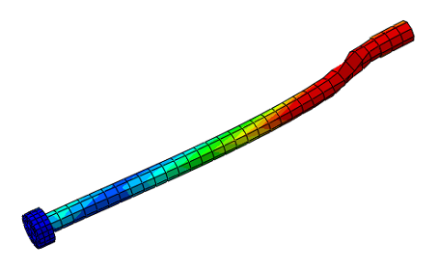
(d) 6 mm (e) 8 mm (f) 12 mm

Figure 10 Mises Stress contours of the bolt model at different displacements (the distortion is five times magnified)

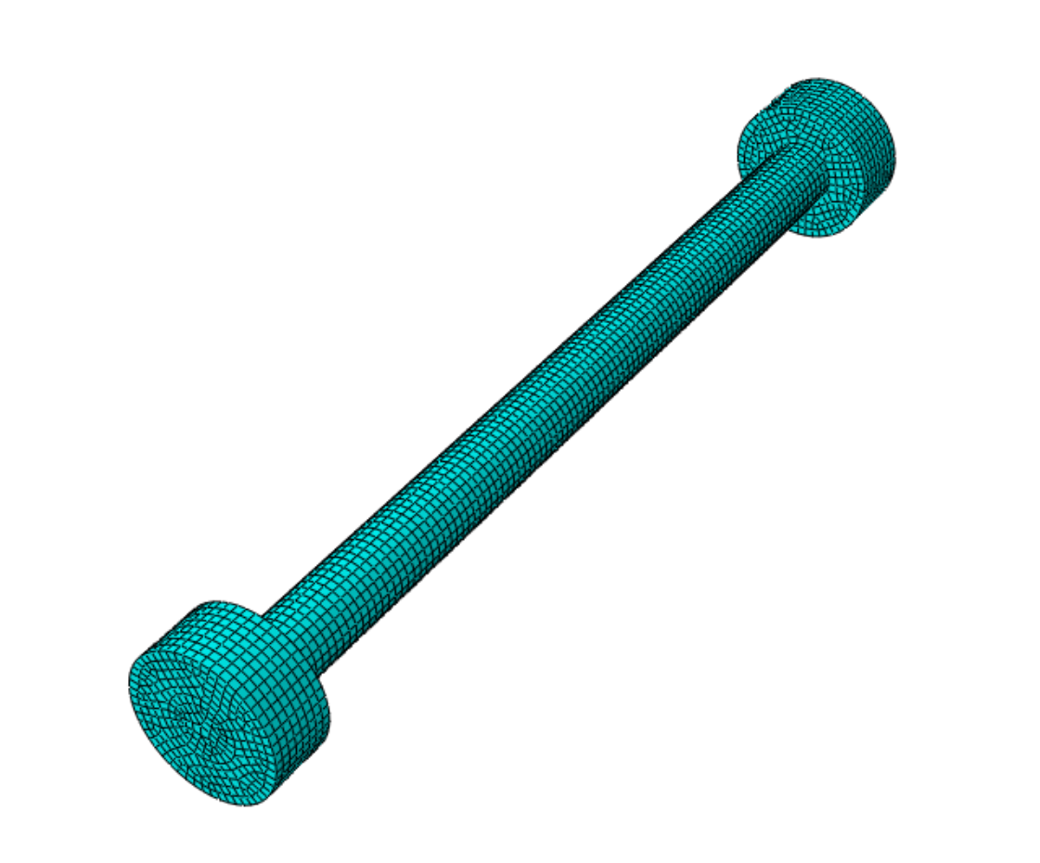
(a)
(b)
(c)
30

30

Figure 11 Bolt model (a) continuum element bolt model (b) single spring model (c) nine-spring model

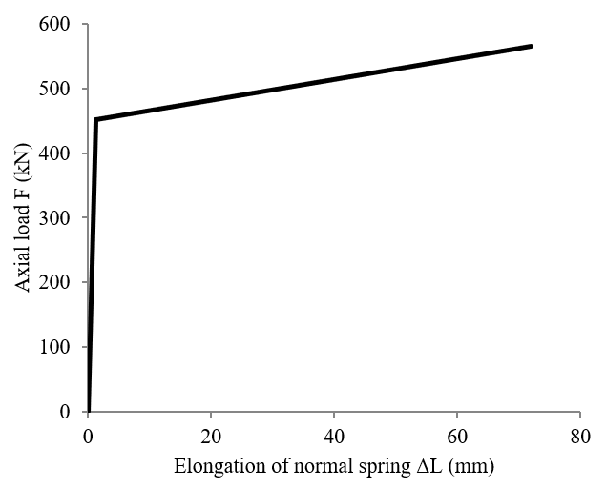
- Normal spring for bending behaviour
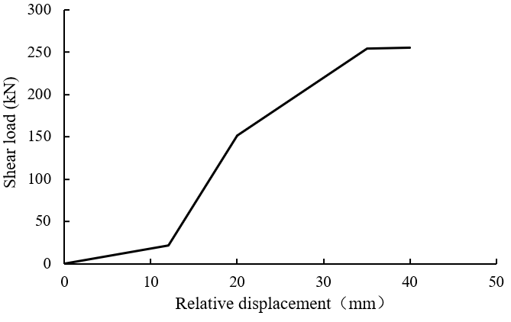
- Shear spring for shear behaviour

Figure 12 load-displacement relationship for bolt-spring model

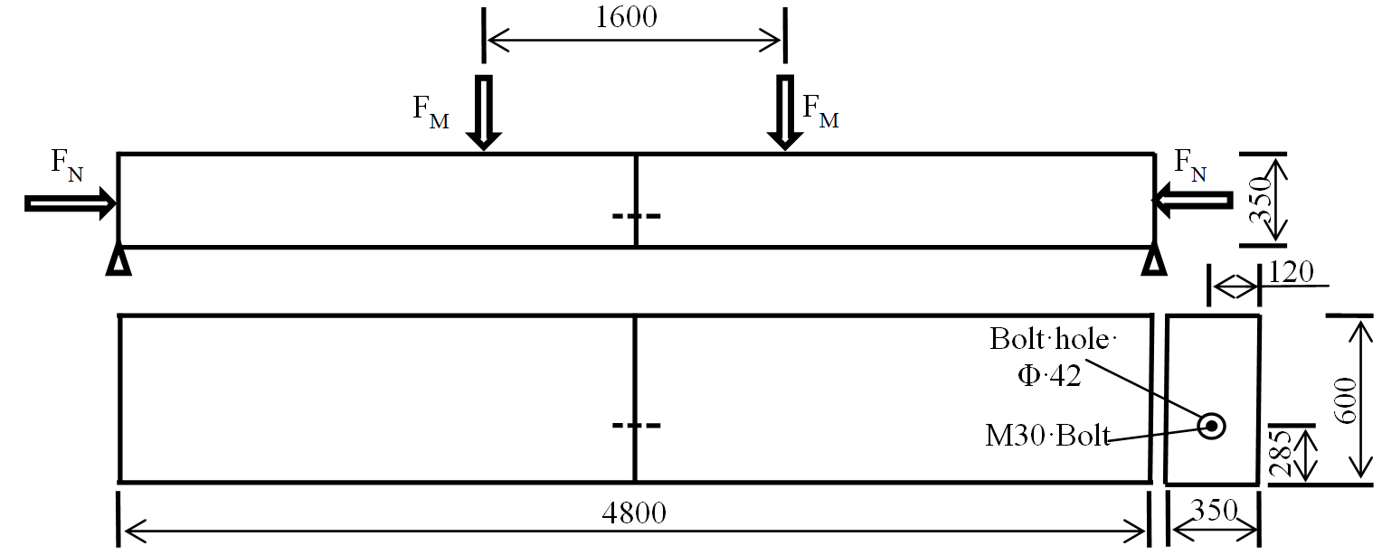
- Schematic of joint model for bending behaviour
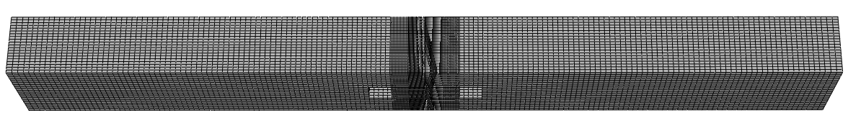
- Mesh of 3D finite element model

Figure 13 3D finite element analysis for rotational bolt-spring model

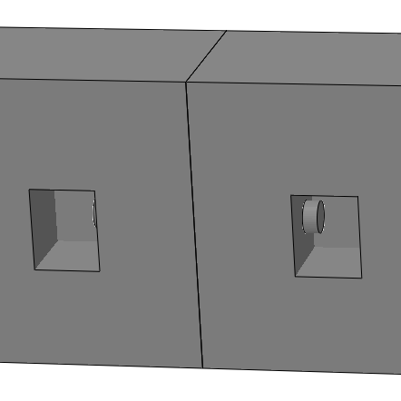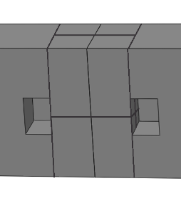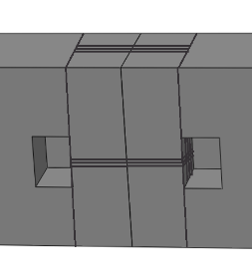
(b)
(c)
(a)

Figure 14 3D finite element models for longitudinal joint (a) continuum element bolt model (b) single spring model (c) nine springs-group spring model

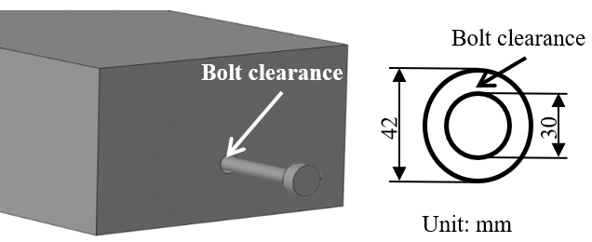

Figure 15 Clearance between bolt and wall of bolt hole

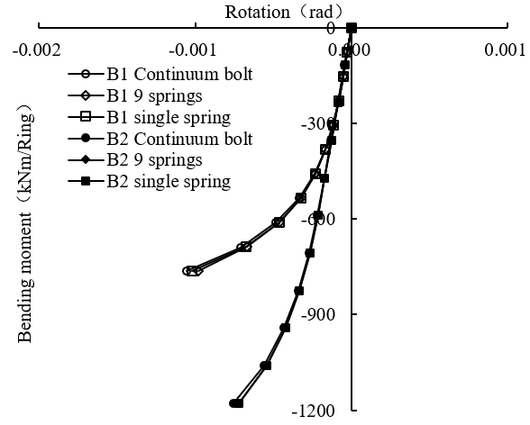
- Negative bending moment
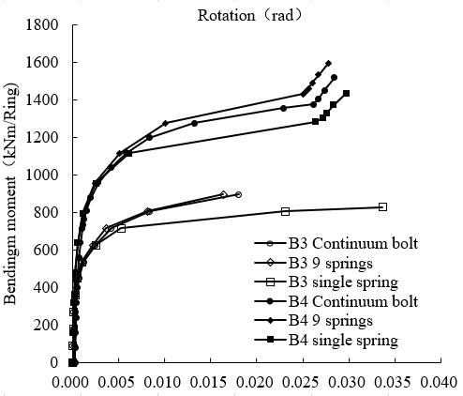
- Positive bending moment

Figure 16 Comparison between continuum model and bolt-spring model under bending moment

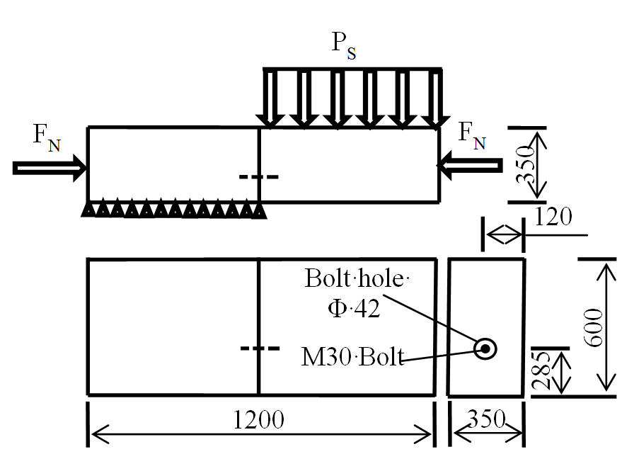
- Schematic of joint model for shear behaviour

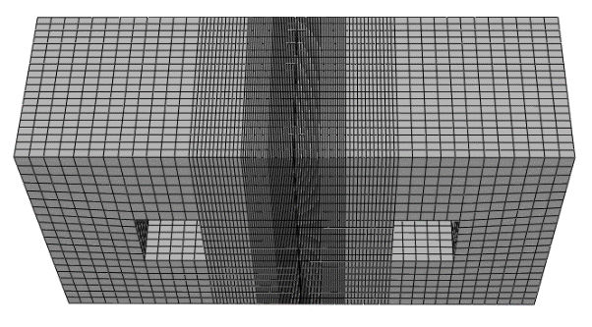
- Mesh of 3D finite element model

Figure 17 3D finite element analysis for shear bolt-spring model

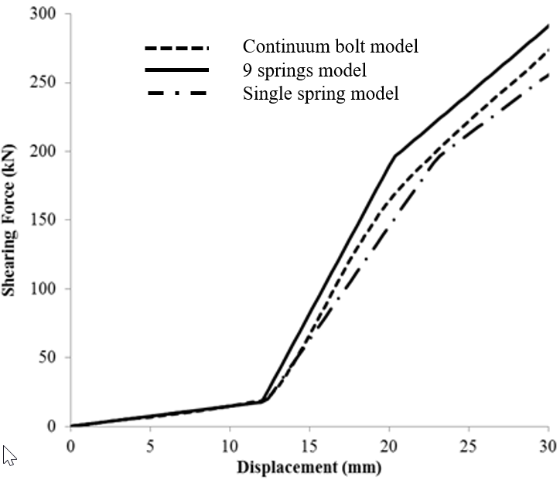

Figure 18 Comparison of shear behaviour of single spring model and nine springs model against that of the continuum bolt model

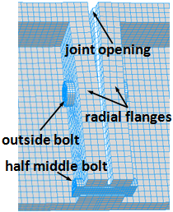

(a) Distortion of cast-iron segments at the joint 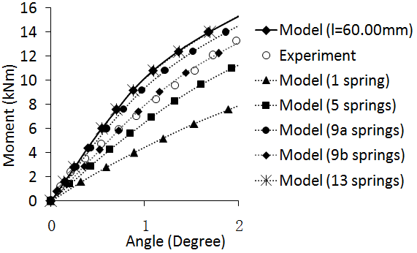
(b) Moment-rotation curves of the segmental joint

Figure 19 bending behaviour of a cast-iron segmental joint (Li et al. 2014)

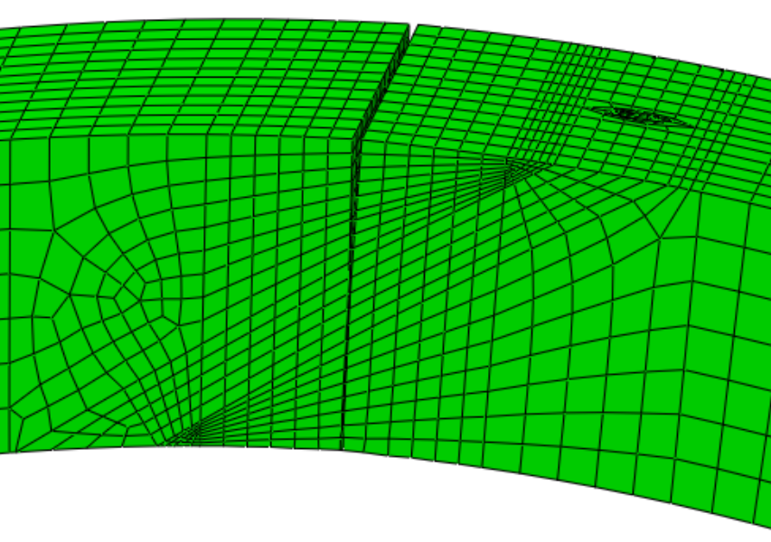
(a) Oblique view of a concrete joint under negative bending
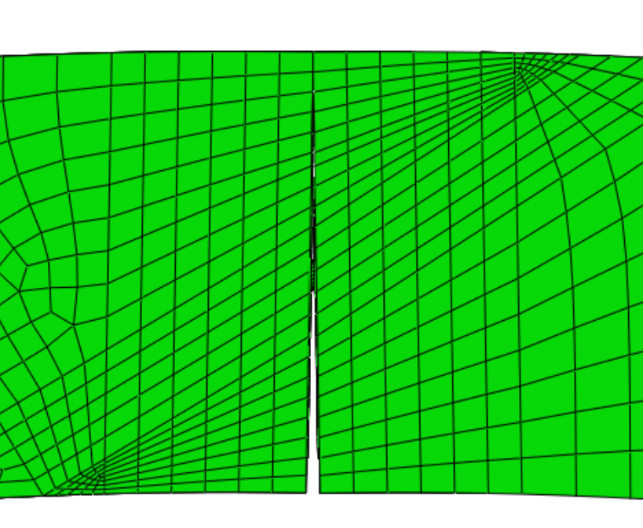
(b) Side view of a concrete joint under positive bending
Figure 20 Bending behaviour of a concrete segmental joint

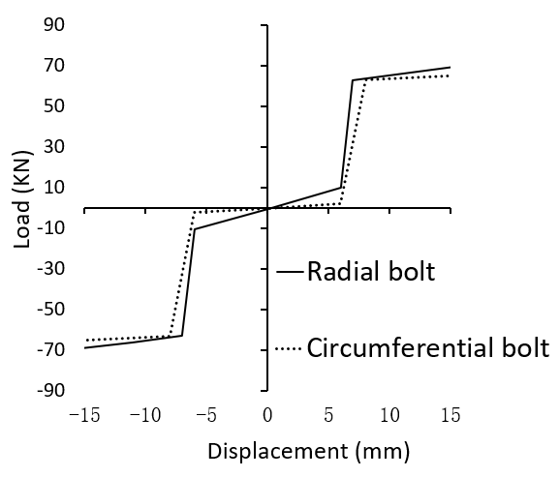

Figure 21 shear behaviour of a cast-iron segmental joint (Li et al. 2014)

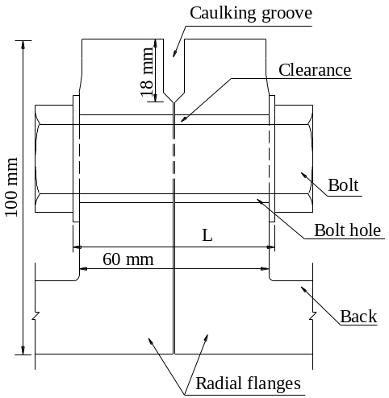

(a) Drawing of a typical cast-iron joint in London Underground
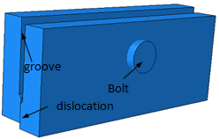

(b) Dislocation at a cast-iron joint
Figure 22 Structural features of a cast-iron joint

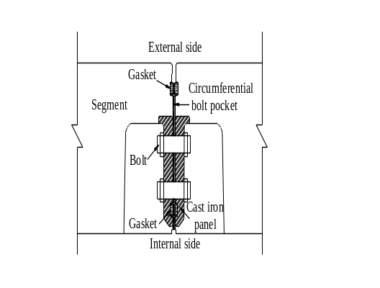
- Drawing of a concrete joint in a water-conveyance tunnel (Jin et al.)

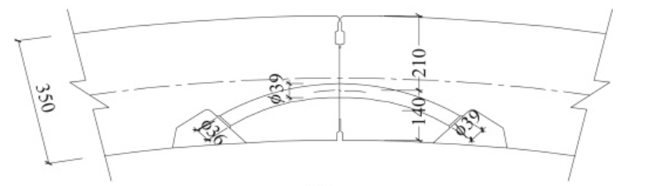
- Drawing of a concrete joint with curved bolt in Fuzhou Metro Line I (Guan et al.)

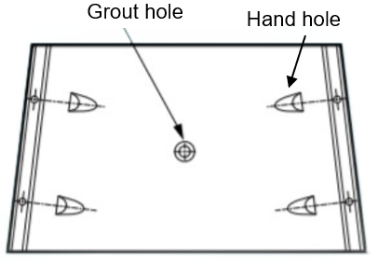
- Illustration of a trapezoidal tunnel segment (Courtesy to Buchan Concrete Solutions Ltd.)
Figure 23 Different types of concrete joints with various structural features

