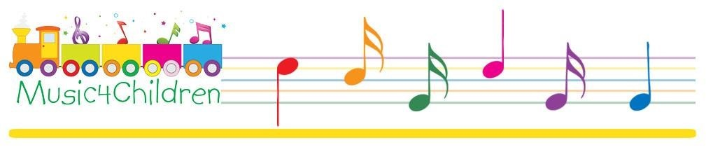

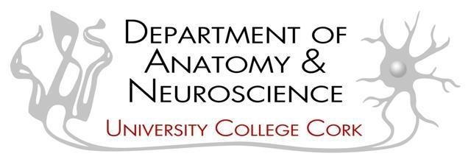
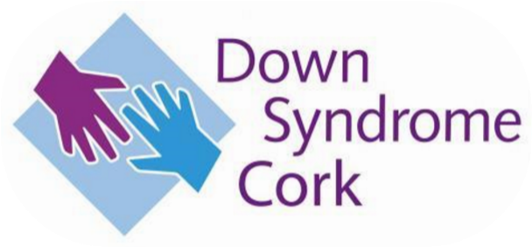

PARENT INFORMATION/CONSENT FORM FOR CHILDREN WITH DOWN SYNDROME ENGAGING WITH MUSIC

CONSENT BY SUBJECT FOR PARTICIPATION IN RESEARCH PROTOCOL

Section A

Protocol Number: ________ Participant Name: _______

Title of Protocol: Investigation of the neurological effects of musical training in
children with Down Syndrome

Investigators Directing Research:
Chief Investigator: Dr. Jason S. Chan,
Researchers: Dr Annalisa Setti,
Dr. Yvonne Nolan,
Dr. Eva McMullan-Glossop

Contact information: jason.chan@ucc.ie and e.mcmullan@ucc.ie; Tel: 021-4904530

Your child is being asked to participate in a research study that will assess how daily interaction with a specifically designed music programme will impact the neurocognitive development of children with Down Syndrome and typically developing children. In order to decide whether or not you and your child want to be a part of this research study, you should understand enough about its risks and benefits to make an informed judgment. This process is known as informed consent. This information and consent form gives detailed information about the research study, which will be discussed with you. Once you understand the study, you will be asked to sign this form if you wish your child to participate.

Section B

I. WHAT YOU AND YOUR CHILD WILL BE ASKED TO DO?

The aims of this project are to understand the behavioural, neural, and hormonal correlates associated with musical training and to establish whether it can be used as a possible intervention for children with Down Syndrome. While Down Syndrome is an incurable genetic disorder, early behavioural intervention can significantly improve independence in later life, we aim to understand whether Musical training constitute a potential way to obtain improvement in the short term, i.e. by the end of the training.

If you agree for your child to participate in the study, he/she will be required to engage with a music programme for eight weeks. This will include watching a video at home on daily basis and engaging with a weekly 45-minute music class online. This music programme will introduce the children to the fundamentals of music and will include sequential songs, rhythm and melody games and learning about musical instruments. This will involve the use of voice, movement, and simple musical tools. You will be sent a music bag in advance of the study.

You and Your child will also be required to engage with various tests, in two separate online testing sessions. The initial test will allow the investigators to mentally age match the children by using the Peabody Picture Vocabulary Test. This is an assessment tool for mental age widely used by clinicians and researchers; the test requires to match words to pictures and cover our selected age range. It takes approximately half an hour online.

The additional testing will include playing online computer games designed to evaluate cognition. Saliva testing will also be carried out and will include collecting saliva samples at home. In addition, hair samples will be collected at the first and final study visit. Both of these samples will be collected by the researcher at the start of the study and at the conclusion of the study to help assess the effectiveness of the music intervention. An information evening will be held on Microsoft Teams in advance of the study to show you how to collect the hair and saliva samples.

Parents will collect the saliva samples from their child at home. To do this you will be given 8 salivettes, 4 to be used at the start of the study and 4 to be used at the end of the study. These salivettes are plastic containers containing a swab. These have been age-appropriately designed for ease of collection from children. Samples will be collected immediately on waking, and then again at 15, 30 and 45 minutes after waking on one morning just before the start of the study and again one day at the end of the study. Levels of the hormones cortisol and oxytocin will be analysed in the laboratory from the saliva samples. The saliva sample must be stored at 4°C until collected by the researcher. Because cortisol accumulates in hair over time, we will also collect hair samples at the beginning and at the end of the study (a very small sample). A hair sample will be collected by you the parent using scissors as close to the scalp as possible at the first and last study visit. The sample will be wrapped in tin foil and stored at -20°C until collected by the researcher and cortisol concentration is measured in the lab.

You will be required to fill out two online questionnaires before the commencement of the study to establish basic details prior to the study. One questionnaire is entitled ‘Why Choose Music?’ that helps to establish details of your child’s prior engagement with music, if any and basic demographic information. The second questionnaire is the ‘Paediatric Quality of Life Inventory’ in which you are invited to answer questions to measure health-related quality of life. This will be filled out at the start and the concluding point of the study to check for any change after the 8 weeks. In addition, you will be required to keep a reflective diary throughout the 8 weeks of musical training.

II. WHAT ARE THE POTENTIAL RISKS AND BENEFITS?

There is no risk of harm to children: the equipment used, and the tests are non-harmful and have been traditionally used with various healthy and pathological groups in the literature; precaution will be taken to ensure that children are not excessively fatigued and distressed because of the length of the tests. All precautions have been taken to minimise risk. There will be the opportunity for breaks about every 5-7 minutes during the tests, but the testing can be paused at any point to ensure the comfort and well-being of the contributor. In terms of musical training, there is no risk of harm, the training has been delivered to children with and without disability in Cork and implies the use of voice, movement, and simple harmless musical tools.

The main benefit of this research will hopefully allow us to refine music training programmes that will impact positively on children with Down Syndrome or those that have other forms of cognitive impairments.

III. FURTHER DETAILS

Participation is voluntary. If you and your child decide to take part in the study and then change your mind, you and your child can withdraw from the study at any point, and all their data will be permanently deleted. Behavioural, EEG and saliva/hair testing are independent components of the study; therefore, should one of them be distressing for a child, it can be dismissed. You and your child may also decide not to take part in this study; this will not affect your ability to take part in the classes.

The tests will be carried out by Dr. Eva McMullan, Dr. Jason S. Chan, Dr. Annalisa Setti, and Dr. Yvonne Nolan. Eva has completed a first aid course and a child protection course, and all investigators have obtained Garda Clearance. All information collected will not be associated with your child’s name. When the results are published, it will be impossible to identify individual participants. All data will be securely stored on a password-protected computer, and any information about participant’s identities will be removed. The results will be presented in an MSc thesis prepared by Dr. McMullan. They will be seen by the supervisors (named above), an internal examiner and an external examiner in accordance with university regulations. The study may be read by future students and may be published in an academic journal. The data collected will remain on record for a period of at least 10 years. Only the investigators in this research project will have access to this material during this time. They are Dr. Jason S. Chan, Dr. Yvonne Nolan, Dr. Annalisa Setti and Dr. Eva McMullan-Glossop.

Section C AGREEMENT TO CONSENT

The research project and the treatment procedures associated with it have been fully explained to me. All experimental procedures have been identified and no guarantee has been given about the possible results. I have had the opportunity to ask questions concerning any and all aspects of the project and any procedures involved. I am aware that participation is voluntary and that I may withdraw my consent for my child to participate at any time. I am aware that my decision not to participate or to withdraw will not restrict my child's access to music training normally available to me. Confidentiality of records concerning my involvement in this project will be maintained in an appropriate manner.

I understand that the investigators have such insurance as is required by law in the event of injury resulting from this research.

I, the undersigned, hereby consent my child to participate as a subject in the above-described project conducted at the School of Applied Psychology, Department of Music, and Department of Anatomy and Neuroscience.

I have received a copy of this consent form for my records. I understand that if I have any questions concerning this research, I can contact the researchers listed above. If I have further queries concerning my rights in connection with the research, I can contact the Clinical Research Ethics Committee of the Cork Teaching Hospitals, Lancaster Hall, 6 Little Hanover Street, Cork.

After reading the entire consent form, if you have no further questions about giving consent, please sign where indicated.

Investigator:

Name of Child

Name of Parent/Guardian:

- I consent for my child to begin the study
- I do not consent; I do not wish my child to participate in the study

Please select the date
 | Month | Day | Year
Please Select: | ▼ January (1 ... December (12) | ▼ 1 (1 ... 31 (31) | ▼ 1900 (1 ... 2049)



DATA PROTECTION NOTICE

Title of Protocol: Investigation of the neurological effects of musical training in
children with Down Syndrome

At University College Cork, we treat your privacy seriously. Any personal data which you provide to the University will be treated with the highest standards of security and confidentiality in accordance with Irish and European Data Protection legislation. This notice sets out details of the information that we collect, how we process it and who we share it with. It also explains your rights under data protection law in relation to our processing of your data.

Who we are
Throughout this Notice, “we”, “us”, and “our” refer to University College Cork as the study sponsor. For more information about us, please refer to our website: www.ucc.ie

How we will use your personal data
By participating in the study, information about your child (also called “personal data”) will be collected for the study purposes mentioned in the Patient information leaflet. This personal data includes, for example:

- information that directly identifies your child (such as their name and year of birth).
- their gender, ethnic and racial background.
- information on their health, medical condition, and quality of life.
- information on their previous music education.
- information on their cognitive pre-tests and post-tests, including the Peabody Vocabulary Test.
- information contained in their hair and saliva samples and the results after analysis.

Personal data collected at any time during the study will be kept strictly confidential. To ensure confidentiality, the data generated during the study is coded with a number that will identify you in the study. Any information that leaves the clinical site will be labelled with your code instead of your name. Every person who has access to your uncoded data (that is kept at the School of Applied Psychology, University College Cork) is subject to professional secrecy and confidentiality.

Data that directly identifies you (uncoded data) is stored in your medical files at the clinical site in which the data have been obtained. The ‘key’ that connects the subject name and subject ID should be kept in a separate location to the data; securely (locked cupboard in a room with restricted access) by the investigator. All files which contain personally identifiable information (e.g., keys) should undergo an additional layer of encryption such as Microsoft

Azure Information Protection.
Unencrypted personal devices (laptops or phones) should not be used to acquire data.

Who will access my personal data?
Your uncoded data will only be accessible to the study investigator and staff. The study's results will be provided to the Clinical Research Ethics Committee of the Cork Teaching Hospitals (CREC) in compliance with national and international regulations on clinical studies.

The purpose and legal basis for collecting your data.
Any personal data you provide to us during the course of this study will be processed fairly and lawfully.

Signing the Informed Consent Form means that your personal data will be used for the purposes outlined in the Patient information leaflet (PIL).

Personal data collected during this study and the results of the study may be presented for scientific purposes. However, you will never be identified individually during these presentations. Your identity will not be revealed in any reports or publications.

The clinical site and the investigator will use your personal data within the scope defined above.

The General Data Protection Regulation allows us to process your data because you have provided your consent. You are entitled to withdraw your consent at any time.

How long we will keep your data.
The personal data collected in the study will be kept for a period of 10 years after the end of the study. However, your anonymised data will be held in accordance with FAIR data principles and may be stored indefinitely in an open data repository.

Your rights
You have various rights under data protection law, subject to certain exemptions, in connection with our processing of your personal data, including the right:

- to find out if we use your personal data, access your personal data, and receive copies of your personal data.
- to have inaccurate/incomplete information corrected and updated.
- in certain circumstances, to have your details deleted from systems that we use to process your personal data or have the use of your personal data restricted in certain ways.
- to object to certain processing of your data by UCC.
- to exercise your right to data portability where applicable (i.e. obtain a copy of your personal data in a commonly used electronic form.
- to withdraw your consent to the processing of your data up to 30 days of participation without giving a reason by notifying your decision to the investigator. This will not affect the lawfulness of processing data about you based on your consent before the withdrawal. If you withdraw your consent for data processing, your participation in the study stops and no further data will be collected from you. Your study physician will present you the options you have concerning your personal data.
- along with study withdrawal, you have the right to request the deletion of data about you, up to 30 days of participation, if your data are no longer necessary for the purposes of processing or there is no other legal ground for their further processing.
- after 30 days of participation, the link between your personal identity and your data will be destroyed, and we will no longer be able to identify you from the rest of the dataset. Thus, it will not be possible to withdraw your data.

If you wish to exercise any of these rights, please address your request to the study coordinator or the Information Compliance Manager University College Cork (details below).

Questions or Complaints
If you have any queries in relation to this study, please contact Dr. Eva McMullan at e.mcmullan@ucc.ie.
If you have any complaints in connection with our processing of your personal data, you can contact UCC’s Information Compliance Manager: Information Compliance Manager, Office of Corporate & Legal Affairs, University College Cork, Western Road, Cork E: foi@ucc.ie Tel: +353 21 4903949

You also have the right to lodge a complaint with the Data Protection Commission if you are unhappy with our processing of your personal data. Details of how to lodge a complaint can be found on the Data Protection Commission’s website www.dataprotection.ie) or by telephoning 1890 252 231.

Name of Parent/Guardian ____________________________________

Date ________________________

Name of Informant ___________________________________

Date ________________________

In submitting this form, you understand and agree that your personal details will be used by the School of Applied Psychology for the purposes outlined above.


PARENT INFORMATION/CONSENT FORM FOR CHILDREN WITH DOWN SYNDROME NOT ENGAGING WITH MUSIC

CONSENT BY SUBJECT FOR PARTICIPATION IN RESEARCH PROTOCOL

Section A

Protocol Number: _________ Participant Name: _______

Title of Protocol: Investigation of the neurological effects of musical training in
children with Down Syndrome

Investigators Directing Research:
Chief Investigator: Dr. Jason S. Chan,
Researchers: Dr Annalisa Setti,
Dr. Yvonne Nolan,
Dr. Eva McMullan-Glossop

Contact information: jason.chan@ucc.ie and e.mcmullan@ucc.ie; Tel: 021-4904530

Your child is being asked to participate in a research study that will assess how daily interaction with a specifically designed music programme will impact on the neurocognitive development of children with Down Syndrome and typically developing children. In order to decide whether or not you want to be a part of this research study, you should understand enough about its risks and benefits to make an informed judgment. This process is known as informed consent. This information and consent form gives detailed information about the research study, which will be discussed with you. Once you understand the study, you will be asked to sign this form if you wish your child to participate.

Section B

I. WHAT YOU AND YOUR CHILD WILL BE ASKED TO DO?

If you agree that your child will participate in the study, he/she will be required to engage with various tests in two separate online testing sessions. The initial test will allow the investigators to mentally age-match the children using the Peabody Picture Vocabulary Test. This is an assessment tool for mental age widely used by clinicians and researchers; the test requires to match words to pictures and cover our selected age range. It takes approximately half an hour online. The additional testing will include computer games.

Saliva testing will also be carried out and will include collecting saliva samples at home. In addition, hair samples will be collected before the study begins. Both of these samples will be collected by the researcher at the start of the study and at the conclusion of the study. All tests will be carried at the commencement of the study and once again after an eight-week period. An information evening will be held on Microsoft Teams in advance of the study to show you how to collect the hair and saliva samples. There is nothing your child needs to do between these testing sessions.

Parents will collect the saliva samples from their child at home. To do this, you will be given 8 salivettes, 4 to be used at the start of the study and 4 to be used at the end of the study. These salivettes are plastic containers containing a swab. These have been age-appropriately designed for ease of collection from children. Samples will be collected immediately on waking and then again at 15, 30 and 45 minutes after waking on one morning just before the start of the study and again one day at the end of the study. Levels of the hormones cortisol and oxytocin will be analysed in the laboratory from the saliva samples. The saliva sample must be stored at 4°C until collected by the researcher. Because cortisol accumulates in hair over time, we will also collect hair samples at the beginning and at the end of the study (a very small sample). A hair sample will be collected by you the parent using scissors as close to the scalp as possible at the first and last study visit. The sample will be wrapped in tin foil and stored at -20°C until collected by the researcher and cortisol concentration is measured in the lab.

You will be required to fill out two online questionnaires before the commencement of the study to establish basic details prior to the study. One questionnaire is entitled ‘Why Choose Music?’ that helps to establish details of your child’s prior engagement with music, if any and basic demographic information. In the second questionnaire, the ‘Paediatric Quality of Life Inventory, you are invited to answer questions to measure health-related quality of life prior to the study. You will be again invited to answer the ‘Paediatric Quality of Life Inventory’ after an eight-week period.

II. WHAT ARE THE POTENTIAL RISKS AND BENEFITS?

There is no risk of harm for children: the equipment used and the tests are non-harmful and have been traditionally used with various healthy and pathological groups in the literature; precaution will be taken to ensure that children are not excessively fatigued and distressed as a consequence of the length of the tests. All precautions have been taken to minimise risk. There will be the opportunity for breaks about every 5-7 minutes during the tests, but the testing can be paused at any point to ensure the comfort and well-being of the contributor.
The main benefit of this research will hopefully allow us to refine music training programmes that will positively impact children with Down Syndrome or those with other forms of cognitive impairment.

III. FURTHER DETAILS

Participation is voluntary. If you and your child decide to take part in the study and then change your mind, you and your child can withdraw from the study at any point, and all their data will be permanently deleted. Behavioural, EEG and saliva/hair testing are independent components of the study; therefore, should one of them be distressing for a child, it can be dismissed. You and your child may also decide not to take part in this study, this will not affect your ability to take part in the classes.

The tests will be carried out by Dr. Eva McMullan, Dr. Jason S. Chan, Dr. Annalisa Setti, and Dr. Yvonne Nolan. Eva has completed a first aid course and a child protection course, and all investigators have obtained Garda Clearance. All information collected will not be associated with your child’s name. When the results are published, it will be impossible to identify individual participants. All data will be securely stored on a password-protected computer, and any information about participant’s identities will be removed. The results will be presented in an MSc thesis prepared by Dr. Eva McMullan. They will be seen by the supervisors (named above), an internal examiner and an external examiner in accordance with University Regulations. The study may be read by future students studying this course and may be published in an academic journal. The data collected will remain on record for a period of at least 10 years. Only the investigators in this research project will have access to this material during this time. They are Dr. Jason S. Chan, Dr. Yvonne Nolan, Dr. Annalisa Setti, and Dr. Eva McMullan-Glossop.

Section C AGREEMENT TO CONSENT

The research project and the treatment procedures associated with it have been fully explained to me. All experimental procedures have been identified and no guarantee has been given about the possible results. I have had the opportunity to ask questions concerning any and all aspects of the project and any procedures involved. I am aware that participation is voluntary and that I may withdraw my consent for my child to participate at any time. I am aware that my decision not to participate or to withdraw will not restrict my child's access to musical training normally available to me. The confidentiality of my records concerning my involvement in this project will be maintained in an appropriate manner.

I understand that the investigators have insurance as required by law in the event of injury resulting from this research.

I, the undersigned, hereby consent to my child's participation as a subject in the above-described project conducted at the School of Applied Psychology, Department of Music, and Department of Anatomy and Neuroscience.

I have received a copy of this consent form for my records. I understand that if I have any questions concerning this research, I can contact the researchers listed above. If I have further queries concerning my rights in connection with the research, I can contact the Clinical Research Ethics Committee of the Cork Teaching Hospitals, Lancaster Hall, 6 Little Hanover Street, Cork.

After reading the entire consent form, if you have no further questions about giving consent, please sign where indicated.

Investigator:

Name of Child:

Signature of Parent/Guardian:

- I consent for my child to begin the study
- I do not consent; I do not wish my child to participate in the study

Please select the date
 | Month | Day | Year
Please Select: | ▼ January (1 ... December (12) | ▼ 1 (1 ... 31 (31) | ▼ 1900 (1 ... 2049)

DATA PROTECTION NOTICE

Title of Protocol: Investigation of the neurological effects of musical training in
children with Down Syndrome

At University College Cork, we treat your privacy seriously. Any personal data which you provide to the University will be treated with the highest standards of security and confidentiality in accordance with Irish and European Data Protection legislation. This notice sets out details of the information that we collect, how we process it and who we share it with. It also explains your rights under data protection law in relation to our processing of your data.

Who we are.
Throughout this Notice, “we”, “us” and “our” refers to University College Cork, as study sponsor. For more information about us, please refer to our website: www.ucc.ie

How we will use your personal data
By participating in the study, information about your child (also called “personal data”) will be collected for the study purposes mentioned in the Patient information leaflet. This personal data includes, for example:

- information that directly identifies your child (such as their name and their year of birth).
- their gender, ethnic and racial background.
- information on their health, medical condition, and quality of life.
- information on their previous music education.
- information on their cognitive pre-tests and post-tests, including the Peabody Vocabulary Test.
- information contained in their hair and saliva samples and the results after analysis.

Personal data collected at any time during the study will be kept strictly confidential. To ensure confidentiality, the data generated during the study is coded with a number that will identify you in the study. Any information that leaves the clinical site will be labelled with your code instead of your name. Every person that has access to your uncoded data (that is kept at the School of Applied Psychology, University College Cork) is subject to professional secrecy and confidentiality.

Data that directly identifies you (uncoded data) is stored in your medical files at the clinical site in which the data have been obtained. The ‘key’ that connects the subject name and subject ID should be kept in a separate location to the data; securely (locked cupboard in a room with restricted access) by the investigator. All files which contain personally identifiable information (e.g., keys) should undergo an additional layer of encryption such as Microsoft Azure Information Protection

Unencrypted personal devices (laptop or phone) should not be used to acquire data.

Who will access my personal data?
Your uncoded data will only be accessible to the study investigator and study staff. Results of the study will be provided to the Clinical Research Ethics Committee of the Cork Teaching Hospitals (CREC) in compliance with national and international regulations on clinical studies.

The purpose and legal basis for collecting your data.
Any personal data you provide to us during the course of this study will be processed fairly and lawfully.

Signing the Informed Consent Form means that your personal data will be used for the purposes outlined in the Patient information leaflet (PIL).

Personal data collected during this study and the results of the study may be presented for scientific purposes. However, you will never be identified individually during these presentations. Your identity will not be revealed in any reports or publications.

The clinical site and the investigator will use your personal data within the scope defined above.

The General Data Protection Regulation allows us to process your data because you have provided your consent. You are entitled to withdraw your consent at any time.

How long we will keep your data.
The personal data collected in the study will be kept for 10 years after the end of the study. However, your anonymised data will be held in accordance with FAIR data principles and may be stored indefinitely in an open data repository.

Your rights
You have various rights under data protection law, subject to certain exemptions, in connection with our processing of your personal data, including the right:

- to find out if we use your personal data, access your personal data, and receive copies of it.
- to have inaccurate/incomplete information corrected and updated.
- in certain circumstances, to have your details deleted from systems that we use to process your personal data or have the use of your personal data restricted in certain ways.
- to object to certain processing of your data by UCC.
- to exercise your right to data portability where applicable (i.e. obtain a copy of your personal data in a commonly used electronic form.
- to withdraw your consent to the processing of your data up to 30 days of participation without giving a reason by notifying your decision to the investigator. This will not affect the lawfulness of processing data about you based on your consent before the withdrawal. If you withdraw your consent for data processing, your participation in the study stops and no further data will be collected from you. Your study physician will present you the options you have concerning your personal data.
- along with study withdrawal, you have the right to request the deletion of data about you, up to 30 days of participation, if your data are no longer necessary for the purposes of processing or there is no other legal ground for their further processing.
- after 30 days of participation, the link between your personal identity and your data will be destroyed, and we will no longer be able to identify you from the rest of the dataset. Thus, it will not be possible to withdraw your data.

If you wish to exercise any of these rights, please address your request to the study coordinator or the Information Compliance Manager University College Cork (details below).

Questions or Complaints
If you have any queries in relation to this study, please contact Dr. Eva McMullan e.mcmullan@ucc.ie.
If you have any complaints in connection with our processing of your personal data, you can contact UCC’s Information Compliance Manager: Information Compliance Manager, Office of Corporate & Legal Affairs, University College Cork, Western Road, Cork E: foi@ucc.ie Tel: +353 21 4903949
If you are unhappy with our processing of your personal data, you have the right to lodge a complaint with the Data Protection Commission. Details of how to lodge a complaint can be found on the Data Protection Commission’s website (HYPERLINK "http://www.dataprotection.ie") or by telephoning 1890 252 231.
Name of Parent/Guardian ____________________________________

Date ________________________

Name of Informant ___________________________________

Date ________________________

In submitting this form, you understand and agree that your personal details will be used by the School of Applied Psychology for the purposes outlined above.

PARENT INFORMATION/CONSENT FORM FOR TYPICALLY DEVELOPING CHILDREN ENGAGING WITH MUSIC

CONSENT BY SUBJECT FOR PARTICIPATION IN RESEARCH PROTOCOL

Section A

Protocol Number: ________ Participant Name:

Title of Protocol: Investigation of the neurological effects of musical training in
children with Down Syndrome

Investigators Directing Research:
Chief Investigator: Dr. Jason S. Chan,
Researchers: Dr Annalisa Setti,
Dr. Yvonne Nolan,
Dr. Eva McMullan-Glossop

Contact information: jason.chan@ucc.ie and e.mcmullan@ucc.ie; Tel: 021-4904530

Your child is being asked to participate in a research study that will assess how daily interaction with a specifically designed music programme will impact the neurocognitive development of children with Down Syndrome and typically developing children. In order to decide whether or not you and your child want to be a part of this research study, you should understand enough about its risks and benefits to make an informed judgment. This process is known as informed consent. This information and consent form gives detailed information about the research study, which will be discussed with you. Once you understand the study, you will be asked to sign this form if you wish your child to participate.

Section B

I. WHAT YOU AND YOUR CHILD WILL BE ASKED TO DO?

The aims of this project are to understand the behavioural, neural, and hormonal correlates associated with musical training and to establish whether it can be used as a possible intervention for children with Down Syndrome. While Down Syndrome is an incurable genetic disorder, early behavioural intervention can significantly improve independence in later life. We aim to understand whether Musical training constitutes a potential way to obtain improvement in the short term, i.e. by the end of the training.

If you agree for your child to participate in the study, he/she will be required to engage with a music programme for eight weeks. This will include watching a video at home on daily basis and engaging with a weekly 45-minute music class online. This music programme will introduce the children to the fundamentals of music and will include sequential songs, rhythm and melody games and learning about musical instruments. This will involve the use of voice, movement, and simple musical tools. You will be sent a music bag in advance of the study.

You and your child will also be required to engage with various tests, in two separate online testing sessions. The initial test will allow the investigators to mentally age match the children by using the Peabody Picture Vocabulary Test. This is an assessment tool for mental age widely used by clinicians and researchers; the test requires to match words to pictures and cover our selected age range. It takes approximately half an hour online.

The additional testing will include playing online computer games designed to evaluate cognition. Saliva testing will also be carried out and will include collecting saliva samples at home. In addition, hair samples will be collected at the first and final study visit. Both of these samples will be collected by the researcher at the start of the study and at the conclusion of the study to help assess the effectiveness of the music intervention. An information evening will be held on Microsoft Teams in advance of the study to show you how to collect the hair and saliva samples.

Parents will collect the saliva samples from their child at home. To do this you will be given 8 salivettes, 4 to be used at the start of the study and 4 to be used at the end of the study. These salivettes are plastic containers containing a swab. These have been age-appropriately designed for ease of collection from children. Samples will be collected immediately on waking, and then again at 15, 30 and 45 minutes after waking on one morning just before the start of the study and again one day at the end of the study. Levels of the hormones cortisol and oxytocin will be analysed in the laboratory from the saliva samples. The saliva sample must be stored at 4°C until collected by the researcher. Because cortisol accumulates in hair over time, we will also collect hair samples at the beginning and at the end of the study (a very small sample). A hair sample will be collected by you the parent using scissors as close to the scalp as possible at the first and last study visit. The sample will be wrapped in tin foil and stored at -20°C until collected by the researcher and cortisol concentration is measured in the lab.

You will be required to fill out two online questionnaires before the commencement of the study to establish basic details prior to the study. One questionnaire is entitled ‘Why Choose Music?’ that helps to establish details of your child’s prior engagement with music, if any and basic demographic information. The second questionnaire is the ‘Paediatric Quality of Life Inventory’ in which you are invited to answer questions to measure health-related quality of life. This will be filled out at the start and the concluding point of the study to check for any change after the 8 weeks. In addition, you will be required to keep a reflective diary throughout the 8 weeks of musical training.

II. WHAT ARE THE POTENTIAL RISKS AND BENEFITS?

There is no risk of harm for children: the equipment used and the tests are non-harmful and have been traditionally used with various healthy and pathological groups in the literature; precaution will be taken to ensure that children are not excessively fatigued and distressed because of the length of the tests. All precautions have been taken to minimise risk. There will be the opportunity for breaks about every 5-7 minutes during the tests, but the testing can be paused at any point to ensure the comfort and well-being of the contributor. In terms of musical training, there is no risk of harm; the training has been delivered to children with and without disability in Cork and implies the use of voice, movement, and simple harmless musical tools.

The main benefit of this research will hopefully allow us to refine music training programmes that will impact positively on children with Down Syndrome or those that have other forms of cognitive impairments.

III. FURTHER DETAILS

Participation in voluntary. If you and your child decide to take part in the study and then change your mind, you and your child can withdraw from the study at any point and all their data will be permanently deleted. Behavioural, EEG and saliva/hair testing are independent components of the study, therefore, should one of them be distressing for a child, it can be dismissed. You and your child may also decide not to take part in this study, this will not affect your ability to take part in the classes.
The tests will be carried out by Dr. Eva McMullan, Dr. Jason S. Chan, Dr. Annalisa Setti, and Dr. Yvonne Nolan. Eva has completed a first aid course and a child protection course, and all investigators have obtained Garda Clearance. All information collected will not be associated with your child’s name. When the results are published, it will be impossible to identify individual participants. All data will be securely stored on a password-protected computer, and any information about participant’s identities will be removed. The results will be presented in an MSc thesis prepared by Dr. McMullan. They will be seen by the supervisors (named above), an internal examiner and an external examiner in accordance with university regulations. The study may be read by future students and may be published in an academic journal. The data collected will remain on record for a period of at least 10 years. Only the investigators in this research project will have access to this material during this time. They are Dr. Jason S. Chan, Dr. Yvonne Nolan, Dr. Annalisa Setti and Dr. Eva McMullan-Glossop.

Section C AGREEMENT TO CONSENT

The research project and the treatment procedures associated with it have been fully explained to me. All experimental procedures have been identified, and no guarantee has been given regarding the possible results. I have had the opportunity to ask questions concerning any and all aspects of the project and any procedures involved. I am aware that participation is voluntary and that I may withdraw my consent for my child to participate at any time. I am aware that my decision not to participate or to withdraw will not restrict my child's access to music training normally available to me. The confidentiality of my records concerning my involvement in this project will be maintained in an appropriate manner.

I understand that the investigators have insurance as required by law in the event of injury resulting from this research.

I, the undersigned, hereby consent to my child's participation as a subject in the above-described project conducted at the School of Applied Psychology, Department of Music, and Department of Anatomy and Neuroscience.

I have received a copy of this consent form for my records. I understand that if I have any questions concerning this research, I can contact the researchers listed above. If I have further queries concerning my rights in connection with the research, I can contact the Clinical Research Ethics Committee of the Cork Teaching Hospitals, Lancaster Hall, 6 Little Hanover Street, Cork.

After reading the entire consent form, if you have no further questions about giving consent, please sign where indicated.

Investigator:

Name of Child

Name of Parent/Guardian:

- I consent for my child to begin the study.
- I do not consent; I do not wish my child to participate in the study

Please select the date
 | Month | Day | Year
Please Select: | ▼ January (1 ... December (12) | ▼ 1 (1 ... 31 (31) | ▼ 1900 (1 ... 2049)

DATA PROTECTION NOTICE

Title of Protocol: Investigation of the neurological effects of musical training in
children with Down Syndrome

At University College Cork, we treat your privacy seriously. Any personal data which you provide to the University will be treated with the highest standards of security and confidentiality, in accordance with Irish and European Data Protection legislation. This notice sets out details of the information that we collect, how we process it and who we share it with. It also explains your rights under data protection law in relation to our processing of your data.

Who we are.
Throughout this Notice, “we”, “us” and “our” refers to University College Cork, as study sponsor. For more information about us, please refer to our website: www.ucc.ie

How we will use your personal data
By participating in the study, information about your child (also called “personal data”) will be collected for the study purposes mentioned in the Patient information leaflet. This personal data includes, for example:

- information that directly identifies your child (such as their name and their year of birth).
- their gender, ethnic and racial background.
- information on their health, medical condition, quality of life.
- information on their previous music education.
- information on their cognitive pre-tests and post-tests, including the Peabody Vocabulary Test.
- information contained in their hair and saliva samples and the results after analysis.

Personal data collected at any time during the study will be kept strictly confidential. To ensure confidentiality, the data generated during the study is coded with a number that will identify you in the study. Any information that leaves the clinical site will be labelled with your code instead of your name. Every person that has access to your uncoded data (that is kept at the School of Applied Psychology, University College Cork) is subject to professional secrecy and confidentiality.

Data that directly identifies you (uncoded data) is stored in your medical files at the clinical site in which the data have been obtained. The ‘key’ that connects the subject name and subject ID should be kept in a separate location to the data; securely (locked cupboard in a room with restricted access) by the investigator. All files which contain personally identifiable information (e.g., keys) should undergo an additional layer of encryption such as Microsoft Azure Information Protection

Unencrypted personal devices (laptop or phone) should not be used to acquire data.

Who will access my personal data?
Your uncoded data will only be accessible to the study investigator and study staff. Results of the study will be provided to the Clinical Research Ethics Committee of the Cork Teaching Hospitals (CREC) in compliance with national and international regulations on clinical studies.

The purpose and legal basis for collecting your data.
Any personal data you provide to us during the course of this study will be processed fairly and lawfully.

Signing the Informed Consent Form means that your personal data will be used for the purposes outlined in the Patient information leaflet (PIL).

Personal data collected during this study and the results of the study may be presented for scientific purposes. However, you will never be identified individually during these presentations. Your identity will not be revealed in any reports or publications.

The clinical site and the investigator will use your personal data within the scope defined above.

The General Data Protection Regulation allows us to process your data because you have provided your consent. You are entitled to withdraw your consent at any time.

How long we will keep your data?
The personal data collected in the study will be kept for a period of 10 years after the end of the study. However, your anonymised data will be held in accordance with FAIR data principles maybe stored indefinitely in an open data repository.

Your rights
You have various rights under data protection law, subject to certain exemptions, in connection with our processing of your personal data, including the right:

- to find out if we use your personal data, access your personal data, and receive copies of your personal data.
- to have inaccurate/incomplete information corrected and updated.
- in certain circumstances, to have your details deleted from systems that we use to process your personal data or have the use of your personal data restricted in certain ways.
- to object to certain processing of your data by UCC.
- to exercise your right to data portability where applicable (i.e. obtain a copy of your personal data in a commonly used electronic form.
- to withdraw your consent to the processing of your data up to 30 days of participation without giving a reason by notifying your decision to the investigator. This will not affect the lawfulness of processing data about you based on your consent before the withdrawal. If you withdraw your consent for data processing, your participation in the study stops and no further data will be collected from you. Your study physician will present you the options you have concerning your personal data.
- along with study withdrawal, you have the right to request the deletion of data about you, up to 30 days of participation, if your data are no longer necessary for the purposes of processing or there is no other legal ground for their further processing.
- after 30 days of participation, the link between your personal identity and your data will be destroyed, and we will no longer be able to identify you from the rest of the dataset. Thus, it will not be possible to withdraw your data.

If you wish to exercise any of these rights, please address your request to the study coordinator or the Information Compliance Manager University College Cork (details below).

Questions or Complaints

If you have any queries in relation to this study, please contact Dr. Eva McMullan at e.mcmullan@ucc.ie.

If you have any complaints in connection with our processing of your personal data, you can contact UCC’s Information Compliance Manager: Information Compliance Manager, Office of Corporate & Legal Affairs, University College Cork, Western Road, Cork E: foi@ucc.ie Tel: +353 21 4903949

You also have the right to lodge a complaint with the Data Protection Commission if you are unhappy with our processing of your personal data. Details of how to lodge a complaint can be found on the Data Protection Commission’s website (www.dataprotection.ie) or by telephoning 1890 252 231.

Name of Parent/Guardian ____________________________________

Date ________________________

Name of Informant ___________________________________

Date ________________________

In submitting this form, you understand and agree that your personal details will be used by the School of Applied Psychology for the purposes outlined above.

PARENT INFORMATION/CONSENT FORM FOR TYPICALLY DEVELOPING CHILDREN NOT ENGAGING WITH MUSIC

CONSENT BY SUBJECT FOR PARTICIPATION IN RESEARCH PROTOCOL

Section A

Protocol Number: _________ Participant Name:

Title of Protocol: Investigation of the neurological effects of musical training in children with Down Syndrome

Investigators Directing Research:
Chief Investigator: Dr. Jason S. Chan
Researchers: Dr Annalisa Setti
Dr. Yvonne Nolan
Dr. Eva McMullan-Glossop

Contact information: jason.chan@ucc.ie and e.mcmullan@ucc.ie; Tel: 021-4904530

Your child is being asked to participate in a research study that will assess how daily interaction with a specifically designed music programme will impact on the neurocognitive development of children with Down Syndrome and typically developing children. In order to decide whether or not you want to be a part of this research study, you should understand enough about its risks and benefits to make an informed judgment. This process is known as informed consent. This information and consent form gives detailed information about the research study, which will be discussed with you. Once you understand the study, you will be asked to sign this form if you wish your child to participate.

Section B

I. WHAT YOU AND YOUR CHILD WILL BE ASKED TO DO?

If you agree that your child will participate in the study, he/she will be required to engage in various tests in two separate online testing sessions. The initial test will allow the investigators to mentally age-match the children using the Peabody Picture Vocabulary Test. This is an assessment tool for mental age widely used by clinicians and researchers; the test requires us to match words to pictures and cover our selected age range. It takes approximately half an hour online. The additional testing will include computer games.

Saliva testing will also be carried out, which will include collecting saliva samples at home. In addition, hair samples will be collected before the study begins. Both of these will be collected by the researcher at the start of the study and at the conclusion of the study all tests will be carried at the commencement of the study and once again after an eight-week period. An information evening will be held on Microsoft Teams in advance of the study to show you how to collect the hair and saliva samples. There is nothing your child needs to do between these testing sessions.

Parents will collect the saliva samples from their child at home. To do this you will be given 8 salivettes, 4 to be used at the start of the study and 4 to be used at the end of the study. These salivettes are plastic containers containing a swab. These have been age-appropriately designed for ease of collection from children. Samples will be collected immediately on waking, and then again at 15, 30 and 45 minutes after waking on one morning just before the start of the study and again one day at the end of the study. Levels of the hormones cortisol and oxytocin will be analysed in the laboratory from the saliva samples. The saliva sample must be stored at 4°C until collected by the researcher. Because cortisol accumulates in hair over time, we will also collect hair samples at the beginning and at the end of the study (a very small sample). A hair sample will be collected by you the parent using scissors as close to the scalp as possible at the first and last study visit. The sample will be wrapped in tin foil and stored at -20°C until collected by the researcher and cortisol concentration is measured in the lab.

You will be required to fill out two online questionnaires before the commencement of the study to establish basic details prior to the study. One questionnaire is entitled ‘Why Choose Music?’ that helps to establish details of your child’s prior engagement with music, if any and basic demographic information. In the second questionnaire, the ‘Paediatric Quality of Life Inventory, you are invited to answer questions to measure health-related quality of life prior to the study. You will be invited to answer the ‘Paediatric Quality of Life Inventory’ again after an eight-week period.

II. WHAT ARE THE POTENTIAL RISKS AND BENEFITS?

There is no risk of harm for children: the equipment used and the tests are non-harmful and have been traditionally used with various healthy and pathological groups in the literature; precaution will be taken to ensure that children are not excessively fatigued and distressed as a consequence of the length of the tests. All precautions have been taken to minimise risk. There will be the opportunity for breaks about every 5-7 minutes during the tests, but the testing can be paused at any point to ensure the comfort and well-being of the contributor.

The main benefit of this research will hopefully allow us to refine music training programmes that will impact positively on children with Down Syndrome or those that have other forms of cognitive impairments.

III. FURTHER DETAILS

Participation in voluntary. If you and your child decide to take part in the study and then changes your mind, you and your child can withdraw from the study at any point and all their data will be permanently deleted. Behavioural, EEG and saliva/hair testing are independent components of the study, therefore should one of them be distressing for a child, it can be dismissed. You and your child may also decide not to take part in this study, this will not affect your ability to take part in the classes.
The tests will be carried out by Dr. Eva McMullan, Dr. Jason S. Chan, Dr. Annalisa Setti, and Dr. Yvonne Nolan. Eva has completed a first aid course; a child protection course and all investigators have obtained Garda Clearance. All information collected will not be associated with your child’s name. When the results are published it will be impossible to identify individual participants. All data will be securely stored on a password protected computer and any information about participant’s identities will be removed. The results will be presented in an MSc thesis prepared by Dr. Eva McMullan. They will be seen by the supervisors (named above), an internal examiner and an external examiner in accordance with University Regulations. The study may be read by future students studying this course and may be published in an academic journal. The data collected will remain on record for a period of at least 10 years. Only the investigators in this research project will have access to this material during this time. They are Dr. Jason S. Chan, Dr. Yvonne Nolan, Dr. Annalisa Setti and Dr. Eva McMullan-Glossop.

Section C AGREEMENT TO CONSENT

The research project and the treatment procedures associated with it have been fully explained to me. All experimental procedures have been identified and no guarantee has been given about the possible results. I have had the opportunity to ask questions concerning any and all aspects of the project and any procedures involved. I am aware that participation is voluntary and that I may withdraw my consent for my child to participate at any time. I am aware that my decision not to participate or to withdraw will not restrict my child's access to musical training normally available to me. Confidentiality of records concerning my involvement in this project will be maintained in an appropriate manner.

I understand that the investigators have such insurance as is required by law in the event of injury resulting from this research.

I, the undersigned, hereby consent my child to participate as a subject in the above-described project conducted at the School of Applied Psychology, Department of Music and Department of Anatomy and Neuroscience.

I have received a copy of this consent form for my records. I understand that if I have any questions concerning this research, I can contact the researchers listed above. If I have further queries concerning my rights in connection with the research, I can contact the Clinical Research Ethics Committee of the Cork Teaching Hospitals, Lancaster Hall, 6 Little Hanover Street, Cork.

After reading the entire consent form, if you have no further questions about giving consent, please sign where indicated.

Investigator:

Name of Child:

Signature of Parent/Guardian:

- I consent for my child to begin the study
- I do not consent; I do not wish my child to participate in the study

Please select the date
 | Month | Day | Year
Please Select: | ▼ January (1 ... December (12) | ▼ 1 (1 ... 31 (31) | ▼ 1900 (1 ... 2049)

DATA PROTECTION NOTICE

Title of Protocol: Investigation of the neurological effects of musical training in
children with Down Syndrome

At University College Cork, we treat your privacy seriously. Any personal data which you provide to the University will be treated with the highest standards of security and confidentiality, in accordance with Irish and European Data Protection legislation. This notice sets out details of the information that we collect, how we process it and who we share it with. It also explains your rights under data protection law in relation to our processing of your data.

Who we are.
Throughout this Notice, “we”, “us” and “our” refers to University College Cork, as study sponsor. For more information about us, please refer to our website: www.ucc.ie

How we will use your personal data
By participating in the study, information about your child (also called “personal data”) will be collected for the study purposes mentioned in the Patient information leaflet. This personal data includes, for example:

- information that directly identifies your child (such as their name and their year of birth).
- their gender, ethnic and racial background.
- information on their health, medical condition, quality of life.
- information on their previous music education.
- information on their cognitive pre-tests and post-tests, including the Peabody Vocabulary Test.
- information contained in their hair and saliva samples and the results after analysis.

Personal data collected at any time during the study will be kept strictly confidential. To ensure confidentiality, the data generated during the study is coded with a number that will identify you in the study. Any information that leaves the clinical site will be labelled with your code instead of your name. Every person that has access to your uncoded data (that is kept at the School of Applied Psychology, University College Cork) is subject to professional secrecy and confidentiality.

Data that directly identifies you (uncoded data) is stored in your medical files at the clinical site in which the data have been obtained. The ‘key’ that connects the subject name and subject ID should be kept in a separate location from the data; it should be securely stored (in a locked cupboard in a room with restricted access) by the investigator. All files that contain personally identifiable information (e.g., keys) should undergo an additional layer of encryption, such as Microsoft Azure Information Protection.

Unencrypted personal devices (laptops or phones) should not be used to acquire data.

Who will access my personal data?
Your uncoded data will only be accessible to the study investigator and staff. The study's results will be provided to the Clinical Research Ethics Committee of the Cork Teaching Hospitals (CREC) in compliance with national and international regulations on clinical studies.

The purpose and legal basis for collecting your data.
Any personal data you provide to us during the course of this study will be processed fairly and lawfully.

Signing the Informed Consent Form means that your personal data will be used for the purposes outlined in the Patient information leaflet (PIL).

Personal data collected during this study and the results of the study may be presented for scientific purposes. However, you will never be identified individually during these presentations. Your identity will not be revealed in any reports or publications.

The clinical site and the investigator will use your personal data within the scope defined above.

The General Data Protection Regulation allows us to process your data because you have provided your consent. You are entitled to withdraw your consent at any time.

How long we will keep your data?
The personal data collected in the study will be kept for 10 years after the end of the study. However, your anonymised data will be held in accordance with FAIR data principles and may be stored indefinitely in an open data repository.

Your rights
You have various rights under data protection law, subject to certain exemptions, in connection with our processing of your personal data, including the right:

- to find out if we use your personal data, access your personal data and receive copies of your personal data.
- to have inaccurate/incomplete information corrected and updated.
- in certain circumstances, to have your details deleted from systems that we use to process your personal data or have the use of your personal data restricted in certain ways.
- to object to certain processing of your data by UCC.
- to exercise your right to data portability where applicable (i.e. obtain a copy of your personal data in a commonly used electronic form.
- to withdraw your consent to the processing of your data up to 30 days of participation without giving a reason by notifying your decision to the investigator. This will not affect the lawfulness of processing data about you based on your consent before the withdrawal. If you withdraw your consent for data processing, your participation in the study stops and no further data will be collected from you. Your study physician will present you with the options you have concerning your personal data.
- along with study withdrawal, you have the right to request the deletion of data about you, up to 30 days of participation, if your data are no longer necessary for the purposes of processing or there is no other legal ground for their further processing.
- after 30 days of participation, the link between your personal identity and your data will be destroyed and we will no longer be able to identify you from the rest of the dataset, thus it will not be possible to withdraw your data.

If you wish to exercise any of these rights, please address your request to the study coordinator or the Information Compliance Manager at University College Cork (details below).

Questions or Complaints

If you have any queries in relation to this study, please contact Dr. Eva McMullan e.mcmullan@ucc.ie.

If you have any complaints in connection with our processing of your personal data, you can contact UCC’s Information Compliance Manager: Information Compliance Manager, Office of Corporate & Legal Affairs, University College Cork, Western Road, Cork E: foi@ucc.ie Tel: +353 21 4903949
You also have the right to lodge a complaint with the Data Protection Commission if you are unhappy with our processing of your personal data. Details of how to lodge a complaint can be found on the Data Protection Commission’s website (www.dataprotection.ie) or by telephoning 1890 252 231.

Name of Parent/Guardian ____________________________________

Date ________________________

Name of Informant ___________________________________

Date ________________________

In submitting this form, you understand and agree that your personal details will be used by the School of Applied Psychology for the purposes outlined above.

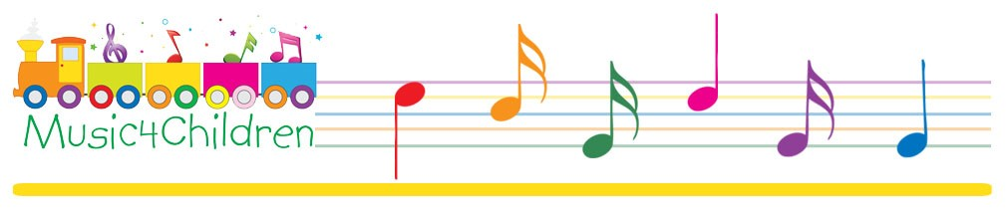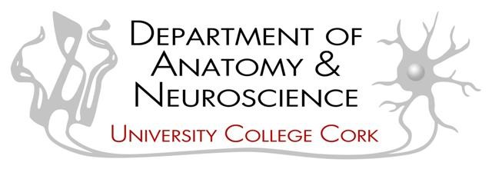
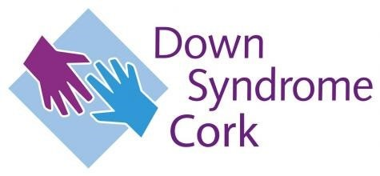

CHILD INFORMATION/ASSENT FORM FOR CHILDREN WITH DOWN SYNDROME ENGAGING WITH MUSIC

CONSENT BY THE CHILD TO TAKE PART

Section A

Protocol Number: _______ Participant Name:

Name of Study: Investigation of the neurological effects of musical training in
children with Down Syndrome

Our names: Dr. Jason S. Chan, Dr Annalisa Setti, Dr. Yvonne Nolan, Dr. Eva McMullan-Glossop

Contact information: jason.chan@ucc.ie and e.mcmullan@ucc.ie; Tel: 021-4904530

You are asked to take part in a test that will assess how music will change the brains of kids with Down Syndrome and typically developing children.

We want to make sure you understand want you have to do before we start. You can decide if you want to take part or not. This is called informed consent. If you agree, we will ask you to sign this form before we start the study.

Section B

I. WHAT YOU WILL BE ASKED TO DO?

We want to know how the brain changes with music training and how this can be different with kids that have something called Down Syndrome. We want to know if music can help kids with Down Syndrome.

If you agree to take part, we will ask you to do the music program online every day for eight weeks, and you will need to come to your group music class online once a week. During this music programme you will get to sing songs and play some musical games and play instruments.

You will do a couple of online tests. These tests will be on the computer, some will be looking at and name some pictures and some will be moving things on a screen.

Your parents will take a saliva sample from your mouth, which just involves sucking on a piece of sponge attached to a stick, and also, they will take a small sample of hair.

We would like you to do these tests before the music training and after the music programme.

If you want to stop and no longer do this anymore, you just need to tell us. You will not get in any trouble, and you can still do the music classes.

The information will be held for a period of 10 years. Only the investigators in this research project will have access to this material during this time. Our names are Dr. Jason S. Chan, Dr. Yvonne Nolan, Dr. Annalisa Setti, and Dr. Eva McMullan-Glossop.

Section C AGREEMENT TO ASSENT

Do I know what I have to do?

Did I get my questions answered?

I know I can stop when I want, and I will not get in trouble.

Investigator:

Name of Child

Name of Parent/Guardian:

- I agree to take part in this study.
- I do not agree to take part in this study.

Please select the date
 | Month | Day | Year
Please Select: | ▼ January (1 ... December (12) | ▼ 1 (1 ... 31 (31) | ▼ 1900 (1 ... 2049)



CHILD INFORMATION/ASSENT FORM FOR CHILDREN WITH DOWN SYNDROME NOT ENGAGING WITH MUSIC

CONSENT BY THE CHILD TO TAKE PART
Section A

Protocol Number: ______ Participant Name:

Name of Study: Investigation of the neurological effects of musical training in
children with Down Syndrome

Our names: Dr. Jason S. Chan, Dr Annalisa Setti, Dr. Yvonne Nolan, Dr. Eva McMullan-Glossop

Contact information: jason.chan@ucc.ie and e.mcmullan@ucc.ie; Tel: 021-4904530

You are asked to take part in a test that will assess how music affects the brains of children with Down Syndrome and typically developing children.

We want to make sure you understand what you have to do before we start. You can decide if you want to take part or not. This is called informed consent. If you agree, we will ask you to sign this form before we start the study.

Section B

I. WHAT YOU WILL BE ASKED TO DO?

We want to know how the brain changes with music training and how this can be different with kids who have Down Syndrome. We want to know if music can help kids with Down Syndrome.

If you agree to take part, you will take some online tests. These tests will be all on the computer. Some will involve looking at and naming pictures, and some will involve moving things on the computer screen.

Your parents will take a saliva sample from your mouth, which just involves sucking on a piece of sponge attached to a stick, and they will take a small sample of hair.

We would like to you do these tests twice. One time and then again after about 8 weeks. You don’t have to do anything in between.

If you want to stop and no longer do this anymore, you just need to tell us. You will not get in any trouble.

The information will be held for a period of at least 10 years. Only the investigators in this research project will have access to this material during this time. Our names are Dr. Jason S. Chan, Dr. Yvonne Nolan, Dr. Annalisa Setti, and Dr. Eva McMullan-Glossop.

Section C AGREEMENT TO ASSENT

Do I know what I have to do?

Did I get my questions answered?

I know I can stop when I want, and I will not get in trouble.

Investigator:

Name of Child

Name of Parent/Guardian:

- I agree to take part in this study
- I do not agree to take part in this study

Please select the date
 | Month | Day | Year
Please Select: | ▼ January (1 ... December (12) | ▼ 1 (1 ... 31 (31) | ▼ 1900 (1 ... 2049)

CHILD INFORMATION/ASSENT FORM FOR TYPICALLY DEVELOPING CHILDREN ENGAGING WITH MUSIC

CONSENT BY THE CHILD TO TAKE PART
Section A

Protocol Number:____________ Participant Name:

Name of Study: Investigation of the neurological effects of musical training in
children with Down Syndrome

Our names: Dr. Jason S. Chan, Dr Annalisa Setti, Dr. Yvonne Nolan, Dr. Eva McMullan-Glossop

Contact information: jason.chan@ucc.ie and e.mcmullan@ucc.ie; Tel: 021-4904530

You are asked to take part in a test that will assess how music will change the brains of kids with Down Syndrome and typically developing children.

We want to make sure you understand want you have to do before we start. You can decide if you want to take part or not. This is called informed consent. If you agree, we will ask you to sign this form before we start the study.

Section B

I. WHAT YOU WILL BE ASKED TO DO?

We want to know how the brain changes with music training and how this can be different with kids that have something called Down Syndrome. We want to know if music can help kids with Down Syndrome.

If you agree to take part, we will ask you to do the music program online every day for eight weeks, and you will need to come to your group music class online once a week. During this music programme you will get to sing songs and play some musical games and play instruments.

You will do a couple of online tests. These tests will be on the computer. Some will involve looking at and naming pictures, and some will involve moving things on a screen.

Your parents will take a saliva sample from your mouth which just involves sucking on a piece of sponge attached to a stick and, they will take a small sample of hair.

We would like you to do these tests before the music training and after the music programme.

If you want to stop doing this, you just need to tell us. You will not get in any trouble, and you can still take the music classes.

The information will be held for a period of 10 years. Only the investigators in this research project will have access to this material during this time. Our names are Dr. Jason S. Chan, Dr. Yvonne Nolan, Dr. Annalisa Setti and Dr. Eva McMullan-Glossop.

Section C AGREEMENT TO ASSENT

Do I know what I have to do?

Did I get my questions answered?

I know I can stop when I want, and I will not get in trouble.

Investigator:

Name of Child

Name of Parent/Guardian:
- I agree to take part in this study.
- I do not agree to take part in this study.

Please select the date
 | Month | Day | Year
Please Select: | ▼ January (1 ... December (12) | ▼ 1 (1 ... 31 (31) | ▼ 1900 (1 ... 2049)

CHILD INFORMATION/ASSENT FORM FOR TYPICALLY DEVELOPING CHILDREN NOT ENGAGING WITH MUSIC

CONSENT BY THE CHILD TO TAKE PART
Section A

Protocol Number: ______ Participant Name:

Name of Study: Investigation of the neurological effects of musical training in
children with Down Syndrome

Our names: Dr. Jason S. Chan, Dr Annalisa Setti, Dr. Yvonne Nolan, Dr. Eva McMullan-Glossop

Contact information: jason.chan@ucc.ie and e.mcmullan@ucc.ie; Tel: 021-4904530

You are asked to take part in a test that will assess how music affects the brains of children with Down Syndrome and typically developing children.

We want to make sure you understand what you have to do before we start. You can decide if you want to take part or not. This is called informed consent. If you agree, we will ask you to sign this form before we start the study.

Section B

I. WHAT YOU WILL BE ASKED TO DO?

We want to know how the brain changes with music training and how this can be different with kids who have Down Syndrome. We want to know if music can help kids with Down Syndrome.

If you agree to take part, you will take some online tests. These tests will be all on the computer. Some will involve looking at and naming pictures, and some will involve moving things on the computer screen.

Your parents will take a saliva sample from your mouth, which just involves sucking on a piece of sponge attached to a stick, and they will take a small sample of hair.

We would like to you do these tests twice. One time and then again after about 8 weeks. You don’t have to do anything in between.

If you want to stop and no longer do this anymore, you just need to tell us. You will not get in any trouble.

The information will be held for a period of at least 10 years. Only the investigators in this research project will have access to this material during this time. Our names are Dr. Jason S. Chan, Dr. Yvonne Nolan, Dr. Annalisa Setti, and Dr. Eva McMullan-Glossop.

Section C AGREEMENT TO ASSENT

Do I know what I have to do?

Did I get my questions answered?

I know I can stop when I want, and I will not get in trouble.

Investigator:

Name of Child

Name of Parent/Guardian:

- I agree to take part in this study
- I do not agree to take part in this study

Please select the date
 | Month | Day | Year
Please Select: | ▼ January (1 ... December (12) | ▼ 1 (1 ... 31 (31) | ▼ 1900 (1 ... 2049)

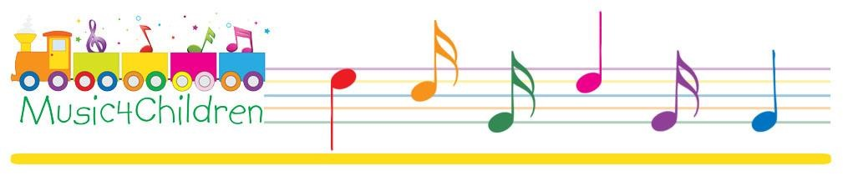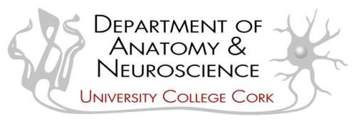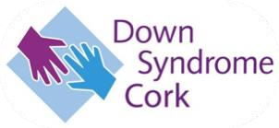

INFORMATION LEAFLET AND INFORMED ASSENT FORM FOR CHILDREN WITH DOWN SYNDROME ENGAGING WITH MUSIC TRAINING

Title of Study: Investigation of the neurological effects of musical training in children with Down Syndrome

Chief Investigator: Dr. Jason Chan (UCC)

My name is Eva, and my job is to research and test your brain to see how important music is in how we grow. We want to know how your brain works and the brain of other children. I am going to give you information and invite you to be part of a research study. You can choose whether or not you want to take part.

What is a study?
A research study is what you do when you want to learn about something or find out something new.

Why is this study being done?
We are doing this study with music to find out how it can help make our brains healthier.

What will happen to me if I take part? I will explain what happens to you, the games and the tests that we will do. If you can, you will be asked to write your name on a form.
This form is to say that you understand the study and what will happen. You will be given your own copy of the form to keep, as well as this leaflet.

This is what you will have to do if you say yes:
You will get to take part in an online music class every Saturday morning and at home watch some music videos. You will get to play musical instruments and play some music games. You will get to look at some pictures and tell us what you see. You will be asked to play some games on the computer. This is to give your brain some exercise. When you are at home, we will ask you if you can give us some saliva and hair that your mum will take.

Do I have to say yes?
No – not at all. It’s up to you! Just say if you don’t want to join in. Nobody will mind.
If you change your mind, that’s okay as well; if you want to stop, you can say it, and it is no problem. This will not change the way you learn music.

What shall I do now?
Now you know about the study you need to think about if you want to take part in the study.

Who can I ask about this?
Your mum or dad (or carer) have been given lots of information, but if you have any questions or would like to speak to me or the music testing team, you can call.
Eva and Jason on 021-4904530

Will the study upset or help me?
No - the study will not upset you. We hope that the information we get from this study will encourage boys and girls to play music in the future.

Thank you very much for taking time to read this.
Please ask any questions if you need to.

INFORMED ASSENT FORM FOR CHILDREN WITH DOWN SYNDROME ENGAGING WITH MUSIC TRAINING

Title of Study: Investigation of the neurological effects of musical training in children with Down Syndrome

To be completed by the child and their parent/guardian

Please highlight all you agree with:
(Child)

Has somebody explained this study to you? Yes / No

Do you understand what the study is about? Yes / No

Have you asked all the questions you want? Yes / No

Have you had your questions answered in a way you understand? Yes / No

Do you understand it’s OK to stop taking part at any time? Yes / No

Are you happy to take part? Yes / No

If any answers are ‘no’ or you don’t want to take part, don’t sign your name! If you do want to take part, please write your name and today’s date.

Your Name:

Today’s Date: _________________

Your parent or guardian must write their name here too if they are happy for you to do the study.

Parent/Guardian Full Name: __________________________________________

Today’s Date: __________________

The researcher who explained this study to you needs to sign too:

Researcher Full Name: ________________________________________________

Today’s Date: _________________

When completed, 1 (original) is to be kept in the researcher site file, and 1 (copy) is to be given to the participant

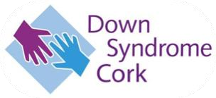

INFORMATION LEAFLET AND INFORMED ASSENT FORM FOR CHILDREN WITH DOWN SYNDROME THAT ARE NOT ENGAGING WITH MUSIC TRAINING

Title of Study: Investigation of the neurological effects of musical training in children with Down Syndrome

Chief Investigator: Dr. Jason Chan (UCC)

My name is Eva, and my job is to research and test your brain to see how amazing it is. We want to know how your brain works and the brains of other children. I am going to give you information and invite you to be part of a research study. You can choose whether or not you want to take part.

What is a study?
A research study is what you do when you want to learn about something or find out something new.

Why is this study being done?
We are doing this study to find how we can help make our brains healthier.

What will happen to me if I take part? I will explain what happens to you, the games and tests that we will do. If you can, you will be asked to write your name on a form.
This form is to say that you understand the study and what will happen. You will be given your own copy of the form to keep, as well as this leaflet.

This is what you will have to do if you say yes:
You will get to look at some pictures and tell us what you see. You will be asked to play some games on the computer. This is to give your brain some exercise. When you are at home, we will ask you if you can give us some saliva and hair that your mum will take.

Do I have to say yes?
No – not at all. It’s up to you! Just say if you don’t want to join in. Nobody will mind. If you change your mind, that’s okay as well. If you want to stop, you can say it, and it is no problem.

What shall I do now?
Now you know about the study you need to think about if you want to take part in the study.

Who can I ask about this?
Your mum or dad (or carer) have been given lots of information, but if you have any questions or would like to speak to me or the testing team, you can call Eva
and Jason on 021-4904530

Will the study upset or help me?
No - the study will not upset you. We hope that the information we get from this study will encourage boys and girls to play music in the future.

Thank you very much for taking time to read this. Please ask any questions if you need to.

INFORMED ASSENT FORM FOR CHILDREN WITH DOWN SYNDROME THAT ARE NOT ENGAGING WITH MUSIC TRAINING

Title of Study: Investigation of the neurological effects of musical training in children with Down Syndrome

To be completed by the child and their parent/guardian

Please highlight all you agree with:
(Child)

Has somebody explained this study to you? Yes / No

Do you understand what the study is about? Yes / No

Have you asked all the questions you want? Yes / No

Have you had your questions answered in a way you understand? Yes / No

Do you understand it’s OK to stop taking part at any time? Yes / No

Are you happy to take part? Yes / No

If any answers are ‘no’ or you don’t want to take part, don’t sign your name! If you do want to take part, please write your name and today’s date.

Your Name:

Today’s Date: __________________

Your parent or guardian must write their name here too if they are happy for you to do the study.

Parent/Guardian Full Name: ________________________________________
Today’s Date: ____________________________

The researcher who explained this study to you needs to sign too:

Researcher Full Name: ______________________________________________

Today’s Date: ________________________

When completed, 1 (original) to be kept in researcher site file and 1 (copy) to be given to the participant

INFORMATION LEAFLET AND INFORMED ASSENT FORM FOR TYPICALLY DEVELOPING CHILDREN ENGAGING WITH MUSIC TRAINING

Title of Study: Investigation of the neurological effects of musical training in children with Down Syndrome

Chief Investigator: Dr. Jason Chan (UCC)

My name is Eva, and my job is to research and test your brain to see how important music is in how we grow. We want to know how your brain works and the brain of other children. I am going to give you information and invite you to be part of a research study. You can choose whether or not you want to take part.

What is a study?
A research study is what you do when you want to learn about something or find out something new.

Why is this study being done?
We are doing this study with music to find out how it can help make our brains healthier.

What will happen to me if I take part? I will explain what happens to you, the games and the tests that we will do. If you can, you will be asked to write your name on a form.
This form is to say that you understand the study and what will happen. You will be given your own copy of the form to keep, as well as this leaflet.

This is what you will have to do if you say yes:
You will get to take part in an online music class every Saturday morning and at home watch some music videos. You will get to play musical instruments and play some music games. You will get to look at some pictures and tell us what you see. You will be asked to play some games on the computer. This is to give your brain some exercise. When you are at home, we will ask you if you can give us some saliva and hair that your mum will take.

Do I have to say yes?
No – not at all. It’s up to you! Just say if you don’t want to join in. Nobody will mind.
If you change your mind, that’s okay as well; if you want to stop, you can say it, and it is no problem. This will not change the way you learn music.

What shall I do now?
Now you know about the study you need to think about if you want to take part in the study.

Who can I ask about this?
Your mum or dad (or carer) have been given lots of information, but if you have any questions or would like to speak to me or the music testing team, you can call.
Eva and Jason on 021-4904530

Will the study upset or help me?
No - the study will not upset you. We hope that the information we get from this study will encourage boys and girls to play music in the future.

Thank you very much for taking time to read this.
Please ask any questions if you need to.

INFORMED ASSENT FORM FOR TYPICALLY DEVELOPING CHILDREN ENGAGING WITH MUSIC TRAINING

Title of Study: Investigation of the neurological effects of musical training in children with Down Syndrome

To be completed by the child and their parent/guardian

Please highlight all you agree with:
(Child)

Has somebody explained this study to you? Yes / No

Do you understand what the study is about? Yes / No

Have you asked all the questions you want? Yes / No

Have you had your questions answered in a way you understand? Yes / No

Do you understand it’s OK to stop taking part at any time? Yes / No

Are you happy to take part? Yes / No

If any answers are ‘no’ or you don’t want to take part, don’t sign your name! If you do want to take part, please write your name and today’s date.

Your Name:

Today’s Date: _________________

Your parent or guardian must write their name here too if they are happy for you to do the study.

Parent/Guardian Full Name: __________________________________________

Today’s Date: __________________

The researcher who explained this study to you needs to sign too:

Researcher Full Name: ________________________________________________

Today’s Date: _________________

When completed, 1 (original) is to be kept in the researcher site file, and 1 (copy) is to be given to the participant

INFORMATION LEAFLET AND INFORMED ASSENT FORM FOR TYPICALLY DEVELOPING CHILDREN THAT ARE NOT ENGAGING WITH MUSIC TRAINING

Title of Study: Investigation of the neurological effects of musical training in children with Down Syndrome

Chief Investigator: Dr. Jason Chan (UCC)

My name is Eva, and my job is to research and test your brain to see how amazing it is. We want to know how your brain works and the brains of other children. I am going to give you information and invite you to be part of a research study. You can choose whether or not you want to take part.

What is a study?
A research study is what you do when you want to learn about something or find out something new.

Why is this study being done?
We are doing this study to find how we can help make our brains healthier.

What will happen to me if I take part? I will explain what happens to you, the games and tests that we will do. If you can, you will be asked to write your name on a form.
This form is to say that you understand the study and what will happen. You will be given your own copy of the form to keep, as well as this leaflet.

This is what you will have to do if you say yes:
You will get to look at some pictures and tell us what you see. You will be asked to play some games on the computer. This is to give your brain some exercise. When you are at home, we will ask you if you can give us some saliva and hair that your mum will take.

Do I have to say yes?
No – not at all. It’s up to you! Just say if you don’t want to join in. Nobody will mind. If you change your mind, that’s okay as well. If you want to stop, you can say it, and it is no problem.

What shall I do now?
Now you know about the study you need to think about if you want to take part in the study.

Who can I ask about this?
Your mum or dad (or carer) have been given lots of information, but if you have any questions or would like to speak to me or the testing team, you can call Eva
and Jason on 021-4904530

Will the study upset or help me?
No - the study will not upset you. We hope that the information we get from this study will encourage boys and girls to play music in the future.

Thank you very much for taking time to read this. Please ask any questions if you need to.

INFORMED ASSENT FORM FOR TYPICALLY DEVELOPING CHILDREN THAT ARE NOT ENGAGING WITH MUSIC TRAINING

Title of Study: Investigation of the neurological effects of musical training in children with Down Syndrome

To be completed by the child and their parent/guardian

Please highlight all you agree with:
(Child)

Has somebody explained this study to you? Yes / No

Do you understand what the study is about? Yes / No

Have you asked all the questions you want? Yes / No

Have you had your questions answered in a way you understand? Yes / No

Do you understand it’s OK to stop taking part at any time? Yes / No

Are you happy to take part? Yes / No

If any answers are ‘no’ or you don’t want to take part, don’t sign your name! If you do want to take part, please write your name and today’s date.

Your Name:

Today’s Date: __________________

Your parent or guardian must write their name here too if they are happy for you to do the study.

Parent/Guardian Full Name: ________________________________________
Today’s Date: ____________________________

The researcher who explained this study to you needs to sign too:

Researcher Full Name: ______________________________________________

Today’s Date: ________________________

When completed, 1 (original) to be kept in researcher site file and 1 (copy) to be given to the participant

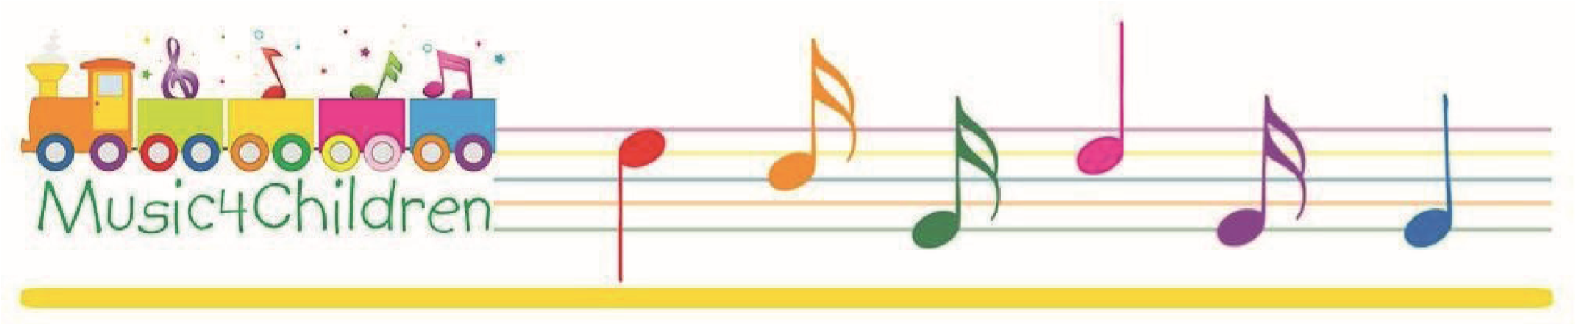

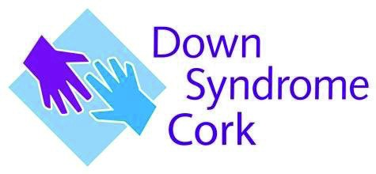
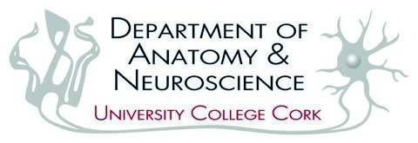
INFORMATION LEAFLET
Title of Study: Investigation of the neurological effects of musical training in children with Down Syndrome

INFORMATION LEAFLET FOR PARENTS OF CHILDREN WHO HAVE ALREADY TAKEN PART IN THE STUDY

Because of your involvement in the study thus far, you are now invited to fill out an additional questionnaire as part of the current study. Entitled ‘A Qualitative Parental Description of Your Child’s Experience of the Music Intervention,’ this Questionnaire has been designed to give you, the parent, the opportunity to reflect and share your observations during and after the intervention.

WHAT IS INVOLVED?

In advance of filling out the questionnaire, you will be asked to give your consent, which will be distributed via a Qualtrics link to the questionnaire. This Questionnaire will include open and closed questions that will permit you, the parent, to input your noted observations during and after the intervention. You will be asked to enter your Subject ID to retain anonymity.

BENEFITS

As researchers, we recognise the vital role that parental observations of their children have in assessing the intervention. Your comments and the neurological and behavioural measures will help comprehensively evaluate the programme.

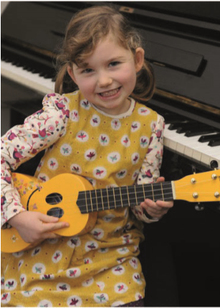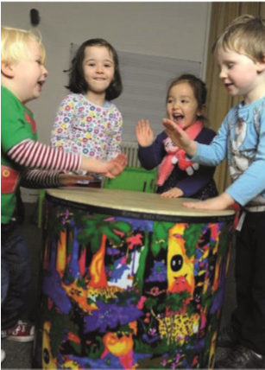

For Further Information
Contact: Dr. Eva McMullan-Glossop e.mcmullan@ucc.ie or jason.chan@ucc.ie or Tel: 021 494536

Celebrating Music Learning through fun and games by taking inspiration from children themselves.

PARENT INFORMATION/CONSENT FORM FOR CHILDREN WITH DOWN SYNDROME ENGAGING WITH MUSIC

CONSENT BY PARENT FOR CONTRIBUTION TO ‘A Qualitative Parental Description of Your Child’s Experience of the Music Intervention’

Section A

Protocol Number: _______ Participant Name: _______

Title of Protocol: Investigation of the neurological effects of musical training in
children with Down Syndrome

Investigators Directing Research:

Chief Investigator: Dr. Jason S. Chan,
Researchers: Dr Annalisa Setti,
Dr. Yvonne Nolan,
Dr. Eva McMullan-Glossop

Contact information: jason.chan@ucc.ie and e.mcmullan@ucc.ie; Tel: 021-4904520

What is Being Asked
You are being asked to fill out an additional questionnaire as part of the existing project, ‘An Investigation of the Neurological Effects of Musical Training in children with Down Syndrome. The questionnaire is entitled ‘A Qualitative Parental Description of Your Child’s Experience of the Music Intervention’ and will be completed after the intervention. You will be asked both open and closed questions.
Risks and Benefits
The are no risks in taking part in this Questionnaire. The main benefit of this research will be to provide us with the knowledge to refine music training programmes that will positively impact children with Down Syndrome or those that have other forms of cognitive impairments.

Section B AGREEMENT TO CONSENT
I understand all that is being asked in relation to my participation in the above survey.

I, the undersigned, hereby consent to participate as a subject in the above-described Questionnaire conducted at the School of Applied Psychology, Department of Music, and Department of Anatomy and Neuroscience.

I have received a copy of this consent form for my records. I understand that if I have any questions concerning this research, I can contact the researchers listed above. If I have further queries concerning my rights in connection with the research, I can contact the Clinical Research Ethics Committee of the Cork Teaching Hospitals, Lancaster Hall, 6 Little Hanover Street, Cork.

After reading the entire consent form, if you have no further questions about giving consent, please sign where indicated.

Name of Parent/Guardian____________________

- I consent to take part in this Questionnaire.
- I do not consent; I do not wishto take part in this Questionnaire.

Please select the date
 | Month | Day | Year
Please Select: | ▼ January (1 ... December (12) | ▼ 1 (1 ... 31 (31) | ▼ 1900 (1 ... 2049)

DATA PROTECTION NOTICE

Title of Protocol: Investigation of the neurological effects of musical training in
children with Down Syndrome

At University College Cork, we treat your privacy seriously. Any personal data which you provide to the University will be treated with the highest standards of security and confidentiality, in accordance with Irish and European Data Protection legislation. This notice sets out details of the information that we collect, how we process it and who we share it with. It also explains your rights under data protection law in relation to our processing of your data.

Who we are.
Throughout this Notice, “we”, “us” and “our” refers to University College Cork, as study sponsor. For more information about us, please refer to our website: www.ucc.ie

How we will use your personal data
By participating in the study, information about your child (also called “personal data”) will be collected for the study purposes mentioned in the Patient information leaflet. This personal data includes, for example:

- information that directly identifies your child (such as their name and their year of birth).
- their gender, ethnic and racial background.
- information on their health, medical condition, quality of life.
- information on their previous music education.
- information on their cognitive pre-tests and post-tests, including the Peabody Vocabulary Test.
- information contained in their hair and saliva samples and the results after analysis.

Personal data collected at any time during the study will be kept strictly confidential. To ensure confidentiality, the data generated during the study is coded with a number that will identify you in the study. Any information that leaves the clinical site will be labelled with your code instead of your name. Every person that has access to your uncoded data (that is kept at the School of Applied Psychology, University College Cork) is subject to professional secrecy and confidentiality.

Data that directly identifies you (uncoded data) is stored in your medical files at the clinical site in which the data have been obtained. The ‘key’ that connects the subject name and subject ID should be kept in a separate location from the data; it should be securely stored (in a locked cupboard in a room with restricted access) by the investigator. All files that contain personally identifiable information (e.g., keys) should undergo an additional layer of encryption, such as Microsoft Azure Information Protection.

Unencrypted personal devices (laptops or phones) should not be used to acquire data.

Who will access my personal data?
Your uncoded data will only be accessible to the study investigator and staff. The study's results will be provided to the Clinical Research Ethics Committee of the Cork Teaching Hospitals (CREC) in compliance with national and international regulations on clinical studies.

The purpose and legal basis for collecting your data.
Any personal data you provide to us during the course of this study will be processed fairly and lawfully.

Signing the Informed Consent Form means that your personal data will be used for the purposes outlined in the Patient information leaflet (PIL).

Personal data collected during this study and the results of the study may be presented for scientific purposes. However, you will never be identified individually during these presentations. Your identity will not be revealed in any reports or publications.

The clinical site and the investigator will use your personal data within the scope defined above.

The General Data Protection Regulation allows us to process your data because you have provided your consent. You are entitled to withdraw your consent at any time.

How long we will keep your data?
The personal data collected in the study will be kept for 10 years after the end of the study. However, your anonymised data will be held in accordance with FAIR data principles and may be stored indefinitely in an open data repository.

Your rights
You have various rights under data protection law, subject to certain exemptions, in connection with our processing of your personal data, including the right:

- to find out if we use your personal data, access your personal data and receive copies of your personal data.
- to have inaccurate/incomplete information corrected and updated.
- in certain circumstances, to have your details deleted from systems that we use to process your personal data or have the use of your personal data restricted in certain ways.
- to object to certain processing of your data by UCC.
- to exercise your right to data portability where applicable (i.e. obtain a copy of your personal data in a commonly used electronic form.
- to withdraw your consent to the processing of your data up to 30 days of participation without giving a reason by notifying your decision to the investigator. This will not affect the lawfulness of processing data about you based on your consent before the withdrawal. If you withdraw your consent for data processing, your participation in the study stops and no further data will be collected from you. Your study physician will present you with the options you have concerning your personal data.
- along with study withdrawal, you have the right to request the deletion of data about you, up to 30 days of participation, if your data are no longer necessary for the purposes of processing or there is no other legal ground for their further processing.
- after 30 days of participation, the link between your personal identity and your data will be destroyed and we will no longer be able to identify you from the rest of the dataset, thus it will not be possible to withdraw your data.

If you wish to exercise any of these rights, please address your request to the study coordinator or the Information Compliance Manager at University College Cork (details below).

Questions or Complaints

If you have any queries in relation to this study, please contact Dr. Eva McMullan e.mcmullan@ucc.ie.

If you have any complaints in connection with our processing of your personal data, you can contact UCC’s Information Compliance Manager: Information Compliance Manager, Office of Corporate & Legal Affairs, University College Cork, Western Road, Cork E: foi@ucc.ie Tel: +353 21 4903949
You also have the right to lodge a complaint with the Data Protection Commission if you are unhappy with our processing of your personal data. Details of how to lodge a complaint can be found on the Data Protection Commission’s website (www.dataprotection.ie) or by telephoning 1890 252 231.

Name of Parent/Guardian ____________________________________

Date ________________________

Name of Informant ___________________________________

Date ________________________

In submitting this form, you understand and agree that your personal details will be used by the School of Applied Psychology for the purposes outlined above.

PARENT INFORMATION/CONSENT FORM FOR TYPICALLY DEVELOPING CHILDREN ENGAGING WITH MUSIC

CONSENT BY PARENT FOR CONTRIBUTION TO ‘A Qualitative Parental Description of Your Child’s Experience of the Music Intervention’
Section A

Protocol Number: _______ Participant Name: _______

Title of Protocol: Investigation of the neurological effects of musical training in
children with Down Syndrome

Investigators Directing Research:

Chief Investigator: Dr. Jason S. Chan,
Researchers: Dr Annalisa Setti,
Dr. Yvonne Nolan,
Dr. Eva McMullan-Glossop

Contact information: jason.chan@ucc.ie and e.mcmullan@ucc.ie; Tel: 021-4904520

What is Being Asked
You are being asked to fill out an additional questionnaire as part of the existing project, ‘An Investigation of the Neurological Effects of Musical Training in children with Down Syndrome. The questionnaire is entitled ‘A Qualitative Parental Description of Your Child’s Experience of the Music Intervention’ and will be completed after the intervention. You will be asked both open and closed questions.
Risks and Benefits
The are no risks in taking part in this Questionnaire. The main benefit of this research will be to provide us with the knowledge to refine music training programmes that will positively impact children with Down Syndrome or those that have other forms of cognitive impairments.

Section B AGREEMENT TO CONSENT
I understand all that is being asked in relation to my participation in the above survey.

I, the undersigned, hereby consent to participate as a subject in the above-described Questionnaire conducted at the School of Applied Psychology, Department of Music, and Department of Anatomy and Neuroscience.

I have received a copy of this consent form for my records. I understand that if I have any questions concerning this research, I can contact the researchers listed above. If I have further queries concerning my rights in connection with the research, I can contact the Clinical Research Ethics Committee of the Cork Teaching Hospitals, Lancaster Hall, 6 Little Hanover Street, Cork.

After reading the entire consent form, if you have no further questions about giving consent, please sign where indicated.

Name of Parent/Guardian____________________

- I consent to take part in this Questionnaire.
- I do not consent; I do not wishto take part in this Questionnaire.

Please select the date
 | Month | Day | Year
Please Select: | ▼ January (1 ... December (12) | ▼ 1 (1 ... 31 (31) | ▼ 1900 (1 ... 2049)

DATA PROTECTION NOTICE

Title of Protocol: Investigation of the neurological effects of musical training in
children with Down Syndrome

At University College Cork, we treat your privacy seriously. Any personal data which you provide to the University will be treated with the highest standards of security and confidentiality, in accordance with Irish and European Data Protection legislation. This notice sets out details of the information that we collect, how we process it and who we share it with. It also explains your rights under data protection law in relation to our processing of your data.

Who we are.
Throughout this Notice, “we”, “us” and “our” refers to University College Cork, as study sponsor. For more information about us, please refer to our website: www.ucc.ie

How we will use your personal data
By participating in the study, information about your child (also called “personal data”) will be collected for the study purposes mentioned in the Patient information leaflet. This personal data includes, for example:

- information that directly identifies your child (such as their name and their year of birth).
- their gender, ethnic and racial background.
- information on their health, medical condition, quality of life.
- information on their previous music education.
- information on their cognitive pre-tests and post-tests, including the Peabody Vocabulary Test.
- information contained in their hair and saliva samples and the results after analysis.

Personal data collected at any time during the study will be kept strictly confidential. To ensure confidentiality, the data generated during the study is coded with a number that will identify you in the study. Any information that leaves the clinical site will be labelled with your code instead of your name. Every person that has access to your uncoded data (that is kept at the School of Applied Psychology, University College Cork) is subject to professional secrecy and confidentiality.

Data that directly identifies you (uncoded data) is stored in your medical files at the clinical site in which the data have been obtained. The ‘key’ that connects the subject name and subject ID should be kept in a separate location from the data; it should be securely stored (in a locked cupboard in a room with restricted access) by the investigator. All files that contain personally identifiable information (e.g., keys) should undergo an additional layer of encryption, such as Microsoft Azure Information Protection.

Unencrypted personal devices (laptops or phones) should not be used to acquire data.

Who will access my personal data?
Your uncoded data will only be accessible to the study investigator and staff. The study's results will be provided to the Clinical Research Ethics Committee of the Cork Teaching Hospitals (CREC) in compliance with national and international regulations on clinical studies.

The purpose and legal basis for collecting your data.
Any personal data you provide to us during the course of this study will be processed fairly and lawfully.

Signing the Informed Consent Form means that your personal data will be used for the purposes outlined in the Patient information leaflet (PIL).

Personal data collected during this study and the results of the study may be presented for scientific purposes. However, you will never be identified individually during these presentations. Your identity will not be revealed in any reports or publications.

The clinical site and the investigator will use your personal data within the scope defined above.

The General Data Protection Regulation allows us to process your data because you have provided your consent. You are entitled to withdraw your consent at any time.

How long we will keep your data?
The personal data collected in the study will be kept for 10 years after the end of the study. However, your anonymised data will be held in accordance with FAIR data principles and may be stored indefinitely in an open data repository.

Your rights
You have various rights under data protection law, subject to certain exemptions, in connection with our processing of your personal data, including the right:

- to find out if we use your personal data, access your personal data and receive copies of your personal data.
- to have inaccurate/incomplete information corrected and updated.
- in certain circumstances, to have your details deleted from systems that we use to process your personal data or have the use of your personal data restricted in certain ways.
- to object to certain processing of your data by UCC.
- to exercise your right to data portability where applicable (i.e. obtain a copy of your personal data in a commonly used electronic form.
- to withdraw your consent to the processing of your data up to 30 days of participation without giving a reason by notifying your decision to the investigator. This will not affect the lawfulness of processing data about you based on your consent before the withdrawal. If you withdraw your consent for data processing, your participation in the study stops and no further data will be collected from you. Your study physician will present you with the options you have concerning your personal data.
- along with study withdrawal, you have the right to request the deletion of data about you, up to 30 days of participation, if your data are no longer necessary for the purposes of processing or there is no other legal ground for their further processing.
- after 30 days of participation, the link between your personal identity and your data will be destroyed and we will no longer be able to identify you from the rest of the dataset, thus it will not be possible to withdraw your data.

If you wish to exercise any of these rights, please address your request to the study coordinator or the Information Compliance Manager at University College Cork (details below).

Questions or Complaints
If you have any queries in relation to this study, please contact Dr. Eva McMullan e.mcmullan@ucc.ie.

If you have any complaints in connection with our processing of your personal data, you can contact UCC’s Information Compliance Manager: Information Compliance Manager, Office of Corporate & Legal Affairs, University College Cork, Western Road, Cork E: foi@ucc.ie Tel: +353 21 4903949
You also have the right to lodge a complaint with the Data Protection Commission if you are unhappy with our processing of your personal data. Details of how to lodge a complaint can be found on the Data Protection Commission’s website (www.dataprotection.ie) or by telephoning 1890 252 231.

Name of Parent/Guardian ____________________________________

Date ________________________

Name of Informant ___________________________________

Date ________________________

In submitting this form, you understand and agree that your personal details will be used by the School of Applied Psychology for the purposes outlined above.

Appendix B: Questionnaires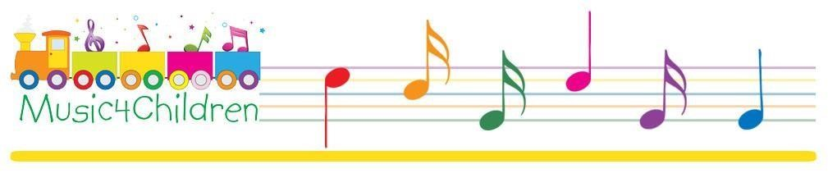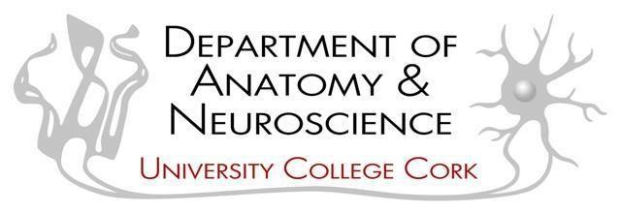
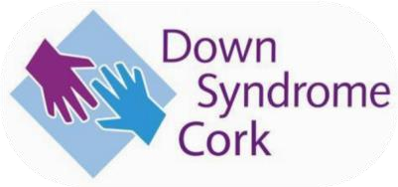
WHY CHOOSE MUSIC? *

This questionnaire, for the study entitled ‘Investigation of the Neurological effects of Musical Training in Children with Down Syndrome’, aims to gather important information about you and your child’s engagement with music. The survey includes the following sections:

- Section One: Background Information
- Section Two: Rate Your Own Engagement with Music
- Section Three Engaged with Music4Children
- Section Four Not Engaged with Music
- Section Five: Open Ended Questions
Section One: Background Information

What is your sex? male female

Please specify your age category. 18-2 30-49 50+

What is your academic qualification?
__________________________________________________________________________________________________________________________________

Is your child currently/has been engaged with a Music4Children programme?
______________________________________________________________________________________________________________________________________________

Section Two: Please Rate your own engagement with Music, with 0 being not true of me and 7 being very true of me.

- I listen to music regularly.

Not at all true of me Very true of me
0 1 2 3 4 5 6 7

- I regularly attend concerts.

Not at all true of me Very true of me
0 1 2 3 4 5 6 7

- I play one or more musical instruments.

Not at all true of me Very true of me
0 1 2 3 4 5 6 7

4. I am myself a musician.

Not at all true of me Very true of me
0 1 2 3 4 5 6 7

5. I have been paid to teach or perform music.

Not at all true of me Very true of me
0 1 2 3 4 5 6 7

Section Three is for those engaged with Music4Children. If your child is not engaged in the Music4Children programme, please proceed to
Section Four.

Section Three: Engaged with Music4Children

- My child is involved in music because I wanted to have a variety of activities.

Not at all true of me Very true of me
0 1 2 3 4 5 6 7

- My child is engaged with a music programme as I feel it would improve their musical skill.

Not at all true of me Very true of me
0 1 2 3 4 5 6 7

- My child is participating in music because their friends are doing music.

Not at all true of me Very true of me
0 1 2 3 4 5 6 7

- My child asked to be involved in music.

Not at all true of me Very true of me
0 1 2 3 4 5 6 7

- I thought being involved with music would improve their social skills.

Not at all true of me Very true of me
0 1 2 3 4 5 6 7

- I feel that music is an important experience for all children.

Not at all true of me Very true of me
0 1 2 3 4 5 6 7

- Please state any other reasons or comments as to why your child is engaged with music.

________________________________________________________________________________________________________________________________
________________________________________________________________

After Section Three is completed, please move to Section Five
Section Four: Not Engaged with Music

- My child has never engaged with music because they refused to attend classes.

Not at all true of me Very true of me
0 1 2 3 4 5 6 7

- I do not think music is a valuable activity at this time in my child’s life.

Not at all true of me Very true of me
0 1 2 3 4 5 6 7

- I do not think that he/she would enjoy it.

Not at all true of me Very true of me
0 1 2 3 4 5 6 7

- I do not think that they have any musical talent.

Not at all true of me Very true of me
0 1 2 3 4 5 6 7

- They never showed any interest in musical activity.

Not at all true of me Very true of me
0 1 2 3 4 5 6 7

- I was not aware of any programmes in our area.

Not at all true of me Very true of me
0 1 2 3 4 5 6 7

- Music lessons are too expensive.

Not at all true of me Very true of me
0 1 2 3 4 5 6 7

- We have never been given the opportunity.

Not at all true of me Very true of me
- 1 2 3 4 5 6 7

- Please state any other reasons or comments why your child has not engaged with music.
______________________________________________________________________

Section Five: Open Ended Questions

- Do you feel that the reasons for involving your other child/children in music programmes were any different from those of the child discussed?
_______________________________________________________________________________________________________________________________________________________________________________________________________________________

- How important do you think music is in a child‘s early experiences?
_______________________________________________________________________________________________________________________________________________________________________________________________________________________

- Please share any other thoughts or comments
_______________________________________________________________________
_______________________________________________________________________
_______________________________________________________________________

Thank You, You Have now Completed the Questionnaire

* *Adapted from ‘Why Choose Music’ from Paterson, J. (2008). Why choose music? A study in parental motivation toward formal music learning and the cultural beliefs regarding its benefits Sydney eScholarship. http://hdl.handle.net/2123/3995

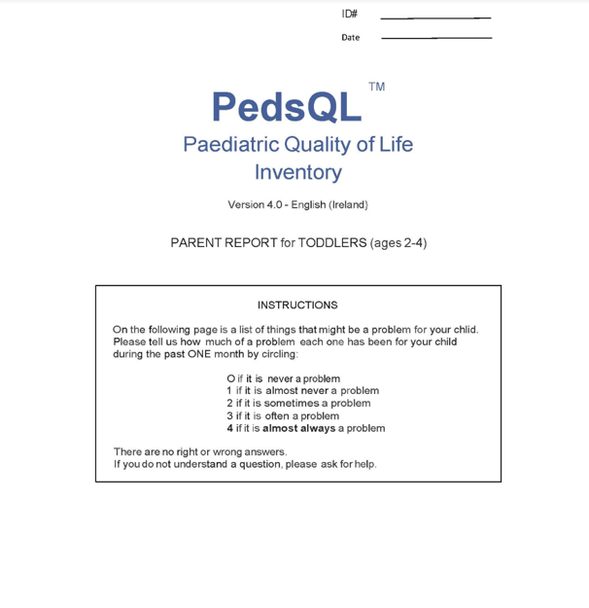
Paediatric Quality of Life Inventory for 2–4-year-olds. Reproduced with permission from Prof. James Varni © (Varni et al. 2001).

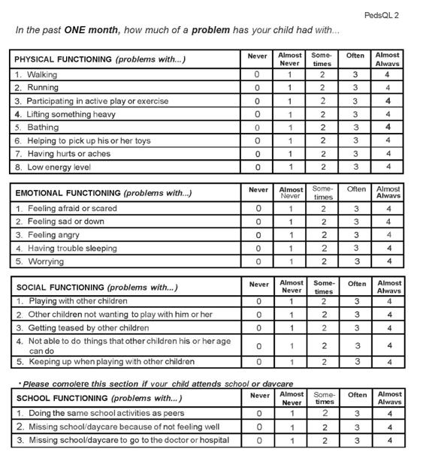

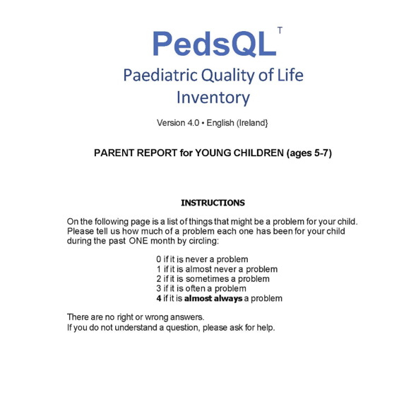
(Paediatric Quality of Life Inventory for 5–7-year-olds. Reproduced with permission from Prof. James Varni © Varni et al., 2001).

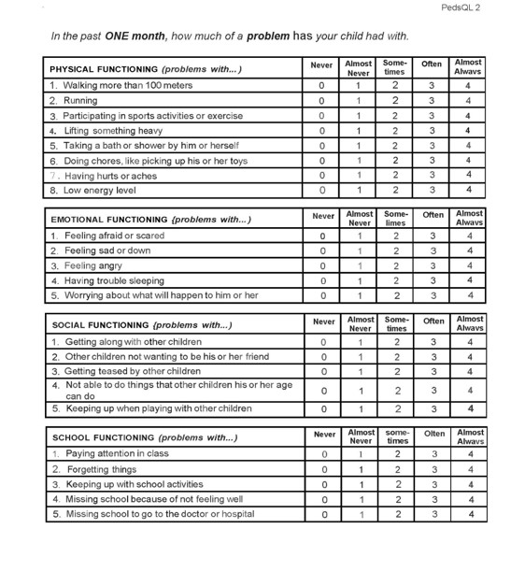

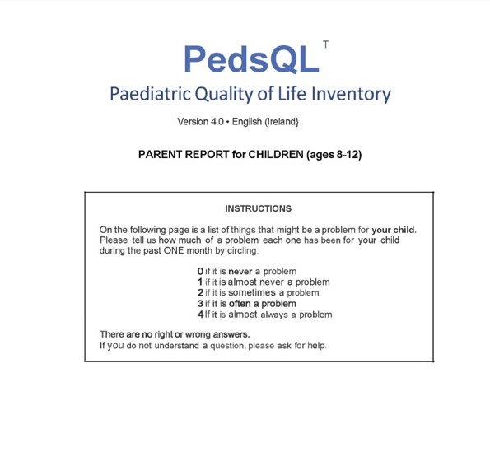
Paediatric Quality of Life Inventory for 8-12-year-olds. Reproduced with permission from Prof. James Varni © Varni et al., 2001).

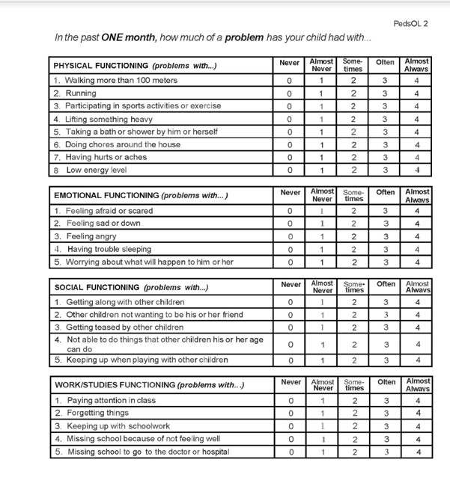

A Qualitative Parental Description of Your Child’s Experience of the Music Intervention

This form should be completed by the parent/guardian of the child who engaged with the music intervention.

Q 1 Subject ID _______________________

Q 2 What aspects of the music intervention videos did your child most enjoy? if so, please indicate which. Please select all that apply.

- Instrument Parade
- Song singing
- Actions
- Music Vocabulary
- Rhythm Family
- Rhythm Family Clocks
- Enjoyed all of the above
- Did not enjoy any of the above

Q 3 Please elaborate on your answer.
________________________________________________________________
________________________________________________________________
________________________________________________________________

Q 4 The online class was an important part of the intervention (0 being not at all important and 10 being extremely important).
Not at all Important Extremely Important
0 1 2 3 4 5 6 7 8 9 10

Q 5 Briefly explain your answer.
________________________________________________________________
________________________________________________________________
________________________________________________________________

Q 6 In your opinion, what would be the optimal number of engagements with the video?
- None at all
- Once a week
- Twice a week
- Three times a week
- Four times a week
- Five times a week
- Six times a week
- Every day

Q 7 In your opinion, what would be the optimal length of the music videos?
- 0 minutes
- 5 minutes
- 10 minutes
- 15 minutes
- 20 minutes

Q 8 Any other comments about the online classes and weekly videos

________________________________________________________________
________________________________________________________________

Q 9 Did your child sing or hum any of the songs outside of music class? (0 being that you did not sing the songs at all outside of the class, with 10 being you sang all of the songs outside of the class)

Did Not Sing the Songs Outside Class Sang All of the Songs Outside Class
0 1 2 3 4 5 6 7 8 9 10

Q 10 Please elaborate on your answer.
________________________________________________________________
________________________________________________________________
________________________________________________________________

Q 11 Do you or another guardian use any of these songs at home with your child? (0 being that you do not sing any at all, with 10 being you sing them all of the time)

Did Not Sing Any Sing All of the Time
0 1 2 3 4 5 6 7 8 9 10

Q 12 Please elaborate on your answer.
________________________________________________________________
________________________________________________________________
________________________________________________________________

Q 13 Did you notice any developmental changes during the music intervention? (0 being that you did not notice any changes, with 10 being that you noticed a lot of developmental changes)

Did Not Notice Any Changes Noticed A lot of Changes
0 1 2 3 4 5 6 7 8 9 10

Q 14 If you did, in what areas did you notice the change?
- Communications skills
- Cognitive concepts
- Personal/Social/Emotional capacities
- Motor Skill

Q 15 Please tell us more about any developmental observations in your child.
________________________________________________________________
________________________________________________________________
________________________________________________________________

Q 16 Please tell us anything else that you think is relevant about your child’s response to the music intervention

________________________________________________________________
________________________________________________________________
________________________________________________________________

Thank You, You Have now Completed the Questionnaire

Investigation in the Neurological effect of music on children with Down Syndrome
Daily Diary

Please Enter your Subject ID _____________________________________

Please select the date
 | Month | Day | Year
Please Select: (1) | ▼ January (1 ... December (12) | ▼ 1 (1 ... 31 (31) | ▼ 1900 (1 ... 2049)

Q1
Engaged with Music Video Today
- Five Minutes - Good Work!
- Fifteen Minutes - Fantastic!
- Ten Minutes Work - Very Good
- Didn't Happen Today Oops, Sorry!

Q2
Sequential Song
- Both singing and actions.
- Observed
- Made no Attempt.
- Singing Only
- Actions Only

Q3
Instrument Recognition
- Attempted but Struggled
- Recognised All
- Attempted with Some Success
- Made no Attempt.

Q4
Instrument Parade?
- Attempted but Struggled
- Attempted with Some Success
- Made no Attempt.
- Recognised All

Q5
Music Note Recognition
- Attempted but Struggled
- Recognised All
- Attempted with Some Success
- Made no Attempt.

Appendix C: Quantitative Analysis and Content Analysis Coding Samples

Why Choose Music?
Coding Sample

Question | Answer | Codes
Reasons for Engaging with Music | - She enjoys it.  - He loves music, and it is a positive motivation.  - Confidence - to have something they are good at and enjoy doing. Because it's so much easier at that age, and you can always come back to.  - Interact with his peer group in a safe setting because he enjoys it  - We are singing and dancing at home but have not participated in a music program yet.  - We look out for opportunities that are geared towards children like our child to expose them to a maximum of opportunities and experiences.  - I hadn’t thought if it is benefiting her in another way at the time.  - At the start, we thought it would be a positive experience. | Enjoyment  Confidence  Opportunity  Motivation  Positive
Reasons for not Engaging with Music | - My child is 4 and has DS.  - I feel they are too young and would take up an instrument quicker when she is older. She is involved in a lot of activities at present, including a dance class where she learns the songs she dances to.  - COVID  - No, they just attend other activities, and I’m conscious of not overfilling his weekends.  - We tried a group session, but my child was unwilling.  - They were 3 at the beginning of Covid. Otherwise, we may have enrolled her in a class.  - Covid has added to uncertainty around signing up for activities generally.  - Concerned that the tutor would not be experienced in teaching a child with an ID.  - As a musician, I didn't want to put pressure on them to do music. I wanted it to come from them rather than me telling them that they should.  - My child would not be able to keep up with regular music classes. | COVID  Age  Other activities  Teaching Experience/classes
Please share any other thoughts or statements regarding the above statements. | - My child has not tried an instrument, as I feel they would pick it up quicker when she is a little bit older. They are already doing lots of activities at present.  - He does really enjoy music and dance.  - Repetition is extremely important for children with ID. Often, tutors want to move on too quickly, which leads to frustration.  - My child really wants to learn to play the keyboard, and it's on the agenda.  - Extra time is needed for our kids to get going with a new activity.  - Although I cannot play an instrument, I do enjoy listening to music. I think it has huge benefits for children and adults alike. I enjoy singing and dancing with the children in the house and car for fun. I believe that music can release good feelings, promote happy feelings, and encourage self-expression.  - Times and locations of music classes are not available, and none are specifically for children with DS, so there is little opportunity to learn.  - I tried to involve my child in a music class when he was 6, but they didn't want to join; I hope to try again soon.  - The intention is there for both kids to start piano this year.  - I attended Music4Children for a few sessions, but the schedule didn’t really suit our family. | Age/older  Activities  ID Teaching  Repetition  Enjoy  Self-Expression  Teaching ID  COVID  Enjoy
Open-Ended Questions  Do you feel that the reasons for involving your other child/children in music programmes were any different from those of the child discussed? | - More focus on activities for older siblings due to more time as a parent. Also, few options due to COVID.  - She would have less activities at the weekends than him so it nice for her to have her own too.  - Yes, they weren't involved in music by choice, my child with DS loves music, but was unwilling to participate in a group session. She was a bit nervous.  - No, they are close in age and generally attend activities together.  - No, they are close in age and generally attend activities together.  - Yes - other children have no interest in music lessons, although they have been offered various instruments, etc.  - The older two boys were told that they should learn an instrument which has worked with one but not the other.  - I put pressure on my older two to be involved in music.  - No, he enjoys music too, so that would be my main reason for encouraging their interests.  - The music programme was for my child with special needs, not his typical siblings.  - Yes, other children are very sporty, and that is all-consuming for them (so they don't do music)—music is his thing!  - No.  - Yes, our daughter did guitar lessons without hesitation as she loves music.  - No: my older children enjoyed their involvement in music programmes and went on to learn to play instruments  - I think music will be good for the girls.  - No, same reasons. I do feel though that my other children would have had better concentration to take part in music programmes  - Yes. Our daughter recently started singing lessons as she has a lovely voice. We were considering percussion instruments for our son.  - No, I treat both girls equally.  - My younger daughter is more eager to get involved in a music programme.  - They enjoy music; my eldest plays the piano and plays the ukulele, has a DJ kit, and loves to listen to music.  - My other child was younger and is only now turning 6, so he is a good age to learn the piano, although my first child started lessons at 5.  - For typically developing children, access to music programmes is much easier, locally.  - No  - Older children enjoy music in school.  - My eldest found playing the piano therapeutic. | Activities  Group lessons.  Age  No interest  Sports Activities  Singing  Percussion  Piano  Enjoy Music  TD programmes easier to access.  Music as therapeutic
How important do you think music is in a child‘s early experiences? | - COVID did not allow indoor activities such as lessons or music programs. We sang and danced at home until indoor activities allowed us to have a music teacher.  - Music is important for speech, mood, concentration, and memory.  - Music is extremely important for speech, memory, concentration, and mood.  - I feel music is very important as it contributes to speech (nursery rhymes, speech sounds), and it helps concentration and memory. It cheers a child up; they feel like dancing while listening to music.  - Children respond and move differently to different music and they enjoy experiencing music.  - I found the music very beneficial, and they really enjoy having music as part of their everyday experience.  - Very importantly I have always enjoyed music and would like my child to learn and be interested in music.  - Of huge value and would love it to be a part of my child's life.  - I can appreciate its value and would love it to be a part of my child's life. Despite poor speech, my child is quiet, musical, and sings in tune.  - I believe it is very important. We have music in the house all the time, and the children love music. We do not play instruments, which has probably led to the children not playing any to date.  - I think it is very important, and we have music on in the house a lot. The children love music, but neither I nor the children’s father play instruments, which has probably contributed to us not pushing this as much.  - As a parent, I am becoming increasingly aware of how important of the role of music in early development  - Music is a form of communication. It elicits positive feelings. It stimulates. He likes it.  - Benefits personal well-being and general happiness.  - It is hugely important.  - I feel it is imperative to their development in several ways. However, there are a number of ways in which music can be integrated into a child's life.  - It was useful for early intervention to respond to her movements before she spoke to encourage interaction and communication.  - Music enhances the children’s senses and can incorporate so many early childhood learning skills.  - Very important  - Music is communication, amongst other things, and aids in development but is also enjoyable and positive.  - The child responded to music from a very early age and could learn language in conjunction with music.  - Music contributes to personal well-being, so it is very important.  - Very important as another way of communicating.  - All children should have the opportunity to be exposed to as wide a range of music as possible. I would like my kids to enjoy music without feeling limited to any genres.  - Very important.  - I think it promotes self-expression, confidence, language development and participation in different aspects of family/school life.  - We have seen the benefits of music and singing for both of our children, including enjoyment, language learning, speech, diction, memory, and winding down for bed.  - Music is a language in itself and aids communication, helps self-regulation and mood and enhances creativity and learning.  - I think music opens the soul and creates great pleasure for everyone.  - Very important, I believe it’s one of the best things to involve them in from an early stage.  - Very important.  - I think it's very important to introduce all forms of music from an early age. It's fun to sing and dance, and I used music as a way to decompress with my daughter when she was very young. Before she learned how to regulate her big feelings, I would turn on some music and dance with her if I felt she was angry or frustrated and couldn't find the words...or didn’t know how to say them. I think music is a great way to express feelings. It resonates emotionally, and some expression through movement in music works. It is great to throw on some tunes while doing the housework...while exercising... I love singing along in the car!  - I believe it is important. I see how much happier they are watching/listening to music.  - It gives confidence, helps literacy, speech, and social opportunities, and is fun.  - Very important, we can see that music helps speech, memory, and recall.  - Helps their development.  - Music stimulates the brain and makes learning fun. It also encourages children to listen. | COVID  Sing and Dance  Speech  Mood  Concentration  Memory  Enjoy  Value  Important  Early Years  Positive  Happiness  Well-being  Early intervention  Self-Expression
Please share any other thoughts or comments | - Good for involvement and self-growth.  - I hope that music will encourage our son's confidence and engagement and show the family that he can engage with them in this form.  - Music has featured fully in my child’s life. It has helped him stay relaxed and calm, but equally, it has provided great fun and entertainment. Music has helped my child find common ground with peers through dance and expression.  - Music was a big part of my life and my sisters when we were children and I appreciate that we were given such an opportunity, I am very keen to provide my kids with the same.  - I find music very interactive. It's next to impossible not to engage on some level in some way.  - Loves music and listens to their favourite songs daily.  - Different teaching methodologies are important for children with ID, and many tutors are unaware of this, leading to frustration on all sides!  - The lack of emphasis on the importance of music in some schools has undermined its importance in the lives of children as they see it.  - As a mum in NICU, I sang one specific song to my child so he would recognise me when I was there. | Self-growth  Confidence  Engagement  Calm/Relaxed  Interactive  Different Teaching Methodologies for Teaching Children with ID  Frustration  Lack of emphasis  Memory

Paediatric Quality of Life: Results

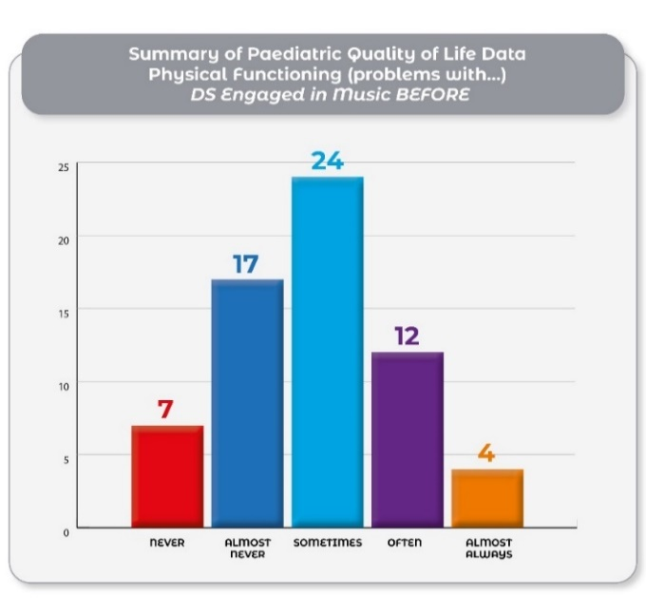
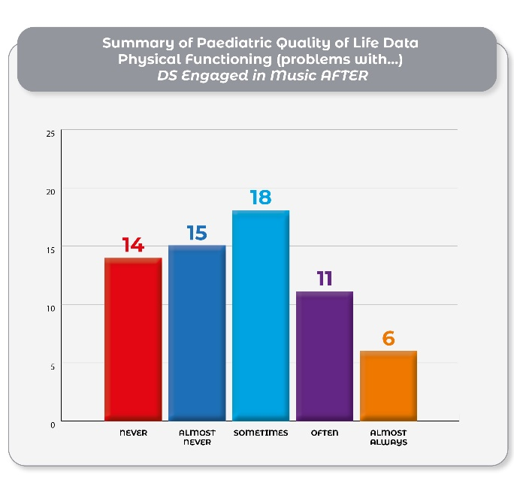
The results of Physical (problems with…) from Children with Down Syndrome engaging with music before and after the intervention.
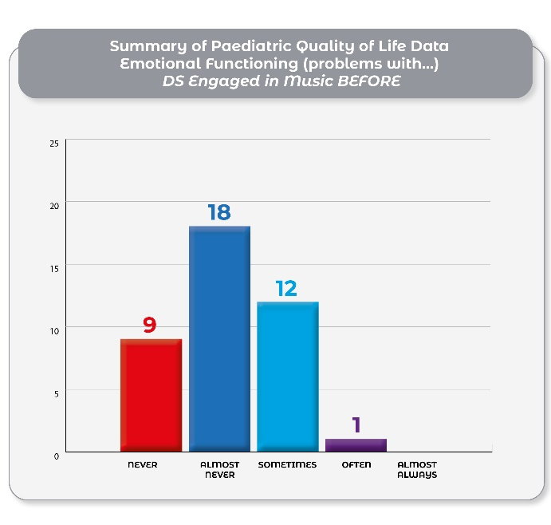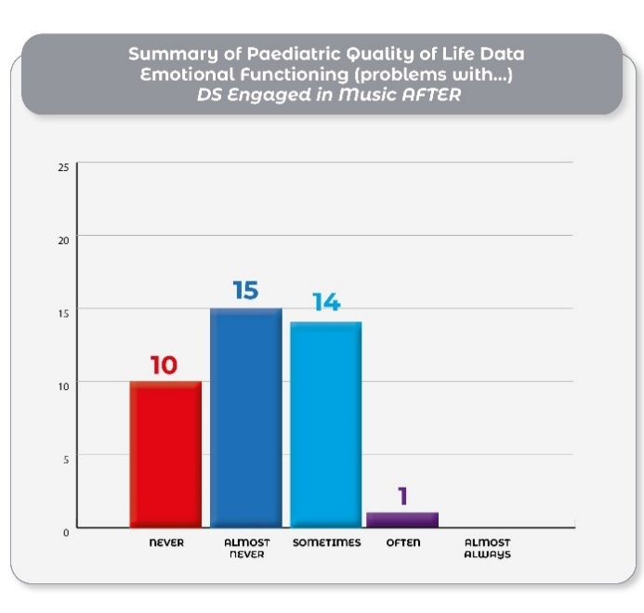
The results of Emotional Functioning (problems with…) from Children with Down Syndrome engaging with music before and after the intervention.
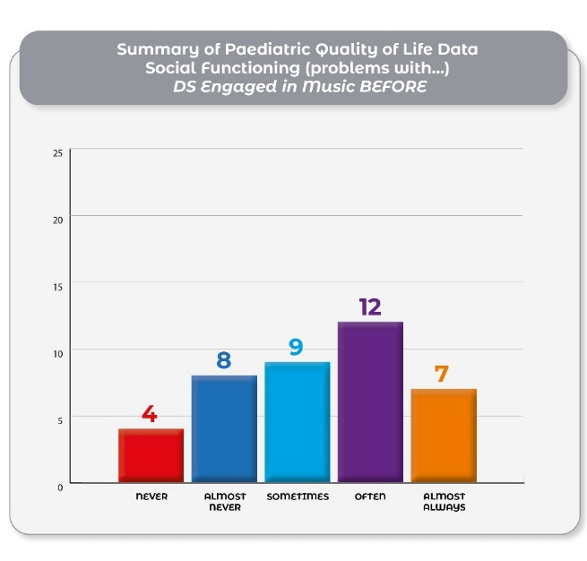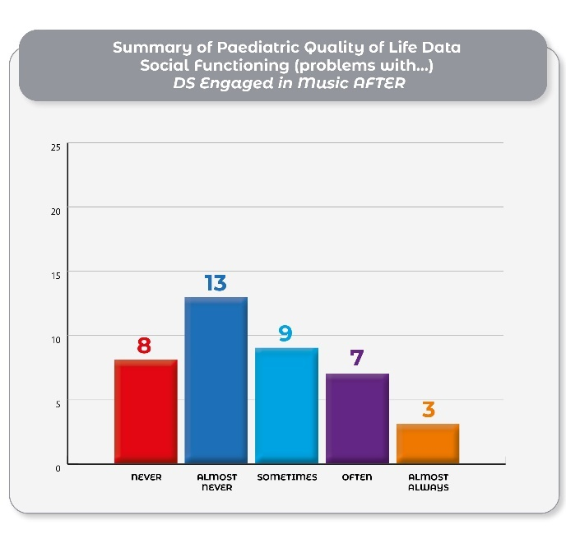
The results of Social Functioning (problems with…) from Children with Down Syndrome engaging with music before and after the intervention.
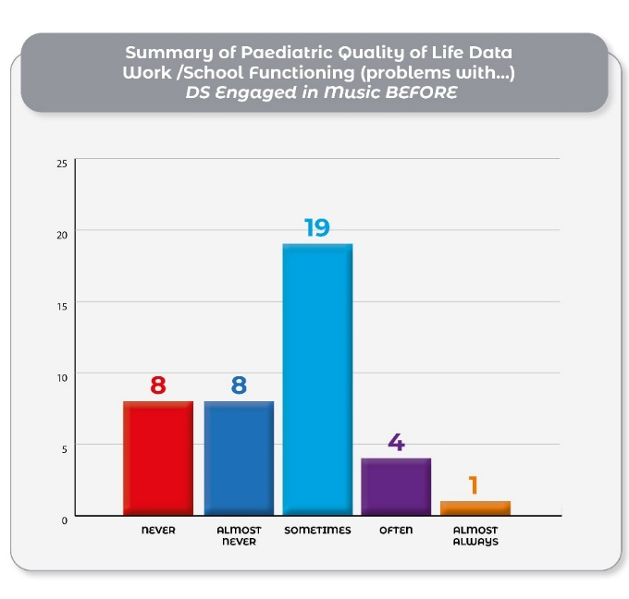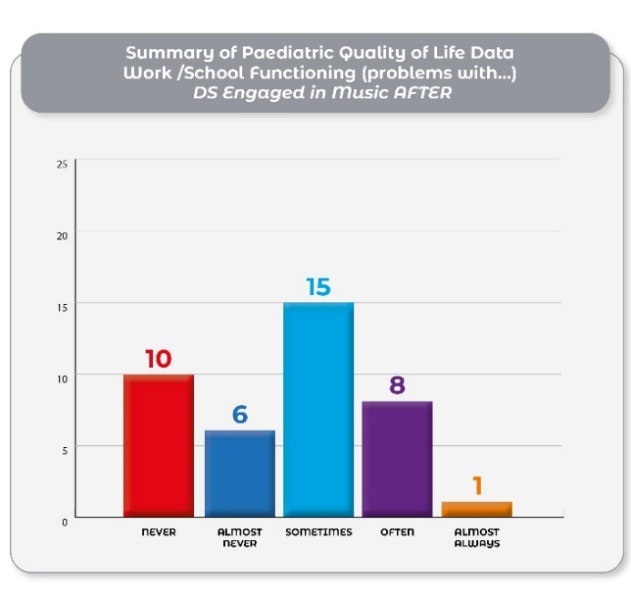
The results of Work/School Functioning (problems with...) from Children with Down Syndrome engaging with music before and after the intervention.
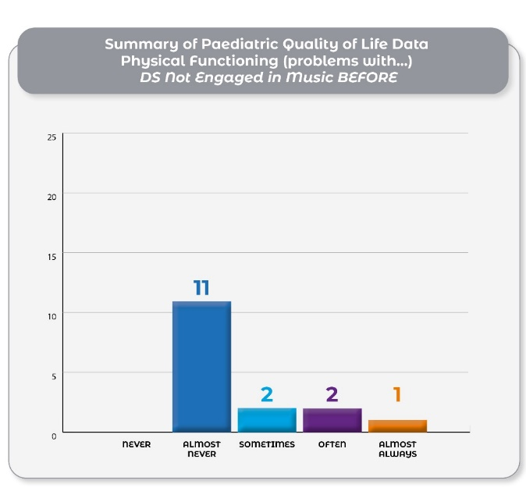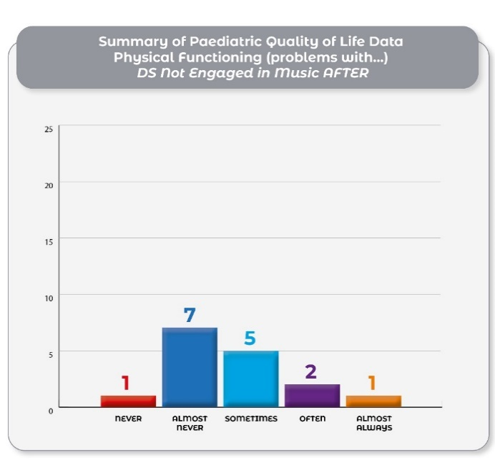
The results of Physical (problems with…) from Children with Down Syndrome not engaging with music before and after the intervention.
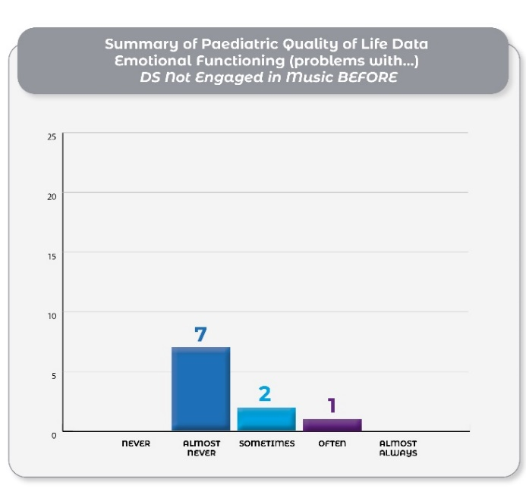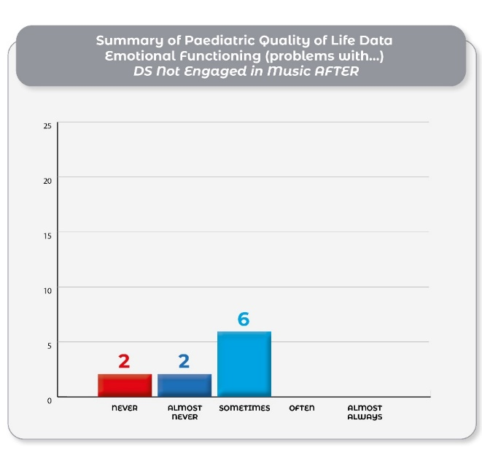
The results of Emotional Functioning (problems with…) from Children with Down Syndrome not engaging with music before and after the intervention.

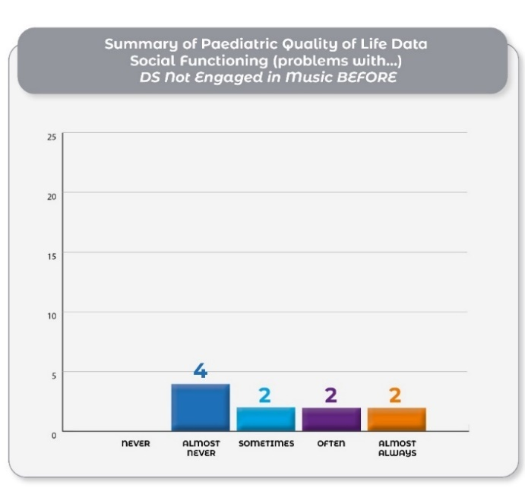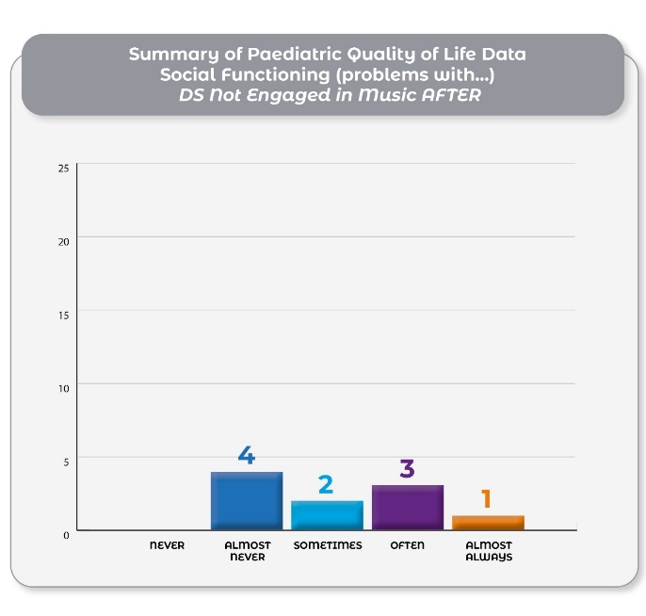
The results of Social Functioning (problems with…) from Children with Down Syndrome not engaging with music before and after the intervention.

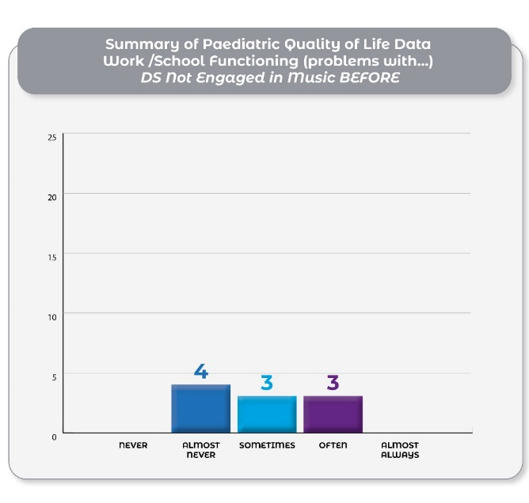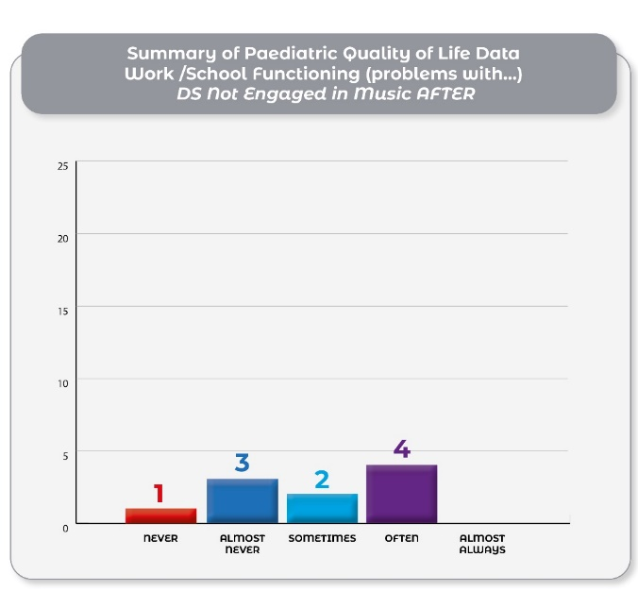
The results of Work/School Functioning (problems with...) from Children with Down Syndrome not engaging with music before and after the intervention.
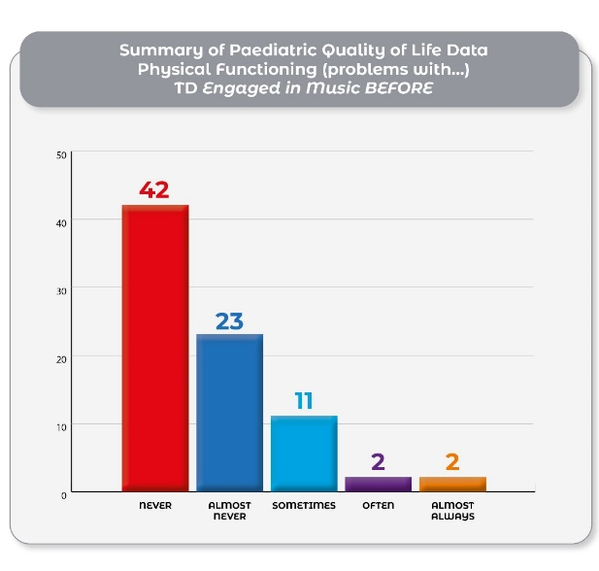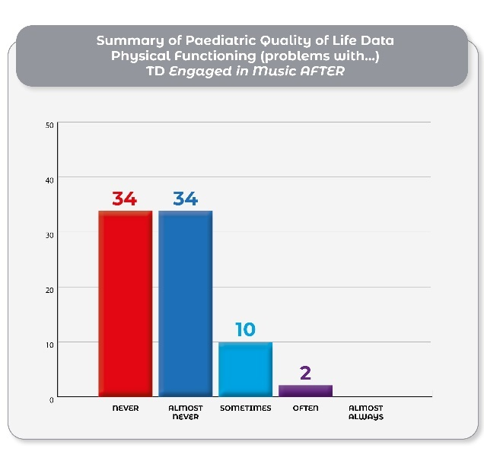
The results of Physical (problems with…) from Typically Developing Children engaging with music before and after the intervention.

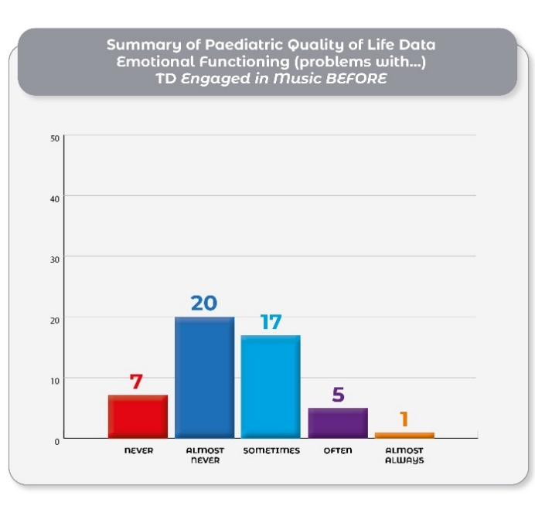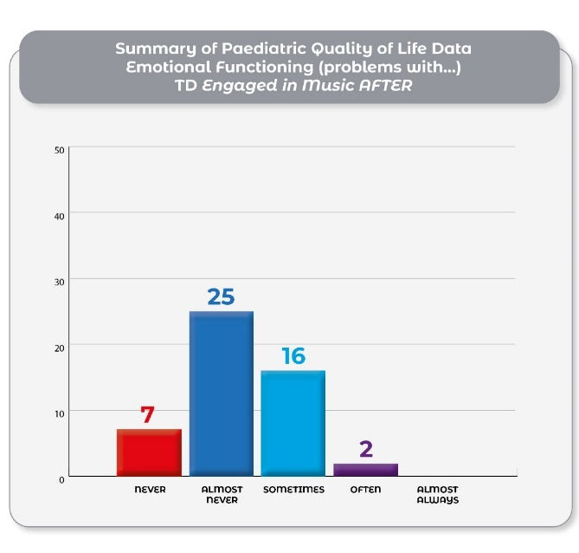
The results of Emotional Functioning (problems with…) from Typically Developing Children engaging with music before the intervention.

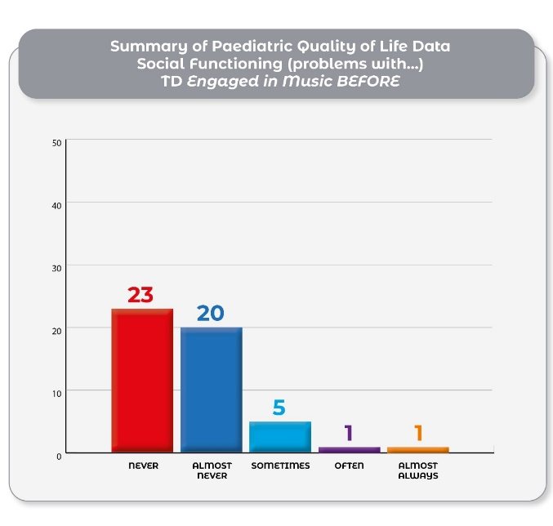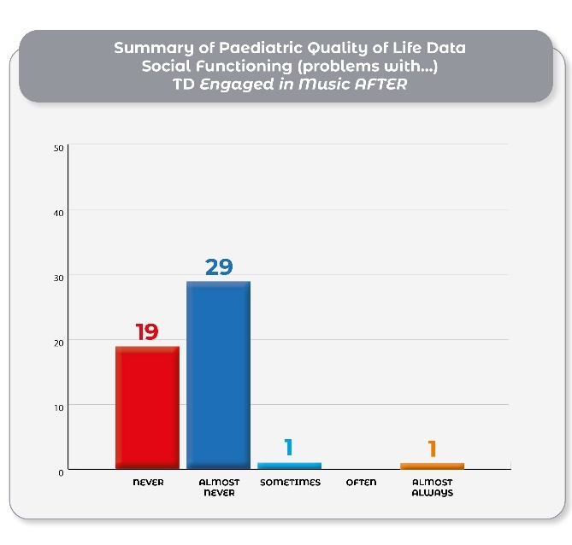
The results of Social Functioning (problems with…) from Typically Developing Children engaging with music before and after the intervention.
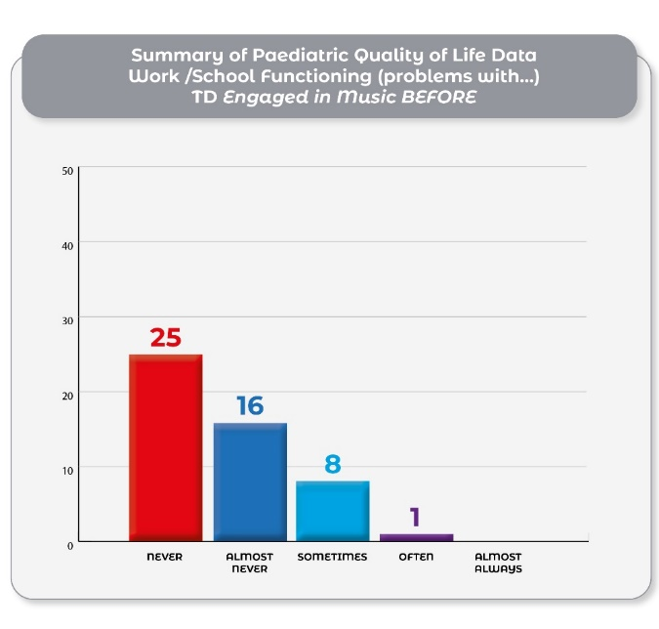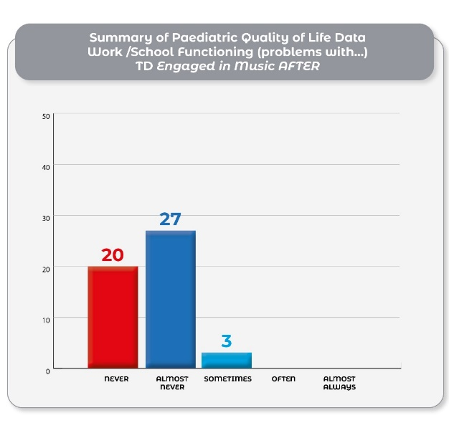
The results of Work/School Functioning (problems with...) from Typically Developing Children engaging with music before and after the intervention.

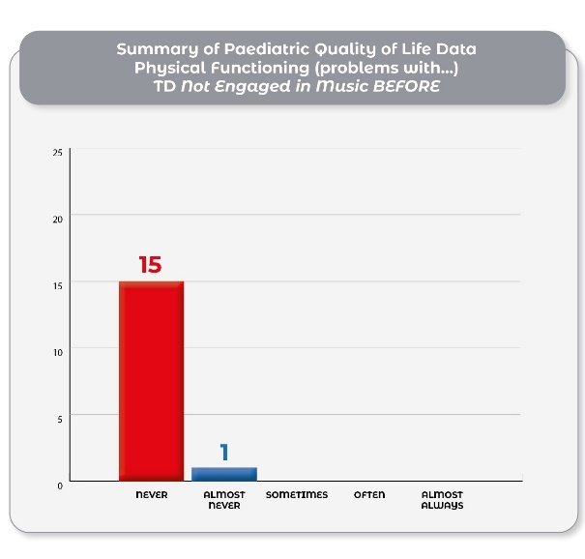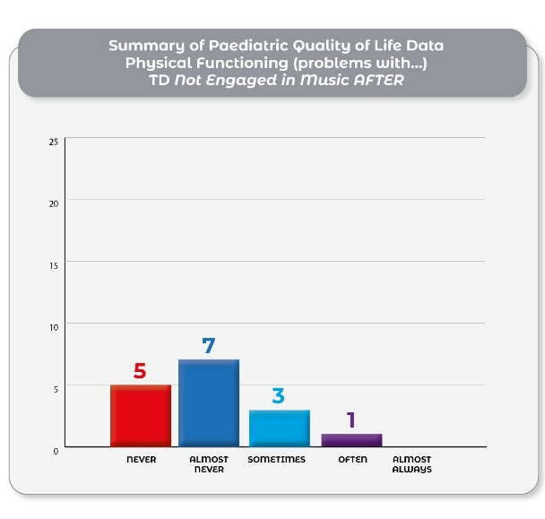
The results of Physical (problems with…) from Typically Developing Children not engaging with music before the intervention.
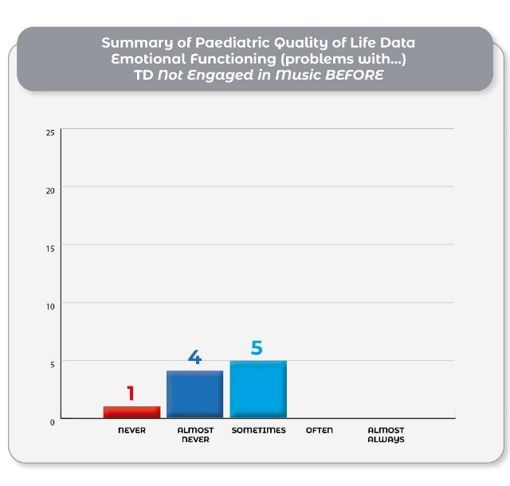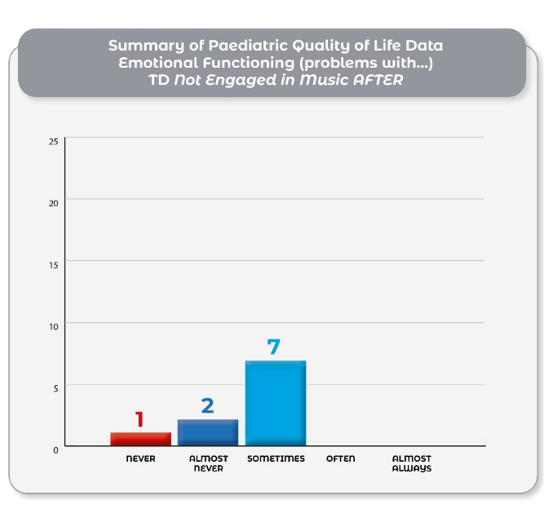
The results of Emotional Functioning (problems with…) from Typically Developing Children not engaging with music before and after the intervention.

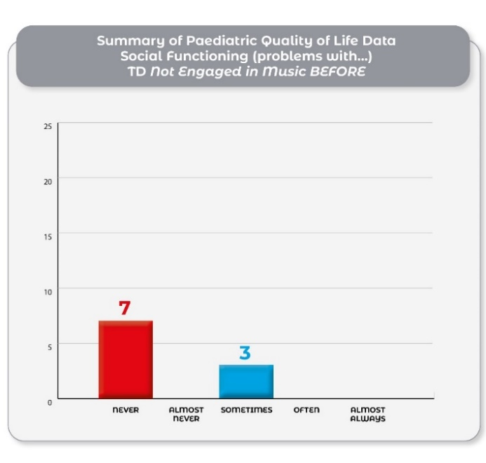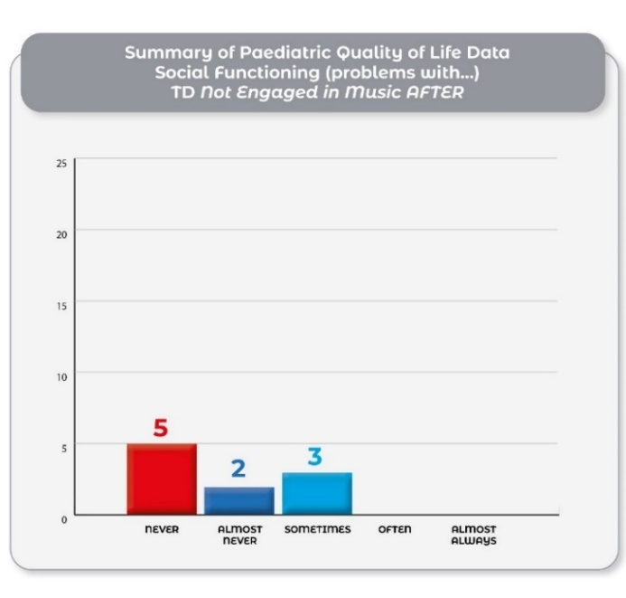
The results of Social Functioning (problems with…) from Typically Developing Children not engaging with music before and after the intervention.

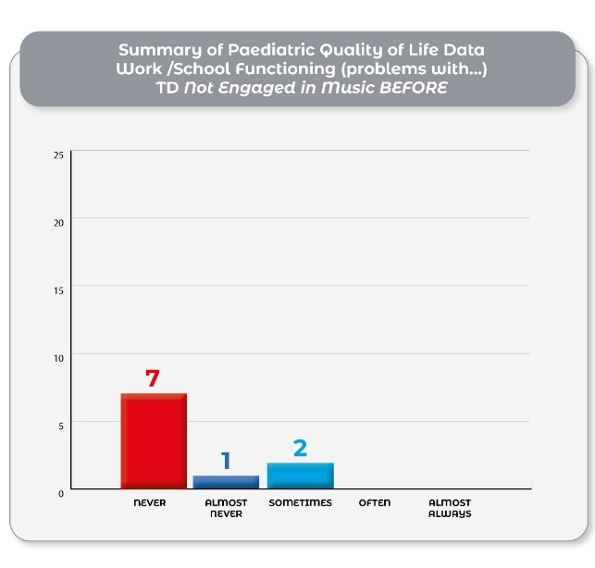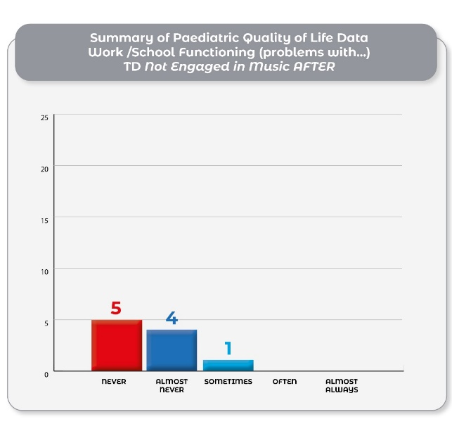
The results of Work/School Functioning (problems with...) from Typically Developing Children not engaging with music before the intervention.

Qualitative Description of Your Child’s Experience of the Music Intervention:
Coding Example

Questions 9 and 10.
Did your child sing or hum any of the songs outside of music class? (0 being that you did not sing the songs at all outside of the class, with 10 being you sang all of the song outside of the class). Please Elaborate on your answer.

Participants’ Response | Codes
Yes, she was singing the songs to her younger sister. I also heard her using the melodies and putting different lyrics to the songs. She engaged with the songs more so than the instruments. | Singing with Siblings  Sociability of Singing  Learning through song  The adaptability of Song
Very rarely, if ever. Singing isn't something he does often anyway. | Inaccessibility of song
Enjoyed using the instruments to perform. | Enjoyment
My kids still sing and laugh about the songs together and correct each other if one gets a bit wrong. | Sociability of Song - togetherness
Watched them on YouTube himself, also. | Visual Engagement with Song  Medium of Intervention
Some songs more than others! | Certain Songs
My daughter is mostly nonverbal, but she would recognise the songs and look to play them on YouTube. Or like when we sung them to her. | Singing as accessibility  Medium of Intervention
We all sang a lot of the songs, and the instruments were used lots in day-to-day life (as part of SLT, too!). | Song as Speech Development
The 'High Low' song made an impact particularly! My son would start singing this if the words 'high' or 'low' were mentioned in a sentence! | The transfer of music to language
She liked the songs, and then when family became familiar with them. | Connections through song
Sung them on a Saturday after attending the Zoom lesson.
I used to hear them singing the songs all of the time, and still do now and again. | Song singing
Some songs were sung by her/him or started by me as it was in my head! | Connections through song

Questions 11 and 12.
Do you or another guardian use any of these songs at home with your child? (O being that you do not sing any at all, with 10 being you sing them all of the time). Please elaborate on your answer.

Participants Responses | Codes
Yes, the songs became a part of the household,  particularly for the duration of the intervention.  We don't sing them as much as we used to now, but sometimes you would hear them being sung. | Family connection through song
Even though he didn't sing them, his younger sibling, who is 3, really loved them. We sang them all the time during the intervention. | Sibling influences
An odd occasion. | Non-transfer
It didn't occur to me!
Didn't think to!
We still sing them in the car. | The mobility of song
Those we remembered.
We like the high-low songs and the forte/piano ones. | Music language
The kids sang them a lot, and it rubbed off on us, eventually. | Family connections through song
We still go back and replay the music intervention videos on a Saturday morning, when their sister is at her music lesson/on a rainy weekend/sick day from school. | Music intervention
Hello everyone song in particular. | Memory and songs
He plays them on Alexa.
 | Non- Transfer
  I keep meaning to but forget.

Question 15
If you did, in what areas did you notice the change?

Participants Responses | Codes
My daughter used a lot of the musical language that she would not have been familiar with before the intervention. So, words like piano/forte and crescendo. Interestingly, these were used only in a musical context and not outside. | Musical Language – frequency infrequency of use.
As the intervention progressed, I felt my son’s concentration levels improved slightly. He also used the musical language and interestingly, outside of a musical environment. For example, if someone was being loud, he would say, 'Please don't be forte'. I felt that he engaged with his older sister, who was doing the intervention in a different way. I would hear them talk about what had gone on in the video and ask about the Rhythm family; he would also make up some stories about them during the week. | Integration of Musical Language  Piano/Forte and High/Low – the use of Musical Language.  Using Narrative as Learning  Communication between Siblings
Wanted to show others the instruments.
I didn't note any changes. | No changed
My son is outgoing and social, but I did feel he gained confidence learning a new language like music and that confidence made him more vocal. He wanted to share the learning and show off what he knew. He also had loads of chats with his sister about what they were learning and the two of them could be heard singing and dancing to the songs they learned along the way. | The Benefits of Learning a Musical Language  Shared learning  Communication between siblings  Song as a sociable interaction
Attempted to say the music vocabulary. | The Impact of Musical Language
The main thing would be concentration, recognising the videos, and knowing when they were over. | Music and heightened concentration
Overall calmer and more open to instruction. | Music and Learning
Communication skills (language): my son learned and retained the instrument names and music terms (e.g. crescendo, largo, presto). | The Positive Impact of Music on Speech Development
Motor skills (gross motor): My son kept time to the music perfectly (shaking, clapping, stomping).  Motor skills (fine motor): My son learned to use the space bar to stop the video (to find an instrument/ pipe cleaner (music note)) and restart. He has progressed to using the computer mouse! | Music and Motor Skill Development
First time using a computer for learning. First time hearing musical terms. | The Impact of Online Learning
Developed a greater understanding about music, vocabulary associated with music, notes and how music is made. | The Positive Impact of Music on Vocabulary.
I just noticed they loved the routine of the video every night but didn't like the online class, probably because they're not used to Zoom. | The Impact of Online Learning
It’s hard to tell what a natural progress was or due to the intervention, but she made strides in her schoolwork, communication skills, listening and learning. | Music on Learning,  Communication skills

Question 16
Please tell us anything else that you think are relevant about your child's response
to the music intervention.

Participants Responses | Codes
The enjoyment factor was really great to see.  Also, how much can be learned? She made strides in her schoolwork, communication skills, listening and learning through the videos more than in the online class.  Seeing the contrast between these two forms of delivery was interesting.  While digital technology and devices are criticised a lot, it was great to see how they can also positively impact learning.  Rosie really engaged with the presenters on the screen.  She was less engaged with the body percussion exercises.  But overall, really loved the programme. | The Impact of Online Learning – Positive versus Negative  Formats of Delivery  The Role of music in learning.  Screen play  Musical mediums of engagement
Relaxed her more. | The Role of Music on Relaxation
This child was 8 at the time of the study and I would say some of the content was a bit juvenile for her. She enjoyed it overall but wasn’t as engaged as my 5-year-old. My son just loved it. Outside of other commitments and activities playing into the schedule, he really enjoyed the music, and he now will sit at the piano (which arrived at XMAS) and has the confidence to bang out a made-up tune. He wouldn't have done that before. It's definitely given him some musicality. He enjoyed the experience, still watches some of the YouTube clips and plays with the egg shaker and tambourine. | The Impact of Music Content on Engagement  Music and Confidence  Music and Instruments
When I would say ‘Music Class’, she would go and get the music bag, which was a great association for her. | Music and Memory
My son loves music. He sings and dances all the time - at home, in the car, in school. We were surprised and very impressed at his ability to remember the names of the people in the rhythm family, the tempo, the instruments, the music terms. Thanks so much to Eva for giving us this opportunity. We are on the lookout for bodhrán lessons locally as a result | The Impact of Music on Learning  Music and Memory.  Music Interventions and Learning
Carryover of the learning was noticed with later comments from the child using the words piano and forte. | The Impact of Music on Language Development
They found Padraig very funny and loved when he acted silly in the videos. | The Role of Play in Learning.  Musical Play  Laughter in Learning.

Appendix D: Narrative for Cognitive Tests

Narrative Created and Used for Temporal Order Judgement Task and Spatial Memory Test

Phase One

Hello, boys and girls. I wonder if you can help me.
My little friend Mert the mouse has run off, and I don’t know where they are.

I wonder if you can help me. Mert is out in the garden, and they love playing tricks, so it is really hard to find them. However, if we use our listening ears, we might be able to find the mouse, as sometimes they make a squeak coming from different parts of the garden.

Can you help me by pressing the arrow on the right when you hear Mert on your right side? When you hear Mert on your left side, press the left arrow.
Thank you for your help!

Press the Space Bar, and you will be ready to go!

TAKE A BREAK

PHASE TWO

Well done on trying to find Mert, but this mouse is super quick, and I think we will need more help as it is now getting very dark outside. I was wondering if we could use a flashlight. We might be able to find Mert easier. You will see your light above or below a crossroads near my house where the mouse might have escaped.

Be sure to let me know where they might be. Press the left arrow when the light flashes above the crossroads and press the right arrow when the light flashes below.
Good luck. I hope we find Mert.

Press the Space Bar, and you will be ready to go!

TAKE A BREAK

PHASE THREE

Thanks so much for helping us find Mert, but the mouse is still hiding from us—they are such tricksters!!! I think we will now have to use both our flashlight and our listening ears to find Mert.

When you hear Mert squeaking or see your flashlight first at the crossroads, press the left arrow if you hear him squeak and press the right arrow if you see the flash.

Press the Space Bar, and you will be ready to go!

TAKE A BREAK

PHASE FOUR

Well done!
Thank you so much, everyone. You have helped me find Mert. After Mert’s afternoon of excitement, poor Mert is very hungry. I wonder what Mert would like to eat. Hmm, do you think they would like apples? What about burgers and chips? No, you are right! Mert Loves Cheese!!!

Mert is very particular about how they like to eat the blocks of cheese. The blocks must be in the right order. Can you help Mert to put these cheese blocks in order?

Press the Space Bar, and you will be ready to go!

THANK YOU

Appendix E: Music Intervention Details

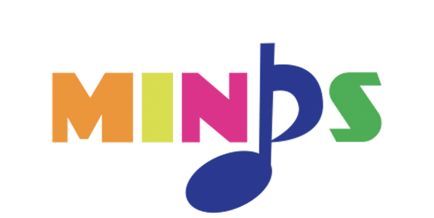

Sound Bag Contents
Information Sheet
Streamers
Lollipop Sticks
Pipe Cleaners
Kazoo
Tambourine
Egg Shaker
Rhythm Family Portrait
Circle Activity Sheet
Balloons
A4 Paper

Lesson One
Hello Song
Introduction to the Instruments using the clock to show the children when to play and when not to play. (Clock 1)
Introduction to the Rhythm Family by clapping and using Dalcroze-inspired movements.
Now play the Rhythm family on the tambourine and egg shaker
Musical extracts are played on the piano using rhythmic values – which rhythm is it?
Let’s make Granny Semibreve out of a pipe cleaner.
Short Instrument Parade (introducing sequence recognition) – tambourine, egg shaker, kazoo.
Zippidy Zap Song.
Goodbye Song

Lesson Two
Hello Song
Revise the Rhythm Family by using body percussion and Instruments.
Use the clock that has the Rhythm Family (Clock 3)
Play the following pieces of music Haydn’s Surprise Symphony, Toreador’s Song from Bizet’s Carmen, Canon in D by Pachelbel) and invite the children to guess which music belongs to which Rhythm Family Member by using streamers.
Let’s Make Cara Crotchet out of a pipe cleaner
Introduce a short Instrument Parade (introducing sequence recognition) – tambourine, egg shaker, kazoo, sleigh bells.
Zippidy Zap Song
Goodbye Song

Lesson Three
Hello Song
Choose your favourite instrument and revise the rhythm in the clock (Clock 3)
The Rhythm Family is going on holiday. Introduce Mrs Treble’s House and project the musical stave on the board behind it.
Introduce the High Low Song
Repeat the High Low Song game using the streamers. Move the streamers up high for the high notes and down low for the low notes.
Let’s Make Mr Minim this week.
Introduce a short Instrument Parade (introducing sequence recognition) – tambourine, sleigh bells, triangle, guiro.
There’s A Beat in My Feat Song (using Kazoos)
Goodbye Song

Lesson Four
Hello Song
Introduce more Body Percussion by singing Are You Sleeping?
Play A Choir Making Sounds of the Rain
Using blank the A4 paper ‘Let’s Go for a walk’ – inspired by Dalcroze.
Introduce the terms Piano/Forte
Play the Piano/Forte Song
Let’s Make the Quavers out of pipe cleaners this week.
Introduce a short Instrument Parade (introducing sequence recognition) – tambourine, egg shaker, sleigh bells, kazoo, agogo, triangle. After the children repeat the sequence, take one instrument away. Let them guess which instrument is missing.
Let’s make the Quavers out of pipe cleaners.
There’s A Beat in My Feat (using Kazoos)
Goodbye Song

Lesson Five
New Hello Song is introduced
Play instruments with the Clock 2
Revise Piano and Forte Song
Ask the children what Instruments play Forte and which ones play Piano. The Forte instruments include the timpani, flute, trumpet, and trombone, while the Piano instrument is the flute.
Explore Piano and Forte in the orchestral work entitled William Tell by Rossini.
It is holiday time again, and the Rhythm Family are going to Mrs Treble’s House.
In preparation for the visit to Mrs. Treble’s House, revise the Rhythm Family on Clock 4.
Introduce C, D and E – (Cora, Dora, Eva). What song has three notes?
Introduce a short Instrument Parade (introducing sequence recognition)– tambourine, egg shaker, sleigh bells, kazoo, agogo, triangle. After the children repeat the sequence, take two instruments away. Let them guess which instruments are missing.
Music Music Song (Lollipop Sticks)
Goodbye Song

Lesson 6
The New Hello Song
Revise the Rhythm Family using Clock 4
Refer to the big Crescendo in the Forte song and look at the big Crescendo on the board behind.
Introduce the Crescendo Song.
Play Grieg’s In the Hall of the Mountain King to explore the Crescendo in the third movement into the fourth, keeping the beat (do you remember there was a beat in our feet?)—this piece of music gets louder.
The Rhythm family is still on holiday.
Cora, Dora, Eva, Fia, Gina are in the house (Notes C, D, E, F, G), but Dora and Fia had to go out. What does the piece of music sound like now? Sing Twinkle Twinkle Little Star
Introduce a short Instrument Parade (introducing sequence recognition)– tambourine, egg shaker, sleigh bells, kazoo, agogo, triangle. After the children repeat the sequence, take three instruments away. Let them guess which instruments are missing.
Music Music (Lollipop Sticks)
Goodbye Song

Lesson Seven
The New Hello Song
Do as I’m Doing Song, alternating between Fast or Slow Tempi
Introduce the Presto/Largo song
Can you guess which music is Presto and Largo? Play the Mexican Hat song (Jarabe Taptio).
Introduce Musical Form by using the picture of a Sandwich
Play the Let’s Make a Sandwich song
Revisit the Mexican Hat song and discuss A and B Form
Play the Twinkle Twinkle Little Star Game
Revise the Rhythm Family by using Clock 4
Revise: Mrs Trebles House
Introduce a short Instrument Parade (introducing sequence recognition)– tambourine, egg shaker, sleigh bells, kazoo, agogo, triangle. After the children repeat the sequence, take three instruments away. Let them guess which instruments are missing.
Stand-Up Sit-Down Song
Goodbye Song

Rhythm Family Clocks
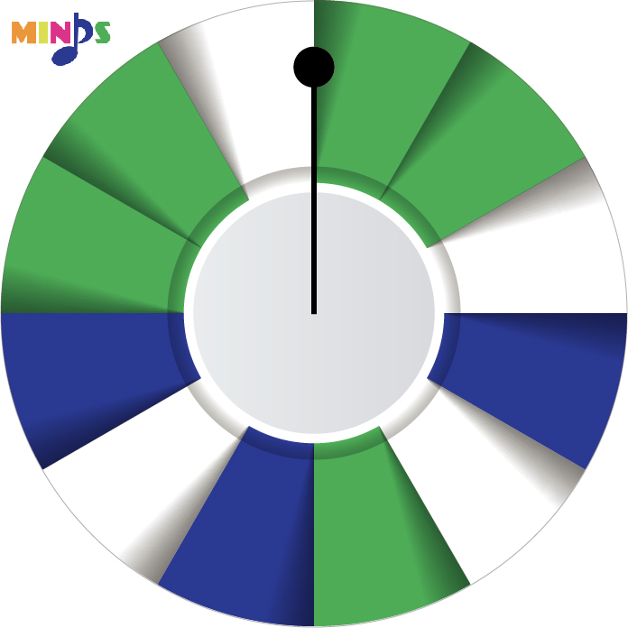
Clock One: Different sounds are played on the green and blue colours; everyone must be silent when the clock hand lands on the white © Music4Children.

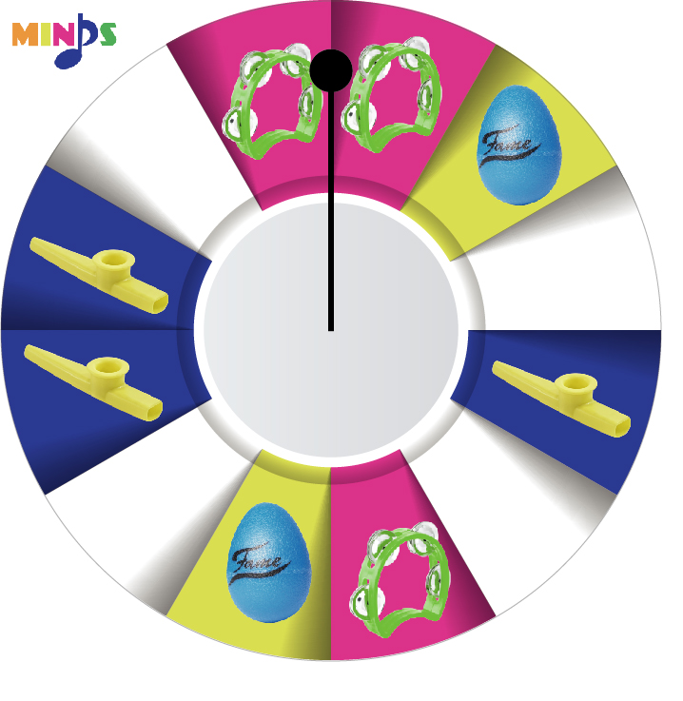
Clock Two: Egg Shakers are played when the clock hand reaches yellow, kazoos when it reaches blue, and tambourines when it reaches pink.
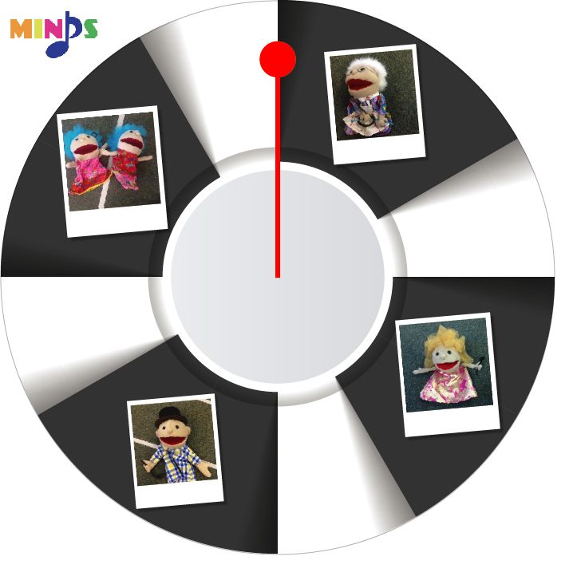
Clock Three: When the hand lands on a member of the rhythm family, the participant must play the relevant rhythmic value.

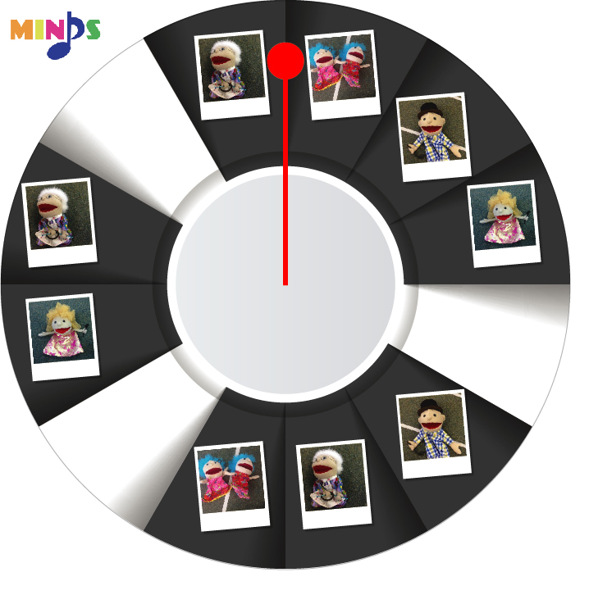
Clock Four: This is the most advanced version of the clock that contains many more rhythms and the clock time moves faster.
