Adaptive strategies of sponges to deoxygenated oceans

Valerio Micaroni, Francesca Strano, Rob Mcallen, Lisa Woods,
John Turner, Luke Harman, James J. Bell

Supplementary Online Information

Supplementary Figures

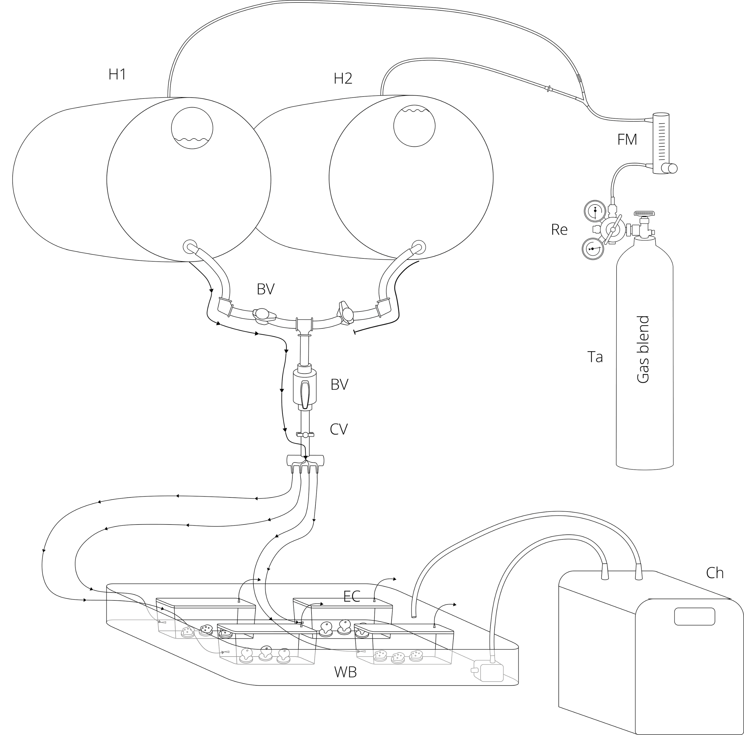

Figure S1. Scheme of a flow-through experimental module used in experiment 1 (moderate hypoxia). The whole setup consisted of eight of these units (two per treatment), each independent of the other and randomly distributed inside the laboratory. For each unit, water was treated in two replicate header tanks (H1 and H2). Each header tank system consisted of two 60L drums (Food Grade HDPE), one for delivering water to the system (H1) and the other for conditioning new water (H2). The header tank delivering water was switched every 12 h, allowing a continuous flow without any interruption. Water was treated by bubbling specific hypoxic gas blends (Ta), whose flow was controlled using a single-stage gas regulator (Re) and a gas flow meter (FM). Treated seawater flowed from the header tank to two replicate experimental chambers for each species (EC, Clip Fresh 2.3L containers, Food-Grade BPA-free Polypropylene) through food-grade vinyl tubing. One-way valves were placed at each experimental chamber’s outlet to stabilize the water flow and avoid air coming back into the chambers. Header tanks were laid horizontally and placed ~1.2 m higher than the experimental chambers to reduce changes in flow rate caused by hydrostatic pressure changes at different water levels in the header tank. Water flow to each chamber was checked daily and finely tuned through a combination of clamp (CV) and ball valves (BV) positioned at different levels of the system. The temperature was kept constant using a water bath (WB) controlled by an aquarium chiller (Ch).

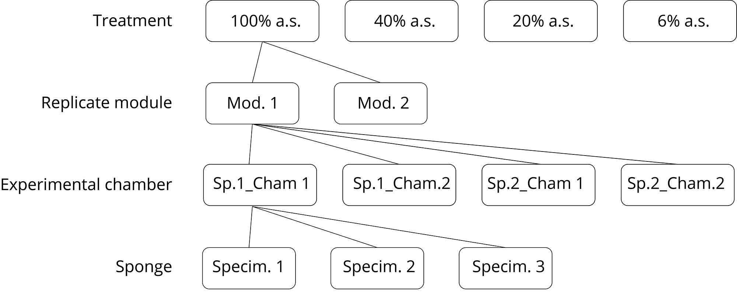

Figure S2. Diagram of the experimental design of experiment 1 (moderate hypoxia). There were four treatments in total, three hypoxic and one normoxic one. Each treatment was replicated in two independent replicate modules. Each replicate module had a total of four experimental chambers, two for each sponge species. Each experimental chamber contained three sponge specimens belonging to the same species.
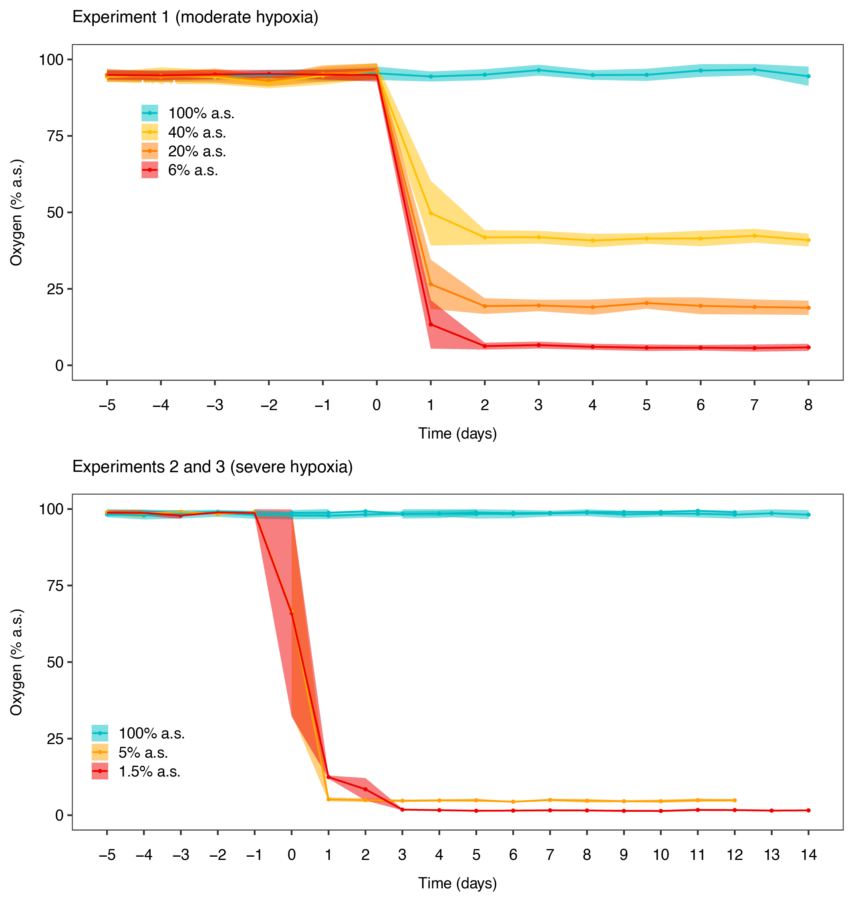

Figure S3. Mean daily oxygen concentration (% air saturation) in the experimental chambers with standard deviation for experiment 1 (moderate hypoxia), and experiments 2 and 3 (severe hypoxia)

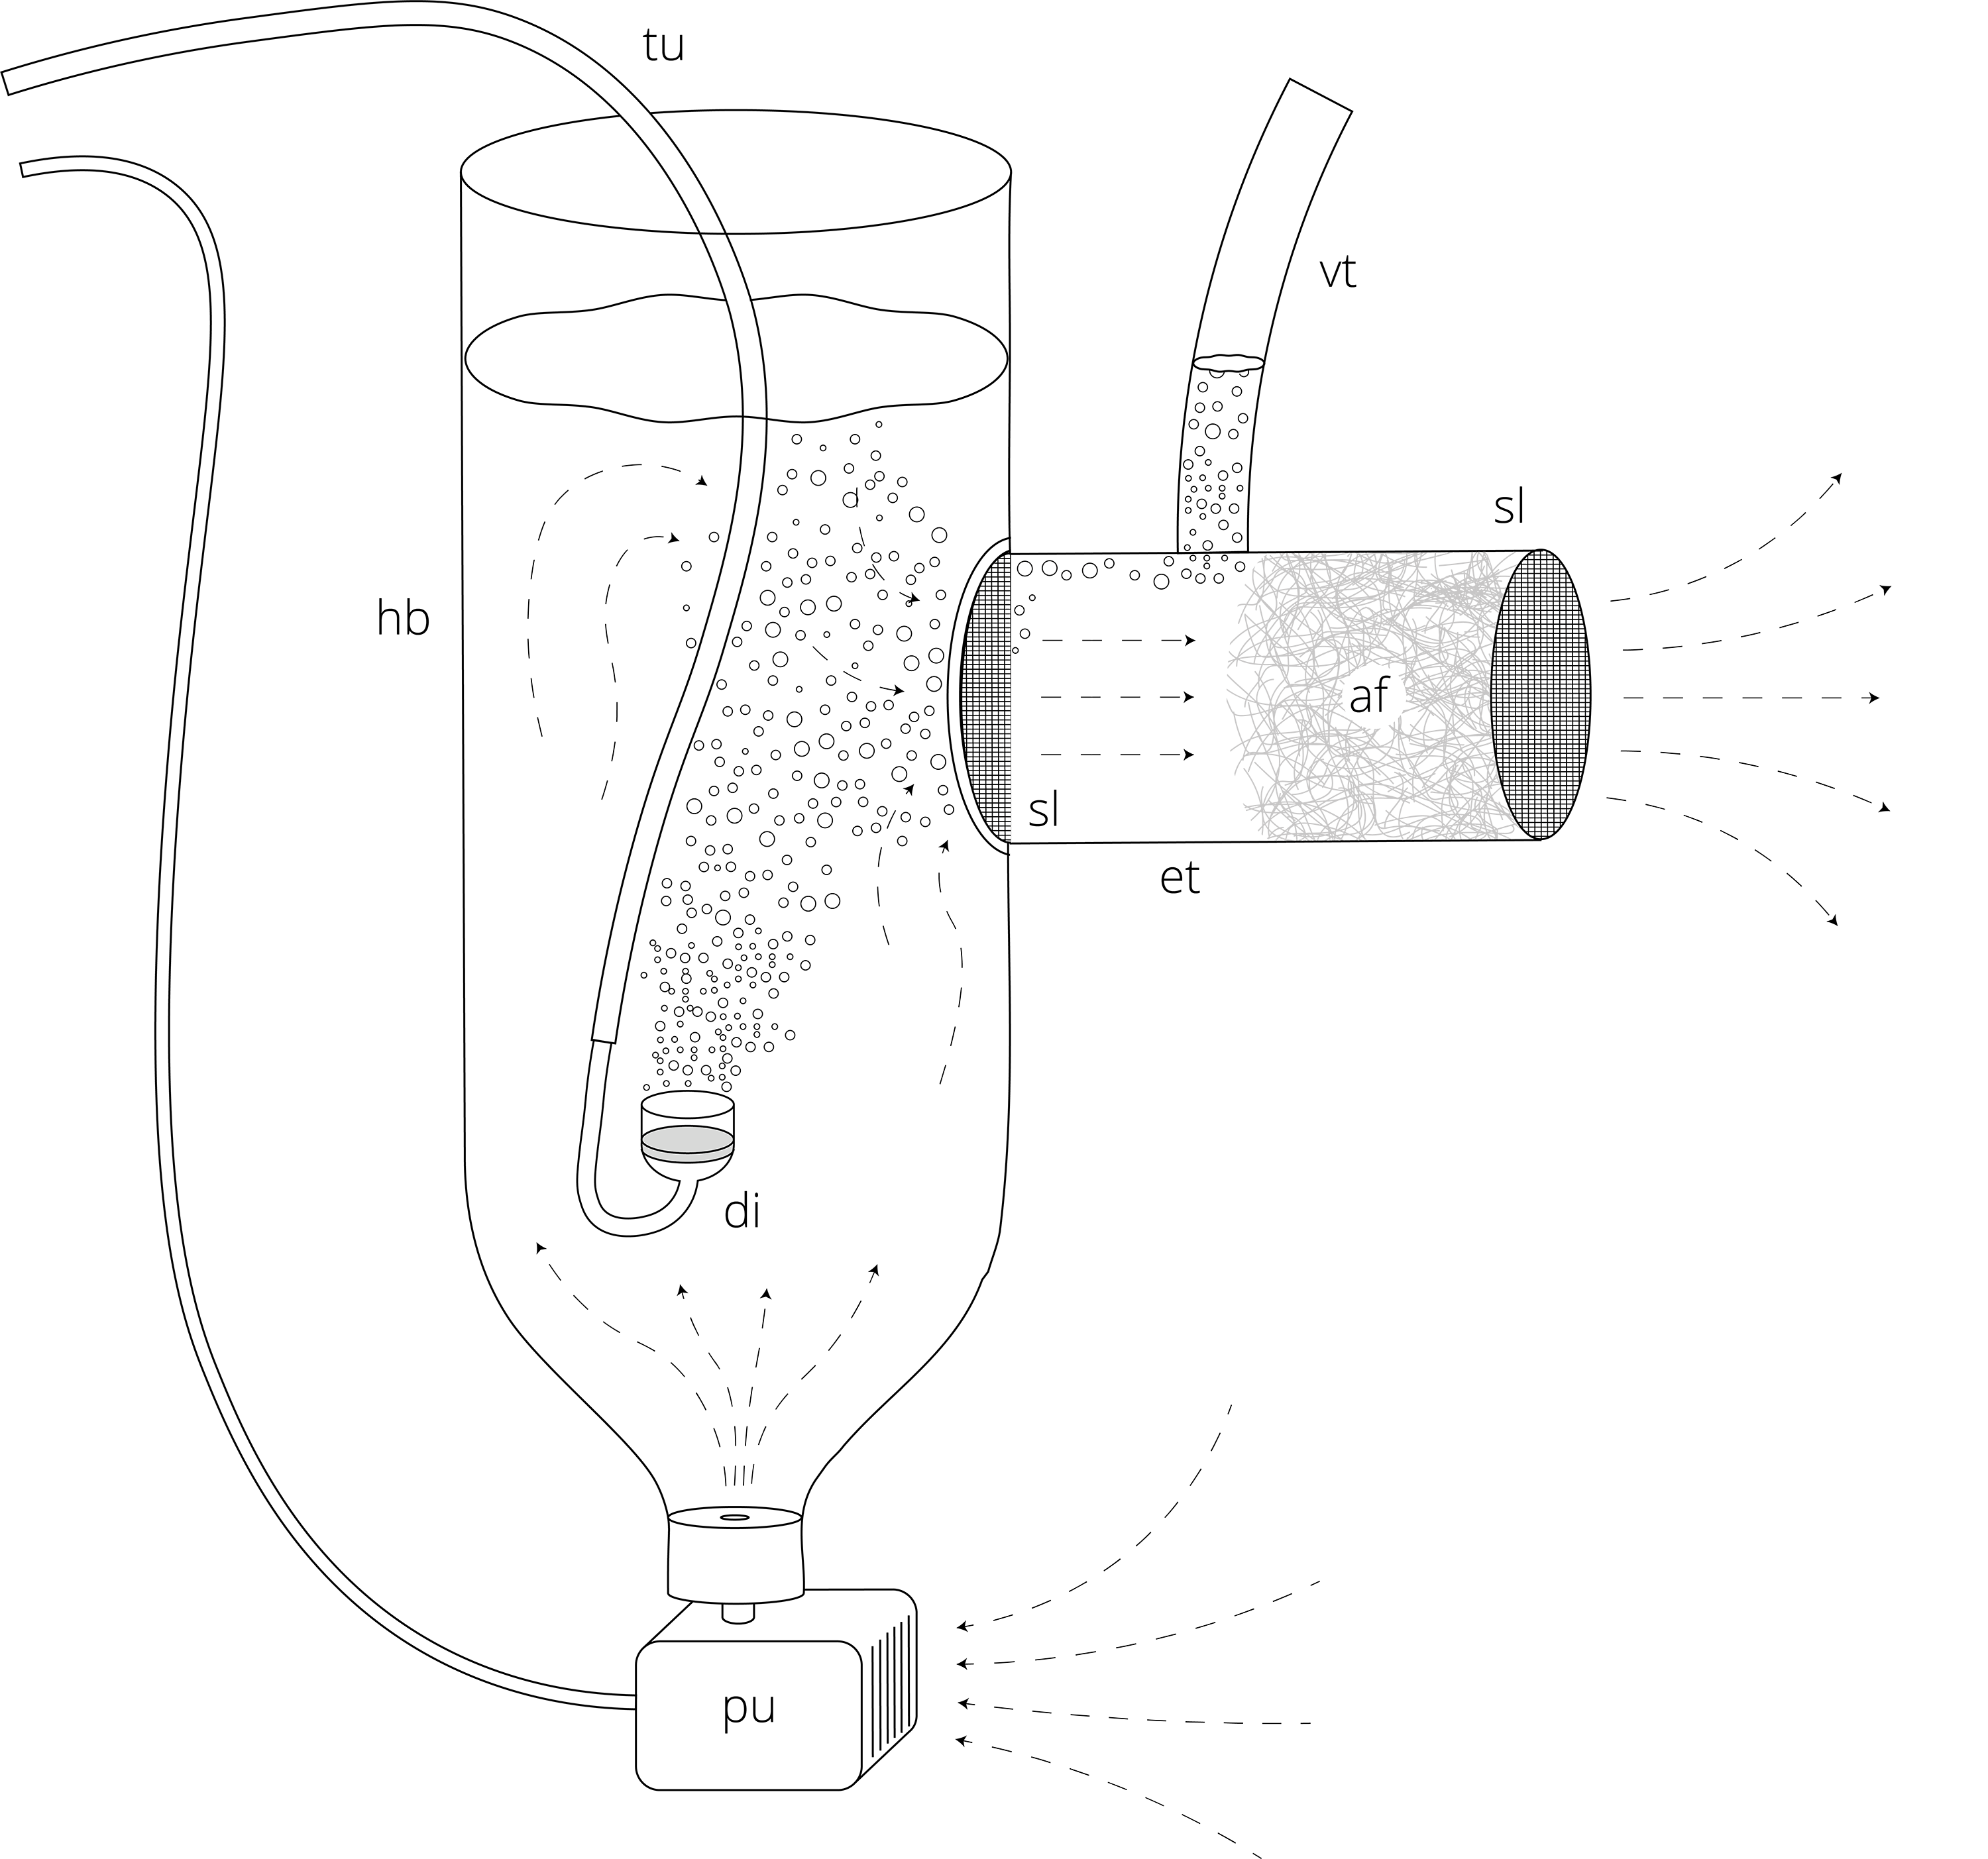

Figure S4. Debubbler device used in experiments 2 and 3 (severe hypoxia). The main body of the debubbler device was composed of an HDPE bottle (hb, 1 L), cut at the base, placed upside down. To isolate it from the experimental chamber, this was fixed to the side of the chamber and had the open extremity 30 mm over the water level. Air/Gas blend was delivered through food-grade vinyl tubing (tu) and bubbled inside the debubbler using a glass-ceramic gas diffuser (di). Water was pumped into the de-bubbler device from the bottleneck using a 3 W pump (pu), and expelled from an exhalant tube (et, vinyl, 40 mm ⌀, 80 mm long) attached on the side of the bottle. The exhalant tube had a scourer sponge layer at the base (sl, 3M™ Scotch-Brite®) and polyester aquarium filter material (af, ZooBest Filterwool) at the extremity to filter the bubbles from the water. The air trapped by the filtering material was then expelled from a vent tube (vt) that connected the exhalant tube to the air gap on the top of the chamber. Dashed lines indicate the water flow.

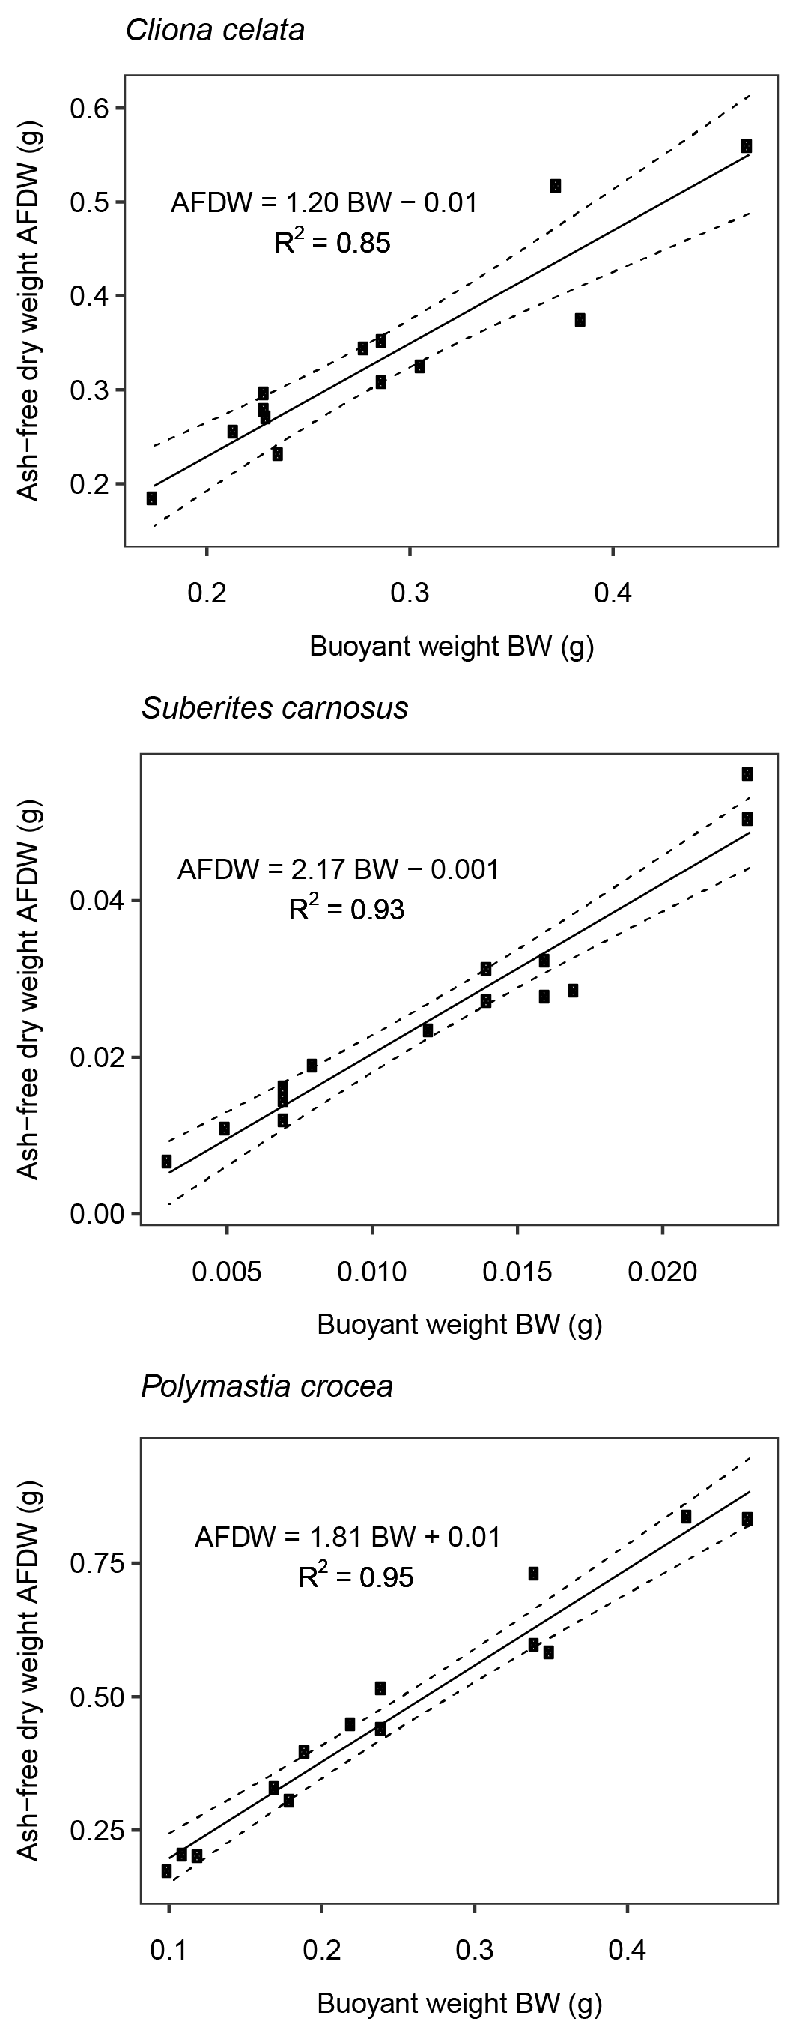

Figure S5. Ash-free dry weight as a function of buoyant weight for Cliona celata, Suberites carnosus and Polymastia crocea. Solid lines indicate the linear regression, while the dashed lines indicate the 95% confidence interval. Conversion ratios were calculated by first measuring the buoyant weight of 14 sponges of each species. The sponges were dried for 72 h in an oven at 60 °C, weighed and then ashed at 500 °C for five hours to determine their AFDW.
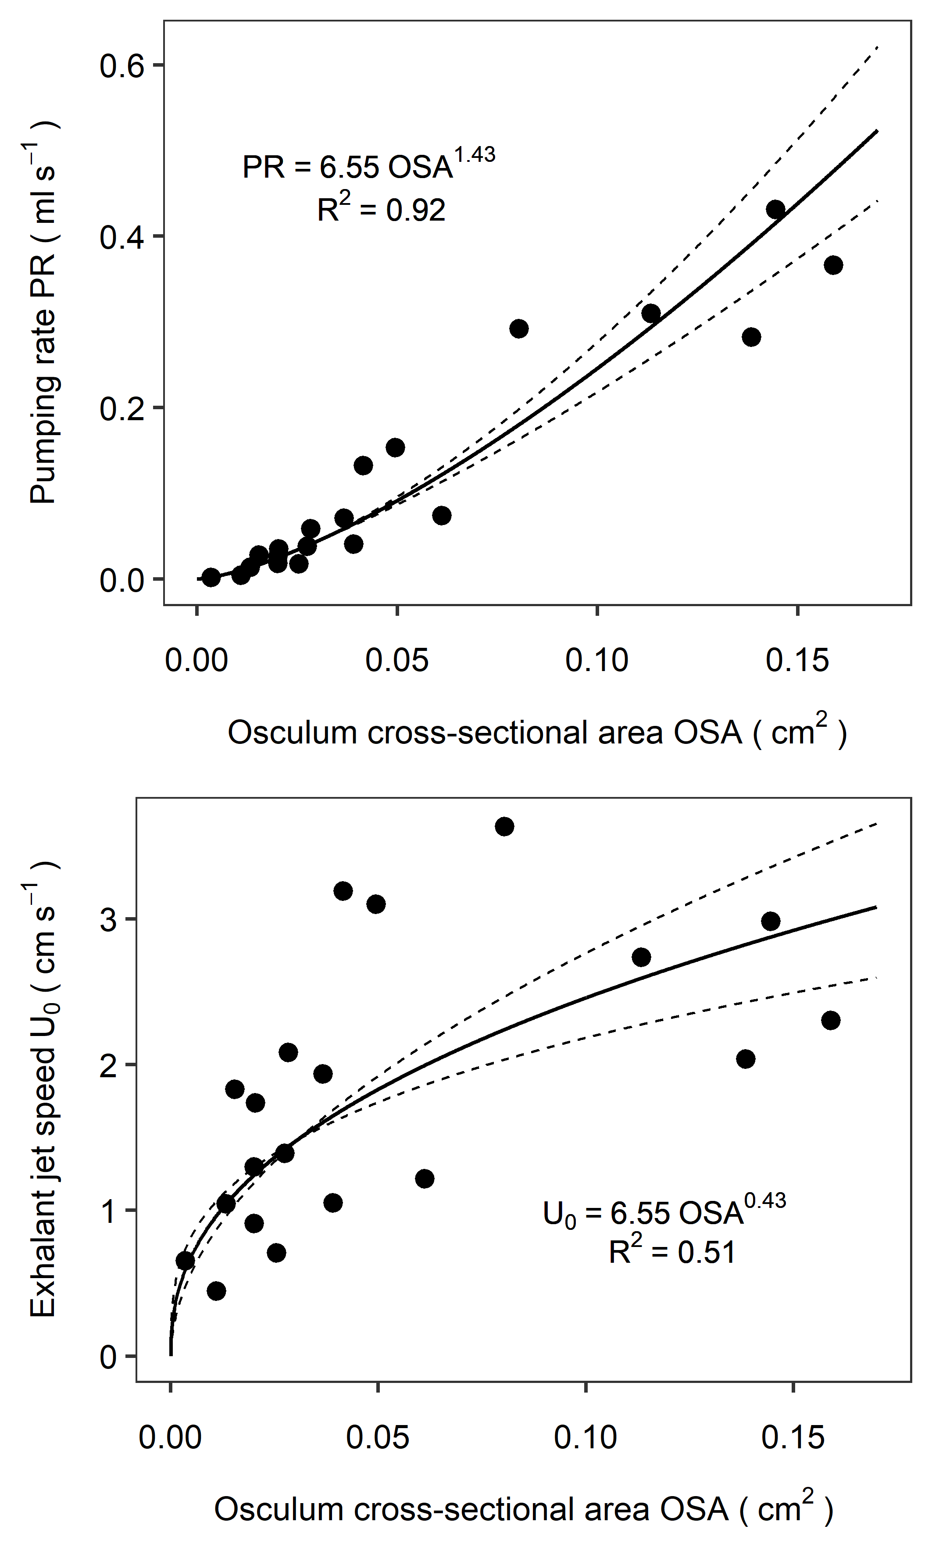

Figure S6. Pumping rate (PR) and Exhalant jet speed (U₀) as functions of Osculum cross-sectional area (OSA) in Suberites australiensis. Solid lines indicate the regression, while the dashed lines indicate the 95% confidence interval.

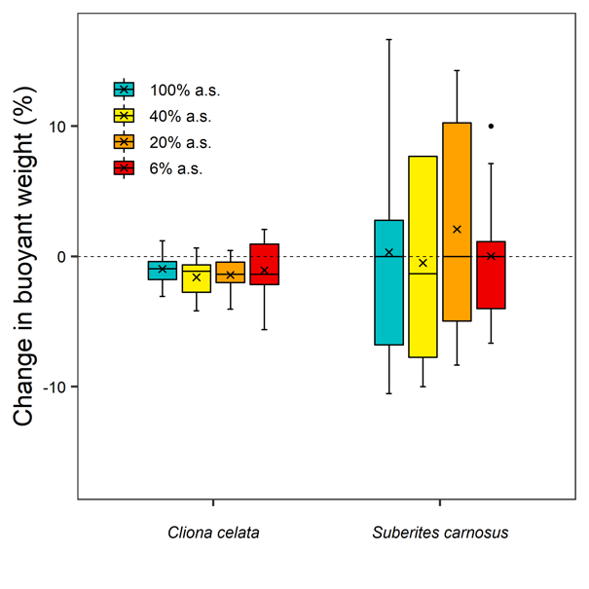

Figure S7. Change in buoyant weight relative to the initial weight between T0 and T-end in Cliona celata and Suberites carnosus from experiment 1 (moderate hypoxia). The oxygen concentration of the different treatments is expressed as % air saturation (% a.s.). Horizontal bars inside the boxplots represent medians; the symbol × represents means. The lower and upper hinges of the boxplots correspond to the first and third quartiles, respectively. Lower and upper whiskers represent the smallest and largest values, respectively. Single dots represent outliers.

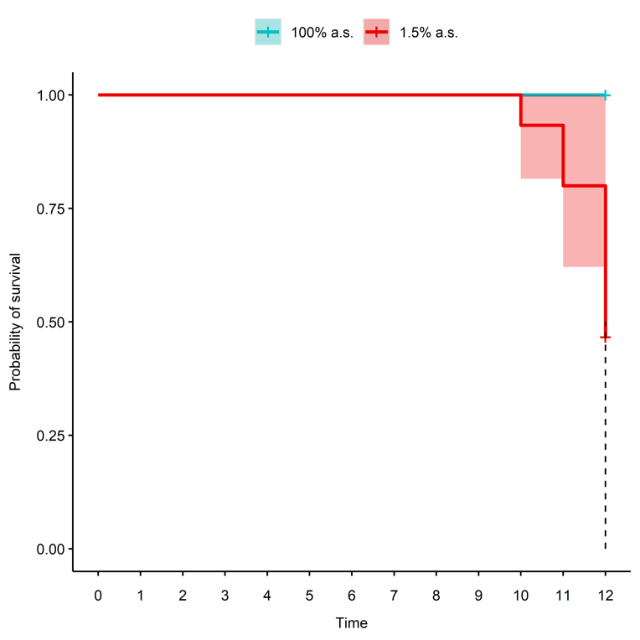

Figure S8. Kaplan-Meier Curve for hypoxia survival in Polymastia crocea from experiment 3 (1.5% a.s.).
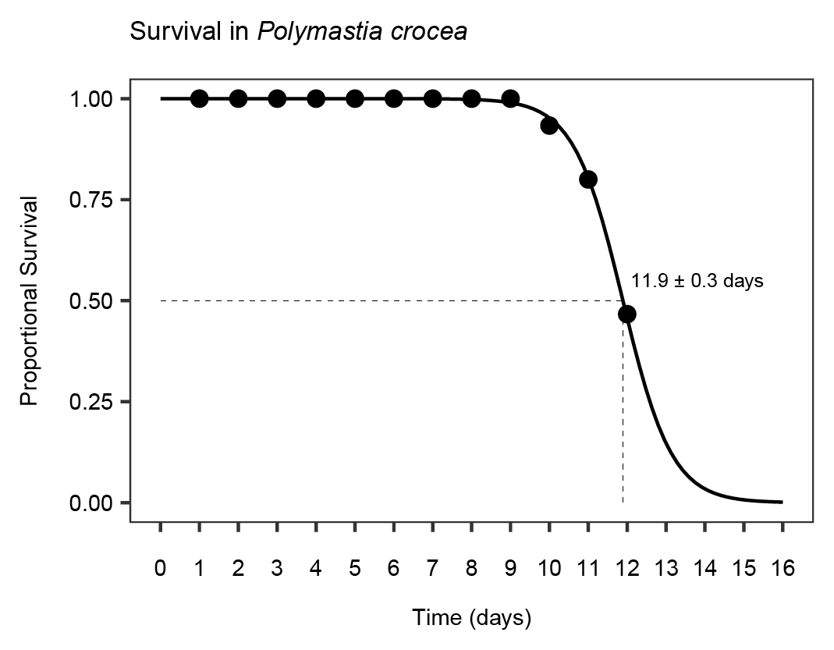

Figure S9. Logistic model of the survival in P. crocea sponges from experiment 3 (1.5% a.s.). Points indicate the recorded values, while the line indicates the model.

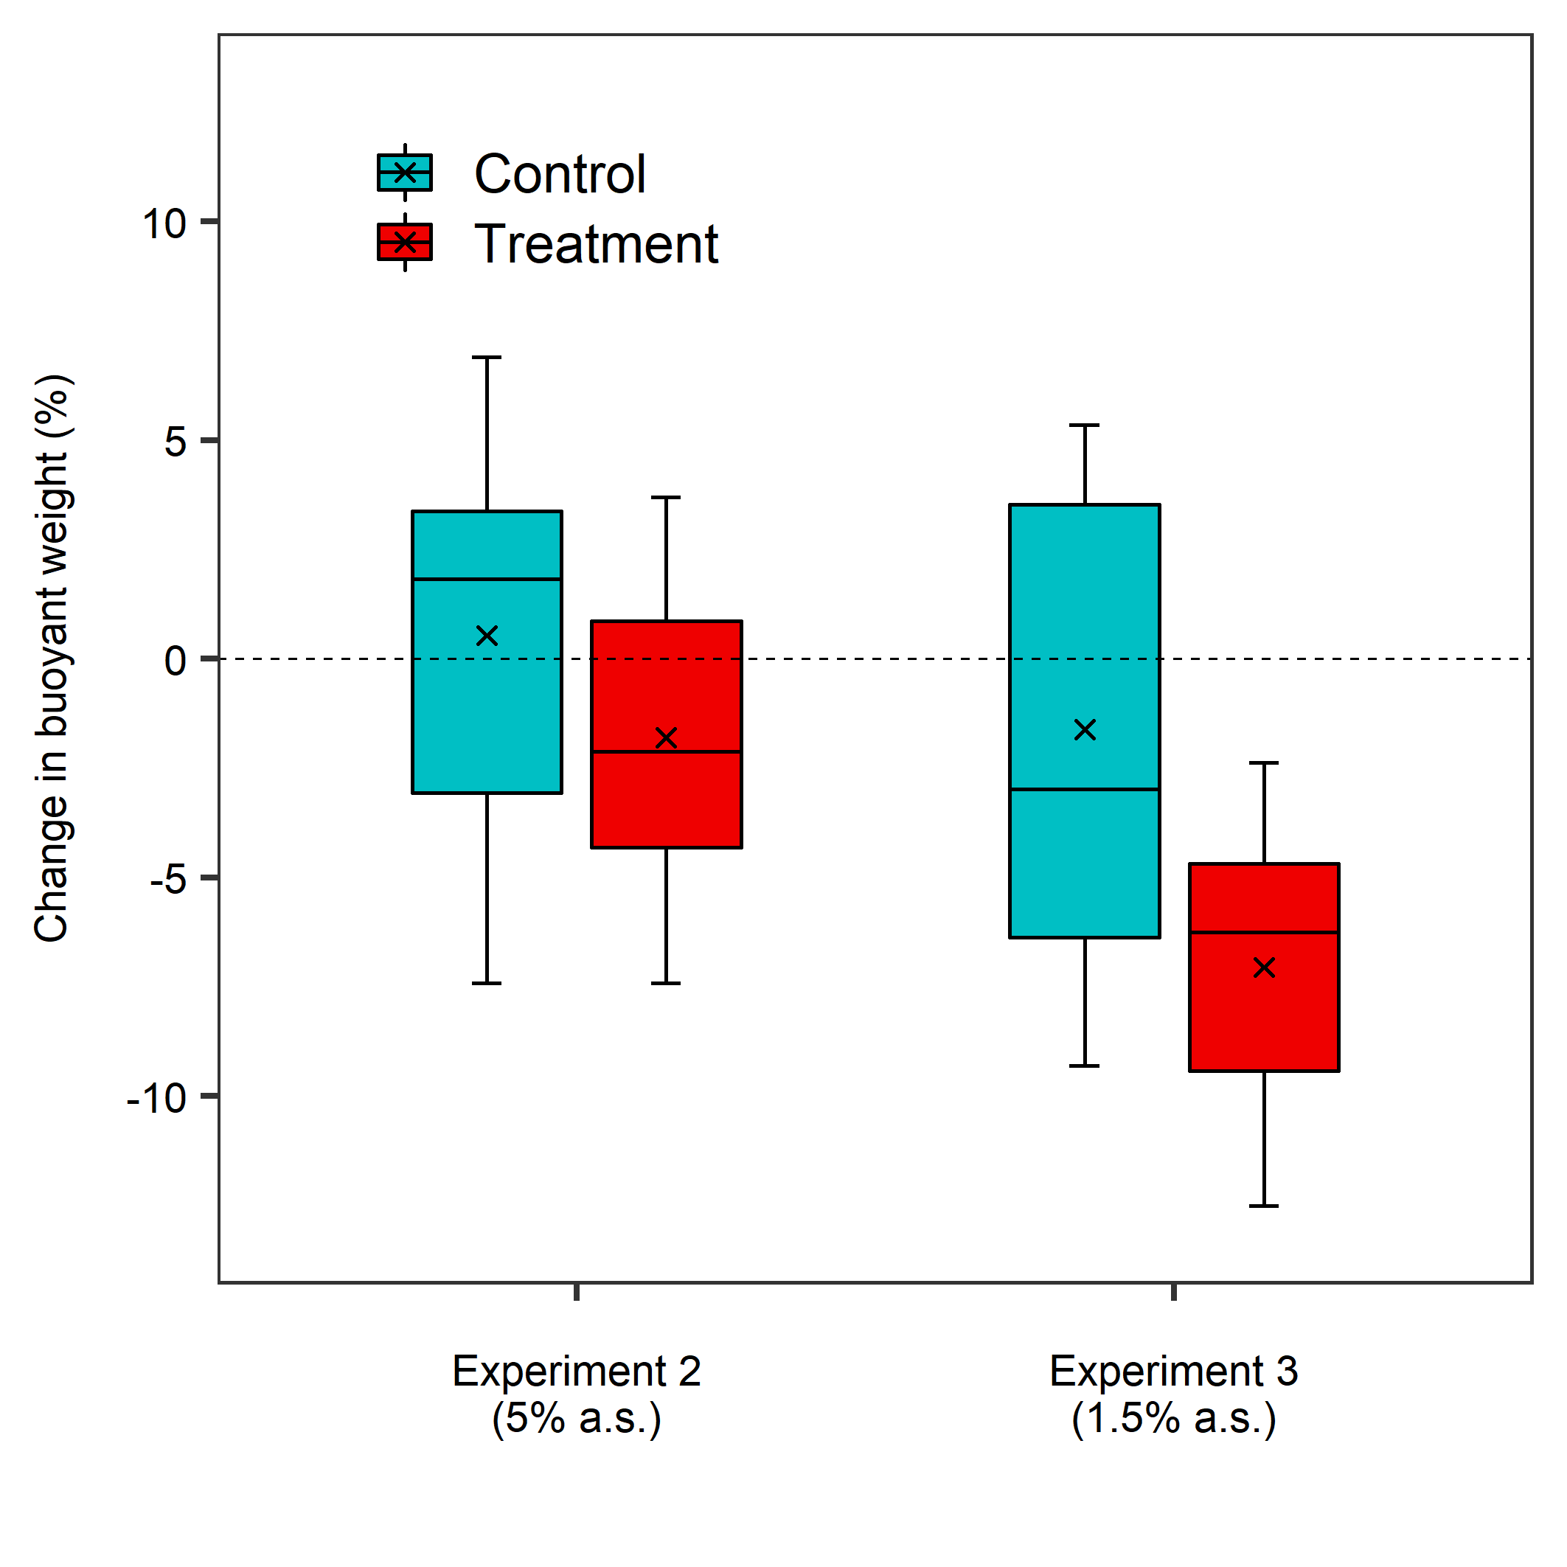

Figure S10. Change in buoyant weight relative to the initial value between T0 and T-end in Polymastia crocea in experiments 2 and 3 (severe hypoxia). Horizontal bars inside the boxplots represent medians; the symbol × represents means. The lower and upper hinges of the boxplots correspond to the first and third quartiles, respectively. The lower and upper whiskers represent the smallest and largest values, respectively. Single dots represent outliers.
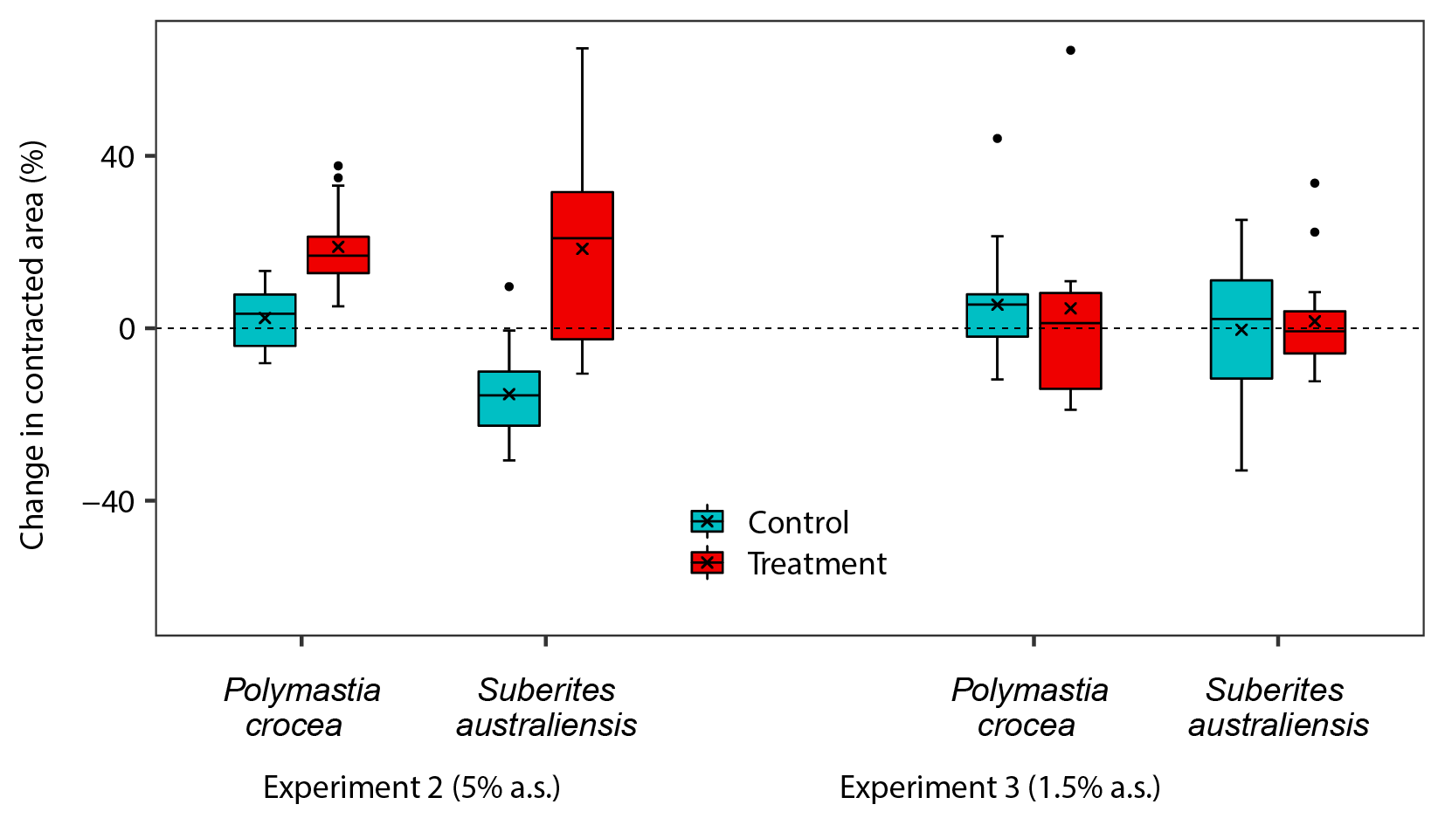

Figure S11. Change in contracted area relative to the initial value between T0 and T-end in Polymastia crocea and Suberites australiensis in experiments 2 and 3 (severe hypoxia). Horizontal bars inside the boxplots represent medians; the symbol × represents means. The lower and upper hinges of the boxplots correspond to the first and third quartiles, respectively. The lower and upper whiskers represent the smallest and largest values, respectively. Single dots represent outliers.

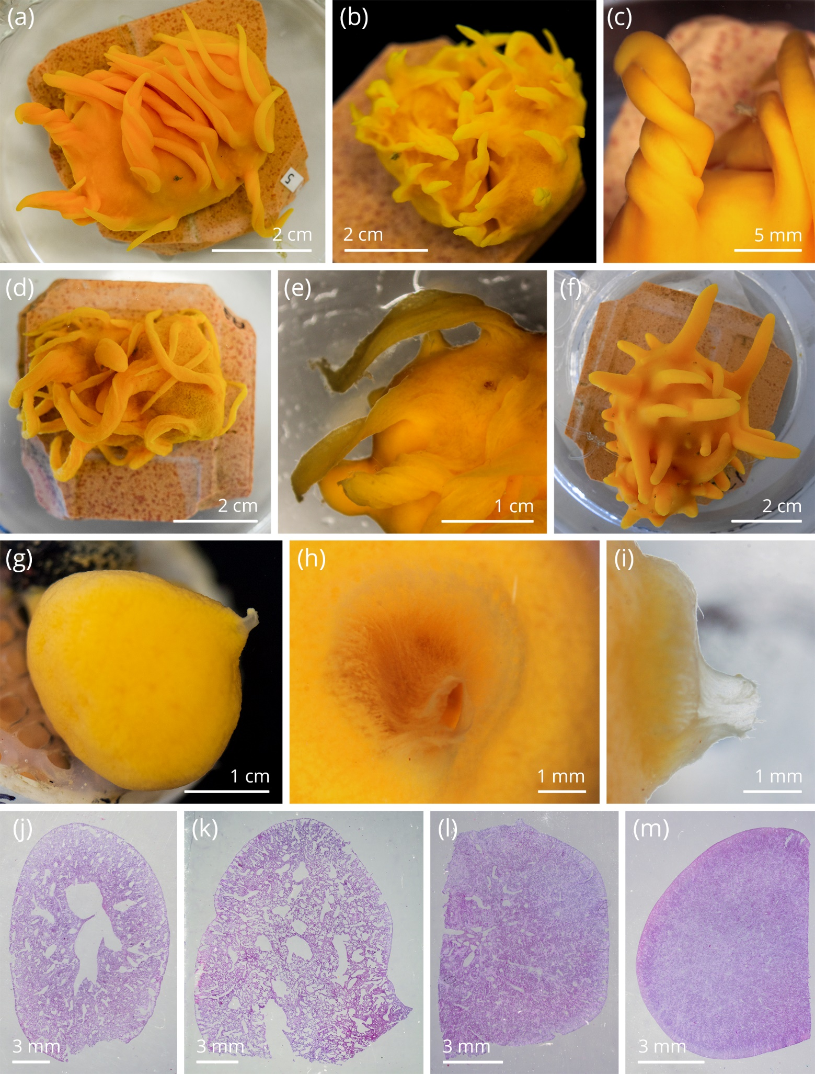

Figure S12. Morphological changes occurred in the sponges exposed to low dissolved oxygen in the severe hypoxia treatments. (a–c) P. crocea exposed to the 5% a.s. treatment; (d–e) P. crocea exposed to the 1.5% a.s. treatment; (f) P. crocea from the control treatment; (g–i) S. australiensis exposed to the 5% a.s. treatment. Histological sections of (j–k) S. carnosus exposed to the 5% a.s. treatment, (l) control, and (m) 1.5% a.s. treatment.

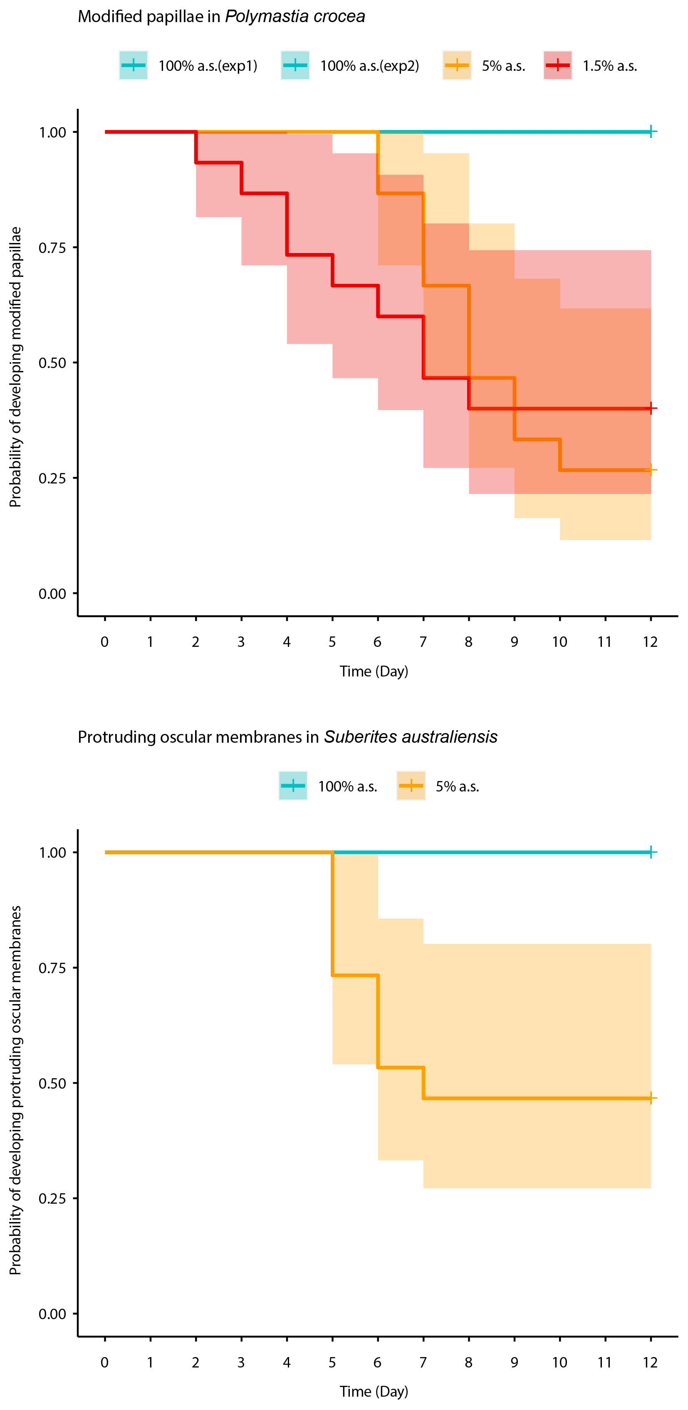

Figure S13. Kaplan-Meier Curve for development of modified papillae in Polymastia crocea and oscular protrusion in S. australiensis from Experiment 2 and 3 (severe hypoxia).

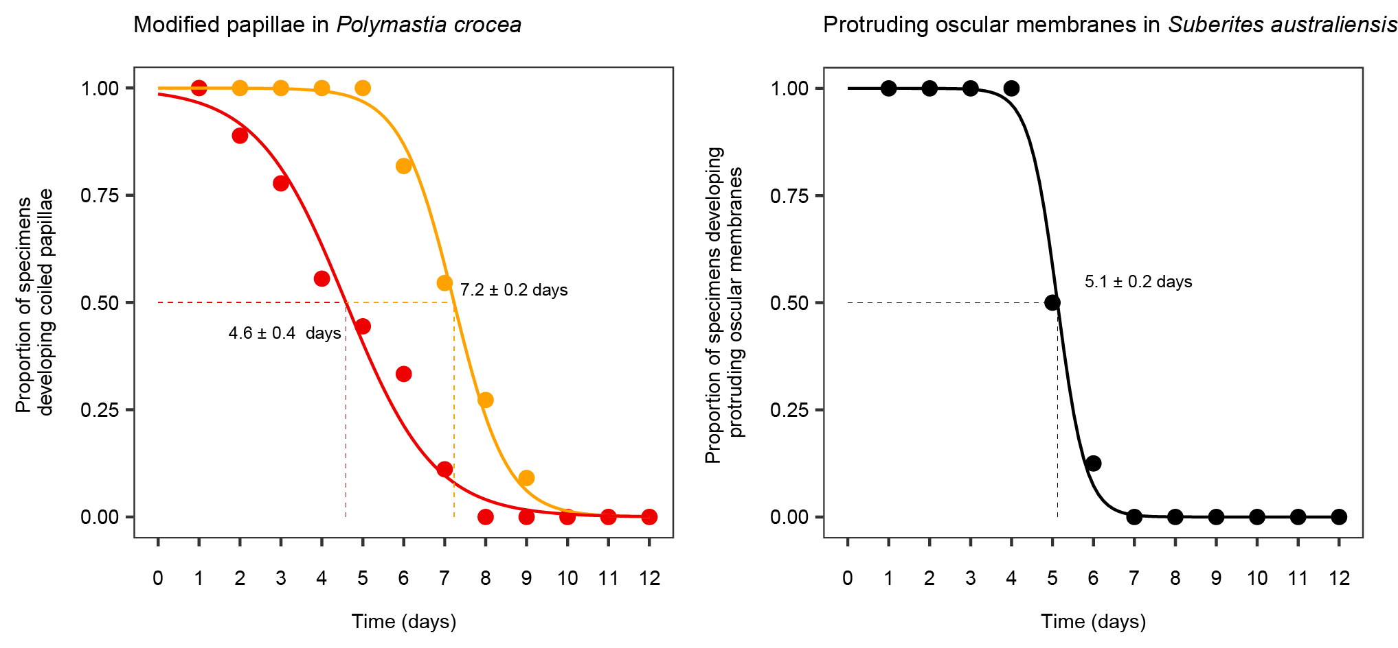

Figure S14. Logistic model of the development of modified papillae in P. crocea from the 5% (yellow) and 1.5% a.s. (red) treatments and protruding oscular membranes in S. australiensis from the 5% a.s. treatment. Points indicate the actual values. Sponges that did not develop these structures were excluded from this analysis.

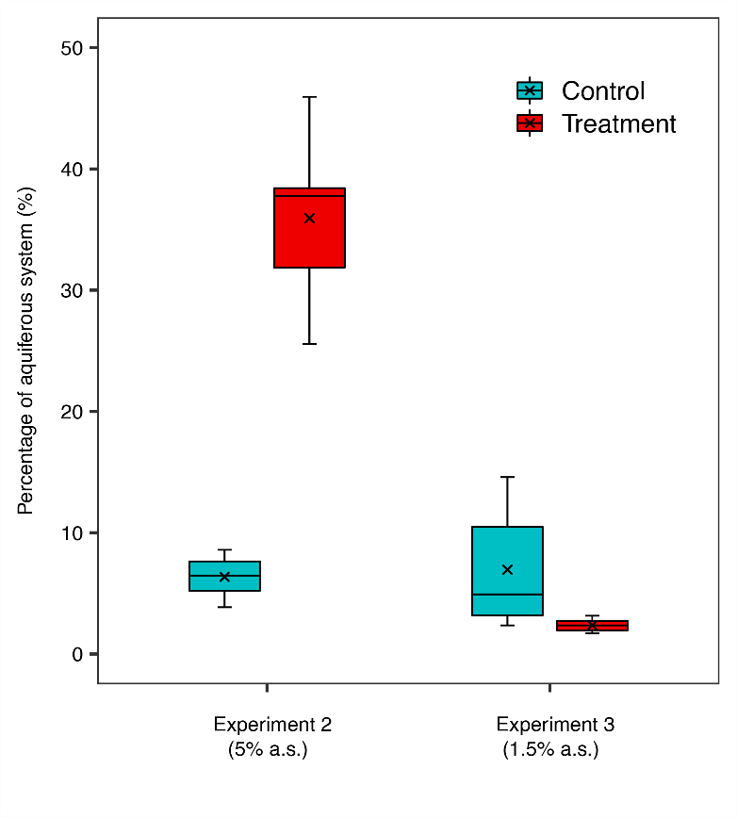

Figure S15. Percentage of sponge body occupied by the aquiferous system at the end of the experiment in Suberites australiensis from Experiment 2 and 3 (severe hypoxia). Horizontal bars inside the boxplots represent medians; the symbol × represents means. The lower and upper hinges of the boxplots correspond to the first and third quartiles, respectively. The lower and upper whiskers represent the smallest and largest values, respectively. Single dots represent outliers.

Supplementary Tables

Table S1. Summary of the experiments performed for this study with measured (*) and calculated (**) seawater parameters represented as the mean (SD) of measurements.

Experiment | Area | Type of System | Length | Treatments | Temp (°C)* | cO₂ (mg/L)* | O₂ (% a.s.)** | O₂ (%)**
1 (moderate hypoxia) | Ireland | Flow-through | 7 days | 100% a.s. | 15.47 (0.23) | 7.71 (0.19) | 95.41 (2.15) | 19.99 (0.45)
 |  |  |  | 40% a.s. | 15.56 (0.24) | 3.34 (0.17) | 41.45 (2.15) | 8.68 (0.45)
 |  |  |  | 20% a.s. | 15.61 (0.23) | 1.56 (0.19) | 19.38 (2.36) | 4.06 (0.50)
 |  |  |  | 5% a.s. | 15.64 (0.20) | 0.48 (0.09) | 6.01 (1.09) | 1.26 (0.23)
2 (severe hypoxia) | New Zealand | Closed system | 12 days | 100% a.s. | 13.25 (0.52) | 8.34 (0.13) | 98.89 (1.13) | 20.72 (0.23)
 |  |  |  | 5% a.s. | 13.26 (0.47) | 0.40 (0.04) | 4.77 (0.49) | 1.00 (0.11)
3 (severe hypoxia) | New Zealand | Closed system | 12 days | 100% a.s. | 14.33 (0.57) | 8.15 (0.16) | 98.34 (1.15) | 20.61 (0.24)
 |  |  |  | 1.5% a.s. | 14.31 (0.61) | 0.13 (0.02) | 1.55 (0.25) | 0.33 (0.06)

Table S2. Summary of the analyses performed. LMM : linear mixed-effects model; GLMM: generalized linear mixed model

Experiment | Species | Variable | Main model | Transformation | Pairwise tests | Model supplement | Pairwise supplement | Table
1 (moderate hypoxia) | C. celata | Change in buoyant weight | Kruskal–Wallis test | - | - | - | - | Tab. S3
1 (moderate hypoxia) | S. carnosus | Change in buoyant weight | Kruskal–Wallis test | - | - | - | - | Tab. S3
1 (moderate hypoxia) | C. celata | Respiration rate | LMM | log (x + 1) | Emmeans | - | - | Tab. S4
1 (moderate hypoxia) | S. carnosus | Respiration rate | LMM | log (x + 1) | Emmeans | - | - | Tab. S5
2 (5% a.s.) | P. crocea | Change in buoyant weight | - | - | Welch t-test | - | - | Tab. S6
3 (1.5% a.s.) | P. crocea | Change in buoyant weight | - | - | Welch t-test | - | - | Tab. S6
2 (5% a.s.) | P. crocea | Change in contracted area | - | - | Wilcoxon test | - | - | Tab. S7
2 (5% a.s.) | S. australiensis | Change in contracted area | - | - | Wilcoxon test | - | - | Tab. S7
3 (1.5% a.s.) | P. crocea | Change in contracted area | - | - | Wilcoxon test | - | - | Tab. S7
3 (1.5% a.s.) | S. australiensis | Change in contracted area | - | - | Wilcoxon test | - | - | Tab. S7
2 (5% a.s.) | P. crocea | Ratio of expanded papillae | PERMANOVA | - | Permutation t-tests | - | - | Tab. S8
3 (1.5% a.s.) | P. crocea | Ratio of expanded papillae | GLMM (beta distribution) | - | Emmeans | - | - | Tab. S9
2 (5% a.s.) | S. australiensis | Expansion ratio | LMM | - | Emmeans | - | - | Tab. S10
3 (1.5% a.s.) | S. australiensis | Expansion ratio | PERMANOVA | - | - | - | - | Tab. S11
2 (5% a.s.) | S. australiensis | Proportion of aquiferous system | - | - | Welch t-test | - | - | -
3 (1.5% a.s.) | S. australiensis | Proportion of aquiferous system | - | - | Welch t-test | - | - | -
2 (5% a.s.) | S. australiensis | Pumping rate | LMM with heterogeneous variance | Square root | Emmeans | PERMANOVA | Permutation t-tests | Tab. S12–13
3 (1.5% a.s.) | S. australiensis | Pumping rate | LMM with heterogeneous variance | Square root | Emmeans | PERMANOVA | Permutation t-tests | Tab. S14–15
2 (5% a.s.) | P. crocea | Respiration rate | LMM | - | Emmeans | - | - | Tab. S16
2 (5% a.s.) | S. australiensis | Respiration rate | LMM | - | Emmeans | - | - | Tab. S17

Table S3. Kruskal–Wallis and One-Sample Wilcoxon Signed Rank tests evaluating the effect of treatment on the relative change in buoyant weight in Cliona celata and Suberites carnosus from experiment 1 (moderate hypoxia). Data are untransformed. P-values are uncorrected, but significance after correction with Benjamini-Hochberg Procedure (sign. corr.) is reported as: *p < 0.05; **p < 0.01; ***p < 0.001; ****p < 0.0001; ns, non-significant. df : degrees of freedom.
Relative change in Buoyant weight - Cliona celata & Suberites carnosus
Experiment 1 (moderate hypoxia)
Untransformed data
Kruskal-Wallis rank sum test
species | Kruskal-Wallis chi-squared |  | p-value | df
C. celata | 1.305 |  | 0.7279 | 3
S. carnosus | 0.767 |  | 0.8574 | 3
One-Sample Wilcoxon Signed-Rank Test (mu = 0)
species | treatment |  | n | W-statistic | p-value | sign. corr.
C. celata | 100% a.s. |  | 12 | 10 | 0.0454 | ns
C. celata | 6% a.s. |  | 12 | 19 | 0.1290 | ns
C. celata | 40% a.s. |  | 12 | 1 | 0.0081 | *
C. celata | 20% a.s. |  | 12 | 1 | 0.0081 | *
S. carnosus | 100% a.s. |  | 12 | 21 | 0.7260 | ns
S. carnosus | 6% a.s. |  | 12 | 15 | 0.9330 | ns
S. carnosus | 40% a.s. |  | 12 | 29.5 | 0.7880 | ns
S. carnosus | 20% a.s. |  | 12 | 35 | 0.4750 | ns

Table S4. Results of the linear mixed effect model (lmer) evaluating the effect of treatment and time on the respiration rate of Cliona celata from experiment 1 (moderate hypoxia). Data are Log (x + 1) transformed. P-values are uncorrected, but significance after correction with Benjamini-Hochberg Procedure (sign. corr.) is reported as: *p < 0.05; **p < 0.01; ***p < 0.001; ****p < 0.0001; ns, non-significant. In fixed effect table: sum sq: sum of squares; mean sq: means quare; numDF: numerator degrees of freedom; denDF: denominator degrees of freedom. In random effects table: npar: number of model parameters; logLik: log-likelihood; AIC: Akaike information criterion; LRT: likelihood ratio test statistic; df : degrees of freedom
Respiration rate - Cliona celata
Experiment 1 (moderate hypoxia)
Linear mixed-effects model (lmer)
Formula: Respiration rate ~ treatment * time + (1|chamber/sponge)
Transformation: Log (x + 1)
Fixed effects test (anova)
 | sum sq | mean sq | numDF | denDF | F-value | p-value
treatment | 0.000 | 0.000 | 3 | 20 | 0.047 | 0.9861
time | 0.011 | 0.005 | 2 | 40 | 2.212 | 0.1227
treatment:time | 0.016 | 0.003 | 6 | 40 | 1.077 | 0.3922
Random effects test (ranova)
 | npar | logLik | AIC | LRT | df | p-value
<none> | 15 | 68.12 | -106.24 | #N/D | #N/D | #N/D
(1 | sponge:chamber) | 14 | 66.36 | -104.73 | 3.51 | 1.00 | 0.061
(1 | chamber) | 14 | 68.12 | -108.24 | 0.00 | 1.00 | 1.000
Pairwise comparisons, time pairs (emmeans)
contrast | treatment | estimate | SE | df | t-ratio | p-value | sign. corr.
day 0 - day 2 | 100% a.s. | -0.01 | 0.03 | 40 | -0.36 | 0.7195 | ns
day 0 - day 7 | 100% a.s. | -0.01 | 0.03 | 40 | -0.42 | 0.6800 | ns
day 2 - day 7 | 100% a.s. | 0.00 | 0.03 | 40 | -0.05 | 0.9574 | ns
day 0 - day 2 | 6% a.s. | 0.04 | 0.03 | 40 | 1.39 | 0.1725 | ns
day 0 - day 7 | 6% a.s. | -0.02 | 0.03 | 40 | -0.87 | 0.3898 | ns
day 2 - day 7 | 6% a.s. | -0.06 | 0.03 | 40 | -2.26 | 0.0294 | ns
day 0 - day 2 | 40% a.s. | 0.01 | 0.03 | 40 | 0.36 | 0.7210 | ns
day 0 - day 7 | 40% a.s. | 0.01 | 0.03 | 40 | 0.45 | 0.6557 | ns
day 2 - day 7 | 40% a.s. | 0.00 | 0.03 | 40 | 0.09 | 0.9291 | ns
day 0 - day 2 | 20% a.s. | 0.07 | 0.03 | 40 | 2.28 | 0.0283 | ns
day 0 - day 7 | 20% a.s. | 0.03 | 0.03 | 40 | 0.87 | 0.3876 | ns
day 2 - day 7 | 20% a.s. | -0.04 | 0.03 | 40 | -1.40 | 0.1688 | ns
Pairwise comparisons, treatment pairs (emmeans)
contrast | time | estimate | SE | df | t-ratio | p-value | sign. corr.
100% a.s. - 6% a.s. | day 0 | -0.01 | 0.03 | 13.92 | -0.19 | 0.8529 | ns
100% a.s. - 40% a.s. | day 0 | -0.02 | 0.03 | 13.92 | -0.46 | 0.6520 | ns
100% a.s. - 20% a.s. | day 0 | -0.03 | 0.03 | 13.92 | -0.93 | 0.3693 | ns
6% a.s. - 40% a.s. | day 0 | -0.01 | 0.03 | 13.92 | -0.27 | 0.7896 | ns
6% a.s. - 20% a.s. | day 0 | -0.02 | 0.03 | 13.92 | -0.74 | 0.4722 | ns
40% a.s. - 20% a.s. | day 0 | -0.02 | 0.03 | 13.92 | -0.47 | 0.6478 | ns
100% a.s. - 6% a.s. | day 2 | 0.04 | 0.03 | 13.92 | 1.31 | 0.2126 | ns
100% a.s. - 40% a.s. | day 2 | 0.01 | 0.03 | 13.92 | 0.16 | 0.8789 | ns
100% a.s. - 20% a.s. | day 2 | 0.04 | 0.03 | 13.92 | 1.32 | 0.2067 | ns
6% a.s. - 40% a.s. | day 2 | -0.04 | 0.03 | 13.92 | -1.15 | 0.2690 | ns
6% a.s. - 20% a.s. | day 2 | 0.00 | 0.03 | 13.92 | 0.02 | 0.9860 | ns
40% a.s. - 20% a.s. | day 2 | 0.04 | 0.03 | 13.92 | 1.17 | 0.2620 | ns
100% a.s. - 6% a.s. | day 7 | -0.02 | 0.03 | 13.92 | -0.58 | 0.5734 | ns
100% a.s. - 40% a.s. | day 7 | 0.01 | 0.03 | 13.92 | 0.28 | 0.7854 | ns
100% a.s. - 20% a.s. | day 7 | 0.01 | 0.03 | 13.92 | 0.17 | 0.8650 | ns
6% a.s. - 40% a.s. | day 7 | 0.03 | 0.03 | 13.92 | 0.85 | 0.4074 | ns
6% a.s. - 20% a.s. | day 7 | 0.03 | 0.03 | 13.92 | 0.75 | 0.4658 | ns
40% a.s. - 20% a.s. | day 7 | 0.00 | 0.03 | 13.92 | -0.10 | 0.9183 | ns

Table S5. Results of the linear mixed effect model (lmer) evaluating the effect of treatment and time on the respiration rate of Suberites carnosus from experiment 1 (moderate hypoxia). Data are Log (x + 1) transformed. P-values are uncorrected, but significance after correction with Benjamini-Hochberg Procedure (sign. corr.) is reported as: *p < 0.05; **p < 0.01; ***p < 0.001; ****p < 0.0001; ns, non-significant. In fixed effect table: sum sq: sum of squares; mean sq: means quare; numDF: numerator degrees of freedom; denDF: denominator degrees of freedom. In random effects table: npar: number of model parameters; logLik: log-likelihood; AIC: Akaike information criterion; LRT: likelihood ratio test statistic; df : degrees of freedom.
Respiration rate - Suberites carnosus
Experiment 1 (moderate hypoxia)
Linear mixed-effects model (lmer)
Formula: Respiration rate ~ treatment * time + (1|chamber/sponge)
Trasformation: Log (x + 1)
Fixed effects test (anova)
 | sum sq | mean sq | numDF | denDF | F-value | p-value
treatment | 0.326 | 0.109 | 3 | 20.000 | 1.700 | 0.1992
time | 0.980 | 0.490 | 2 | 40.000 | 7.663 | 0.0015
treatment:time | 1.350 | 0.225 | 6 | 40.000 | 3.521 | 0.0068
Random effects test (ranova)
 | npar | logLik | AIC | LRT | df | p-value
<none> | 15 | -32.10 | 94.20 | #N/A | #N/A | #N/A
(1 | sponge:chamber) | 14 | -35.81 | 99.61 | 7.41 | 1.00 | 0.006
(1 | chamber) | 14 | -32.10 | 92.20 | 0.00 | 1.00 | 1.000
Pairwise comparisons, time pairs (emmeans)
contrast | treatment | estimate | SE | df | t-ratio | p-value | sign. corr.
day 0 - day 2 | 100% a.s. | 0.10 | 0.15 | 40 | 0.70 | 0.4907 | ns
day 0 - day 7 | 100% a.s. | 0.04 | 0.15 | 40 | 0.26 | 0.7992 | ns
day 2 - day 7 | 100% a.s. | -0.06 | 0.15 | 40 | -0.44 | 0.6627 | ns
day 0 - day 2 | 6% a.s. | -0.06 | 0.15 | 40 | -0.43 | 0.6677 | ns
day 0 - day 7 | 6% a.s. | 0.68 | 0.15 | 40 | 4.64 | < 0.0001 | ***
day 2 - day 7 | 6% a.s. | 0.74 | 0.15 | 40 | 5.07 | < 0.0001 | ***
day 0 - day 2 | 40% a.s. | 0.06 | 0.15 | 40 | 0.40 | 0.6894 | ns
day 0 - day 7 | 40% a.s. | 0.06 | 0.15 | 40 | 0.44 | 0.6623 | ns
day 2 - day 7 | 40% a.s. | 0.01 | 0.15 | 40 | 0.04 | 0.9703 | ns
day 0 - day 2 | 20% a.s. | 0.01 | 0.15 | 40 | 0.07 | 0.9445 | ns
day 0 - day 7 | 20% a.s. | 0.26 | 0.15 | 40 | 1.78 | 0.0825 | ns
day 2 - day 7 | 20% a.s. | 0.25 | 0.15 | 40 | 1.71 | 0.0949 | ns
Pairwise comparisons, treatment pairs (emmeans)
contrast | time | estimate | SE | df | t-ratio | p-value | sign. corr.
100% a.s. - 6% a.s. | day 0 | -0.20 | 0.18 | 11.29 | -1.08 | 0.3019 | ns
100% a.s. - 40% a.s. | day 0 | 0.21 | 0.18 | 11.29 | 1.14 | 0.2766 | ns
100% a.s. - 20% a.s. | day 0 | 0.15 | 0.18 | 11.29 | 0.84 | 0.4187 | ns
6% a.s. - 40% a.s. | day 0 | 0.41 | 0.18 | 11.29 | 2.22 | 0.0473 | ns
6% a.s. - 20% a.s. | day 0 | 0.35 | 0.18 | 11.29 | 1.92 | 0.0803 | ns
40% a.s. - 20% a.s. | day 0 | -0.06 | 0.18 | 11.29 | -0.30 | 0.7668 | ns
100% a.s. - 6% a.s. | day 2 | -0.36 | 0.18 | 11.29 | -1.98 | 0.0730 | ns
100% a.s. - 40% a.s. | day 2 | 0.17 | 0.18 | 11.29 | 0.91 | 0.3815 | ns
100% a.s. - 20% a.s. | day 2 | 0.06 | 0.18 | 11.29 | 0.34 | 0.7379 | ns
6% a.s. - 40% a.s. | day 2 | 0.53 | 0.18 | 11.29 | 2.89 | 0.0144 | ns
6% a.s. - 20% a.s. | day 2 | 0.43 | 0.18 | 11.29 | 2.32 | 0.0400 | ns
40% a.s. - 20% a.s. | day 2 | -0.10 | 0.18 | 11.29 | -0.57 | 0.5814 | ns
100% a.s. - 6% a.s. | day 5 | 0.44 | 0.18 | 11.29 | 2.40 | 0.0348 | ns
100% a.s. - 40% a.s. | day 5 | 0.24 | 0.18 | 11.29 | 1.29 | 0.2231 | ns
100% a.s. - 20% a.s. | day 5 | 0.38 | 0.18 | 11.29 | 2.05 | 0.0644 | ns
6% a.s. - 40% a.s. | day 5 | -0.20 | 0.18 | 11.29 | -1.11 | 0.2904 | ns
6% a.s. - 20% a.s. | day 5 | -0.06 | 0.18 | 11.29 | -0.35 | 0.7336 | ns
40% a.s. - 20% a.s. | day 5 | 0.14 | 0.18 | 11.29 | 0.76 | 0.4627 | ns

Table S6. Welch t-tests evaluating the effect of treatment on the relative change in buoyant weight in Polymastia crocea & Suberites australiensis from experiments 2 and 3 (severe hypoxia). Data are untransformed. P-values are uncorrected, but significance after correction with Benjamini-Hochberg Procedure (sign. corr.) is reported as: *p < 0.05; **p < 0.01; ***p < 0.001; ****p < 0.0001; ns, non-significant. df : degrees of freedom

Relative change in Buoyant weight - Polymastia crocea & Suberites australiensis
Experiments 2 and 3 (severe hypoxia)
Untransformed data
Two-Sample Welch t-test
experiment | species | group1 | group2 | n1 | n2 | t | df | p-value | sign. corr.
2 (5% a.s.) | P. crocea | 100% a.s. | 5% a.s. | 15 | 15 | 1.6 | 25.8 | 0.1180 | ns
3 (1.5% a.s.) | P. crocea | 100% a.s. | 1.5% a.s. | 15 | 7 | 2.8 | 16.8 | 0.0119 | *
One-Sample Welch t-test (mu = 0)
experiment | species | treatment |  | n |  | t | df | p-value | sign. corr.
2 (5% a.s.) | P. crocea | 100% a.s. |  | 15 |  | 0.5 | 14 | 0.6520 | ns
2 (5% a.s.) | P. crocea | 5% a.s. |  | 15 |  | -2.1 | 14 | 0.0545 | ns
3 (1.5% a.s.) | P. crocea | 100% a.s. |  | 15 |  | -1.2 | 14 | 0.2580 | ns
3 (1.5% a.s.) | P. crocea | 1.5% a.s. |  | 7 |  | -5.2 | 6 | 0.0021 | **

Table S7. Wilcoxon signed-rank tests evaluating the effect of treatment on the relative change in contracted area in Polymastia crocea & Suberites australiensis from experiments 2 and 3 (severe hypoxia). Data are untransformed. P-values are uncorrected, but significance after correction with Benjamini-Hochberg Procedure (sign. corr.) is reported as: *p < 0.05; **p < 0.01; ***p < 0.001; ****p < 0.0001; ns, non-significant.

Relative change in Contracted area - Polymastia crocea & Suberites australiensis
Experiments 2 and 3 (severe hypoxia)
Untransformed data
Two-Sample Wilcoxon Signed-Rank Test
experiment | species | group1 | group2 | n1 | n2 | W-statistic | p-value | sign. corr.
2 (5% a.s.) | P. crocea | 100% a.s. | 5% a.s. | 15 | 15 | 12 | < 0.0001 | ****
2 (5% a.s.) | S. australiensis | 100% a.s. | 5% a.s. | 15 | 15 | 13 | < 0.0001 | ****
3 (1.5% a.s.) | P. crocea | 100% a.s. | 1.5% a.s. | 15 | 7 | 54 | 0.9450 | ns
3 (1.5% a.s.) | S. australiensis | 100% a.s. | 1.5% a.s. | 15 | 15 | 123 | 0.6830 | ns
One-Sample Wilcoxon Signed-Rank Test (mu = 0)
experiment | species | treatment |  |  | n | W-statistic | p-value | sign. corr.
2 (5% a.s.) | P. crocea | 100% a.s. |  |  | 15 | 80 | 0.2770 | ns
2 (5% a.s.) | P. crocea | 5% a.s. |  |  | 15 | 120 | 0.0001 | ***
2 (5% a.s.) | S. australiensis | 100% a.s. |  |  | 15 | 3 | 0.0003 | **
2 (5% a.s.) | S. australiensis | 5% a.s. |  |  | 15 | 105 | 0.0084 | *
3 (1.5% a.s.) | P. crocea | 100% a.s. |  |  | 15 | 84 | 0.1880 | ns
3 (1.5% a.s.) | P. crocea | 1.5% a.s. |  |  | 7 | 16 | 0.8130 | ns
3 (1.5% a.s.) | S. australiensis | 100% a.s. |  |  | 15 | 60 | 0.6600 | ns
3 (1.5% a.s.) | S. australiensis | 1.5% a.s. |  |  | 15 | 55 | 0.8040 | ns

Table S8. Results of the PERMANOVA model, and permutation t-tests evaluating the effect of treatment and time on the ratio of expanded papillae in Polymastia crocea from experiment 2 (5% a.s.). Data are untransformed. P-values are uncorrected, but significance after correction with Benjamini-Hochberg Procedure (sign. corr.) is reported as: *p < 0.05; **p < 0.01; ***p < 0.001; ****p < 0.0001; ns, non-significant. df : degrees of freedom; SS: sum of squares; MS: mean squares; perms: number of permutations.
Ratio of expanded papillae - Polymastia crocea
Experiment 2 (5% a.s.)
Repeated Measures Univariate PERMANOVA
Resemblance: D1 Euclidean distance
Sums of squares type: Type I (sequential)
Permutation method: Permutation of residuals under a reduced model
Number of permutations: 9999
Untransformed data
Factors | Abbrev. | Type
treatment | TR | Fixed
chamber | CH | Random
sponge | SP | Random
time | TI | Fixed
source | df | SS | MS | pseudo-F | p-value | perms
TR | 1 | 7.6 | 7.6 | 18.4 | 0.1028 | 10
CH(TR) | 4 | 1.7 | 0.4 | 1.5 | 0.2395 | 9957
SP(CH(TR)) | 24 | 6.8 | 0.3 | 19.8 | 0.0001 | 9898
TI | 12 | 12.1 | 1.0 | 61.9 | 0.0001 | 9948
TRxTI | 12 | 5.2 | 0.4 | 26.6 | 0.0001 | 9918
CH(TR)xTI | 48 | 0.8 | 0.0 | 1.1 | 0.2642 | 9872
Res | 288 | 4.1 | 0.0
Total | 389 | 38.3
Pairwise permutation t-tests, pairs of times |  |  |  |  | Pairwise permutation t-tests, pairs of treatments
treatment | comparison | p-value | sign. corr. |  | time | comparison | p-value | sign. corr.
5% a.s. | T1 vs T0 | 0.4920 | ns |  | T0 | 5% a.s. vs 100% a.s. | 0.7412 | ns
5% a.s. | T2 vs T1 | 0.4994 | ns |  | T1 | 5% a.s. vs 100% a.s. | 0.4810 | ns
5% a.s. | T3 vs T2 | 0.2554 | ns |  | T2 | 5% a.s. vs 100% a.s. | 0.7980 | ns
5% a.s. | T4 vs T3 | 0.0088 | * |  | T3 | 5% a.s. vs 100% a.s. | 0.2644 | ns
5% a.s. | T5 vs T4 | 0.0038 | * |  | T4 | 5% a.s. vs 100% a.s. | 0.1754 | ns
5% a.s. | T6 vs T5 | 0.0012 | * |  | T5 | 5% a.s. vs 100% a.s. | 0.0346 | ns
5% a.s. | T7 vs T6 | 0.0008 | * |  | T6 | 5% a.s. vs 100% a.s. | 0.0052 | **
5% a.s. | T8 vs T7 | 0.0038 | * |  | T7 | 5% a.s. vs 100% a.s. | 0.0016 | **
5% a.s. | T9 vs T8 | 0.0076 | * |  | T8 | 5% a.s. vs 100% a.s. | 0.0004 | **
5% a.s. | T10 vs T9 | 0.0024 | * |  | T9 | 5% a.s. vs 100% a.s. | 0.0002 | ***
5% a.s. | T11 vs T10 | 0.6480 | ns |  | T11 | 5% a.s. vs 100% a.s. | 0.0002 | ***
5% a.s. | T12 vs T0 | 0.0002 | ** |  | T12 | 5% a.s. vs 100% a.s. | 0.0002 | ***
5% a.s. | T12 vs T11 | 0.1368 | ns |  | T10 | 5% a.s. vs 100% a.s. | 0.0002 | ***
100% a.s. | T1 vs T0 | 0.7442 | ns
100% a.s. | T2 vs T1 | 0.4920 | ns
100% a.s. | T3 vs T2 | 0.4938 | ns
100% a.s. | T4 vs T3 | 0.1302 | ns
100% a.s. | T5 vs T4 | 0.2494 | ns
100% a.s. | T6 vs T5 | 0.7522 | ns
100% a.s. | T7 vs T6 | 0.2014 | ns
100% a.s. | T8 vs T7 | 0.6058 | ns
100% a.s. | T9 vs T8 | 0.0580 | ns
100% a.s. | T10 vs T9 | 0.0248 | ns
100% a.s. | T11 vs T10 | 0.1494 | ns
100% a.s. | T12 vs T0 | 0.0024 | *
100% a.s. | T12 vs T11 | 0.5778 | ns

Table S9. Results of the generalized linear mixed effect model (glmmTMB) evaluating the effect of treatment and time on the ratio of expanded papillae in Polymastia crocea from experiment 3 (1.5% a.s.). Data are untransformed. P-values are uncorrected, but significance after correction with Benjamini-Hochberg Procedure (sign. corr.) is reported as: *p < 0.05; **p < 0.01; ***p < 0.001; ****p < 0.0001; ns, non-significant. chisq: chi-square statistic; df : degrees of freedom.

Ratio of expanded papillae - Polymastia crocea
Experiment 3 (1.5% a.s.)
Generalized linear mixed models - Beta regression with logit link (glmmTMB)
Formula: Expansion ratio ~ treatment * time + (1|chamber/sponge)
Untransformed data
Fixed effects test (anova)
 | chisq | df | p-value
(Intercept) | 27 | 1 | < 0.0001
treatment | 4 | 1 | 0.0582
time | 142 | 11 | < 0.0001
treatment:time | 21 | 11 | 0.0303
Pairwise comparisons, time pairs (emmeans)
contrast | treatment | estimate | SE | df | t-ratio | p-value | sign. corr.
T0 - T1 | 100% a.s. | -0.02 | 0.36 | 333 | -0.05 | 0.9622 | ns
T0 - T11 | 100% a.s. | -1.48 | 0.36 | 333 | -4.15 | < 0.0001 | ***
T1 - T2 | 100% a.s. | 0.13 | 0.36 | 333 | 0.35 | 0.7255 | ns
T2 - T3 | 100% a.s. | -0.12 | 0.36 | 333 | -0.33 | 0.7415 | ns
T3 - T4 | 100% a.s. | -1.05 | 0.36 | 333 | -2.90 | 0.0040 | *
T4 - T5 | 100% a.s. | -0.36 | 0.34 | 333 | -1.06 | 0.2911 | ns
T5 - T6 | 100% a.s. | 0.49 | 0.34 | 333 | 1.45 | 0.1474 | ns
T6 - T7 | 100% a.s. | -0.36 | 0.35 | 333 | -1.02 | 0.3096 | ns
T7 - T8 | 100% a.s. | -0.09 | 0.33 | 333 | -0.26 | 0.7965 | ns
T8 - T9 | 100% a.s. | 0.57 | 0.34 | 333 | 1.66 | 0.0969 | ns
T9 - T10 | 100% a.s. | -0.80 | 0.33 | 333 | -2.38 | 0.0177 | ns
T10 - T11 | 100% a.s. | 0.10 | 0.32 | 333 | 0.32 | 0.7503 | ns
T0 - T1 | 1.5% a.s. | -0.56 | 0.43 | 333 | -1.29 | 0.1966 | ns
T0 - T11 | 1.5% a.s. | -2.48 | 0.41 | 333 | -6.11 | < 0.0001 | ****
T1 - T2 | 1.5% a.s. | -0.36 | 0.37 | 333 | -0.97 | 0.3351 | ns
T2 - T3 | 1.5% a.s. | -0.42 | 0.33 | 333 | -1.25 | 0.2107 | ns
T3 - T4 | 1.5% a.s. | -0.06 | 0.32 | 333 | -0.17 | 0.8626 | ns
T4 - T5 | 1.5% a.s. | -0.56 | 0.30 | 333 | -1.85 | 0.0648 | ns
T5 - T6 | 1.5% a.s. | 0.39 | 0.31 | 333 | 1.23 | 0.2203 | ns
T6 - T7 | 1.5% a.s. | -0.72 | 0.32 | 333 | -2.24 | 0.0256 | ns
T7 - T8 | 1.5% a.s. | -0.22 | 0.32 | 333 | -0.69 | 0.4929 | ns
T8 - T9 | 1.5% a.s. | -0.11 | 0.32 | 333 | -0.33 | 0.7384 | ns
T9 - T10 | 1.5% a.s. | -0.31 | 0.31 | 333 | -1.02 | 0.3070 | ns
T10 - T11 | 1.5% a.s. | 0.45 | 0.31 | 333 | 1.48 | 0.1390 | ns
Pairwise comparisons, treatment pairs (emmeans)
contrast | time | estimate | SE | df | t-ratio | p-value | sign. corr.
100% a.s. - 1.5% a.s. | T0 | -0.27 | 0.74 | 333 | -0.37 | 0.7140 | ns
100% a.s. - 1.5% a.s. | T1 | -0.81 | 0.72 | 333 | -1.13 | 0.2602 | ns
100% a.s. - 1.5% a.s. | T2 | -1.30 | 0.70 | 333 | -1.85 | 0.0657 | ns
100% a.s. - 1.5% a.s. | T3 | -1.60 | 0.70 | 333 | -2.27 | 0.0237 | ns
100% a.s. - 1.5% a.s. | T4 | -0.61 | 0.69 | 333 | -0.88 | 0.3780 | ns
100% a.s. - 1.5% a.s. | T5 | -0.81 | 0.69 | 333 | -1.18 | 0.2382 | ns
100% a.s. - 1.5% a.s. | T6 | -0.92 | 0.69 | 333 | -1.33 | 0.1859 | ns
100% a.s. - 1.5% a.s. | T7 | -1.29 | 0.70 | 333 | -1.85 | 0.0655 | ns
100% a.s. - 1.5% a.s. | T8 | -1.42 | 0.69 | 333 | -2.05 | 0.0412 | ns
100% a.s. - 1.5% a.s. | T9 | -2.10 | 0.70 | 333 | -3.01 | 0.0028 | *
100% a.s. - 1.5% a.s. | T10 | -1.62 | 0.68 | 333 | -2.37 | 0.0181 | ns
100% a.s. - 1.5% a.s. | T11 | -1.27 | 0.69 | 333 | -1.84 | 0.0667 | ns

Table S10. Results of the linear mixed effect model (lmer) evaluating the effect of treatment and time on the expansion ratio in Suberites australiensis from experiment 2 (5% a.s.). Data are untransformed. P-values are uncorrected, but significance after correction with Benjamini-Hochberg Procedure (sign. corr.) is reported as: *p < 0.05; **p < 0.01; ***p < 0.001; ****p < 0.0001; ns, non-significant. In fixed effect table: sum sq: sum of squares; mean sq: means quare; numDF: numerator degrees of freedom; denDF: denominator degrees of freedom. In random effects table: npar: number of model parameters; logLik: log-likelihood; AIC: Akaike information criterion; LRT: likelihood ratio test statistic; df : degrees of freedom.

Expansion ratio - Suberites australiensis
Experiment 2 (5% a.s.)
Linear mixed-effects model (lmer)
Formula: Expansion ratio ~ treatment * time + (1|chamber/sponge)
Untransformed data
Fixed effects test (anova)
 | sum sq | mean sq | numDF | denDF | F-value | p-value
treatment | 1.82 | 1.82 | 1 | 4 | 67.3 | 0.0012
time | 6.03 | 0.50 | 12 | 336 | 18.6 | < 0.0001
treatment:time | 4.62 | 0.39 | 12 | 336 | 14.2 | < 0.0001
Random effects test (ranova)
 | npar | logLik | AIC | LRT | df | p-value
<none> | 29 | 49.24 | -40.48 | #N/D | #N/D | #N/D
(1 | sponge:chamber) | 28 | -59.18 | 174.36 | 216.84 | 1.00 | < 0.0001
(1 | chamber) | 28 | 49.19 | -42.38 | 0.10 | 1.00 | 0.7516
Pairwise comparisons, time pairs (emmeans)
contrast | treatment | estimate | SE | df | t-ratio | p-value | sign. corr.
T0 - T1 | 100% a.s. | -0.09 | 0.06 | 336 | -1.49 | 0.1374 | ns
T0 - T12 | 100% a.s. | 0.31 | 0.06 | 336 | 5.11 | < 0.0001 | ****
T1 - T2 | 100% a.s. | 0.02 | 0.06 | 336 | 0.39 | 0.6987 | ns
T2 - T3 | 100% a.s. | 0.07 | 0.06 | 336 | 1.21 | 0.2254 | ns
T3 - T4 | 100% a.s. | -0.01 | 0.06 | 336 | -0.10 | 0.9200 | ns
T4 - T5 | 100% a.s. | 0.12 | 0.06 | 336 | 1.93 | 0.0549 | ns
T5 - T6 | 100% a.s. | -0.10 | 0.06 | 336 | -1.65 | 0.1009 | ns
T6 - T7 | 100% a.s. | 0.10 | 0.06 | 336 | 1.58 | 0.1145 | ns
T7 - T8 | 100% a.s. | 0.10 | 0.06 | 336 | 1.73 | 0.0841 | ns
T8 - T9 | 100% a.s. | 0.00 | 0.06 | 336 | -0.04 | 0.9660 | ns
T9 - T10 | 100% a.s. | 0.06 | 0.06 | 336 | 0.96 | 0.3355 | ns
T10 - T11 | 100% a.s. | 0.03 | 0.06 | 336 | 0.50 | 0.6204 | ns
T11 - T12 | 100% a.s. | 0.00 | 0.06 | 336 | 0.08 | 0.9358 | ns
T0 - T1 | 5% a.s. | -0.68 | 0.06 | 336 | -11.26 | < 0.0001 | ****
T0 - T12 | 5% a.s. | -0.41 | 0.06 | 336 | -6.76 | < 0.0001 | ****
T1 - T2 | 5% a.s. | -0.09 | 0.06 | 336 | -1.43 | 0.1535 | ns
T2 - T3 | 5% a.s. | 0.16 | 0.06 | 336 | 2.74 | 0.0065 | *
T3 - T4 | 5% a.s. | 0.03 | 0.06 | 336 | 0.48 | 0.6347 | ns
T4 - T5 | 5% a.s. | -0.09 | 0.06 | 336 | -1.43 | 0.1536 | ns
T5 - T6 | 5% a.s. | 0.01 | 0.06 | 336 | 0.22 | 0.8256 | ns
T6 - T7 | 5% a.s. | -0.12 | 0.06 | 336 | -1.94 | 0.0533 | ns
T7 - T8 | 5% a.s. | 0.14 | 0.06 | 336 | 2.34 | 0.0197 | ns
T8 - T9 | 5% a.s. | -0.05 | 0.06 | 336 | -0.78 | 0.4352 | ns
T9 - T10 | 5% a.s. | 0.17 | 0.06 | 336 | 2.88 | 0.0043 | *
T10 - T11 | 5% a.s. | 0.01 | 0.06 | 336 | 0.09 | 0.9310 | ns
T11 - T12 | 5% a.s. | 0.08 | 0.06 | 336 | 1.34 | 0.1818 | ns

Table S10. (Continued)
Pairwise comparisons, treatment pairs (emmeans)
contrast | time | estimate | SE | df | t-ratio | p-value | sign. corr.
100% a.s. - 5% a.s. | T0 | 0.00 | 0.10 | 8.85 | -0.05 | 0.9643 | ns
100% a.s. - 5% a.s. | T1 | -0.59 | 0.10 | 8.85 | -5.88 | 0.0003 | ***
100% a.s. - 5% a.s. | T2 | -0.70 | 0.10 | 8.85 | -6.96 | 0.0001 | ***
100% a.s. - 5% a.s. | T3 | -0.61 | 0.10 | 8.85 | -6.05 | 0.0002 | ***
100% a.s. - 5% a.s. | T4 | -0.57 | 0.10 | 8.85 | -5.71 | 0.0003 | ***
100% a.s. - 5% a.s. | T5 | -0.78 | 0.10 | 8.85 | -7.71 | < 0.0001 | ****
100% a.s. - 5% a.s. | T6 | -0.66 | 0.10 | 8.85 | -6.60 | 0.0001 | ***
100% a.s. - 5% a.s. | T7 | -0.88 | 0.10 | 8.85 | -8.70 | < 0.0001 | ****
100% a.s. - 5% a.s. | T8 | -0.84 | 0.10 | 8.85 | -8.33 | < 0.0001 | ****
100% a.s. - 5% a.s. | T9 | -0.88 | 0.10 | 8.85 | -8.78 | < 0.0001 | ****
100% a.s. - 5% a.s. | T10 | -0.77 | 0.10 | 8.85 | -7.63 | < 0.0001 | ****
100% a.s. - 5% a.s. | T11 | -0.79 | 0.10 | 8.85 | -7.88 | < 0.0001 | ****
100% a.s. - 5% a.s. | T12 | -0.72 | 0.10 | 8.85 | -7.13 | 0.0001 | ***

Table S11. Results of the PERMANOVA model evaluating the effect of treatment and time on the expansion ratio in Suberites australiensis from experiment 3 (1.5% a.s.). Data are untransformed. P-values are uncorrected, but significance after correction with Benjamini-Hochberg Procedure (sign. corr.) is reported as: *p < 0.05; **p < 0.01; ***p < 0.001; ****p < 0.0001; ns, non-significant. df : degrees of freedom; SS: sum of squares; MS: mean squares; perms: number of permutations.

Expansion ratio - Suberites australiensis
Experiment 3 (1.5% a.s.)
Repeated Measures Univariate PERMANOVA
Untransformed data
Resemblance: D1 Euclidean distance
Sums of squares type: Type I (sequential)
Permutation method: Permutation of residuals under a reduced model
Number of permutations: 9999
Factors | Abbrev. | Type
treatment | TR | Fixed
chamber | CH | Random
sponge | SP | Random
time | TI | Fixed
source | df | SS | MS | pseudo-F | p-value | perms
TR | 1 | 0.3 | 0.33 | 0.4 | 0.8 | 10
CH(TR) | 4 | 3.5 | 0.88 | 2.9 | 0.0234 | 9940
SP(CH(TR)) | 24 | 7.4 | 0.31 | 20.2 | 0.0001 | 9913
TI | 14 | 0.7 | 0.05 | 2.4 | 0.0118 | 9921
TRxTI | 14 | 0.1 | 0.01 | 0.5 | 0.9356 | 9937
CH(TR)xTI | 56 | 1.2 | 0.02 | 1.4 | 0.0418 | 9853
Res | 336 | 5.2 | 0.02
Total | 449 | 18.5

Table S12. Results of the linear mixed effect model (lme) evaluating the effect of treatment and time on the pumping rate in Suberites australiensis from experiment 2 (5% a.s.). Data are square root trasformed. P-values are uncorrected, but significance after correction with Benjamini-Hochberg Procedure (sign. corr.) is reported as: *p < 0.05; **p < 0.01; ***p < 0.001; ****p < 0.0001; ns, non-significant. In fixed effect table: sum sq: sum of squares; mean sq: means quare; numDF: numerator degrees of freedom; denDF: denominator degrees of freedom; df : degrees of freedom.

Pumping rate - Suberites australiensis
Experiment 2 (5% a.s.)
Linear mixed-effects model (lme) with different variances per stratum
Formula: Pumping rate ~ treatment * time + (1|chamber/sponge)
Variance model: varIdent (form = ~ 1|time * treatment)
Trasformation: Square root
Fixed effects test (anova)
 | numDF | denDF | F-value | p-value
(Intercept) | 1 | 192 | 140.3 | < 0.0001
treatment | 1 | 4 | 16.7 | 0.0151
time | 12 | 192 | 23.3 | < 0.0001
treatment:time | 12 | 192 | 9.3 | < 0.0001
Pairwise comparisons, time pairs (emmeans)
contrast | treatment | estimate | SE | df | t-ratio | p-value | sign. corr.
T0 - T1 | 100% a.s. | -0.01 | 0.02 | 192 | -0.37 | 0.7106 | ns
T0 - T12 | 100% a.s. | 0.04 | 0.01 | 192 | 3.84 | 0.0002 | **
T1 - T2 | 100% a.s. | 0.00 | 0.02 | 192 | 0.20 | 0.8384 | ns
T2 - T3 | 100% a.s. | 0.00 | 0.02 | 192 | 0.14 | 0.8892 | ns
T3 - T4 | 100% a.s. | 0.02 | 0.02 | 192 | 0.73 | 0.4687 | ns
T4 - T5 | 100% a.s. | 0.01 | 0.01 | 192 | 0.77 | 0.4410 | ns
T5 - T6 | 100% a.s. | -0.01 | 0.02 | 192 | -0.74 | 0.4578 | ns
T6 - T7 | 100% a.s. | 0.00 | 0.02 | 192 | 0.18 | 0.8563 | ns
T7 - T8 | 100% a.s. | 0.01 | 0.02 | 192 | 0.73 | 0.4658 | ns
T8 - T9 | 100% a.s. | 0.01 | 0.01 | 192 | 0.98 | 0.3294 | ns
T9 - T10 | 100% a.s. | 0.01 | 0.01 | 192 | 1.46 | 0.1451 | ns
T10 - T11 | 100% a.s. | -0.01 | 0.00 | 192 | -1.13 | 0.2587 | ns
T11 - T12 | 100% a.s. | 0.00 | 0.00 | 192 | 0.39 | 0.6980 | ns
T0 - T1 | 5% a.s. | -0.24 | 0.04 | 192 | -5.62 | < 0.0001 | ****
T0 - T12 | 5% a.s. | 0.03 | 0.01 | 192 | 2.20 | 0.0293 | ns
T1 - T2 | 5% a.s. | -0.01 | 0.05 | 192 | -0.21 | 0.8357 | ns
T2 - T3 | 5% a.s. | 0.16 | 0.03 | 192 | 4.56 | < 0.0001 | ***
T3 - T4 | 5% a.s. | 0.05 | 0.02 | 192 | 2.84 | 0.0050 | *
T4 - T5 | 5% a.s. | 0.02 | 0.01 | 192 | 1.90 | 0.0584 | ns
T5 - T6 | 5% a.s. | 0.00 | 0.01 | 192 | -0.41 | 0.6841 | ns
T6 - T7 | 5% a.s. | 0.01 | 0.01 | 192 | 1.30 | 0.1967 | ns
T7 - T8 | 5% a.s. | 0.01 | 0.01 | 192 | 1.38 | 0.1688 | ns
T8 - T9 | 5% a.s. | 0.01 | 0.00 | 192 | 1.79 | 0.0754 | ns
T9 - T10 | 5% a.s. | 0.01 | 0.00 | 192 | 1.34 | 0.1825 | ns
T10 - T11 | 5% a.s. | 0.01 | 0.00 | 192 | 3.78 | 0.0002 | **
T11 - T12 | 5% a.s. | 0.00 | 0.00 | 192 | -0.34 | 0.7365 | ns

Table S12. (Continued)

Pairwise comparisons, treatment pairs (emmeans)
contrast | time | estimate | SE | df | t-ratio | p-value | sign. corr.
100% a.s. - 5% a.s. | T0 | 0.00 | 0.02 | 4.00 | 0.23 | 0.8326 | ns
100% a.s. - 5% a.s. | T1 | -0.23 | 0.04 | 4.00 | -5.18 | 0.0066 | *
100% a.s. - 5% a.s. | T2 | -0.24 | 0.03 | 4.00 | -7.51 | 0.0017 | *
100% a.s. - 5% a.s. | T3 | -0.09 | 0.03 | 4.00 | -3.28 | 0.0305 | ns
100% a.s. - 5% a.s. | T4 | -0.05 | 0.02 | 4.00 | -3.53 | 0.0242 | ns
100% a.s. - 5% a.s. | T5 | -0.04 | 0.01 | 4.00 | -3.47 | 0.0257 | ns
100% a.s. - 5% a.s. | T6 | -0.03 | 0.02 | 4.00 | -1.78 | 0.1501 | ns
100% a.s. - 5% a.s. | T7 | -0.02 | 0.01 | 4.00 | -1.52 | 0.2039 | ns
100% a.s. - 5% a.s. | T8 | -0.02 | 0.01 | 4.00 | -2.13 | 0.1000 | ns
100% a.s. - 5% a.s. | T9 | -0.03 | 0.01 | 4.00 | -3.21 | 0.0327 | ns
100% a.s. - 5% a.s. | T10 | -0.03 | 0.01 | 4.00 | -3.90 | 0.0175 | ns
100% a.s. - 5% a.s. | T11 | -0.01 | 0.01 | 4.00 | -1.28 | 0.2688 | ns
100% a.s. - 5% a.s. | T12 | -0.01 | 0.01 | 4.00 | -1.71 | 0.1619 | ns

Table S13. Results of the PERMANOVA model, and permutation t-tests evaluating the effect of treatment and time on the pumping rate in Suberites australiensis from experiment 2 (5% a.s.). Data are square root transformed. P-values are uncorrected, but significance after correction with Benjamini-Hochberg Procedure (sign. corr.) is reported as: *p < 0.05; **p < 0.01; ***p < 0.001; ****p < 0.0001; ns, non-significant. df : degrees of freedom; SS: sum of squares; MS: mean squares; perms: number of permutations.

Pumping rate - Suberites australiensis
Experiment 2 (5% a.s.)
Repeated Measures Univariate PERMANOVA
Resemblance: D1 Euclidean distance
Sums of squares type: Type I (sequential)
Permutation method: Permutation of residuals under a reduced model
Number of permutations: 9999
Transformation: Square root
Factors | Abbrev. | Type
treatment | TR | Fixed
chamber | CH | Random
sponge | SP | Random
time | TI | Fixed
PERMANOVA
source | df | SS | MS | pseudo-F | p-value | perms
TR | 1 | 42556 | 42556 | 50.9 | 0.0974 | 10
CH(TR) | 4 | 3346 | 837 | 0.2 | 0.9929 | 9951
SP(CH(TR)) | 12 | 57026 | 4752 | 8.0 | 0.0001 | 9892
TI | 12 | 78718 | 6560 | 13.4 | 0.0001 | 9922
TRxTI | 12 | 39320 | 3277 | 6.7 | 0.0001 | 9910
CH(TR)xTI | 48 | 23492 | 489 | 0.8 | 0.9067 | 9809
Res | 144 | 85166 | 591
Total | 233 | 329620
Pairwise permutation t-tests, time pairs |  |  |  |  | Pairwise permutation t-tests, treatment pairs
treatment | comparison | p-value | sign. corr. |  | time | comparison | p-value | sign. corr.
5% a.s. | T1 vs T0 | 0.0046 | ns |  | T0 | 5% a.s. vs 100% a.s. | 0.8060 | ns
5% a.s. | T2 vs T1 | 0.7716 | ns |  | T1 | 5% a.s. vs 100% a.s. | 0.0004 | **
5% a.s. | T3 vs T2 | 0.0044 | ns |  | T2 | 5% a.s. vs 100% a.s. | 0.0002 | **
5% a.s. | T4 vs T3 | 0.0090 | ns |  | T3 | 5% a.s. vs 100% a.s. | 0.0102 | *
5% a.s. | T5 vs T4 | 0.0442 | ns |  | T4 | 5% a.s. vs 100% a.s. | 0.0084 | *
5% a.s. | T6 vs T5 | 0.4746 | ns |  | T5 | 5% a.s. vs 100% a.s. | 0.0096 | *
5% a.s. | T7 vs T6 | 0.0746 | ns |  | T6 | 5% a.s. vs 100% a.s. | 0.1270 | ns
5% a.s. | T8 vs T7 | 0.2062 | ns |  | T7 | 5% a.s. vs 100% a.s. | 0.1920 | ns
5% a.s. | T9 vs T8 | 0.0786 | ns |  | T8 | 5% a.s. vs 100% a.s. | 0.0680 | ns
5% a.s. | T10 vs T9 | 0.2472 | ns |  | T9 | 5% a.s. vs 100% a.s. | 0.0046 | *
5% a.s. | T11 vs T10 | 0.0148 | ns |  | T10 | 5% a.s. vs 100% a.s. | 0.0018 | **
5% a.s. | T12 vs T0 | 0.0642 | ns |  | T11 | 5% a.s. vs 100% a.s. | 0.1116 | ns
5% a.s. | T12 vs T11 | 0.6956 | ns |  | T12 | 5% a.s. vs 100% a.s. | 0.0932 | ns
100% a.s. | T1 vs T0 | 0.8358 | ns
100% a.s. | T2 vs T1 | 0.7748 | ns
100% a.s. | T3 vs T2 | 0.8860 | ns
100% a.s. | T4 vs T3 | 0.3416 | ns
100% a.s. | T5 vs T4 | 0.0458 | ns
100% a.s. | T6 vs T5 | 0.3480 | ns
100% a.s. | T7 vs T6 | 0.7690 | ns
100% a.s. | T8 vs T7 | 0.1670 | ns
100% a.s. | T9 vs T8 | 0.5058 | ns
100% a.s. | T10 vs T9 | 0.2648 | ns
100% a.s. | T11 vs T10 | 0.3676 | ns
100% a.s. | T12 vs T0 | 0.0066 | ns
100% a.s. | T12 vs T11 | 0.6638 | ns

Table S14. Results of the linear mixed effect model (lme) evaluating the effect of treatment and time on the pumping rate in Suberites australiensis from experiment 3 (1.5% a.s.). Data are square root transformed. P-values are uncorrected, but significance after correction with Benjamini-Hochberg Procedure (sign. corr.) is reported as: *p < 0.05; **p < 0.01; ***p < 0.001; ****p < 0.0001; ns, non-significant. In fixed effect table: sum sq: sum of squares; mean sq: means quare; numDF: numerator degrees of freedom; denDF: denominator degrees of freedom; df : degrees of freedom.

Pumping rate - Suberites australiensis
Experiment 3 (1.5% a.s.)
Linear mixed-effects model (lme) with different variances per stratum
Formula: Pumping rate ~ treatment * time + (1|chamber/sponge)
Variance model: varIdent (form = ~ 1|time * treatment)
Transformation: Square root
Fixed effects test (anova)
 | numDF | denDF | F-value | p-value
(Intercept) | 1 | 224 | 42.5 | < 0.0001
treatment | 1 | 4 | 0.0 | 0.9499
time | 14 | 224 | 3.7 | < 0.0001
treatment:time | 14 | 224 | 1.7 | 0.0486
Pairwise comparisons, time pairs (emmeans)
contrast | treatment | estimate | SE | df | t-ratio | p-value | sign. corr.
T0 - T1 | 100% a.s. | -0.01 | 0.02 | 224 | -0.70 | 0.4858 | ns
T0 - T14 | 100% a.s. | 0.01 | 0.01 | 224 | 1.43 | 0.1549 | ns
T1 - T2 | 100% a.s. | -0.01 | 0.03 | 224 | -0.22 | 0.8267 | ns
T2 - T3 | 100% a.s. | 0.00 | 0.04 | 224 | -0.11 | 0.9149 | ns
T3 - T4 | 100% a.s. | 0.03 | 0.03 | 224 | 1.07 | 0.2862 | ns
T4 - T5 | 100% a.s. | 0.00 | 0.00 | 224 | -0.43 | 0.6661 | ns
T5 - T6 | 100% a.s. | 0.01 | 0.00 | 224 | 1.38 | 0.1682 | ns
T6 - T7 | 100% a.s. | -0.01 | 0.00 | 224 | -1.78 | 0.0763 | ns
T7 - T8 | 100% a.s. | -0.01 | 0.01 | 224 | -0.70 | 0.4856 | ns
T8 - T9 | 100% a.s. | 0.01 | 0.01 | 224 | 0.73 | 0.4655 | ns
T9 - T10 | 100% a.s. | 0.00 | 0.01 | 224 | -0.41 | 0.6854 | ns
T10 - T11 | 100% a.s. | 0.01 | 0.01 | 224 | 0.84 | 0.4033 | ns
T11 - T12 | 100% a.s. | 0.00 | 0.00 | 224 | 0.71 | 0.4782 | ns
T12 - T13 | 100% a.s. | 0.00 | 0.00 | 224 | 2.34 | 0.0201 | ns
T13 - T14 | 100% a.s. | 0.00 | 0.00 | 224 | -1.33 | 0.1855 | ns
T0 - T1 | 1.5% a.s. | -0.02 | 0.02 | 224 | -0.92 | 0.3589 | ns
T0 - T14 | 1.5% a.s. | 0.02 | 0.00 | 224 | 3.78 | 0.0002 | **
T1 - T2 | 1.5% a.s. | 0.02 | 0.02 | 224 | 0.83 | 0.4074 | ns
T2 - T3 | 1.5% a.s. | 0.00 | 0.02 | 224 | 0.31 | 0.7593 | ns
T3 - T4 | 1.5% a.s. | 0.00 | 0.02 | 224 | -0.02 | 0.9860 | ns
T4 - T5 | 1.5% a.s. | 0.01 | 0.01 | 224 | 0.50 | 0.6149 | ns
T5 - T6 | 1.5% a.s. | 0.00 | 0.00 | 224 | 0.00 | 0.9971 | ns
T6 - T7 | 1.5% a.s. | 0.00 | 0.00 | 224 | 0.33 | 0.7420 | ns
T7 - T8 | 1.5% a.s. | 0.00 | 0.00 | 224 | 0.19 | 0.8522 | ns
T8 - T9 | 1.5% a.s. | 0.00 | 0.00 | 224 | -0.19 | 0.8463 | ns
T9 - T10 | 1.5% a.s. | 0.00 | 0.00 | 224 | 1.83 | 0.0682 | ns
T10 - T11 | 1.5% a.s. | 0.00 | 0.00 | 224 | -0.64 | 0.5197 | ns
T11 - T12 | 1.5% a.s. | 0.00 | 0.00 | 224 | 1.40 | 0.1636 | ns
T12 - T13 | 1.5% a.s. | 0.00 | 0.00 | 224 | -2.10 | 0.0365 | ns
T13 - T14 | 1.5% a.s. | 0.00 | 0.00 | 224 | 1.56 | 0.1193 | ns

Table S14. (Continued)
Pairwise comparisons, treatment pairs (emmeans)
contrast | time | estimate | SE | df | t-ratio | p-value | sign. corr.
100% a.s. - 1.5% a.s. | T0 | -0.01 | 0.01 | 4.00 | -0.69 | 0.5297 | ns
100% a.s. - 1.5% a.s. | T1 | -0.01 | 0.03 | 4.00 | -0.41 | 0.7035 | ns
100% a.s. - 1.5% a.s. | T2 | 0.02 | 0.03 | 4.00 | 0.52 | 0.6313 | ns
100% a.s. - 1.5% a.s. | T3 | 0.02 | 0.03 | 4.00 | 0.89 | 0.4256 | ns
100% a.s. - 1.5% a.s. | T4 | 0.00 | 0.01 | 4.00 | -0.23 | 0.8300 | ns
100% a.s. - 1.5% a.s. | T5 | 0.01 | 0.01 | 4.00 | 0.76 | 0.4910 | ns
100% a.s. - 1.5% a.s. | T6 | 0.00 | 0.01 | 4.00 | -0.15 | 0.8876 | ns
100% a.s. - 1.5% a.s. | T7 | 0.01 | 0.01 | 4.00 | 1.29 | 0.2660 | ns
100% a.s. - 1.5% a.s. | T8 | 0.02 | 0.01 | 4.00 | 1.49 | 0.2107 | ns
100% a.s. - 1.5% a.s. | T9 | 0.01 | 0.01 | 4.00 | 1.36 | 0.2464 | ns
100% a.s. - 1.5% a.s. | T10 | 0.02 | 0.01 | 4.00 | 1.57 | 0.1916 | ns
100% a.s. - 1.5% a.s. | T11 | 0.01 | 0.01 | 4.00 | 0.97 | 0.3858 | ns
100% a.s. - 1.5% a.s. | T12 | 0.01 | 0.00 | 4.00 | 1.45 | 0.2201 | ns
100% a.s. - 1.5% a.s. | T13 | 0.00 | 0.00 | 4.00 | -0.17 | 0.8717 | ns
100% a.s. - 1.5% a.s. | T14 | 0.00 | 0.00 | 4.00 | 0.90 | 0.4185 | ns

Table S15. Results of the PERMANOVA model, and permutation t-tests evaluating the effect of treatment and time on the pumping rate in Suberites australiensis from experiment 3 (1.5% a.s.). Data are square root transformed. P-values are uncorrected, but significance after correction with Benjamini-Hochberg Procedure (sign. corr.) is reported as: *p < 0.05; **p < 0.01; ***p < 0.001; ****p < 0.0001; ns, non-significant. df : degrees of freedom; SS: sum of squares; MS: mean squares; perms: number of permutations.

Pumping rate - Suberites australiensis
Experiment 3 (1.5% a.s.)
Repeated Measures Univariate PERMANOVA
Resemblance: D1 Euclidean distance
Sums of squares type: Type I (sequential)
Permutation method: Permutation of residuals under a reduced model
Number of permutations: 9999
Transformation: Square root
Factors | Abbrev. | Type
treatment | TR | Fixed
chamber | CH | Random
sponge | SP | Random
time | TI | Fixed
source | df | SS | MS | pseudo-F | p-value | perms
TR | 1 | 5517.0 | 5517.0 | 0.8 | 0.5043 | 10
CH(TR) | 4 | 27467.0 | 6866.7 | 0.8 | 0.5382 | 9945
SP(CH(TR)) | 12 | 98683.0 | 8223.6 | 19.6 | 0.0001 | 9888
TI | 14 | 15644.0 | 1117.5 | 2.4 | 0.0006 | 9910
TRxTI | 14 | 13409.0 | 957.8 | 2.1 | 0.0023 | 9901
CH(TR)xTI | 56 | 26026.0 | 464.8 | 1.1 | 0.2108 | 9786
Res | 168 | 70386.0 | 419.0
Total | 269 | 257130.0

Table S15. (continued)
Pairwise permutation t-tests, time pairs |  |  |  |  | Pairwise permutation t-tests, treatment pairs
treatment | comparison | p-value | sign. corr. |  | time | comparison | p-value | sign. corr.
1.5% a.s. | T1 vs T0 | 0.3106 | ns |  | T0 | 1.5% a.s. vs 100% a.s. | 0.5414 | ns
1.5% a.s. | T2 vs T1 | 0.0044 | ns |  | T1 | 1.5% a.s. vs 100% a.s. | 0.5072 | ns
1.5% a.s. | T3 vs T2 | 0.0476 | ns |  | T2 | 1.5% a.s. vs 100% a.s. | 0.6702 | ns
1.5% a.s. | T4 vs T3 | 0.8556 | ns |  | T3 | 1.5% a.s. vs 100% a.s. | 0.4812 | ns
1.5% a.s. | T5 vs T4 | 0.7006 | ns |  | T4 | 1.5% a.s. vs 100% a.s. | 0.9818 | ns
1.5% a.s. | T6 vs T5 | 0.9906 | ns |  | T5 | 1.5% a.s. vs 100% a.s. | 0.5304 | ns
1.5% a.s. | T7 vs T6 | 0.6656 | ns |  | T6 | 1.5% a.s. vs 100% a.s. | 0.9024 | ns
1.5% a.s. | T8 vs T7 | 0.6816 | ns |  | T7 | 1.5% a.s. vs 100% a.s. | 0.3368 | ns
1.5% a.s. | T9 vs T8 | 0.8134 | ns |  | T8 | 1.5% a.s. vs 100% a.s. | 0.1784 | ns
1.5% a.s. | T10 vs T9 | 0.1416 | ns |  | T9 | 1.5% a.s. vs 100% a.s. | 0.2734 | ns
1.5% a.s. | T11 vs T10 | 0.2038 | ns |  | T10 | 1.5% a.s. vs 100% a.s. | 0.1428 | ns
1.5% a.s. | T12 vs T11 | 0.0038 | ns |  | T11 | 1.5% a.s. vs 100% a.s. | 0.2474 | ns
1.5% a.s. | T13 vs T12 | 0.0634 | ns |  | T12 | 1.5% a.s. vs 100% a.s. | 0.0146 | ns
1.5% a.s. | T14 vs T0 | 0.0064 | ns |  | T13 | 1.5% a.s. vs 100% a.s. | 0.8450 | ns
1.5% a.s. | T14 vs T13 | 0.1464 | ns |  | T14 | 1.5% a.s. vs 100% a.s. | 0.1288 | ns
100% a.s. | T1 vs T0 | 0.6332 | ns
100% a.s. | T2 vs T1 | 0.7626 | ns
100% a.s. | T3 vs T2 | 0.5176 | ns
100% a.s. | T4 vs T3 | 0.0704 | ns
100% a.s. | T5 vs T4 | 0.6258 | ns
100% a.s. | T6 vs T5 | 0.0610 | ns
100% a.s. | T7 vs T6 | 0.0246 | ns
100% a.s. | T8 vs T7 | 0.5062 | ns
100% a.s. | T9 vs T8 | 0.7590 | ns
100% a.s. | T10 vs T9 | 0.9840 | ns
100% a.s. | T11 vs T10 | 0.2478 | ns
100% a.s. | T12 vs T11 | 0.8248 | ns
100% a.s. | T13 vs T12 | 0.0416 | ns
100% a.s. | T14 vs T0 | 0.3148 | ns
100% a.s. | T14 vs T13 | 0.1882 | ns

Table S16. Results of the linear mixed effect model (lmer) evaluating the effect of treatment and time on the respiration rate of Polymastia crocea from experiment 2 (5% a.s.). Data are untransformed. P-values are uncorrected, but significance after correction with Benjamini-Hochberg Procedure (sign. corr.) is reported as: *p < 0.05; **p < 0.01; ***p < 0.001; ****p < 0.0001; ns, non-significant. In fixed effect table: sum sq: sum of squares; mean sq: means quare; numDF: numerator degrees of freedom; denDF: denominator degrees of freedom. In random effects table: npar: number of model parameters; logLik: log-likelihood; AIC: Akaike information criterion; LRT: likelihood ratio test statistic; df : degrees of freedom

Respiration Rate -Polymastia crocea
Experiment 2 (5% a.s.)
Linear mixed-effects model (lmer)
Formula: Respiration rate ~ treatment * time + (1|chamber/sponge)
Untransformed data
Fixed effects test (anova)
 | sum sq | mean sq | numDF | denDF | F-value | p-value
treatment | 0.00 | 0.00 | 1 | 4 | 0.4 | 0.5454
time | 0.01 | 0.00 | 2 | 32 | 5.6 | 0.0082
treatment:time | 0.00 | 0.00 | 2 | 32 | 1.4 | 0.2661
Random effects test (ranova)
 | npar | logLik | AIC | LRT | df | p-value
<none> | 9 | 83.79 | -149.59 | #N/D | #N/D | #N/D
(1 | sponge:chamber) | 8 | 80.04 | -144.08 | 7.51 | 1.00 | 0.0061
(1 | chamber) | 8 | 83.74 | -151.49 | 0.10 | 1.00 | 0.7552
Pairwise comparisons, time pairs (emmeans)
contrast | treatment | estimate | SE | df | t-ratio | p-value | sign. corr.
day 0 - day 5 | 100% a.s. | 0.00 | 0.01 | 32 | 0.28 | 0.7823 | ns
day 0 - day 12 | 100% a.s. | -0.04 | 0.01 | 32 | -2.81 | 0.0084 | *
day 5 - day 12 | 100% a.s. | -0.04 | 0.01 | 32 | -3.09 | 0.0041 | *
day 0 - day 5 | 5% a.s. | -0.01 | 0.01 | 32 | -0.78 | 0.4436 | ns
day 0 - day 12 | 5% a.s. | -0.02 | 0.01 | 32 | -1.52 | 0.1389 | ns
day 5 - day 12 | 5% a.s. | -0.01 | 0.01 | 32 | -0.74 | 0.4635 | ns
Pairwise comparisons, treatment pairs (emmeans)
contrast | time | estimate | SE | df | t-ratio | p-value | sign. corr.
100% a.s. - 5% a.s. | day 0 | 0.01 | 0.02 | 8.28 | 0.49 | 0.6352 | ns
100% a.s. - 5% a.s. | day 5 | 0.00 | 0.02 | 8.28 | -0.23 | 0.8232 | ns
100% a.s. - 5% a.s. | day 12 | 0.03 | 0.02 | 8.28 | 1.38 | 0.2042 | ns

Table S17. Results of the linear mixed effect model (lmer) evaluating the effect of treatment and time on the respiration rate of Suberites australiensis from experiment 2 (5% a.s.). Data are untransformed. P-values are uncorrected, but significance after correction with Benjamini-Hochberg Procedure (sign. corr.) is reported as: *p < 0.05; **p < 0.01; ***p < 0.001; ****p < 0.0001; ns, non-significant. In fixed effect table: sum sq: sum of squares; mean sq: means quare; numDF: numerator degrees of freedom; denDF: denominator degrees of freedom. In random effects table: npar: number of model parameters; logLik: log-likelihood; AIC: Akaike information criterion; LRT: likelihood ratio test statistic; df : degrees of freedom

Respiration Rate - Suberites australiensis
Experiment 2 (5% a.s.)
Linear mixed-effects model (lmer)
Formula: Respiration rate ~ treatment * time + (1|chamber/sponge)
Untransformed data
Fixed effects test (anova)
 | sum sq | mean sq | numDF | denDF | F-value | p-value
treatment | 0.02 | 0.02 | 1 | 16 | 2.1 | 0.1666
time | 0.13 | 0.06 | 2 | 32 | 7.4 | 0.0023
treatment:time | 0.04 | 0.02 | 2 | 32 | 2.2 | 0.1277
Random effects test (ranova)
 | npar | logLik | AIC | LRT | df | p-value
<none> | 9 | 25.61 | -33.22 | #N/D | #N/D | #N/D
(1 | sponge:chamber) | 8 | 21.61 | -27.21 | 8.01 | 1.00 | 0.0047
(1 | chamber) | 8 | 25.61 | -35.22 | 0.00 | 1.00 | 1.0000
Pairwise comparisons, time pairs (emmeans)
contrast | treatment | estimate | SE | df | t-ratio | p-value | sign. corr.
day 0 - day 7 | 100% a.s. | -0.01 | 0.04 | 32 | -0.19 | 0.8535 | ns
day 0 - day 14 | 100% a.s. | 0.12 | 0.04 | 32 | 2.82 | 0.0082 | *
day 7 - day 14 | 100% a.s. | 0.13 | 0.04 | 32 | 3.00 | 0.0051 | *
day 0 - day 7 | 5% a.s. | 0.10 | 0.04 | 32 | 2.25 | 0.0318 | *
day 0 - day 14 | 5% a.s. | 0.11 | 0.04 | 32 | 2.57 | 0.0152 | *
day 7 - day 14 | 5% a.s. | 0.01 | 0.04 | 32 | 0.32 | 0.7510 | ns
Pairwise comparisons, treatment pairs (emmeans)
contrast | time | estimate | SE | df | t-ratio | p-value | sign. corr.
100% a.s. - 5% a.s. | day 0 | -0.10 | 0.06 | 9.65 | -1.69 | 0.1227 | ns
100% a.s. - 5% a.s. | day 7 | 0.01 | 0.06 | 9.65 | 0.12 | 0.9076 | ns
100% a.s. - 5% a.s. | day 14 | -0.11 | 0.06 | 9.65 | -1.88 | 0.0907 | ns

