Table S1 Spectral assignation of each metabolite extracted from ¹H NMR spectrum of C. rotundus. The signals reported in bold are those chosen for quantification. Raffinose family oligosaccharides are reported in non-bold, due to observable but not quantifiable signals derived by overlapping resonances. Signals multiplicity: s singulet, d doublet, t triplet, q quartet, m multiplet.
Compound | ¹H δ ppm | ¹³C δ ppm | ¹H Multiplicity | Assignment
Amino acids
Alanine | 1,48 | 18,96 | d | β-CH3
Alanine | 3,8 | 53,27 | q | α-CH
Asparagine | 2,86 | 37,27 | dd | β’-CH
Asparagine | 2,89 | 37,27 | dd | β-CH
Asparagine | 4,01 | 54,02 | m | α-CH
Arginine | 3,76 | 57,19 | t | α-CH2
Arginine | 1,93 | 30,9 | m | β-CH2
Arginine | 1,71 | 26,73 | m | γ′,γ-CH
Arginine | 1,45 | 42,9 | m | δ -CH2
Arginine | 3,2 | 43,4 | t | e -CH
Aspartic Acid | 2,7 | 39,15 | dd | β’-CH
Aspartic Acid | 2,83 | 39,15 | dd | β-CH
Aspartic Acid | 3,87 | 54,87 | m | α-CH
γ-Aminobutyric acid (GABA) | 3,01 | 41,97 | t | ỿ-CH2
γ-Aminobutyric acid (GABA) | 2,28 | 37,32 | t | α-CH2
γ-Aminobutyric acid (GABA) | 1,89 | 26,33 | m | β-CH2
Glutamic acid | 2,04 | 29,68 | m | ỿ-CH2
Glutamic acid | 2,36 | 36,52 | m | β-CH2
Glutamic acid | 3,74 | 57,3 | m | α-CH
Glutamine | 2,14 | 28,98 | m | ỿ-CH2
Glutamine | 2,45 | 33,72 | m | β-CH2
Glutamine | 3,81 | 56,88 | m | α-CH
Isoleucine | 0,95 | 13,83 | t | 0
Isoleucine | 1,02 | 17,64 | d | g-CH3
Isoleucine | 1,25 | 27,13 | m | g’-CH
Isoleucine | 1,49 | 27,13 | m | g’’-CH
Isoleucine | 1,99 | 38,77 | m | β-CH
Isoleucine | 3,69 | 62,33 | m | α-CH
Leucine | 0,97 | 19.51, 20.60 | m | δ,δ’-CH3
Leucine | 1,72 | 42,56 | m | g-CH
Leucine | 1,73 | 42,56 | m | β-CH2
Leucine | 3,74 | 56,13 | m | α-CH
Tyrosine | 7,17 | 122,12 | d | CH-2,6
Tyrosine | 6,89 | 118,57 | d | CH-3,5
Tyrosine | 3,15 | 38,31 | dd | β-CH2
Tyrosine | 3,93 | 58,9 | dd | α-CH
Valine | 0,99 | 19,52 | d | g-CH3
Valine | 1,05 | 20,54 | d | g’-CH3
Valine | 2,29 | 31,8 | m | β-CH
Valine | 3,62 | 63,1 | m | α-CH
Organic Acids
4-Hydroxyphenylacetic acid | 6,87 | 132,96 | dd | CH-2,6
4-Hydroxyphenylacetic acid | 7,17 | 116,21 | dd | CH-3,5
Citric Acid | 2,69 | 47,39 | d | ỿ-CH2
Citric Acid | 2,54 | 47,39 | d | α-CH2
Formic Acid | 8,46 | 143,64 | s | CH
Fumaric Acid | 6,51 | 138,5 | s | CH=CH
Lactic Acid | 1,33 | 22,95 | d | CH3
Lactic Acid | 4,11 | 77,04 | q | CH
Malic Acid | 4,28 | 72,93 | dd | α-CH
Malic Acid | 2.38;2.69 | 45,27 | dd | β,β’-CH
Succinic Acid | 2,42 | 36,59 | s | α,β-CH2
Carbohydrates
α-Glucose | 5,23 | 94,83 | d | CH-1
α-Glucose | 3,55 | 63,3 | m | CH-2
α-Glucose | 3,72 | 73,89 | m | CH-3
α-Glucose | 3,42 | 70,59 | m | CH-4
α-Glucose | 3,84 | 72,64 | m | CH-5
α-Glucose | 3.73,3.90 | 75,26 | m | CH2-6
β-Glucose | 4,69 | 98,65 | d | CH-1
β-Glucose | 3,26 | 62,07 | m | CH-2
β-Glucose | 3,5 | 78,84 | m | CH-3
β-Glucose | 3,42 | 70,77 | m | CH-4
β-Glucose | 3,48 | 74,43 | m | CH-5
β-Glucose | 3.74, 3.91 | 61,79 | m | CH2-6
Sucrose | 5,44 | 93,22 | d | G CH-1
Sucrose | 3,59 | 72,11 | m | CH-2
Sucrose | 3,79 | 73,54 | m | CH-3
Sucrose | 3,48 | 70,26 | m | CH-4
Sucrose | 3,85 | 73,38 | m | CH-5
Sucrose | 3,82 | 61,18 | m | CH2-6
Sucrose | 3,69 | 62,44 | m | F CH2-1’
Sucrose | \ | 104,85 | \ | C-2
Sucrose | 4,22 | 77,45 | m | CH-3’
Sucrose | 4,06 | 75,04 | m | CH-4’
Sucrose | 3,9 | 82,44 | m | CH-5’
Sucrose | 3,82 | 63,38 | m | CH2-6
Raffinose-family oligosaccharides | 5,45 | 101,16 | d | GLC CH-1
Raffinose-family oligosaccharides | 5,01 | 94,89 | d | GAL CH-1
Raffinose-family oligosaccharides | 4,22 | 68,56 | d | FRU CH-3
Lipids & Sterols
b-Sitosterol | 1.08, 1.85 | 37,19 | m | CH2-1
b-Sitosterol | 1.51, 1.84 | 31,5 | m | CH2-2
b-Sitosterol | 3,52 | 71,81 | m | CHOH-3
b-Sitosterol | 2,28 | 42,37 | m | CH2-4
b-Sitosterol | 5,34 | 121,79 | m | CH-6
b-Sitosterol | 1.52, 1.98 | 31,98 | m | CH2-7
b-Sitosterol | 1,46 | 31,78 | m | CH-8
b-Sitosterol | 0,99 | 56,74 | m | CH-14
b-Sitosterol | 1,57 | 24,25 | m | CH2-15
b-Sitosterol | 1.26, 1.85 | 28,37 | m | CH2-16
b-Sitosterol | 0,68 | 12,2 | s | CH3-18
b-Sitosterol | 1,01 | 19,12 | s | CH3-25
Campe sterol | 1.08, 1.85 | 37,19 | m | CH2-1
Campe sterol | 1.51, 1.84 | 31,5 | m | CH2-2
Campe sterol | 3,52 | 71,81 | m | CHOH-3
Campe sterol | 2,28 | 42,37 | m | CH2-4
Campe sterol | 5,34 | 121,79 | m | CH-6
Campe sterol | 1.52, 1.98 | 31,98 | m | CH2-7
Campe sterol | 1,46 | 31,78 | m | CH-8
Campe sterol | 0,99 | 56,74 | m | CH-14
Campe sterol | 1,57 | 24,25 | m | CH2-15
Campe sterol | 1.26, 1.85 | 28,37 | m | CH2-16
Campe sterol | 0,7 | 12,21 | s | CH3-18
Campe sterol | 1,01 | 19,12 | s | CH3-25
Saturated fatty acid (SFA) | 0,87 | 14,1 | t | CH3
Saturated fatty acid (SFA) | 1,26 | 29,33 | m | n-CH2
Saturated fatty acid (SFA) | 1,62 | 24,57 | m | CH2-CH2-CO2-
Saturated fatty acid (SFA) | 2,3 | 33,63 | t | CH2-CO2-
Monounsaturated ω-9 fatty acid (ω-9 FA) | 0,88 | 14,1 | t | CH3
Monounsaturated ω-9 fatty acid (ω-9 FA) | 1,27 | 29,33 | m | n-CH2
Monounsaturated ω-9 fatty acid (ω-9 FA) | 2,03 | 27,16 | m | CH2-CH=CH
Polyunsaturated ω-6 fatty acid (ω-6 FA) | 0,86 | 14,35 | t | CH3
Polyunsaturated ω-6 fatty acid (ω-6 FA) | 1,36 | 29,41 | m | n-CH2
Polyunsaturated ω-6 fatty acid (ω-6 FA) | 2,04 | 29,5 | m | CH2-CH=CH
Polyunsaturated ω-6 fatty acid (ω-6 FA) | 5,37 | 128.26, 130.5 | m | CH=CH
Polyunsaturated ω-6 fatty acid (ω-6 FA) | 2,76 | 26,83 | t | =CH-CH2-CH=
Polyunsaturated ω-6 fatty acid (ω-6 FA) | 2,06 | 24,57 | m | CH2-CH2-CO2-
Polyunsaturated ω-6 fatty acid (ω-6 FA) | 2,31 | 34,02 | t | CH2-CO2-
Polyunsaturated ω-3 fatty acid (ω-3 FA) | 0,95 | 14,27 | t | CH3
Polyunsaturated ω-3 fatty acid (ω-3 FA) | 1,37 | 29,21 | m | n-CH2
Polyunsaturated ω-3 fatty acid (ω-3 FA) | 2,04 | 20,57 | m | CH2-CH=CH
Polyunsaturated ω-3 fatty acid (ω-3 FA) | 5,36 | 128,13 | m | CH=CH
Polyunsaturated ω-3 fatty acid (ω-3 FA) | 2,82 | 26,88 | t | =CH-CH2-CH=
Polyunsaturated ω-3 fatty acid (ω-3 FA) | 2,03 | 27,22 | m | CH2-CH2-CO2-
Polyunsaturated ω-3 fatty acid (ω-3 FA) | 2,3 | 33,94 | t | CH2-CO2-
Glycerol-D. (Diacylglyceride) | 4,2 | 68,15 | dd | 2CH2
Glycerol-D. (Diacylglyceride) | 5.09 | 76,33 | m | CH
Glycerol-M. (Monoacylglyceride) | 4.16 | 70,32 | m | CH
Glycerol-M. (Monoacylglyceride) | 4.16-3.65 | 75,12 | m | 2CH2
Glycerol-T. (Triacylglycerids) | 5,25 | 77,45 | m | CH
Glycerol-T. (Triacylglycerids) | 4.15-4.29 | 68,23 | dd | 2CH2
Other Metabolites
Choline | 3,21 | 56,55 | s | N-(CH3)3
Choline | 3,51 | 70,12 | t | CH2
Choline | 4,07 | 58,33 | t | CH2
Dihydroxyacetone | 4,41 | 67,61 | s | CH2
Inosine | 6,07 | 90,97 | d | CH-1’
Inosine | 8,3 | 142,88 | s | CH-2
Inosine | 8,2 | 148,94 | s | CH-8
Luteolin-7-O-Glycoside | 6.33 | 104.7 | t | CH-3
Luteolin-7-O-Glycoside | 6.63 | 108.35 | sd | CH-6
Luteolin-7-O-Glycoside | 6.9-6.87 | 118.26 | m | CH 5', CH-8
Luteolin-7-O-Glycoside | 7.33 | 130.04 | m | CH 2'-6'
Luteolin-7-O-Glycoside | 5.12 | 101.8 | d | GLU-1
Uracil | 7,52 | 146,18 | d | 1-CH
Uracil | 5,79 | 103,91 | d | 2-CH
Uridine | 5,91 | 92,01 | d | RIB-CH-1
Uridine | 7,86 | 144,56 | d | UR-CH-5
Uridine | 5,89 | 105 | d | UR-CH-6
Trigonelline | 9,11 | 148,4 | s | CH-1
Trigonelline | 8,83 | 148,71 | m | CH-3
Trigonelline | 8,11 | 130,58 | m | CH-4
Trigonelline | 8,83 | 148,71 | m | CH-5
Trigonelline | 4,43 | 51,07 | s | CH3

Figure S1. ¹H assigned spectrum of C. rotundus hydrophilic extract, 0.9-2.2 ppm region. 1. Leucine, 2. Isoleucine, 3. Valine, 4. Lactic acid, 5. Alanine, 6. Arginine.
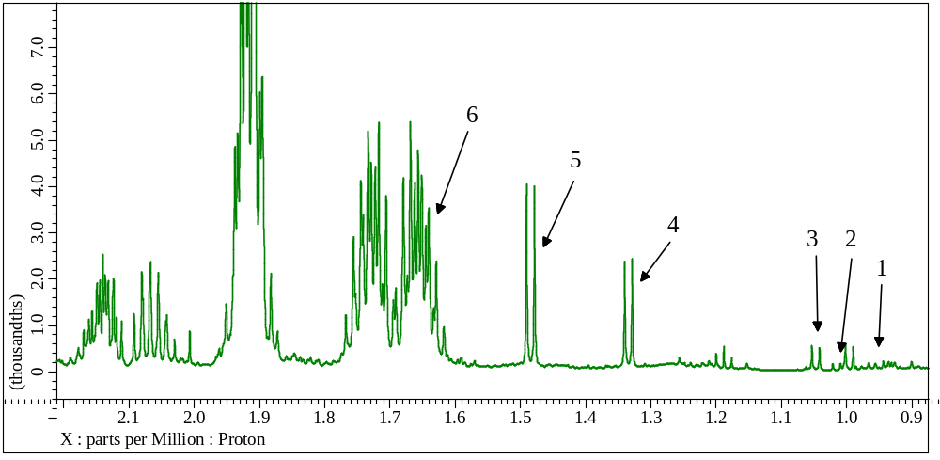

Figure S2. ¹H assigned spectrum of C. rotundus hydrophilic extract, 2.2- 3.4 ppm region. 7. GABA, 8. Glutamic acid, 9. Succinic acid, 10. Glutamine, 11. Citric acid, 12. Aspartic acid, 13. Asparagine, 14. Choline.
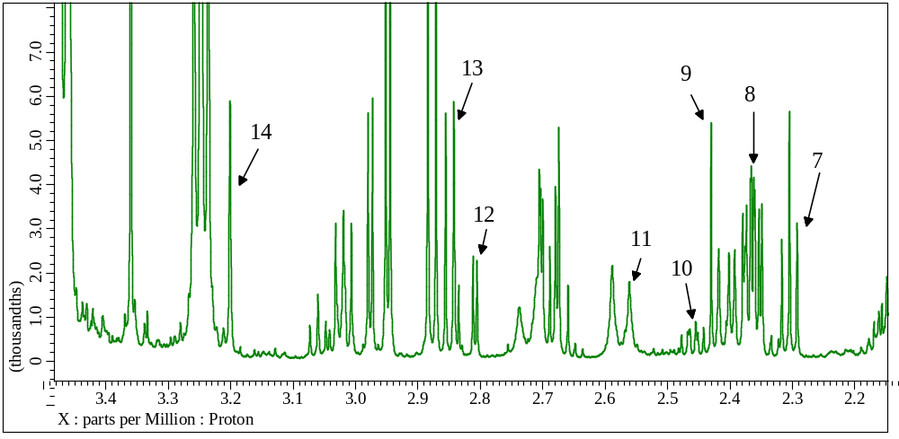

Figure S3. ¹H assigned spectrum of C. rotundus hydrophilic extract, 3.9- 5.8 ppm region. 15. Malic acid, 16. Dihydroxyacetone, 17. Glucose, 18. Raffinose oligosaccharides, 19. Sucrose.
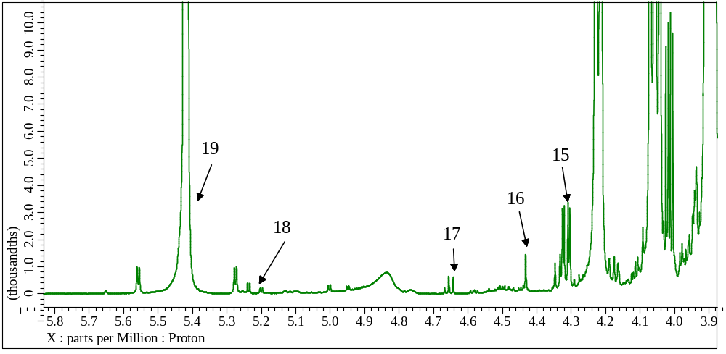

Figure S4. ¹H assigned spectrum of C. rotundus hydrophilic extract, 3.9- 5.8 ppm region. 21. Luteolin-7-O-Glycoside, 22. Fumaric acid, 23. 4-Hydroxyphenylacetic acid, 24. Tyrosine, 25. Uracil, 26. Uridine, 27. NAD, 28. Inosine, 29. Formic acid, 30. Trigonelline.
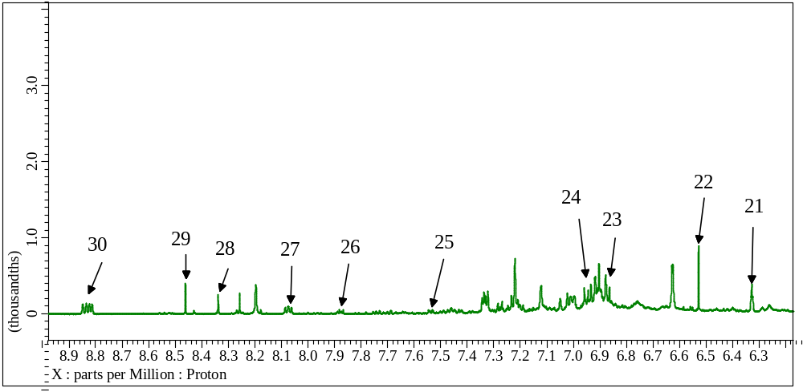

Figure S5. ¹H assigned spectrum of C. rotundus lipophilic extract, 0.6- 3.0 ppm region. 31. B-sitosterol, 32. Campesterol, 33. Saturated fatty acids, 34. Omega 6 fatty acids, 35. Omega 3 fatty acids
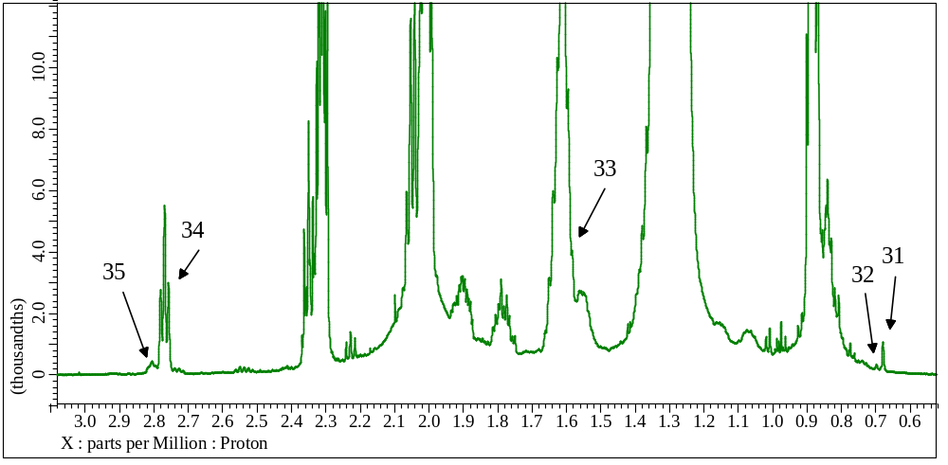

Figure S6. ¹H assigned spectrum of C. rotundus lipophilic extract, 3.6- 5.4 ppm region. 36. Glycerol M., 37. Glycerol D. 38. Glycerol T., 39. Omega 9 Fatty acids.
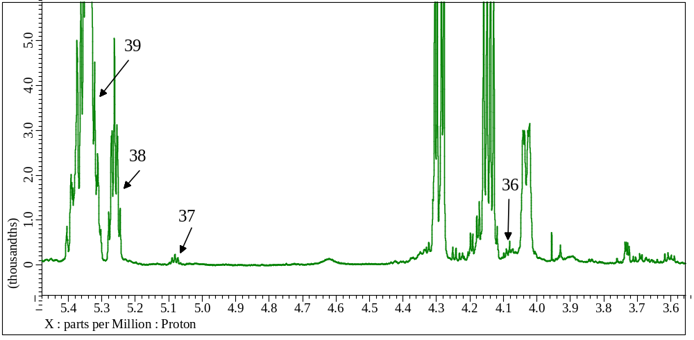

Figure S7. ¹H-¹H TOCSY spectrum of C. rotundus hydrophilic extract.
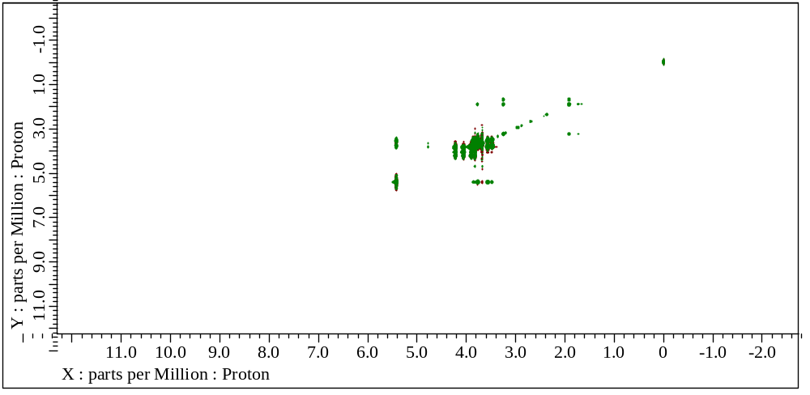

Figure S8. ¹H-¹³C HSQC spectrum of C. rotundus hydrophilic extract.
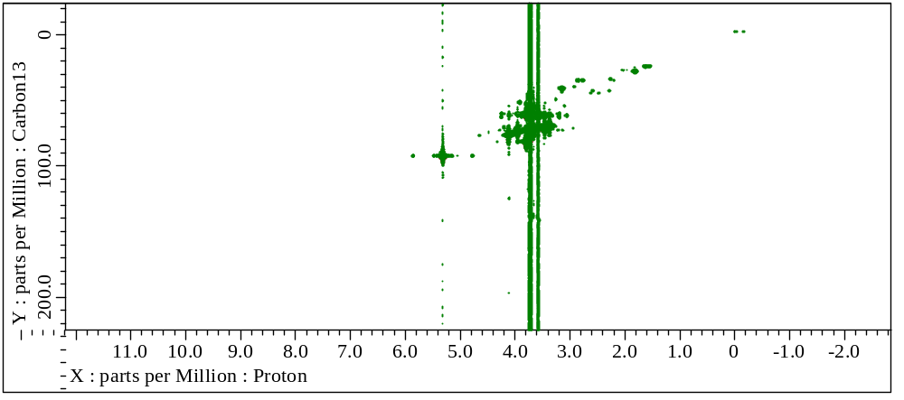

Figure S9. ¹H-¹H TOCSY spectrum of C. rotundus lipophilic extract.
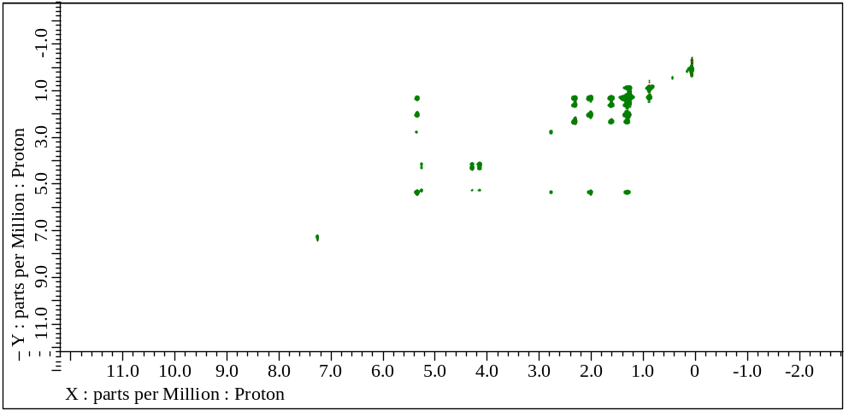

Figure S10. ¹H-¹³C HSQC spectrum of C. rotundus lipophilic extract.
