SUPPLEMENTARY INFORMATION
Indoor plants’ effect on Occupants’ Performance, Perceived Comfort, and Affect in an Open-plan Space in Composite Climatic Regions, India
Mukesh Budaniya ª, Asit Kumar Mishra ^{b,c*}, Aakash C. Rai ^{d, e}, and M.S. Dasgupta ª
ª Department of Mechanical Engineering, Birla Institute of Technology and Science, Pilani, Rajasthan, India - 333031.
^{b} School of Public Health, University College Cork, Ireland.
^{c} DTU Sustain, Technical University of Denmark, Denmark.
^{d} Department of Sustainable Energy Engineering, Kotak School of Sustainability, Indian Institute of Technology Kanpur, Uttar Pradesh, India - 208016.
^{e} Chandrakanta Kesavan Centre for Energy Policy and Climate Solutions, Kotak School of Sustainability, Indian Institute of Technology Kanpur, Uttar Pradesh, India - 208016.
* Corresponding author: Email: AKumarMishra@ucc.ie

Methods

Experiment design
We used G*Power [1] for a priori power analysis, to determine the optimum number of participants for significance testing at the desired levels of Type I and Type II error probability. The comparison would be for the difference between two independent means (two independent groups of participants) with one-tailed testing. For Type I error probability of 5% and study power of 80%, typical values for these parameters [2], and medium-sized effects, the required sample size was calculated to be 51 for t-tests and 53 for Wilcoxon-Mann-Whitney tests. Based on this analysis, we decided to have 60 participants in each WP and WoP group.

Participant recruitment
Notice board postings and email invites were used to inform the potential pool of participants on campus. Potential participants who contacted us and met the criteria listed above were recruited. We did not design to recruit matched participants for the two groups, except for maintaining the same sex ratio in both WoP and WP groups. We primarily recruited undergraduate students. All participants were Indians, though they came from different states of India and had been staying on campus for more than one year; thus, they were well-acclimatized to the local climate. The 60 participants in each group were subdivided into ten subgroups, one for each day of study. While it was intended to have five males and one female in each subgroup, due to the unavailability of enough female participants, we could not maintain this sex ratio in two of the subgroups.
One day before the session, during orientation, participants signed an informed consent form, accenting their participation in the study. They were made aware that they could still withdraw from the study at any point if they did not want to continue their involvement. As a token of appreciation, after each session, five participants received a gift valued at ₹100 (~$1.2), while one randomly selected participant got a prize of ₹250 (~$3.0). The added value for one gift voucher was intended as a means of boosting participation while keeping within the budget.

Experimental set-up and measurements
The equipment measuring indoor environmental conditions was set up at the centre of the room, at least 1 m from any occupant and at a height of 1.1 meters from the ground. The height matches the breathing zone of seated occupants. Following the conclusion of each session, we measured the decay of CO₂ levels in the room, from 6:30 pm to 10:30 pm to estimate the ventilation rate.

Table S1 Equipment specifications
Parameter | Equipment/Sensor | Make (model) | Range (resolution) | Accuracy
Indoor air temperature | Heat index WBGT meter | Lutron  (WBGT-2010SD) | 0–50 ℃ (0.1°C) | ±0.8 ℃
Indoor humidity | Heat index WBGT meter | Lutron  (WBGT-2010SD) | 5–95 % (0.1%) | ±3 %
Globe temperature | Heat index WBGT meter | Lutron  (WBGT-2010SD) | 0–80 °C (0.1°C) | ±0.6 °C
Air speed | Hot wire anemometer | Testo (405i) | 0–30 m/s (0.01 m/s) | ±(0.1 m/s + 5 % of mv)
Horizontal illuminance | Light meter | CHY  (CHY-332) | 20–20K lux (0.1 lux) | ±5 %
CO2 | NDIR CO2 sensor | Greywolf  (TVSPL-CL-DSII-5) | 350–1500 ppm  (1 ppm) | ±35 ppm
Outdoor solar radiation | Silicon pyranometer | HOBO  (S-LIB-M003) | 0–1280 W/m2  (1.25 W/m2) | ±10 W/m²
Outdoor temperature  and humidity | Both sensor with radiation shield, 12-bit | HOBO  (S-THB-M003) | −40–70 °C (0.02°C) | ±0.21 °C
Outdoor temperature  and humidity | Both sensor with radiation shield, 12-bit | HOBO  (S-THB-M003) | 0–100 % (0.1%) | ± 2.5 %
Outdoor air speed | Cup type anemometer | HOBO  (S-WSB-M003) | 0–76 m/s (0.5 m/s) | ±1.1 m/s
Precipitation | Rain gauge smart sensor | HOBO  (S-RGF-M002) | 0–10.2 cm (0.2 mm) | ±4 %

Prior to starting the experiment in April, we ensured the calibration of all equipment and then measurements were conducted in the room to assess uniformity of temperature, air speed, and lux level within the room. A hexagonal seating arrangement (Fig. 2) was finalized for the participants ensuring a minimum 2.4 m distance between each participant. This distance was chosen to assure work environment privacy for the participants. The positions of potted plants were chosen such that each participant had a clear view of 2 to 3 plants in their peripheral view while sitting, without any interference with their activities. Plants were watered prior to the sessions, and their foliage was washed. We ensured that through the period of experiments, the plants remained healthy.

Experimental procedure
Orientation questionnaire included details of the venue, session time, participant ID (an anonymized ID to use during the sessions), background questions about personality (Big Five inventory-10 item [3]) and health, and instructions for the session. We requested participants to practice at least one round of the Operation Span (OSPAN) task on the PEBL platform to get familiar with the software platform and its layout.
Participants were asked not to engage in any strenuous physical activity before their session and to follow their usual routine and sleep schedule prior to the session. To create a focused and distraction-free environment during the main session, we requested participants to wear plain-coloured, comfortable clothing and refrain from wearing any perfume. We also asked them to keep their cell phones silent during the session and maintain silence. The session concluded with participants submitting the orientation questionnaire and confirming their willingness to participate.
In preparation for the sessions, before participants arrived, the room was cleaned using cleaning agents that did not have strong odours. In their free time during the sessions, participants were free to do their own work, like reading, writing, etc. Participants were not instructed in any manner to look toward the plants or the overall room aesthetics. The timelines of WoP and WP sessions were identical. The only difference between the two groups of sessions was the presence or absence of plants.

Participants’ feedback and assessments
The circumplex model of affect contains eight categories (octant) of emotions: high arousal positive (HAP), positive (P), low arousal positive (LAP), low arousal (LA), low arousal negative (LAN), negative (N), high arousal negative (HAN), and high arousal (HA) (see Figure S1). Each category has three to four adjectives (words) associated with it.
OSPAN targets working memory. Working memory is one of the core executive functions [4] and as such, an important measure of cognitive performance. In previous research, OSPAN has been shown to be able to distinguish performance under different indoor environmental conditions [5]. OSPAN was administrated using the PEBL platform. PEBL was installed by the participants on their laptops one day before the main session. OSPAN involves memorizing a series of letters while solving simple additions and subtractions (arithmetic distractor). The intervening arithmetic tasks are intended as a distractor that increases cognitive load. The OSPAN task in the PEBL platform is set up so that participants have a complete a practice round of tasks before proceeding to the actual test.
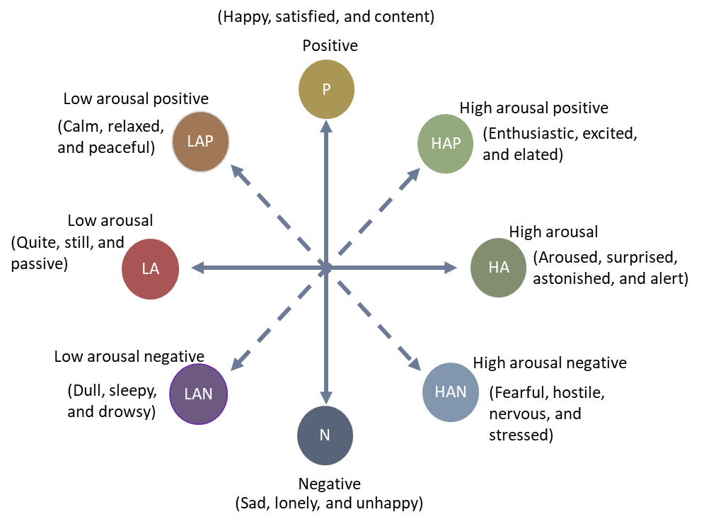
Figure S1 The circumplex model of affect.
The complete set of survey questions have been attached at the end of this document.

Results and discussions
Table S2 Results summary
Component | Attribute for which significant effect observed | Effect size, p value | Subjective Perception
Indoor environment | Decoration | −0.42, < 0.0001 | Perceived as more aesthetically pleasing
Indoor environment | Cleanliness | −0.16, 0.04 | Perception of cleanliness improved
Indoor environment | Overall visual comfort | −0.22, 0.01 | Visual comfort increased
Indoor environment | Lighting | −0.08, 0.2 | No significant difference
Indoor environment | Glare and reflection | 0.05, 0.7 | No significant difference
Indoor environment | Space available | −0.14, 0.07 | No significant difference
Indoor environment | Furnishing | −0.08, 0.2 | No significant difference
Indoor environment | Noise | 0.02, 0.01 | No significant difference
Indoor environment | Overall room environment | −0.10, 0.1 | No significant difference
Perceived thermal comfort | Thermal sensation | 0.18, 0.02 | Felt slightly cooler
Perceived thermal comfort | Humidity sensation | 0.18, 0.03 | Felt less dry
Perceived thermal comfort | Temperature preference | 0.12, 0.2 | No significant difference
Perceived thermal comfort | Temperature satisfaction | 0.03, 0.7 | No significant difference
Perceived thermal comfort | Humidity satisfaction | −0.03, 0.7 | No significant difference
Perceived thermal comfort | Air movement satisfaction | 0.06, 0.5 | No significant difference
Perceived air quality | Air freshness | −0.11, 0.2 | No significant difference
Perceived air quality | Overall air quality | 0.005, 0.9 | No significant difference
Sick building syndrome (SBS) | Dry/Itchy/Watery eyes | 0.08, 0.7 | No significant difference
Sick building syndrome (SBS) | Nose/Throat Irritation/Dryness | 0.38, 0.9 | No significant difference
Sick building syndrome (SBS) | Difficulty in breathing | −0.46, 0.08 | No significant difference
Sick building syndrome (SBS) | Lethargy/Tiredness | 0.40, 0.9 | No significant difference
Sick building syndrome (SBS) | Headache | 0.09, 0.4 | No significant difference
Sick building syndrome (SBS) | Skin irritation/dry/itching | 0.02, 0.5 | No significant difference
Sick building syndrome (SBS) | Dizziness | −0.17, 0.3 | No significant difference
Sick building syndrome (SBS) | Difficulty in concentrating | −0.15, 0.2 | No significant difference
Sick building syndrome (SBS) | Sleepiness | 0.13, 0.7 | No significant difference
Affect | Positive (P) | −0.45, p < 0.0001 | Positive affect increased
Affect | High arousal positive (HAP) | −0.24, 0.004 | Enhanced high arousal positive affect
Affect | Low arousal positive (LAP) | −0.21, 0.01 | Increased low arousal positive affect
Affect | High arousal (HA) | −0.29, 0.001 | High arousal affect increased
Affect | Low arousal (LA) | −0.08, 0.02 | Low arousal affect increased
Affect | Negative (N) | 0.18, 0.02 | Negative affect decreased
Affect | High arousal negative (HAN) | −0.14, 0.9 | No significant difference
Affect | Low arousal negative (LAN) | −0.02, 0.6 | No significant difference
Cognitive performance | Working memory capacity | 0.06, 0.8 | No significant difference
Cognitive performance | Ability to handle cognitive load | 0.17, 0.4 | No significant difference
Cognitive performance | Processing speed and task efficiency | 0.19, 0.3 | No significant difference
Subjective performance | Perception about the effort invested | −0.13, 0.09 | No significant difference
Subjective performance | Perceived task difficulty | 0.13, 0.09 | No significant difference
Subjective performance | Self-assessed performance | 0.03, 0.7 | No significant difference
Subjective performance | Perceived time related stress | −0.07, 0.8 | No significant difference
Subjective performance | Perceived mental effort | −0.05, 0.6 | No significant difference

Subjective responses regarding indoor climate and well-being

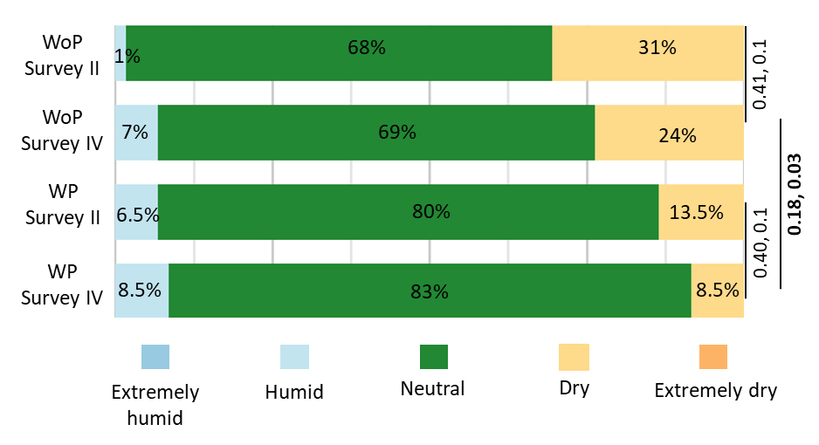
Figure S2 Comparison of humidity sensation votes (HSeV), across each session type and between WoP and WP sessions.

Effect on participant affect
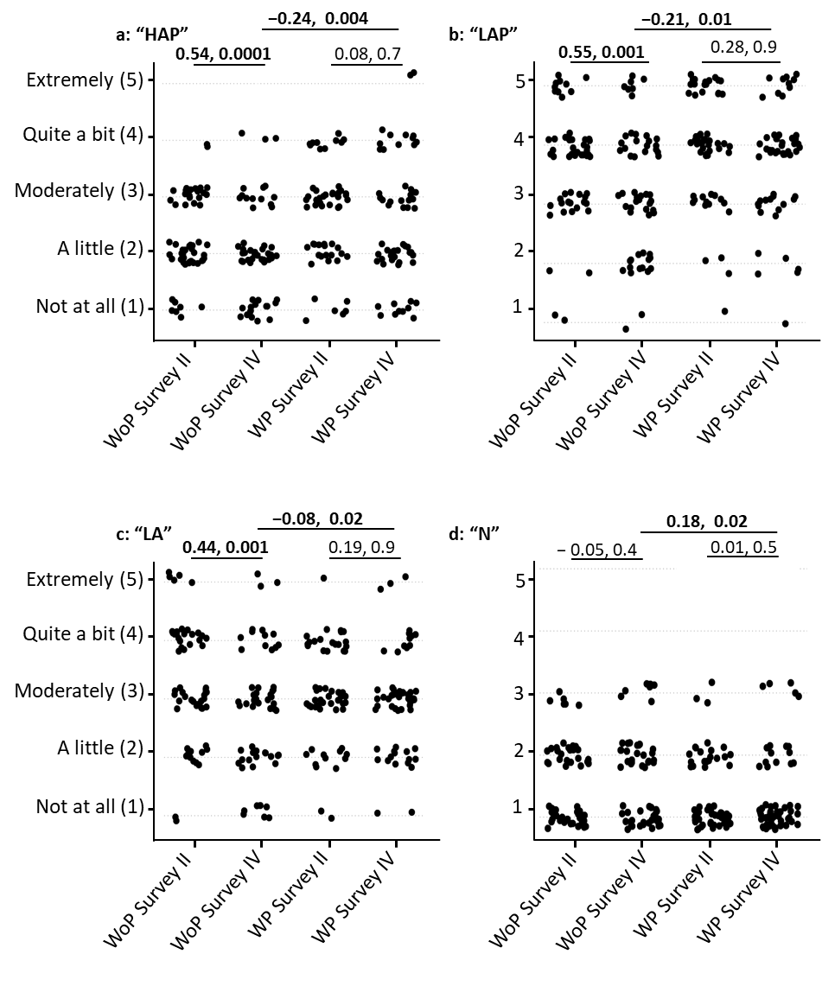
Figure S3 Comparison of affect votes, across each session type and between WoP and WP sessions. Note: The two values written above the horizontal lines connecting two scatter plots are r value followed by p value.

Effect on cognitive performance and self-assessed performance
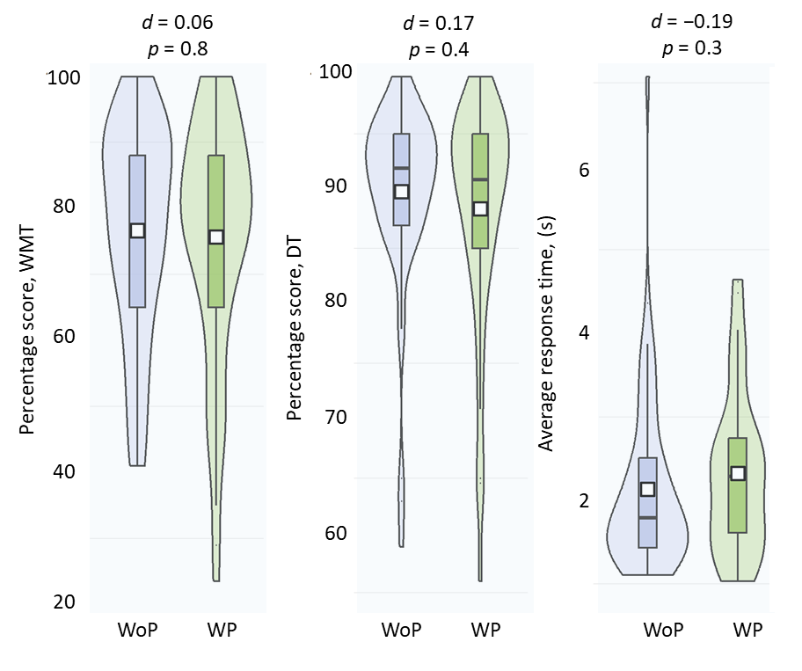
Figure S4 Comparison of cognitive performance between WoP and WP sessions.

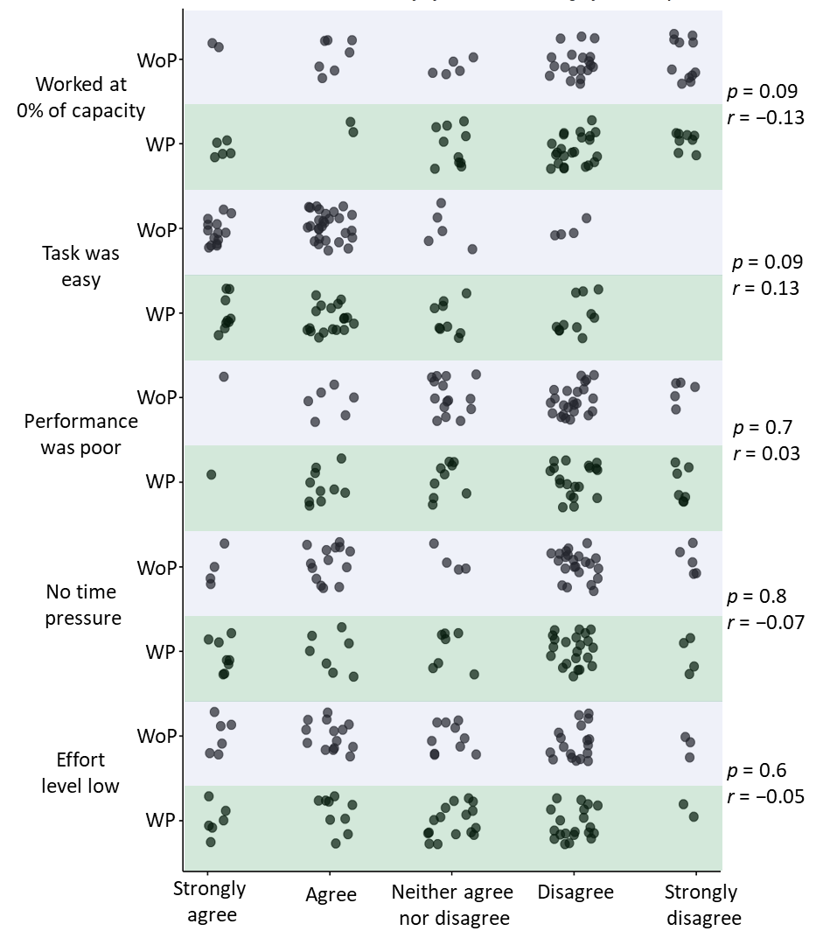
Figure S5 Comparison of self-assessed performance between WoP and WP sessions.

Indoor plants and possible energy savings in indoor conditioning
Table S3 ACDDs calculation for different types of scenarios
Scenario type | Comfort temperature/ equation | ACDD
1. Baseline (PMV model) | 24.5°C, for seated occupants engaged in typing work, dressed in trousers and long-sleeve shirts. | ACDD=$\sum_{i=1}^{N}{{(24.5-DMT)}^{+}}$  where T is the daily mean ambient temperature, DMT is daily mean temperature, and N the number of days in the year. The ‘+’ superscript denotes that only positive values contribute to the adaptive degree-day calculations.
2. Plant-adjusted baseline temperature by 0.5°C (PMV+ 0.5°C) | 24.5°C+0.5°C = 25°C | ACDD=$\sum_{i=1}^{N}{{(25-DMT)}^{+}}$
3. Plant-adjusted baseline temperature by 1°C (PMV+ 1°C) | 24.5°C+1.0°C = 25.5°C | ACDD=$\sum_{i=1}^{N}{{(25.5-DMT)}^{+}}$
4. Indian Model of Adaptive Comfort (IMAC) | Tn= 0.28*RMT+17.87 | ACDD=$\sum_{i=1}^{N}{{(T_{n}-DMT)}^{+}}$
5. Plant-adjusted IMAC temperature by 0.5°C (IMAC+ 0.5°C) | Tn1 = Tn + 0.5°C | ACDD=$\sum_{i=1}^{N}{{(T_{n1}-DMT)}^{+}}$

Table S4 Percentage reductions in ACDDs, with PMV Baseline as reference
City | PMV+0.5 °C | PMV+1 °C | IMAC | IMAC+0.5 °C
Hyderabad | 13 | 24 | 30 | 42
New Delhi | 9 | 17 | 29 | 38
Pilani (town) | 9 | 18 | 29 | 37
Gwalior | 8 | 16 | 29 | 37
Kota | 8 | 16 | 30 | 38

Appendix
Complete Questionnaire

Orientation session questionnaire
Dear participants, thank you for agreeing to participate in our survey session!
Note: Dear participants please fill out the questionnaire below which contains participants handouts, participant consent, demographic and personality related questions followed by instructions related to installation of PEBL software and practice of cognitive task i.e. OSPAN.
Participant handouts (Do's and Don'ts) for the main session
- You need to bring your laptop in fully charged condition.
- Carefully read the instructions (at page No. 05 of this questionnaire) about installation of the PEBL software. Based on the provided instruction, please practice the one round of cognitive task before coming to the main session.
- Mobile phones to be in silent/switched-off mode.
- Talking or whispering during the session is not permitted.
- No computer gaming and loud music allowed.
- You will not be allowed to change your seating position during the session.
- You will not be allowed to adjust the window, light, fan, or AC settings.
- You will not be allowed to go outside the room for bio-break or any other reason except for emergency conditions. Once you go outside, the experiment ends for you.
- Wear plain color comfortable clothing that you normally wear to the institute for classes; the same can be self-adjusted to ensure comfort.
- Please do not use any strong-smelling cosmetics or personal hygiene products during the session.
- No eatables allowed, but you can drink water.
- Please don't engage yourself in any physically strenuous activity just before coming to the session.
- Please do not to change your usual daily routine and sleep schedule around the session day.
- Please reach 10 minutes before the scheduled start time of the session.
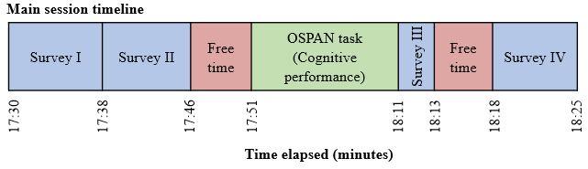
Participation consent (please read carefully):
I have gone through the Do's and Don'ts in the recruitment email. I understand that my participation in this research is voluntary, and I may withdraw at any time from the study. The study will not expose me to any potentially harmful ambiance or any indoor environment that I do not come across during my regular life. My name or any other identifiable information, associated with me (like email, registration number etc.) will not be used as part of the study reports. While the researchers will make every effort to prevent any leak of personal data, there is always a small chance that this may happen.
I understand that the duration of this session is 55 minutes. During this session, I will be providing my feedback through questionnaires. I will not be stepping out of the room unless it is an emergency. If I do need to step out, my participation in the session ends there. My responses will all be processed anonymously.
If I have concerns or complaints regarding the way the research is or has been conducted, I can contact the institute management team, BITS Pilani, Pilani campus. I understand that information gathered will be used to work towards more energy efficient and comfortable indoors.
I agree to participate in the studies described above. [If you do not agree, do not submit this form]
- Agree
- Participant ID number provided to you by our team?
2. What is your weight (in kg e.g. 72)?

3. During the past month, how would you rate your sleep quality, overall?
- Very good | - Fairly bad
- Fairly good | - Very bad
4. What is your current state of health?
- Sick |  |  | - Good
- Not too bad
5. Have you been diagnosed with these health disorders?
- Asthma | - Sleep apnoea |  |  | - Diabetes
- Low/high blood pressure | - Any other chronic disease |  |  | - None
6. Do you smoke?
- No, never smoked |  | - Yes, < 10 a day
- No, give up within the last year |  | - Yes, > 10 a day

7. How much do you usually perspire (sweat)?
- Not at all |  |  | - Somewhat
- Very little |  |  | - Very much
8. How many minutes do you exercise per day?
9. Is there any other information about yourself, which may affect your perception of an indoor space, that you would like the researchers to know? If so, please state in the space provided below:
10. How well do the following statements describe your personality?
I see myself as someone who.. | Disagree strongly | Disagree a little |  | Neither agree nor disagree | Agree a little | Agree strongly
..is reserved
..is generally trusting
..tends to be lazy
..is relaxed handles stress well
..has few artistic interests
..is outgoing, sociable
..tends to fault with others
..does a thorough job
..gets nervous easily
..has an active imagination
11. Please read below information about the cognitive task (OSPAN) that you have to practice before coming to the main session
“As part of the session, we will be using a cognitive task called OSPAN, which is a computer-based working memory task. To ensure that you are well-prepared for the session, we have provided some instructions and practice materials below.
Instructions for Downloading and Installing the PEBL Software:
1. Please click on below link to see the instructional video to install and practice the software on your laptop.
https://drive.google.com/file/d/12Iv8ntlByCQrhisFdEGwO8gsNCxj94mW/view? usp=share_link
2. If you face any issues with the installation or use of the PEBL software or the OSPAN task, contact us for assistance
If you have any questions about the OSPAN task or the PEBL software, please contact us at mukesh.budaniya@pilani.bits-pilani.ac.in. We appreciate your participation and look forward to seeing you at the main session!
With best regards,
Research Team (BITS Pilani, IIT Kanpur, and the University of Galway, Ireland)”

First round questionnaire of main session
Note: This questionnaire is about the participant's sleep quality, followed by what the participant feels about the room noise level, layout, lighting, aesthetics, and overall indoor environment.
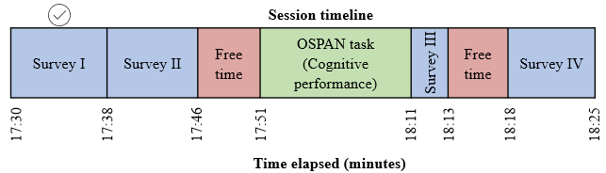
            - Participant ID number?

            - What you were doing in the most part of the last 30 minutes?
- Walking | - Washing
- Running | - Eating
- Sitting | - Reading or writing
- Relaxing
            - The questionnaire is used to evaluate how well you slept last night. Please answer True or False to the best of your recollection.
 | TRUE | FALSE
I had a deep sleep last night
I feel like I slept poorly last night
It took me more than half an hour to fall asleep last night
I felt tired after waking up this morning
I woke up several times last night
I feel like I did not get enough sleep last night
I got up in the middle of the night
I felt rested after waking up this morning
I feel like I only had a couple of hours of sleep last night
I feel I slept well last night
I did not sleep a wink last night
I did not have any trouble falling asleep last night
After I woke up last night, I had trouble falling asleep again
I tossed and turned all night last night
I did not get more than 5 hours sleep last night

4. In general, how satisfied are you with each of the following aspects of the room?
 |  |  | Dissatisfied |  |  |  | Slightly  dissatisfied |  |  |  |  | Neutral |  | Slightly  satisfied |  | Satisfied
Lighting
Glare and reflections
The amount of space available to you
The Furnishings (Chair desk, equipment, etc)
Room decoration
Room
cleanliness
5. If you are dissatisfied with the lighting aspect of this room, which of the following do you think are (is) causing it? (Check all that apply).
- Too dark |  |  |  | - Without lighting control |  |  |  |  |  |  |  |  |  | - Glare
- Too bright |  |  |  | - Reflections on the laptop screen |  |  |  |  |  |  |  |  |  | - Not applicable
- Not enough daylight |  |  |  | - Shadows on the workspace |  |  |  |  |  |  |  |  |  | - Flicker lighting
- Too much daylight |  |  |  | - Undesirable lighting colour |  |  |  |  |  |  |  |  |  | - Other
6. In general, how satisfied are you with noise level aspect of this room?
 | Dissatisfied |  |  |  |  | Slightly  dissatisfied |  |  |  |  | Neutral |  | Slightly  satisfied |  | Satisfied
Noise
7. If you are dissatisfied with the noise levels aspect of this room, which of the following do you think are (is) causing it? (Check all that apply).
- Noise from equipment |  |  |  |  | - Noise from outdoor |  |  |  |  |  |  |  | - Noise from people
- Noise from the air-conditioning system |  |  |  |  |  |  |  |  | - Not applicable
8. If you are dissatisfied with room cleanliness or decoration, which of the following do you think are (is) causing it? (Check all that apply)
- Surface dust on other surfaces you might touch like doorknobs & handles
- Dust on table and chair surfaces |  |  |  |  |  |  |  | - Dirty floors
- Significant source of odor |  |  |  |  |  |  |  | - Other, please specify
9. In general, how satisfied are you with each of the following aspect of this room?
 |  | Dissatisfied |  |  |  | Slightly  dissatisfied |  |  |  |  | Neutral |  | Slightly  satisfied |  | Satisfied
Overall visual comfort
Overall indoor environment quality
10. If you are feeling discomfort in this room, please describe about the sources of discomfort.

Second round questionnaire of main session
Note: This questionnaire about what you feel about the thermal environment, indoor air quality, mood, and sick building syndrome.
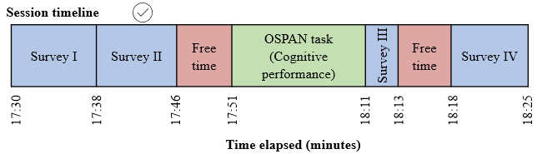
1. Participant ID number?
2. How do you feel about room air temperature right now?
 | Hot |  |  |  | Warm |  |  | Slightly warm |  |  | Neutral |  |  | Slightly cool |  |  |  | Cool |  |  | Cold
Air temperature
3. How do you feel about room air humidity right now?
 |  |  |  | Extremely dry |  |  |  | Dry |  |  |  | Neutral |  |  | Humid |  |  |  | Extremely humid
Room air humidity
4. Would you prefer to feel?
 |  |  | Cooler |  |  |  |  |  |  |  |  | No change |  |  |  |  | Warmer
Room air temperature
5. How satisfied are you with the following aspects of this room right now?
 | Very dissatisfied |  | Dissatisfied |  |  |  |  | Slightly dissatisfied |  |  |  | Neutral |  | Slightly satisfied |  |  | Satisfied |  |  | Highly satisfied
Temperature
Air movement
Air freshness
Odors
Humidity
Overall air quality
6. If you are dissatisfied with the temperature and/or air movement in this room. Which of the following contribute to your dissatisfaction? (Check all that apply).
- My area is too hot |  |  |  |  |  |  |  |  |  | - Air movement too weak
- My area is too cold |  |  |  |  |  |  |  |  |  | - Not applicable
- Humidity too high (damp) |  |  |  |  |  |  |  |  |  | - Other
- Air movement too strong
7. If you feel any unpleasant odor in the room air, which of the following do you think is the reason? (Check all that apply).
- Furniture |  |  |  |  |  |  |  |  |  | - Mold
- Other people |  |  |  |  |  |  |  |  |  | - Odors from outdoor
- Perfumes/Deodorants |  |  |  |  |  |  |  |  |  | - Not applicable
- Cleaning products |  |  |  |  |  |  |  |  |  | - Other
8. Right now, do you feel any?
 |  | Not at all |  |  |  | Light |  |  | Moderate |  |  |  | Strong |  |  | Very strong |  |  | Overwhelming
Eye dryness, Itchy or watery eyes
Nose/throat irritation or dryness
Difficulty breathing
Lethargy and/or tiredness
Headache
Dry, itching or irritated skin
Dizziness
Difficulty concentrating
Sleepiness
9. Read each item and indicate to what extent you feel this way right now.
 |  | Very slightly or not at all |  |  |  |  | A little |  |  |  | Moderately |  |  |  | Quite a bit |  |  |  | Extremely
Enthusiastic
Sleepy
Happy
Sad
Calm
Fearful
Quiet
Aroused
Excited
Dull
Satisfied
Lonely
Relaxed
Hostile
Still
Surprised
Elated
Drowsy
Content
Unhappy
Peaceful
Nervous
Passive
Astonished
Alert
Stressed

Third round questionnaire of main session
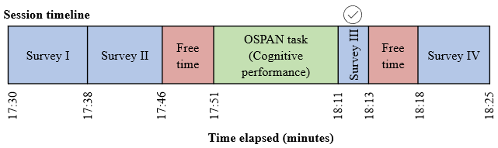
Note: This questionnaire is about what you feel about the cognitive task you just performed.
 | Strongly agree | Agree | Neither agree nor disagree | Disagree | Strongly disagree
They were very easy
Your effort level was very low
There was no time pressure
You worked at 0% of your capacity
Your performance was poor

Fourth round questionnaire of main session
Note: The fourth round of the questionnaire was a duplicate of the second round of the questionnaire and hence has not been repeated here.

Questionnaire source
We used questionnaires which have been extensively used and validated in studies related to indoor environmental quality and occupant perceptions. A summary of the sources is provided below in Table S5.
Table S5 Questionnaire source
Question(s) | Source
Personality | A 10-item short version of the Big Five Inventory in English and German [3]
Sleep quality | Groningen Sleep Quality Scale (standardized questionnaire) [6]
Questions related to Lighting, Glare and reflections, Space, Furnishings, Room décor, Room cleanliness, Noise, Overall visual comfort, Overall indoor environment quality, Air movement, Air freshness, and Overall air quality | Center for the Built Environment (CBE) questionnaire [7]
Thermal preference scale | McIntyre scale
Thermal sensation scale | ASHRAE 7-point scale
Thermal satisfaction scale | ASHRAE 7-point scale
Humidity sensation scale | ASHRAE 7-point scale
Humidity satisfaction scale | ASHRAE 7-point scale
09 questions related to sick building syndrome symptoms | Sick building syndrome questionnaire [8]
26 questions related to Affect | Circumplex model of affect [9]
05 questions related to subjective performance | DTU subjectively evaluated work performance (SEPX) questionnaire [10]

References
[1] M. El Maniani, M. Rechchach, A. El Mahfoudi, M. El Moudane, A. Sabbar, G*Power 3: A flexible statistical power analysis program for the social, behavioral, and biomedical sciences, J. Mater. Environ. Sci. 7 (2016) 3759–3766.
[2] J. Gao, P-values - A chronic conundrum, BMC Med. Res. Methodol. 20 (2020) 1–8. https://doi.org/10.1186/s12874-020-01051-6.
[3] B. Rammstedt, O.P. John, Measuring personality in one minute or less: A 10-item short version of the Big Five Inventory in English and German, J. Res. Pers. 41 (2007) 203–212. https://doi.org/10.1016/j.jrp.2006.02.001.
[4] A. Diamond, Executive functions, Annu. Rev. Psychol. 64 (2013) 135–168. https://doi.org/10.1146/annurev-psych-113011-143750.
[5] H. Maula, V. Hongisto, V. Naatula, A. Haapakangas, H. Koskela, The effect of low ventilation rate with elevated bioeffluent concentration on work performance, perceived indoor air quality, and health symptoms, Indoor Air 27 (2017) 1141–1153. https://doi.org/10.1111/ina.12387.
[6] T.F. Meijman, de Vries-Griever, de V. A. H., G, The evaluation of the Groningen Sleep Quality Scale. Groningen: Heymans Bulletin (HB 88—13—EX), (1988).
[7] L.T. Graham, T. Parkinson, S. Schiavon, Lessons learned from 20 years of CBE’s occupant surveys, Build. Cities 2 (2021) 166–184. https://doi.org/10.5334/bc.76.
[8] A.K. Mishra, S. Schiavon, P. Wargocki, K.W. Tham, Respiratory performance of humans exposed to moderate levels of carbon dioxide, Indoor Air 31 (2021) 1540–1552. https://doi.org/10.1111/ina.12823.
[9] J.A. Russell, A circumplex model of affect, J. Pers. Soc. Psychol. 39 (1980) 1161–1178. https://doi.org/10.1037/h0077714.
[10] L. Lan, L. Xia, R. Hejjo, D.P. Wyon, P. Wargocki, Perceived air quality and cognitive performance decrease at moderately raised indoor temperatures even when clothed for comfort, 2020. https://doi.org/10.1111/ina.12685.

