Supplementary material

Factors affecting the creaming of human milk

F. Meng, T. Uniacke-Lowe, E. Lanfranchi, G. Meehan, C. A. O’Shea, P. F. Fox, T. Huppertz, C. A. Ryan, A. L. Kelly

Contents
Table S1. Composition of human milk from individual mothers.
Table S2. The size distribution of fat globules in the human milk cream layer after 24 h creaming at 5 °C.
Fig. S1. Delta backscattering profile for fresh human milk and fresh bovine milk at 5 °C and 40 °C.
Fig. S2. Conversion of ΔBS profile to mean value profile and peak thickness profile of cream layer as a function of time.
Fig. S3. The TSI, mean value and peak thickness profiles of human milk cream layer before and after preheating as a function of time.
Fig. S4. TSI values of cream layer of fresh human milk and treated human milk with added bovine whey protein isolate and human milk with added bovine Igs.

Table S1
Composition of human milk from individual mothers. ª

Sample | Fat | Protein | Carbohydrate | Total solids
HM001 | 37 | 16 | 70 | 125
HM002 | 53 | 19 | 69 | 142
HM003 | 41 | 15 | 75 | 134
HM004 | 24 | 15 | 74 | 115
HM005 | 26 | 17 | 68 | 113
HM006 | 26 | 15 | 68 | 113
HM007 | 24 | 16 | 73 | 114
HM008 | 32 | 18 | 67 | 120
HM009 | 27 | 16 | 69 | 114
HM010 | 41 | 18 | 69 | 130
HM011 | 13 | 14 | 65 | 93
HM012 | 32 | 13 | 70 | 117

ª Data (in g L⁻¹) are the averages of duplicate measurements.

Table S2
The size distribution of fat globules in the human milk cream layer after 24 h creaming at 5 °C. ª
Treatment | Dx (10) | Dx (50) | Dx (90) | D [4,3] | Dx (75) | Span | D [3,2]
Untreated | 4.00 (0.02) | 6.87 (0.12) | 11.40 (0.36) | 7.33 (0.16) | 9.12 (0.22) | 1.08 (0.03) | 6.29 (0.09)
Diluted in  1% SDS | 3.39 (0.03) | 5.90 (0.07) | 10.33 (0.06) | 6.42 (0.04) | 8.08 (0.08) | 1.17 (0.01) | 5.43 (0.05)

ª Data are the average with standard deviation in parenthesis. The average size decreased after dilution with 1% SDS, indicating that flocculation occurred during human milk creaming.

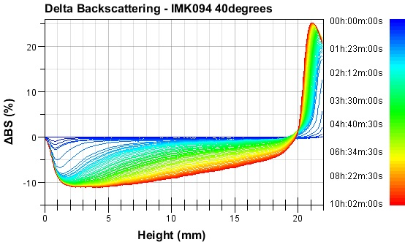
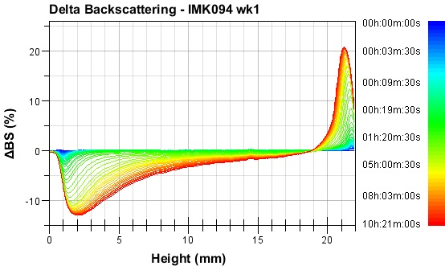
B
A

First profile
First profile
Last profile
Last profile

10 hours, 5°C
10 hours, 40°C

v
r₂
r₂
r₁
r₁
r₃
r₃
Measuring zone (H)
Measuring zone (H)

(Continued)
D

C

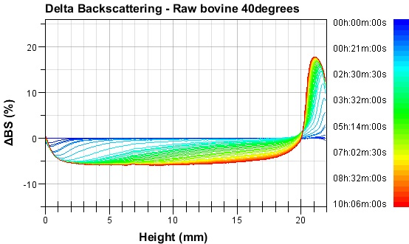
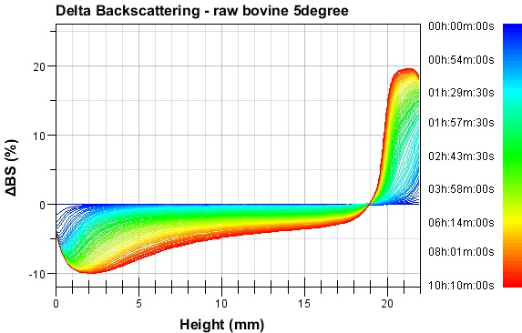
Fig. S1. Delta backscattering (ΔBS) profile (backscattering of near near-infrared light through sample cell as a function of height using the first scan as reference scan) for (A) fresh human milk at 5 °C, (B) fresh human milk at 40 °C, (C) fresh bovine milk at 5 °C, and (D) fresh bovine milk at 40 °C. Samples were scanned every 30 s; however, only the most significant scans were kept by software after 10 h scanning. The colours of the curves correspond to the time on the second Y axis. Calculation regions of creaming (r₁), clarification (r₂), and bottom (r_{3,} 1/5 H) are indicated with blue broken lines. Schematic illustrations of the influence of temperature on the profiles are shown for the first (0 s, stable dispersion) and the last (10 h, phase separation) profiles. Creaming profiles are from individual samples but are representative of data from multiple independent samples.
Fig. S2. Conversion of △BS profile (A) to mean value profile (B) and peak thickness profile (C) of cream layer as a function of time. ΔBS profile of human milk at time 0 (reference scan; blue line), 2 h (orange line) and 10 h (red line) are shown. To convert to mean value (of ΔBS) profiles, lower and upper limits were set to define the cream layer (or other zones). Mean value of cream layer as a function of time was then computed by Turbiscan software (B). The thickness of the cream layer, starting where the backscattering value is greater than 2% (absolute) in comparison with the baseline, and the threshold are indicated with the broken black line. The peak thickness (cream layer) as a function of time (C) was computed by Turbiscan software automatically.
Mean Value at 2hours
Mean Value at 10hours
Lower limit
Upper limit
Peak thickness at 10hours
T = 0 hours
T = 2 hours
T = 10 hours
Threshold
Peak thickness at 2hours
A

B

C

Fig. S3. The TSI (A), mean value (B), and peak thickness (C) profiles of human milk cream layer before () and after preheating at 70 °C for 10 min () as a function of time. The profile is from an individual sample but is representative of data from others.

Fig. S4. TSI values of cream layer of fresh human milk (closed symbols) and treated human milk (open symbols) with added bovine WPI (,) and human milk with added bovine Igs (,) held at 5 °C. TSI profiles are from individual samples but are representative of data from multiple experiments.

