Supporting Information: Impact of Gamma Irradiation and Ethylene Oxide Sterilisation on the Stability of Crystalline and Amorphous Drug Solids

Table S1: Melting temperature and Glass transition temperature of each drug molecule (Elkhashab et al., 2025; Hanna et al., 2019; Sartawi et al., 2023; Stevenson et al., 2019; “Vismodegib - American Chemical Society,”.; “Zolmitriptan | C16H21N3O2 | CID 60857 - PubChem,”).
Molecule | Melting temperature (°C) | Glass transition temperature (°C)
Itraconazole | 165 | 59
Vismodegib | 180 | 84
Betamethasone dipropionate | 178 | 96
Estradiol | 177 | 85
Zolmitriptan | 136 | 49

Table S2: Mobile phases, detection wavelengths and run time for HPLC analysis of each drug.
Molecule | Mobile phase (% v/v) | Wavelength (nm) | Run time (minutes)
Itraconazole | 60% acetonitrile, 40% water, 0.075% formic acid | 264 | 16
Vismodegib | 50% water, 50% acetonitrile, 0.1% formic acid | 264 | 12
Betamethasone dipropionate | 65% acetonitrile, 35% water | 254 | 15
Estradiol | 60% acetonitrile, 40% water, 0.1% formic acid | 280 | 16
Zolmitriptan | 15% acetonitrile, 85% buffer containing 0.2% triethylamine, 0.1% formic acid | 223 | 8

(+) Clostridium |  | (+) Staphylococcus | Control | Crystalline powder | Amorphous sample |  | (+) Clostridium | (+) Staphylococcus | Control | Crystalline powder | Amorphous sample
 | 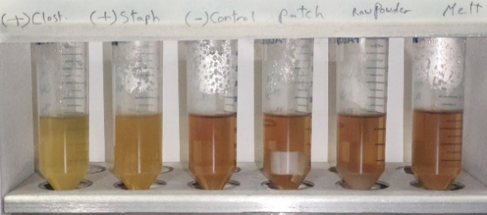  a |  |  |  |  |  | 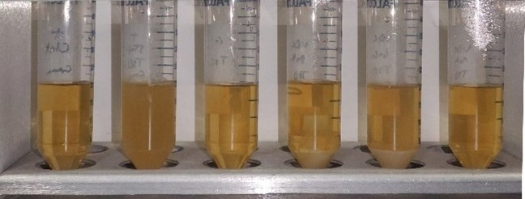  b
 | 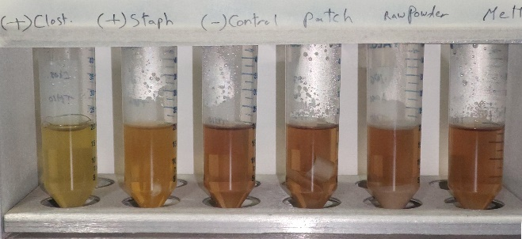  cc |  |  |  |  |  | 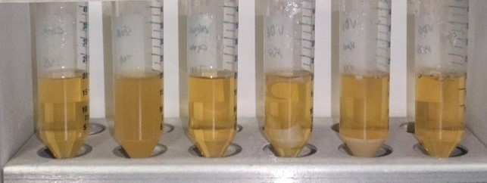  d
 | Figure S1: Results of the 14-day sterility test of vismodegib crystalline powder and amorphous samples following gamma irradiation and ethylene oxide sterilisation. (a) Gamma irradiated samples in fluid thioglycolate medium, (b) Gamma irradiated samples in soybean-casein digest medium, (c) Ethylene oxide sterilised samples in fluid thioglycolate medium, (d) Ethylene oxide sterilised samples in soybean-casein digest medium. The positive and negative controls for each respective medium were common to Figures S1–S5.

(+) Clostridium | (+) Staphylococcus | Control | Crystalline powder | Amorphous sample |  | (+) Clostridium | (+) Staphylococcus | Control | Crystalline powder | Amorphous sample
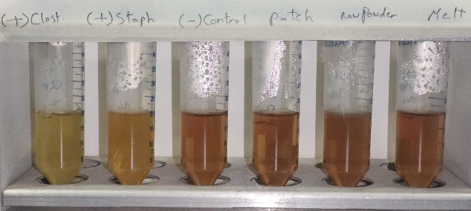  a |  |  |  |  |  | 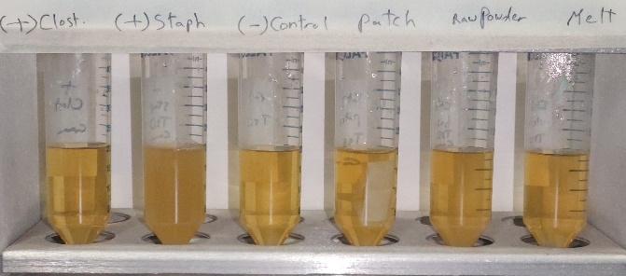  b
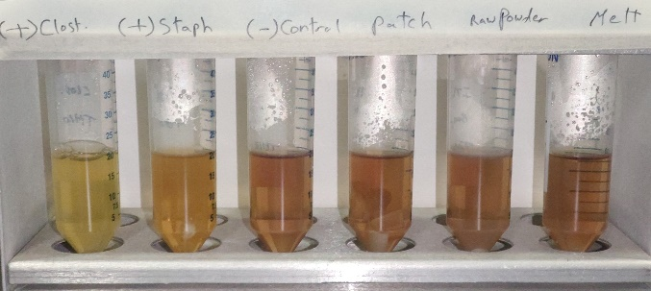  c |  |  |  |  |  | 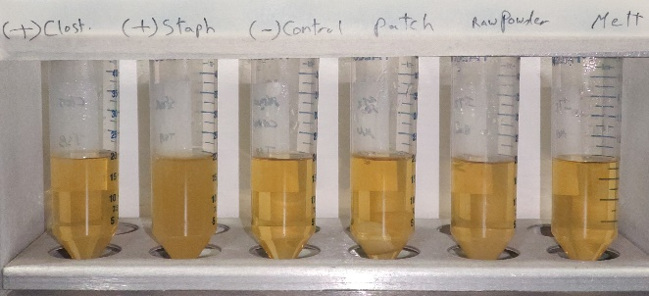  d
Figure S2: Results of the 14-day sterility test of itraconazole crystalline powder and amorphous samples following gamma irradiation and ethylene oxide sterilisation. (a) Gamma irradiated samples in fluid thioglycolate medium, (b) Gamma irradiated samples in soybean-casein digest medium, (c) Ethylene oxide sterilised samples in fluid thioglycolate medium, (d) Ethylene oxide sterilised samples in soybean-casein digest medium. The positive and negative controls for each respective medium were common to Figures S1–S5.

(+) Clostridium | (+) Staphylococcus | Control | Crystalline powder | Amorphous sample |  |  | (+) Clostridium |  | (+) Staphylococcus | Control | Crystalline powder | Amorphous sample
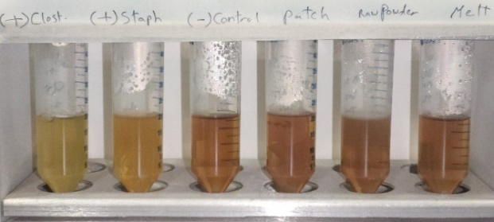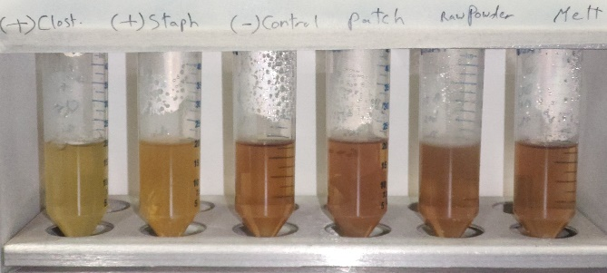  a |  |  |  |  |  |  |  | 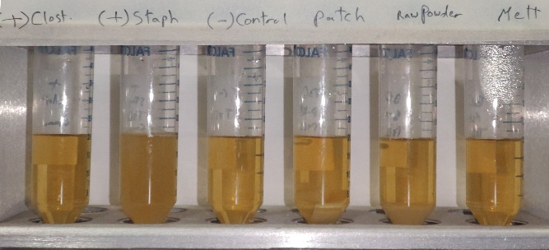  b
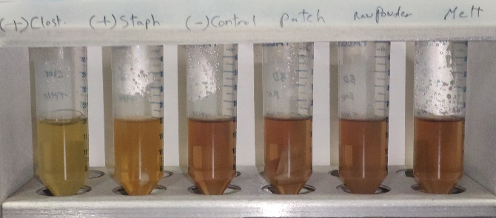  c |  |  |  |  |  |  |  | 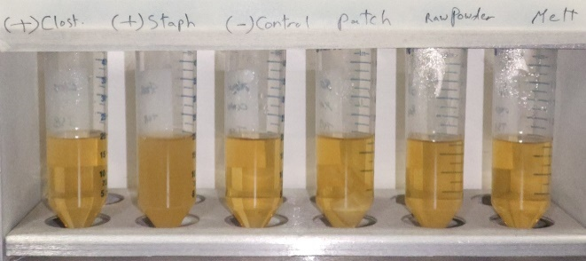  d
Figure S3: Results of the 14-day sterility test of betamethasone dipropionate crystalline powder and amorphous samples following gamma irradiation and ethylene oxide sterilisation. (a) Gamma irradiated sterilised samples in fluid thioglycolate medium, (b) Gamma irradiated samples in soybean-casein digest medium, (c) Ethylene oxide sterilised samples in fluid thioglycolate medium, (d) Ethylene oxide sterilised samples in soybean-casein digest medium. The positive and negative controls for each respective medium were common to Figures S1–S5.

(+) Clostridium | (+) Staphylococcus | Control | Crystalline powder | Amorphous sample |  | (+) Clostridium | (+) Staphylococcus | Control | Crystalline powder | Amorphous sample
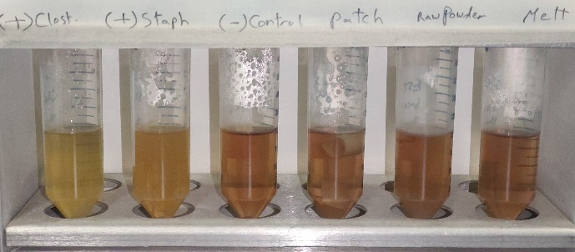  a |  |  |  |  |  | 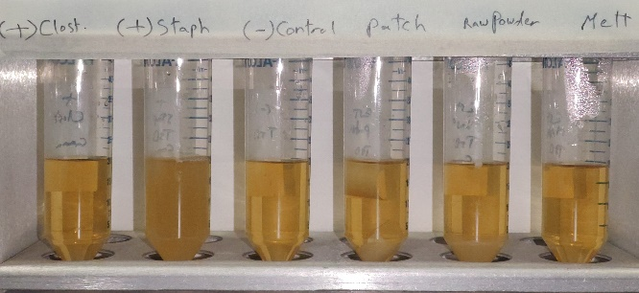  b
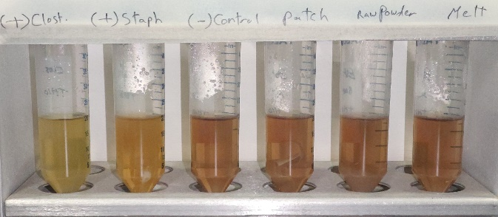  c |  |  |  |  |  | 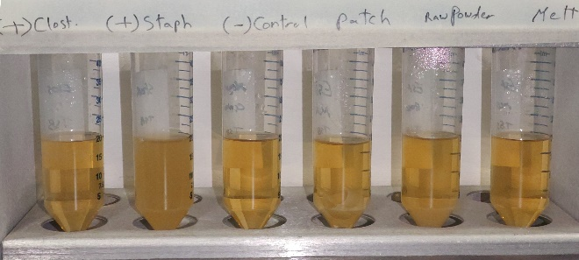  d
Figure S4: Results of the 14-day sterility test of estradiol crystalline powder and amorphous samples following gamma irradiation and ethylene oxide sterilisation. (a) Gamma irradiated samples in fluid thioglycolate medium, (b) Gamma irradiated samples in soybean-casein digest medium, (c) Ethylene oxide sterilised samples in fluid thioglycolate medium, (d) Ethylene oxide sterilised samples in soybean-casein digest medium. The positive and negative controls for each respective medium were common to Figures S1–S5.

(+) Clostridium | (+) Staphylococcus | Control | Crystalline powder | Amorphous sample |  | (+) Clostridium | (+) Staphylococcus | Control | Crystalline powder | Amorphous sample
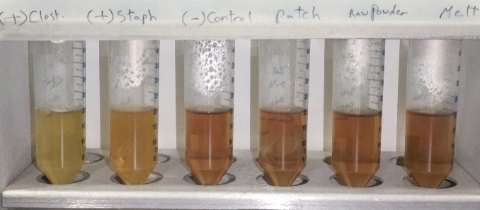  c  a |  |  |  |  |  | 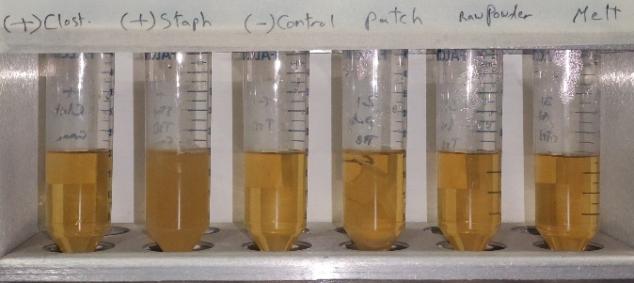  b
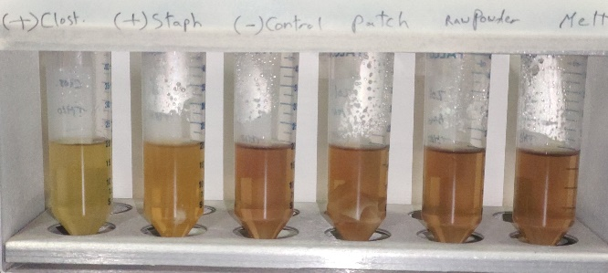 |  |  |  |  |  | 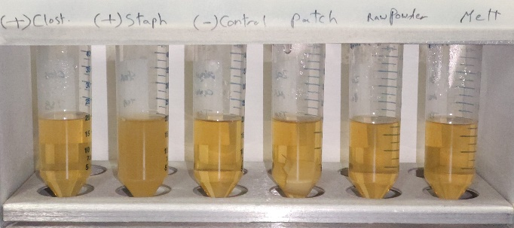  d
Figure S5: Results of the 14-day sterility test of zolmitriptan crystalline powder and amorphous samples following gamma irradiation and ethylene oxide sterilisation. (a) Gamma irradiated samples in fluid thioglycolate medium, (b) Gamma irradiated samples in soybean-casein digest medium, (c) Ethylene oxide sterilised samples in fluid thioglycolate medium, (d) Ethylene oxide sterilised samples in soybean-casein digest medium. The positive and negative controls for each respective medium were common to Figures S1–S5.

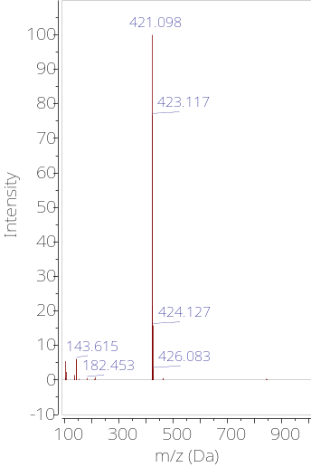  a | 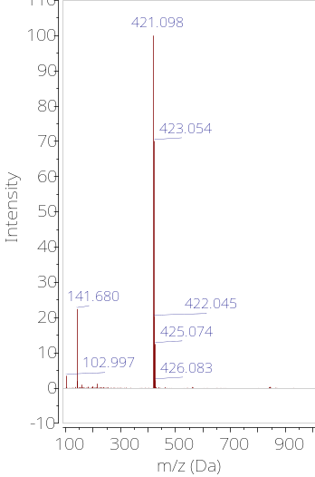  b | 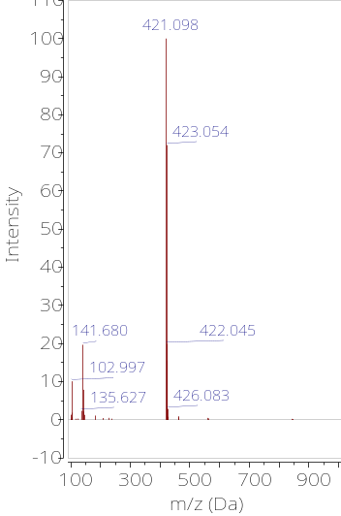  c
 | 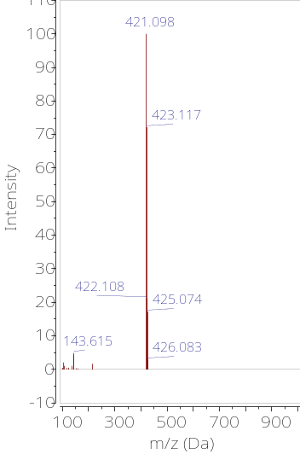  d | 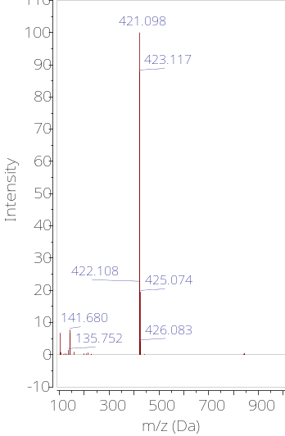  e
Figure S6: Mass spectrum of vismodegib control and samples post sterilisation. (a) LC-MS of vismodegib control. (b) LC-MS of gamma irradiated vismodegib crystalline powder. (c) LC-MS of gamma irradiated vismodegib amorphous sample. (d) LC-MS of vismodegib crystalline powder post ethylene oxide sterilisation. (e) LC-MS of vismodegib amorphous sample post ethylene oxide sterilisation.

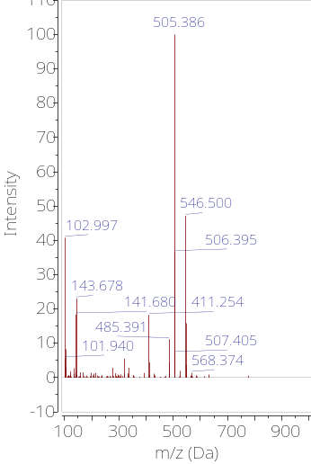  a | 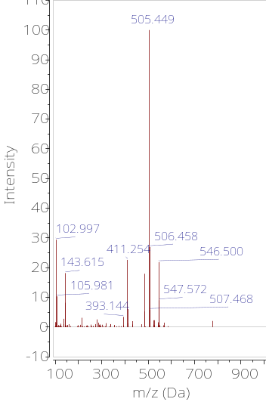  b | 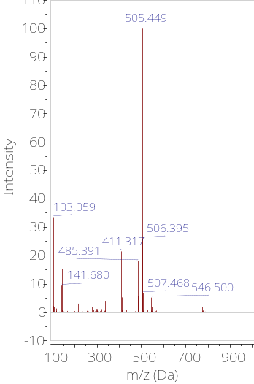  c
 | 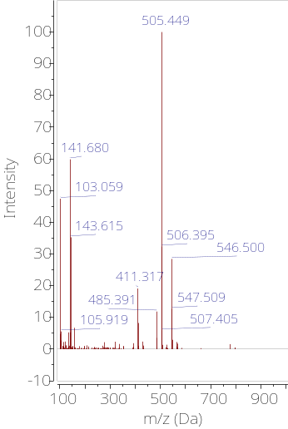  d | 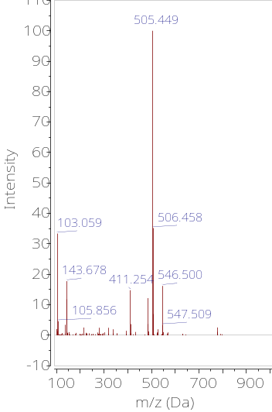  e
Figure S7: Mass spectrum of betamethasone dipropionate control and samples post sterilisation. (a) LC-MS of betamethasone dipropionate control. (b) LC-MS of gamma irradiated betamethasone dipropionate crystalline powder. (c) LC-MS of gamma irradiated betamethasone dipropionate amorphous sample. (d) LC-MS of betamethasone dipropionate crystalline powder post ethylene oxide sterilisation. (e) LC-MS of betamethasone dipropionate amorphous sample post ethylene oxide sterilisation.

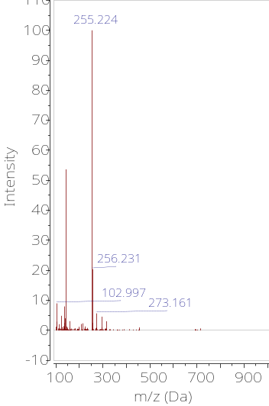  a | 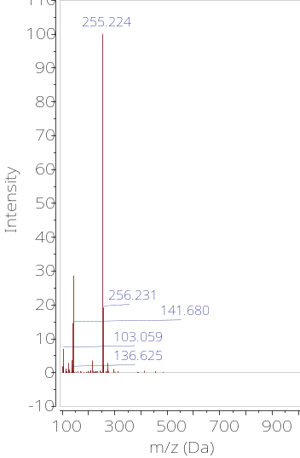  b | 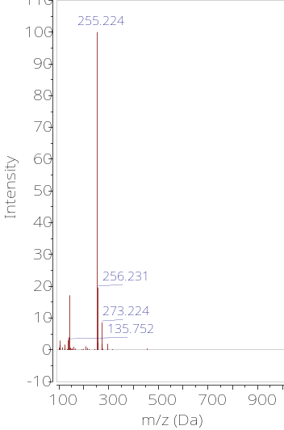  c
 | 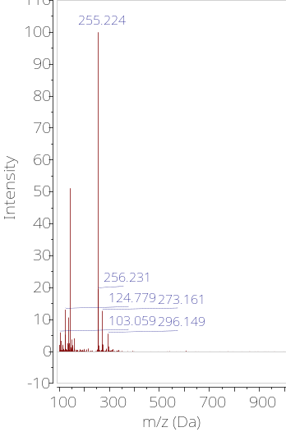  d | 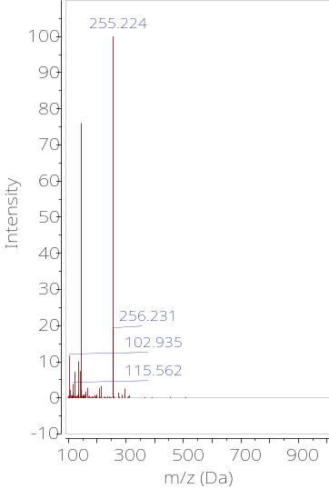  e
Figure S8: Mass spectrum of estradiol control and samples post sterilisation. (a) LC-MS of estradiol control. (b) LC-MS of gamma irradiated estradiol crystalline powder. (c) LC-MS of gamma irradiated estradiol amorphous sample. (d) LC-MS of estradiol crystalline powder post ethylene oxide sterilisation. (e) LC-MS of estradiol amorphous sample post ethylene oxide sterilisation.

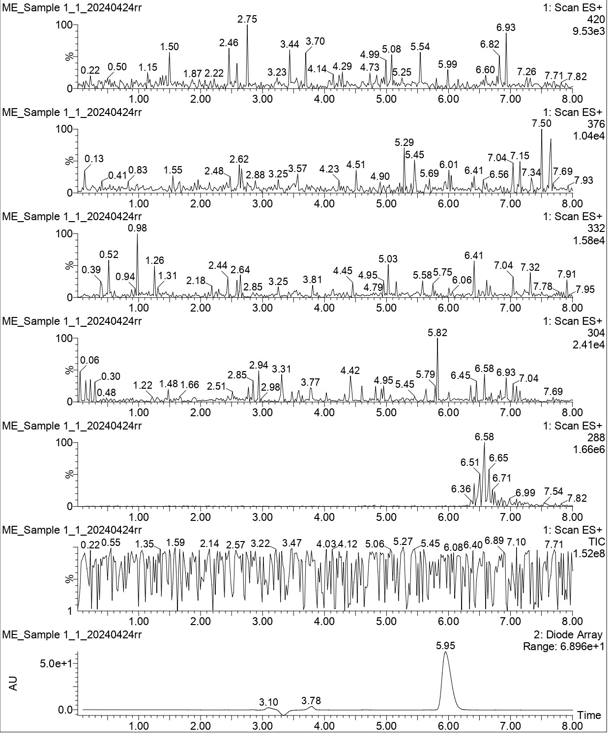
Figure S9: UV chromatogram and ES+ scan of control zolmitriptan sample pre sterilisation showing zolmitriptan signal with molecular weight of 288 g/mol

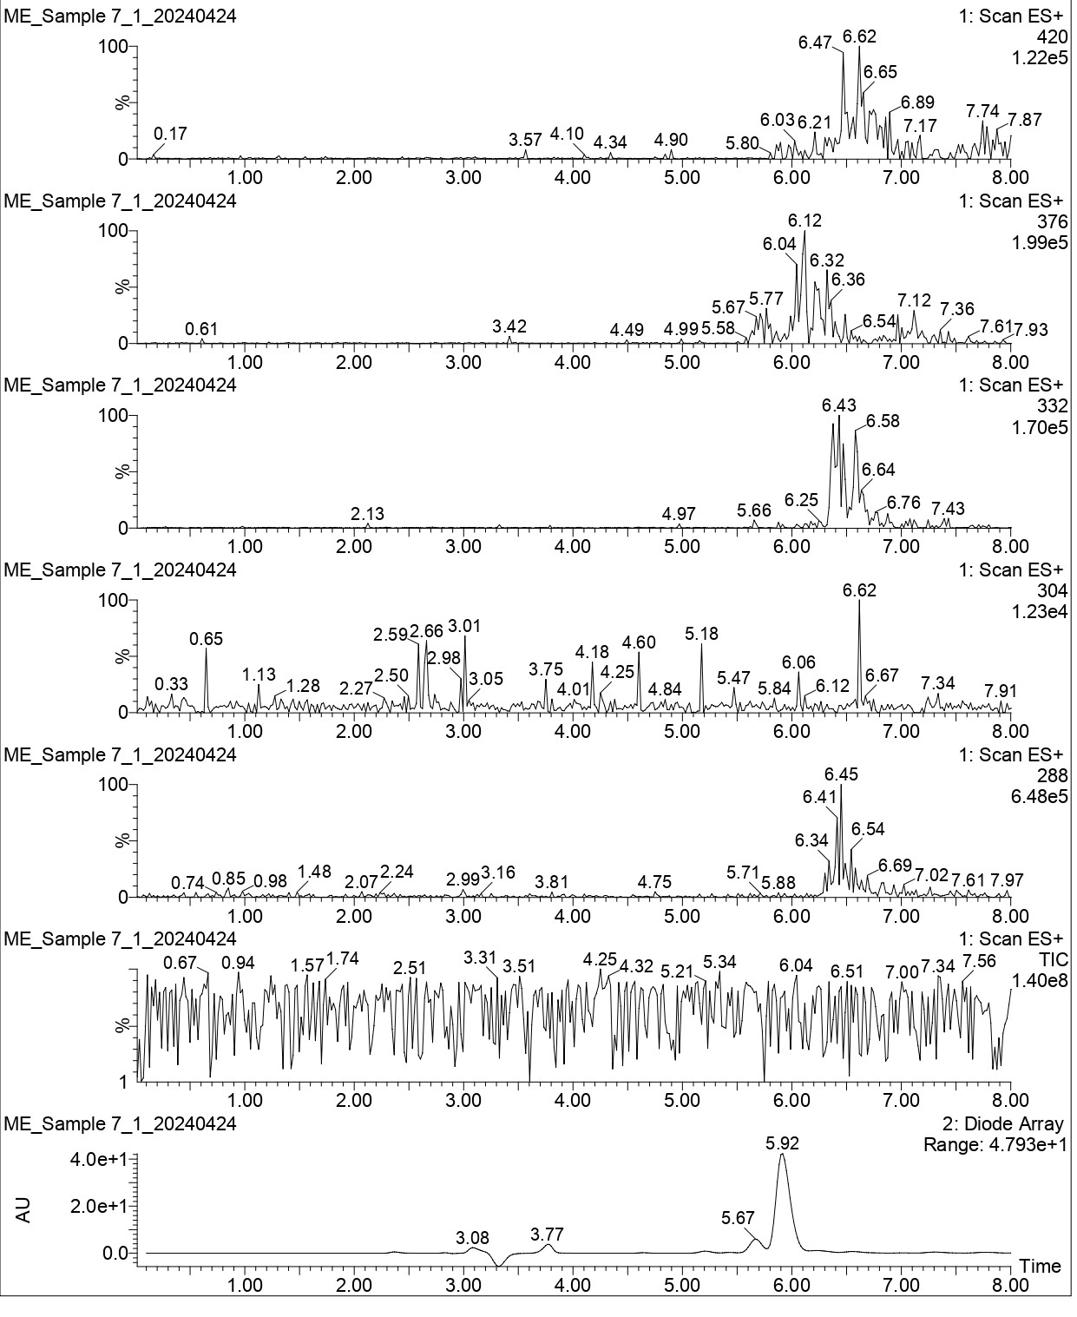
Figure S10: UV chromatogram and ES+ scan of zolmitriptan crystalline powder post ethylene oxide sterilisation showing degradation products with molecular weight of 420, 376, 332 and 304 g/mol

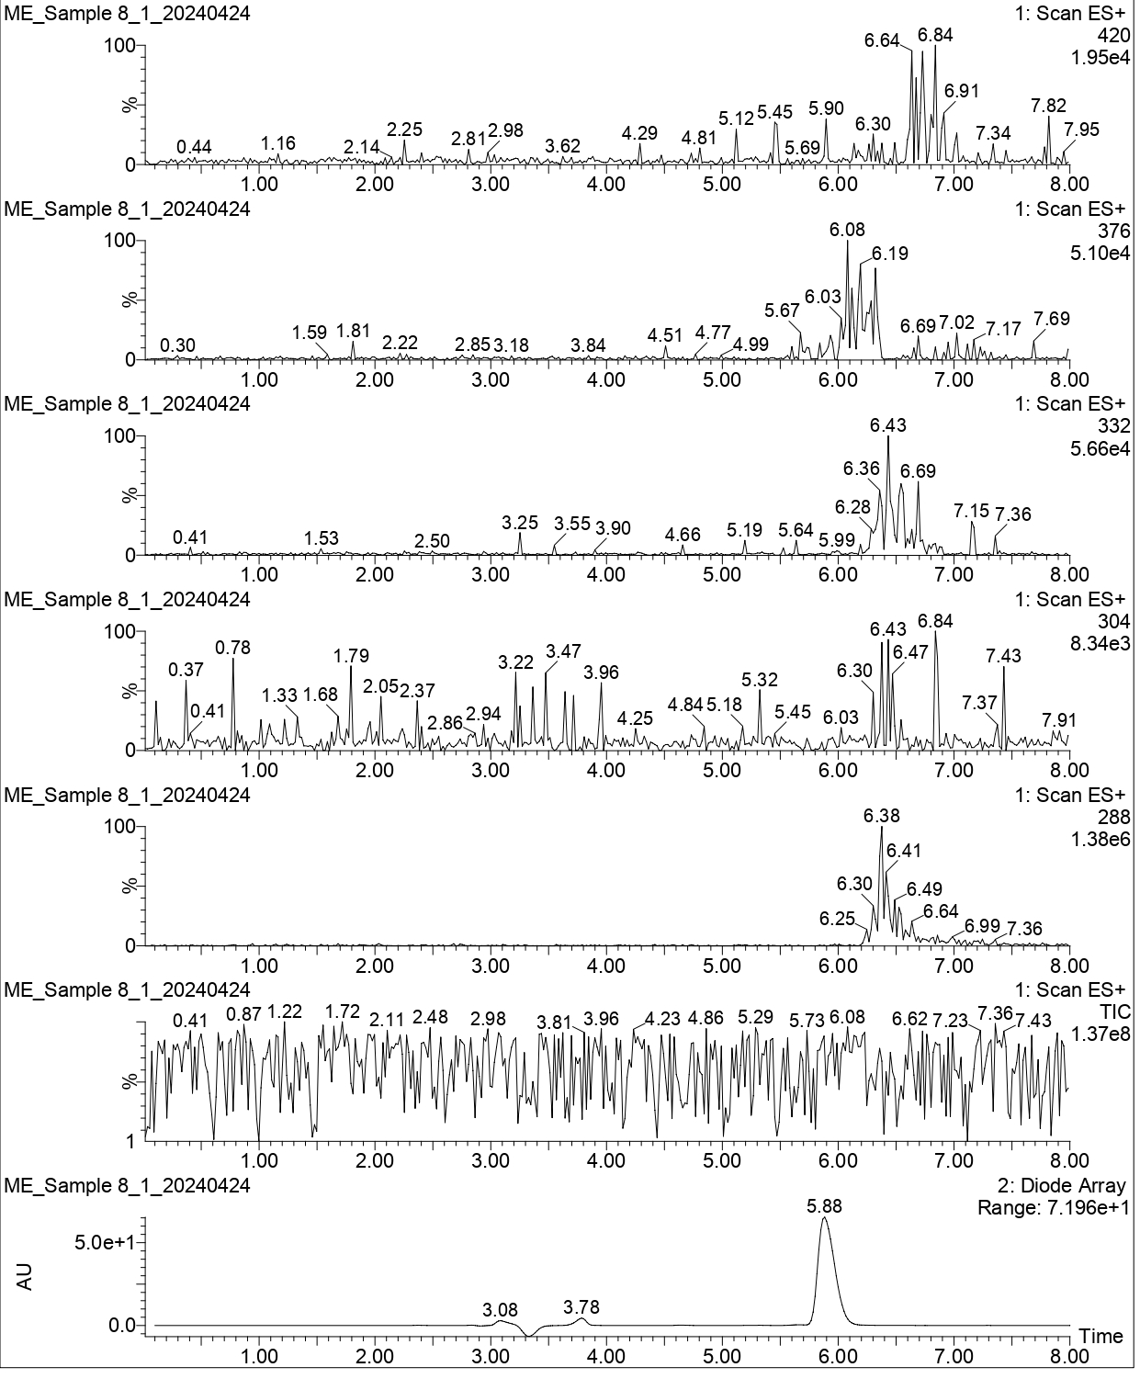
Figure S11: UV chromatogram and ES+ scan of zolmitriptan amorphous sample post ethylene oxide sterilisation showing degradation products with molecular weight of 420, 376, 332 and 304 g/mol

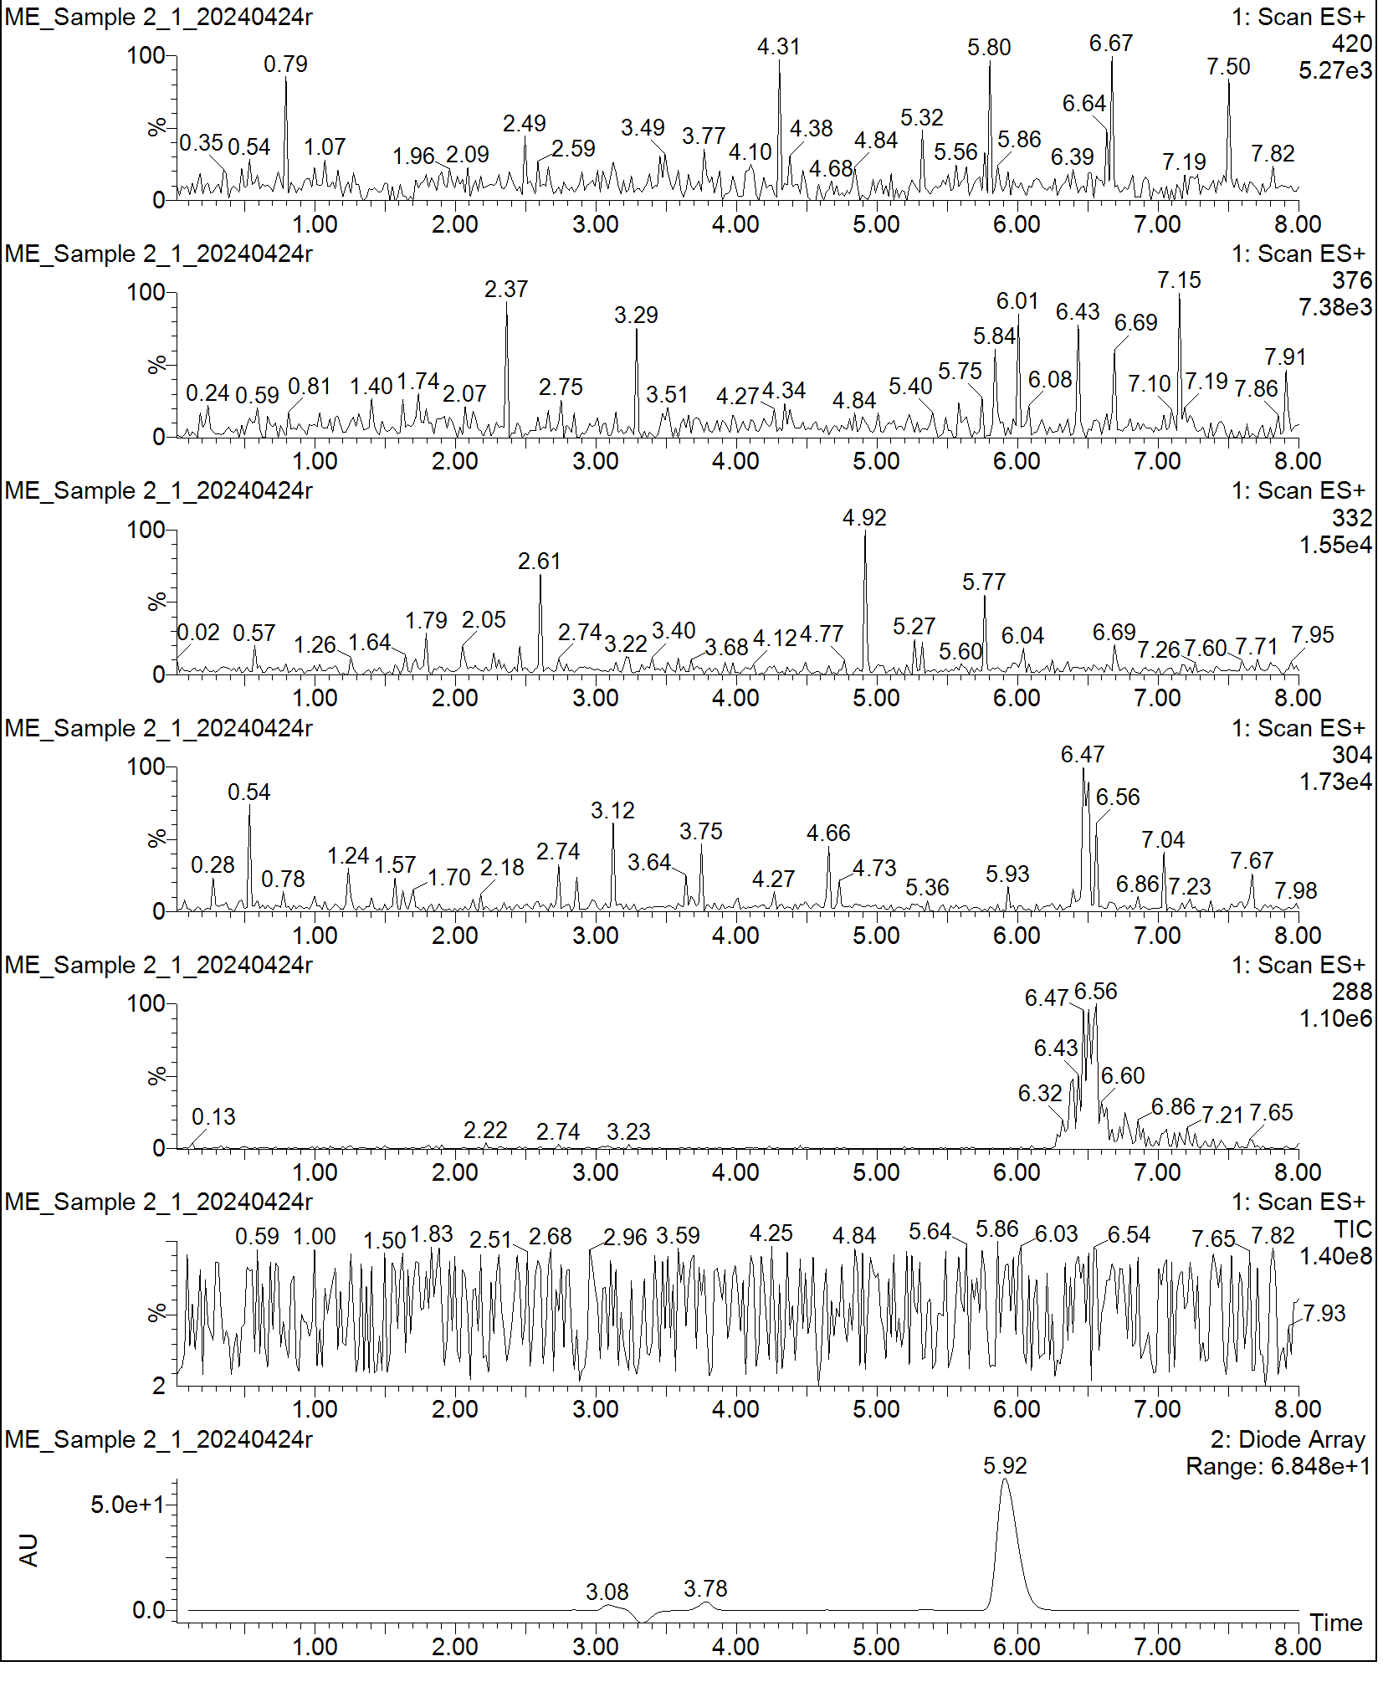
Figure S12: UV chromatogram and ES+ scan of zolmitriptan amorphous sample post gamma irradiation showing minor low-mass fragment ions at m/z 304.

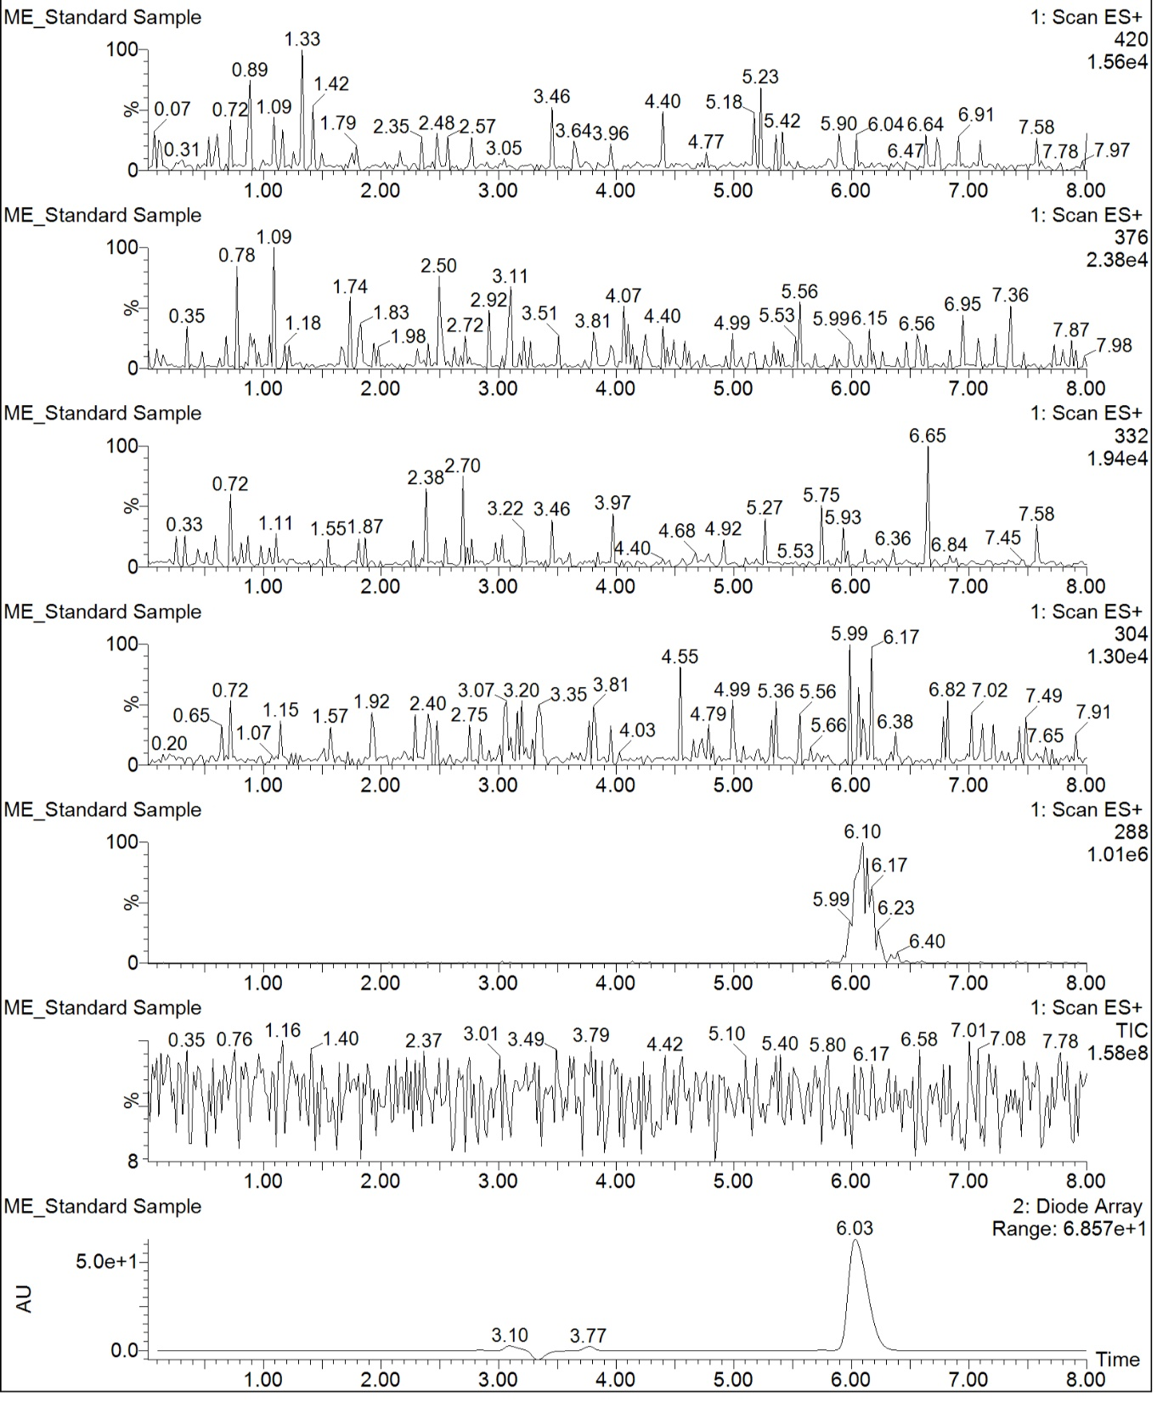
Figure S13: UV chromatogram and ES+ scan of control zolmitriptan amorphous sample pre sterilisation showing zolmitriptan signal with molecular weight of 288 g/mol

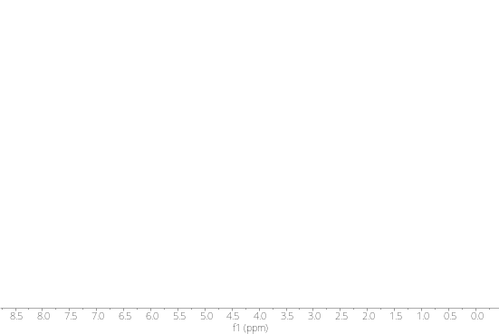  a | 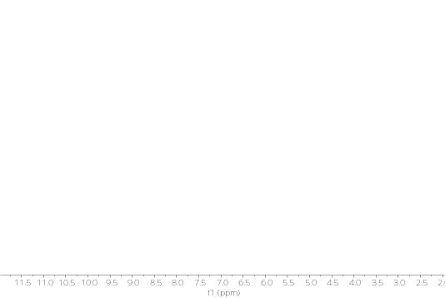  b |  |  | Gamma  irradiated | Crystalline  powder control  Ethylene oxide  sterilised
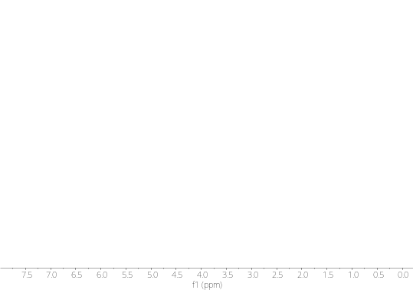  c | 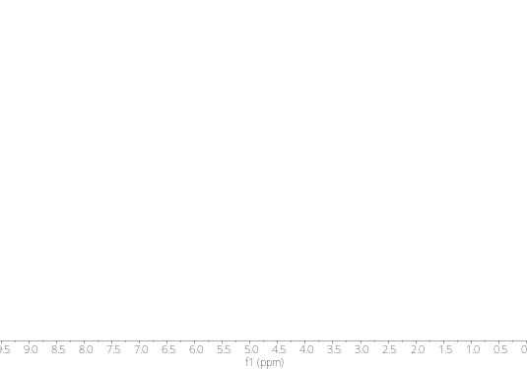  d
Figure S14: Representative ¹H-NMR spectrum of crystalline powders of (a) itraconazole, (b) vismodegib, (c) betamethasone dipropionate and (d) estradiol post gamma irradiation and ethylene oxide sterilisation.

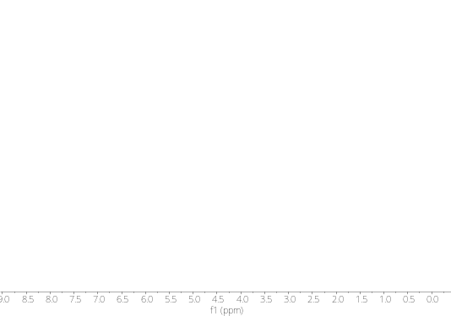  a | 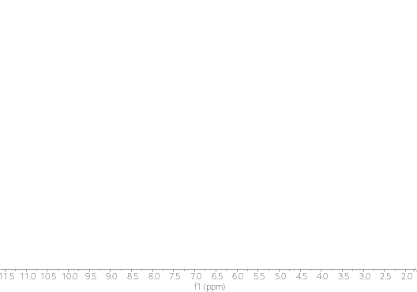  b |  |  | Amorphous  control  Gamma  irradiated  Ethylene oxide  sterilised
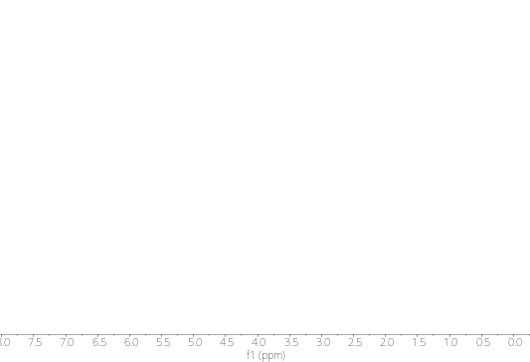  c | 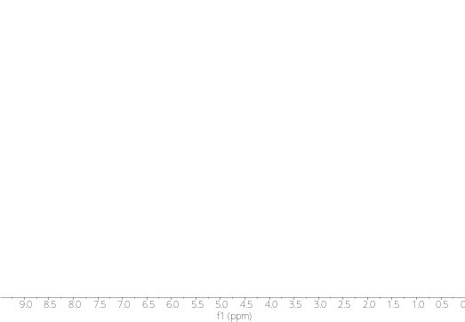  d
Figure S15: Representative ¹H-NMR spectrum of amorphous samples of (a) itraconazole, (b) vismodegib, (c) betamethasone dipropionate and (d) estradiol post gamma irradiation and ethylene oxide sterilisation.

References:
Elkhashab, M., Sartawi, Z., Faisal, W., Crean, A., 2025. Glassy Drug Microneedle Array Design: Drug Glass-Forming Ability and Stability. Mol. Pharm. 22, 1373–1383. https://doi.org/10.1021/ACS.MOLPHARMACEUT.4C01067/ASSET/IMAGES/LARGE/MP4C01067_0010.JPEG
Hanna, P.A., Ghorab, M.M., Gad, S., 2019. Development of Betamethasone Dipropionate-loaded Nanostructured Lipid Carriers for Topical and Transdermal Delivery. Antiinflamm. Antiallergy Agents Med. Chem. 18, 26. https://doi.org/10.2174/1871523017666181115104159
Sartawi, Z., Blackshields, C., Ariamanesh, A., Farag, F.F., Griffin, B., Crean, A., Devine, K., Elkhashab, M., Aldejohann, A.M., Kurzai, O., Faisal, W., 2023. Glass Microneedles: A Case Study for Regulatory Approval Using a Quality by Design Approach. Advanced Materials 2305834. https://doi.org/10.1002/ADMA.202305834
Stevenson, E.L., Lancaster, R.W., Buanz, A.B.M., Price, L.S., Tocher, D.A., Price, S.L., 2019. The solid state forms of the sex hormone 17-β-estradiol. CrystEngComm 21, 2154–2163. https://doi.org/10.1039/C8CE01874J
Vismodegib - American Chemical Society [WWW Document], n.d. URL https://www.acs.org/molecule-of-the-week/archive/v/vismodegib.html (accessed 5.12.26).
Zolmitriptan | C16H21N3O2 | CID 60857 - PubChem [WWW Document], n.d. URL https://pubchem.ncbi.nlm.nih.gov/compound/Zolmitriptan#section=Experimental-Properties (accessed 5.12.26).

