Figure 1 PRISMA Flow
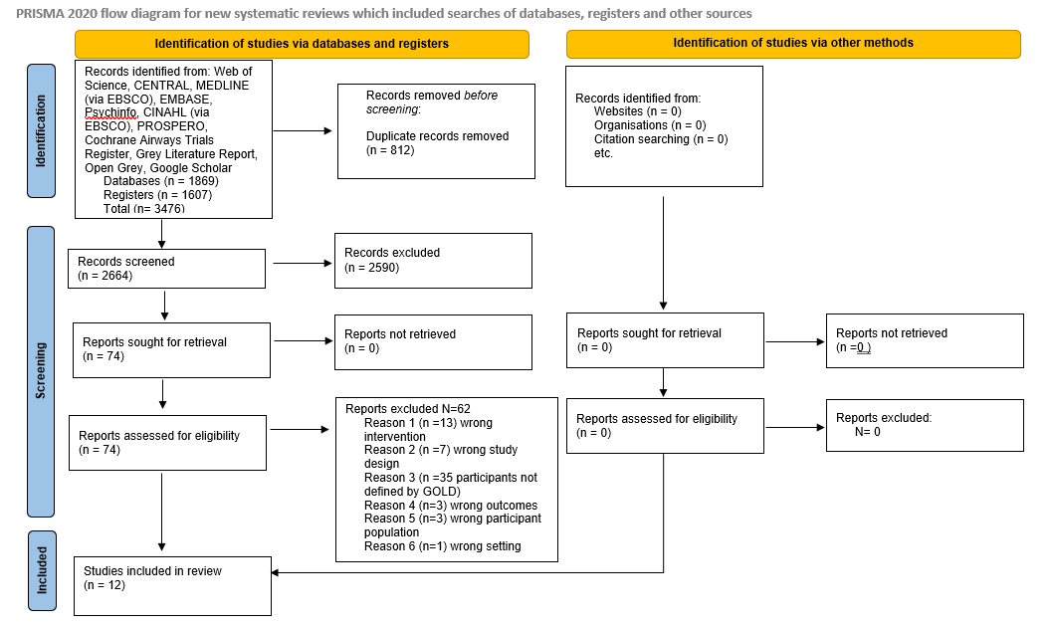

Figure 2 Meta analysis of all studies that reported steps per day as an outcome
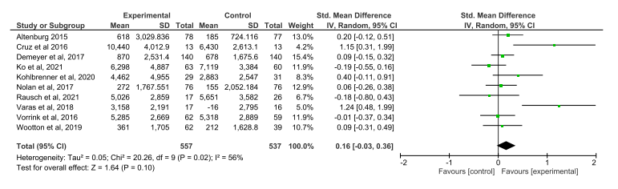

Figure 3 Meta analysis of studies that measured steps per day as an outcome and met the valid* measurement criteria for physical activity
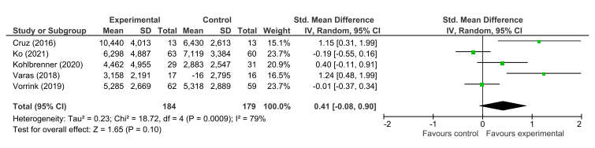
* minimum of four consecutive days, over seven days for more than eight hours per day [58, 59]

