L.R. Pure et al.: A high resolution ⁴⁰Ar/³⁹Ar lava chronology and edifice construction history for Tongariro volcano, New Zealand

Journal of Volcanology and Geothermal Research

Supplementary Material

S1. METHODS

S1.1. Field studies, sampling and mapping
Samples were collected during field campaigns in 2016-2018 that predominantly targeted the forested NW, NE and E sectors of the volcano that were previously under-sampled. The mapping undertaken here defines the exposed eruptive materials on Tongariro’s edifice: surficial alluvium, fan deposits, till, glacial outwash and other sedimentary deposits were not differentiated (see Townsend et al., 2017). Mapping was undertaken using field-based examination and ArcGIS software, which aided identification, interpretation and cross-comparison with geomorphological features on aerial photographs, topographic maps and a digital surface elevation model (DSM). All resources and sample location information were handled in the New Zealand Transverse Mercator 2000 (NZTM2000) map projection. Contours were obtained from 1:50,000 Topo50 series digital topographic maps published by Land Information New Zealand (LINZ). The 2 m-resolution DSM used in this study was developed by GNS and was previously used by Gómez-Vasconcelos et al. (2016). Sample locations (accurate to about ± 10 m: Townsend et al., 2017) were obtained with a Garmin GPS unit. To help differentiate edifice-forming volcanic materials, new geochemical data were plotted visually to iteratively refine unit boundaries. Mapped units were stratigraphically ordered using field observations and radiometric age determinations obtained for this study and from elsewhere (Topping, 1974; Hobden et al., 1996; Townsend et al., 2017).

S1.2. Rock crushing and powdering
Samples were trimmed back to uniformly-coloured grey-black interior material with a diamond saw. Hand-sized pieces of samples were crushed in a Rocklabs® Boyd Crusher at Victoria University of Wellington (VUW) or a roller mill at GNS Science, Gracefield. For whole-rock samples, at least 100 g of material was crushed, but usually 200-500 g which ensured sample representativity. Whole-rock samples were powdered in a Rocklabs® agate ring mill (Scott® Automation, NZ).

S1.3. ⁴⁰Ar/³⁹Ar geochronology
See section S3.1, below.

S1.4. Whole-rock geochemistry
Major oxide, Sr and Ba concentrations were analysed by X-ray fluorescence (XRF) spectrometry at the University of Waikato (UW) after sample preparation at VUW. Analytical accuracy is within 5 % (1 r.s.d.) for each oxide concentration but generally ≤2.5 % (1 r.s.d.). Duplicate analyses of LP009B indicate an external precision (2 s.d.) better than 5 % for all oxides and Sr; however, Ba reproducibility is ~13 %. XRF analyses by Hobden (1997) of the same map units sampled in this study show good agreement, generally within 5 % (1 r.s.d.) of XRF data presented here. XRF data from Cole (1978, 1979) and Wahyudin (1993) are less accurate and generally within 5-10 % (1 r.s.d.) of data from this study, and were only used to inform mapping when more accurate data from this study or Hobden (1997) were unavailable.

S1.5. Volume estimates of exposed stratigraphic units and total edifice
The volumes of edifice-forming map units on Tongariro were estimated from their known or inferred areas multiplied by their thicknesses. To minimise inaccuracies, the volumes of all map polygons were estimated individually using their local areas and thicknesses. These volumes were then summed together to estimate the total volume of each stratigraphic unit. Note however that stratigraphic units generally consist of multiple separated polygons, as shown in Figs. 4, 8 and 11 in the main mext.
In most cases, map units are partially buried. To address this, estimated volumes were multiplied by ‘f’-factors that account for buried areas, which were needed to connect exposures to their inferred source vent location (Table 4 in main text), as inferred from field relations. Tongariro’s total edifice volume was calculated with the “Zonal Statistics as Table” tool in ArcMap on a digital surface model (DSM), which strongly depends on the elevation on which Tongariro was constructed. Justification for the chosen elevation is given in the main text, section 4. The elevation of the volcanic base that separates Tongariro’s eruptives from underlying sediments is ~750 m above sea level (a.s.l). If reasonable alternative datum elevations are used for computing the total edifice volume, the results are 101 km³ (for 700 m a.s.l.) and 79 km³ (for 800 m a.s.l.): see discussion in section 4 of the Main Text. Therefore, Tongariro’s total volume is considered accurate to ±12 %. The volcanic base elevation was then subtracted from the average absolute elevation above sea level (a.s.l.), computed in the previous step, which gives the average thickness of Tongariro between its base and upper surface (410 m). The total edifice volume was then computed by multiplying this average volcano thickness by the total footprint area of lava flows emanating from the edifice (220 km²).
The cumulative volumes plotted in Fig. 16c represent all map units that are formally defined (S6 below) using the values in Table 4 of the main text, but exclude undifferentiated units. Cumulative volume versus time trends in Fig. 16c were first plotted without predetermined segmentation. Changes in gradient were noted in the volume-time data between 230-190, 190-130, 130-70, 70-7 ka and 7-0 ka (Fig. 16c of the main text). Subsequently it was recognised that these periods correlated with Marine Isotope Stage boundaries at 191 ka (MIS 7-6), 130 ka (MIS 6-5), 71 ka (MIS 5-4) and 14 ka (MIS 2-1) (Lisiecki and Raymo, 2005). To emphasise this correlation, the edifice building rates in these intervals are plotted with linear regression lines and annotated with gradients and r² values in Fig. 16c.

S2. SAMPLE LIST
A summary of sample coordinates in New Zealand Transverse Mercator 2000 (NZTM2000) coordinates is presented here. The analytical batches corresponding to each sample for X-ray fluorescence (XRF) and year of ⁴⁰Ar/³⁹Ar age analysis are provided here.

Table S2.1. List of samples, coordinates, assigned stratigraphic units, year of ⁴⁰Ar/³⁹Ar age determinations and batch numbers for XRF analyses.
Sample | Easting | Northing | unit | XRF batch | ⁴⁰Ar/³⁹Ar year
CC351 | 1839661 | 5675104 | PH | 5 | 2017
GL1951 | 1823360 | 5671213 | dtp | 10
GL1957 | 1823579 | 5670392 | OT? | 10
GL2007 | 1826896 | 5663982 | arp |  | 2014
GL2132 | 1827579 | 5660057 | aut |  | 2014
GL2139 | 1824716 | 5664547 | arp | 10
GL2142 | 1824245 | 5665630 | arp | 10
GL2145 | 1823965 | 5666864 | dtp | 10
GL2148 | 1823917 | 5667288 | dtp | 10
GL2218 | 1831305 | 5665594 | awu | 2
GL2222 | 1832085 | 5667346 | att | X
GL2223 | 1832034 | 5667697 | att | 1 | 2016
GL2224 | 1832711 | 5666015 | dpk2 | X
GL2225 | 1833388 | 5664973 | mhi | X
GL2226 | 1831655 | 5666225 | aww | X
GL2229 | 1834803 | 5665968 | arp | X
GL2230 | 1836663 | 5666922 | arh | X
GL2231 | 1833999 | 5666462 | arp | 1
GL2232 | 1836558 | 5664529 | mhi | X
GL2233 | 1835700 | 5664323 | mhi | X
GL2234 | 1834789 | 5664211 | mhi | 2
LP001 | 1819612 | 5668420 | PN | 1 | 2017
LP002 | 1828323 | 5672925 | arh | 1
LP003 | 1832587 | 5672119 | api | 5
LP004 | 1844045 | 5665122 | RUG | 1
LP005 | 1844075 | 5664946 | RUG | 1
LP006 | 1844127 | 5664908 | ?
LP007 | 1842057 | 5660527 | RUG | 1 | 2017
LP008 | 1826825 | 5664687 | dtp | 1

Table S2.1. Continued.
Sample | Easting | Northing | unit | XRF batch | ⁴⁰Ar/³⁹Ar year
LP009A | 1825244 | 5664270 | dtp | 1
LP009B | 1825244 | 5664270 | dtp | 1
LP010 | 1827029 | 5665491 | amp | 1 | 2018
LP011 | 1827320 | 5666955 | atr | 1
LP012 | 1827139 | 5667391 | ari
LP013 | 1826887 | 5667660 | ari | 6
LP014 | 1826746 | 5667191 | dtp | 1
LP018 | 1826053 | 5666778 | aok | 1
LP019 | 1826210 | 5667166 | dtp | 1
LP020 | 1826297 | 5667739 | dtp | 1
LP021 | 1826257 | 5667853 | dtp | 1
LP022 | 1826145 | 5667188 | dtp
LP023 | 1825799 | 5666527 | atr clast | 1 | 2016
LP024 | 1825282 | 5667158 | dtp | 1
LP025 | 1825321 | 5666833 | dtp | 1
LP026 | 1826658 | 5666432 | atr | 1
LP027 | 1827089 | 5666438 | atr | 1
LP028 | 1828550 | 5667795 | ari | 1
LP029 | 1828461 | 5668417 | ari | 1
LP030 | 1828239 | 5668711 | aok | 1
LP031 | 1827968 | 5668236 | ari | 1
LP032 | 1827394 | 5669025 | aok | 1
LP033 | 1825842 | 5659715 | atw | 1 | 2016
LP034 | 1826718 | 5661370 | ato | 1
LP035 | 1826206 | 5661182 | ato | 1
LP036 | 1825189 | 5661297 | ato | 1 | 2016
LP037 | 1825199 | 5660461 | atw | 1
LP038 | 1825556 | 5663261 | apk | 6
LP039 | 1825202 | 5663324 | apk | 2 | 2017
LP040 | 1825753 | 5662740 | apk | 6
LP041 | 1839192 | 5656753 | RUG | 5
LP042 | 1840016 | 5656323 | RUG | 5
LP043 | 1825208 | 5673472 | aok | 6
LP044 | 1825755 | 5672986 | aok | 2
LP045 | 1827363 | 5667271 | ari
LP046A | 1827690 | 5667295 | ari | 5
LP046B | 1827690 | 5667295 | ari | 5
LP047 | 1827461 | 5667585 | ari | 6
LP048 | 1826524 | 5668288 | ari | 4
LP049 | 1826955 | 5668380 | ari
LP050 | 1821341 | 5667793 | PN
LP051 | 1826845 | 5672334 | arh | 2 | 2017
LP052 | 1826917 | 5672234 | aok | 12
LP053 | 1827955 | 5670913 | dtp | 4
LP054 | 1828784 | 5659262 | atw | 6
LP056 | 1824820 | 5673667 | dtp | 2
LP057 | 1824700 | 5673397 | dtp | 6
LP058 | 1824750 | 5673056 | dtp | 4
LP060 | 1825448 | 5671592 | aok | 2
LP062 | 1829106 | 5675989 | uol | 2 | 2017
LP063 | 1828350 | 5667547 | ari | 4
LP064 | 1827713 | 5667937 | ari | 6
LP065 | 1827713 | 5667937 | ari
LP066 | 1826738 | 5669208 | aok | 6

Table S2.1. Continued.
Sample | Easting | Northing | unit | XRF batch | ⁴⁰Ar/³⁹Ar year
LP067 | 1826409 | 5669514 | aok | 2
LP070 | 1827048 | 5669741 | aok | 6
LP071 | 1827579 | 5670009 | aok | 2
LP072 | 1830438 | 5659913 | atw | 2 | 2017
LP073 | 1829982 | 5660440 | mtu | 4
LP074 | 1829821 | 5660463 | mtu | 2 | 2017
LP075 | 1829843 | 5660485 | ?
LP077 | 1825045 | 5671182 | ari | 5
LP079 | 1825181 | 5670952 | ari | 6
LP080 | 1825188 | 5670572 | ari | 6
LP081 | 1824975 | 5670144 | ari | 2
LP087 | 1823763 | 5670051 | OT | 6
LP088 | 1823855 | 5670040 | dtp | 6
LP090 | 1824217 | 5669754 | dtp | 2
LP091 | 1824415 | 5669598 | dtp
LP092 | 1824926 | 5668933 | dtp
LP093 | 1825214 | 5668645 | dtp
LP095 | 1825347 | 5668614 | dtp | 2
LP096 | 1823571 | 5670384 | PN | 2
LP097 | 1823538 | 5670030 | OT | 2 | 2019
LP098 | 1823408 | 5669640 | dtp | 4
LP099 | 1823449 | 5669377 | dtp | 4
LP102 | 1823805 | 5668732 | dtp
LP103 | 1823956 | 5668561 | dtp | 2 | 2017
LP107 | 1842019 | 5660531 | RUG
LP108H | 1823466 | 5673714 | TW clast | 4
LP108L | 1823466 | 5673714 | TW clast | 4
LP109 | 1825103 | 5658116 | alt | 5
LP110 | 1825406 | 5657913 | RUG | 13
LP113 | 1825837 | 5658660 | TU | 6 | 2018
LP117 | 1832659 | 5665620 | awp | 4
LP118 | 1832763 | 5665964 | dpk2 | 2 | 2017
LP119 | 1832790 | 5666029 | att | 4
LP120 | 1832584 | 5666099 | att | 4
LP122 | 1832345 | 5666116 | dtp | 5
LP123 | 1832231 | 5665634 | awp | 4
LP124 | 1832201 | 5665495 | awp | 4
LP125 | 1832608 | 5663753 | mhi | 5
LP126 | 1832926 | 5664819 | mhi | 2 | 2017
LP128 | 1832661 | 5665088 | awp | 4
LP129 | 1832720 | 5664995 | dpk1 | 2 | 2017
LP130 | 1832164 | 5662817 | awp | 5
LP131 | 1832619 | 5662840 | awp
LP132 | 1833092 | 5662205 | awp
LP134 | 1830251 | 5665390 | aww | 5
LP135 | 1830711 | 5665377 | aww | 6
LP137 | 1831046 | 5665366 | awu
LP138 | 1831043 | 5665389 | awu | 5
LP140 | 1831269 | 5665549 | awu | 6
LP141 | 1831337 | 5665593 | awu | 4
LP143 | 1831466 | 5665760 | dtp | 4
LP145 | 1831289 | 5665941 | awu | 5
LP147 | 1830848 | 5666330 | aww | 2 | 2017
LP148 | 1830348 | 5666524 | arp?

Table S2.1. Continued.
Sample | Easting | Northing | unit | XRF batch | ⁴⁰Ar/³⁹Ar year
LP149 | 1824643 | 5663438 | ato | 5 | 2017
LP150 | 1828495 | 5666269 | ari | 7
LP151 | 1828332 | 5666754 | amt | 7 | 2018
LP152 | 1828531 | 5667048 | amt | 7
LP155 | 1827714 | 5664501 | arp | 7
LP156 | 1827207 | 5664735 | dtp | 7
LP157 | 1831971 | 5666387 | att | 8
LP158 | 1831979 | 5666280 | arh | 8
LP159 | 1832027 | 5666254 | dtp | 11
LP160 | 1832217 | 5666308 | att | 8
LP161 | 1832188 | 5666246 | ati | 9
LP163 | 1832454 | 5666088 | arp | 9
LP164 | 1832456 | 5666079 | arp | 9
LP165 | 1832452 | 5666073 | arp | 9
LP166 | 1832463 | 5666050 | dtp | 10
LP167 | 1832451 | 5666021 | dtp | 10
LP168 | 1832474 | 5665970 | dpk2 | 10
LP169 | 1832550 | 5665978 | dpk2 clast | 11
LP170 | 1832560 | 5665934 | dpk2 | 9
LP171 | 1832619 | 5665965 | dpk2 | 10
LP172 | 1832702 | 5665883 | dpk2 | 9
LP173 | 1831651 | 5666532 | aok | 11
LP174 | 1839169 | 5662530 | mhi clast | 10
LP175A | 1836282 | 5655679 | ? | 9
LP175B | 1836282 | 5655679 | RUG? | 9
LP176 | 1836246 | 5655610 | RUG
LP177H | 1835951 | 5648524 | ? | 11
LP177L | 1835951 | 5648524 | ? | 11
LP179 | 1830773 | 5666078 | aww | 9
LP180 | 1830800 | 5666091 | aww | 9
LP181 | 1831075 | 5666220 | aww | 9
LP182 | 1830778 | 5666239 | aww | 11
LP183 | 1830494 | 5666525 | dpk2 | 9
LP184 | 1830470 | 5666589 | awu | 9
LP185 | 1830458 | 5666569 | aww | 11
LP186 | 1830745 | 5666921 | dpk2 | 9
LP187 | 1830747 | 5667011 | dpk2 | 9
LP188 | 1830719 | 5667023 | arp?
LP189 | 1830736 | 5667033 | arp?
LP190 | 1830691 | 5667027 | arp | 9
LP191 | 1831144 | 5665321 | awu | 12
LP192 | 1831222 | 5665346 | awu | 8
LP193 | 1831426 | 5665406 | awu | 8
LP194 | 1831495 | 5665384 | awu | 8
LP197 | 1831324 | 5665050 | awu | 8
LP198 | 1831358 | 5665120 | awu | 8
LP199 | 1831378 | 5665143 | awu | 8
LP200 | 1831567 | 5665033 | awu | 8
LP201 | 1833716 | 5670340 | ? | 10
LP202 | 1833855 | 5669646 | ? | 10
LP203 | 1835514 | 5670000 | ? | 10
LP204 | 1834663 | 5669129 | ? | 8
LP205 | 1834471 | 5669018 | ? | 10
LP206 | 1834416 | 5668980 | arp | 7

Table S2.1. Continued.
Sample | Easting | Northing | unit | XRF batch | ⁴⁰Ar/³⁹Ar year
LP208 | 1834245 | 5668836 | arp | 7
LP209 | 1833940 | 5668673 | mtm | 11
LP211 | 1833741 | 5668576 | arp | 11 | 2018
LP212 | 1834120 | 5668619 | arp | 12
LP213 | 1836621 | 5668206 | ? | 7
LP214 | 1835747 | 5668694 | arh | 12 | 2018
LP215 | 1835666 | 5668627 | arh | 9
LP217 | 1835491 | 5668428 | arp | 7
LP219 | 1835430 | 5668389 | arp | 7
LP220A | 1834810 | 5667967 | arh | 7
LP220B | 1836634 | 5667987 | arh | 11
LP221 | 1836739 | 5667628 | arh | 11
LP222 | 1836365 | 5667101 | arh | 11
LP224 | 1836040 | 5666386 | arh | 8
LP225 | 1831580 | 5664957 | awu | 8
LP226 | 1831533 | 5664906 | awu | 11
LP227 | 1831648 | 5664846 | awu | 8
LP228 | 1831647 | 5664764 | dpk2 | 8
LP229 | 1831657 | 5664737 | dpk2 | 8
LP231 | 1831809 | 5664880 | mhi | 7
LP232 | 1831931 | 5664799 | mhi | 11
LP233 | 1831954 | 5664871 | dpk2 | 11
LP234 | 1831986 | 5664962 | dpk2 | 7 | 2018
LP235 | 1831880 | 5664961 | dpk2 | 7
LP236 | 1831691 | 5665555 | awp | 11
LP237 | 1831641 | 5666024 | dtp | 8
LP238 | 1832376 | 5665929 | awh | 7
LP239 | 1832557 | 5665753 | dpk1 | 9 | 2019
LP240 | 1832772 | 5665775 | dpk2 | 11
LP241 | 1832785 | 5665805 | dpk2 | 7
LP242 | 1833404 | 5665725 | dpk2 | 7
LP243 | 1833567 | 5666176 | arp | 12
LP244 | 1833378 | 5666388 | att | 7
LP245 | 1833459 | 5666275 | awh | 10 | 2018
LP247 | 1833134 | 5666718 | awh | 10
LP248 | 1832954 | 5666881 | att | 10
LP249 | 1832853 | 5666861 | att? | 8
LP250 | 1824862 | 5664128 | amp | 7 | 2018
MSR15017A | 1833061 | 5661833 | awp | X
MSR15018 | 1833196 | 5662123 | awp | 1 | 2016
MSR15019 | 1834895 | 5662561 | mhi | X | 2017
MSR15020A | 1834686 | 5661675 | awp | X
MSR15021 | 1835958 | 5660679 | awp | X
MSR15022 | 1835191 | 5659525 | awp | X
MSR15023 | 1834692 | 5658591 | atw | X
MSR15024 | 1833412 | 5658012 | mtu? | 1
MSR15025 | 1833726 | 5658749 | atw? | 2
MSR15026 | 1833493 | 5659904 | dpk2? | X
MSR15027 | 1833522 | 5660731 | dpk2? | 2
MSR15028 | 1832496 | 5663974 | mhi | 1
MSR15029 | 1833097 | 5663966 | mhi | 2
MSR15030 | 1833292 | 5664105 | mhi | X
MSR15031 | 1833549 | 5663982 | mhi | 2
MSR15032 | 1833712 | 5663924 | mhi | 2

Table S2.1. Continued.
Sample | Easting | Northing | unit | XRF batch | ⁴⁰Ar/³⁹Ar year
MSR15033 | 1833822 | 5663753 | mhi | 2
MSR15034 | 1834050 | 5663807 | mhi | 2
MSR15035 | 1834286 | 5663671 | mhi | X
MSR15036 | 1834767 | 5663405 | mhi
MSR15037 | 1834946 | 5663061 | mhi | X
MSR15038 | 1835682 | 5663527 | ? | 2
RPC070 | 1828602 | 5665097 | dtp | X
RPC077 | 1828150 | 5664778 | arp | X
RPC078 | 1828216 | 5664767 | arp | X
RPC088C | 1827855 | 5664986 | dtp | X
RPC090 | 1828203 | 5665318 | ati | X
RPC110 | 1828203 | 5665318 | ati |  | 2016
TG084 | 2741700 | 6222550 | dpk2 |  | 2018
TG088 | 2742250 | 6222800 | ahi |  | 2018
Notes: Eastings and Northings are in NZTM2000.
Units abbreviations in alphabetical order are: Te Ahititi Member (ahi), Heretoa Member (aht), Lower Tama Member (alt), Mangatepopo Member (amp), Mangatapate Member (amt), Otamangakau Member (aok), Pungarara Member (apg), Paungaiti Member (api), Pukekaikiore Member (apk), Rahuituki Member (arh), Rangitaupahi Member (ari), Rotopaunga Member (arp), Te Wakarikiariki Member (ati), Toatoa Member (ato), Te Rurunga Member (atr), Te Tatau Member (att), Tawhairauiki Member (atw), Upper Tama Member (aut), Waiaruhairiki Member (awh), Waipoa Member (awp), Waitakatorua Member (awu), Te Wai Whakaata Member (aww), the Te Pakiraki Member (dpk) is subdivided into pre-Waiaruhairiki Member age (dpk1) and post-Waiaruhairiki age (dpk2), Te Porere Member (dtp), Mangatetipua Member (mgt), Mangahouhouiti Member (mhi), Makahikatoa Formation (MK), Matariki Member (mmt), Papamānuka Member (mpa), Toakakura Member (mtk), Tātaramoa Member (mtm), Te Rongo Member (mtr), Tutangatahiro Member (mtu), Otamatereinga Formation (OT), Pihanga Formation (PH), Pukeonake Formation (PN), Ruapehu Group (RUG), Tupuna Formation (TU), Te Whaiau Formation [debris flows] (TW).
XRF batch refers to the sessions wherein sample-BLiO₂ flux mixtures were weighed and LOIs were determined. XRF analyses for several of these batches were performed together. These groupings were: 1, 2, 3, 4-5, 6, 7-11, 12, 13. X indicates that XRF data was provided by others, with sample prefixes: GL (G. S. Leonard, unpubl. data), MSR (M. S. Rattenbury, pers. comm., 2016), RPC (Cole et al., 2018).

S3. ⁴⁰AR/³⁹AR STEP HEATING RESULTS

S3.1. Methods
Groundmass materials were separated from crushed bulk rock samples to obtain the 250-355 µm size fraction. Dust adhering to the grains was washed away by repeatedly filling and decanting a glass beaker containing sieved samples with water, until clear. The grains were dried overnight in a warm oven at <100 °C. Grains of groundmass material were separated with a hand magnet by exploiting the abundance of highly-magnetic titanomagnetite in holocrystalline groundmass material relative to phenocrystic components. For up to 10 cycles each of 20-40 mins, the grains were ultrasonicated in glass beakers filled with tap-water, with the water decanted between cycles, then the grains dried overnight at <100 °C. Dried grains were handpicked to obtain pure groundmass separates, free of phenocryst fragments. These grains were washed in glass beakers in four 20 min cycles in an ultrasonic bath. The first wash was with acetone that was later decanted, which was followed by three washes of 15 MΩ H₂O with the water decanted between cycles. The grains were then dried overnight at <100 °C. Total yields of groundmass separates in the 250-355 µm size fraction were ~200-300 mg. Two samples (LP001 and LP007) were prepared and analysed for 60-90 µm size fractions.
⁴⁰Ar/³⁹Ar age determinations on Tongariro lavas were performed at the United States Geological Survey geochronological facility in Menlo Park by A. T. Calvert, G. S. Leonard and D. T. Downs between 2016-2019. For irradiation, 88-210 mg separates were packaged in metal foil and placed in a cylindrical quartz vial, together with fluence monitors of known age and K-glass and fluorite to measure interfering isotopes from K and Ca. The quartz vials were wrapped in 0.5 mm-thick Cd foil to shield samples from thermal neutrons during irradiation. The majority (32 of 34) of samples were irradiated in four separate irradiations, each for one hour in the central thimble of the US Geological Survey TRIGA reactor in Denver, Colorado (Dalrymple et al., 1981). The reactor vessel was rotated continuously during irradiation to avoid lateral neutron flux gradients and oscillated vertically to minimize vertical gradients. Due to a temporary reactor shutdown, samples LP097 and LP239 were irradiated in the CLICIT facility at the TRIGA reactor at Oregon State University (OSU). Reactor constants determined for the Denver irradiations were indistinguishable from recent irradiations, and a weighted mean of constants obtained over the past five years yields ⁴⁰Ar/³⁹ArK = 0.0010 ± 0.0004, ³⁹Ar/³⁷ArCa = 0.00071 ± 0.00005, and ³⁶Ar/³⁷ArCa = 0.000281 ± 0.000006. We utilized reactor constants from Niespolo et al. (2017) for the OSU irradiation, once corrected for an obvious typographical error in the ³⁶Ar/³⁷ArCa correction: ⁴⁰Ar/³⁹ArK = 0.000730 ± 0.000092, ³⁹Ar/³⁷ArCa = 0.000702 ± 0.000012, and ³⁶Ar/³⁷ArCa = 0.0002702 ± 0.0000040. Bodie Hills sanidine (BHs, Fleck et al., 2019) was used as a fluence monitor with an age of 9.797 Ma. BHs is a secondary standard calibrated against the primary intralaboratory standard, GA1550 biotite, that has an age of 98.79 ± 0.96 Ma (McDougall and Wellman, 2011). Fluence monitors were analysed using a continuous CO₂ laser system and MAP 216 mass spectrometer described by Dalrymple (1989). Unknowns were heated either with a Staudacher-type resistance furnace or a continuous diode laser system, then analysed on the MAP spectrometer. Gas was purified continuously during extraction using two SAES ST-175 getters operated at 4 A and 0 A.
Mass spectrometer discrimination and system blanks are important factors in the precision and accuracy of ⁴⁰Ar/³⁹Ar age determinations of Pleistocene samples because of low radiogenic yields. Discrimination is routinely monitored by analysing splits of atmospheric Ar from a reservoir attached to the extraction line. Typical system blanks including mass spectrometer backgrounds were 1.5x10⁻¹⁸ mol of m/z = 36, 9x10⁻¹⁷ mol of m/z = 37, 3x10⁻¹⁸ mol of m/z = 39 and 1.5x10⁻¹⁶ mol of m/z = 40, where m/z is mass/charge ratio.
Plateau and isochron steps are excluded if they cause the goodness of fit parameter MSWD (Mean Square Weighted Deviate) to yield a poor fit using the criteria of Mahon (1996). An age is defined as a "plateau age" if the included steps yield a good fit according to Mahon (1996) and the steps together comprise 50 % or more of the ³⁹Ar released in the incremental heating experiment. We exclude data if steps cause a high MSWD, not if the steps are distinguishable at 2 s.d.; however, those results are similar.
Data from these age analyses are presented below, as step heating results in alphabetical order which are plotted with 1 s.d. analytical uncertainties (Fig. S3.1). All data presented in this paper are reproduced in Table S3.1 for completeness.

S3.2. Age determinations
Some samples (LP051, LP126) have non-ideal proportions of groundmass glass (up to 15 vol%) but yield ages that appear to be accurate as indicated by other age determinations and field relationships, so are reported here (but not in Table 1 in the main text). One sample reported here yields a ⁴⁰Ar/³⁹Ar age result that cannot be quantified in terms of specific mean age values and standard deviations, but does however allow semi-quantitative statements to be made about its age (LP001). LP001 is from the Pukeonake Formation, and the red-coloured step heating results (below) indicate an age that could be around 40 to 30 ka, consistent with 25.4 ka Oruanui deposits that overlie Pukeonake Formation scoria in the prominent cone at the end of the Mangatepopo valley (stratigraphy from Topping, 1974; Oruanui age from Vandergoes et al., 2013).

Table S3.1. (Same as Table 1 in main paper.) Summary of new ⁴⁰Ar/³⁹Ar age determinations for Tongariro lavas.
Sample | Formation – Member (member abbreviation)¹ | Plateau age² |  |  |  | Isochron age² |  |  |  | Total gas age
Sample | Formation – Member (member abbreviation)¹ | n/N | %³⁹Ar | MSWD | (ka ± 2 s.d.) | %³⁹Ar | MSWD | (ka ± 2 s.d.) | ⁴⁰Ar/³⁶Ar_{i} (± 2 s.d.) | (ka ± 2 s.d.)
TG088 | RC – Te Ahititi (ahi) | 6/10 | 77.8 | 2.07 | 12.9 ± 11.8 | 77.8 | 2.40 | 8.3 ± 25.4 | 301.4 ± 22.4 | 21.8 ± 10.2
LP147 | MM – Te Wai Whakaata (aww) | 11/11 | 100.0 | 0.46 | 28.3 ± 5.2 | 100.0 | 0.50 | 29.3 ± 7.6 | 298.0 ± 3.5 | 27.2 ± 6.0
LP151 | MM – Mangatapate (amt) | 5/10 | 69.3 | 0.41 | 30.1 ± 6.0 | 69.3 | 0.49 | 26.8 ± 14.8 | 305.0 ± 33.7 | 51.6 ± 6.2
GL2223 | TA – Te Tatau (att) | 11/11 | 100.0 | 1.31 | 56.2 ± 4.6 | 100.0 | 1.05 | 59.5 ± 5.4 | 296.3 ± 2.8 | 54.8 ± 4.8
LP211 | TA – Rotopaunga (arp) | 9/10 | 98.9 | 3.47 | 86.4 ± 12.4 | 98.9 | 1.60 | 68.3 ± 15.4 | 319.3 ± 18.4 | 96.0 ± 7.6
GL2007 | TA – Rotopaunga (arp) | 9/10 | 97.4 | 0.44 | 76.1 ± 3.5 | 97.4 | 0.38 | 78.4 ± 5.9 | 291.2 ± 10.1 | 73.3 ± 4.1
RPC110 | TA – Te Wakarikiariki (ati) | 4/11 | 63.6 | 0.98 | 80.6 ± 4.8 | 63.6 | 1.13 | 74.8 ± 15.2 | 304.0 ± 15.7 | 82.9 ± 6.0
LP062 | undifferentiated Otukou lava (uol) | 10/10 | 100.0 | 0.87 | 85.0 ± 6.0 | 100.0 | 0.86 | 89.7 ± 11.6 | 296.7 ± 4.4 | 83.8 ± 6.6
LP023 | TA – Te Rurunga (atr) | 6/11 | 58.7 | 1.07 | 87.5 ± 4.2 | 58.7 | 0.79 | 84.2 ± 6.2 | 304.0 ± 9.0 | 96.0 ± 4.0
LP103 | TA – Te Porere (dtp) | 4/10 | 71.2 | 0.69 | 98.9 ± 2.6 | 71.2 | 0.96 | 101.1 ± 14.2 | 290.7 ± 55.7 | 98.5 ± 3.0
LP010 | TA – Mangatepopo (amp) | 8/10 | 96.4 | 1.80 | 108.5 ± 8.4 | 96.4 | 1.73 | 102.9 ± 15.6 | 305.1 ± 21.2 | 119.1 ± 7.2
MSR15019 | TA – Mangahouhouiti (mhi) | 10/11 | 99.2 | 0.89 | 116.8 ± 23.4 | 99.2 | 0.88 | 141.4 ± 56.2 | 297.3 ± 3.1 | 108.0 ± 25.4
LP250 | TA – Mangatepopo (amp) | 7/10 | 70.5 | 2.12 | 121.1 ± 12.2 | 70.5 | 1.83 | 114.3 ± 14.6 | 307.0 ± 21.4 | 169.2 ± 9.0
LP214 | TA – Rahuituki (arh) | 7/10 | 75.9 | 0.77 | 124.4 ± 4.8 | 75.9 | 0.78 | 124.2 ± 5.4 | 297.4 ± 6.2 | 135.0 ± 5.6
TG084 | MH – Te Pakiraki (dpk) | 8/10 | 90.5 | 0.84 | 136.5 ± 7.0 | 90.5 | 0.79 | 130.8 ± 11.8 | 304.2 ± 12.6 | 153.3 ± 7.6
LP245 | MH – Waiaruhairiki (awh) | 7/10 | 81.8 | 0.30 | 147.3 ± 7.4 | 81.8 | 0.35 | 148.9 ± 17.4 | 296.9 ± 17.2 | 174.9 ± 7.6
LP234 | MH – Te Pakiraki (dpk) | 8/10 | 96.0 | 0.92 | 151.8 ± 4.0 | 96.0 | 0.62 | 146.7 ± 7.4 | 310.5 ± 18.0 | 158.9 ± 4.6
LP118 | MH – Te Pakiraki (dpk) | 8/10 | 88.2 | 1.35 | 155.4 ± 5.2 | 88.2 | 1.48 | 157.1 ± 13.4 | 297.0 ± 11.3 | 152.6 ± 5.0
LP129 | MH – Te Pakiraki (dpk) | 10/10 | 100.0 | 1.13 | 164.9 ± 5.8 | 100.0 | 1.23 | 166.2 ± 12.2 | 296.8 ± 11.5 | 164.9 ± 5.8
LP239 | MH – Te Pakiraki (dpk) | 3/10 | 58.2 | 2.43 | 203.8 ± 9.6 | 58.2 | 1.12 | 185.5 ± 22.4 | 319.1 ± 28.2 | 296.9 ± 8.6
MSR15018 | HA – Waipoa (awp) | 6/11 | 74.0 | 1.19 | 191.1 ± 4.4 | 74.0 | 0.72 | 195.8 ± 7.0 | 292.2 ± 8.5 | 196.4 ± 4.2
LP039 | HA – Pukekaikiore (apk) | 7/10 | 95.1 | 0.38 | 194.7 ± 5.0 | 95.1 | 0.40 | 197.7 ± 12.6 | 296.1 ± 11.0 | 192.6 ± 5.8
LP036 | HA – Toatoa (ato) | 8/10 | 96.3 | Recoil | 205.1 ± 6.0 | 100.0 | 7.97 | 208.9 ± 7.4 | 293.0 ± 17.7 | 208.8 ± 4.2
LP149 | HA – Toatoa (ato) | 4/10 | 67.2 | 1.72 | 205.1 ± 6.0 | 67.2 | 1.48 | 191.3 ± 23.4 | 311.0 ± 24.4 | 225.6 ± 5.0
GL2132 | HA – Upper Tama (aut) | 6/11 | 85.2 | 0.74 | 209.1 ± 4.9 | 85.2 | 0.84 | 211.8 ± 17.9 | 290.9 ± 31.0 | 201.9 ± 5.7
LP072 | HA – Tawhairauiki (atw) | 10/10 | 100.0 | 0.72 | 217.7 ± 4.4 | 100.0 | 0.76 | 219.0 ± 6.6 | 296.6 ± 7.2 | 215.6 ± 5.6
LP074 | HA – Tutangatahiro (mtu) | 6/10 | 89.0 | 0.66 | 223.3 ± 5.6 | 89.0 | 0.45 | 214.1 ± 16.2 | 305.5 ± 13.9 | 221.2 ± 6.6
LP113 | TU | 5/10 | 67.0 | 1.85 | 304.4 ± 11.4 | 67.0 | 1.06 | 281.1 ± 24.2 | 316.2 ± 41.0 | 336.4 ± 10.2
LP097 | OT | 3/11 | 62.2 | 0.51 | 512.0 ± 59.4 | 62.2 | 0.52 | 631.1 ± 338.4 | 294.6 ± 12.6 | 931.1 ± 57.4
¹ Formation abbreviations: OT = Otamatereinga, TU = Tupuna, MH = Mangahouhounui, HA = Haumata, TA = Taiko, MM = Mokomoko, RC = Red Crater.
² n/N = number [n] of heating steps used for plateau age calculation out of total [N] steps in age analysis. %³⁹Ar is the percentage of radiogenic argon released over the selected plateau steps of the total radiogenic argon. Recoil ages are noted where used instead of plateau ages—see Fig. S3.1 for heating step data.
⁴⁰Ar/³⁶Ar_{i} = denotes the isochron intercept value. Preferred ages appear in bold typeface. Details of heating step experiments, ⁴⁰Ar/³⁶Ar intercepts, isochrons and plateau spectra are provided in Fig. S3.1, below.
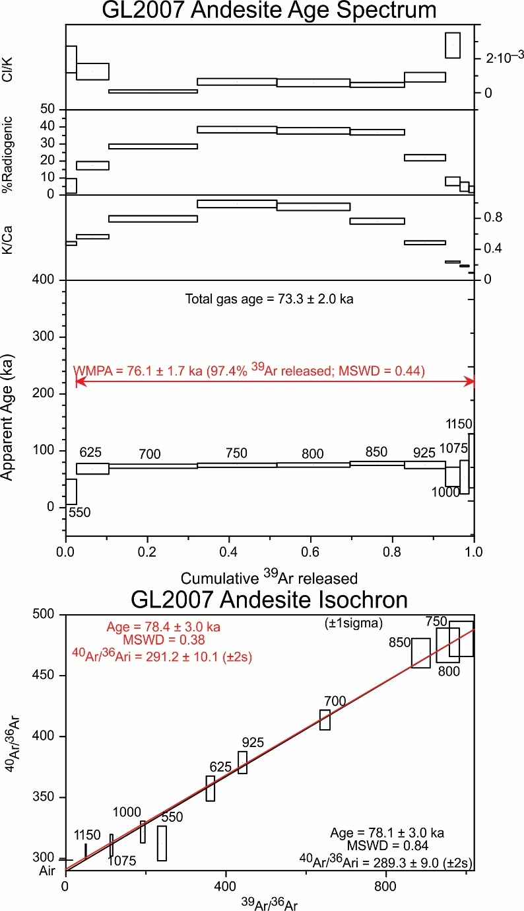 Fig. S3.1. ⁴⁰Ar/³⁹Ar step heating data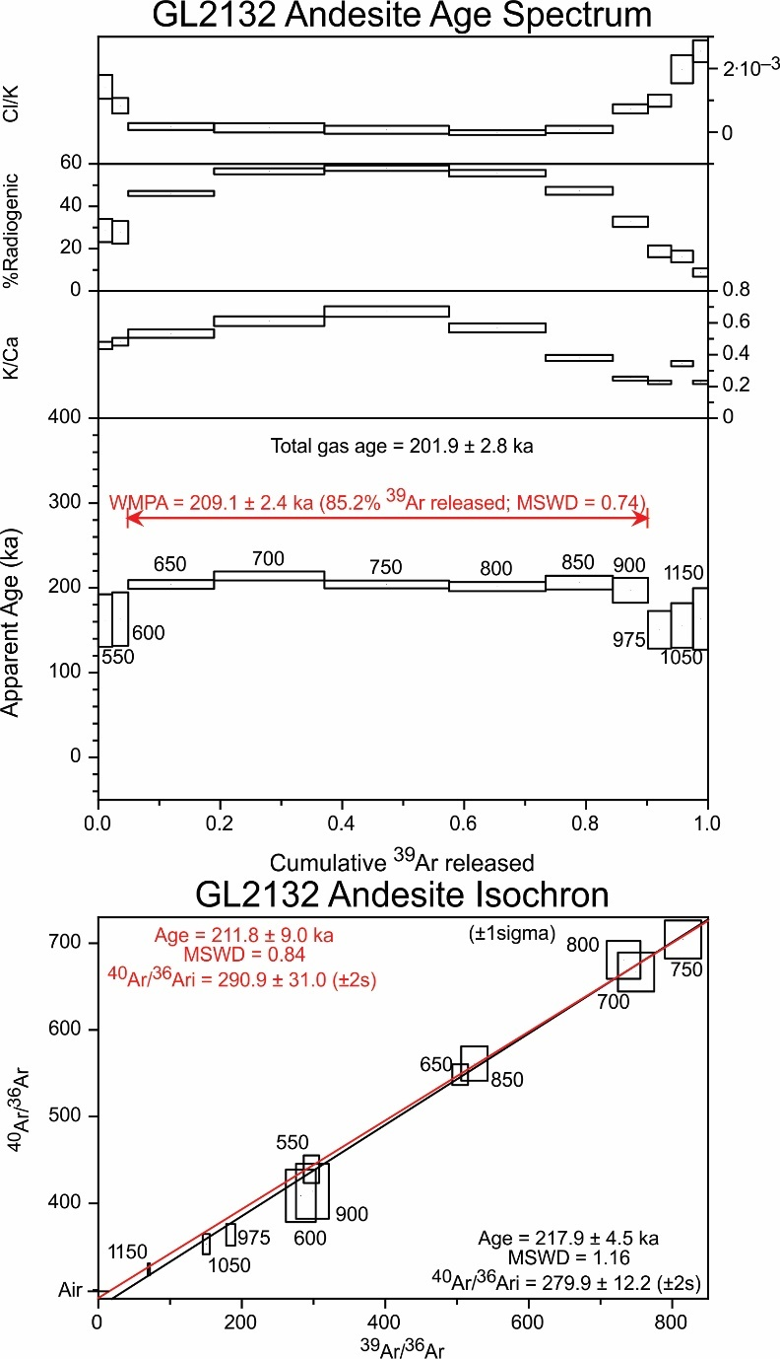 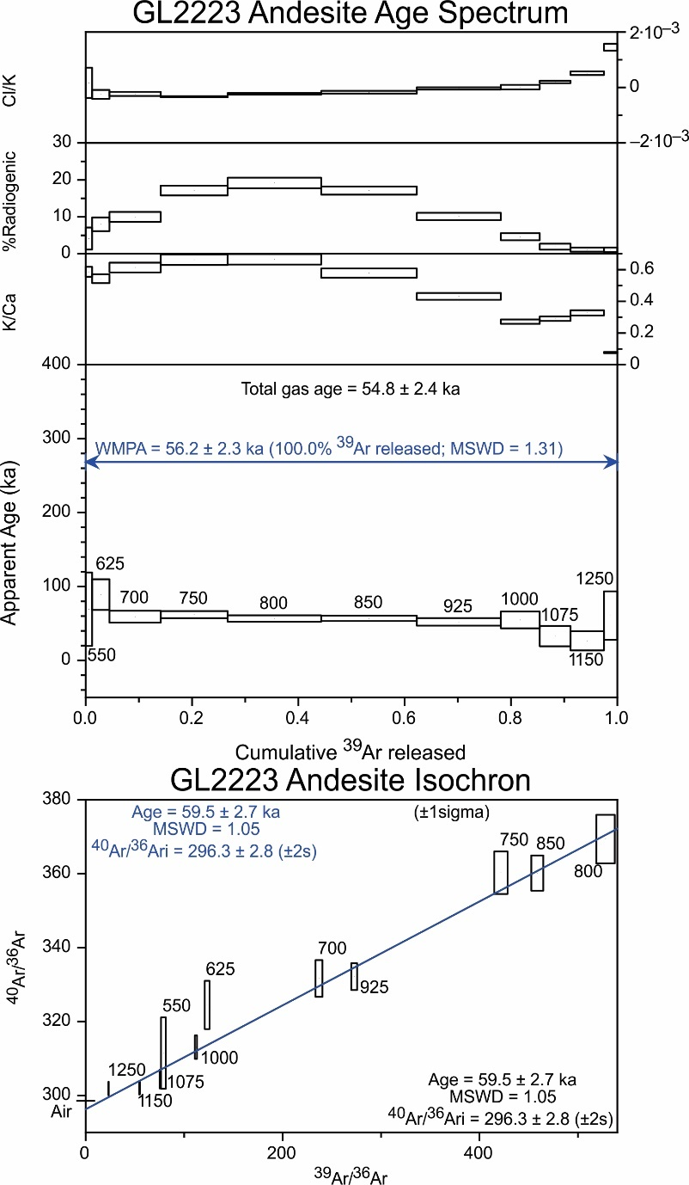Fig. S3.1. Continued. 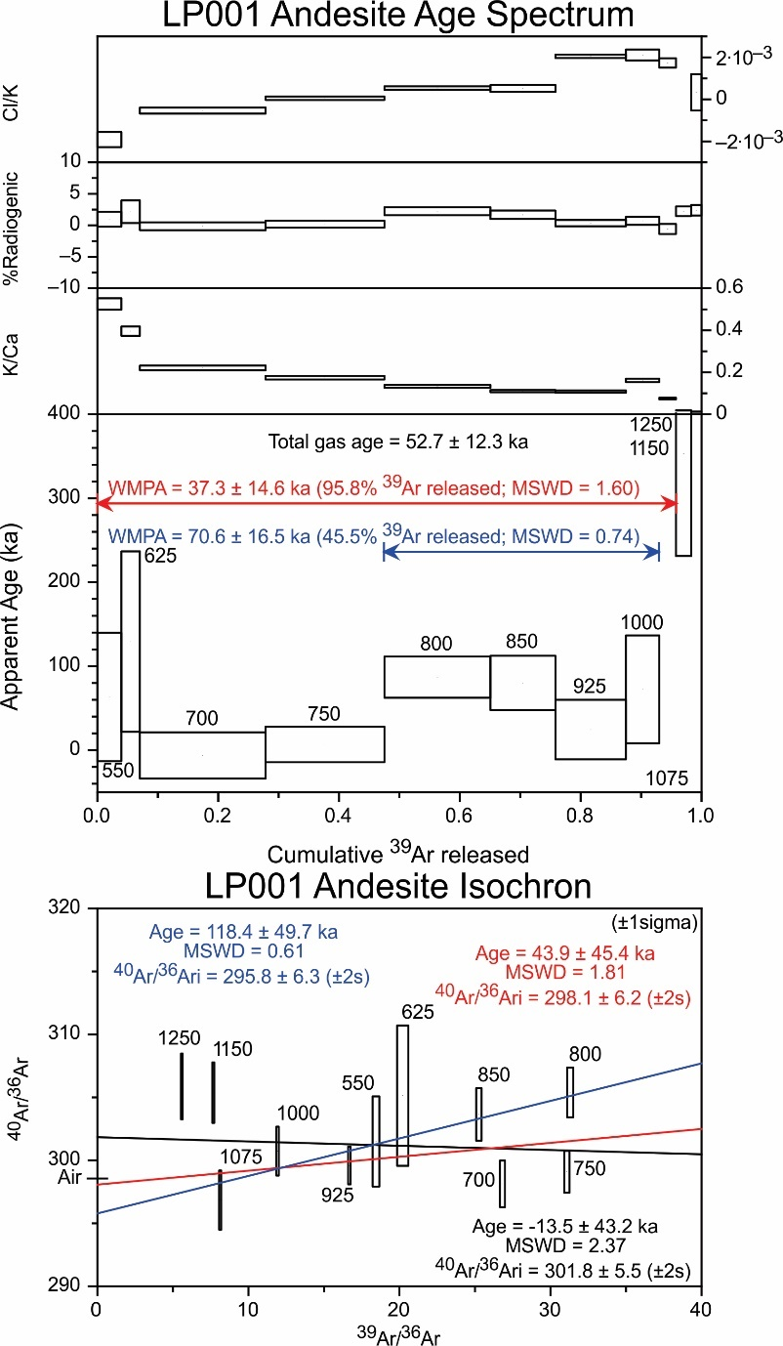
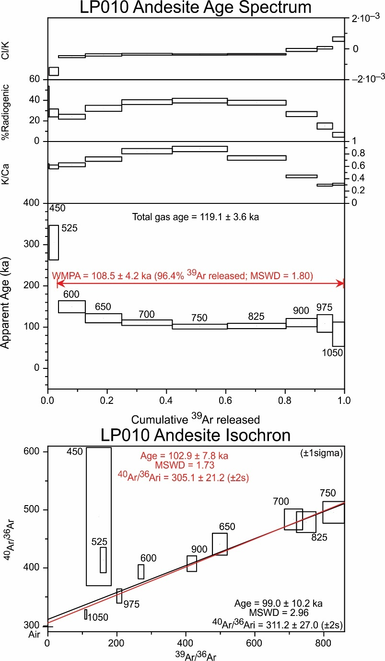 Fig. S3.1. Continued. 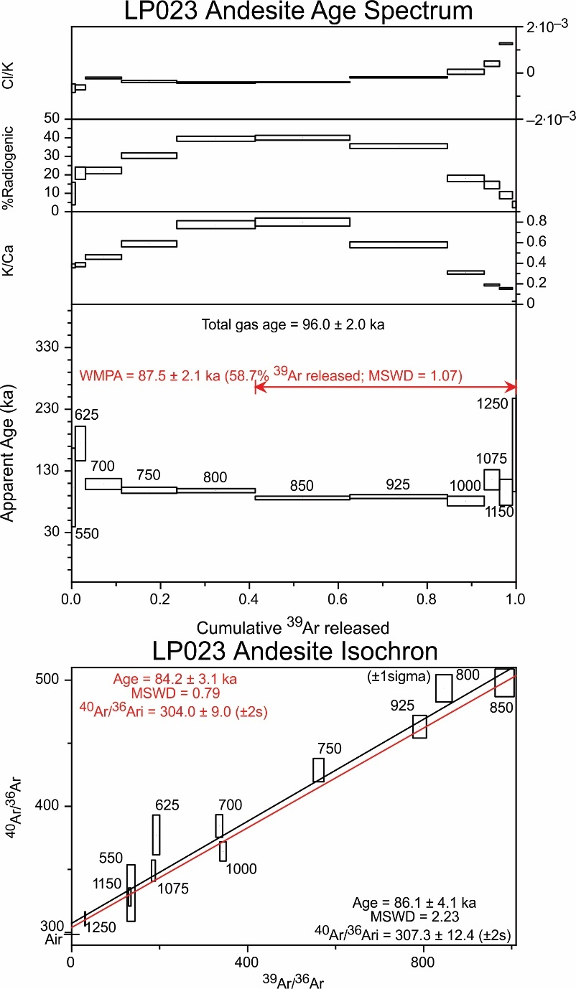
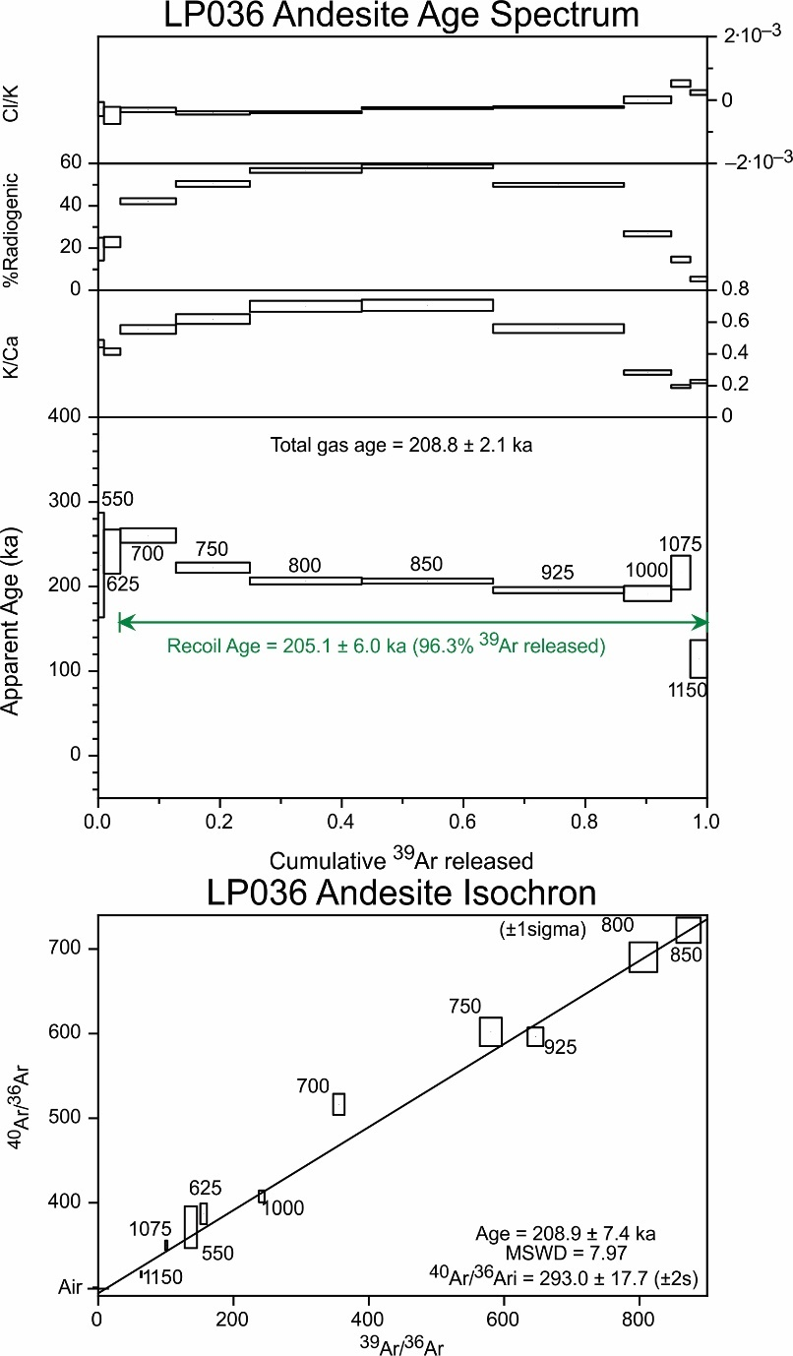 Fig. S3.1. Continued .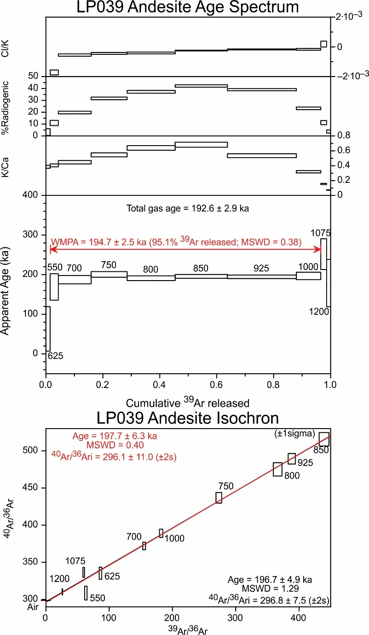
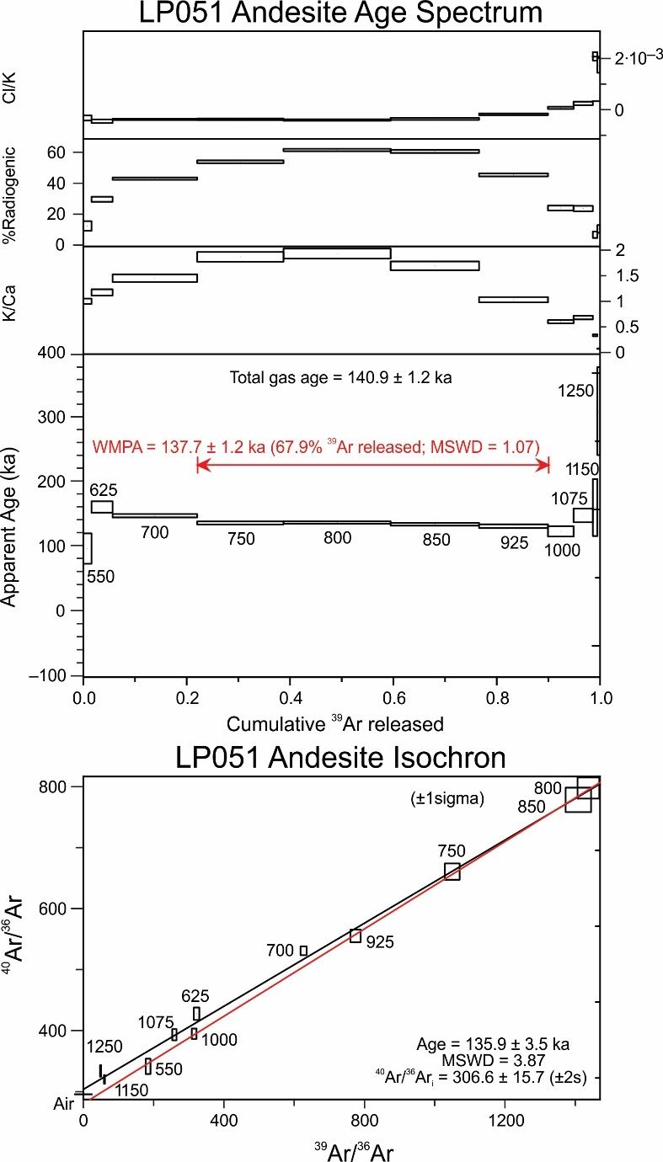 Fig. S3.1. Continued. 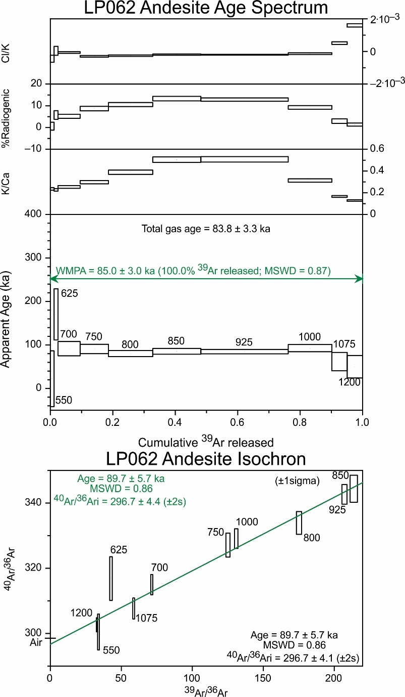
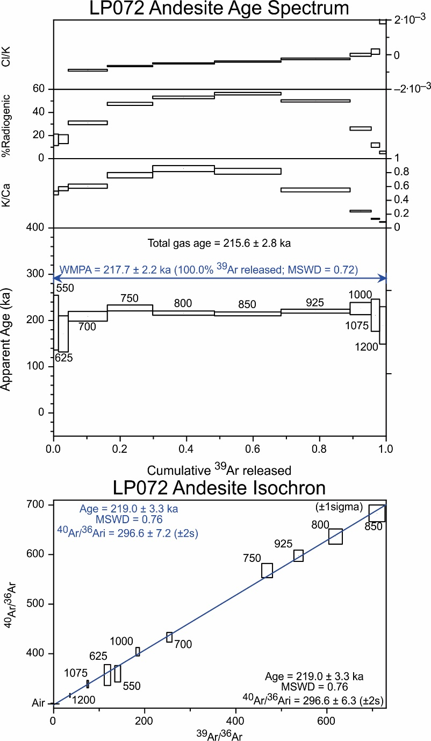 Fig. S3.1. Continued. 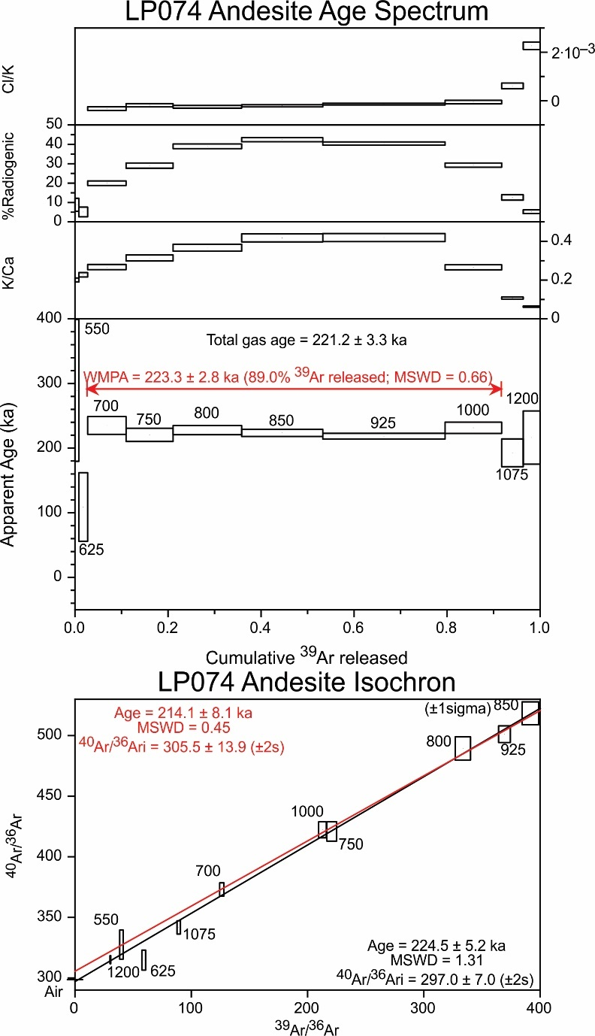
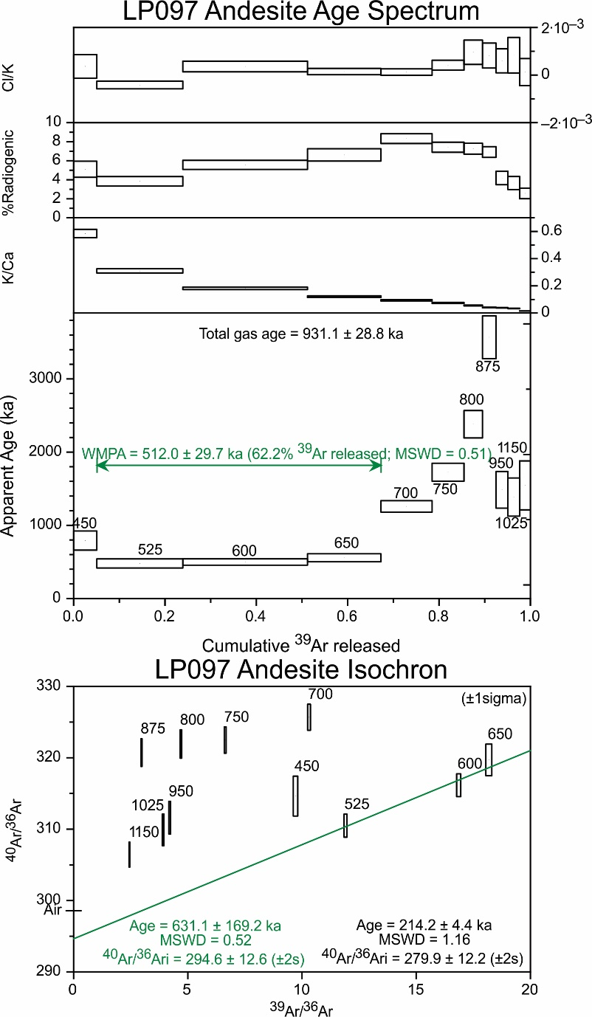 Fig. S3.1. Continued. 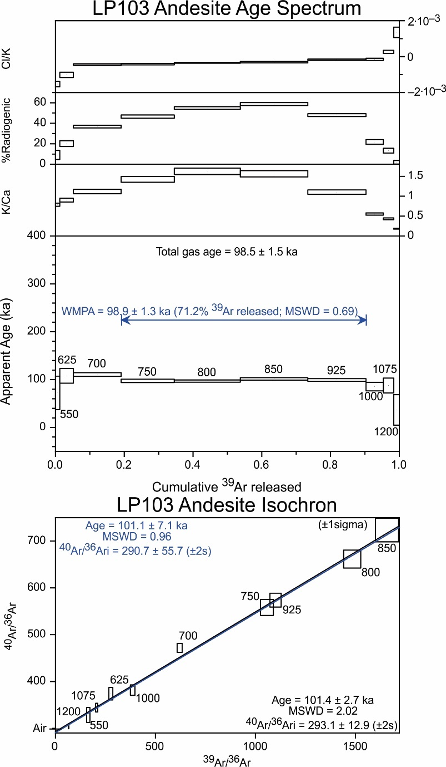 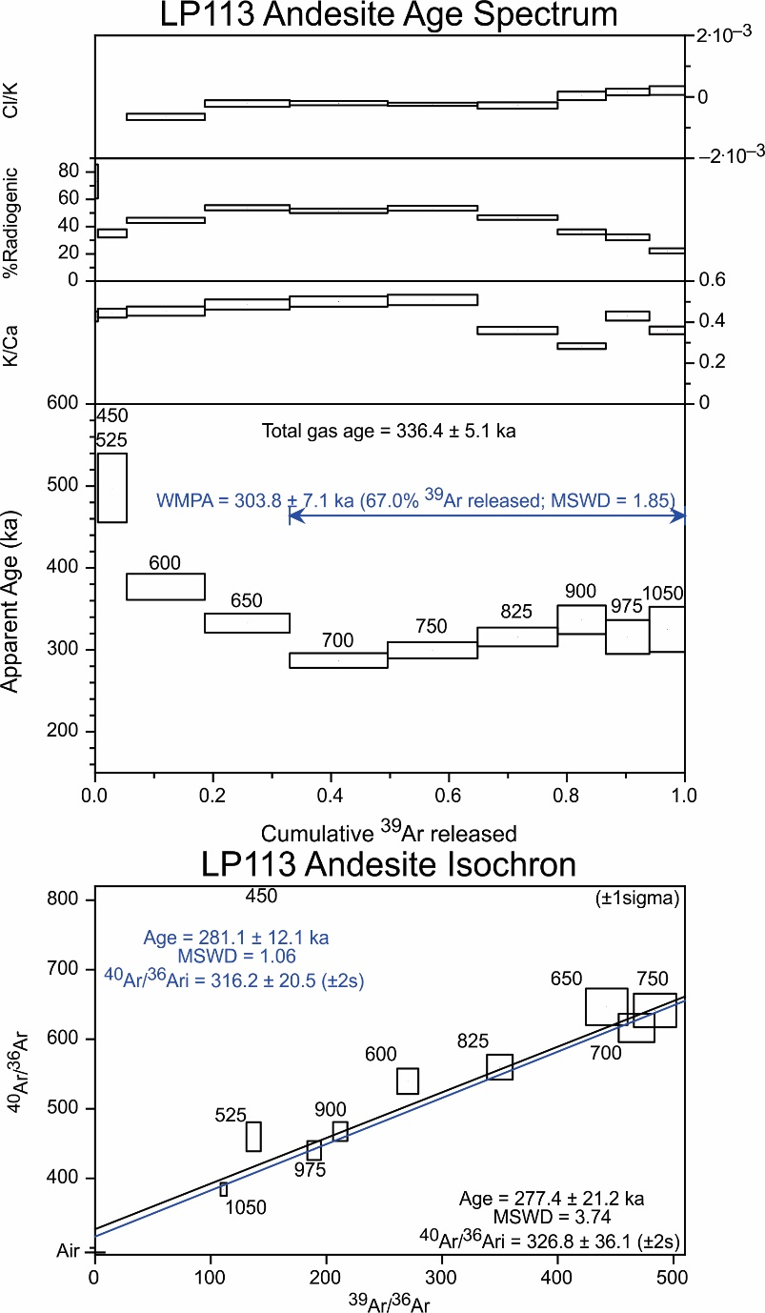 Fig. S3.1. Continued. 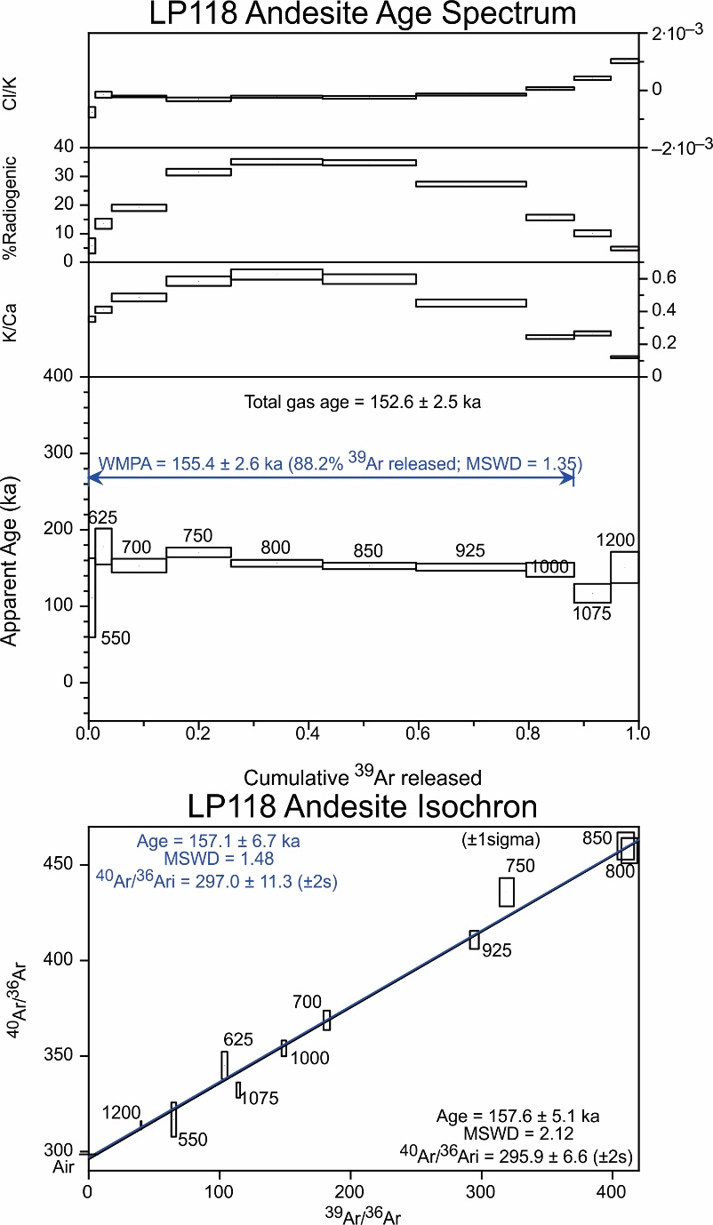 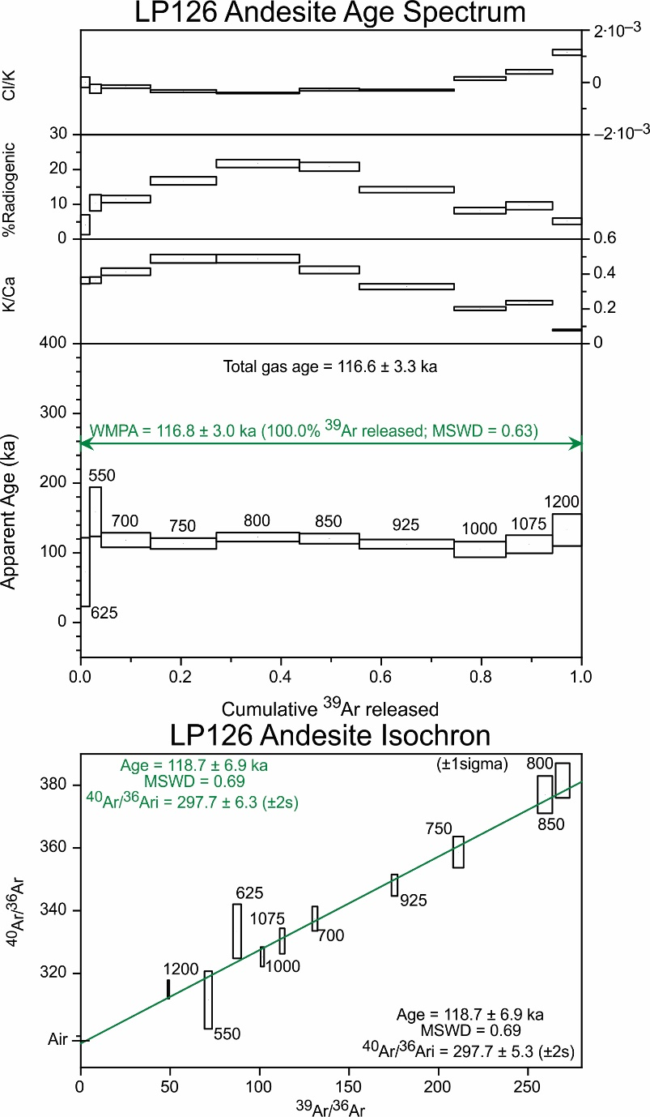 Fig. S3.1. Continued. 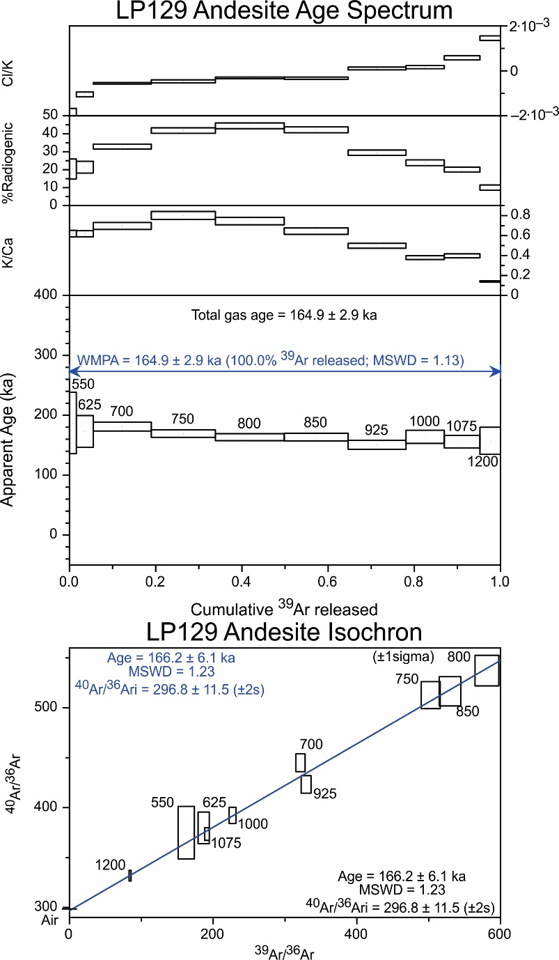 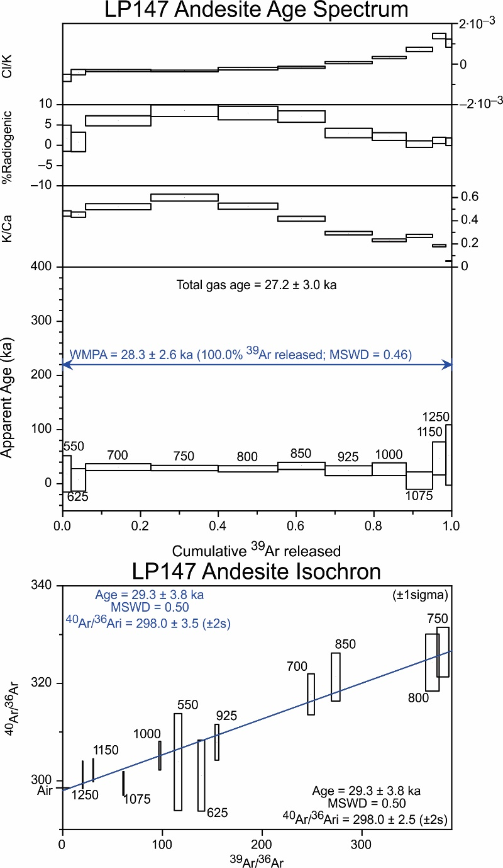 Fig. S3.1. Continued. 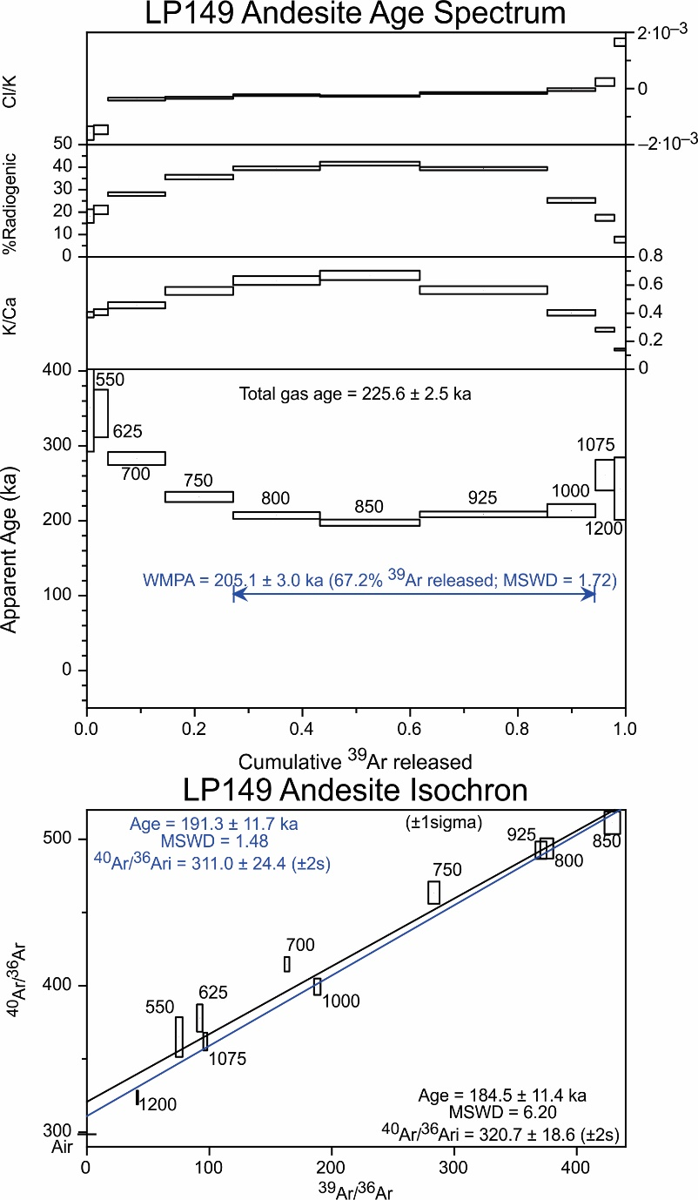 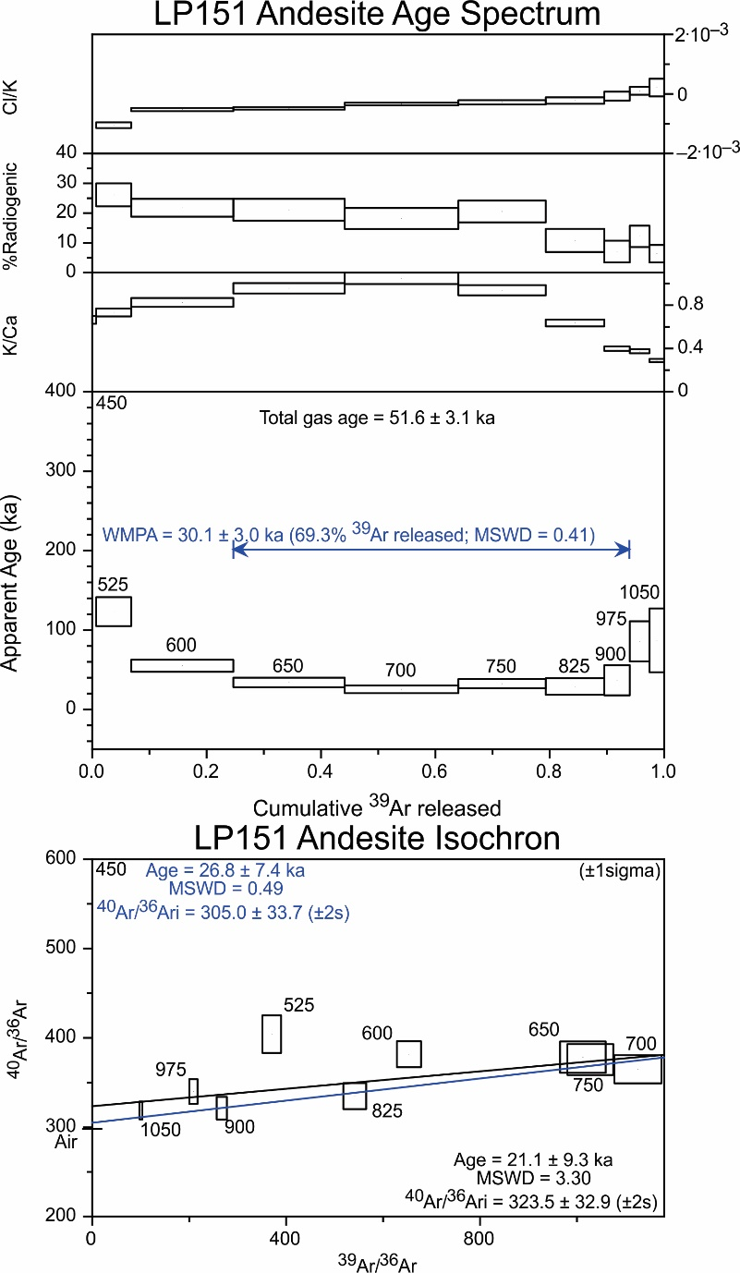 Fig. S3.1. Continued. 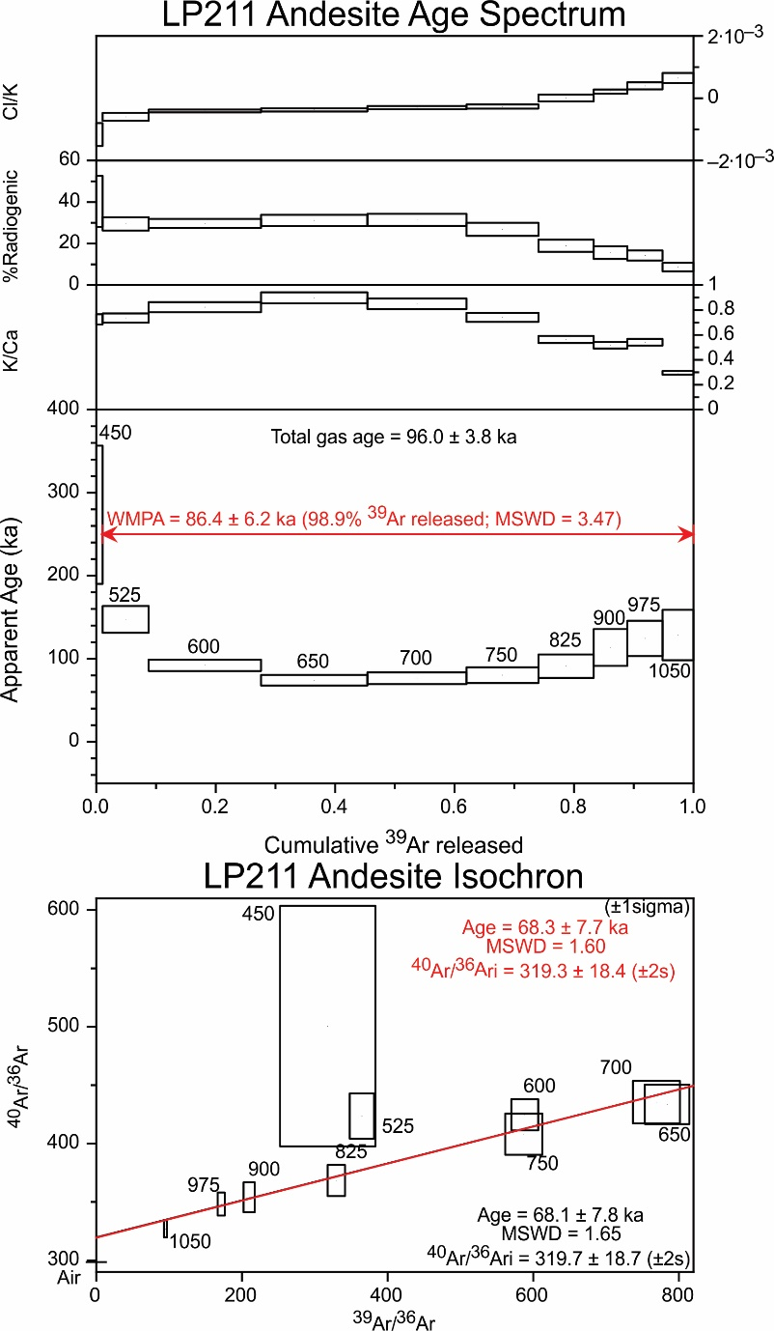 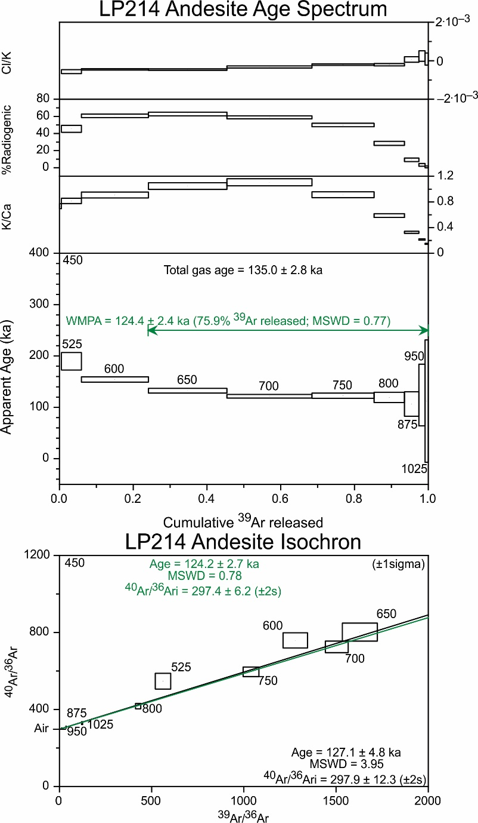 Fig. S3.1. Continued. 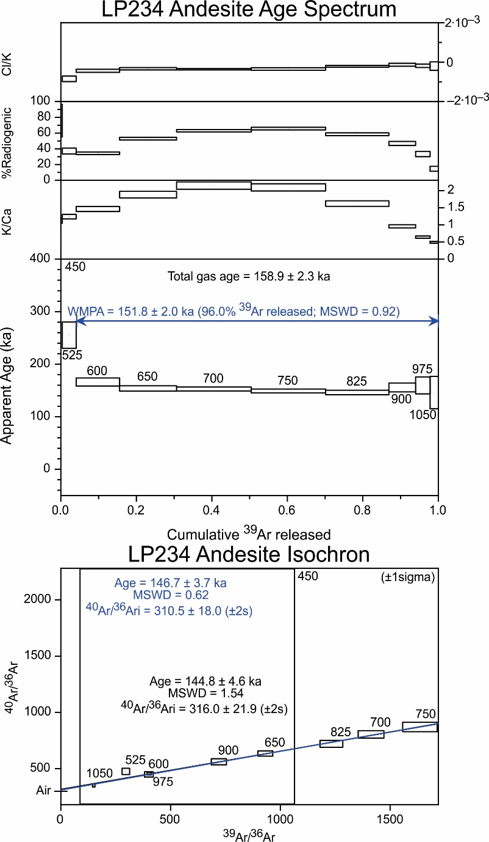 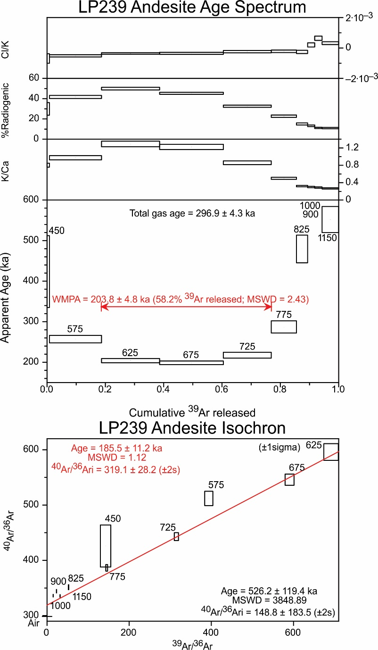 Fig. S3.1. Continued. 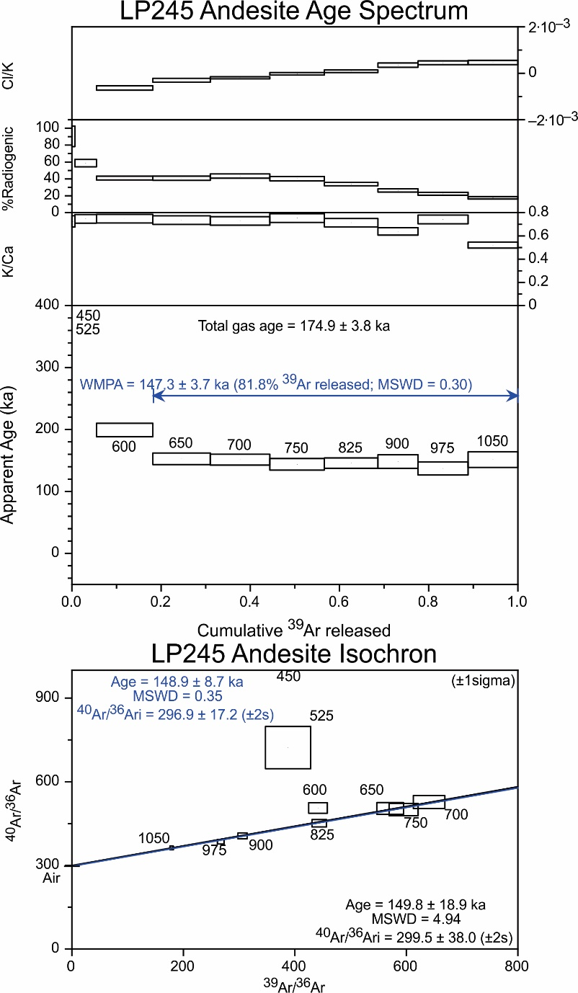 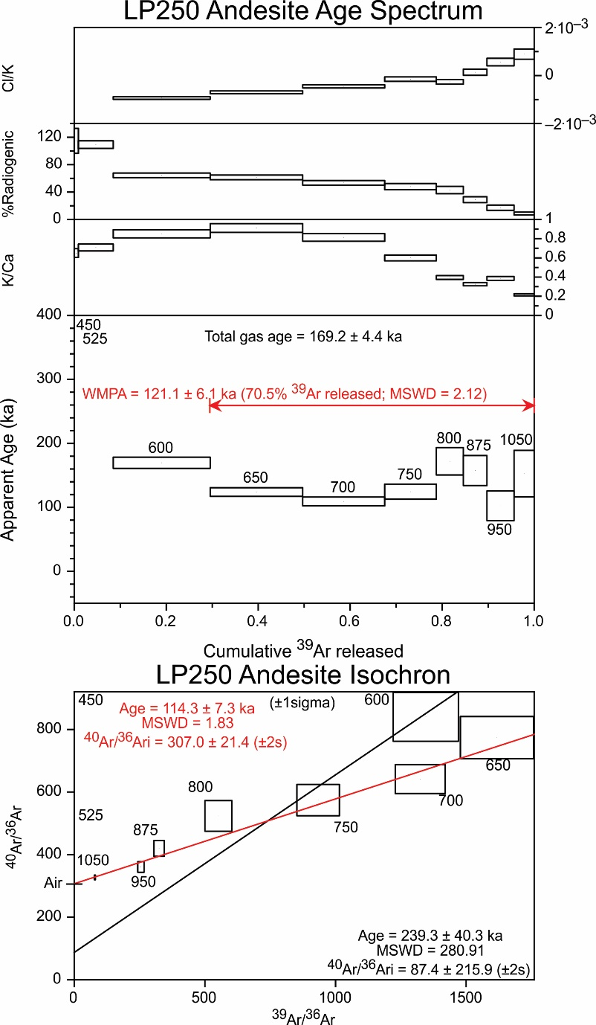 Fig. S3.1. Continued. 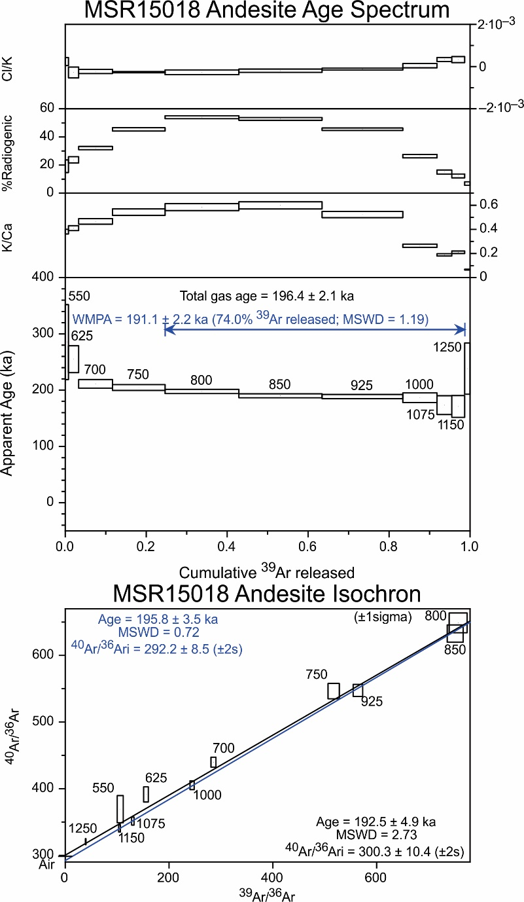 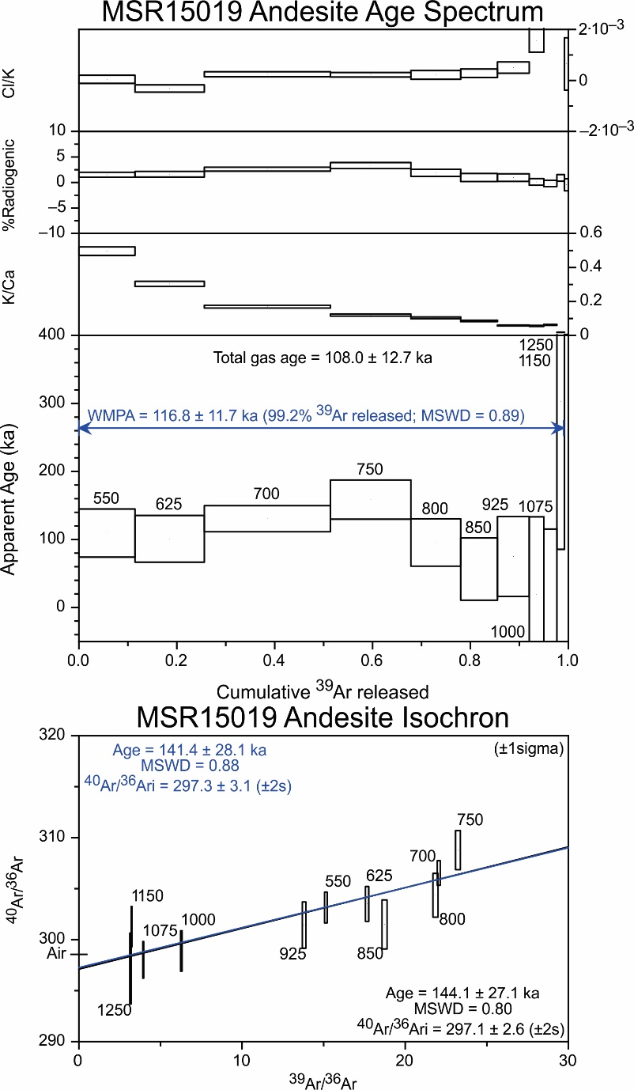 Fig. S3.1. Continued. 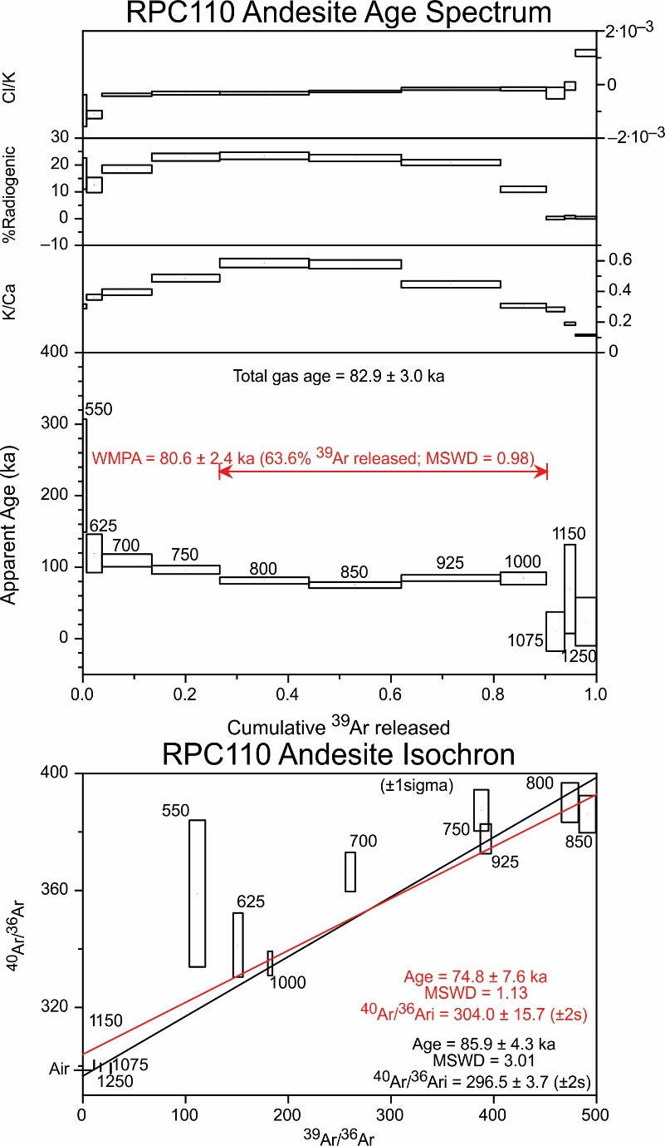 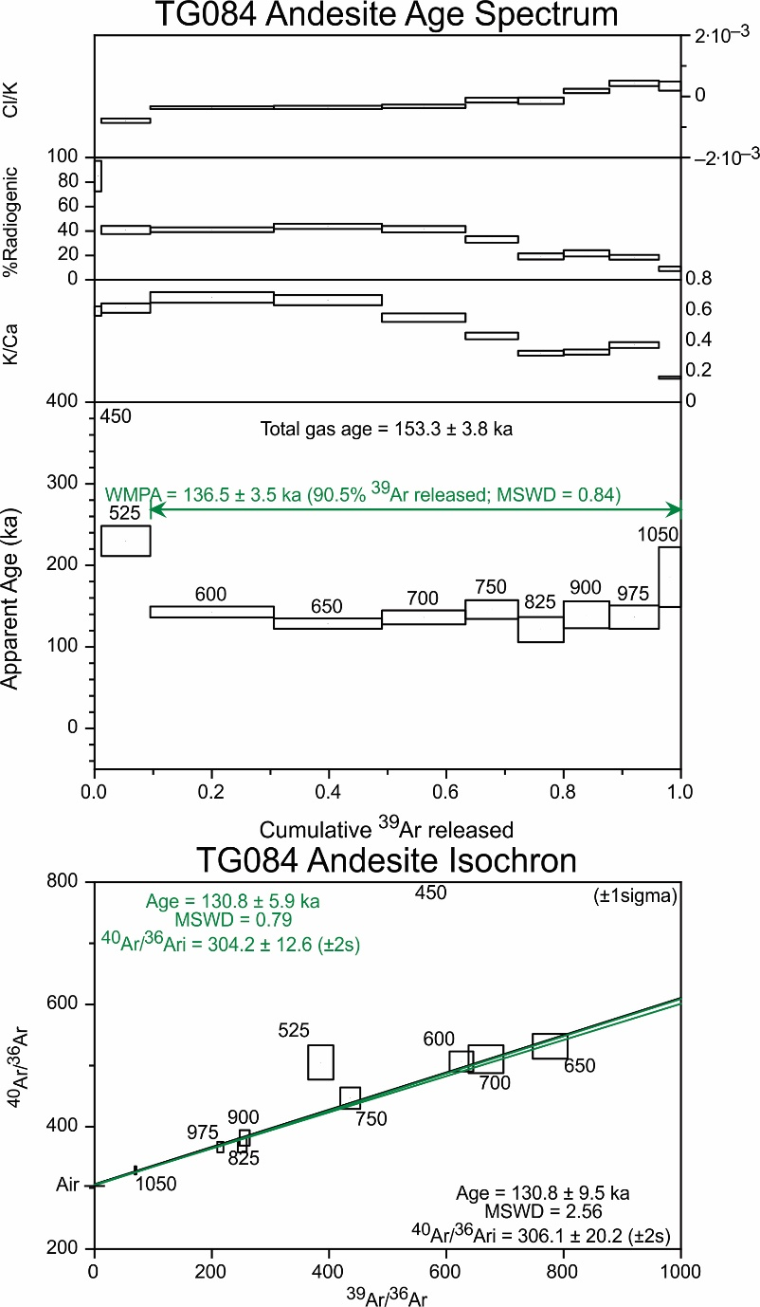 Fig. S3.1. Continued. 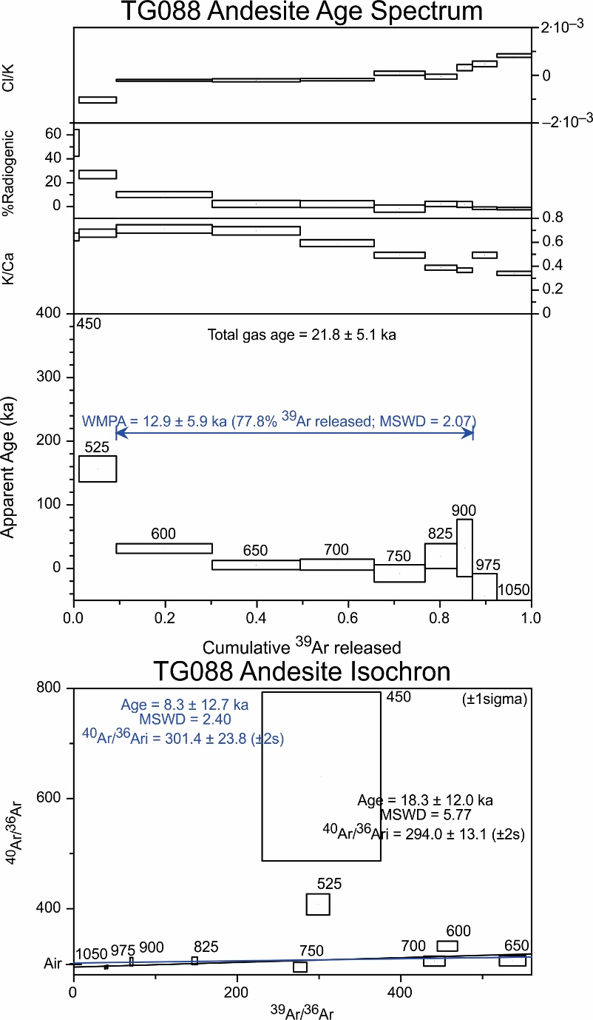
Fig. S3.1 notes. Boxes on plateau and isochron plots show 1 s.d. errors. The coloured text and isochrons indicate the number of steps (n) of the total steps (N) specified in Table S3.1, above. The specific colours themselves do not signify anything except to distinguish them from black text. Black text and isochrons reflect age assignments that use all heating steps.

S4. WHOLE-ROCK MAJOR OXIDE, Sr AND Br CONCENTRATIONS BY XRF
All data presented in Table S4.1, below, were obtained in Pure (2020), except for the following exceptions.
- XRF major oxide data were provided by G. S. Leonard (unpubl. data) for samples GL2222, GL2224, GL2225, GL2226, GL2229, GL2230, GL2232 and GL2233.
- XRF data were previously reported for sample RPC090 (not ⁴⁰Ar/³⁹Ar dated), by Cole et al. (2018), which was sampled from the same outcrop as RPC110 (⁴⁰Ar/³⁹Ar dated).
- TG084 and TG084 XRF data are from Hobden (1997).
- XRF major oxide data were provided by M. T. Rattenbury via D. B. Townsend (pers. comm., 2016) for samples MSR15017A, MSR15018, MSR15019, MSR15020A, MSR15021, MSR15022, MSR15023, MSR15024, MSR15026, MSR15035 and MSR15037.
Analytical precision and accuracy were monitored with standards AGV-1, BCR-2, BHVO-2, OREAS, WS-E and an internal standard (LP009B). Analytical accuracy is within 5 % (1 r.s.d.) for each oxide concentration but generally ≤2.5 % (1 r.s.d.), as determined with rock standards compared with the recommended values of Jochum et al. (2016). Duplicate analyses of LP009B indicate an external precision (2 s.d.) better than 5 % for all major oxides and Sr, however Ba reproducibility is ~13 %. Samples LP009BX and LP130X are cognate crystal clots hosted in the samples LP009B and LP130, respectively. LP108L is a mingled magma enclave hosted in LP108H.

Table S4.1. Whole-rock major oxides (in wt%), Sr and Ba concentrations.
Sample | CC351 | GL2139 | GL2142 | GL2145 | GL2148 | GL2218 | GL2222 | GL2223
SiO₂ | 55.59 | 62.39 | 60.20 | 61.46 | 60.74 | 59.04 | 57.70 | 57.90
TiO₂ | 0.63 | 0.78 | 0.73 | 0.84 | 0.82 | 0.69 | 0.72 | 0.79
Al₂O₃ | 16.44 | 16.48 | 16.48 | 16.58 | 17.29 | 16.28 | 17.31 | 16.71
Fe₂O₃ total | 8.23 | 6.86 | 7.32 | 7.49 | 7.37 | 6.46 | 7.11 | 7.65
MnO | 0.13 | 0.11 | 0.12 | 0.13 | 0.12 | 0.11 | 0.12 | 0.12
MgO | 5.98 | 2.54 | 3.53 | 2.70 | 2.72 | 5.15 | 4.56 | 4.60
CaO | 7.79 | 5.08 | 6.15 | 5.54 | 5.10 | 6.97 | 7.42 | 7.40
Na₂O | 2.63 | 3.43 | 3.36 | 3.49 | 3.30 | 3.08 | 3.31 | 3.23
K₂O | 0.95 | 2.07 | 1.63 | 1.80 | 1.84 | 1.48 | 1.11 | 1.33
P₂O₅ | 0.12 | 0.17 | 0.16 | 0.18 | 0.16 | 0.15 | 0.14 | 0.17
LOI | 0.31 | -0.03 | 0.13 | -0.07 | 0.87 | 0.31 | 0.90 | 0.96
Total | 98.92 | 100.00 | 99.90 | 100.29 | 100.40 | 99.85 | 100.44 | 100.97
Ba (ppm) | 192 | 398 | 303 | 409 | 403 | 308 |  | 266
Sr (ppm) | 450 | 232 | 232 | 260 | 239 | 306 |  | 319

Sample | GL2224 | GL2225 | GL2226 | GL2229 | GL2230 | GL2231 | GL2232 | GL2233
SiO₂ | 57.97 | 55.45 | 57.09 | 59.21 | 60.17 | 59.16 | 57.69 | 55.97
TiO₂ | 0.79 | 0.79 | 0.79 | 0.77 | 0.71 | 0.78 | 0.68 | 0.72
Al₂O₃ | 16.90 | 16.90 | 17.07 | 17.12 | 16.96 | 17.11 | 14.92 | 15.57
Fe₂O₃ total | 8.17 | 9.15 | 7.76 | 7.25 | 6.86 | 7.33 | 7.58 | 7.88
MnO | 0.13 | 0.15 | 0.14 | 0.12 | 0.12 | 0.12 | 0.14 | 0.14
MgO | 4.17 | 5.08 | 4.15 | 3.47 | 3.19 | 3.10 | 6.34 | 6.72
CaO | 6.70 | 8.41 | 7.18 | 6.40 | 5.85 | 6.26 | 7.93 | 8.03
Na₂O | 2.93 | 2.79 | 2.98 | 3.31 | 3.18 | 3.38 | 2.70 | 2.63
K₂O | 1.46 | 1.03 | 1.30 | 1.50 | 1.68 | 1.71 | 1.00 | 0.97
P₂O₅ | 0.14 | 0.14 | 0.13 | 0.14 | 0.14 | 0.16 | 0.13 | 0.13
LOI | 0.87 | 0.26 | 0.37 | 0.35 | 1.27 | 0.11 | 0.75 | 1.48
Total | 100.26 | 100.18 | 98.98 | 99.68 | 100.17 | 99.34 | 99.91 | 100.31
Ba (ppm) |  |  |  |  |  | 345
Sr (ppm) |  |  |  |  |  | 259

Table S4.1. Continued. Major oxides in wt%, trace elements in ppm.
Sample | GL2234 | LP001 | LP002 | LP003 | LP008 | LP009A | LP009B | LP009BX
SiO₂ | 57.08 | 55.35 | 61.00 | 59.52 | 60.65 | 62.08 | 62.09 | 57.28
TiO₂ | 0.69 | 0.68 | 0.69 | 0.74 | 0.86 | 0.77 | 0.76 | 0.91
Al₂O₃ | 15.30 | 14.23 | 16.45 | 16.21 | 16.97 | 16.65 | 16.64 | 17.89
Fe₂O₃ total | 7.84 | 7.60 | 6.68 | 7.53 | 7.51 | 6.77 | 6.67 | 8.06
MnO | 0.13 | 0.12 | 0.11 | 0.12 | 0.12 | 0.11 | 0.11 | 0.13
MgO | 6.42 | 9.47 | 3.04 | 3.97 | 2.57 | 2.58 | 2.52 | 3.11
CaO | 8.15 | 7.22 | 6.02 | 6.33 | 5.81 | 5.35 | 5.18 | 5.75
Na₂O | 2.84 | 2.64 | 3.33 | 3.20 | 3.55 | 3.45 | 3.45 | 3.12
K₂O | 1.15 | 1.30 | 1.83 | 1.64 | 1.84 | 2.10 | 2.11 | 1.64
P₂O₅ | 0.14 | 0.14 | 0.15 | 0.17 | 0.17 | 0.16 | 0.16 | 0.13
LOI | -0.09 | 1.27 | 0.97 | -0.01 | 0.20 | 0.22 | 0.89 | 2.41
Total | 99.85 | 100.15 | 100.41 | 99.54 | 100.37 | 100.35 | 100.69 | 100.57
Ba (ppm) | 242 | 297 | 362 | 322 | 417 | 466 | 455 | 370
Sr (ppm) | 303 | 264 | 235 | 301 | 268 | 251 | 236 | 253

Sample | LP010 | LP011 | LP013 | LP014 | LP018 | LP019 | LP020 | LP021
SiO₂ | 58.80 | 58.49 | 58.52 | 61.05 | 60.28 | 60.23 | 60.78 | 60.92
TiO₂ | 0.76 | 0.71 | 0.72 | 0.86 | 0.74 | 0.81 | 0.86 | 0.86
Al₂O₃ | 16.49 | 16.13 | 15.77 | 16.86 | 16.59 | 17.01 | 16.89 | 16.89
Fe₂O₃ total | 7.78 | 7.69 | 7.71 | 7.35 | 7.09 | 7.29 | 7.34 | 7.33
MnO | 0.13 | 0.13 | 0.13 | 0.12 | 0.12 | 0.12 | 0.12 | 0.12
MgO | 4.23 | 4.97 | 4.79 | 2.47 | 3.37 | 2.85 | 2.46 | 2.47
CaO | 6.95 | 7.31 | 6.86 | 5.81 | 6.29 | 6.30 | 5.82 | 5.72
Na₂O | 3.22 | 3.08 | 3.08 | 3.68 | 3.42 | 3.54 | 3.67 | 3.63
K₂O | 1.51 | 1.44 | 1.48 | 1.82 | 1.72 | 1.68 | 1.81 | 1.81
P₂O₅ | 0.15 | 0.15 | 0.16 | 0.18 | 0.15 | 0.17 | 0.17 | 0.17
LOI | 0.30 | 0.18 | 0.00 | 0.03 | 0.32 | 0.36 | 0.23 | 0.07
Total | 100.42 | 100.39 | 99.30 | 100.34 | 100.23 | 100.46 | 100.24 | 100.11
Ba (ppm) | 337 | 303 | 293 | 380 | 348 | 351 | 317 | 363
Sr (ppm) | 259 | 275 | 265 | 270 | 244 | 275 | 255 | 249

Sample | LP023 | LP024 | LP025 | LP026 | LP027 | LP028 | LP029 | LP030
SiO₂ | 58.39 | 61.96 | 60.24 | 58.26 | 58.26 | 59.85 | 58.56 | 59.73
TiO₂ | 0.75 | 0.92 | 0.83 | 0.71 | 0.71 | 0.71 | 0.70 | 0.79
Al₂O₃ | 16.18 | 16.75 | 16.87 | 16.04 | 16.00 | 16.17 | 15.96 | 17.19
Fe₂O₃ total | 7.99 | 7.43 | 7.22 | 7.73 | 7.70 | 7.35 | 7.56 | 7.00
MnO | 0.13 | 0.12 | 0.12 | 0.13 | 0.13 | 0.13 | 0.13 | 0.12
MgO | 4.89 | 2.01 | 2.64 | 4.87 | 4.96 | 4.42 | 4.94 | 3.42
CaO | 7.13 | 5.32 | 5.85 | 7.17 | 7.06 | 6.68 | 6.92 | 6.45
Na₂O | 3.10 | 3.74 | 3.54 | 3.05 | 3.05 | 3.21 | 3.06 | 3.34
K₂O | 1.43 | 1.94 | 1.73 | 1.44 | 1.45 | 1.62 | 1.49 | 1.76
P₂O₅ | 0.14 | 0.18 | 0.17 | 0.15 | 0.15 | 0.15 | 0.15 | 0.16
LOI | 0.14 | 0.14 | 0.80 | 0.60 | 0.68 | 0.11 | 0.73 | 0.15
Total | 100.37 | 100.61 | 100.13 | 100.27 | 100.28 | 100.52 | 100.34 | 100.23
Ba (ppm) | 272 | 418 | 347 | 296 | 317 | 335 | 278 | 408
Sr (ppm) | 246 | 236 | 256 | 258 | 247 | 249 | 270 | 268

Sample | LP031 | LP032 | LP033 | LP034 | LP035 | LP036 | LP037 | LP038
SiO₂ | 58.86 | 59.65 | 60.08 | 60.99 | 60.07 | 60.46 | 59.89 | 59.93
TiO₂ | 0.71 | 0.76 | 0.59 | 0.59 | 0.59 | 0.59 | 0.64 | 0.60
Al₂O₃ | 15.95 | 16.67 | 16.61 | 16.43 | 15.80 | 15.60 | 16.67 | 16.62
Fe₂O₃ total | 7.53 | 7.32 | 6.92 | 6.70 | 6.99 | 6.89 | 6.88 | 6.86
MnO | 0.13 | 0.12 | 0.12 | 0.12 | 0.12 | 0.12 | 0.12 | 0.12
MgO | 4.84 | 3.91 | 3.76 | 4.01 | 4.58 | 4.53 | 3.77 | 3.87
CaO | 7.04 | 6.57 | 6.67 | 6.33 | 7.26 | 6.80 | 6.40 | 6.14
Na₂O | 3.09 | 3.17 | 3.33 | 3.29 | 3.07 | 3.07 | 3.33 | 3.26
K₂O | 1.52 | 1.75 | 1.31 | 1.39 | 1.27 | 1.40 | 1.40 | 1.34
P₂O₅ | 0.15 | 0.16 | 0.13 | 0.13 | 0.13 | 0.13 | 0.14 | 0.14
LOI | 0.26 | 0.58 | 0.86 | 0.57 | 0.37 | 0.61 | 0.96 | 0.30
Total | 100.21 | 100.78 | 100.50 | 100.63 | 100.33 | 100.31 | 100.32 | 99.24
Ba (ppm) | 328 | 393 | 333 | 310 | 273 | 344 | 321 | 282
Sr (ppm) | 285 | 252 | 216 | 220 | 247 | 239 | 274 | 263
Table S4.1. Continued. Major oxides in wt%, trace elements in ppm.
Sample | LP039 | LP040 | LP043 | LP044 | LP046A | LP046B | LP047 | LP048
SiO₂ | 60.07 | 60.19 | 59.79 | 59.95 | 58.17 | 58.34 | 58.55 | 58.32
TiO₂ | 0.61 | 0.59 | 0.77 | 0.76 | 0.71 | 0.73 | 0.72 | 0.70
Al₂O₃ | 16.39 | 16.21 | 16.68 | 16.76 | 15.81 | 15.87 | 15.81 | 15.83
Fe₂O₃ total | 6.98 | 6.85 | 7.08 | 7.21 | 7.78 | 7.74 | 7.71 | 7.70
MnO | 0.12 | 0.12 | 0.12 | 0.12 | 0.13 | 0.13 | 0.13 | 0.13
MgO | 4.02 | 3.99 | 3.36 | 3.48 | 5.03 | 4.65 | 4.78 | 4.90
CaO | 6.55 | 6.38 | 5.93 | 6.06 | 6.53 | 6.34 | 6.88 | 6.98
Na₂O | 3.29 | 3.25 | 3.27 | 3.25 | 2.96 | 3.07 | 3.09 | 3.04
K₂O | 1.30 | 1.34 | 1.83 | 1.81 | 1.49 | 1.56 | 1.48 | 1.45
P₂O₅ | 0.13 | 0.13 | 0.17 | 0.17 | 0.16 | 0.17 | 0.16 | 0.16
LOI | -0.04 | 0.03 | 0.12 | 0.04 | 0.55 | 0.34 | -0.07 | 0.02
Total | 99.56 | 99.13 | 99.22 | 99.74 | 99.47 | 99.05 | 99.38 | 99.34
Ba (ppm) | 270 | 292 | 373 | 389 | 308 | 306 | 319 | 338
Sr (ppm) | 275 | 275 | 270 | 269 | 282 | 245 | 271 | 269

Sample | LP051 | LP052 | LP053 | LP054 | LP056 | LP057 | LP058 | LP060
SiO₂ | 61.14 | 59.37 | 60.80 | 58.78 | 60.64 | 60.57 | 60.98 | 59.81
TiO₂ | 0.73 | 0.77 | 0.91 | 0.62 | 0.87 | 0.85 | 0.86 | 0.78
Al₂O₃ | 16.51 | 16.80 | 16.84 | 16.93 | 17.62 | 17.46 | 17.46 | 16.70
Fe₂O₃ total | 7.10 | 7.11 | 7.72 | 7.59 | 6.85 | 6.76 | 6.73 | 7.18
MnO | 0.10 | 0.12 | 0.12 | 0.13 | 0.11 | 0.11 | 0.11 | 0.12
MgO | 2.91 | 3.41 | 2.29 | 4.14 | 2.03 | 2.05 | 2.05 | 3.40
CaO | 5.40 | 6.14 | 4.84 | 6.28 | 5.28 | 5.47 | 5.44 | 6.01
Na₂O | 3.27 | 3.46 | 3.49 | 3.21 | 3.68 | 3.66 | 3.69 | 3.30
K₂O | 2.05 | 1.80 | 1.98 | 1.22 | 2.02 | 1.99 | 2.01 | 1.82
P₂O₅ | 0.18 | 0.16 | 0.19 | 0.14 | 0.19 | 0.19 | 0.19 | 0.17
LOI | 0.28 | 0.19 | 0.40 | 0.54 | 0.28 | 0.21 | 0.10 | 0.02
Total | 99.78 | 99.42 | 99.70 | 99.65 | 99.69 | 99.43 | 99.76 | 99.44
Ba (ppm) | 343 | 375 | 404 | 286 | 465 | 508 | 515 | 400
Sr (ppm) | 222 | 270 | 230 | 201 | 267 | 277 | 273 | 271

Sample | LP062 | LP063 | LP064 | LP066 | LP067 | LP070 | LP071 | LP072
SiO₂ | 58.33 | 58.58 | 58.12 | 59.75 | 59.33 | 59.85 | 60.10 | 59.05
TiO₂ | 0.66 | 0.72 | 0.72 | 0.79 | 0.77 | 0.77 | 0.77 | 0.57
Al₂O₃ | 14.99 | 15.88 | 15.97 | 16.89 | 16.73 | 16.71 | 16.55 | 16.23
Fe₂O₃ total | 7.48 | 7.62 | 7.73 | 7.18 | 7.16 | 7.16 | 7.21 | 7.50
MnO | 0.12 | 0.13 | 0.13 | 0.12 | 0.12 | 0.12 | 0.12 | 0.13
MgO | 5.91 | 4.71 | 4.67 | 3.50 | 3.44 | 3.44 | 3.44 | 4.70
CaO | 7.53 | 6.83 | 6.95 | 5.97 | 5.91 | 5.96 | 5.92 | 6.71
Na₂O | 2.99 | 3.08 | 3.04 | 3.24 | 3.25 | 3.27 | 3.27 | 3.15
K₂O | 1.24 | 1.49 | 1.37 | 1.80 | 1.79 | 1.81 | 1.84 | 1.17
P₂O₅ | 0.15 | 0.16 | 0.16 | 0.17 | 0.17 | 0.17 | 0.17 | 0.13
LOI | -0.25 | 0.01 | 0.44 | -0.03 | 0.24 | 0.14 | 0.00 | 0.11
Total | 99.51 | 99.32 | 99.38 | 99.50 | 99.04 | 99.50 | 99.53 | 99.56
Ba (ppm) | 250 | 337 | 335 | 428 | 391 | 382 | 395 | 257
Sr (ppm) | 386 | 260 | 274 | 272 | 268 | 260 | 262 | 272

Sample | LP073 | LP074 | LP077 | LP079 | LP080 | LP081 | LP087 | LP088
SiO₂ | 55.55 | 56.14 | 58.63 | 58.39 | 58.58 | 58.54 | 56.04 | 60.45
TiO₂ | 0.73 | 0.66 | 0.72 | 0.71 | 0.72 | 0.72 | 0.67 | 0.86
Al₂O₃ | 17.74 | 17.82 | 15.87 | 15.84 | 15.84 | 15.74 | 16.48 | 16.76
Fe₂O₃ total | 8.63 | 8.24 | 7.73 | 7.70 | 7.63 | 7.51 | 8.67 | 7.46
MnO | 0.14 | 0.14 | 0.13 | 0.13 | 0.13 | 0.13 | 0.15 | 0.12
MgO | 4.40 | 4.23 | 4.83 | 4.78 | 4.65 | 4.46 | 5.29 | 2.44
CaO | 7.37 | 7.53 | 6.84 | 6.90 | 6.83 | 6.61 | 7.78 | 5.55
Na₂O | 3.28 | 3.32 | 3.03 | 3.08 | 3.11 | 3.14 | 2.77 | 3.58
K₂O | 0.90 | 0.89 | 1.47 | 1.47 | 1.49 | 1.54 | 0.91 | 1.77
P₂O₅ | 0.16 | 0.16 | 0.16 | 0.16 | 0.16 | 0.16 | 0.14 | 0.18
LOI | -0.10 | -0.22 | -0.12 | -0.07 | -0.03 | -0.05 | 0.24 | 0.19
Total | 99.00 | 99.21 | 99.53 | 99.24 | 99.22 | 98.68 | 99.20 | 99.46
Ba (ppm) | 192 | 280 | 299 | 267 | 327 | 357 | 201 | 356
Sr (ppm) | 258 | 260 | 273 | 269 | 266 | 240 | 297 | 255
Table S4.1. Continued. Major oxides in wt%, trace elements in ppm.
Sample | LP090 | LP095 | LP096 | LP097 | LP098 | LP099 | LP103 | LP108H
SiO₂ | 60.83 | 60.82 | 56.15 | 55.54 | 59.66 | 60.27 | 60.89 | 54.65
TiO₂ | 0.87 | 0.84 | 0.71 | 0.68 | 0.85 | 0.86 | 0.94 | 0.67
Al₂O₃ | 16.55 | 16.46 | 14.42 | 16.66 | 17.25 | 17.14 | 16.93 | 16.40
Fe₂O₃ total | 7.60 | 7.39 | 7.59 | 8.79 | 7.36 | 7.28 | 7.73 | 8.93
MnO | 0.12 | 0.12 | 0.12 | 0.15 | 0.12 | 0.12 | 0.12 | 0.14
MgO | 2.34 | 2.51 | 8.29 | 5.34 | 2.72 | 2.61 | 1.97 | 6.21
CaO | 5.21 | 5.45 | 7.04 | 7.88 | 5.70 | 5.63 | 4.91 | 8.03
Na₂O | 3.49 | 3.52 | 2.83 | 2.74 | 3.56 | 3.59 | 3.54 | 2.72
K₂O | 1.88 | 1.94 | 1.45 | 0.80 | 1.78 | 1.85 | 1.94 | 0.72
P₂O₅ | 0.19 | 0.18 | 0.16 | 0.14 | 0.19 | 0.19 | 0.19 | 0.13
LOI | 0.12 | -0.19 | 0.29 | 0.40 | 0.18 | -0.08 | 0.24 | 0.69
Total | 99.32 | 99.34 | 99.15 | 99.22 | 99.49 | 99.65 | 99.51 | 99.37
Ba (ppm) | 388 | 408 | 322 | 239 | 412 | 511 | 434 | 145
Sr (ppm) | 254 | 253 | 269 | 293 | 285 | 297 | 260 | 218

Sample | LP108L | LP109 | LP113 | LP117 | LP118 | LP119 | LP120 | LP122
SiO₂ | 54.80 | 62.46 | 59.41 | 60.34 | 57.46 | 57.65 | 56.90 | 60.75
TiO₂ | 0.67 | 0.43 | 0.54 | 0.62 | 0.82 | 0.69 | 0.71 | 0.76
Al₂O₃ | 16.35 | 16.97 | 16.91 | 18.08 | 16.74 | 16.29 | 16.25 | 16.74
Fe₂O₃ total | 8.75 | 5.85 | 6.93 | 6.09 | 8.32 | 7.66 | 7.67 | 6.94
MnO | 0.15 | 0.11 | 0.13 | 0.10 | 0.13 | 0.13 | 0.13 | 0.10
MgO | 6.22 | 3.05 | 3.92 | 3.06 | 4.23 | 5.39 | 5.38 | 2.86
CaO | 8.30 | 5.26 | 6.46 | 5.98 | 6.91 | 6.63 | 6.79 | 5.71
Na₂O | 2.77 | 3.58 | 3.40 | 3.43 | 3.04 | 3.04 | 3.05 | 3.46
K₂O | 0.75 | 1.13 | 1.04 | 1.24 | 1.47 | 1.39 | 1.35 | 1.87
P₂O₅ | 0.13 | 0.14 | 0.13 | 0.13 | 0.17 | 0.15 | 0.16 | 0.18
LOI | 0.33 | 0.57 | 0.16 | 0.43 | -0.17 | 0.45 | 0.49 | 0.09
Total | 99.31 | 99.64 | 99.10 | 99.61 | 99.40 | 99.65 | 98.99 | 99.57
Ba (ppm) | 196 | 279 | 324 | 301 | 340 | 326 | 310 | 394
Sr (ppm) | 237 | 242 | 247 | 212 | 260 | 297 | 317 | 264

Sample | LP123 | LP124 | LP125 | LP126 | LP128 | LP129 | LP130 | LP130X
SiO₂ | 60.11 | 61.08 | 57.24 | 57.50 | 61.68 | 58.34 | 59.35 | 55.73
TiO₂ | 0.57 | 0.62 | 0.68 | 0.68 | 0.54 | 0.73 | 0.65 | 0.54
Al₂O₃ | 16.93 | 16.72 | 15.14 | 15.14 | 17.24 | 16.62 | 16.96 | 16.11
Fe₂O₃ total | 6.75 | 6.68 | 7.84 | 7.79 | 6.48 | 8.20 | 7.11 | 8.58
MnO | 0.10 | 0.11 | 0.13 | 0.13 | 0.10 | 0.13 | 0.12 | 0.17
MgO | 3.62 | 3.31 | 6.42 | 6.02 | 2.64 | 3.95 | 3.86 | 6.38
CaO | 6.05 | 5.95 | 7.90 | 7.99 | 5.56 | 6.67 | 6.50 | 8.15
Na₂O | 3.36 | 3.42 | 2.88 | 2.79 | 3.51 | 3.02 | 3.37 | 2.56
K₂O | 1.28 | 1.45 | 1.11 | 1.12 | 1.40 | 1.50 | 1.24 | 0.87
P₂O₅ | 0.14 | 0.15 | 0.15 | 0.15 | 0.14 | 0.16 | 0.15 | 0.11
LOI | 0.64 | 0.16 | -0.28 | -0.10 | 0.20 | -0.06 | -0.05 | 0.07
Total | 99.93 | 99.74 | 99.60 | 99.41 | 99.59 | 99.43 | 99.41 | 99.35
Ba (ppm) | 279 | 321 | 260 | 218 | 307 | 298 | 368 | 190
Sr (ppm) | 222 | 234 | 334 | 413 | 220 | 229 | 251 | 222

Sample | LP134 | LP135 | LP138 | LP140 | LP141 | LP143 | LP145 | LP147
SiO₂ | 57.04 | 57.34 | 58.25 | 58.38 | 58.79 | 59.35 | 57.69 | 57.57
TiO₂ | 0.80 | 0.80 | 0.70 | 0.68 | 0.70 | 0.86 | 0.69 | 0.82
Al₂O₃ | 17.29 | 17.04 | 16.03 | 15.98 | 16.11 | 16.80 | 16.69 | 17.15
Fe₂O₃ total | 7.89 | 8.20 | 6.92 | 7.30 | 6.92 | 7.68 | 7.42 | 8.17
MnO | 0.14 | 0.14 | 0.12 | 0.12 | 0.11 | 0.19 | 0.12 | 0.14
MgO | 4.10 | 4.17 | 5.51 | 5.12 | 5.21 | 2.80 | 5.02 | 4.04
CaO | 6.92 | 6.96 | 6.82 | 6.90 | 6.82 | 5.56 | 7.48 | 7.13
Na₂O | 2.97 | 3.02 | 3.04 | 3.10 | 3.14 | 3.39 | 3.08 | 3.04
K₂O | 1.31 | 1.40 | 1.33 | 1.41 | 1.45 | 1.82 | 1.14 | 1.38
P₂O₅ | 0.15 | 0.16 | 0.15 | 0.15 | 0.15 | 0.20 | 0.14 | 0.17
LOI | 0.26 | -0.08 | 0.54 | 0.10 | 0.12 | 0.90 | -0.10 | -0.14
Total | 98.97 | 99.32 | 99.68 | 99.38 | 99.67 | 99.68 | 99.57 | 99.69
Ba (ppm) | 300 | 386 | 334 | 310 | 261 | 389 | 264 | 329
Sr (ppm) | 258 | 254 | 321 | 348 | 332 | 295 | 230 | 257
Table S4.1. Continued. Major oxides in wt%, trace elements in ppm.
Sample | LP149 | LP150 | LP151 | LP152 | LP155 | LP156 | LP157 | LP158
SiO₂ | 59.98 | 59.93 | 59.88 | 59.19 | 57.82 | 60.45 | 58.82 | 61.13
TiO₂ | 0.62 | 0.74 | 0.74 | 0.75 | 0.86 | 0.85 | 0.66 | 0.71
Al₂O₃ | 16.47 | 16.39 | 16.20 | 16.81 | 15.80 | 17.09 | 15.79 | 17.00
Fe₂O₃ total | 6.94 | 7.43 | 7.53 | 7.52 | 7.56 | 7.60 | 7.24 | 6.60
MnO | 0.11 | 0.13 | 0.13 | 0.13 | 0.12 | 0.12 | 0.13 | 0.11
MgO | 3.97 | 4.11 | 4.21 | 4.21 | 3.53 | 2.60 | 5.63 | 3.24
CaO | 6.47 | 6.39 | 6.47 | 6.59 | 6.13 | 5.77 | 7.45 | 5.96
Na₂O | 3.30 | 3.17 | 3.16 | 3.14 | 3.01 | 3.48 | 2.79 | 3.21
K₂O | 1.30 | 1.57 | 1.55 | 1.44 | 1.57 | 1.74 | 1.20 | 1.77
P₂O₅ | 0.13 | 0.16 | 0.16 | 0.16 | 0.16 | 0.18 | 0.15 | 0.16
LOI | 0.03 | -0.02 | -0.07 | -0.02 | 0.12 | 0.07 | 0.33 | 0.30
Total | 99.43 | 100.10 | 100.10 | 100.03 | 96.76 | 100.04 | 100.26 | 100.28
Ba (ppm) | 277 | 312 | 351 | 287 | 342 | 454 | 260 | 379
Sr (ppm) | 261 | 251 | 252 | 273 | 245 | 269 | 362 | 255

Sample | LP159 | LP160 | LP161 | LP163 | LP164 | LP165 | LP166 | LP167
SiO₂ | 60.53 | 59.23 | 57.78 | 59.66 | 59.49 | 60.27 | 61.81 | 60.84
TiO₂ | 0.76 | 0.69 | 0.68 | 0.72 | 0.70 | 0.70 | 0.77 | 0.77
Al₂O₃ | 16.88 | 15.90 | 16.94 | 16.67 | 17.07 | 16.62 | 16.72 | 16.85
Fe₂O₃ total | 7.26 | 7.33 | 7.72 | 7.22 | 6.90 | 7.06 | 6.84 | 7.17
MnO | 0.13 | 0.13 | 0.13 | 0.12 | 0.11 | 0.12 | 0.10 | 0.11
MgO | 3.08 | 5.15 | 4.44 | 3.41 | 3.15 | 3.23 | 2.59 | 2.99
CaO | 5.84 | 6.78 | 7.56 | 6.24 | 6.36 | 6.15 | 5.59 | 5.95
Na₂O | 3.35 | 3.10 | 3.13 | 3.21 | 2.97 | 3.31 | 3.48 | 3.40
K₂O | 1.75 | 1.45 | 1.16 | 1.65 | 1.60 | 1.65 | 1.91 | 1.77
P₂O₅ | 0.17 | 0.16 | 0.14 | 0.16 | 0.15 | 0.16 | 0.18 | 0.17
LOI | 0.21 | -0.02 | 0.12 | 0.66 | 1.44 | 0.68 | 0.10 | 0.03
Total | 100.05 | 100.00 | 99.84 | 99.79 | 100.00 | 100.01 | 100.18 | 100.12
Ba (ppm) | 367 | 275 | 225 | 342 | 288 | 313 | 362 | 359
Sr (ppm) | 278 | 317 | 223 | 229 | 238 | 237 | 265 | 273

Sample | LP168 | LP169 | LP170 | LP171 | LP172 | LP173 | LP174 | LP175A
SiO₂ | 56.94 | 57.93 | 57.67 | 58.32 | 57.17 | 60.39 | 56.78 | 58.13
TiO₂ | 0.77 | 0.78 | 0.76 | 0.81 | 0.77 | 0.79 | 0.69 | 0.68
Al₂O₃ | 16.67 | 16.37 | 16.62 | 16.70 | 16.71 | 17.08 | 15.17 | 16.12
Fe₂O₃ total | 8.55 | 7.94 | 8.29 | 8.25 | 8.69 | 6.73 | 8.05 | 7.69
MnO | 0.13 | 0.14 | 0.14 | 0.13 | 0.14 | 0.12 | 0.14 | 0.13
MgO | 4.50 | 4.28 | 4.35 | 4.17 | 4.65 | 3.61 | 6.87 | 4.94
CaO | 6.92 | 6.76 | 6.94 | 6.84 | 7.22 | 5.63 | 7.83 | 7.45
Na₂O | 2.67 | 2.67 | 2.90 | 3.01 | 2.87 | 3.24 | 2.67 | 3.12
K₂O | 1.34 | 1.84 | 1.37 | 1.48 | 1.26 | 1.81 | 0.97 | 1.19
P₂O₅ | 0.16 | 0.16 | 0.15 | 0.17 | 0.15 | 0.17 | 0.15 | 0.15
LOI | 1.48 | 0.62 | 0.54 | -0.13 | 0.32 | 0.65 | 0.36 | -0.26
Total | 100.20 | 99.57 | 99.78 | 99.95 | 99.99 | 100.35 | 99.75 | 99.70
Ba (ppm) | 257 | 306 | 309 | 323 | 288 | 419 | 238 | 281
Sr (ppm) | 206 | 228 | 211 | 253 | 215 | 255 | 314 | 449

Sample | LP175B | LP179 | LP180 | LP181 | LP182 | LP183 | LP184 | LP185
SiO₂ | 60.56 | 56.93 | 57.36 | 58.46 | 57.89 | 61.47 | 58.77 | 57.93
TiO₂ | 0.70 | 0.81 | 0.81 | 0.80 | 0.80 | 0.69 | 0.71 | 0.80
Al₂O₃ | 16.44 | 17.24 | 17.25 | 17.03 | 17.04 | 16.61 | 16.51 | 17.13
Fe₂O₃ total | 6.97 | 8.40 | 8.70 | 7.68 | 8.15 | 6.61 | 7.28 | 8.10
MnO | 0.11 | 0.14 | 0.14 | 0.14 | 0.14 | 0.11 | 0.11 | 0.14
MgO | 3.98 | 4.32 | 3.97 | 4.16 | 4.27 | 3.15 | 4.73 | 4.05
CaO | 5.89 | 7.04 | 6.73 | 7.06 | 7.22 | 5.87 | 5.55 | 7.00
Na₂O | 3.14 | 2.92 | 2.90 | 3.04 | 2.98 | 3.17 | 2.93 | 3.00
K₂O | 1.92 | 1.24 | 1.18 | 1.39 | 1.32 | 1.82 | 1.31 | 1.33
P₂O₅ | 0.16 | 0.15 | 0.14 | 0.16 | 0.16 | 0.16 | 0.15 | 0.16
LOI | 0.18 | 0.73 | 1.00 | -0.06 | -0.03 | 0.31 | 2.32 | 0.18
Total | 100.13 | 100.01 | 100.24 | 100.00 | 100.03 | 100.04 | 100.67 | 99.89
Ba (ppm) | 432 | 305 | 305 | 288 | 280 | 334 | 317 | 375
Sr (ppm) | 210 | 258 | 250 | 258 | 256 | 248 | 306 | 259
Table S4.1. Continued. Major oxides in wt%, trace elements in ppm.
Sample | LP186 | LP187 | LP190 | LP191 | LP192 | LP193 | LP194 | LP197
SiO₂ | 61.28 | 60.49 | 60.27 | 58.05 | 58.96 | 58.84 | 59.24 | 57.88
TiO₂ | 0.69 | 0.72 | 0.79 | 0.68 | 0.69 | 0.68 | 0.69 | 0.72
Al₂O₃ | 16.47 | 16.98 | 16.97 | 16.16 | 15.71 | 16.00 | 16.07 | 16.61
Fe₂O₃ total | 6.85 | 7.00 | 7.19 | 7.15 | 7.40 | 7.38 | 7.22 | 8.14
MnO | 0.12 | 0.12 | 0.12 | 0.12 | 0.13 | 0.13 | 0.12 | 0.11
MgO | 3.18 | 3.52 | 3.49 | 5.28 | 5.48 | 5.41 | 5.05 | 4.92
CaO | 5.91 | 5.90 | 5.80 | 7.16 | 7.01 | 6.92 | 6.78 | 6.41
Na₂O | 3.17 | 3.12 | 3.25 | 3.27 | 3.08 | 3.07 | 3.15 | 3.01
K₂O | 1.80 | 1.67 | 1.79 | 1.35 | 1.38 | 1.37 | 1.44 | 1.24
P₂O₅ | 0.16 | 0.16 | 0.17 | 0.14 | 0.15 | 0.15 | 0.16 | 0.11
LOI | 0.28 | 0.43 | 0.26 | 0.22 | 0.00 | 0.08 | 0.03 | 1.02
Total | 99.99 | 100.18 | 100.21 | 99.65 | 100.06 | 100.08 | 100.02 | 100.24
Ba (ppm) | 360 | 353 | 342 | 232 | 262 | 264 | 301 | 259
Sr (ppm) | 230 | 246 | 265 | 308 | 306 | 344 | 327 | 307

Sample | LP198 | LP199 | LP200 | LP201 | LP202 | LP203 | LP204 | LP205
SiO₂ | 58.68 | 58.34 | 58.84 | 59.61 | 60.33 | 59.64 | 60.54 | 59.57
TiO₂ | 0.71 | 0.70 | 0.69 | 0.75 | 0.76 | 0.77 | 0.75 | 0.75
Al₂O₃ | 16.38 | 16.18 | 16.30 | 16.68 | 16.57 | 16.48 | 16.58 | 16.37
Fe₂O₃ total | 7.64 | 7.63 | 7.16 | 7.70 | 7.48 | 7.82 | 7.15 | 7.77
MnO | 0.12 | 0.12 | 0.13 | 0.14 | 0.13 | 0.13 | 0.12 | 0.13
MgO | 4.89 | 5.37 | 5.20 | 3.62 | 3.29 | 3.74 | 3.27 | 3.77
CaO | 6.36 | 6.66 | 6.67 | 6.10 | 6.10 | 6.32 | 5.91 | 6.37
Na₂O | 2.97 | 3.00 | 3.05 | 3.11 | 3.26 | 3.22 | 3.37 | 3.25
K₂O | 1.45 | 1.34 | 1.38 | 1.58 | 1.66 | 1.58 | 1.76 | 1.56
P₂O₅ | 0.15 | 0.14 | 0.15 | 0.16 | 0.16 | 0.17 | 0.17 | 0.17
LOI | 0.69 | 0.51 | 0.57 | 0.68 | 0.14 | 0.28 | 0.42 | 0.02
Total | 100.11 | 100.07 | 100.21 | 100.21 | 99.96 | 100.22 | 100.13 | 99.80
Ba (ppm) | 255 | 283 | 308 | 344 | 359 | 268 | 331 | 318
Sr (ppm) | 317 | 322 | 331 | 252 | 259 | 270 | 249 | 275

Sample | LP206 | LP208 | LP209 | LP211 | LP212 | LP213 | LP214 | LP215
SiO₂ | 60.23 | 60.61 | 53.77 | 61.03 | 60.36 | 59.24 | 60.99 | 60.84
TiO₂ | 0.76 | 0.75 | 0.83 | 0.76 | 0.72 | 0.72 | 0.65 | 0.68
Al₂O₃ | 16.69 | 16.62 | 17.92 | 16.44 | 16.85 | 17.41 | 17.05 | 16.75
Fe₂O₃ total | 7.14 | 7.23 | 9.50 | 7.50 | 7.22 | 7.48 | 6.91 | 7.23
MnO | 0.12 | 0.12 | 0.16 | 0.13 | 0.12 | 0.13 | 0.12 | 0.12
MgO | 3.19 | 3.32 | 5.32 | 3.34 | 3.32 | 3.60 | 3.18 | 3.61
CaO | 5.79 | 5.82 | 7.91 | 5.94 | 6.16 | 6.08 | 5.99 | 5.93
Na₂O | 3.35 | 3.37 | 2.72 | 3.27 | 3.44 | 3.04 | 3.28 | 3.07
K₂O | 1.75 | 1.78 | 0.74 | 1.76 | 1.75 | 1.34 | 1.75 | 1.69
P₂O₅ | 0.17 | 0.17 | 0.15 | 0.16 | 0.15 | 0.16 | 0.14 | 0.15
LOI | 0.00 | 0.66 | 0.74 | -0.15 | 0.00 | 0.96 | 0.25 | 0.23
Total | 99.27 | 100.52 | 99.81 | 100.40 | 100.17 | 100.23 | 100.38 | 100.37
Ba (ppm) | 378 | 346 | 297 | 423 | 360 | 373 | 330 | 360
Sr (ppm) | 251 | 247 | 258 | 233 | 246 | 218 | 225 | 228

Sample | LP217 | LP218 | LP219 | LP220 | LP221 | LP222 | LP224 | LP225
SiO₂ | 61.29 | 60.96 | 60.64 | 60.89 | 60.51 | 60.32 | 61.41 | 58.52
TiO₂ | 0.75 | 0.76 | 0.72 | 0.71 | 0.71 | 0.71 | 0.71 | 0.68
Al₂O₃ | 16.58 | 16.38 | 16.82 | 16.78 | 16.67 | 16.67 | 16.72 | 15.76
Fe₂O₃ total | 7.08 | 7.29 | 7.12 | 7.10 | 7.11 | 7.14 | 6.96 | 7.70
MnO | 0.11 | 0.12 | 0.12 | 0.12 | 0.12 | 0.12 | 0.12 | 0.13
MgO | 3.03 | 3.41 | 3.33 | 3.31 | 3.30 | 3.38 | 3.28 | 5.38
CaO | 5.72 | 5.76 | 5.67 | 5.91 | 5.75 | 6.00 | 5.90 | 7.15
Na₂O | 3.40 | 3.35 | 3.21 | 3.26 | 3.20 | 3.22 | 3.25 | 3.07
K₂O | 1.84 | 1.83 | 1.74 | 1.77 | 1.76 | 1.71 | 1.79 | 1.34
P₂O₅ | 0.17 | 0.17 | 0.17 | 0.17 | 0.16 | 0.17 | 0.16 | 0.15
LOI | -0.02 | 0.02 | 0.41 | 0.04 | 0.80 | 0.66 | 0.05 | -0.07
Total | 100.06 | 100.12 | 100.03 | 100.10 | 100.16 | 100.17 | 100.42 | 99.95
Ba (ppm) | 354 | 358 | 395 | 328 | 371 | 366 | 385 | 296
Sr (ppm) | 260 | 239 | 231 | 242 | 241 | 247 | 239 | 350
Table S4.1. Continued. Major oxides in wt%, trace elements in ppm.
Sample | LP226 | LP227 | LP228 | LP229 | LP231 | LP232 | LP233 | LP234
SiO₂ | 58.09 | 59.07 | 58.53 | 58.55 | 57.55 | 58.05 | 60.78 | 64.84
TiO₂ | 0.68 | 0.69 | 0.71 | 0.71 | 0.68 | 0.67 | 0.71 | 0.65
Al₂O₃ | 16.00 | 16.52 | 16.95 | 16.94 | 15.06 | 14.94 | 16.70 | 16.13
Fe₂O₃ total | 7.72 | 7.24 | 7.73 | 7.70 | 7.75 | 7.59 | 6.95 | 5.30
MnO | 0.12 | 0.12 | 0.12 | 0.12 | 0.14 | 0.14 | 0.12 | 0.09
MgO | 5.49 | 4.79 | 4.23 | 4.20 | 5.84 | 6.01 | 3.17 | 2.52
CaO | 6.87 | 6.66 | 6.92 | 6.90 | 7.96 | 8.05 | 5.91 | 4.67
Na₂O | 3.03 | 3.04 | 3.12 | 3.15 | 2.74 | 2.80 | 3.21 | 3.30
K₂O | 1.35 | 1.34 | 1.16 | 1.15 | 1.05 | 1.12 | 1.73 | 2.27
P₂O₅ | 0.12 | 0.15 | 0.15 | 0.15 | 0.15 | 0.15 | 0.16 | 0.17
LOI | 0.33 | 0.68 | 0.28 | 0.39 | 0.41 | 0.03 | 0.57 | 0.37
Total | 99.90 | 100.36 | 99.95 | 100.01 | 99.40 | 99.62 | 100.08 | 100.39
Ba (ppm) | 282 | 305 | 259 | 255 | 233 | 224 | 339 | 435
Sr (ppm) | 339 | 340 | 222 | 222 | 398 | 406 | 243 | 200

Sample | LP235 | LP236 | LP237 | LP238 | LP239 | LP240 | LP241 | LP242
SiO₂ | 58.45 | 60.76 | 61.55 | 58.64 | 61.89 | 58.61 | 56.64 | 59.72
TiO₂ | 0.83 | 0.58 | 0.83 | 0.64 | 0.73 | 0.75 | 0.77 | 0.74
Al₂O₃ | 16.58 | 17.00 | 16.74 | 15.95 | 16.71 | 16.73 | 16.74 | 16.83
Fe₂O₃ total | 7.10 | 6.66 | 6.36 | 7.69 | 6.67 | 8.23 | 8.74 | 7.36
MnO | 0.11 | 0.09 | 0.10 | 0.13 | 0.10 | 0.13 | 0.14 | 0.12
MgO | 3.65 | 3.58 | 2.44 | 5.44 | 3.03 | 3.82 | 4.80 | 3.43
CaO | 4.42 | 6.27 | 5.20 | 7.19 | 5.56 | 6.54 | 7.35 | 6.09
Na₂O | 1.98 | 3.41 | 2.88 | 2.82 | 3.27 | 3.02 | 2.88 | 3.28
K₂O | 1.62 | 1.22 | 2.07 | 1.03 | 1.74 | 1.47 | 1.19 | 1.61
P₂O₅ | 0.17 | 0.14 | 0.19 | 0.14 | 0.17 | 0.17 | 0.16 | 0.16
LOI | 3.72 | 0.40 | 1.64 | 0.37 | 0.33 | 0.50 | 0.29 | 0.00
Total | 98.67 | 100.17 | 100.33 | 100.14 | 100.30 | 100.04 | 99.78 | 99.40
Ba (ppm) | 351 | 258 | 453 | 196 | 366 | 324 | 300 | 297
Sr (ppm) | 128 | 220 | 270 | 326 | 189 | 239 | 225 | 224

Sample | LP243 | LP244 | LP245 | LP247 | LP248 | LP249 | LP250
SiO₂ | 60.45 | 59.10 | 58.39 | 58.37 | 59.37 | 56.25 | 59.41
TiO₂ | 0.77 | 0.70 | 0.66 | 0.67 | 0.72 | 0.66 | 0.76
Al₂O₃ | 16.94 | 16.20 | 15.28 | 15.24 | 16.21 | 15.68 | 15.49
Fe₂O₃ total | 7.11 | 7.50 | 7.83 | 7.88 | 7.46 | 8.26 | 8.19
MnO | 0.12 | 0.13 | 0.13 | 0.13 | 0.13 | 0.14 | 0.13
MgO | 2.91 | 4.86 | 5.56 | 5.58 | 4.23 | 6.56 | 4.88
CaO | 5.78 | 6.38 | 7.57 | 7.55 | 6.71 | 7.23 | 6.40
Na₂O | 3.61 | 3.11 | 2.87 | 2.88 | 3.21 | 2.44 | 3.09
K₂O | 1.82 | 1.50 | 1.28 | 1.29 | 1.50 | 1.12 | 1.56
P₂O₅ | 0.17 | 0.15 | 0.14 | 0.14 | 0.16 | 0.14 | 0.15
LOI | 0.71 | 0.31 | -0.08 | -0.12 | 0.04 | 1.55 | -0.04
Total | 100.48 | 100.01 | 99.79 | 99.80 | 99.81 | 100.20 | 100.13
Ba (ppm) | 383 | 310 | 251 | 244 | 317 | 222 | 303
Sr (ppm) | 256 | 290 | 357 | 358 | 255 | 314 | 226

Sample | MSR15017A | MSR15018 | MSR15019 | MSR15020A | MSR15021 | MSR15022 | MSR15023
SiO₂ | 59.52 | 59.99 | 56.77 | 58.70 | 57.94 | 60.10 | 60.29
TiO₂ | 0.62 | 0.65 | 0.68 | 0.65 | 0.65 | 0.60 | 0.54
Al₂O₃ | 17.43 | 17.10 | 15.54 | 17.38 | 17.36 | 16.81 | 16.76
Fe₂O₃ total | 6.87 | 6.99 | 7.82 | 6.99 | 6.96 | 6.72 | 6.77
MnO | 0.11 | 0.12 | 0.14 | 0.12 | 0.12 | 0.12 | 0.12
MgO | 3.54 | 3.74 | 6.31 | 3.74 | 3.74 | 3.35 | 4.17
CaO | 6.59 | 6.75 | 8.14 | 6.28 | 6.55 | 5.40 | 6.58
Na₂O | 3.32 | 3.42 | 2.76 | 3.20 | 3.21 | 3.11 | 3.20
K₂O | 1.23 | 1.28 | 0.99 | 1.18 | 1.10 | 1.49 | 1.11
P₂O₅ | 0.12 | 0.14 | 0.13 | 0.12 | 0.12 | 0.12 | 0.10
LOI | 0.70 | 0.19 | 0.86 | 1.26 | 1.97 | 2.19 | 0.72
Total | 100.08 | 100.46 | 100.18 | 99.65 | 99.75 | 100.07 | 100.41
Ba (ppm) |  | 307
Sr (ppm) |  | 233
Table S4.1. Continued. Major oxides in wt%, trace elements in ppm.
Sample | MSR15024 | MSR15025 | MSR15026 | MSR15027 | MSR15028 | MSR15029 | MSR15030
SiO₂ | 56.72 | 65.87 | 60.45 | 59.72 | 57.61 | 57.48 | 57.14
TiO₂ | 0.70 | 0.48 | 0.81 | 0.81 | 0.68 | 0.67 | 0.67
Al₂O₃ | 16.58 | 16.15 | 17.08 | 17.07 | 15.21 | 16.18 | 16.12
Fe₂O₃ total | 7.89 | 4.60 | 7.23 | 7.33 | 7.79 | 7.65 | 7.64
MnO | 0.13 | 0.08 | 0.12 | 0.12 | 0.13 | 0.13 | 0.13
MgO | 5.48 | 1.94 | 2.89 | 2.98 | 6.43 | 5.53 | 5.49
CaO | 8.08 | 4.64 | 6.18 | 6.06 | 8.38 | 7.25 | 6.96
Na₂O | 3.03 | 3.54 | 3.53 | 3.45 | 2.90 | 2.99 | 2.93
K₂O | 1.00 | 1.95 | 1.56 | 1.61 | 1.15 | 1.32 | 1.27
P₂O₅ | 0.14 | 0.13 | 0.15 | 0.16 | 0.14 | 0.14 | 0.12
LOI | 0.39 | 0.37 | 0.11 | 0.09 | 0.00 | 0.37 | 1.74
Total | 100.26 | 99.85 | 100.16 | 99.53 | 100.54 | 99.84 | 100.28
Ba (ppm) | 284 | 384 |  | 332 | 252 | 273
Sr (ppm) | 456 | 177 |  | 229 | 317 | 304

Sample | MSR15031 | MSR15032 | MSR15033 | MSR15034 | MSR15035 | MSR15037 | MSR15038
SiO₂ | 57.32 | 57.18 | 55.94 | 56.93 | 57.60 | 56.19 | 60.12
TiO₂ | 0.68 | 0.68 | 0.70 | 0.68 | 0.68 | 0.69 | 0.80
Al₂O₃ | 15.14 | 15.17 | 15.64 | 15.20 | 15.32 | 15.70 | 17.06
Fe₂O₃ total | 7.82 | 7.88 | 8.01 | 7.90 | 7.85 | 7.89 | 7.31
MnO | 0.13 | 0.13 | 0.14 | 0.14 | 0.14 | 0.14 | 0.11
MgO | 6.48 | 6.51 | 6.55 | 6.70 | 6.61 | 6.35 | 2.85
CaO | 8.61 | 8.50 | 8.47 | 8.35 | 7.98 | 8.17 | 6.06
Na₂O | 2.79 | 2.76 | 2.76 | 2.82 | 2.74 | 2.65 | 3.57
K₂O | 1.08 | 1.08 | 0.99 | 1.11 | 1.10 | 0.95 | 1.66
P₂O₅ | 0.14 | 0.14 | 0.14 | 0.14 | 0.13 | 0.13 | 0.17
LOI | -0.21 | -0.11 | 0.43 | -0.18 | 0.46 | 1.38 | 0.04
Total | 100.29 | 100.15 | 99.89 | 100.07 | 100.66 | 100.31 | 99.84
Ba (ppm) | 240 | 225 | 199 | 223 |  |  | 267
Sr (ppm) | 339 | 353 | 327 | 305 |  |  | 228

Sample | RPC110 (RPC090) | TG084 | TG088
SiO₂ | 58.14 | 58.69 | 59.39
TiO₂ | 0.68 | 0.73 | 0.73
Al₂O₃ | 17.00 | 16.96 | 16.54
Fe₂O₃ total | 6.82 | 7.51 | 7.31
MnO | 0.13 | 0.12 | 0.12
MgO | 4.62 | 3.86 | 4.37
CaO | 7.19 | 7.21 | 7.29
Na₂O | 3.03 | 3.23 | 3.16
K₂O | 1.19 | 1.30 | 1.48
P₂O₅ | 0.13 | 0.14 | 0.14
LOI | 1.45 | -0.18 | -0.54
Total | 101.37 | 99.57 | 99.99
Ba (ppm) | 245 | 304 | 317
Sr (ppm) | 225 | 267 | 295

S5. FEATURES USED TO DEFINE AND DISCRIMINATE MEMBERS AND FORMATIONS ON TONGARIRO VOLCANO

S5.1. Introduction
The descriptions here explain the distinctions between separate map units of this study, derived on the basis of the following comparators. Previous K/Ar age determinations (Stipp, 1969; Hobden et al., 1996), new ⁴⁰Ar/³⁹Ar age determinations, previous usage of map unit names and the mapping discriminants are summarised for all map units in Table S5.1. The coding for map unit discriminants, as in Table S5.1, uses the following acronyms.

C – compositional. This relates to major and trace element concentrations and petrographic differences. Compositional data are summarised in Table 3 in the main paper and detailed in Table S4.1, above.
F – field relations. This relates to contacts with other map units observed at field localities.
G – geochronological. This relates to age differences between map units as established by ⁴⁰Ar/³⁹Ar and K/Ar age determinations.
S – spatial. This relates to the spatial separation between map units or their inferred source vent locations, typically for distances exceeding 5 km.
L – lithological. This relates to differences in the lithologies of separate map units. It is most often used to distinguish units that were erupted subaerially versus subglacially.
A – adopted ages. This heading provides a case-by-case consideration of age control information for each map unit are, from which ages are proposed and adopted.

Table S5.1. Summary of age determinations and mapping discriminants for new Tongariro formations and members of this study.
Formation | Member | K/Ar ages ^{1, 2}  (ka ± 2 s.d.) | ⁴⁰Ar/³⁹Ar ages relevant to unit  (ka ± 2 s.d.) | Previous mapping reference  ^{3, 4, 5, 6, 7} | Mapping discriminants  (C, F, G, S, L)⁹ | Confidence factor in discrimination  (0 to 10)¹⁰
Te Pupu (TP) | Matariki (mmt) |  |  | Te Pupu Formation³ | Witnessed | 10
Te Pupu (TP) | undifferentiated (utp) |  |  | Te Pupu Formation³ | F | 2
Te Pupu (TP) | Toakakura (mtk) |  |  | Te Pupu Formation³ | F | 8
Te Pupu (TP) | Papamānuka (mpa) |  |  | Te Pupu Formation³ | F | 8
Red Crater (RC) | Te Rongo (mtr) |  |  | Red Crater Formation³ | C, F | 9
Red Crater (RC) | Te Ahititi (ahi) |  | 13 ± 12 (TG088) | Red Crater Formation³ | C, F | 9
Te Maari (TM) | Mangatetipua (mgt) |  |  | Te Maari Formation³ | C, F | 9
Te Maari (TM) | Heretoa (aht) |  |  | Te Maari Formation³ | F | 7
Te Maari (TM) | Paungaiti (api) |  |  | Te Maari Formation³ | F | 7
Te Maari (TM) | undifferentiated (utm) |  |  | Te Maari Formation³ | F | 7
Makahikatoa (MK) | (no members) |  |  | Makahikatoa Formation³ | C, F, S, L | 9
Pukeonake (PN) | (no members) |  |  | Pukeonake Formation³ | C, F, S | 9
Mokomoko (MM) | Te Wai Whakaata (aww) |  | 28 ± 5 (LP147) | Blue Lake Formation³ | F, G, S | 9
Mokomoko (MM) | Mangatapate (amt) |  | 30 ± 6 (LP151) | North Crater Formation³ | C, F, G, S | 9
Mokomoko (MM) | Rangitaupahi (ari) |  |  | North Crater Formation³ | C, F, L | 9
Te Whaiau (TW) | (no members) |  |  | ^{3, 7} | L | 6
(Formation unclear) | undifferentiated Otukou lava (uol) | 85 ± 6 (3258)² | 85 ± 6 (LP062) | Otukou Quarry Andesite⁶ | C, G, S | 8

Table S5.1. Continued (Taiko Formation).
Formation | Member | K/Ar ages ^{1, 2}  (ka ± 2 s.d.) | ⁴⁰Ar/³⁹Ar ages relevant to unit  (ka ± 2 s.d.) | Previous mapping reference  ^{3, 4, 5, 6, 7} | Mapping discriminants  (C, F, G, S, L)⁹ | Confidence factor  (0 to 10)¹⁰
Taiko (TA) | Te Tatau (att) |  | 56 ± 5 (GL2223) | Te Tatau Formation³ | C, F, G, L | 4
Taiko (TA) | Rotopaunga (arp) | 64 ± 22 (TG330)¹  79 ± 18 (TG147)¹  87 ± 10 (TG051)¹ | 68 ± 15 (LP211)  76 ± 4 (GL2007) | Rotopaunga Formation³ | C, F, G, L | 8
Taiko (TA) | Te Wakarikiariki (ati) |  | 81 ± 5 (RPC110) | overlap w/ units in ⁵ | C, F, G | 7
Taiko (TA) | Te Rurunga (atr) |  | 88 ± 4 (LP023) | [new] | C, F, G, S | 9
Taiko (TA) | Waitakatorua (awu) | 104 ± 26 (TG227)¹  105 ± 24 (TG258)¹  122 ± 20 (TG247)¹  128 ± 24 (TG123)¹  164 ± 24 (TG249)¹ |  | [new] | C, F, L | 6
Taiko (TA) | Otamangakau (aok) |  |  | Undiff. central Tongariro deposits³ | C, F | 6
Taiko (TA) | Te Porere (dtp) | 68 ± 22 (TG235)¹  81 ± 34 (TG228)¹  91 ± 18 (TG182)¹  91 ± 14 (TG144)¹  95 ± 20 (TG178)¹  110 ± 12 (TG138)¹  107 ± 20 (3257)² | 99 ± 3 (LP103) | Undiff. central Tongariro deposits³ | C, F, G, L | 9
Taiko (TA) | Mangatepopo (amp) |  | 109 ± 8 (LP010)  121 ± 12 (LP250) | Undiff. central Tongariro deposits³ | C, F, G | 7
Taiko (TA) | Mangahouhouiti (mhi) | 123 ± 32 (TG109)¹  202 ± 46 (TG400)¹ | 117 ± 23 (MSR15019) | [new] | C, F | 9
Taiko (TA) | Pungarara (apg) | 77 ± 28 (TG077)¹  103 ± 24 (TG171)¹ |  | Undiff. central Tongariro deposits³ | C, F, S | 5
Taiko (TA) | Rahuituki (arh) |  | 124 ± 5 (LP214) | [new] | C, F, G | 5
Taiko (TA) | undifferentiated (uta) |  |  |  | F | 1

Table S5.1. Continued (Mangahouhounui Formation).
Formation | Member | K/Ar ages ^{1, 2}  (ka ± 2 s.d.) | ⁴⁰Ar/³⁹Ar ages relevant to unit  (ka ± 2 s.d.) | Previous. mapping reference  ^{3, 4, 5, 6, 7} | Mapping discriminants  (C, F, G, S, L)⁹ | Confidence factor  (0 to 10)¹⁰
Mangahouhounui  (MH) | Tātaramoa (mtm) |  |  | [new] | C, S | 8
Mangahouhounui  (MH) | Waiaruhairiki (awh) |  | 147 ± 7 (LP245) | ³ | C, F | 6
Mangahouhounui  (MH) | Te Pakiraki (dpk) | 97 ± 20 (TG084)¹  123 ± 20 (TG114)¹ | 137 ± 7 (TG084)  152 ± 4 (LP234)  155 ± 5 (LP118)  165 ± 6 (LP129)  186 ± 22 (LP239) | ³ | C, F, G, S | 7
Mangahouhounui  (MH) | undifferentiated (umh) |  |  |  | F | 2

Table S5.1. Continued (Haumata, Tupuna and Otamatereinga formations).
Formation | Member | K/Ar ages ^{1, 2}  (ka ± 2 s.d.) | ⁴⁰Ar/³⁹Ar ages relevant to unit  (ka ± 2 s.d.) | Prev. mapping reference  ^{3, 4, 5, 6, 7} | Mapping discriminants  (C, F, G, S, L)⁹ | Confidence factor  (0 to 10)¹⁰
Haumata (HA) | Waipoa (awp) | 173 ± 20 (TG098)¹  229 ± 22 (TG111)¹  247 ± 20 (TG048)¹ | 191 ± 4 (MSR15018) | [new] | S, (G) | 5
Haumata (HA) | undifferentiated (uha) |  |  |  | F | 2
Haumata (HA) | Pukekaikiore (apk) | 121 ± 46 (TG151)¹ | 195 ± 5 (LP039) | Pukekaikiore Formation³  Pukekaikiore Andesite⁴ | C, F, G | 6
Haumata (HA) | Toatoa (ato) | 158 ± 28 (TG265)¹  190 ± 18 (TG155)¹  204 ± 30 (TG373)¹  204 ± 26 (TG383)¹ | 205 ± 6 (LP036)  205 ± 6 (LP149) | Tama Trig Formation³ | C, F | 7
Haumata (HA) | Upper Tama (aut) |  | 209 ± 5 (GL2132) | Tama Trig Formation³ | C, F | 7
Haumata (HA) | Tawhairauiki (atw) | 91 ± 62 (TG298)¹  203 ± 22 (TG292)¹  206 ± 28 (TG382)¹  208 ± 28 (TG389)¹  209 ± 32 (TG294)¹  216 ± 28 (TG028)¹ | 218 ± 4 (LP072) | Tama Trig Formation³ | C, F, G | 9
Haumata (HA) | Tutangatahiro (mtu) | 207 ± 36 (TG300)¹ | 223 ± 6 (LP074) | Tama Trig Formation³ | C, F, G | 9
Haumata (HA) | Lower Tama (alt) | 266 ± 24 (N89)¹ |  | Tama Formation³ | C, F | 9
Tupuna (TU) | (no members) | 273 ± 44 (TG136)¹  266 ± 6 (3254)² | 304 ± 14 (LP113) | Tama Formation³ | C, F, G | 7
Otamatereinga (OT) | (no members) |  | 512 ± 59 (LP097) | [new] | C, F, G, S | 9
¹ K/Ar ages from Hobden et al. (1996). Sample numbers in parentheses.
² K/Ar ages from Stipp (1969) via Hobden et al. (1996), who recalculated ages with the decay constants of Steiger and Jaeger (1977). Sample numbers in parentheses.
³ Where defined names are identical to previous usage, only reference numbers are given. Townsend et al. (2017); ⁴ Gregg (1960); ⁵ Cole et al. (2018); ⁶ Stipp (1969); ⁷ Lecointre et al. (2002).
⁹ C = compositional from any combination of major oxides, trace elements and petrography; F = field relations; G = geochronology, S = spatial separation, L = lithological differences (see Supplementary Materials for details). ¹⁰ Estimated based on the weight of evidence from all contributing discriminants. 0 = zero confidence, 1-5 = will probably require revision when more data becomes available, 6-9 = unlikely to change with future work, 10 = total confidence; linear scale.

S5.2. Systematic descriptions

S5.2.1. Otamatereinga Formation (between 571 and 453 ka) – OT
C: The Otamatereinga Formation is entirely basaltic-andesite, which contrasts with the next-youngest Formation exposed on Tongariro’s edifice, the 340-293 ka Tupuna Formation.
F: Otamatereinga Formation basaltic-andesite is an inlier within 102-96 ka Te Porere Member lava to the east and <53 ka Pukeonake Formation lava to the SW. These field contacts are adjacent and inferred, and are the only contacts with the Otamatereinga Formation. However, no direct contacts are observed between the Otamatereinga Formation and younger Tongariro eruptives.
G: The Otamatereinga Formation has a minimum age at least 200 kyr older than any other dated material on Tongariro. The ⁴⁰Ar/³⁹Ar age determination (weighted mean plateau age) of LP097 is 512 ± 59 ka. If alternative combinations of heating steps are chosen (which have poorer isochron ⁴⁰Ar/³⁶Ar intercept values), the mean plateau age values are older. Isochron ages and total gas ages are also older than 512 ± 59 ka. See section S3 for ⁴⁰Ar/³⁹Ar age analysis data.
S: This formation is separated from the next oldest volcanic product (Tupuna Formation) on Tongariro by 12 km.
A: The adopted age for the Otamatereinga Formation is the 2 s.d. range from the ⁴⁰Ar/³⁹Ar age determination on LP097, which is between 571 and 453 ka.

S5.2.2. Tupuna Formation (between 349 and 293 ka) – TU
C: Tupuna Formation lavas are characterised by distinctive ≤3 mm phenocrystic hornblendes, which are the dominant ferromagnesian mineral (Hobden, 1997). This feature distinguishes Tupuna Formation andesites from any other in situ products on Tongariro and Ruapehu. In addition to the distinctive petrography of the Tupuna Formation, the 290-242 ka Lower Tama Member of the Haumata Formation has lower MgO (3.0-3.1 wt%) and higher SiO₂ (61.2-62.7 wt%) than the Tupuna Formation.
F: The Tupuna Formation occurs as lava boulders up to 0.4 m in diameter found predominantly on the ridge east of Lower Tama lake. The inferred in situ location for this formation is beneath Lower Tama lake and the boulders are thought to have been excavated during the ~11 ka Wharepu eruption (Nairn et al., 1998). The Tupuna Formation is therefore inferred to underlie the Lower Tama Member of the Haumata Formation.
G: A new ⁴⁰Ar/³⁹Ar age determination on a Tupuna Formation boulder of 304 ± 11 ka does not overlap within error of age determinations (K/Ar and ⁴⁰Ar/³⁹Ar) for other Tongariro map units. This ⁴⁰Ar/³⁹Ar age determination has mixed agreement with previous K/Ar age determinations on Tupuna Formation lava boulders. Initial K/Ar dating by Stipp (1969) of 259 ± 6 ka was revised with the decay constants of Steiger and Jaeger (1977) by Hobden et al. (1996) to give 266 ± 6 ka who also re-dated (by K/Ar methods) the same unit for a result of 273 ± 44 ka. Of these, the ⁴⁰Ar/³⁹Ar age result is only within analytical error of Hobden et al.’s (1996) K/Ar result.
A: The adopted ages of Tupuna Formation eruptives are between ~349 and 293 ka. The maximum age boundary value of ~349 ka is suggested by compositional correlations between Tupuna Formation andesite boulders found in the Tama lakes area of Tongariro and hornblende-phyric clasts in the Turakina Formation debris flow deposits. These debris flows reached the distal Turakina River which drains into the Wanganui Basin, which is ~100 km SSW of Tongariro (Tost and Cronin, 2015). The Turakina Formation debris flows have maximum depositional ages of ~349 ka because they overlie marine terraces correlated in time with the 349 ka Whakamaru super eruption (Pillans, 1983; age from Downs et al., 2014). The correlation between the Tupuna Formation and clasts in the Turakina Formation is discussed section 5.2.1 in the main text. The adopted minimum age value of 293 ka is the minimum value of the sole ⁴⁰Ar/³⁹Ar age determination on the Tupuna Formation at 2 s.d. (304 ± 11 ka: LP113).

S5.2.3. Haumata Formation (between 290 and 189 ka)

S5.2.3.1. Lower Tama Member (between 290 and 242 ka) – alt
C: Lower Tama Member andesites have lower MgO (3.0-3.1 wt%) and higher SiO₂ (61.2-62.7 wt%) than the Tupuna Formation. Lower Tama Member andesites also contain abundant Fe-Ti oxide pseudomorphs after amphibole, which suggests a shared lineage with the older hornblende-phyric Tupuna Formation. Amphibole pseudomorphs occur in other >189 ka Tongariro lavas (≤2 vol%) but are most abundant in Lower Tama Member lavas (~5 vol%).
F: Lower Tama Member lavas have an inferred contact overlying Tupuna Formation andesites.
G: The K/Ar age determination of 266 ± 24 ka (N89: Hobden et al., 1996) is outside of analytical error of all ⁴⁰Ar/³⁹Ar determinations on Tongariro. However, there is overlap within analytical error of other K/Ar age determinations because of the poorer precision on age determinations by the K/Ar method relative to the ⁴⁰Ar/³⁹Ar method (e.g. Stipp, 1969; Hobden et al., 1996).
A: The adopted ages of Lower Tama Member eruptives are between 290 and 242 ka. The minimum and maximum possible ages of the Lower Tama Member are defined by the values at 2 s.d. for the K/Ar age determination of 266 ± 24 ka (N89: Hobden et al., 1996). No contact is observed directly between the Lower Tama Member and the underlying 340-293 ka Tupuna Formation.

S5.2.3.2. Tutangatahiro Member (between 229 and 220 ka) – mtu
C: Basaltic-andesite lavas of the Tutangatahiro Member are characterised by ≤6 mm euhedral clinopyroxenes, making them unique when compared with other >190 ka volcanic products on Tongariro. The additional presence of Fe-Ti oxide pseudomorphs after amphibole (≤3 vol%) also suggests a lineage with the Tupuna Formation and Lower Tama Member.
F, G & A: The adopted age of Tutangatahiro Member lavas are between 229 and 220 ka. The maximum value of 229 ka corresponds with the maximum value at 2 s.d. for the sole ⁴⁰Ar/³⁹Ar age determination on the Tutangatahiro Member (223 ± 6 ka: LP074). The minimum value of 220 ka is a midpoint between the ⁴⁰Ar/³⁹Ar age determinations of LP074 (Tutangatahiro Member) and LP072 (Tawhairauiki Member, direct overlying contact). LP072 is dated at 218 ± 4 ka, hence the preferred midpoint of 220 ka as the upper age of the Tutangatahiro Member. This adopted 229-220 ka age range is consistent with a single K/Ar determination on Tutangatahiro Member lava of 207 ± 36 ka (TG300: Hobden et al., 1996).

S5.2.3.3. Tawhairauiki Member (between 220 and 214 ka) – atw
C: Tawhairauiki Member andesites are the oldest Tongariro eruptives observed containing apatite. Andesitic SiO₂ concentrations and apatite distinguish Tawhairauiki Member lavas from underlying Tutangatahiro Member basaltic-andesites. Compared with older Haumata Formation andesites, Tawhairauiki Member andesites are the most magnesian (>3.8 wt%). Tawhairauiki Member lavas also contain Fe-Ti oxide pseudomorphs after amphibole, but they are less abundant (≤2 vol%) than other >190 ka eruptives.
F, G & A: Field relations and ⁴⁰Ar/³⁹Ar age determinations indicate that Tawhairauiki Member andesites were emplaced between 220 ka (see Tutangatahiro Member, above) and 214 ka. The younger age boundary value of 214 ka is the minimum value at 2 s.d. of the Tawhairauiki Member’s sole ⁴⁰Ar/³⁹Ar age determination (218 ± 4 ka: LP072).

S5.2.3.4. Upper Tama Member (between 214 and 207 ka) – aut
C: Lower MgO concentrations (<3 wt%) distinguish Upper Tama Member andesites from all other Haumata Formation materials (>3 wt%).
F: The Upper Tama Member overlies the 229-220 ka Tutangatahiro Member and 220-214 ka Tawhairauiki members.
G: The sole ⁴⁰Ar/³⁹Ar age determination for the Upper Tama Member (209 ± 5 ka: GL2132) has no age overlap within analytical error of ⁴⁰Ar/³⁹Ar age determinations for the Tawhairauiki or Tutangatahiro members.
A: Upper Tama Member lavas have adopted ages between 214 and 207 ka. The upper limit of 214 ka is obtained from the maximum value of the Upper Tama Member’s sole ⁴⁰Ar/³⁹Ar age determination at 2 s.d. (209 ± 5 ka: GL2132). This is consistent with relations with the underlying 220-214 ka Tawhairauiki Member, which has an independently-constrained minimum age boundary value of 214 ka. The Upper Tama Member’s minimum age boundary value of 207 ka is a midpoint between the mean age values of GL2132 (209 ± 5 ka, Upper Tama Member) and the two similar ⁴⁰Ar/³⁹Ar age determinations for the Toatoa Member (both 205 ± 6 ka: LP036 and LP149).

S5.2.3.5. Toatoa Member (between 207 and 200 ka) – ato
C: MgO concentrations above 3 wt% distinguish Toatoa Member andesites from underlying Upper Tama Member andesites (<3 wt% MgO).
F: The Toatoa Member overlies the Tawhairauiki and Upper Tama members and underlies the Pukekaikiore Member. Forming the Pukekaikiore landform, the Toatoa and Pukekaikiore members are separated by a horizontal contact where agglutinated material caps the Toatoa Member bluff and underlies the hackly base of the Pukekaikiore Member’s bluff.
G: Distinct ⁴⁰Ar/³⁹Ar age determinations for the Toatoa Member (both 205 ± 6 ka: LP036 and LP149) and underlying Tawhairauiki Member (218 ± 4 ka: LP072) do not overlap within analytical uncertainty.
A: The ages of Toatoa Member andesites are likely between 207 and 200 ka. For justification of the older 207 ka age boundary value, see Upper Tama Member, above. The Toatoa Member’s younger age boundary of 200 ka is the midpoint between ⁴⁰Ar/³⁹Ar age determinations of the overlying Pukekaikiore Member (195 ± 5 ka, LP039) and the Toatoa Member (both 205 ± 6 ka: LP036 and LP149), which overlap by 1 kyr within 2 s.d. analytical uncertainty. The two ⁴⁰Ar/³⁹Ar age determinations for the Toatoa Member that are both 205 ± 6 ka have mixed agreement with K/Ar age determinations of 204 ± 30, 204 ± 26, 190 ± 18, and 158 ± 28 ka by Hobden et al. (1996). In particular, the 205 ± 6 ka (LP149, ⁴⁰Ar/³⁹Ar) and 158 ± 28 ka (TG265, K/Ar) age determinations, which are from the same exposure, do not overlap within analytical error.

S5.2.3.6. Pukekaikiore Member (between 200 and 190 ka) – apk
C: Unlike Toatoa Member andesites, Pukekaikiore Member andesites contain olivine and no apatite (this study; Hobden, 1997).
F: A time-break between the eruption of Toatoa Member and Pukekaikiore Member andesites is indicated by distinct terracing in the southern Mangatepopo valley. No field contact is observed between the Pukekaikiore Member and 195-189 ka Waipoa Member.
G: The Pukekaikiore Member’s single ⁴⁰Ar/³⁹Ar age determination (195 ± 5 ka, LP039) has a mean value 10 kyr younger than the mean values of Toatoa Member’s ⁴⁰Ar/³⁹Ar age determinations (both 205 ± 6 ka: LP036 and LP149).
A: The adopted ages of the Pukekaikiore Member is between 200 and 190 ka. Justification for the older age boundary is given in the Toatoa Member, above. The younger age boundary value of 190 ka adopted here is the minimum value of the Pukekaikiore Member’s ⁴⁰Ar/³⁹Ar age determination at 2 s.d. (195 ± 5 ka, LP039). This ⁴⁰Ar/³⁹Ar age determination is incompatible with the K/Ar age determination of 121 ± 46 ka (TG151: Hobden et al., 1996) from a sample collected 500 m away from LP039.

S5.2.3.7. Waipoa Member (between 195 and 189 ka) – awp
C: Andesite lavas comprising the Waipoa Member are distinguished from older Haumata Formation eruptives partially by trace amounts of serpentinised olivine xenocrysts that have not been observed in other Haumata Formation eruptives.
S: Andesite lavas comprising the Waipoa Member are distinguished from older Haumata Formation eruptives primarily on spatial separation. Up to five conformable Waipoa Member lavas totalling up to 100 m thick occur in the NE Oturere valley wall, with trajectories pointing back towards the present-day position of Central Crater. The presence of other Waipoa Member lavas in the Mangatawai Stream and the SW Mangahouhounui valley further supports this interpretation of the vent location. The Waipoa Member contrasts with all other Haumata Formation eruptives which appear to triangulate back to a vent focus beneath present-day Ngauruhoe. Compositionally, Waipoa Member andesites are indistinguishable within analytical uncertainties of the Pukekaikiore Member for major and trace elements, although minor petrographic contrasts are observed. Trace amounts of serpentinised olivine are observed in Waipoa Member andesites but have not yet been observed in the Pukekaikiore Member (Hobden, 1997; this study). However, Fe-Ti oxide pseudomorphs after amphibole are observed in Waipoa Member lavas, the presence of which suggest a lineage with other Haumata Formation eruptives.
(G) & A: Waipoa Member andesites have adopted ages between 195 and 189 ka. The older age boundary of 195 ka is defined by the maximum value of MSR15018’s ⁴⁰Ar/³⁹Ar age determination of 191 ± 4 ka at 2 s.d.. The younger age boundary of 198 ka is a midpoint between ⁴⁰Ar/³⁹Ar age determinations of the Waipoa and overlying Te Pakiraki Members. The oldest ⁴⁰Ar/³⁹Ar age determination of the Te Pakiraki Member is 186 ± 22 ka (LP239). Considering the better analytical precision (and therefore also the probability density) of MSR15018’s age determination (191 ± 4 ka), the midpoint of 198 ka between Waipoa Member and Te Pakiraki Member eruptives is chosen to be closer to MSR15018’s mean age value. The single ⁴⁰Ar/³⁹Ar age determination for the Waipoa Member of 191 ± 4 ka contrasts with K/Ar determinations by Hobden et al. (1996) of 247 ± 20 ka (TG048), 229 ± 22 ka (TG111) and 173 ± 20 ka (TG098). These K/Ar determinations are all from outcrops at similar stratigraphic levels in the NE Oturere valley that are inherently unlikely to span >70 kyr of eruptive activity, as implied by the range of their mean ages. This suggests that some of these K/Ar age determinations are inaccurate. The Waipoa Member’s sole ⁴⁰Ar/³⁹Ar age determination (191 ± 4 ka) has a younger mean value (although within analytical error) than that for the Pukekaikiore Member (195 ± 5 ka), but no field contact is observed between the two.

S5.2.3.8. Undifferentiated Haumata Formation eruptives – uhm
F: The landscape-forming lithology in the upper NE Oturere valley is comprised of volcanic products with poor exposure and are heavily covered in fan deposits. These units are mapped as undifferentiated Haumata Formation products. Field relations imply that these units underlie the Waipoa Member and therefore must be products of the Haumata Formation (or, but less likely, the Tupuna Formation or Otamatereinga Formation).

S5.2.4. Mangahouhounui Formation – MH

S5.2.4.1. Te Pakiraki Member (between 189 and 130 ka) – dpk
C: Te Pakiraki Member eruptives are characterised by their (generally) andesitic to dacitic compositions and large plagioclase (up to 9 mm) and clinopyroxene (up to 8 mm) phenocrysts. This feature distinguishes Te Pakiraki Member eruptives from all other older volcanic products on Tongariro.
F & S: Field relations show that Te Pakiraki Member products were erupted contemporaneously with the Waiaruhairiki Member. The inferred vent location for Te Pakiraki Member eruptives is at a northern focus, near present-day Central Crater, which contrasts with all older Tongariro eruptives (except the Waipoa Member) that were erupted from a southern vent location beneath present-day Ngauruhoe.
G & A: The adopted ages of Te Pakiraki Member eruptives are between 189 and 130 ka. The older age boundary of 189 ka is the midpoint between the only Waipoa Member and oldest Te Pakiraki Member ⁴⁰Ar/³⁹Ar age determinations, because Te Pakiraki Member eruptives directly overlie Waipoa Member andesites in the Mangahouhounui and Oturere valleys. The younger age boundary of 130 ka is defined by the minimum age at 2 s.d. for Te Pakiraki Member’s youngest ⁴⁰Ar/³⁹Ar age determination of 137 ± 7 ka. This ⁴⁰Ar/³⁹Ar age determination was performed on TG084, which is a sample from the collection of Hobden (1997) that has a K/Ar age determination of 97 ± 20 ka (Hobden et al., 1996). The ⁴⁰Ar/³⁹Ar and K/Ar age results for this sample do not overlap within analytical uncertainty.

S5.2.4.2. Waiaruhairiki Member (between 152 and 150 ka) – awh
C: Greater MgO concentrations (5.4-6.2 wt%) distinguish Waiaruhairiki Member eruptives from the Te Pakiraki Member eruptives (2.5-4.8 wt% MgO). Waiaruhairiki Member eruptives are also on average less silicic than Te Pakiraki Member eruptives. Despite this, field relations and geochronological results indicate the two members were erupted contemporaneously.
F: The Waiaruhairiki Member bisects Te Pakiraki Member eruptives in the NE wall and headwall of the Mangahouhounui valley and is found as an inlier on the NE Mangahouhounui planeze. Like Te Pakiraki Member eruptives, Waiaruhairiki Member lavas contain large plagioclase (up to 9 mm) and clinopyroxene (up to 8 mm) phenocrysts, which suggests a common magmatic source. Waiaruhairiki Member outcrops in the NE wall and headwall of the Mangahouhounui valley are compositionally correlated to an inlier of lava (LP245) on the NE Mangahouhounui planeze. However, the phenocrysts in sample LP245 are only up to 5 mm across, which is smaller than in other Mangahouhounui Formation eruptives. In each location where they occur, Waiaruhairiki Member eruptives only bisect Te Pakiraki Member eruptives once as singular occurrences: they do not sandwich Te Pakiraki Member eruptives.
A: The adopted age of Waiaruhairiki Member eruptives is between 152 and 150 ka. The older age boundary of 152 ka is chosen as a midpoint between Te Pakiraki Member and Waiaruhairiki Member ⁴⁰Ar/³⁹Ar age determinations. Te Pakiraki Member lava overlying Waiaruhairiki Member eruptives in the NE Mangahouhounui valley has a ⁴⁰Ar/³⁹Ar age determination of 155 ± 5 ka (LP118). This determination has an older mean value than the single Waiaruhairiki Member ⁴⁰Ar/³⁹Ar age determination of 147 ± 7 ka (LP245) from a separate location ~800 m to the northeast, where Te Pakiraki Member eruptives are not exposed (see F, above). These comparative age determinations conflict with field relations because the younger mean age occurs in the underlying unit. However, field relations and ⁴⁰Ar/³⁹Ar age determinations can be reconciled within analytical uncertainties. Adjusting each age determination by ~1.5 s.d. in opposite directions indicates alternative ages to mean ⁴⁰Ar/³⁹Ar values of ~152 ka (LP245, Waiaruhairiki Member) and ~151 ka (LP118, Te Pakiraki Member), which indicate a maximum age boundary of 152 ka for the Waiaruhairiki Member. Whilst it is possible that the compositional correlation between LP245 and other Waiaruhairiki Member eruptives is inaccurate, this is the simplest interpretation that considers all available compositional data, field relations and geochronological results within their analytical uncertainties. Another ⁴⁰Ar/³⁹Ar age determination from Te Pakiraki Member lava underlying Waiaruhairiki Member eruptives in the NE Mangahouhounui valley (same cliff section as Te Pakiraki Member sample LP118) of 186 ± 22 ka (LP239) is consistent with an adopted maximum age boundary of 152 ka for the Waiaruhairiki Member. The minimum age boundary of 150 ka is required by the adjusted mean age values as discussed above, where Te Pakiraki Member eruptives overlying Waiaruhairiki Member lava can be no older than 150 ka without exceeding 2 s.d. age uncertainties on LP118 (Te Pakiraki Member sample). A minimum age of 150 ka for the Waiaruhairiki Member is also compatible with field relations in the head of the Mangahouhounui valley where a Waiaruhairiki Member lava underlies a Te Pakiraki Member lava (inferred adjacent contact). A single ⁴⁰Ar/³⁹Ar age determination on this Te Pakiraki Member outcrop was adversely affected by glassy groundmass, but yields an age of about 145 ka (LP187: Table S3.1 and section S3).

S5.2.4.3. Tātaramoa Member (between 189 and 130 ka) – mtm
S: An isolated outcrop (<300 m of streambed) of basaltic-andesite in the Tahurangi Stream on NE Tongariro is the sole location for the Tātaramoa Member. Large (up to 9 mm) plagioclase and clinopyroxene phenocrysts in this unit associate it with other Mangahouhounui Formation eruptives.
C: Tātaramoa Member’s low SiO₂ concentration (53.9 wt%) distinguishes it from other Mangahouhounui Formation eruptives (>56 wt% SiO₂).
A: Field relations with the overlying Rotopaunga Member indicate that Tātaramoa Member basaltic-andesite must pre-date 68 ± 15 ka (LP211, locally), which is the only field relationship that provides age control. No direct geochronological results exist for the Tātaramoa Member basaltic-andesite, so the large crystal sizes, as with other Mangahouhounui Formation eruptives, is preferred as an indicator of age. Given the ages of other Mangahouhounui Formation eruptives, the Tātaramoa Member was probably erupted between 189 and 130 ka.

S5.2.4.4. Undifferentiated Mangahouhounui Formation products – uma
F: Landscape-forming materials in the lower Mangahouhounui valley’s headwall are poorly exposed, covered in fan deposits, and have not been sampled. Extrapolating Te Pakiraki Member and Waiaruhairiki Member outcrops from north of the headwall of the Mangahouhounui valley (uphill of Te Maari Craters) into the area of this undifferentiated material suggests that the deposits are likely Mangahouhounui Formation eruptives and they are thus mapped here as undifferentiated Mangahouhounui Formation. However, it is also possible that they are older Haumata Formation eruptives.

S5.2.5. Taiko Formation (between 133 and 52 ka) – TA

S5.2.5.1. Rahuituki Member (between 129 and 119 ka) – arh
C: Rahuituki Member andesites are distinguished from older Mangahouhounui Formation eruptives by phenocryst sizes ≤5 mm and the lack of apatite. Lower TiO₂ (<0.75 wt%) and Sr (~190-260 ppm) concentrations distinguish Rahuituhi andesites from 130-102 ka Pungarara Member andesites (0.78-0.89 wt% TiO₂; 268-326 ppm Sr).
F: Rahuituki Member eruptives have no field contacts with Mangahouhounui Formation eruptives. Rahuituki Member eruptives have generally splayed geomorphologies with greater runout distances than Mangahouhounui Formation eruptives which suggests that they were erupted in an ice-poorer environment than Mangahouhounui Formation eruptives.
G & A: Rahuituki Member andesites were likely erupted between 129 and 119 ka, which are the minimum and maximum values of their sole ⁴⁰Ar/³⁹Ar age determination (124 ± 5 ka: LP214) at 2 s.d.. This age determination is younger than the youngest Te Pakiraki Member age determination which do not overlap within error (137 ± 7 ka: TG084 re-date from this study). The oldest Tongariro eruptive overlying the Rahuituki Member is the Te Porere Member, which has a maximum adopted age of 102 ka, therefore consistent with field relations.

S5.2.5.2. Pungarara Member (between 130 and 102 ka) – apg
C: Pungarara Member andesites are distinguished from other Tongariro eruptives by their distinctive compositions, with high TiO₂ (0.78-0.89 wt%), moderate Ba (290-353 ppm) and high Sr (268-326 ppm) (Hobden, 1997). These compositions contrast with lower values in the Rahuituki Member (<0.75 wt% TiO₂; ~190-260 ppm Sr) and Te Pakiraki Member (<0.75 wt% TiO₂) members. Pungarara Member lavas have K₂O concentrations of 1.2-1.7 wt% which distinguishes them from overlying Te Porere Member lavas (1.6-2.2 wt%). Pungarara Member andesites also contain traces of Fe-Ti oxide pseudomorphs after amphibole, which Rahuituki Member lavas lack.
F: Pungarara Member andesites also underlie the 102-96 ka Te Porere Member and no other direct field contacts are observed. Pungarara Member lavas are inferred to overlie the younger Te Pakiraki Member lava.
A: Field relations indicate that Pungarara Member andesites were erupted between 130 and 102 ka. Pungarara Member andesites overlie a Te Pakiraki Member lava re-dated with ⁴⁰Ar/³⁹Ar in this study at 137 ± 7 ka (TG084; inferred contact, locally). The minimum value of this ⁴⁰Ar/³⁹Ar age determination at 2 s.d. provides the maximum age boundary value for the Pungarara Member. The minimum age boundary value of 102 ka is adopted because the Pungarara Member underlies the 102-96 ka Te Porere Member. This adopted age range has mixed agreement with K/Ar age determinations by Hobden et al. (1996). The two K/Ar ages relevant to the Pungarara Member of 103 ± 24 ka (TG171) and 77 ± 28 ka (TG077) are considered inaccurate due to sample alteration (TG171), glassiness (TG171 and TG077; see Appendix 4 in Hobden, 1997) and low radiogenic argon yield (TG077: Hobden et al., 1996). Because of these concerns, field relations provide the preferred age constraints here.
S: Pungarara Member andesites occur on SE Tongariro, >5 km from outcrops of the 129-119 ka Rahuituki Member on Tongariro’s NE and NW flanks.

S5.2.5.3. Mangahouhouiti Member (between 130 and 96 ka) – mhi
C: High MgO concentrations (5.5-7.1 wt%) in combination with an olivine- and clinopyroxene-dominated mineralogy (over plagioclase) distinguish Mangahouhouiti Member basaltic-andesites from all older Tongariro eruptives.
F: Direct field contacts show that the Mangahouhouiti Member overlies the 189-130 ka Te Pakiraki Member and underlies the 96-79 ka Waitakatorua Member. All these units have distinctive compositions in SiO₂-MgO space (Table 3; Pure, 2020). The field relations distinguish Mangahouhouiti Member basaltic-andesites from other Tongariro eruptives.
G: Field relations are consistent with the two ⁴⁰Ar/³⁹Ar age determinations on Mangahouhouiti Member lavas. Of these two, that for sample LP126 was adversely affected by groundmass glass and has a mean age of ~117 ka. LP126’s mean value matches the second ⁴⁰Ar/³⁹Ar age determination of 117 ± 23 ka (MSR15019), which is the preferred radiometric age constraint. The 117 ± 23 ka ⁴⁰Ar/³⁹Ar age result has mixed agreement with previous K/Ar determinations of 202 ± 46 and 123 ± 32 ka (Hobden et al., 1996). The older K/Ar age has a low yield of radiogenic argon (3.5%; TG400) whereas the younger age’s yield is greater (7.1 %; TG109) and agrees within error to the ⁴⁰Ar/³⁹Ar age estimate here. Age results for MSR15019 and TG109 are consistent with field relations of Mangahouhouiti Member eruptives overlying a Te Pakiraki Member dacite lava (152 ± 4 ka at this location: LP234).
A: The adopted age of Mangahouhouiti Member eruptives is between 130 and 96 ka. The older age boundary value is constrained by field relations that show Mangahouhouiti Member eruptives overlying 189-130 ka Te Pakiraki Member eruptives. The minimum age boundary for the Mangahouhouiti Member of 96 ka is the maximum age of the 96-79 ka Waitakatorua Member, which overlies the Te Porere Member (see section S5.2.5.7, below). The Mangahouhouiti Member’s adopted minimum age of 96 ka is close to the minimum age (94 ka) at 2 s.d. for MSR15019’s ⁴⁰Ar/³⁹Ar age determination of 117 ± 23 ka.

S5.2.5.4. Mangatepopo Member (between 133 and 102 ka) – amp
C: The Mangatepopo Member lavas have greater MgO concentrations (4.2-4.9 wt%) than the similar-age Rahuituki (2.9-3.4 wt%) and Pungarara Member (2.5-3.9 wt%) members. Mangatepopo Member andesites also contain traces of olivine, which Rahuituki and Pungarara Members do not.
F: The lower boundary of the Mangatepopo Member is not observed at any known field localities. Mangatepopo Member andesites underlie 102-96 ka Te Porere Member eruptives in the northern Mangatepopo valley. The distribution of Mangatepopo Member lavas in topographic lows, such as the floor of the Mangatepopo valley, suggests emplacement in an ice-free environment, in similar fashion to Rahuituki Member lavas.
G: ⁴⁰Ar/³⁹Ar ages determined for the Mangatepopo Member are 109 ± 8 ka (LP010) and 121 ± 12 ka (LP250), which are compatible with K/Ar age determinations for overlying Te Porere Member lavas, which range from 107 ± 20 ka to 91 ± 14 ka (Stipp, 1969; Hobden et al., 1996).
A: The adopted ages of Mangatepopo Member andesites are between 133 and 102 ka. The older age boundary value of 133 ka is the maximum age of LP250 (121 ± 12 ka) at 2 s.d.. The minimum age boundary value of 102 ka is implied by direct field contact with the Mangatepopo Member underlying the Te Porere Member. This is similar to the minimum value (101 ka) of LP010’s ⁴⁰Ar/³⁹Ar age determination at 2 s.d. (109 ± 8 ka).

S5.2.5.5. Te Porere Member (between 102 and 96 ka) – dtp
C: Te Porere Member andesites and dacites have high average incompatible element concentrations (e.g. K₂O ~2 wt%; Ba ~400 ppm: Hobden, 1997). Greater TiO₂ concentrations distinguish Te Porere Member eruptives (0.74-0.94 wt%) from Rahuituki Member andesites (0.65-0.73 wt%). Te Porere Member eruptives are MgO-poorer (1.7-3.1 wt%) than Mangatepopo Member andesites (4.2-4.9 wt%). Te Porere Member eruptives cluster towards higher Ba (317-515 ppm) and lower Sr (214-296 ppm) than Pungarara Member andesites (290-353 ppm Ba; 268-326 ppm Sr). Apatite also occurs in Te Porere Member eruptives, which is absent in Pungarara Member andesites. However, the minor compositional overlap between Te Porere Member and Pungarara Member eruptives is compatible with a common magmatic lineage. This is supported by Te Porere Member eruptives overlying Pungarara Member andesites in the SW Oturere valley.
F: Te Porere Member eruptives overlie the 130-102 ka Mangatepopo Member, from which they are geochemically distinct (C, above).
L: In addition to lavas and agglutinates, Te Porere Member eruptives include hyaloclastites, lapilli tuffs and lapilli tuff breccias (labelled ERh, ERltb, ERc, PLT and PCB in Cole et al., 2018). These lithologies have not been observed in older Tongariro materials.
G: A single ⁴⁰Ar/³⁹Ar age determination on a Te Porere Member lava of 99 ± 3 ka is within error of most previous K/Ar determinations for this member of 110 ± 12, 97 ± 20, 95 ± 20, 95 ± 20, 91 ± 18, 81 ± 34, 68 ± 22 ka (Hobden et al., 1996) and 107 ± 20 ka (Stipp, 1969). Compared with other Tongariro ⁴⁰Ar/³⁹Ar age determinations, the Te Porere Member result has minimal error overlap with results for the Mangahouhouiti and Mangatepopo members of 117 ± 23 ka and 109 ± 8 ka, respectively.
A: The adopted age of Te Porere Member eruptives is between 102 and 96 ka, which are the minimum and maximum ages of the Te Porere Member ⁴⁰Ar/³⁹Ar age determination at 2 s.d. (99 ± 3 ka: LP103).

S5.2.5.6. Otamangakau Member (between 96 and 92 ka) – aok
C: The Otamangakau Member is characterised by higher MgO concentrations (3.4-3.9 wt%) than the 102-96 ka Te Porere Member (1.7-3.1 wt%) but is otherwise compositionally similar and also contains apatite. These features suggest a shared magmatic lineage.
F & A: All occurrences of the Otamangakau Member overlie the 102-96 ka Te Porere Member. Otamangakau Member lavas also underlie eruptives of the 92-84 ka Te Rurunga Member and the 61-23 ka Mokomoko Formation. These field relations indicate that the Otamangakau Member was erupted between 96 and 92 ka.

S5.2.5.7. Waitakatorua Member (between 96 and 79 ka) – awu
C: Higher MgO concentrations (4.8-5.8 wt%) distinguish the Waitakatorua Member from the 102-96 ka Te Porere (1.7-3.1 wt%), 96-92 ka Otamangakau (3.4-3.9 wt%), 86-79 ka Te Wakarikiariki (3.8-4.6 wt%) and 79-61 ka Rotopaunga (3.0-4.2 wt%) members. Sr concentrations of 307-396 ppm distinguish Waitakatorua Member from Te Rurunga Member eruptives (246-275 ppm) (Hobden, 1997).
F: Visible contacts separate the Waitakatorua Member from the overlying Rotopaunga Member and underlying Mangahouhouiti and Te Porere members.
L: The Waitakatorua Member contains lapilli tuff breccias that are sometimes reworked and are intercalated with coherent lavas. This situation is similar to some Rotopaunga Member materials. However, these lithological features distinguish Waitakatorua Member eruptives from other similar-age members that do not contain lapilli tuffs or lapilli tuff breccias: the 92-84 ka Te Rurunga, 86-79 ka Te Wakarikiariki and 61-52 ka Te Tatau members.
A: The adopted ages for Waitakatorua Member eruptives are between 96 and 79 ka. The maximum age boundary value of 96 ka is inferred by field contacts with underlying 102-96 ka Te Porere Member eruptives. The minimum age value of 79 ka is assigned because the Waitakatorua Member underlies the 79-61 ka Rotopaunga Member (see section S5.2.5.10, below). This adopted age window is consistent within analytical error with only the younger of two previous K/Ar determinations by Hobden et al. (1996) of 128 ± 24 ka (TG123) and 104 ± 26 ka (TG227) for lavas mapped here into the Waitakatorua Member.

S5.2.5.8. Te Rurunga Member (between 92 and 84 ka) – atr
C: Te Rurunga Member eruptives have lower SiO₂ (58.1-58.3 wt%) and higher MgO (4.9-5.0 wt%) concentrations than the older Otamangakau Member (59.4-61.7 wt% SiO₂; 3.4-3.9 wt% MgO) and Te Porere Member (59.4-63.9 wt% SiO₂; 1.7-3.1 wt% MgO) eruptives.
F: Te Rurunga Member andesites overlie older Otamangakau Member and 102-96 ka Te Porere Member eruptives which are compositionally distinct (C, above).
G: A single ⁴⁰Ar/³⁹Ar age determination of 88 ± 4 ka (LP023) was determined on a boulder within 1 km of in situ Te Rurunga Member andesites. This boulder is compositionally correlated to other in situ Te Rurunga Member products but which were texturally unsuitable for dating due to high proportions of glassy matrix. This age result has minimum error overlap with only one other Tongariro ⁴⁰Ar/³⁹Ar age determination of 81 ± 5 ka from the younger Te Wakarikiariki Member, which is compositionally distinct from the Te Rurunga Member.
A: Te Rurunga Member eruptives have an adopted age between 92 and 84 ka. These age boundaries are the maximum and minimum values at 2 s.d. for LP023’s ⁴⁰Ar/³⁹Ar age determination of 88 ± 4 ka.

S5.2.5.9. Te Wakarikiariki Member (between 86 and 79 ka) – ati
C: MgO concentrations (3.8-4.6 wt%) distinguish Te Wakarikiariki Member lavas from similar-age 92-84 ka Te Rurunga Member (4.9-5.0 wt%) and older 102-96 ka Te Porere Member (1.7-3.1 wt%) and 96-92 ka Otamangakau Member (3.4-3.9 wt%) eruptives. One Te Wakarikiariki Member lava (LP161) contains plagioclase crystals up to 7 mm, which suggests a possible magmatic lineage with the earlier Mangahouhounui Formation eruptives.
G & F: A single ⁴⁰Ar/³⁹Ar age determination of 81 ± 5 ka for Te Wakarikiariki Member lava was previously reported by Cole et al. (2018). This ⁴⁰Ar/³⁹Ar age result is consistent with field relations that show Te Wakarikiariki Member lavas overlying the 102-96 ka Te Porere Member and underlying the 79-61 ka Rotopaunga Member and 61-52 ka Te Tatau Member.
A: Te Wakarikiariki Member eruptives have adopted ages between 86 and 79 ka. The upper age boundary is the maximum value at 2 s.d. for RPC110’s ⁴⁰Ar/³⁹Ar age determination of 81 ± 5 ka (Cole et al., 2018). The minimum age boundary is a midpoint between the mean ⁴⁰Ar/³⁹Ar age values for RPC110 (Te Wakarikiariki Member) and GL2007, which is the sample with the oldest ⁴⁰Ar/³⁹Ar age determination for the Rotopaunga Member of 76 ± 4 ka.

S5.2.5.10. Rotopaunga Member (between 79 and 61 ka) – arp
C: MgO concentrations distinguish Rotopaunga Member eruptives (3.0-4.2 wt%) from older 92-84 ka Te Rurunga Member (4.9-5.0 wt%) eruptives. Rotopaunga Member eruptives also have generally lower MgO and higher SiO₂ (57.6-61.3 wt%) concentrations than older Te Wakarikiariki Member lavas (4.0-4.6 wt% MgO; 58.9-59.1 wt% SiO₂). Rotopaunga Member eruptives also contain apatite in crystal clots whereas apatite has not been observed in Te Rurunga Member and Te Wakarikiariki Member eruptives.
L: In addition to lavas and agglutinates, the Rotopaunga Member includes hyaloclastites and lapilli tuff breccias on upper Tongariro and correspond to units named ERh and ERltb, respectively, in Cole et al. (2018). These lithologies are not observed in the similar-age 86-79 ka Te Wakarikiariki or 92-84 ka Te Rurunga members.
F & G: Field relations and radiometric age data distinguish Rotopaunga Member eruptives from Te Porere Member eruptives. Two ⁴⁰Ar/³⁹Ar ages determined for Rotopaunga Member lavas add to three previous K/Ar determinations. An inlier of lava partially buried by Ngauruhoe (Te Pupu Formation) eruptives yielded a ⁴⁰Ar/³⁹Ar result of 76 ± 4 ka. This result compares well with a previous K/Ar age from the same inlier of 79 ± 18 ka (Hobden et al., 1996). A second ⁴⁰Ar/³⁹Ar age determination on a lava exposed in Tahurangi Stream (NE Tongariro) gives 68 ± 15 ka. These results are indistinguishable within uncertainty of the two other Rotopaunga Member K/Ar determinations of 87 ± 20 ka (TG051) and 64 ± 22 ka (TG330; Hobden et al., 1996). The ⁴⁰Ar/³⁹Ar age results are consistent with field relations elsewhere showing Rotopaunga Member eruptives overlying the 102-96 ka Te Porere Member (upper Tongariro) and a 86-79 ka Te Wakarikiariki Member lava (NE Mangahouhounui valley).
A: Rotopaunga Member eruptives have adopted ages between 79 and 61 ka. Justification for the maximum age value is given in (A) for the Te Wakarikiariki Member. The minimum age value of 61 ka is the maximum value at 2 s.d. of 56 ± 5 ka, which is the Te Tatau Member’s sole ⁴⁰Ar/³⁹Ar age determination (GL2223).

S5.2.5.11. Te Tatau Member (between 61 and 52 ka) – att
C: Te Tatau Member eruptives are low-silica andesites (57.4-59.5 wt% SiO₂), that have high MgO (4.2-6.5 wt%; Table 3) and contain trace amounts of olivine. Some compositional similarity with Waitakatorua Member lavas and lapilli tuff breccias indicates they were sourced from a related magma and are possibly of similar age.
F: The Te Tatau Member overlies the 79-61 ka Rotopaunga, 86-79 ka Te Wakarikiariki and 96-92 ka Otamangakau members.
G: A single ⁴⁰Ar/³⁹Ar age determination of 56 ± 5 ka for the Te Tatau Member is younger outside of error than ⁴⁰Ar/³⁹Ar age determinations of the Te Wakarikiariki Member (81 ± 5 ka: RPC110).
L: The Te Tatau Member is comprised of scoria, agglutinates and lavas exposed north of the Mangahouhounui valley. These lithologies present no evidence for syn-glacial eruptive activity which distinguishes them from the earlier 96-79 ka Waitakatorua Member, 86-79 ka Te Wakarikiariki Member and 79-61 ka Rotopaunga Member eruptives.
A: The ages of Te Tatau Member eruptives are between 61 and 52 ka, which are the maximum and minimum age values at 2 s.d. for the sole ⁴⁰Ar/³⁹Ar age determination of this member (56 ± 5 ka: GL2223).

S5.2.6. Undifferentiated Otukou lava (between 91 and 79 ka) – uol
C: The Otukou lava’s low crystal content (7 vol%) distinguishes it from all eruptives on Tongariro, except the Mangahouhouiti Member. However, the Mangahouhouiti Member is generally olivine- and clinopyroxene-dominant, in contrast to the plagioclase-dominant Otukou lava.
G: A single ⁴⁰Ar/³⁹Ar age determination for the Otukou lava of 85 ± 6 ka (LP062) is identical to Stipp’s (1969) K/Ar age determination of 85 ± 6 ka (sample 3258). These age results distinguish the Otukou lava from the older 130-96 ka Mangahouhouiti Member, with which the Otukou lava is petrographically similar.
S: The Otukou lava has no known field contact with any Tongariro eruptives observed in outcrop due to its location on Tongariro’s distal northern flank.
A: The adopted age for the Otukou lava is between the minimum and maximum values at 2 s.d. for the ⁴⁰Ar/³⁹Ar age determination of 85 ± 6 ka (LP062), which gives between 91 and 79 ka.

S5.2.7. Te Whaiau Formation (between 50 and 45 ka) – TW
L: The Te Whaiau Formation is a series of debris flows that are lithologically distinct from all other map units presented in this study, which are primary volcanic products.
A: The Te Whaiau Formation has an adopted age between 50 and 45 ka. It overlies the Rotoehu Ash (Lecointre et al., 2002), which has a debated age (cf. Danišík et al., 2012) that provides the maximum possible age of the Te Whaiau Formation (54 ka). The adopted maximum age of the Te Whaiau Formation is about 50 ka which accounts for ~2 m of sediment that accumulated between it and the Rotoehu Ash. The preferred age value of the Rotoehu Ash is the heating-stepped ⁴⁰Ar/³⁹Ar isochron age of Flude and Storey (2016) of 54 ± 6 ka (5 K-feldspars and 1 biotite). This value is preferred because it is in good agreement with an estimate of 54 ± 7 ka determined from marine terrace chronology, after Berryman (1992). (The mean value of 54 ka is revised from Berryman’s (1992) original figure of 52 ka by using more recent age estimates for the relevant correlative marine terraces on the Huon Peninsula, Papua New Guinea: Chappell, 2002.) Alternatively, when the Flude and Storey (2016) ⁴⁰Ar/³⁹Ar data are trimmed of oldest and youngest ages until an acceptable MSWD (= 1.8) is obtained, which corresponds to the 17 median analyses, the data yield a weighted mean of 52.9 ± 3.2 ka (95 % confidence) which is within error of the isochron value of 54 ± 6 ka. The minimum possible age of the Te Whaiau Formation is likely around 45 ka. Lecointre et al. (2002) report ~45 ka Tihoi and Tahuna (Wilson and Charlier, 2009) and 25.4 ka Oruanui fall deposits overlying the Te Whaiau Formation. Depending on the locality, the Oruanui and Te Whaiau Formation deposits are separated by erosion horizons and then either 1 m of sand or 1.5 m of paleosols and poorly identified tephras. These erosion and sediment horizons probably represent an equivalent or longer time period (≥5 kyr) than between the Rotoehu Ash and overlying Te Whaiau Formation. Although Tihoi fall deposits are unlikely to be easily identified in the Tongariro area, the accompanying horizon of Tahuna fall deposits are larger-volume and likely to be corrected identified, as reported by Lecointre et al. (2002). An erosional contact between the Te Whaiau Formation and overlying soils and Tihoi fall deposits support a >45 ka age for the Te Whaiau Formation. The Te Whaiau Formation also underlies the Pukeonake Formation of Tongariro (next section) that itself underlies Oruanui fall deposits with paleosols in between. Based on these field relations, a minimum possible age of the Te Whaiau Formation of 45 ka is adopted. This adopted age conflicts with the 60-55 ka age adopted by Lecointre et al. (2002) who suggest the range of 60-55 ka based on a single radiocarbon age where the measured ¹⁴C signal is within error of background.

S5.2.8. Pukeonake Formation (between 40 and 30 ka) – PN
C: Pukeonake Formation eruptives are more magnesian (7.9-8.9 wt% MgO) than all other eruptives from Tongariro. They also have pyroxene-dominated phenocryst assemblages that include forsteritic olivines (Hobden, 1997; Beier et al., 2017) which are rarely observed in Tongariro’s eruptives.
F & S: Pukeonake Formation eruptives were vented from the Pukeonake cone, and possibly two ~20 m-high mounds that are probably smaller but related cones found 800 m and 1100 m to the north of the main cone. These distinct vent locations distinguish Pukeonake Formation eruptives from all other eruptives on Tongariro.
A: The adopted age of the Pukeonake Formation is between 40 and 30 ka. Pukeonake Formation eruptives overlie the Te Whaiau Formation, which has a minimum adopted age of 45 ka (see section S5.2.7, above). In Pukeonake’s crater, a paleosol underlies 25.4 ka Oruanui fall deposits (age from Vandergoes et al., 2013). This soil probably took at least several hundred years to accumulate, possibly longer, indicating a minimum age of about 30 ka for Pukeonake Formation eruptives (Topping, 1974; Townsend et al., 2017). This figure compares well with the age of the Ohakune Craters eruptives located to the SW of Ruapehu, which also have a pyroxene-dominated mineralogy (over olivine and plagioclase) like Pukeonake Formation eruptives (e.g. Cole, 1978), and probably represent a period of related peripheral vent magmatism at 35.4 ± 0.6 ka (Froggatt and Lowe, 1990, via OxCal reprocessing by Townsend et al., 2017). The adopted age between 40 and 30 ka for the Pukeonake Formation is consistent with a ⁴⁰Ar/³⁹Ar age determination that was adversely affected by glassy material in the groundmass. The age analysis data are presented in section S3 (LP001) and a mean age value that is consistent with field relations (after the 54 ± 6 ka Rotoehu Ash and ~45 ka Tihoi and Tahuna fall deposits: Berryman, 1992; Wilson and Charlier, 2009; Flude and Storey, 2016) suggests an age of ~37 ka (red weighted mean plateau age) for the Pukeonake Formation. Note that in the heating step results for LP001, the influence of degassing glass is likely to occur at higher temperature steps than other andesites with ⁴⁰Ar/³⁹Ar age determinations in this study. This is because Pukeonake Formation eruptives are basaltic-andesites with dacitic groundmass and melt inclusions (Beier et al., 2017; Pure, 2020), which contrasts with generally rhyolitic groundmass and melt inclusions in Tongariro and Ruapehu andesites (Price et al., 2012; Beier et al., 2017; Conway et al., 2018; Pure, 2020).

S5.2.9. Mokomoko Formation (between 45 and 23 ka) – MK

S5.2.9.1. Rangitaupahi Member (between 45 and 36 ka) – ari
C: K₂O and Sr concentrations distinguish the Rangitaupahi Member (1.4-1.7 wt% K₂O, <300 ppm Sr) from the 61-52 ka Te Tatau Member (1.2-1.5 wt% K₂O; ~290-360 ppm Sr). Likewise, the Rangitaupahi Member has lower Sr concentrations than the 96-79 ka Waitakatorua Member (307-396 ppm). Compared with Rangitaupahi Member eruptives (4.2-6.5 wt% MgO), 79-61 ka Rotopaunga Member eruptives have lower MgO (3.0-4.2 wt%) for equal SiO₂ concentrations.
F: Rangitaupahi Member eruptives overlie the older 102-96 ka Te Porere, 96-92 ka Otamangakau, 92-84 ka Te Rurunga, 86-79 ka Te Wakarikiariki and 79-61 ka Rotopaunga members.
L: The Rangitaupahi Member is primarily comprised of lava and agglutinate but also contains smaller proportions of bedded lapilli tuffs on upper Tongariro (units LTa, LTac, LTb, LTc, LTd, LTo in Cole et al., 2018) at earlier stratigraphic positions of this member. Lapilli tuffs, breccias or reworked materials are not observed in the 96-92 ka Otamangakau, 92-84 ka Te Rurunga or 86-79 ka Te Wakarikiariki members, making a point of difference with the Rangitaupahi Member.
A: The adopted ages for the Rangitaupahi Member’s eruptives are between 45 and 36 ka. The maximum age boundary value of 45 ka is the minimum adopted age of the Te Whaiau Formation debris flows, which must pre-date the Mokomoko Formation based on field relations. The minimum age boundary value of 36 ka is adopted from relations between the Rangitaupahi Member and the overlying 36-24 ka Mangatapate Member that collectively form North Crater.

S5.2.9.2. Mangatapate Member (between 36 and 24 ka) – amt
C: Compared with the underlying Rangitaupahi Member (0.65-0.72 wt% TiO₂; 4.4-5.1 wt% MgO), Mangatapate Member eruptives do not contain olivine, have less orthopyroxene than clinopyroxene and have higher TiO₂ (0.74-0.80 wt%) and lower MgO (3.8-4.2 wt%). Mangatapate Member SiO₂ concentrations also cluster at higher values (~60 wt%) than Rangitaupahi Member SiO₂ concentrations (~59 wt%).
F: The Mangatapate Member includes agglutinates that clearly drape underlying the Rangitaupahi Member eruptives that form the outer rim of North Crater.
G: Based on geochronological results, the Mangatapate Member is younger than all eruptives from the Taiko Formation (and older formations) on Tongariro. A single ⁴⁰Ar/³⁹Ar age determination of 30 ± 6 ka (LP151) conflicts with suggestions that North Crater is entirely post-Oruanui in age (25.4 ka: Shane et al., 2008). Outside of the analytical error, this ⁴⁰Ar/³⁹Ar age determination is younger than all ⁴⁰Ar/³⁹Ar age determinations on eruptives from the 133-52 ka Taiko Formation. Note that the slight U-shaped concavity in the heating steps for the Mangatapate Member’s ⁴⁰Ar/³⁹Ar age determination (30 ± 6 ka: LP151) indicates excess ⁴⁰Ar (see section S3). The effect of excess ⁴⁰Ar on the determined age is the least pronounced where radiogenic ³⁹Ar proportions are the greatest (approximately the 700 °C step). A caveat of this feature is that the plateau age value is probably slightly older than the true eruption age. However, it is not possible to accurately quantify the effect of possible excess ⁴⁰Ar.
S: The Mangatapate Member’s vent source is the inner North Crater explosion pit. This vent source differs from that of the Te Wai Whakaata Member, which was vented from the area of Blue Lake.
A: The adopted ages for eruptives of the Mangatapate Member are between 36 and 24 ka, which are the maximum to minimum values of LP151’s ⁴⁰Ar/³⁹Ar age determination (30 ± 6 ka) at 2 s.d.

S5.2.9.3. Te Wai Whakaata Member (between 33 and 23 ka) – aww
F: Te Wai Whakaata Member eruptives overlie 96-79 ka Waitakatorua Member deposits and abut against 79-61 ka Rotopaunga Member eruptives to the north.
G: A single ⁴⁰Ar/³⁹Ar age determination of 28 ± 5 ka (LP147) for the Te Wai Whakaata Member is outside of analytical error of all ⁴⁰Ar/³⁹Ar age determinations from the Taiko Formation.
S: The Te Wai Whakaata Member’s distinct vent source from a focus at present-day Blue Lake distinguishes it from the Mangatapate Member that was vented from North Crater.
A: The adopted ages of the Te Wai Whakaata Member’s eruptives are between 33 and 23 ka, which are the maximum and minimum age values of the (28 ± 5 ka: LP147)

S5.2.10. Te Maari Formation (older than 26 ka to present) – TM

S5.2.10.1. Undifferentiated pre-Oruanui Te Maari Formation lava (before 26 ka) – utm
F: Geomorphology suggests that this undifferentiated Te Maari Formation lava was probably erupted from a (now buried) vent located ~500 m east of Lower Te Maari Crater (Townsend et al., 2017). At roadcut outcrops on State Highway 46, the lava underlies the 25.4 ka Oruanui deposits from Taupo volcano (Cronin, 1996; Lecointre et al., 2004). These field relations distinguish this undifferentiated lava from other Te Maari Formation eruptives.
A: This undifferentiated Te Maari Formation lava was emplaced some time before the 25.4 ka Oruanui eruption. Cronin (1996: section 83) and Lecointre et al. (2004: location S12) report 0.6-0.9 m of sand and tephra deposits between this undifferentiated Te Maari Formation lava and overlying Oruanui deposits. The major and trace element concentrations in the sole sample of the undifferentiated Te Maari Formation lava (JWC-81: Cole, 1979) are similar to eruptives of the Te Pakiraki, Pungarara, Rahuituki, Otamangakau and Rotopaunga members. There is a possibility therefore that the lava is much older and is not related.

S5.2.10.2. Paungaiti Member (between 25.4 and 17.5 ka) – api
F: Andesite lavas comprising the Paungaiti Member have indistinguishable compositions to the undifferentiated Te Maari Formation lava, within analytical error. However, Paungaiti Member lavas do not underlie Oruanui fall deposits (Topping, 1974; Townsend et al., 2017). Paungaiti Member lavas can be traced geomorphologically back to a vent focus at the Lower Te Maari Crater.
A: Paungaiti Member lavas were erupted between 25.4 ka as inferred by the lack of overlying Oruanui deposits (Topping, 1974; Townsend et al., 2017) and 17.5 ka, because they underlie the rhyolitic Rerewhakaaitu Tephra from Okataina volcano (Townsend et al., 2017). This relationship was noted by Lecointre et al. (2004) at their location S11.

S5.2.10.3. Heretoa Member (between 11.0 and 3.5 ka) – aht
F: The Heretoa Member consists of andesite lavas erupted from a vent located ~500 m NNE of Lower Te Maari Crater, which distinguishes these lavas from older Paungaiti Member eruptives that were vented from Lower Te Maari Crater itself. Unlike for the Paungaiti Member, the 17.5 ka Rerewhakaaitu Tephra is not observed overlying the Heretoa Member.
A: The adopted ages of Heretoa Member andesites are between 11.0 and 3.5 ka. Deposits of the 12-11 ka Pahoka-Mangamate tephra sequence are observed overlying Paungaiti Member eruptives (Topping, 1974; Townsend et al., 2017) but these tephras do not overlie Heretoa Member lavas. Heretoa Member lavas thus have ages younger than 11.0 ka (Nairn et al., 1998; Hitchcock and Cole, 2007). The minimum age for the Heretoa Member is constrained by the overlying 3.5 ka Papakai Tephra (Topping, 1974; Donoghue et al., 1995; Townsend et al., 2017) that overlies Heretoa Member lavas.

S5.2.10.4. Mangatetipua Member (from 0.5 ka to 2012 CE) – mgt
C: The Mangatetipua Member is composed of olivine-bearing basaltic-andesite lava which is compositionally distinct from older Te Maari Formation eruptives that are all andesitic (Cole, 1978; 1979; Hobden, 1997). Note that Mangatetipua Member lava contains 4.7 vol% olivine and 6.9 wt% MgO (Cole, 1978; sample 24266). In contrast, Hobden’s (1997) sample TG282, which is reported to be from the same Mangatetipua Member lava, contains only trace amounts of olivine and is andesitic in composition with 3.6 wt% MgO. Comparisons between sample TG282 and other Te Maari Formation samples suggest that Hobden (1997) may have sampled an older Te Maari Formation lithic within the blocky 1528 CE lava.
Note that the name ‘Mangatipua’ has been used previously for the ‘Mangatipua mudflow’, a debris flow originating from the Ketetahi Springs area that occurred in c. 1896 (Topping 1974), and mis-named after a stream on local topographic maps The correct name for the stream, ‘Mangatetipua’, is used here.
F & S: The Mangatetipua Member was erupted from Upper Te Maari Crater, which distinguishes it from older Te Maari Formation eruptives that were erupted from separate vent locations.
A: The age of eruptives from Upper Te Maari Crater define the age boundaries of the Mangatetipua Member as from 0.5 ka to 2012 CE. Dendrochronology indicates that the basaltic-andesite lava that comprises the Mangatetipua Member was erupted at 1528 CE (Topping, 1974). A phreatic eruption at Upper Te Maari Crater was witnessed in 2012 CE but did not contain any juvenile magmatic material (e.g. Pardo et al., 2014). These two eruptive events define the current age boundaries of the Mangatetipua Member.

S5.2.11. Makahikatoa Formation (approximately 17.5 ka) – MK
C: The Makahikatoa Formation is comprised of high Sr (~630 ppm) basaltic-andesite lava, spatter and scoria. These compositions are distinct because they are not observed in any other eruptives from Tongariro. Makahikatoa Member eruptives also possess orthopyroxene- and clinopyroxene-dominated phenocryst assemblages (over plagioclase), which are rare in Tongariro’s eruptives.
F & S: The Makahikatoa Formation was erupted from a distinct vent on top of the Pukekaikiore landform. Field relations also indicate that the Makahikatoa Formation is 17.5 ka in age, which is a further point of distinction with other Tongariro eruptives (see A).
A: Scoria in the Makahikatoa Formation sandwiches deposits of the 17.5 ka Rerewhakaaitu Tephra (Topping, 1974; Lowe et al., 2013). Conformable field relations and the absence of erosion between vent-proximal lavas and scoria suggest that all Makahikatoa Member eruptives are of similar age (Topping, 1974). These field relationships are consistent with those that show Makahikatoa Member lava flowing around pre-existing last-glacial moraines (MIS 2) at the southwestern terminus of the Mangatepopo valley (Townsend et al., 2017). Glacial retreat that occurred after these moraines were deposited was underway by ~18 ka, as indicated by cosmogenic ³He dating on moraine boulders (Eaves et al., 2016).

S5.2.12. Red Crater Formation (between 11.0 and 0.1 ka) – RC

S5.2.12.1. Te Ahititi Member (between 11.0 and 1.8 ka) – ahi
C: The Te Ahititi Member is comprised of andesite lavas which are distinct from younger basaltic-andesite Te Rongo Member eruptives.
F: The 1.8 ka Taupo ignimbrite occurs between older Te Ahititi Member lavas and overlying Te Rongo Member lavas, which are therefore separated in time (Topping, 1974). Note however that both Te Ahititi and Te Rongo members were erupted from Red Crater, as indicated by their geomorphologies that can be traced back to the vent.
G: The pre-1.8 ka age of Te Ahititi Member eruptives is consistent with an imprecise ⁴⁰Ar/³⁹Ar age determination for a Te Ahititi Member sample (re-date on sample TG088 from the collection of Hobden, 1997) of 12.9 ± 11.4 ka.
A: The absence of the 12-11 ka Mangamate Formation (age from Hitchcock and Cole, 2007) and the presence of overlying 1.8 ka Taupo ignimbrite (field relations from Topping, 1974 and Nairn et al., 1998; age from Hogg et al., 2012) indicates ages between 11.0 and 1.8 ka for the Te Ahititi Member. This is consistent with the lack of loess and surficial striations or till overlying Te Ahititi Member lavas (Topping, 1974).

S5.2.12.2. Te Rongo Member (1.8 – 0.15 ka) – mtr
C: The Te Rongo Member is comprised of basaltic-andesite lava, spatter and scoria. It is notable for its high MgO concentrations (6.3-7.7 wt%) and the presence of olivine. These features distinguish Te Rongo Member eruptives from older Te Ahititi Member eruptives.
F: Te Rongo Member eruptives overlie both the Te Ahititi Member and the 1.8 ka Taupo ignimbrite (Topping, 1974; Hobden, 1997; Townsend et al., 2017).
A: The ages of Te Rongo Member eruptives are between 1.8 ka and about 1800 CE, or 0.15 ka (to 1950 CE datum). The absence of 1.8 ka Taupo ignimbrite on top of Te Rongo Member eruptives indicates post-1.8 ka ages. No historical accounts of volcanic activity from Red Crater by European settlers report incandescence (1855 CE: Hochstetter, 1864; 1926 CE: Thompson, 1926), so whether eruptive activity actually occurred in 1855 and 1926 is unclear. However, paleomagnetic studies have inferred that the young Central Crater-filling lava flow from Red Crater (in the Te Rongo Member) was emplaced between 1500-1800 CE (Greve et al., 2016), which defines the minimum age boundary value of 1800 CE for the Te Rongo Member.

S5.2.13. Te Pupu Formation (7 ka? – 1975 CE) – TP

S5.2.13.1. Papamānuka Member (Holocene – 1.8 ka) – mpa
F & A: The Papamānuka Member is comprised of all 16 lava flows vented from Ngauruhoe that are observed underlying the 1.8 ka Taupo ignimbrite (Hogg et al., 2012). These lavas correspond to all nine of the Group 1, five of Group 2 and two of Group 3 lavas documented by Hobden et al. (2002). Collectively, these are approximately equivalent to the Pre-Taupo lava flows (ql_{a}) of Townsend et al. (2017). Papamānuka Member lavas are demonstrably Holocene because they are found in all key drainage areas around Ngauruhoe that were previously glaciated in MIS 2: Mangatepopo valley, Makahikatoa Stream and Waihohonu valley (Eaves et al., 2016). These field relations indicate a Holocene to 1.8 ka age for the Papamānuka Member. This age range is more generalised than the range adopted by Townsend et al. (2017), which are based on the interpretations of Moebis et al. (2011). A proposed age of Ngauruhoe activity, as old as 7 ka, is discussed in section 5.2.6 in the main text.

S5.2.13.2. Toakakura Member (1.8 – 0.08 ka) – mtk
F & A: Lavas and block and ash flows erupted after 1.8 ka (absence of overlying Taupo ignimbrite:) and before European arrival in New Zealand comprise the Toakakura Member. In relation to the groupings of Hobden et al. (2002), this member includes nine Group 2 lava flows but also an unknown number of unmapped flows that blanket the E and SE flanks of Ngauruhoe, with lesser representation also on the S and SW slopes.

S5.2.13.3. Undifferentiated Te Pupu Formation eruptives – utp
Products erupted from Ngauruhoe that (a) were not witnessed in eruption and (b) have an observed presence or absence of overlying Taupo ignimbrite are grouped into this undifferentiated Member. The eruptives in this member compositionally overlap with other Te Pupu Formation eruptives. Because compositional types (cf., groups 1-5: Hobden et al., 2002) reappear before and after time-markers, compositions cannot be used to infer age. Undifferentiated Te Pupu Formation eruptives crudely approximate Hobden et al.’s (2002) Group 4 but do not map onto each other one-to-one. This undifferentiated unit also includes one Group 3 flow and three flows not grouped by Hobden et al. (2002) on Ngauruhoe’s NE (2) and W (1) slopes. Collectively, these eruptives total ~17 subunits.

S5.2.13.4. Matariki Member (0.08 ka – 1975 CE) – mmt
All materials erupted from Ngauruhoe since European settlement are mapped into this member, including scoria within Ngauruhoe’s summit crater (F & A), and will include any materials erupted from Ngauruhoe in the future. Detailed summaries of eruption year and type are given by Hobden et al. (2002) and Townsend et al. (2017). The Matariki Member encompasses 20 separate lava flows and block and ash flows with a total volume of ~0.1 km³. Eruptive events that produced lava flows or BAFs occurred in 1870 (2 lava flows: Hector, 1870; Townsend et al., 2017), 1949 (1 BAF and 1 lava flow: Battey, 1949; Hobden et al., 2002), 1954-5 (10 lava flows and 3 associated BAFs: Gregg, 1956; Hobden et al., 2002) and 1974-5 (3 BAFs: Nairn and Self, 1978; Hobden et al., 2002).

S6. REVISED AND NEW FORMATIONS AND MEMBERS FOR THE TE HOATA GROUP (TONGARIRO VOLCANO)

S6.1. Introduction
New geochronological and compositional observations (geochemical and petrographic), and the recognition that syn-glacial eruptive activity has exerted a fundamental influence on Tongariro’s edifice construction, along with sampling from under-examined NE and NW sectors, have necessitated a new stratigraphic framework to be devised for Tongariro volcano. Formal definitions of formations and members referred to throughout the thesis are presented here as follows. These definitions supersede those of Townsend et al. (2017) which were the most recent definitions available at the time of this work. Naming conventions for new units follow recent mapping work on Ruapehu volcano by Conway et al. (2016) which were formally defined by Townsend et al. (2017). Names are taken from nearby landmarks, flora or fauna in the Māori language, chosen to match (where relevant) the geographic areas where formations and members occurred.
Edifice-forming eruptives from Tongariro volcano and its related vents are defined as the Te Hoata Group (Townsend et al., 2017). As a result of the updates arising from this study, existing formations within the Te Hoata Group are recommended to be reused where appropriate, demoted to ‘member’ status, or abandoned. The Pukeonake and Makahikatoa formations are not revised here. The adopted ages of each stratigraphic formation and member are presented with supporting discussion in section S5 but duplicated here for completeness, as are relevant K/Ar age determinations by Hobden et al. (1996) and ⁴⁰Ar/³⁹Ar age determinations from this study. Most ages are weighted mean plateau ages (WPMA) as noted. Adopted age ranges include consideration of field relationships and known (dated) ages of other bounding units. The geochemical and petrographic compositions that define each stratigraphic unit are discussed in section S5 wherein their distinguishing characteristics are fully explained. All age determinations are cited with 2 s.d. uncertainties. All grid references are in the New Zealand Transverse Mercator projection (Easting, Northing).

S6.2. Formal formation and member definitions

S6.2.1. Otamatereinga Formation
Previous usage or definition: None.
Name: Named after the Otamatereinga Bush region on western Tongariro.
Reference area and distribution: An inlier on northwestern Tongariro and as boulders in the Te Whaiau Formation debris flows. In situ outcrop occurs between flow lobes of Pukeonake Formation and Te Porere Member lava. Sample LP097 (E1823540, N5670030) shows typical petrological and geochemical characteristics of the unit and provides age control (see below).
Content: Olivine-bearing basaltic-andesite lava.
Source vent: Unclear; probably not Tongariro and more likely to be a buried independent cone or peripheral vent.
Age: ⁴⁰Ar/³⁹Ar age determination (WMPA) on sample LP097 gives 512.0 ± 59.4 ka. The adopted age range for this formation is between 571 and 453 ka.

S6.2.2. Tupuna Formation
Previous Usage or definition: none.
Name: Named after the Ngati Tūwharetoa word for ‘ancestor’ – Tupuna.
Reference area and distribution: Occurs as boulders up to ~3 km east of Lower Tama Lake. Sample LP113 (E1825840, N5658660) shows typical petrological and geochemical characteristics of the unit and provides age control (see below).
Content: Hornblende-bearing andesite boulders that are inferred to be derived from subsurface lava beneath Lower Tama Lake. The boulders were ejected alongside juvenile components of the ~11 ka Wharepu eruption of the Pahoka-Mangamate eruptions (cf. Nairn et al., 1998; Nakagawa et al., 1998).
Source vent: Buried or eroded vent in the approximate position of the present-day Ngauruhoe cone.
Age: ⁴⁰Ar/³⁹Ar age determination (WMPA) on sample LP113 gives 303.8 ± 11.4 ka. The adopted age range for this formation is between 349 and 293 ka.

S6.2.3. Haumata Formation
Previous usage or definition: None with this naming, however the formation is broadly synonymous with the Tama Trig Formation of Townsend et al. (2017) and includes minor spatial overlap with the Tama Formation of Townsend et al. (2017). The formation is here subdivided into seven members (see below).
Name: Named after the Māori word for Chionochloa rubra (red tussock or snow grass), because this species is found in the Tama Lakes area of southern Tongariro at altitudes above 1000 m a.s.l. where this formation occurs.
Reference area and distribution: Much of southern, southwestern and southeastern Tongariro in the Tama Lakes area, including the Pukekaikiore landform (between the Mangatepopo Valley and Makahikatoa Stream) and in the Oturere, Waihohonu and Mangahouhounui valleys. Type localities are given at the member level, as below.
Content: Basaltic-andesite and andesite lavas and andesite pyroclastic deposits.
Source vent: Buried or eroded vent in the approximate position of the present-day Ngauruhoe cone.
Age: The adopted age range for this formation is between 290 and 189 ka.

S6.2.3.1. Lower Tama Member
Previous usage or definition: None.
Name: Named after Lower Tama Lake which is adjacent to the type locality.
Reference area and distribution: Variably fresh to altered in situ lavas surrounding Lower Tama lake. Sample LP109 (E1825100, N5658120) shows typical petrological and geochemical characteristics of the unit.
Content: Andesite lavas with ~5 vol% Fe-Ti oxide pseudomorphs after amphibole.
Source vent: Buried or eroded vent in the approximate position of the present-day Ngauruhoe cone.
Age: K/Ar age determination on sample N89 gives 266 ± 24 ka (Hobden et al., 1996). The adopted age range for this member is between 290 and 242 ka.

S6.2.3.2. Tutangatahiro Member
Previous usage or definition: None.
Name: Named after the Tutangatahiro Stream, located SE of Tongariro.
Reference area and distribution: southeastern Tongariro in the walls and headwall of the Waihohonu Valley. Sample LP074 (E182980, N5660470) shows typical petrological and geochemical characteristics of this unit and provides age control (see below).
Content: Basaltic-andesite lavas that contains ≤6 mm euhedral clinopyroxenes and ≤3 vol% Fe-Ti oxide pseudomorphs after amphibole.
Source vent: Buried or eroded vent in the approximate position of the present-day Ngauruhoe cone.
Age: ⁴⁰Ar/³⁹Ar age determination (WMPA) on sample LP074 gives 223.3 ± 5.6 ka. The adopted age range for this member is between 229 and 220 ka.

S6.2.3.3. Tawhairauriki Member
Previous usage or definition: None.
Name: Named after the Māori word for Nothofagus solandri, (mountain beech) because this species is found in the Tama Lakes-Waihohonu area of southern Tongariro at altitudes above 800 m a.s.l. where this member occurs.
Reference area and distribution: Southern and southeastern Tongariro in the Tama Lakes area and in walls of the Waihohonu Valley. Sample LP072 (E1830440, N5659910) shows typical petrological and geochemical characteristics of this unit and provides age control (see below).
Content: Andesite lavas in the Tama-Waihohonu area that contain ≤2 vol% Fe-Ti oxide pseudomorphs after amphibole and has the earliest occurrence of phenocrystic apatite in known Tongariro eruptives.
Source vent: Buried or eroded vent in the approximate position of the present-day Ngauruhoe cone.
Age: ⁴⁰Ar/³⁹Ar age determination (WMPA) on sample LP072 gives 217.7 ± 4.4 ka. The adopted age range for this member is between 220 and 214 ka.

S6.2.3.4. Upper Tama Member
Previous usage or definition: None.
Name: Named after Upper Tama Lake which is adjacent to the type locality.
Reference area and distribution: Southern Tongariro around Upper Tama lake and the ridgeline ~1 km east of Upper Tama lake. Sample TG376 (E1826540, N5660150) shows typical petrological and geochemical characteristics of this unit (Hobden, 1997).
Content: Andesite lavas and pumice-bearing pyroclastic deposits which have lower MgO concentrations (<3 wt%) than other Haumata Formation eruptives. Also contains <1 vol% of phenocrystic apatite and ≤2 vol% Fe-Ti oxide pseudomorphs after amphibole.
Source vent: Buried or eroded vent in the approximate position of the present-day Ngauruhoe cone.
Age: ⁴⁰Ar/³⁹Ar age determination (WMPA) on sample GL2132 gives 209.1 ± 4.9 ka. The adopted age range for this member is between 214 and 207 ka.

S6.2.3.5. Toatoa Member
Previous usage or definition: None.
Name: Named after the Māori word for Phyllocladus toatoa (celery pine), because this species is found in the Tama Lakes area of southern Tongariro at altitudes above 1000 m a.s.l. where this member occurs.
Reference area and distribution: Southern and western Tongariro, including the Pukekaikiore landform, and in the Tama Lakes area. Sample LP149 (E1824640, N5663440) shows typical petrological and geochemical characteristics of this unit and provides age control.
Content: Andesite lavas that contain <1 vol% of phenocrystic apatite and ≤2 vol% Fe-Ti oxide pseudomorphs after amphibole.
Source vent: Buried or eroded vent in the approximate position of the present-day Ngauruhoe cone.
Age: ⁴⁰Ar/³⁹Ar age determinations on samples LP149 (WMPA) and LP036 (recoil) both give 205.1 ± 6.0 ka. The adopted age range for this member is between 207 and 200 ka.

S6.2.3.6. Pukekaikiore Member
Previous usage or definition: None.
Name: Named after the Pukekaikiore landform (hill) on western Tongariro.
Reference area and distribution: The upper of two ~100 m thick terraces of andesite lava which comprise the Pukekaikiore landform. Sample LP039 (E1825200, N5663320) shows typical petrological and geochemical characteristics of the unit.
Content: Andesite lavas that contain <1 vol% of phenocrystic apatite and ≤2 vol% Fe-Ti oxide pseudomorphs after amphibole.
Source vent: Buried or eroded vent in the approximate position of the present-day Ngauruhoe cone.
Age: ⁴⁰Ar/³⁹Ar age determination (WMPA) on sample LP039 gives 194.7 ± 5.0 ka. The adopted age range for this member is between 200 and 190 ka.

S6.2.3.7. Waipoa Member
Previous usage or definition: None.
Name: Named after the Waipoa Stream on eastern Tongariro.
Reference area and distribution: Southeastern and eastern Tongariro in the Oturere and Mangahouhounui valleys. Sample MSR15018 (E1833200, N5662120) shows typical petrological and geochemical characteristics of the unit and provides age control. However, the available thin section for MSR15018 does not contain serpentinised olivine (see below) whereas the thin section for sample LP123 does (E1832230, N5665640).
Content: Andesite lavas that contain trace amounts of serpentinised olivine xenocrysts, <1 vol% of phenocrystic apatite and ≤2 vol% Fe-Ti oxide pseudomorphs after amphibole.
Source vent: Buried or eroded vent in the approximate position of the present-day Ngauruhoe cone.
Age: ⁴⁰Ar/³⁹Ar age determination (WMPA) on sample MSR15018 gives 191.1 ± 4.4 ka. The adopted age range for this member is between 195 and 189 ka.

S6.2.4. Mangahouhounui Formation
Previous usage or definition: Synonymous and has general overlap (by about 60 %) with the Mangahouhounui Formation of Townsend et al. (2017). Three members are defined here (see below).
Name: Named after the Mangahouhounui valley where all members in this formation are exposed.
Reference area and distribution: In the Mangahouhounui valley and between the Oturere and Waihohonu valleys. Type localities are given at the member level, as below.
Content: Basaltic-andesite to dacite composition lavas, agglutinates and breccias, which are notable for their large (up to 8-9 mm) plagioclase and clinopyroxene phenocrysts.
Source vent: Buried or eroded vent in the approximate position of the present-day Central Crater and a flank vent for the Tātaramoa Member (see below).
Age: The adopted age range for this formation is between 189 and 130 ka.

S6.2.4.1. Te Pakiraki Member
Previous usage or definition: None.
Name: Named after the Te Pakiraki Stream on northeastern Tongariro.
Reference area and distribution: In the Mangahouhounui valley and between the Oturere and Waihohonu valleys. Samples LP129 (E1832720, N566500), LP234 (E1831990, N5664960) and LP241 (E1832790, N5665810) show typical petrological and geochemical characteristics of the unit. Sample LP229 (E1831660, N5664740) is from a location that displays chiselled horizontal column joints that are indicative of chilling when impounded by ice (Conway et al., 2015), and represent some of the best examples of these features on Tongariro.
Content: Basaltic-andesite to dacite composition lavas, agglutinates and breccias, which are notable for their large (up to 8-9 mm) plagioclase and clinopyroxene phenocrysts.
Source vent: Buried or eroded vent in the approximate position of the present-day Central Crater.
Age: ⁴⁰Ar/³⁹Ar age determinations give 185.5 ± 22.4 ka (sample LP239: isochron), 164.9 ± 5.8 ka (sample LP129: WMPA), 155.4 ± 5.2 ka (sample LP118: WMPA), 151.8 ± 4.0 ka (sample LP234: WMPA) and 136.5 ± 7.0 ka (redate on sample TG084 collected by Hobden, 1997: WMPA). The adopted age range for this member is between 189 and 130 ka.

S6.2.4.2. Waiaruhairiki Member
Previous usage or definition: None.
Name: Named after the Waiaruhairiki Stream on northeastern Tongariro.
Reference area and distribution: In the headwall and northeastern wall of the Mangahouhounui valley, and as an inlier on the northeastern flank. Samples LP238 (E1832380, N5665930) and LP245 (E1833460, N5666280) show typical petrological and geochemical characteristics of the unit.
Content: Basaltic-andesite lavas and agglutinates, which are notable for their large (up to 8-9 mm) plagioclase and clinopyroxene crystals.
Source vent: Buried or eroded vent in the approximate position of the present-day Central Crater.
Age: ⁴⁰Ar/³⁹Ar age determination (WMPA) on sample LP245 gives 147.3 ± 7.4 ka. The adopted age range for this member is between 152 and 150 ka. The adopted age does not include the mean age value of 147.3 ka for sample LP245 because of field relationships with the Te Pakiraki Member. The older age boundary of 152 ka for the Waiaruhairiki Member is chosen as a midpoint between Te Pakiraki Member and Waiaruhairiki Member ⁴⁰Ar/³⁹Ar age determinations. Te Pakiraki lava overlying Waiaruhairiki eruptives in the NE Mangahouhounui Valley has a ⁴⁰Ar/³⁹Ar age determination of 155.4 ± 5.2 ka (sample LP118). This determination has an older mean value than the single Waiaruhairiki ⁴⁰Ar/³⁹Ar age determination of 147.3 ± 7.4 ka (sample LP245) from a separate location ~800 m to the northeast, where Te Pakiraki eruptives are not exposed (see section S5). These comparative age determinations have some conflict with field relations because the younger mean age occurs in the underlying unit. However, field relations and ⁴⁰Ar/³⁹Ar age determinations can be reconciled within analytical uncertainties. Adjusting each age determination by ~1.5 s.d. in opposite directions indicates alternative ages to mean ⁴⁰Ar/³⁹Ar values of ~152 ka (sample LP245, Waiaruhairiki Member) and ~151 ka (sample LP118, Te Pakiraki Member), which indicate a maximum age boundary of 152 ka for the Waiaruhairiki Member. Whilst it is possible that the compositional correlation between sample LP245 and other Waiaruhairiki Member eruptives is inaccurate, this is the simplest interpretation that considers all available compositional data, field relations and geochronological results within their analytical uncertainties. Another ⁴⁰Ar/³⁹Ar age determination from Te Pakiraki Member lava underlying Waiaruhairiki Member eruptives in the NE Mangahouhounui Valley (same cliff section as Te Pakiraki Member sample LP118) of 185.5 ± 22.4 ka (LP239) is consistent with a suggested maximum age boundary of 152 ka for the Waiaruhairiki Member. The minimum age boundary of 150 ka is required by the adjusted mean age values as discussed above, where Te Pakiraki Member eruptives overlying Waiaruhairiki lava can be no older than 150 ka without exceeding 2 s.d. age uncertainties on LP118 (Te Pakiraki sample).

S6.2.4.3. Tātarāmoa Member
Previous usage or definition: none.
Name: named after the Māori word for Rubus cissoides, Rubus australis, Rubus squarrosus and Rubus schmidelioides, collectively known as bush lawyer. These species are found in native forest on northern Tongariro where this unit occurs.
Reference area and distribution: as in situ lava in the bed of Tahurangi Stream on northern Tongariro. Sample LP209 (E1833940, N5668670) shows typical petrological and geochemical characteristics of the unit.
Content: basaltic-andesite lava and agglutinate, which contain large (up to 8-9 mm) plagioclase and clinopyroxene crystals.
Source vent: a buried vent, possibly beneath surficial material on the Te Tatau summit/hill between the Te Maari and northern Mangahouhounui regions on Tongariro, which is interpreted to be distinct from the Central Crater vent area for other Mangahouhounui Formation eruptives.
Age: The adopted age range for this member is between 189 and 130 ka on the basis of petrographic associations (with large plagioclase and clinopyroxene crystals) to other Mangahouhounui Formation eruptives which have well-defined ages.

S6.2.5. Taiko Formation
Previous usage or definition: none with this naming, however the formation is broadly synonymous with the undifferentiated central Tongariro deposits of Townsend et al. (2017).
Name: named after the Ngati Tūwharetoa word for ‘mutton bird’ – taiko, which used to nest on Tongariro. The formation is subdivided into 11 members (see below).
Reference area and distribution: much of northwestern, northeastern, southeastern and central Tongariro. Exposed in the Mangatepopo, Mangahouhounui, Oturere and Waihohonu valleys. Type localities are given at the member level, as below.
Content: basaltic-andesite to dacite composition lavas, agglutinates, lapilli tuffs and lapilli tuff breccias, hyaloclastites and pyroclastic deposits.
Source vent: buried or eroded vent in the approximate position of the present-day Central Crater.
Age: The adopted age range for this formation is between 133 and 52 ka.

S6.2.5.1. Rahuituki Member
Previous usage or definition: none.
Name: named after the Rahuituki Stream on northeastern Tongariro.
Reference area and distribution: on the northeastern and northwestern flanks of Tongariro. Samples LP051 (E1826850, N5672330) and LP214 (E1835750, N5668690) show typical petrological and geochemical characteristics of the unit.
Content: Andesite lavas that display negative Ce anomalies in some samples.
Source vent: Buried or eroded vent in the approximate position of the present-day Central Crater.
Age: ⁴⁰Ar/³⁹Ar age determination (WMPA) on sample LP214 gives 124.4 ± 4.8 ka. The adopted age range for this member is between 129 and 119 ka. (⁴⁰Ar/³⁹Ar age determination on sample LP051 was unsuccessful because of groundmass glass.)

S6.2.5.2. Pungarara Member
Previous usage or definition: None.
Name: Named after the Pungarara Stream on northeastern Tongariro. Commonly misspelled as “Pangarara” on topographic maps but “Pungarara” is the correct spelling.
Reference area and distribution: In the upper-valley area of southeastern Oturere valley. Sample TG077 (Hobden, 1997) (E1829940, N5663100) shows typical petrological and geochemical characteristics of the unit.
Content: Andesite lavas with <1 vol% of Fe-Ti oxide pseudomorphs after amphibole.
Source vent: Buried or eroded vent in the approximate position of the present-day Central Crater.
Age: The adopted age range for this member is between 130 and 102 ka.

S6.2.5.3. Mangahouhouiti Member
Previous usage or definition: None.
Name: Named after the Mangahouhouiti Stream on eastern Tongariro.
Reference area and distribution: On the planèze between the Mangahouhounui and Oturere valleys. Sample MSR15019 (E1834900, N5662560) shows typical petrological and geochemical characteristics of the unit.
Content: Basaltic-andesite and andesite lavas and agglutinates with greater modal abundances of olivine and clinopyroxene than plagioclase.
Source vent: Buried or eroded vent in the approximate position of the present-day Central Crater, or an indistinguishable flank vent in this area.
Age: ⁴⁰Ar/³⁹Ar age determination (WMPA) on sample MSR15019 gives 116.8 ± 23.4 ka. The adopted age range for this member is between 130 and 96 ka.

S6.2.5.4. Mangatepopo Member
Previous usage or definition: None.
Name: Named after the Mangatepopo valley on western Tongariro.
Reference area and distribution: Central edifice areas and on the western flank of Tongariro. Sample LP250 (E1824860, N5664130) shows typical petrological and geochemical characteristics of the unit.
Content: Andesite lavas with trace amounts of olivine.
Source vent: Buried or eroded vent in the approximate position of the present-day Central Crater.
Age: ⁴⁰Ar/³⁹Ar age determinations (WMPA) give 121.1 ± 12.2 ka (sample LP250: WMPA) and 108.5 ± 8.4 ka (sample LP010: WMPA). The adopted age range for this member is between 133 and 102 ka.

S6.2.5.5. Te Porere Member
Previous usage or definition: None.
Name: Named after the Te Porere Redoubt located northwest of Tongariro.
Reference area and distribution: Central edifice areas and on the western, northwestern, southeastern flanks of Tongariro and in the Mangatepopo, Oturere and Mangahouhounui valleys. Sample LP103 (E1823960, N5668560) shows typical petrological and geochemical characteristics of the unit.
Content: Widespread andesite and dacite lavas, agglutinates, lapilli tuffs, lapilli tuff breccias and hyaloclastites with trace amounts of apatite in some samples.
Source vent: Buried or eroded vent in the approximate position of the present-day Central Crater.
Age: ⁴⁰Ar/³⁹Ar age determination (WMPA) on sample LP103 gives 98.9 ± 2.6 ka. The adopted age range for this member is between 102 and 96 ka.

S6.2.5.6. Otamangakau Member
Previous usage or definition: None.
Name: Named after the Otamangakau Stream (and lake) located northwest of Tongariro.
Reference area and distribution: on the western and northern flanks of Tongariro and in the Mangahouhounui valley. Sample LP071 (E1827580, N5670010) shows typical petrological and geochemical characteristics of the unit.
Content: Andesite lavas and agglutinates with trace amounts of apatite and olivine.
Source vent: Buried or eroded vent in the approximate position of the present-day Central Crater.
Age: The adopted age range for this member is between 96 and 92 ka.

S6.2.5.7. Waitakatorua Member
Previous usage or definition: None.
Name: Named after the Waitakatorua Stream on eastern Tongariro.
Reference area and distribution: in the upper valley-areas of the Oturere and Mangahouhounui valleys. Sample LP141 (E1831340, N5665590) shows typical petrological and geochemical characteristics of the unit.
Content: Andesite lavas and lapilli tuff breccias with trace amounts of olivine.
Source vent: Buried or eroded vent in the approximate position of the present-day Central Crater.
Age: The adopted age range for this member is between 96 and 79 ka.

S6.2.5.8. Te Rurunga Member
Previous usage or definition: None.
Name: Named after the Te Rurunga area on western Tongariro.
Reference area and distribution: On the upper western flank of Tongariro. Sample LP023 (not in situ: E1825800, N5666530) shows typical petrological and geochemical characteristics of the unit.
Content: Andesite lavas and agglutinates that contain olivine.
Source vent: Buried or eroded vent in the approximate position of the present-day Central Crater.
Age: ⁴⁰Ar/³⁹Ar age determination (WMPA) on sample LP023 gives 87.5 ± 4.2 ka. The adopted age range for this member is between 92 and 84 ka.

S6.2.5.9. Te Wakarikiariki Member
Previous usage or definition: None.
Name: Named after the Te Wakarikiariki Stream on northeastern Tongariro.
Reference area and distribution: Central edifice areas and in the Mangahouhounui valley. Sample RPC110/RPC090 (E1828200, N5665320) (Cole, 2019) shows typical petrological and geochemical characteristics of the unit.
Content: Andesite lavas that contain plagioclase crystals with widths up to 7 mm in some samples.
Source vent: Buried or eroded vent in the approximate position of the present-day Central Crater.
Age: ⁴⁰Ar/³⁹Ar age determination (WMPA) on sample RPC110 gives 80.6 ± 4.8 ka. The adopted age range for this member is between 86 and 79 ka.

S6.2.5.10. Rotopaunga Member
Previous usage or definition: Follows the Rotopaunga Formation of Townsend et al. (2017) but is demoted to ‘member’ status and incorporated into the Taiko Formation, defined here.
Name: Named after the Rotopaunga summit on upper northeastern Tongariro.
Reference area and distribution: On the western, northeastern and southeastern flanks of Tongariro and in the Mangahouhounui valley. Sample LP211 (E1833740, N5668580) shows typical petrological and geochemical characteristics of the unit.
Content: Andesite lavas, agglutinates, lapilli tuffs, lapilli tuff breccias and hyaloclastites that contain trace amounts of apatite.
Source vent: Buried or eroded vent in the approximate position of the present-day Central Crater.
Age: ⁴⁰Ar/³⁹Ar age determinations give 76.1 ± 3.5 ka (sample GL2007: WMPA) and 68.3 ± 15.4 ka (sample LP211: isochron). The adopted age range for this member is between 79 and 61 ka.

S6.2.5.11. Te Tatau Member
Previous usage or definition: Follows the Te Tatau Formation of Townsend et al. (2017) but is demoted to ‘member’ status and incorporated into the Taiko Formation, defined here.
Name: Named after the Te Tatau summit on upper northeastern Tongariro.
Reference area and distribution: On the northeastern area of Tongariro near the Te Tatau summit and north of the Mangahouhounui valley. Sample GL2223 (E1832030, N5667700) shows typical petrological and geochemical characteristics of the unit.
Content: Basaltic-andesite and andesite lavas, agglutinates and scoria that contain trace olivine.
Source vent: Buried or eroded vent in the approximate position of the present-day Central Crater.
Age: ⁴⁰Ar/³⁹Ar age determination (WMPA) on sample GL2223 gives 56.2 ± 4.6 ka. The adopted age range for this member is between 61 and 52 ka.

S6.2.6. Mokomoko Formation
Previous usage or definition: None with this naming. This formation combines the North Crater and Blue Lake formations of Townsend et al. (2017), redefined here as three new members (see below).
Name: Named after the Māori word for ‘lizard’ – mokomoko.
Reference area and distribution: Northwestern and upper central Tongariro, including minor representation in the head of the Mangahouhounui valley. Type localities are given at the member level, as below.
Content: Andesite lavas, agglutinates, bedded lapilli tuffs and spatter.
Source vent: Both North Crater and Blue Lake.
Age: The adopted age range for this formation is between 45 and 23 ka.

S6.2.6.1. Rangitaupahi Member
Previous usage or definition: None with this name. This member has general equivalence to many of the older subunits in the North Crater Formation of Townsend et al. (2017). However, some of the deposits previously mapped as North Crater Formation are here included within the Taiko Formation, defined above.
Name: Named after the Rangitaupahi area on western Tongariro.
Reference area and distribution: On northwestern and upper Tongariro. Samples LP011 (E1827320, N5666960) and LP063 (E1828350, N5667550) show typical petrological and geochemical characteristics of the unit.
Content: Andesite lavas and agglutinates that contain trace olivine and apatite.
Source vent: The North Crater vent associated with the formation of the main outer crater.
Age: The adopted age range for this member is between 45 and 36 ka.

S6.2.6.2. Mangatapate Member
Previous usage or definition: None with this name. This member has general equivalence to the undifferentiated pyroclastic deposits mapped on the upper North Crater summit area by Townsend et al. (2017).
Name: Named after the Mangatapate area on western Tongariro.
Reference area and distribution: On northwestern and upper Tongariro. Sample LP151 (E1828330, N5666750) shows typical petrological and geochemical characteristics of the unit.
Content: Andesite lavas, agglutinates and spatter.
Source vent: On upper North Crater, creating a ~400 m diameter explosion pit within the western floor of the main North Crater summit area.
Age: ⁴⁰Ar/³⁹Ar age determination (WMPA) on sample LP151 gives 30.1 ± 6.0 ka. The adopted age range for this member is between 36 and 24 ka.

S6.2.6.3. Te Wai Whakaata Member
Previous usage or definition: None with this name. This member is synonymous with the Blue Lake Formation of Townsend et al. (2017).
Name: Named after a Ngati Tūwharetoa term for the Blue Lake area of Tongariro – Te Wai Whakaata.
Reference area and distribution: On northwestern and upper Tongariro. Sample LP147 (E1830850, N5666330) shows typical petrological and geochemical characteristics of the unit.
Content: Andesite lavas, agglutinates, spatter and scoria that contain trace amounts of apatite.
Source vent: The crater now occupied by Blue Lake.
Age: ⁴⁰Ar/³⁹Ar age determination (WMPA) on sample LP147 gives 28.3 ± 5.2 ka. The adopted age range for this member is between 33 and 23 ka.

S6.2.7. Te Maari Formation
Previous usage or definition: Synonymous with the Te Maari Formation of Townsend et al. (2017). Lavas within the Te Maari Formation that are pre-Oruanui (25.4 ka: age from Vandergoes et al., 2013) in age, but may be considerably older, are not formally defined here with member status. The only (probably) in situ sample from this unit is JWC-91/24265 (Cole, 1979). Other parts of the formation are subdivided here into three members (see below), broadly following the mapping of Townsend et al. (2017).
Name: Named after the Te Maari region on northern Tongariro.
Reference area and distribution: Northern Tongariro. Type localities are given at the member level, as below.
Content: Basaltic-andesite and andesite lavas, agglutinates, spatter and pyroclastic deposits.
Source vent: Upper Te Maari Crater, Lower Te Maari Crater and a vent to the north.
Age: The adopted age for this formation is from before 25.4 ka until the present-day (e.g. 2012 eruption).

S6.2.7.1. Paungaiti Member
Previous usage or definition: None with this name. This member is broadly equivalent to some of the middle-aged andesitic lavas in the Te Maari Formation as defined by Townsend et al. (2017).
Name: Named with the Ngati Tūwharetoa term for an emergent stream or river (= iti) from the ground in this area of northern Tongariro – Paungaiti (cf. “Rotopaunga” which is the compound name for lake [= roto] at a summit point on northern Tongariro [= Paunga]).
Reference area and distribution: Lavas and agglutinates erupted from Lower Te Maari Crater on northern Tongariro. Sample TG349 (E1831640, N5668350), which was collected and analysed by Hobden (1997), shows typical petrological and geochemical characteristics of the unit.
Content: Andesite lavas and agglutinates.
Source vent: Lower Te Maari Crater.
Age: The adopted age range for this member is between 25.4 and 17.5 ka.

S6.2.7.2. Heretoa Member
Previous usage or definition: None with this name. This member is broadly equivalent to some of the middle-aged andesitic lavas in the Te Maari Formation as defined by Townsend et al. (2017).
Name: Named with the Ngati Tūwharetoa word for an area near the southwestern shores of Lake Rotoaira – Heretoa.
Reference area and distribution: Lavas and agglutinates erupted from a vent system located ~500 m north of Lower Te Maari Crater on northern Tongariro, which is presently represented by a ~30 m-tall mound with three vents or pits spaced in a triangular geometry that are each ~100 m apart. Sample TG027 (E1832332, N5671850), which was collected and analysed by Hobden (1997), shows typical petrological and geochemical characteristics of the unit.
Content: Andesite lavas and agglutinates.
Source vent: A vent located ~500 m north of Lower Te Maari Crater.
Age: The adopted age range for this member is between 11.0 and 3.5 ka.

S6.2.7.3. Mangatetipua Member
Previous usage or definition: None with this name. This member is equivalent to youngest lava in the Te Maari Formation (Townsend et al. 2017).
Name: Named after the “Mangatipua Stream” on northern Tongariro. The correct spelling however, from which this member takes its name, is “Mangatetipua”, despite the incorrect annotations on most local topographic maps. No streams near Tongariro are named “Mangatipua”. Note that the Mangatipua Formation defined by Townsend et al. (2017), is a lahar deposit and is quite separate from the Mangatetipua Member, defined here.
Reference area and distribution: A lava flow with conspicuous levees emanating from Upper Te Maari Crater on northern Tongariro. Sample JWC-52 (E1830260, N5671100) shows typical petrological and geochemical characteristics of the unit.
Content: Basaltic-andesite lava.
Source vent: Upper Te Maari Crater.
Age: The adopted age for this member is from 1528 CE to present, including the 2012 CE eruption (Topping, 1974).

S6.2.8. Red Crater Formation
Previous usage or definition: Synonymous with the Red Crater Formation of Townsend et al. (2017). Subdivided here into two members (see below).
Name: Named after Red Crater on central/eastern Tongariro.
Reference area and distribution: Central and eastern Tongariro and on the Oturere valley floor. Type localities are given at the member level, as below.
Content: Basaltic-andesite and andesite lavas, agglutinates, spatter and pyroclastic deposits.
Source vent: Red Crater.
Age: The adopted age of this formation is between 11.0 to 0.1 ka.

S6.2.8.1. Te Ahititi Member
Previous usage or definition: None with this name. This member is equivalent to older andesitic lavas in the Red Crater Formation (Townsend et al., 2017).
Name: Named after the term associated with eastern Tongariro by the Ngati Tūwharetoa – Te Ahititi.
Reference area and distribution: A long flow, or flows, forming the floor of the middle Oturere valley. Sample TG088 (E1832190, N5661250), which was collected and geochemically analysed by Hobden (1997), shows typical petrological and geochemical characteristics of the unit.
Content: Andesite lavas and agglutinates.
Source vent: Red Crater.
Age: ⁴⁰Ar/³⁹Ar age determination (WMPA) on sample TG088 (collected by Hobden, 1997) gave 12.9 ± 11.8 ka. The adopted age range for this member is between 11.0 and 1.8 ka.

S6.2.8.2. Te Rongo Member
Previous usage or definition: None with this name. This member is equivalent to the youngest basaltic-andesite eruptives in the Red Crater Formation (Townsend et al., 2017).
Name: Named after a shortened version of a name associated with eastern Tongariro by the Ngati Tūwharetoa – Te Rongo.
Reference area and distribution: Distributed proximally around the Red Crater vent, with flows that flow west, north into Central Crater and east into the Oturere Valley. Sample TG126 (E1829490, N5665450), which was collected and analysed by Hobden (1997), shows typical petrological and geochemical characteristics of the unit.
Content: Basaltic-andesite lava, spatter, agglutinate and scoria that contain olivine.
Source vent: Red Crater.
Age: The adopted age range for this member is between 1.8 and 0.1 ka.

S6.2.9. Te Pupu Formation
Previous usage or definition: Te Pupu Formation was formally defined by Townsend et al. (2017). Three new members are defined within the formation (see below).
Name: Derived from Māori folklore. Te Pupu is the name of a spirit entity that brought fire to Ngātoroirangi during a blizzard on Tongariro (Townsend et al., 2017, and references therein).
Reference area and distribution: Around the Ngauruhoe vent of Tongariro, which includes lavas in the floors of the Mangatepopo valley, Waihohonu valley and Makahikatoa Stream, and the cone itself. Type localities are given at the member level, as below.
Content: Basaltic-andesite lavas, spatter, pyroclastic deposits and scoria that sometimes contain olivine.
Source vent: Ngauruhoe.
Age: The adopted age of this formation is between 7(?) ka to 1975 CE. Uncertainty in the older age boundary of Papamānuka Member eruptives precludes precise statements about the maximum age of the Ngauruhoe cone and Te Pupu Formation, which is explained in section S6.2.9.1, next.

S6.2.9.1. Papamānuka Member
Previous usage or definition: None with this name. As mapped here, the Papamānuka Member closely corresponds to the “Pre-Taupo lava flows” of Townsend et al. (2017).
Name: Named after a stream on western Tongariro - Papamānuka.
Reference area and distribution: Around the Ngauruhoe vent of Tongariro, which includes lavas in the floors of the Mangatepopo valley, Waihohonu valley and Makahikatoa Stream. Samples TG156 (E1825540, N5662400), TG205 (E1829600, N5659540) and TG266 (E1824790, N5663600), which were collected and analysed by Hobden et al. (1999; 2002), show typical petrological and geochemical characteristics of the unit.
Content: Basaltic-andesite lavas.
Source vent: Ngauruhoe.
Age: The adopted age range for this member is between 7(?) and 1.8 ka. Uncertainty in the older age boundary of Papamānuka Member eruptives precludes precise statements about the maximum age of the Ngauruhoe cone and Te Pupu Formation. It has been suggested that Ngauruhoe’s construction was underway by ~7 ka (Moebis et al., 2011). This age is consistent with field evidence for construction in an ice-free environment (Ngauruhoe is a perfect cone) and lava flows that fill drainage systems that were glaciated before the Holocene: Mangatepopo valley, Makahikatoa Stream and Waihohonu valley (Eaves et al., 2016; Townsend et al., 2017). The older age boundary of ~7 ka was established by associating Ngauruhoe with tephra in Papakai Formation that underlies the ~6.9 ka Motutere rhyolitic tephra from Taupo (Moebis et al., 2011). This association was established from similarities in glass compositions between Ngauruhoe’s 1954 CE and 1975 CE eruptions and >6.9 ka tephra from the Papakai Formation, which contrast with tephra glass compositions in the Tufa Trig Formation of Ruapehu (between 1.8 ka and 1314 CE: Donoghue et al., 1995; Donoghue and Neall, 1996; ages from Hogg et al., 2012 and Lowe et al., 2013) and Te Rongo Member scoria from Red Crater (between 1.8 ka and 1800 CE: Topping, 1973; Greve et al., 2016). However, in opposition to arguments put forward by Moebis et al. (2011), the available data indicates that Red Crater is a more likely source vent for >6.9 ka tephra in the Papakai Formation. Whole-rock compositions from Red Crater’s Te Ahititi Member (between 11-1.8 ka) are more evolved than the Ngauruhoe-sourced Papamānuka Member (older than 1.8 ka), which is the reverse relation to Red Crater versus Ngauruhoe tephra glass compositions reported by Moebis et al. (2011). In contrast, Moebis et al. (2011) excluded Red Crater as a possible source vent for >6.9 ka tephra in the Papakai Formation because its <1.8 ka compositions are more mafic than Ngauruhoe-sourced eruptives, although this argument is not applicable for materials older than 1.8 ka. Available isopach data for the Papakai Formation cannot distinguish between Ngauruhoe and Red Crater as source vents (Donoghue et al., 1995), and also indicate a contribution of Ruapehu-sourced material to the Papakai Formation (Topping, 1973). Further detailed tephra provenance studies are required in order to constrain the timing of the onset of Ngauruhoe cone-building.

S6.2.9.2. Toakakura Member
Previous usage or definition: None with this name. As mapped here, the Toakakura Member closely corresponds to the “Post-Taupo lava and pyroclastic density current deposits” unit of Townsend et al. (2017).
Name: Named after the Toakakura Stream on western Tongariro.
Reference area and distribution: Around the Ngauruhoe vent of Tongariro, which includes lavas in the floors of the Mangatepopo valley, Waihohonu valley and Makahikatoa Stream. Sample TG020 (E1825940, N5663450), which was collected and analysed by Hobden et al. (1999; 2002), shows typical petrological and geochemical characteristics of the unit.
Content: Basaltic-andesite lavas and pyroclastic deposits that contain olivine in some samples.
Source vent: Ngauruhoe.
Age: The adopted age range for this member is between 232 and 1870 CE.

S6.2.9.3. Matariki Member
Previous usage or definition: None with this name. As mapped here, the Matariki Member closely corresponds to the “Historical lava, pyroclastic density current deposits, and scoria” unit of Townsend et al. (2017).
Name: Named after the Matariki Stream on western Tongariro, which is also the Māori name for the Southern Hemisphere New Year..
Reference area and distribution: Mainly on the northern to western quadrant of Ngauruhoe cone, Tongariro, which includes lavas and pyroclastics in the floor of the Mangatepopo valley. Samples TG001 (E1827090, N5664050) and TG010 (E1826740, N5663850), which were collected and analysed by Hobden et al. (1999; 2002), show typical petrological and geochemical characteristics of the unit.
Content: Basaltic-andesite lavas and pyroclastic deposits that contain olivine in some samples.
Source vent: Ngauruhoe.
Age: The adopted age range for this member is between 1870 and 1975 CE and would include any erupted material in the future.

S7. REGRESSION EQUATIONS FOR MgO VERSUS TIME DATA

Table S7.1. Regression equations for linear segments in MgO versus time array (Fig. 15d in main paper).
Stratigraphic unit  (and pivot points)¹ | Age range midpoint ± range (ka) | MgO midpoint ± range (wt%) | MgO regression equation
mtu (A₁) | 224.5 ± 4.5 | 4.58 ± 0.88 | y = 0.020x – 0.0523  r² = 0.883
atw | 217 ± 3 | 4.23 ± 0.49 | y = 0.020x – 0.0523  r² = 0.883
ato | 203.5 ± 3.5 | 3.99 ± 0.57 | y = 0.020x – 0.0523  r² = 0.883
apk | 195 ± 5 | 3.92 ± 0.36 | y = 0.020x – 0.0523  r² = 0.883
awp | 192 ± 3 | 3.57 ± 0.91 | y = 0.020x – 0.0523  r² = 0.883
dpk1 (A₂) | 171 ± 18 | 3.50 ± 0.48 | y = 0.020x – 0.0523  r² = 0.883
dpk1 (A₂) | 171 ± 18 | 3.50 ± 0.48 | y = -0.166x – 31.887  (r² = 1)
mtm (A₃) | 160 ± 27 | 5.30 | y = -0.166x – 31.887  (r² = 1)
mtm (A₃) | 160 ± 27 | 5.30 | y = 0.035x – 0.2262  r² = 0.306
awh | 151 ± 1 | 5.50 ± 0.07 | y = 0.035x – 0.2262  r² = 0.306
dpk2 | 140 ± 10 | 3.66 ± 1.15 | y = 0.035x – 0.2262  r² = 0.306
arh | 124 ± 5 | 3.26 ± 0.34 | y = 0.035x – 0.2262  r² = 0.306
mhi | 117 ± 6 | 6.11 ± 1.04 | y = 0.035x – 0.2262  r² = 0.306
amp | 116 ± 14 | 4.54 ± 0.33 | y = 0.035x – 0.2262  r² = 0.306
apg | 111.5 ± 9.5 | 2.90 ± 0.57 | y = 0.035x – 0.2262  r² = 0.306
dtp (A₄) | 99 ± 3 | 2.54 ± 0.77 | y = 0.035x – 0.2262  r² = 0.306
dtp (A₄) | 99 ± 3 | 2.54 ± 0.77 | y = -0.203x + 22.928  r² = 0.9021
aok | 94 ± 2 | 4.36 ± 0.99 | y = -0.203x + 22.928  r² = 0.9021
atr | 87.5 ± 5 | 4.90 ± 0.05 | y = -0.203x + 22.928  r² = 0.9021
awu (A₅) | 87.5 ± 8.5 | 5.20 ± 0.50 | y = -0.203x + 22.928  r² = 0.9021
awu (A₅) | 87.5 ± 8.5 | 5.20 ± 0.50 | y = 0.096x – 3.1768  r² = 0.999
ati | 81 ± 5 | 4.63 ± 0.87 | y = 0.096x – 3.1768  r² = 0.999
arp (A₆) | 70 ± 9 | 3.53 ± 0.64 | y = 0.096x – 3.1768  r² = 0.999
arp (A₆) | 70 ± 9 | 3.53 ± 0.64 | y = -0.1331x + 12.844  (r² = 1)
att (A₇) | 56 ± 4.5 | 5.39 ± 1.15 | y = -0.1331x + 12.844  (r² = 1)
att (A₇) | 56 ± 4.5 | 5.39 ± 1.15 | y = 0.0502x + 2.5719  r² = 0.994
ari | 40.5 ± 4.5 | 4.58 ± 0.47 | y = 0.0502x + 2.5719  r² = 0.994
amt | 30 ± 6 | 4.02 ± 0.19 | y = 0.0502x + 2.5719  r² = 0.994
aww | 28 ± 5 | 4.06 ± 0.26 | y = 0.0502x + 2.5719  r² = 0.994
api (A₈) | 21.5 ± 4 | 3.64 ± 0.47 | y = 0.0502x + 2.5719  r² = 0.994
api (A₈) | 21.5 ± 4 | 3.64 ± 0.47 | y = -0.0221x + 4.0991  r² = 0.458
aht | 7.25 ± 3.75 | 3.73 | y = -0.0221x + 4.0991  r² = 0.458
ahi (A₉) | 6.4 ± 4.6 | 4.16 ± 0.33 | y = -0.0221x + 4.0991  r² = 0.458
Notes: Stratigraphic unit ranges were calculated from data in this study, Hobden (1997) and Cole (1978, 1979). Pivot points define the stratigraphic units between which regressions are calculated and were chosen interpretively following consideration of whole-rock, groundmass and stratigraphic unit time-composition variations reported in the main text. The pivot points are denoted A₁…A₉ etc. as annotated in Fig. 15 in the main paper. Regressions were calculated through the midpoints of compositional and age ranges for each stratigraphic unit, as shown in this table.
¹ dpk1 and dpk2 refer to 189-130 ka Te Pakiraki Member eruptives that occur before and after the intervening 152-150 ka Waiaruhairiki Member. See sections S5 and S6 for unit abbreviations.

S8. INFERRED ICE THICKNESSES FROM GEOLOGIC FEATURES
Table S8.1. Inferred valley ice thicknesses from geologic features for Tongariro map units and samples.
Package  /sample | Formation | Peak elevation of outcrop used to infer thickness (m) | Mid-point of adopted age (ka) | Error (± encompasses full adopted age range [ka]) | Inferred valley ice thickness (m) | Ice thickness error (m)
MP1201 | Moraine | 1480 | 30 | 1.4 | 120 | 30
MP1202 | Moraine | 1420 | 23 | 1 | 100 | 30
MP1203 | Moraine | 1410 | 15.5 | 1 | 90 | 30
MP1204 | Moraine | 1450 | 22.5 | 1.8 | 110 | 30
MP1205 | Moraine | 1430 | 25.6 | 1 | 100 | 30
MP1206 | Moraine | 1370 | 18.2 | 1.4 | 80 | 20
MP1207 | Moraine | 1380 | 20.5 | 1.2 | 80 | 20
MP1208 | Moraine | 1380 | 57.4 | 2 | 120 | 20
MP1209 | Moraine | 1370 | 52.5 | 2 | 120 | 20
MP1210 | Moraine | 1380 | 45.9 | 2 | 120 | 20
MP1211 | moraine | 1380 | 51.8 | 2.2 | 120 | 20
dtp | TA | 1810 | 99 | 3 | 120 | 20
awu | TA | 1830 | 87.5 | 8.5 | 200 | 40
ati | TA | 1880 | 81 | 5 | 100 | 30
ari | MM | 1910 | 40.5 | 4.5 | 150 | 40
arp | TA | 1970 | 70 | 9 | 250 | 50
amp 1 (LP250) | TA | 1200 | 121.1 | 12.2 | 20 | 10
alt | HA | 1400 | 266 | 26 | 100 | 20
dpk pre-awh | MH | 1410 | 171 | 18 | 130 | 20
awh | MH | 1440 | 151 | 1 | 160 | 25
aok | TA | 1500 | 94 | 2 | 120 | 20
att | TA | 1500 | 56 | 4.5 | 120 | 10
arh | TA | 1520 | 124 | 5 | 100 | 40
dpk post-awh | MH | 1530 | 137 | 7 | 280 | 50
aut | HA | 1560 | 209.5 | 4.5 | 130 | 70
awp | HA | 1560 | 192 | 3 | 100 | 20
mtu | HA | 1600 | 224.5 | 4.5 | 60 | 20
atw | HA | 1600 | 217 | 3 | 120 | 20
aww | MM | 1600 | 28 | 5 | 50 | 20
ato | HA | 1650 | 205 | 3.5 | 90 | 20
apg | TA | 1680 | 111.5 | 9.5 | 100 | 20
apk | HA | 1690 | 195 | 5 | 210 | 40
mhi | TA | 1720 | 117 | 8 | 150 | 30
amp 2 (LP010) | TA | 1720 | 108.5 | 8.4 | 150 | 50
Moraine samples are from Eaves et al. (2016) which have individual ³He cosmogenic age determinations.

References

Battey, M.H., 1949. The recent eruption of Ngauruhoe. Rec. Auck. Inst. Mus. 3, 387-395.
Beier, C., Haase, K., Brandl, P.A., Krumm, S., 2017. Primitive andesites from the Taupo Volcanic Zone formed by magma mixing. Contrib. Mineral. Petrol. 172, 33.
Berryman, K., 1992. A stratigraphic age of Rotoehu Ash and late Pleistocene climate interpretation based on marine terrace chronology, Mahia Peninsula, North Island, New Zealand. N.Z. J. Geol. Geophys. 35, 1-7.
Chappell, J., 2002. Sea level changes forced ice breakouts in the Last Glacial cycle: new results from coral terraces. Quat. Sci. Rev. 21, 1229-1240.
Cole, J.W., 1978. Andesites of the Tongariro Volcanic Centre, North Island, New Zealand. J. Volcanol. Geotherm. Res. 3, 121-153.
Cole, J.W., 1979. Chemical analyses of lavas and ignimbrites of the Taupo Volcanic Zone. Publ. Geol. Dept,, Victoria University of Wellington 13, 31 pp.
Cole, R.P., 2019. Andesitic glaciovolcanic interactions at Tongariro and Ruapehu volcanoes, New Zealand. Unpubl. PhD thesis, University of Otago, Dunedin, 208 pp.
Cole, R.P., White, J.D.L., Conway, C.E., Leonard, G.S., Townsend, D.B., Pure, L.R., 2018. The glaciovolcanic evolution of an andesitic edifice, South Crater, Tongariro volcano, New Zealand. J. Volcanol. Geotherm. Res. 352, 55-77.
Conway, C.E., Townsend, D.B., Leonard, G.S., Wilson, C.J.N., Calvert, A.T., Gamble, J.A., 2015. Lava-ice interaction on a large composite volcano: a case study from Ruapehu, New Zealand. Bull. Volcanol. 77, 21.
Conway, C.E., Leonard, G.S., Townsend, D.B., Calvert, A.T., Wilson, C.J.N., Gamble, J.A., Eaves, S.R., 2016. A high-resolution ⁴⁰Ar/³⁹Ar lava chronology and edifice construction history for Ruapehu volcano, New Zealand. J. Volcanol. Geotherm. Res. 327, 152-179.
Conway, C.E., Gamble, J.A., Wilson, C.J.N., Leonard, G.S., Townsend, D.B., Calvert, A.T., 2018. New petrological, geochemical, and geochronological perspectives on andesite-dacite magma genesis at Ruapehu volcano, New Zealand. Am. Mineral. 103, 565-581.
Cronin, S.J., 1996. Late Quaternary volcanic stratigraphy within a portion of the northeastern Tongariro Volcanic Centre. Unpubl. PhD thesis, Massey University, Palmerston North, New Zealand. 181 pp.
Dalrymple, G.B., 1989. The GLM continuous laser system for ⁴⁰Ar/³⁹Ar dating: description and performance characteristics. U.S. Geol. Surv. Bull. 1890, 89-96.
Dalrymple, G.B., Alexander E.C. Jr., Lanphere, M.A., Kraker, G.P., 1981. Irradiation of samples for ⁴⁰Ar/³⁹Ar dating using the Geological Survey TRIGA reactor. U.S. Geol. Surv. Prof. Pap. 1176.
Danišík, M., Shane, P., Schmitt, A.K., Hogg, A., Santos, G.M., Storm, S. Evans, N.J., Fifield, L.K., Lindsay, J.M., 2012. Re-anchoring the late Pleistocene tephrochronology of New Zealand on concordant radiocarbon ages and combined ²³⁸U/^{230Th} disequilibrium and (U-Th)/He zircon ages. Earth Planet. Sci. Lett. 349-350, 240-250.
Donoghue, S.L., Neall, V.E., 1996. Tephrostratigraphic studies at Tongariro volcanic centre, New Zealand: an overview. Quat. Intl. 34, 13-20.
Donoghue, S.L., Neall, V.E., Palmer, A.S., 1995. Stratigraphy and chronology of late Quaternary andesitic tephra deposits, Tongariro Volcanic Centre, New Zealand. J. Roy. Soc. N.Z. 25, 115-206.
Downs, D.T., Wilson, C.J.N., Cole, J.W., Rowland, J.V., Calvert, A.T., Leonard, G.S., Keall, J.M., 2014. Age and eruptive center of the Paeroa Subgroup ignimbrites (Whakamaru Group) within the Taupo Volcanic Zone of New Zealand. Geol. Soc. Am. Bull. 126, 1131-1144.
Eaves, S.R., Mackintosh, A.N., Winckler, G., Schaefer, J.M., Alloway, B.V., Townsend, D.B., 2016. A cosmogenic ³He chronology of late Quaternary glacier fluctuations in North Island, New Zealand (39°S). Quat. Sci. Rev. 132, 40-56.
Fleck, R.J., Calvert, A.T., Coble, M.A., Wooden, J.L., Hodges, K., Hayden, L.A., van Soest, M.C., du Bray, E.A., John, D.A., 2019. Characterization of the rhyolite of Bodie Hills and ⁴⁰Ar/³⁹Ar intercalibration with Ar mineral standards. Chem. Geol. 525, 282-302.
Flude, S., Storey, M., 2016. ⁴⁰Ar/³⁹Ar age of the Rotoiti Breccia and Rotoehu Ash, Okataina Volcanic Complex, New Zealand, and identification of heterogeneously distributed excess ⁴⁰Ar in supercooled crystals. Quat Geochron. 33, 13-23.
Froggatt, P.C., Lowe, D.J., 1990. A review of late Quaternary silicic and some other tephra formations from New Zealand: their stratigraphy, nomenclature, distribution, volume and age. N.Z. J. Geol. Geophys. 33, 89-109.
Gómez-Vasconcelos, M.G., Villamor, P., Cronin, S.J., Procter, J., Kereszturi, G., Palmer, A., Townsend, D., Leonard, G., Berryman, K., Ashraf, S., 2016. Earthquake history at the eastern boundary of the south Taupo Volcanic Zone, New Zealand. N.Z. J. Geol. Geophys. 59, 522-543.
Gregg, D.R., 1956. Eruption of Ngauruhoe 1954–1955. N.Z. J. Sci. Technol. B37, 675-688.
Greve, A., Turner, G.M., Conway, C.E., Townsend, D.B., Gamble, J.A., Leonard, G.S., 2016. Palaeomagnetic refinement of the eruption ages of Holocene lava flows, and implications for the eruptive history of the Tongariro Volcanic Centre, New Zealand. Geophys. J. Int. 207, 702-718.
Hector, J.D., 1870. Eruption of the volcano Tongariro, New Zealand. Nature 2, 477-479.
Hitchcock, D.W., Cole, J.W., 2007. Potential impacts of a widespread subplinian andesitic eruption from Tongariro volcano, based on a study of the Poutu Lapilli. N.Z. J. Geol. Geophys. 50, 53-66.
Hobden, B.J., 1997. Modelling magmatic trends in space and time: eruptive and magmatic history of the Tongariro volcanic complex. Unpubl. PhD thesis, University of Canterbury, Christchurch, New Zealand, 508 pp.
Hobden, B.J., Houghton, B.F., Lanphere, M.A., Nairn, I.A., 1996. Growth of the Tongariro volcanic complex: new evidence from K-Ar age determinations. N.Z. J. Geol. Geophys. 39, 151-154.
Hobden, B.J., Houghton, B.F., Davidson, J.P., Weaver, S.D., 1999. Small and short-lived magma batches at composite volcanoes: time windows at Tongariro volcano, New Zealand. J. Geol. Soc. Lond. 156, 865-868.
Hobden, B.J., Houghton, B.F., Nairn, I.A., 2002. Growth of a young, frequently active composite cone: Ngauruhoe volcano, New Zealand. Bull. Volcanol. 64, 392-409.
Hochstetter. F. von, (1864). Geologie von Neu Seeland. (Novara Expedition, Geological Part l(1)): 274 pp. (English translation by C. A. Fleming, Government Printer, Wellington, 1959).
Hogg, A., Lowe, D., Palmer, J., Boswijk, G., Ramsey, C.B., 2012. Revised calendar date for the Taupo eruption derived by ¹⁴C wiggle-matching using a New Zealand ¹⁴C calibration data set. Holocene 22, 439-449.
Jochum, K.P., Weis, U., Schwagger, B., Stoll, B., Wilson, S.A., Haug, G.H., Andreae, M.O., Enzweiler, J., 2016. Reference values following ISO guidelines for frequently requested rock reference materials. Geostand. Geoanal. Res. 40, 333-350.
Lecointre, J.A., Neall, V.E., Wallace, R.C., Prebble, W.M., 2002. The 55- to 60-ka Te Whaiau Formation: a catastrophic, avalanche-induced, cohesive debris-flow deposit from proto-Tongariro volcano, New Zealand. Bull. Volcanol. 63, 509-525.
Lecointre, J.A., Neall, V.E., Wallace, R.C., Elliot, M.B., Sparks, R., 2004. Late Quaternary evolution of the Rotoaira Basin, northern Tongariro ring plain, New Zealand. N.Z. J. Geol. Geophys. 47, 549-565.
Lisiecki, L.E., Raymo, M. E., 2005. A Pliocene‐Pleistocene stack of 57 globally distributed benthic δ¹⁸O records. Paleoceanography 20, PA1003.
Lowe, D.J., Blaauw, M., Hogg, A.G., Newnham, R.M., 2013. Ages of 24 widespread tephras erupted since 30,000 years ago in New Zealand, with re-evaluation of the timing and palaeoclimatic implications of the Lateglacial cool episode recorded at Kaipo bog. Quat. Sci. Rev. 74, 170-194.
Mahon, K.I., 1996. The New "York" Regression: Application of an Improved Statistical Method to Geochemistry, Int. Geol. Rev. 38, 293-303.
McDougall, I., Wellman, P., 2011. Calibration of GA1550 biotite standard for K/Ar and ⁴⁰Ar/³⁹Ar dating. Chem. Geol. 280, 19-25.
Moebis, A., Cronin, S.J., Neall, V.E., Smith, I.E.M., 2011. Unravelling a complex volcanic history from fine-grained, intricate Holocene ash sequences at the Tongariro Volcanic Centre, New Zealand. Quat. Int. 246, 352-363.
Nairn, I.A., Self, S., 1978. Explosive eruptions and pyroclastic avalanches from Ngauruhoe in February 1975. J. Volcanol. Geotherm. Res. 3, 39-60.
Nairn, I.A., Kobayashi, T., Nakagawa, M., 1998. The ~10 ka multiple vent pyroclastic eruption sequence at Tongariro Volcanic Centre, Taupo Volcanic Zone, New Zealand: Part 1. Eruptive processes during regional extension. J. Volcanol. Geotherm. Res. 86, 19-44.
Nakagawa, M., Nairn, I.A., Kobayashi, T., 1998. The ~10 ka multiple vent pyroclastic eruption sequence at Tongariro Volcanic Centre, Taupo Volcanic Zone, New Zealand: Part 2. Petrological insights into magma storage and transport during regional extension. J. Volcanol. Geotherm. Res. 86, 45-65.
Niespolo, E.M., Rutte, D., Deino, A.L., Renne, P.R., 2017. Intercalibration and age of the Alder Creek sanidine ⁴⁰Ar/³⁹Ar standard. Quat. Geochron. 39, 205-213.
Pardo, N., Cronin, S.J., Németh, K., Brenna, M., Schipper, C.I., Breard, E., White, J.D.L, Procter, J., Stewart, B., Agustín-Flores, J., Moebis, A., 2014. Perils in distinguishing phreatic from phreatomagmatic ash; insights into the eruption mechanisms of the 6 August 2012 Mt. Tongariro eruption, New Zealand. J. Volcanol. Geotherm. Res. 286, 397-414.
Pillans, B., 1983. Upper Quaternary marine terrace chronology and deformation, South Taranaki, New Zealand. Geology 11, 292-297.
Price, R.C., Gamble, J.A., Smith, I.E.M., Maas, R., Waight, T., Stewart, R.B., Woodhead, J., 2012. The anatomy of an andesite volcano: a time–stratigraphic study of andesite petrogenesis and crustal evolution at Ruapehu volcano, New Zealand. J. Petrol. 53, 2139-2189.
Pure, L.R., 2020. The volcanic and magmatic evolution of Tongariro volcano, New Zealand. Unpubl. PhD thesis, Victoria University of Wellington, Wellington, New Zealand, 436 pp.
Shane, P., Doyle, L.R., Nairn, I.A., 2008. Heterogeneous andesite-dacite ejecta in 26-16.6 ka pyroclastic deposits of Tongariro volcano, New Zealand: the product of multiple magma-mixing events. Bull. Volcanol. 70, 517-536.
Steiger, R.H., Jaeger, E., 1977. Subcommission on geochronology: convention on the use of decay constants on geo- and cosmochronology. Earth Planet. Sci. Lett. 36, 359-362.
Stipp, J.J., 1969. The geochronology and petrogenesis of the Cenozoic volcanics of the North Island, New Zealand. Unpubl. PhD thesis, Australian National University, Canberra, Australia, 438 pp.
Thompson, J.B., 1926. Tongariro National Park, Annual Report of the Board. Department of Lands and Survey. House of General Assembly, New Zealand (Session C13).
Topping, W.W., 1973. Tephrostratigraphy and chronology of late Quaternary eruptives from the Tongariro Volcanic Centre, New Zealand. N.Z. J. Geol. Geophys. 16, 397-423.
Topping, W.W., 1974. Some aspects of Quaternary history of Tongariro Volcanic Centre. Unpubl. Ph.D. thesis, Victoria University of Wellington, Wellington, New Zealand, 245 pp.
Tost, M., Cronin, S.J., 2015. Linking distal volcaniclastic sedimentation and stratigraphy with the development of Ruapehu volcano, New Zealand. Bull. Volcanol. 77, 94.
Townsend, D.B., Leonard, G.S., Conway, C.E., Eaves, S.R., Wilson, C.J.N., 2017. Geology of the Tongariro National Park area. Lower Hutt (NZ): GNS Science. 1 sheet + 109 pp., scale 1:60,000. (GNS Science geological map 4).
Vandergoes, M.J., Hogg, A.G., Lowe, D.J., Newnham, R.M., Denton, G.H., Southon, J., Barrell, D.J.A., Wilson, C.J.N., McGlone, M.S., Allan, A.S.R., Almond, P.C., Petchey, F., Dabell, K., Dieffenbacher-Krall, A.C., Blaauw, M., 2013. A revised age for the Kawakawa/Oruanui tephra, a key marker for the Last Glacial Maximum in New Zealand. Quat. Sci. Rev. 74, 195-201.
Wahyudin, D., 1993. Volcanology and petrology of the Tama Lakes area, Tongariro Volcanic Centre, New Zealand. Unpubl. MSc thesis, Victoria University of Wellington, Wellington, New Zealand, 153 pp.
Wilson, C.J.N., Charlier, B.L.A., 2009. Rapid rates of magma generation at contemporaneous magma systems, Taupo volcano, New Zealand: insights from U-Th model-age spectra in zircons. J. Petrol. 50, 875-907.

