Supplementary material

S1 – Pictures of post-digestion media
A  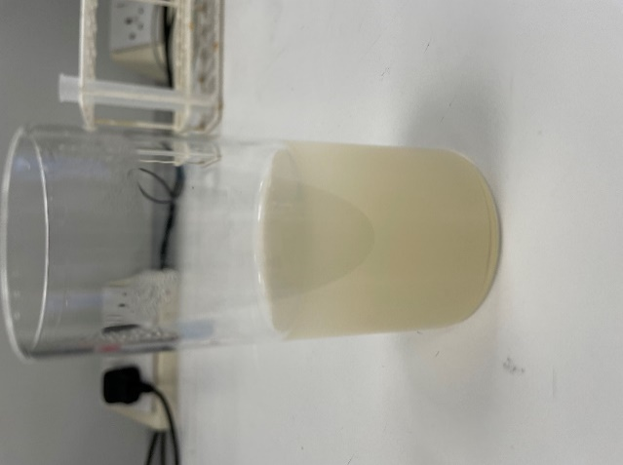 | 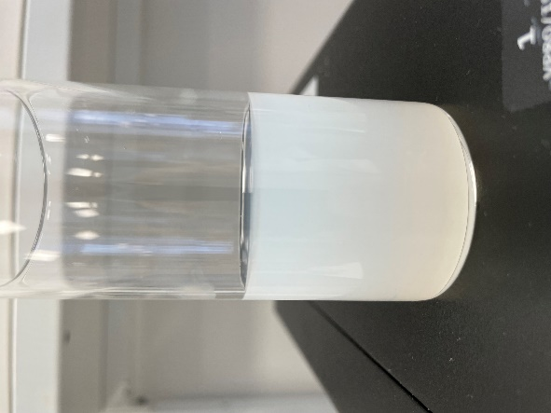  B | 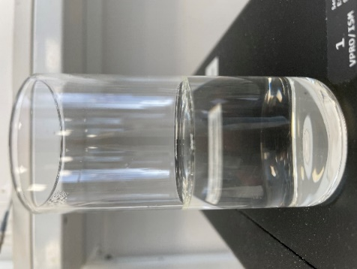  C
Figure S1a: Picture of the media post one h of digestion of the medium-chain LBF (40% Miglyol 812, 40% Tween 85, and 20% Cremophor RH40) in the pH-stat setup. A) shows the media post-digestion digestion with porcine pancreatin with calcium, B) shows the media post-digestion with Palatase® 20000 L with calcium, and C) shows the media post-digestion with Palatase® 20000 L without calcium.
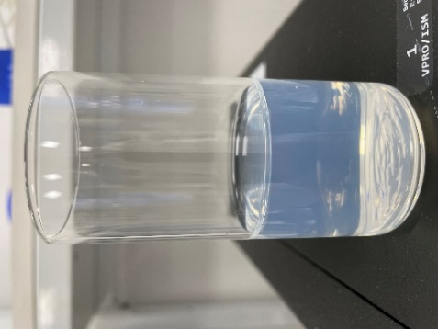 | 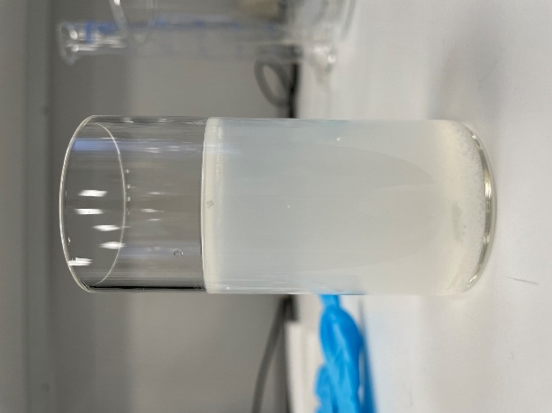 | 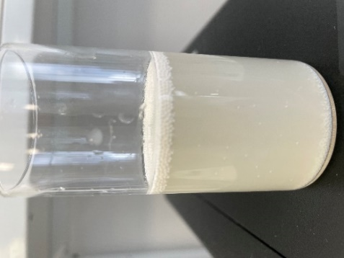 | 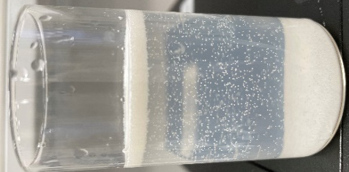
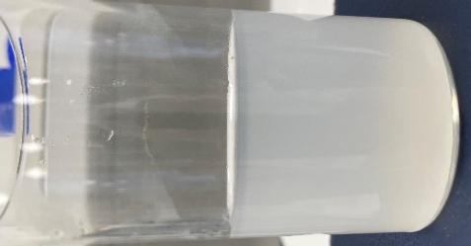  A B C D  E F G | 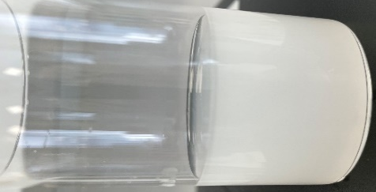 | 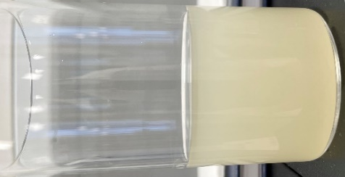
Figure S1b: Pictures of the media after one hour of digestion in the pH-stat setup. The pictures are for the medium-chain LBF (40% Miglyol 812, 40% Tween 85, and 20% Cremophor RH 40) with low lipid load and with calcium. The media shown is A) without digestion, B) Novozym® 435, C) Lipozyme® RM, D) Sigma beads, E) Lipozyme® CALB L, F) Lipozyme® TL 100 L, and G) NovoCor® AD L.

S2 - Digestion profiles for long-chain LBF
 | Liquid lipases | Immobilised Lipases
Low lipid load, with calcium |  | A1 B1
High lipid load, with calcium |  | A2 B2
Low lipid load without calcium |  | A3 B3
High lipid load, without calcium | A4 B4
Figure S2: Digestion profiles from pH-stat experiments showing the release of FFA versus time for the range of lipases. The digestion profiles are for the long-chain LBF (40% Olive oil, 40% Tween 85, and 20% Cremophor RH40). Porcine pancreatin (×) is in all graphs as a reference. The A figures are liquid lipases: Palatase® 20000 L () and Lipozyme® TL 100 L (▲), and the B figures are the immobilised lipases: Lipozyme® RM () and Novozym® 435 (○). Experiments with low lipid load (1:200) are shown in 1 and 3, and high lipid load (1:40) are shown in 2 and 4. Experiments with calcium are shown in 1 and 2, and experiments without calcium are shown in 3 and 4. Every 24 data points are shown in the graph (data point every 2 minutes) to improve graph legibility. The data shown is n = 3 ± SD.

S3 – Extend of digestion for surfactant-only formulation

Figure S3: Extend of surfactant-only formulation (67% Tween 85 and 33% Cremophor RH40) digested in percent from experiments conducted in the pH-stat setup with high lipid load with calcium (blue) and high lipid load without calcium (orange). The data shown is n = 3 ± SD.

