Table S1. Chemical composition of experimental diets
Parameter | CON | HT-c | HT-t | CT-m | CT-g
Dry matter (%) | 89.65 | 89.29 | 89.30 | 89.26 | 89.59
Crude protein (% DM) | 15.67 | 14.20 | 14.49 | 14.36 | 15.15
Ether extract (% DM) | 2.68 | 2.67 | 2.75 | 2.52 | 2.85
Ash (% DM) | 7.01 | 6.43 | 6.55 | 6.19 | 6.49
NDF (% DM) | 30.36 | 28.93 | 26.91 | 27.26 | 27.38
ADF (% DM) | 15.97 | 14.07 | 13.85 | 13.85 | 14.49
ADL (% DM) | 3.62 | 3.79 | 3.22 | 2.37 | 3.76
¹Total phenol (g/kg DM) | 4.7 | 24.9 | 29.1 | 25.3 | 11.68
Total tannins (% of total phenols) | 32.1 | 84.2 | 86.9 | 88.1 | 63.00
CON: Control; HT-c: Chestnut hydrolysable tannin; HT-t: Tara hydrolysable tannin; CT-m: Mimosa condensed tannin; CT-g: Gambier Condensed tannin; DM: Dry matter; NDF: Neutral detergent fiber; ADF: Acid detergent fiber; ADL: Acid detergent lignin.
¹Expressed as g of tannic acid (TA) equivalents / kg DM of diet
ONLINE SUPPLEMENTARY DATA

Table S2. List of primers used for quantitative PCR and ion torrent next generation sequencing (NGS)
Target gene and group | References | Primer set | Sequence (5` to 3` direction) | Tª | Amplicon (bp)
Quantitative PCR
18S rDNA for total protozoa | Sylvester, Karnati, Yu, et al. (2004) | PSSU-316f  PSSU-539R | F: GCTTTCGWTGGTAGTGTATT  R: CTTGCCCTCYAATCGTWCT | 55 | 223
16S rRNA for total bacteria | Maeda, Fujimoto, Haruki, et al. (2003) | Univ16S_1048-1067  Univ16S_1175_1194 | F: GTGSTGCAYGGYTGTCGTCA  R: ACGTCRTCCMCACCTTCCTC | 61 | 150
ªmcrA gene for methanogenic archaea | Denman, Tomkins and McSweeney (2007) | qmcrA-f  qmcra-r | F: TTCGGTGGATCDCARAGRGC  R: GBARGTCGWAWCCGTAGAATCC | 56 | 140
18S rRNA and ITS1 for total anaerobic fungi | Denman and McSweeney (2006) | Denfun f  Denfun r | F: GAGGAAGTAAAAGTCGTAACAAGGTTTC  R: CAAATTCACAAAGGGTAGGATGATT | 62 | 120
Ion torrent NGS
Bacterial Adaptors |  |  | F: CCATCTCATCCCTGCGTGTCTCCGACTCAG  R: CCTCTCTATGGGCAGTCGGTGAT
Bacterial primers | Spear, Sikaroodi, Zariffard, et al. (2008) | 27F  357R | F: AGAGTTTGATCMTGGCTCAG  R: CTGCTGCCTYCCGTA | 58 | 348
Methanogens adaptors |  |  | F: CCATCTCATCCCTGCGTGTCTCCGACTCAG  R: CCTCTCTATGGGCAGTCGGTGAT
Methanogens primers | Wright and Pimm (2003)  Turner, Pryer, Miao, et al. (1999) | 86F  519R | F: GCTCAGTAACACGTGG  R: GWATTACCGCGGCKGCTG | 58 | 433
ªmcrA gene: methyl-coenzyme M reductase alpha subunit gene

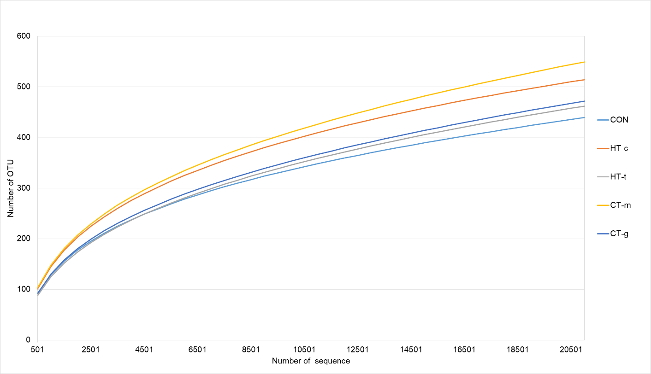

Figure S1. Rarefaction curves illustrating the sequencing depth of the rumen bacterial communities in lambs fed different tannin extracts. Dietary treatments are: CON, control; HT-c, chestnut hydrolysable tannin; HT-t, tara hydrolysable tannin; CT-m, mimosa condensed tannin; CT-g, gambier condensed tannin.

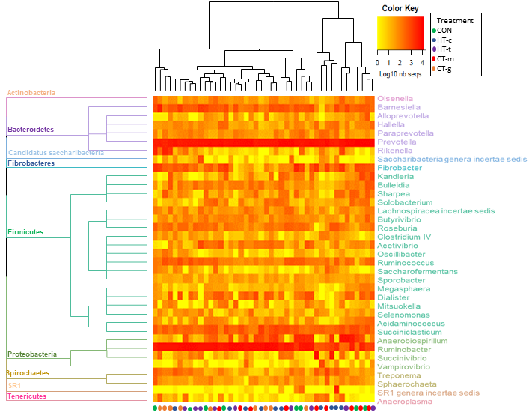

Figure S2. Heat map illustrating the abundance of bacterial genera in the rumen of lambs fed a control diet (CON) and four dietary treatments supplemented with different tannin extracts. Dietary treatments are: CON, control; HT-c, chestnut hydrolysable tannin; HT-t, tara hydrolysable tannin; CT-m, mimosa condensed tannin; CT-g, gambier condensed tannin. Bacterial genera with relative abundance less than 0.1% were discarded and a dendrogram was created based on UPGMA (Unweighted Pair Group Method with Arithmetic Mean) clustering of the Bray-Curtis distances.

Table S3. Correlation coefficients of canonical correspondence analysis indicating relationship between rumen bacterial community structure, fermentation and microbial variables
 | R² | P-value
Rumen pH | 0.085 | 0.265
Protein content | 0.351 | 0.002
NH₃-N | 0.007 | 0.897
Total volatile fatty acids | 0.047 | 0.434
Acetate | 0.156 | 0.058
Propionate | 0.036 | 0.475
Iso-butyrate | 0.038 | 0.528
Butyrate | 0.579 | 0.001
Iso-valerate | 0.033 | 0.599
Valerate | 0.073 | 0.239
Acetate/propionate ratio | 0.793 | 0.001
Total bacteria | 0.033 | 0.453
Total archaea | 0.105 | 0.152
Total fungi | 0.060 | 0.344
Total protozoa | 0.053 | 0.438
Archaea/bacteria ratio | 0.113 | 0.109
Bacterial diversity | 0.415 | 0.001
Methanogen diversity | 0.047 | 0.444
Lipase activity | 0.063 | 0.218
Carboxymethyl cellulase activity | 0.020 | 0.745
Xylanase activity | 0.064 | 0.286
Amylase activity | 0.152 | 0.075

Table S4. Correlation coefficients of canonical correspondence analysis indicating relationship between rumen methanogen community structure, fermentation and microbial variables
 | R² | P-value
Rumen pH | 0.017 | 0.744
Protein content | 0.002 | 0.959
NH₃-N | 0.036 | 0.469
Total volatile fatty acids | 0.014 | 0.776
Acetate | 0.033 | 0.532
Propionate | 0.005 | 0.905
Iso-butyrate | 0.006 | 0.905
Butyrate | 0.028 | 0.550
Iso-valerate | 0.035 | 0.461
Valerate | 0.039 | 0.446
Acetate/propionate ratio | 0.045 | 0.316
Total bacteria | 0.149 | 0.062
Total archaea | 0.090 | 0.147
Total fungi | 0.078 | 0.196
Total protozoa | 0.046 | 0.404
Archaea/bacteria ratio | 0.033 | 0.470
Bacterial diversity | 0.033 | 0.508
Methanogen diversity | 0.015 | 0.729
Lipase activity | 0.003 | 0.933
Carboxymethyl cellulase activity | 0.075 | 0.206
Xylanase activity | 0.044 | 0.399
Amylase activity | 0.146 | 0.047

References

Denman SE, McSweeney CS. Development of a real-time PCR assay for monitoring anaerobic fungal and cellulolytic bacterial populations within the rumen. FEMS Microbiol Ecol 2006;58: 572-82.
Denman SE, Tomkins NW, McSweeney CS. Quantitation and diversity analysis of ruminal methanogenic populations in response to the antimethanogenic compound bromochloromethane. FEMS Microbiol Ecol 2007;62: 313-22.
Maeda H, Fujimoto C, Haruki Y et al. Quantitative real-time PCR using TaqMan and SYBR Green for Actinobacillus actinomycetemcomitans, Porphyromonas gingivalis, Prevotella intermedia, tetQ gene and total bacteria. FEMS Immun Med Microbiol 2003;39: 81-86.
Spear GT, Sikaroodi M, Zariffard MR et al. Comparison of the diversity of the vaginal microbiota in HIV-infected and HIV-uninfected women with or without bacterial vaginosis. J Infect Dis 2008;198: 1131-40.
Sylvester JT, Karnati SK, Yu Z et al. Development of an assay to quantify rumen ciliate protozoal biomass in cows using real-time PCR. J Nutr 2004;134: 3378-84.
Turner S, Pryer KM, Miao VP et al. Investigating deep phylogenetic relationships among cyanobacteria and plastids by small subunit rRNA sequence analysis. J. Eukaryot Microbiol 1999;46: 327-338.
Wright A-DG, Pimm C. Improved strategy for presumptive identification of methanogens using 16S riboprinting. J Microbiol Methods 2003;55: 337-49.

