Fabrication of a sensitive amperometric sensor for NADH and H₂O₂ using palladium nanoparticles-multiwalled carbon nanotubes nanohybrid

Hassan Hamidi a* and Behzad Haghighi ^{b,c∗}

ª Department of Chemistry, Islamic Azad University of Zanjan, P.O. Box 49195-467, Zanjan, Iran.
^{b} Department of Chemistry, Institute for Advanced Studies in Basic Sciences, P.O. Box 45195-1159, Gava Zang, Zanjan, Iran.
^{c} Department of Chemistry, College of Sciences, Shiraz University, Shiraz 71454, Iran.
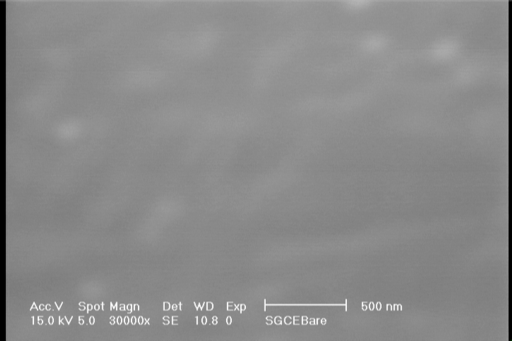
A
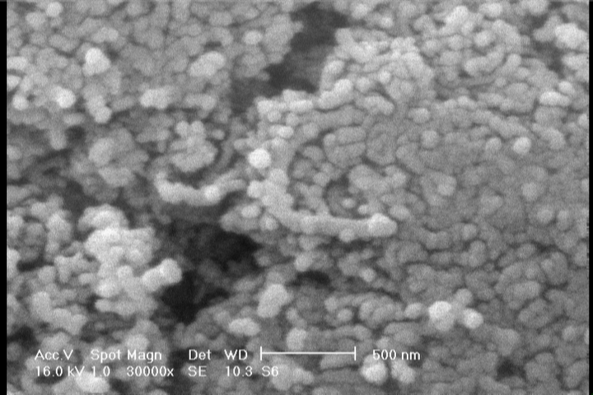

Fig. S1 SEM images of GCE (A) and GCE/PdNPs-MWCNTs (B).
B

Fig. S2 Cyclic voltammograms for a PdNPs-MWCNTs/GCE in 0.5 M H₂SO₄ solution at a scan rate of 50 mV s⁻¹

Fig. S3 The plot of peak current versus PdNPs-MWCNTs amount (mg mL⁻¹ in DMF) obtained from cyclic voltammetric studies in 0.1 M KCl solution containing 1 mM K₃Fe(CN)₆ at a scan rate of 50 mV s⁻¹.
Fig. S4 The plot of current response versus pH obtained from amperometric studies in the presence of 10 µM NADH. Conditions: supporting electrolyte, Ar-saturated phosphate buffer solution (0.1 M, pH 7.4); operating potential: +0.45 mV versus Ag|AgCl|KCl_{sat}; rotating speed: 2000 rpm
Fig. S5 The plot of current response versus pH obtained from amperometric studies in the presence of 10 µM H₂O₂. Conditions: supporting electrolyte, Ar-saturated phosphate buffer solution (0.1 M, pH 7.4); operating potential: +0.35 mV versus Ag|AgCl|KCl_{sat}; rotating speed: 2000 rpm.

Fig. S6 Lineweaver-Burk plot for glucose at Nafion/GOx/PdNPs-MWCNTs/GCE (in pH 7.4 phosphate buffer and at the applied potential of +0.350 V vs. Ag|AgCl|KCl_{sat}).

∗ Corresponding authors: Tel: +98 24 3346 1001, Fax: +98 24 3346 0037 (H. Hamidi) E-mail address: hamidi.h@hotmail.com (H. Hamidi) Tel: +98 71 3613 7178, Fax: +98 71 3646 0724 (B. Haghighi) E-mail address: bhaghighi@shirazu.ac.ir (B. Haghighi))

