Table 1.

Source of variation | Sum of squares (SQ) | Degrees of freedom (DF) | Mean square (MS) | F value
Regression (R) | 1.10 x 10⁸ | 5 | 2.20 x 10⁷ | 61.92*
Residual (r) | 1.78 x 10⁶ | 5 | 3.55 x 10⁵ | 4.90**
Lack of fit (Lf) | 1,56 x 10⁶ | 3 | 5.22 x 10⁵
Pure error (Pe) | 2.13 x 10⁵ | 2 | 1.06 x 10⁵
Total (T) | 1.12 x 10⁸ | 10
R² | 0.984
F listed values (90% of confidence) |  |  |  | *F_{5,5} = 3.45  **F_{3,2} = 9.16

Figure 1.

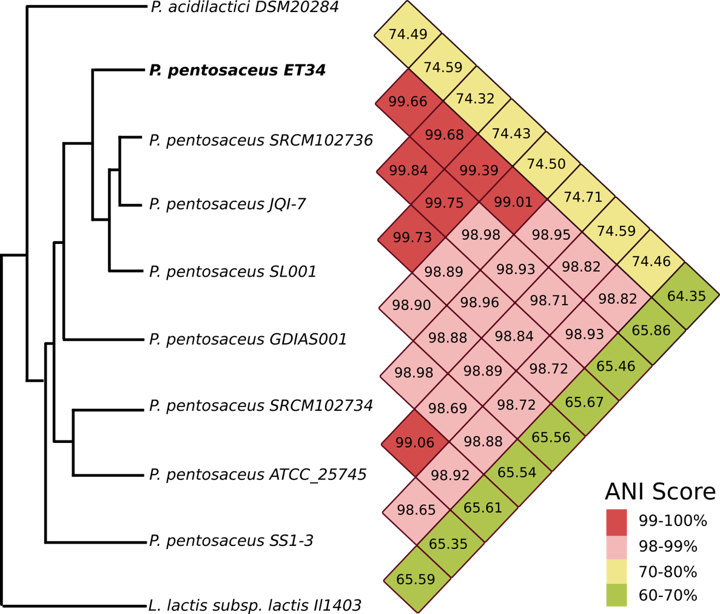
a)
b)
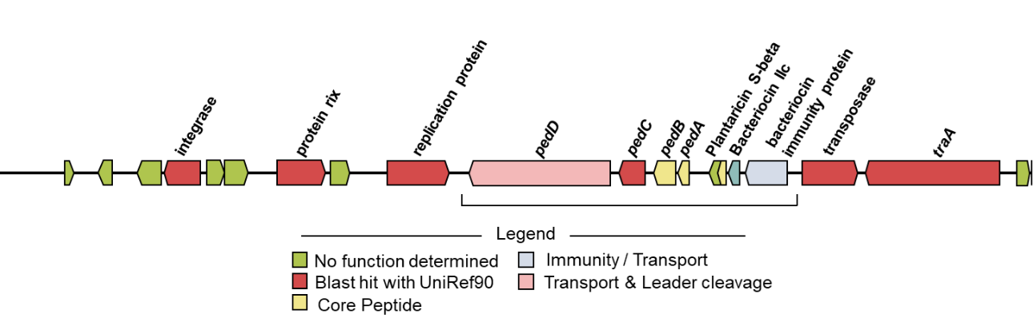

Figure 2.

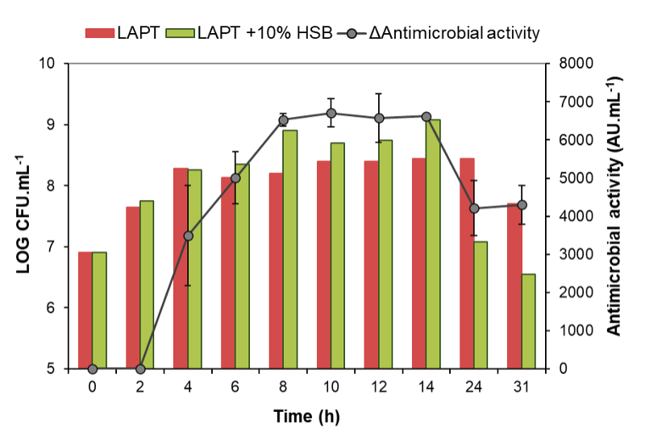
a)
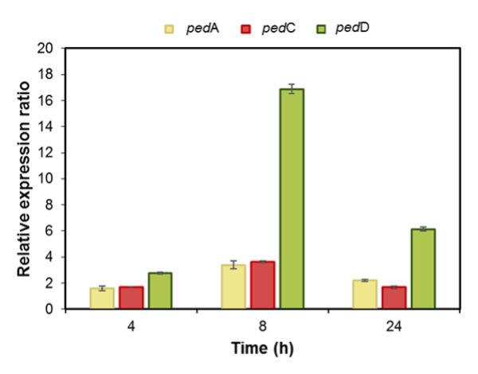
b)

Figure 3.

.

Figure 4.

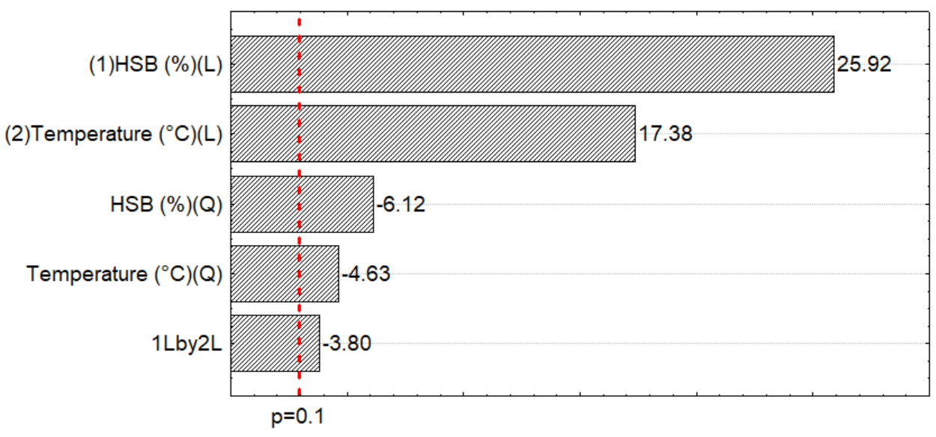
b)
a)
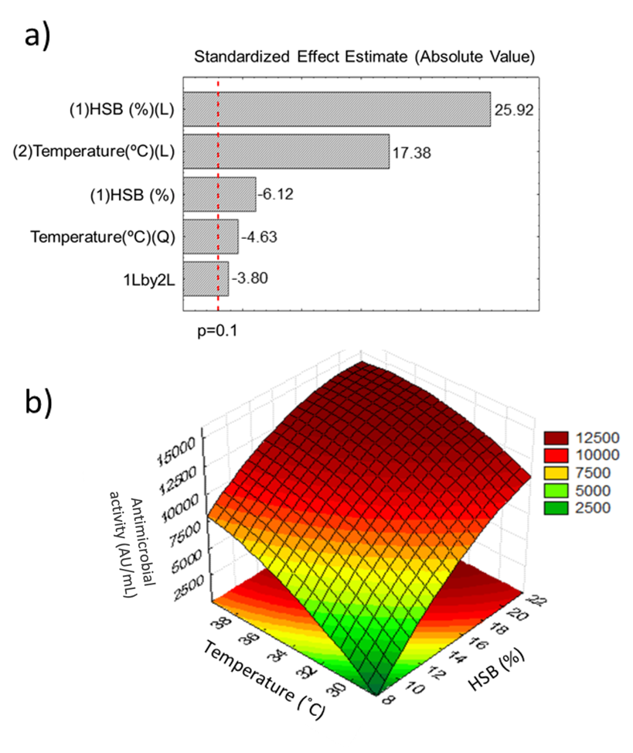

Figure 5.

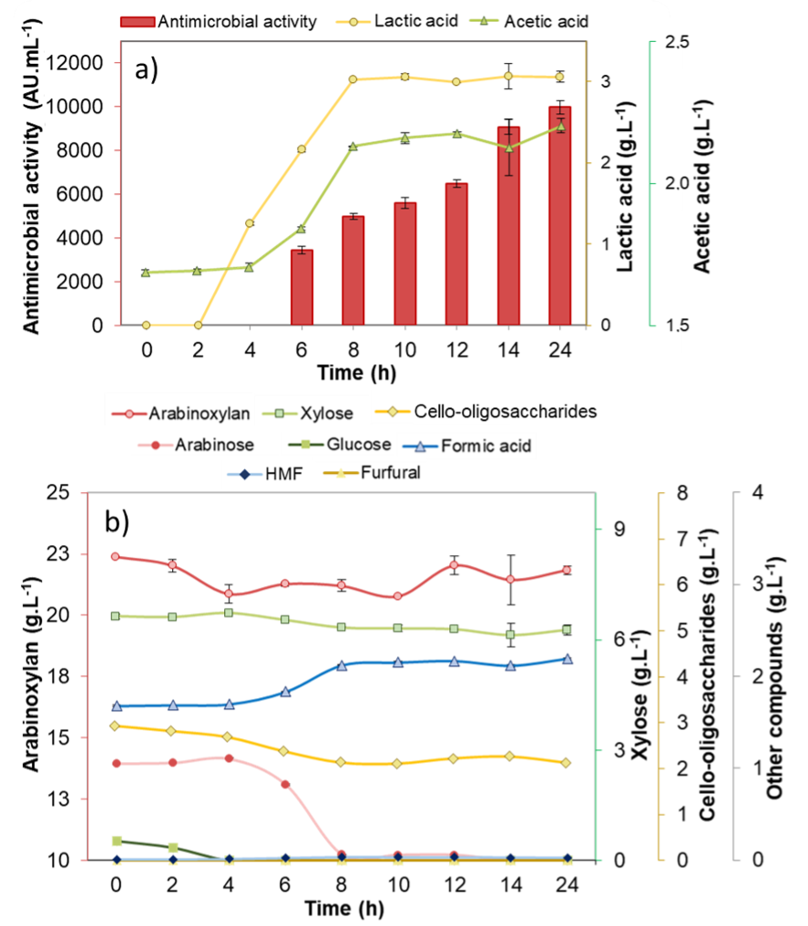

Figure 6.

