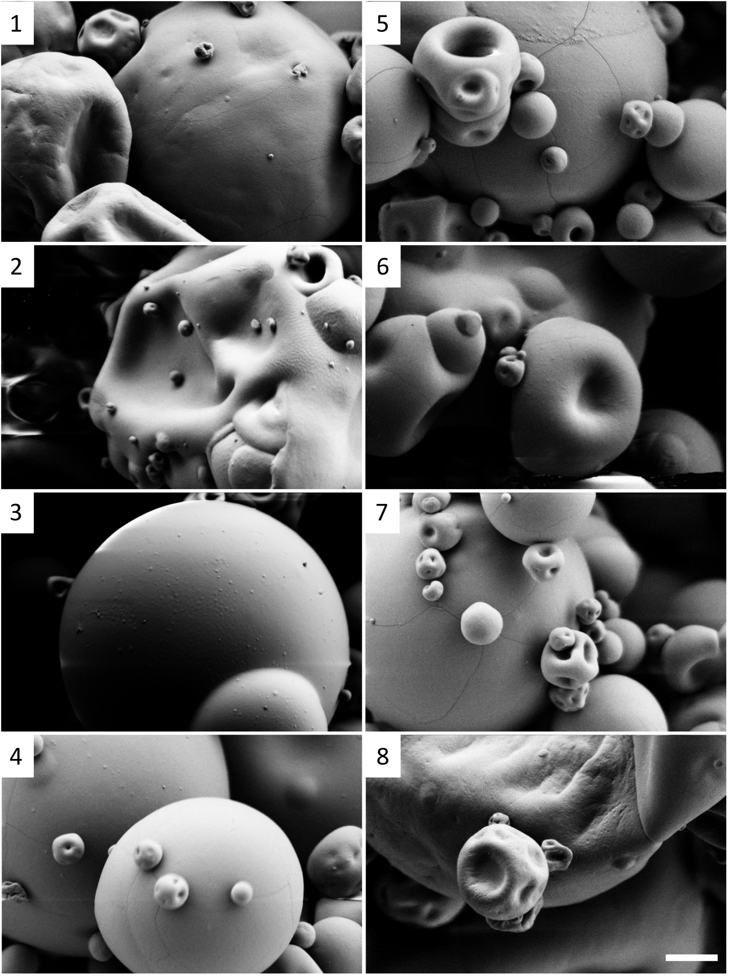
H.
G.
F.
E.
D.
C.
A.
B.
Fig. S1. Scanning electron microscopy (SEM) images of control milk protein concentrate powder containing 0 (A), 2.5 (B), 5 (C) or 10 mM (D) sodium hexametaphosphate and crosslinked milk protein concentrate powder containing 0 (E), 2.5 (F), 5 (G) or 10 mM (H) sodium hexametaphosphate.

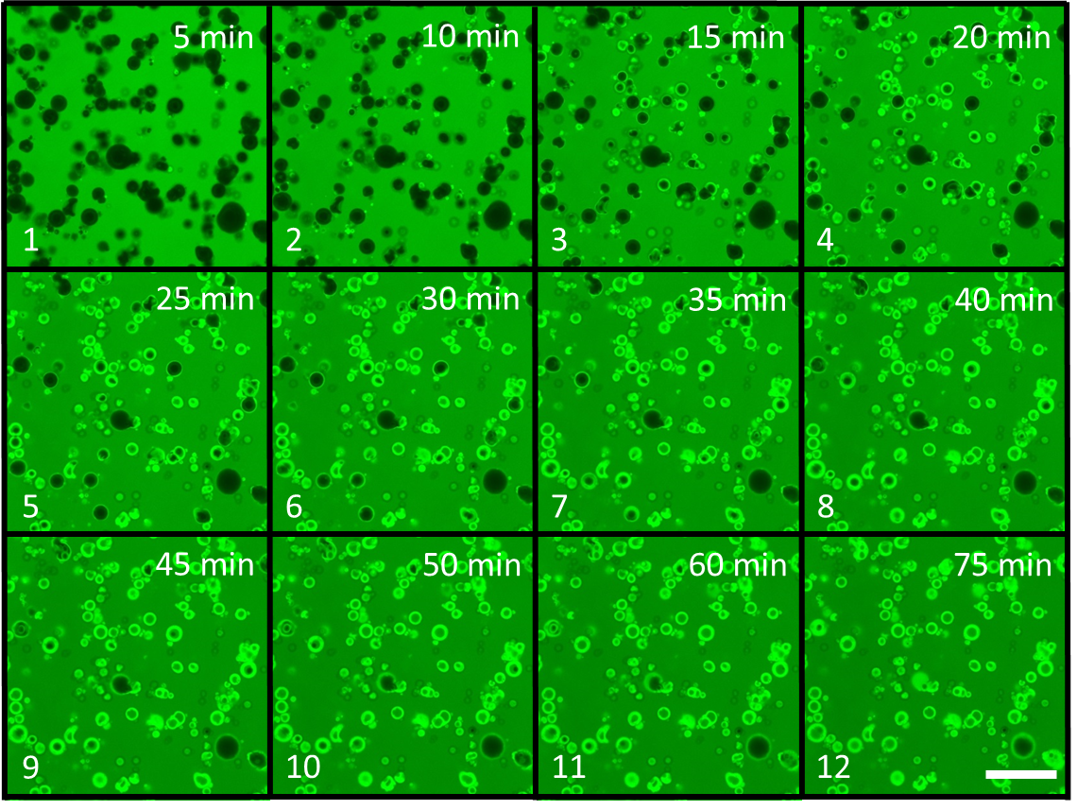
Fig. S2. Confocal scanning laser micrographs of anhydrous control milk protein concentrate powder 0 mM at 10 (1), 20 (2), 25 (3), 30 (4), 40 (5), 45 (6), 55 (7), 60 (8), 65 (9), 70 (10), 75 (11), 80 (12), 85 (13), 90 (14), 95 (15) and 100 min (16) after addition of rhodamine B. Scale bar is 25 µm.

A

Fig. S3. Effective diffusivity of Rhodamine B (0.1% in water) measured as a function of particle size of control (A) and crosslinked milk protein concentrate powder (B) with 0 (◊), 2.5 (■), 5 (▲) and 10 mM (×) additions of sodium hexametaphosphate. Data was compiled and calculated from confocal laser scanning microscopy images.

