Supplementary materials
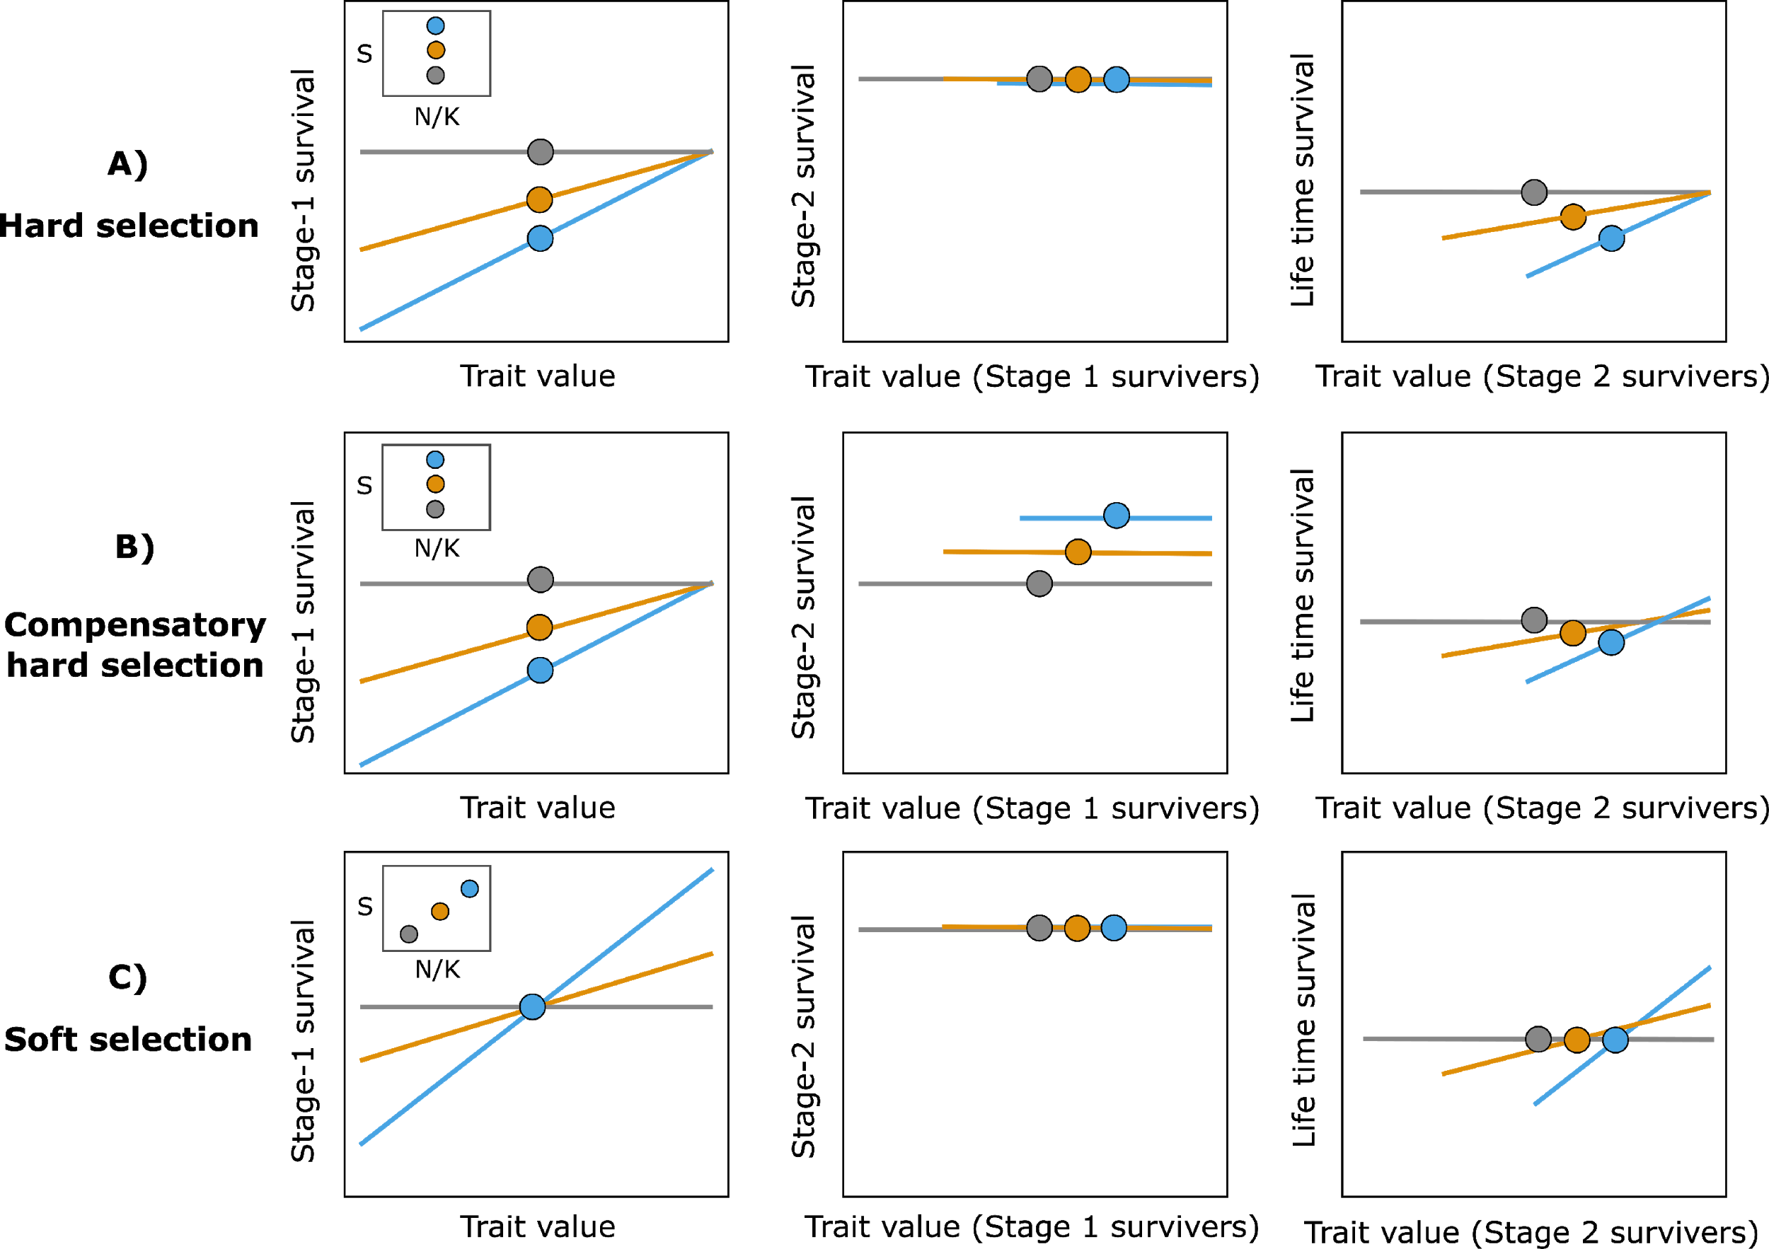

Figure S1. Schematic depiction of the net demographic costs of (A) hard selection, (B) partially compensatory hard selection and (C) soft selection across life stages. In each scenario, a single episode of selection occurs during life stage-1 (left-hand column) and three different years are depicted (grey, orange, blue) across which linear selection strength varies. The steeper the relationship between individual survival during life stage-1 and the trait value, the stronger the selection differential (S). The small inset graphs present the relationship between population density (N relative to K) and selection differentials. Selection differentials under hard selection are dependent upon the external environment (e.g., climate) and are independent of density. In contrast, the strength of soft selection is correlated with population density. Under hard selection (A), selection is followed by density- and trait-independent mortality in stage-2. Under compensatory hard selection (B), selection is followed by density dependence at stage-2, hence the stronger the reduction in mean survival in stage-1, the higher the mean survival in stage-2 owing to release from competition (note that compensation is partial as depicted). Under soft selection(C), survival at stage-2 could be density dependent or independent, but either way the expected mean is the same across years as soft selection at stage-1 has not impacted the number of survivors. The right-hand panels show the net outcomes in terms of life time survival (product of survival in stage-1 and stage-2). Circles represent population means.

