Supporting Information S2: The DRA adjudication guide


DRUG-RELATED HOSPITAL ADMISSIONS ADJUDICATION GUIDE
Stefanie Thevelin, Jean-Baptiste Beuscart, Benoit Boland, Jacques Donzé, Anne Spinewine, Olivia Dalleur

TABLE OF CONTENTS
1 AIM 1
2 DEFINITIONS 2
2.1 Drug-related problems 2
2.2 Drug-related hospital admission 2
3 A THREE-STEP APPROACH FOR IDENTIFYING DRA 8
4 DATA ABSTRACTION (Study nurse) 10
4.1 Aim 10
4.2 Instructions for data abstraction 10
4.3 Required data abstracts 10
5 SCREENING FOR POTENTIAL ADE (Adjudication Committee) 11
5.1 Aim 11
5.2 Definitions 11
5.3 Instructions for screening for potential ADE 12
5.3.1 STEP a: Screening for triggered potential ADE using the DRA trigger tool 14
5.3.2 STEP b: Screening for non-triggered potential ADE using the screening questions 15
5.3.3 Other conditions that could have contributed to the event 16
6 ADJUDICATION (Adjudication Committee) 17
6.1 Aim 17
6.2 Instructions for adjudication 17
6.2.1 ADE causality assessment 18
6.2.2 Assessment of ADE contribution to hospital admission 20
6.2.3 Adjudication rules 21
7 DRA CASE REPORT FORM 22
8 REFERENCES 23
9 APPENDICES 24

ABBREVIATIONS
ACE-inhibitor: Antiotensin-converting enzyme inhibitor
ADE: Adverse drug event
ADR: Adverse drug reaction
ADWE: Adverse drug withdrawal event
COPD: Chronic obstructive pulmonary disease
DRA: Drug-related hospital admission
DRP: Drug-related problems
DVT: Deep vein thrombosis
eCRF: Electronic case report form
GP: General practitioner
INR: International normalized ratio
LMWH: Low molecular weight heparins
ME: Medication error
NSAID: Non-steroidal anti-inflammatory drugs
PE: Pulmonary embolism
PPI: Proton pump inhibitor
SSRI: Selective serotonine re-uptake inhibitor
VKA: Vitamin K antagonists

AIM
The drug-related hospital admissions adjudication guide is a standardised and validated method to identify drug-related hospital admissions (DRA) in older people caused by adverse drug reactions and medication errors including overuse, misuse and underuse of medications.
The DRA adjudication guide is intended for use by clinicians who are trained in using the guide and who have experience in geriatric medicine.
The DRA adjudication guide is a manual containing definitions, examples and step-by-step instructions for identification of DRA including:
- A list of definitions and examples of types of drug-related problems (DRP) that will be assessed
- A list of data abstracts required for DRA identification
- Screening instructions for potential ADE: a DRA trigger tool and screening questions for non-triggered events
- Adjudication instructions: ADE causality assessment (WHO UMC causality criteria) and assessment of ADE contribution to hospital admission (Hallas criteria)
Note
A video tutorial on the use of the DRA adjudication guide is available via the following link: https://www.youtube.com/watch?v=fadmO-WcCHM
Training material is available upon request.

DEFINITIONS

Drug-related problems
Drug-related problems (DRP) are defined as ‘any irregularity in the process of medication use’. DRP can be divided into two groups, problems related to an error and problems not related to an error:
- In the first group a mistake is made somewhere in the medication distribution process (error in prescribing, dispensing, administering or monitoring the medication); these are called medication errors (ME). ME may or may not result in patient harm and are preventable.
- In the second group, a problem occurs although no errors have been made in the medication distribution process, these are called adverse drug reactions (ADR). ADR always result in patient harm and are not preventable [1].
Taking into account the aim of the DRA adjudication guide, we are only interested in DRP that cause harm i.e. adverse drug events. Adverse drug events (ADE) are defined as a medication errors or adverse drug reactions with the condition that it leads to patient harm.
Definitions and examples of DRP are presented in Table 1.

Drug-related hospital admission
A drug-related hospital admission (DRA) is a hospitalisation due to an ADE; harm due to an ADR or a ME related to overuse, misuse or underuse of prescription and non-prescription medications and which is the main reason for or contributes to hospital admission of a patient.
- The main reason for admission is the primary cause of admission and is usually documented in the admission or discharge letter.
- A contributory reason for admission is a clinically significant contributory factor to admission i.e. an event that worsened the main reason for admission or played a substantial role in the admission but other factors also contributed significantly to the admission.
ADE that occur during a course of a hospitalisation are not considered as DRA and are therefore excluded from our definition of DRA. Figure 1 shows the different types of DRP and the relationship between ADE, ME, ADR and DRA.

DRA
Medication errors
ADR, non-preventable
ADE

Preventable
FIGURE 1: DRUG-RELATED PROBLEMS – RELATIONSHIP BETWEEN ME, ADR, ADE AND DRA

Inclusion/exclusion criteria for hospital admissions to be adjudicated:
Hospitalisation is defined as an inpatient hospitalisation for longer than 24 hours.
Inclusion of the following admissions:
- Non-elective/emergency admissions (= when admission is unpredictable and at short notice because of clinical need)
Exclusion of the following admissions:
- Visits to emergency room without inpatient hospitalisation (even if overnight)
- Hospitalisation for diagnostic or elective (surgical) procedures for pre-existing conditions

TABLE 1: DEFINITIONS AND EXAMPLES OF DRUG-RELATED PROBLEMS
Drug-related problem | Definition | Example
Adverse drug event (ADE) | Harm resulting from the use of a drug [2]. This can be either an ADR (no error – non-preventable) or a medication error (error in prescribing, dispensing, administering (including patient adherence) or monitoring medication – preventable) with the condition that it results in patient harm.
- Adverse drug reaction (ADR) Non-preventable | A response to a drug which is noxious and unintended and which occurs at doses normally used in man for prophylaxis, diagnosis or therapy of disease or the modification of physiological function. [3] Correctly used and prescribed medicines can harm due to side effects or allergic reactions that cannot be anticipated or prevented, even with sufficient knowledge of the patient’s history and prescription according to the correct pharmacological principles.  - Drug allergy: An immune response to a medication characterised by anaphylaxis, skin reactions, fever, serum sickness or the involvement of various organ systems including the liver, bone marrow and blood.  - Side effect: Any unintended effect of a pharmaceutical product occurring at normal dosage which is related to the pharmacological properties of the drug [4]. | An anaphylactic reaction induced by penicillin in a patient who received the antibiotic for the first time is an ADR. Isoniazid-induced peripheral neuropathy is a side effect of medication and therefore an ADR [5].
- Medication error (ME)  Preventable | Any error in the process of prescribing, dispensing, administering (including patient adherence) or monitoring the medication (including drug-interactions) [1] associated with overuse, misue or underuse of medications. | A patient with a documented ACE-inhibitor allergy admitted with angio-oedema is a preventable ME due to misprescribing.
Overuse | “Drug, no indication”  The use or prescription of more drugs than clinically needed [6], including:  - Any drug prescribed or used without an evidence-based clinical indication.  - Medication prescribed or used beyond the recommended duration.  - Therapeutic duplication. Optimisation of monotherapy with a single drug class should be observed before considering a new drug. | - Cimetidine prescribed for haemorrhoids  - Use of benzodiazepines for ≥ 4 weeks  - Two concurrent ACE-inhibitors, SSRIs, loop diuretics etc.

Underuse | “Indication, no drug”  A failure to use or prescribe drugs that are indicated including:  - Omission of an evidence-based drug: failure to prescribe a drug for acute or chronic therapy when there is an indication. If a drug is omitted appropriately due to a comorbid condition or due to patient preference as documented in the patient’s record, it is not considered underuse e.g. a previous allergy, anticoagulation in a patient with severe bleeding risk.  - Too short duration: the total course of therapy was too short to achieve the desired effect.  - Non-adherence: a deviation from the prescribed medication regimen or monitoring instructions because of choice, non-comprehension or forgetfulness producing an exacerbation of symptoms of the patients’ condition [7]. | -A patient is admitted with a new myocardial infarction who had known, but untreated risk factors (e.g. hypercholesterolemia, hypertension) for cardiovascular disease.  -Laboratory values indicate that the patient has high blood glucose but no hypoglycaemic agent was prescribed.  -The patient was prescribed a 10 days antibiotic course for an infection but he didn’t complete the course resulting in reinfection.  -A patient has severe shortness of breath and admits not using prescribed inhaled bronchodilators [5, 8].
Misuse | “Drug + indication but medication error”  Incorrect (de)prescription or use of needed drugs or the presence of potentially inappropriate medications [6]. There is a drug and an indication, but an error in prescribing, dispensing, administering or monitoring the medication occurred e.g. wrong drug, wrong dose, wrong route, drug-drug or drug-food interactions, inappropriate monitoring, inappropriate discontinuation, misuse by the patient.
- Wrong drug | - Drug therapy when there is a contraindication or precaution for a certain condition with increased risk of toxicity.  - Drug-disease interactions.  - Drug therapy is effective for the condition but not effective in the patient and needs to be substituted.  - Drug therapy is not the most effective for the indication being treated.  - Drug therapy is known to be ineffective for the condition (no evidence-based medicine) and/or is not recommended in clinical guidelines.  - The patient has an infection involving organisms that are resistant to the drug.  - The dosage form is inappropriate.  - The patient has become refractory to the current drug treatment. | -Use of NSAIDS in patients with chronic kidney disease, drugs that should be avoided in older patients, known drug allergies.  - Verapamil/diltiazem in patients with heart failure, ACE-inhibitors in patients with renal arterial stenosis.  -Use of thiazide diuretics for hypertension in patients with stage 4 chronic kidney disease.  -A patient with swallowing problems receives crushed carbamazepine tablets although a liquid carbamazepine syrup is available.
- Wrong dose  (supratherapeutic or subtherapeutic) | - Medication dosages that are too high or too low to optimally treat the target condition.  - Inappropriate frequency of administration: the dose is given too frequently or not frequent enough to achieve the desired pharmacokinetics needed for the therapeutic effect.  - The medication dose is not adapted to the patient characteristics i.e. age, renal function, liver function, circulating protein binding capacity, comorbidities.  - The patient’s serum drug concentration or a bioassay are outside the therapeutic range.  - The drug dose was increased too rapidly.  - Accidentally ingesting a toxic amount of drug.  - The dose is PRN when it should be regular or vice versa. | -Digoxin, 250 µg qd-dose is too high for a 79-year old patient with documented renal failure.  -Calcium 500 mg qd-dose is too low to treat diagnosed osteoporosis in a patient without sufficient dietary intake.
- Inappropriate monitoring | Drug serum concentrations, bioassays or laboratory values related to medication use are not appropriately monitored. | - A patient with congestive heart failure was started on spironolactone in hospital. The patient was discharged on this medication in addition to ramipril, furosemide and potassium supplements (as the patient had been taking prior to admission). No monitoring of the patient’s electrolytes following discharge was performed. As a result the patient developed hyperkalaemia.  - A patient is admitted with digoxin toxicity due to failure to monitor renal function and/or digoxin levels.  - A patient is admitted with phenytoin toxicity or a patient is admitted with a seizure due to failure to monitor phenytoin levels.
- Inappropriate discontinuation | Inappropriate removal or dosage decrease of a drug by the prescriber (misdeprescribing) or by the patient leading to an adverse drug withdrawal event (ADWE = a clinically significant set of symptoms or signs related to inappropriate discontinuation of a drug [8] or return of the underlying disease). | - Physiological withdrawal reaction (symptomatic tachycardia) following abrupt discontinuation of a β-blocker.  - Worsening of angina after discontinuation of nitrates.
- Drug interactions | - - Drug-drug interaction: clinical (pharmacologic) responses that are not explained by a single drug but rather are due to two or more drugs acting simultaneously. It includes interactions that cause harmful effects as well as interactions that decrease or increase the efficacy of one or both drugs through pharmacokinetic interactions (absorption, protein binding, inhibiting or inducing metabolism, excretion) or pharmacodynamic interactions (synergism or antagonism). It includes interactions of other drugs with alcohol, nicotine, phytotherapy or nutritional supplements if use of these substances is documented in the patient’s medical record.  - - Drug-food interaction: clinical responses that are explained by a drug and food acting simultaneously, including effects on pharmacokinetics and pharmacodynamics action. | - Grapefruit juice might increase the effects of cyclosporine.  - Cyclosporine might increase the effects of colchicine by inhibiting the P-glycoprotein.  - Cimetidine might increase the effects of theophylline, diazepam or warfarin by reducing their rate of metabolism [5].  - Monoamine oxidase inhibitors and tyramine-containing foods and drinks with risk of potential fatal sever hypertensive crises.  - A high protein diet may slow down and decrease the absorption of levodopa from the intestine [5].
- Other | An error in dispensing, preparation (e.g crushing), administering (e.g inappropriate route of administration, inappropriate time) or using the medication. | - Intrathecal administration of vincristine.  - The patient takes the drug with food while it should be taken on an empty stomach.

A THREE-STEP APPROACH FOR IDENTIFYING DRA
Identification of DRA will be performed using retrospective medical record review in 3 steps: data abstraction, screening for potential ADE and adjudication. In Figure 2, a general overview of the DRA identification process is presented. Each step is discussed in detail in the following chapters.

Figure 2: Three-step approach for identifying DRA

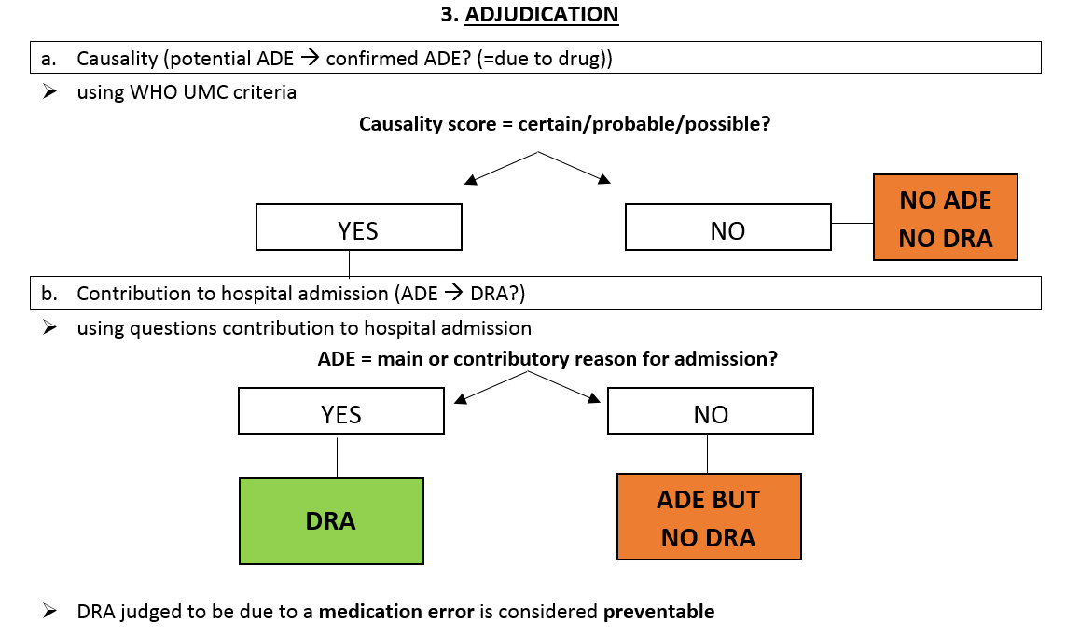

DATA ABSTRACTION (Study nurse)

Aim
The data abstraction step aims to collect a standardised list of data required for DRA identification.

Instructions for data abstraction
For every hospitalisation, a study nurse abstracts relevant data from the medical record. The documents indicated with an asterisk (*) usually contain all necessary information for adjudications.

Required data abstracts
The following data must be abstracted:

Demographics (gender, date of birth, height, weight, ethnos)
  - Past medical history (ICD-10)
  - Documented ADR (allergies, side effects)
  - Immunisation information (influenza and/or pneumococcal vaccine received)

Smoking status, smoking history, alcohol consumption
  - Previous falls
- Admission letter* from the emergency department (including presenting complaint, main reason for admission, past medical history)
- Discharge letter* (including main diagnosis and other diagnoses during admission (in ICD-10), ward specialty)
- Laboratory values up to day 2 of hospitalisation*: clinical parameters, blood results, blood gases, microbiology, therapeutic drug monitoring results
- Medication lists*: this includes all prescription and non-prescription medicines, including “as required” medications
- best-possible medication history (available from admission /discharge letter)
- medication taken up to day 2 of admission (available from the medication chart in the hospital)
- discharge medication (available from discharge letter)
- Adherence information: If available collect information on medication adherence e.g by using of a validated adherence measure or information on prescription refills.

SCREENING FOR POTENTIAL ADE (Adjudication Committee)

Aim
The screening step aims to identify potential ADE causing or contributing to hospital admission (i.e. potential DRA). Potential ADE identified in the screening step will subsequently assessed for ADE causality and ADE contribution to hospital admission in the adjudication step.

Definitions
- Main or contributory reason for admission
The main reason for admission is the primary cause of hospitalisation and is usually documented in the admission or discharge letter. There can be more than one main reason for admission. E.g. a patient admitted for a fall and fracture + intracranial bleeding.
A contributory reason for admission is a clinically significant contributory factor to admission i.e. an event that worsened the main reason for admission or played a substantial role in the admission but other factors also contributed significantly to the admission. E.g. a patient admitted for pneumonia who also has a low white blood cell count due to an immunosuppressive drug, can be a contributory reason for admission. A patient admitted for a stroke who also happens to have back pain is not a contributory reason for admission.
- Trigger
A positive trigger is an event (diagnosis/abnormal laboratory value…) + a causative drug or cause of drug underuse. A positive trigger is thus a potential ADE.
- Potential ADE
A potential ADE is a suspected ADE (detected either by the trigger tool or spontaneously), but the causal relationship with the drug has not been proven yet (i.e. is the event due to the drug or other conditions). Causality will be assessed using the WHO UMC causality criteria during adjudication.
- One or more potential ADE?
One or more drugs contributing to the same adverse event is considered as 1 potential ADE (e.g aspirin + clopidogrel + direct oral anticoagulant causing a major bleeding = 1 potential ADE or an opiate + benzodiazepine causing a fall = 1 potential ADE). In the adjudication step causality will be assessed for the group of drugs causing the potential ADE and not for each drug individually.
However, one drug can cause more than 1 potential ADE (e.g. a benzodiazepine can cause a fall but also confusion = 2 potential ADE related to benzodiazepine use). The causality will then be assessed for each potential ADE separately (i.e. the causal relationship for benzodiazepine + fall and the causal relationship for the benzodiazepine + confusion should be assessed separately).
- The “unit” for causality assessment is thus per potential ADE.

Instructions for screening for potential ADE
Screening for potential ADE is performed by an adjudication committee composed of a physician and pharmacist given their complementary knowledge and experience [9]. The adjudication committee should have expertise in geriatric medicine. The committee takes all decisions in consensus. In case of disagreement, a back-up committee should be consulted.

Screening for potential ADE is involves 2 main steps:
- Screening for triggered events using the trigger tool for DRA in older persons (5.3.1).
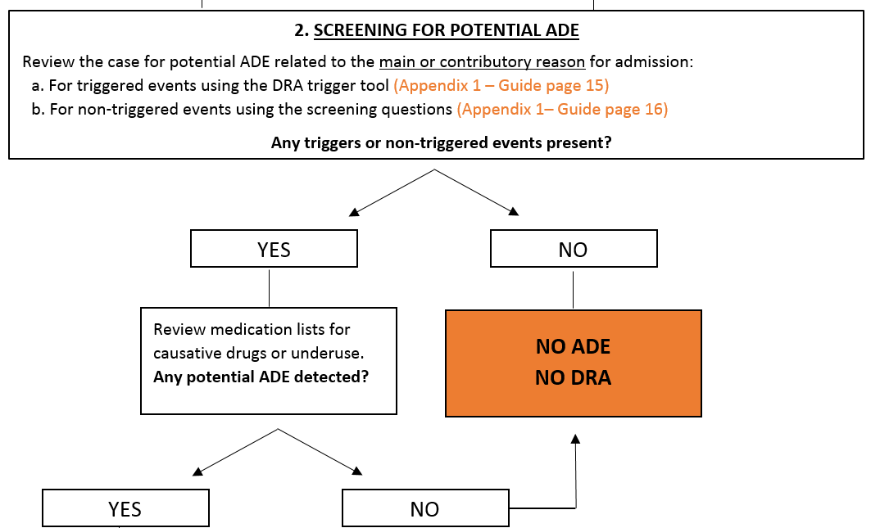
- Screening for non-triggered events using the screening questions (5.3.2).
FIGURE 3: SCREENING FOR POTENTIAL ADE

STEP a: Screening for triggered potential ADE using the DRA trigger tool
A trigger tool is an explicit screening instrument aiming to facilitate screening for potential ADE by bringing standardisation and improving efficiency [10]. The trigger tool for detecting DRA in older persons was designed and validated by an international Delphi panel. Triggers are “red lights” or alarm signals found upon review of the data abstracts that could be related to a DRA. A trigger does not necessarily mean that there is an ADE or DRA, further investigation is needed in the adjudication step to determine if it is a confirmed ADE and/or DRA.
The trigger tool for DRA in older persons (Appendix 1) consists of 26 triggers divided in 3 sections: diagnoses, abnormal laboratory values and some “other” triggers including the use of antidotes, abrupt medication stops or documented ADE. For each trigger, a list of potential causative drugs or omission of certain drugs (=underuse) is provided to help screening for potential ADE. In Figure 4, an example of the trigger “heart failure exacerbation” with potential causative drugs or causes for drug underuse is presented. Also adherence issues or too short duration of therapy are considered as underuse. E.g. a patient admitted for heart failure exacerbation who was also taking NSAIDs is a positive trigger and thus a potential ADE, which needs further adjudication.
Only triggers and non-triggered events up to 48 hours of admission should be included (e.g. hypokalaemia on day 1 of admission could represent a DRA, whereas hypokalaemia on day 4 of hospitalisation is unlikely to be a DRA).
TRIGGER HEART FAILURE EXACERBATION
Use of any drugs that could precipitate heart failure exacerbation?
- Non-steroidal anti-inflammatory drugs  - Corticosteroids  - Thiazolidinediones (glitazones)  - Non-dihydropyridine calciumchannel blockers (verapamil, diltiazem) | - Sodium containing formulations (effervescent, dispersible & soluble medications)  - Other (Please specify) :
Underuse of any of the following drugs?
- β-blockers*  - ACE-inhibitors* | - Diuretics
Note: β-blockers & ACE-inhibitors in heart failure due to left ventricular dysfunctions
FIGURE 4: EXAMPLE TRIGGER HEART FAILURE EXACERBATION

STEP b: Screening for non-triggered potential ADE using the screening questions
Previous studies have demonstrated that by restricting the ADE detection method only to trigger tools, whole classes of ADE can be missed [11] [12, 13]. Hence, in addition to screening using the trigger tool, data abstracts will also be screened for non-triggered potential ADE using 2 screening questions (Appendix 1 + Figure 5). Question 1 screens whether the reason for admission is related to an ADR, overuse or misuse of a drug. Question 2 screens whether the reason for admission is related to underuse.
Screening questions for non-triggered, spontaneously detected events
- Could the main or contributory reason for admission be related to a drug or recent change in medications?
- Adverse drug reaction  - Overuse of medication(s) (drug without an indication, too long duration of therapy, therapeutic duplication)  - Inappropriate discontinuation (removal or dosage decrease) leading to physiological withdrawal signs/symptoms or return of the underlying disease signs/symptoms | - Wrong drug  - Wrong dose (supratherapeutic or subtherapeutic)  - Clinically significant drug-drug or drug-food interactions  - Inappropriate monitoring  - Other (e.g. drug not correctly dispensed/prepared/administered)
- Could the main or contributory reason for admission be related to underuse?
- Omission of an indicated drug  - Too short duration of medication therapy | - Suspected adherence concerns
FIGURE 5: SCREENING QUESTIONS

Other conditions that could have contributed to the event
Once you have detected one or more potential ADE (triggered or non-triggered), it is very important to
look for and record all other conditions that could have contributed to the event. This is needed to help you distinguish between drug-related or disease- related causes for the potential ADE during causality assessment in the adjudication step. E.g. if a patient taking benzodiazepines was admitted for a fall, but also has Parkinson’s disease, this could explain the fall in addition to the benzodiazepines. Or heart failure exacerbation in a patient with end stage renal disease will not be caused by underuse of diuretics (which would be inappropriate in this patient) but rather by other conditions such as underlying renal disease. On the other hand you should also look for objective evidence that supports the potential ADE e.g. laboratory values, medication adjustment, results of scans.
Results from screening can be recorded in the DRA case report form – screening part (Appendix 4). Examples of screening for triggered and non-triggered potential ADE are presented in Figure 6.
Triggered events
Hypoglycaemia was found as a trigger. Upon medical record review it became clear that it was caused by acute alcohol intoxication and there was no evidence that the patient was on medications with hypoglycaemic potential. In this case, there is no potential ADE.
A patient is admitted with hypoglycaemia caused by taking a too high of a dose of antidiabetic medications (= valid trigger - suspected causative drugs) or a patient with chronic atrial fibrillation without anticoagulation was admitted for a stroke (=suspected underuse). In these cases, there is a triggered potential ADE that needs further adjudication.
A patient is admitted for dehydration on severe diarrhoea. A contributory reason for admission was a fall. Upon reviewing the medication lists, there were no causative drugs for the trigger dehydration = no potential ADE. Whereas for the fall, there were 2 benzodiazepines as a causative drug = potential ADE that needs further adjudication for causality and contribution to admission.
Non-triggered events
- A patient who is immunosuppressed due to long term corticosteroid use is admitted for urosepsis (ADR).
- A patient with a mechanical aortic valve is admitted with a acute coronary syndrome following VKA withdrawal after a previous hospitalisation (inappropriate discontinuation).
- A patient is admitted for pyelonephritis for which he took an antibiotic course for 5 days although the guideline recommends a minimum of 14 days (underuse).

FIGURE 6: EXAMPLES OF SCREENING FOR POTENTIAL ADE

ADJUDICATION (Adjudication Committee)

Aim
The adjudication step aims to draw a final conclusion regarding the drug-relatedness of the admission. Potential ADE detected in the screening step will be accepted or rejected as a DRA in the adjudication process.

Instructions for adjudication
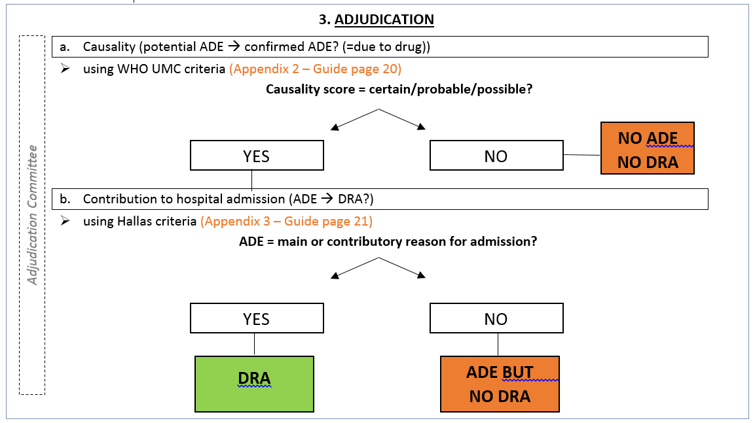
Every potential ADE detected in the screening step will be adjudicated for ADE causality and ADE contribution to hospital admission as presented in Figure 7. First a potential ADE will be assessed for causality i.e. is the potential ADE due to the drug and thus a confirmed ADE (possible/probable/certain causal relationship) or is it due to other factors such as an exacerbation of the underlying disease. In case of a confirmed ADE, ADE contribution to hospital admission will be assessed and thus whether the ADE is a DRA (main or contributory reason for admission). The two steps are explained in detail in 6.2.1 and 6.2.2.

FIGURE 7: ADJUDICATION

ADE causality assessment
Causality assessment is the evaluation of the likehood that a particular treatment causes an observed ADE [14]. It evaluates the relationship between the use of a drug and the occurrence of an ADE. When a potential ADE is assessed as “certain, probable or possible” it should be considered as a “confirmed” ADE and further adjudicated for contribution to hospital admission (chapter 6.2.2). When a potential ADE is assessed as “unlikely” or “unassessable”, it is not a confirmed ADE and thus no DRA. Detailed instructions for applying the criteria can be found in Appendix 2.
An inherent problem in identifying ADE is that most cases concern suspected ADE. ADE are rarely specific for the drug, diagnostic tests are usually absent and a rechallenge is rarely ethically justified. In practice, few ADE are “certain” or “unlikely”, most are somewhere in between these extremes i.e. “possible” or “probable” [15].
Each potential ADE identified in the screening step should be assessed for causality seperately. The “unit for causality assessment” is thus per potential ADE. E.g. a benzodiazepine potentially causing a fall but also confusion = two potential ADE related to benzodiazepine use, hence two separate causality assessments should be done. However, as explained under 5.2, more than one drug can contribute to the same potential ADE, this is considered as 1 potential ADE and thus causality should be assessed for the group of drugs at once and not for each drug individually. A hip fracture caused by a benzodiazepine, SSRI and underuse of vitamin D = 1 potential ADE and thus 1 causality assessment for the group of drugs should be performed.
For causality assessment, the WHO UMC system for standardised case causality assessment (Appendix 2) was adopted [15]. The WHO UMC causality criteria take into account the clinical-pharmacological aspects of the case as well as the quality of documentation of the observation. The causality categories are presented in Table 2. To assess causality due to underuse, the WHO-causality criteria were adapted according to the approach used by Klopotowska et al [12][13]. Depending if the potential ADE relates to drug use* or underuse**, the criteria can be used for drug intake* (yellow) or drug omission** (blue) respectively. For drug-interactions, the WHO UMC system can be used by assessing the actor drug, which influences the kinetics or dynamics of the other drug (which has usually been taken over a longer period), in the medical context of the patient.

TABLE 2: WHO UMC CRITERIA FOR CAUSALITY ASSESSMENT
Causality term | Assessment criteria for use* or underuse**  (all points should be reasonably complied with)
Certain | - Event or laboratory test abnormality with plausible time relationship to drug intake* or drug omission**  - Cannot be explained by disease or other drugs  - Response to withdrawal* or drug initiation** plausible (pharmacologically, pathologically)  - Event definitive pharmacologically or phenomenologically (i.e. an objective and specific medical disorder or a recognised pharmacological phenomenon)  - Rechallenge (=what happens when the drug is stopped and later on resumed)* or withdrawing a drug previously initiated (=what happens when an omitted drug is initiated and later on again withdrew)** is satisfactory, if necessary
Probable | - Event or laboratory test abnormality with reasonable time relationship to drug intake* or drug omission  - Unlikely to be attributed to disease or other drugs  - Response to withdrawal* or drug initiation** clinically reasonable  - Rechallenge* or withdrawing a drug previously initiated ** not required
Possible | - Event or laboratory test abnormality with reasonable time relationship to drug intake* or drug omission**  - Could also be explained by disease or other drugs  - Information on withdrawal* or drug initiation** may be lacking or unclear
Unlikely | - Event or laboratory test abnormality with a time to drug intake* or drug omission** that makes a relationship improbable (but not impossible)  - Disease or other drugs provide plausible explanations
Unassessable/unclassifiable | - Report suggesting an adverse reaction  - Cannot be judged because information is insufficient or contradictory  - Data cannot be supplemented or verified

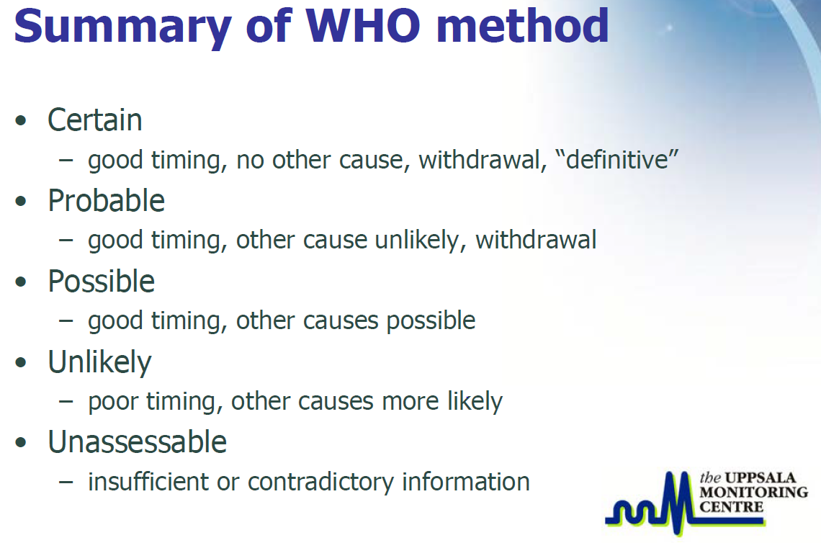

Assessment of ADE contribution to hospital admission
Following ADE causality assessment, the relationship between all confirmed ADE (possible/probable/certain causal relationship) and hospital admission will be assessed.
According to our definition of DRA, hospitalisations due to an ADE that is the main reason for admission as well as an ADE that is a contributory reason for admission are considered as DRA. You might have identified more than one ADE in the causality step; therefore all confirmed ADE (possible/probable/certain causal relationship) identified, will be taken in to account as a group for DRA assessment. Three questions (Appendix 3) will help to structure and standardise the assessment of DRA based on the method published Hallas et al. (1990) [16].
HALLAS CRITERIA FOR ASSESSMENT OF ADE CONTRIBUTION TO HOSPITAL ADMISSION
1. Was the ADE listed as one of the primary reasons for admission?
- NO | - YES: Consider as a DRA (main reason)

Select YES if the ADE was the primary cause of admission and no other diseases or symptoms contributed significantly to the admission. This is considered as a DRA.
If NO, proceed to question 2.
Example: The primary reason for admission is a fall. Upon screening overuse of benzodiazepines was detected, a possible causal relationship with the drug was proven using the WHO causality criteria and hence the confirmed ADE is also considered as a confirmed DRA.

2. Did the ADE worsen the reason for admission?
- Definitely/probably/more than likely NO: | - Definitely/probably/more than likely YES: Consider as a DRA (contributory reason)

Select YES if the ADE played definitely/probably/more than likely a substantial role in admission but other factors also contributed significantly.
If definitely/probably/more than likely NO, proceed to question 3.

Example:
- A patient was admitted with dehydration due to severe diarrhoea. The patient was also using diuretics, which contributed to dehydration. However without use of diuretics, the patient might have been dehydrated too due to severe diarrhoea. Therefore this ADE can be considered as a contributory reason for admission rather than the main reason. Since diuretics worsened dehydration it is still considered a DRA.
- A patient admitted with a major bleed who also happens to have untreated constipation due to underuse is not a contributory reason for admission and thus not a DRA.

3. Without occurrence of the ADE, would the patient have been admitted to hospital?
- Definitely/probably/more than likely YES:  Don’t consider as a DRA | - Definitely/probably/more than likely NO: Consider as a DRA

Select YES if the ADE played a minor or uncertain role and the patient would definitely/probably/more than likely have been admitted without occurrence of the ADE and other symptoms or circumstances were the reason for hospitalisation. This ADE shouldn’t be considered as a DRA.
Select NO if without occurrence of the ADE, the patient would definitely/probably/more than likely not have been admitted and consider this as a DRA.

Adjudication rules
Despite development of a standardised procedure, a certain degree of disagreement is to be expected in the adjudication of complex multimorbidity cases. Following an inter-rater reliability test across 4 international adjudication teams, the need for further standardising consensus procedures for more subjective adjudications such as underuse, contributory reasons for admission and non-triggered events was highlighted. Therefore adjudication rules have been developed in consensus with all adjudication teams (Appendix 5). The rules should be adhered to in order to minimize subjectivity and to ensure standardised adjudications of similar types of ADE or DRA. Additional rules might be developed during the trial.

DRA CASE REPORT FORM
During the screening and adjudication process, the outcome will be recorded in the DRA case report form (CRF) (Appendix 4). There are two parts in DRA case report form; a first part to record the outcome of the screening process and a second part to record the outcome of the adjudication process.
In screening part a) any triggered potential ADE can be recorded. In screening part b) any non-triggered potential ADE can be recorded. Furthermore all potential ADE identified should be described along with evidence that could confirm the potential ADE such as laboratory values/imaging results/documentation in the medical notes etc, any corrective actions that were taken such as medication adjustment (drug discontinuation, dose changes, new medication started) or use of antidotes etc. Complete with potential other causes that could have contributed to the event.
In the adjudication part a, record for each potential ADE identified, the result of the ADE causality assessment (certain/probable/possible/unlikely/unassessable). Causality assessment for a group of drugs contributing to the same potential ADE, should be done as a whole and not for each drug individually. In case of a confirmed ADE (certain, probable or possible score), proceed with assessment of ADE contribition to hospital admission in adjudication part b. Indicate whether a DRA was present or not and if yes, indicate whether it was the main or contributory reason for admission. Provide a description of the DRA and indicate the number of medications involved as well as the 4 most likely medications (by importance) that caused the admission.

REFERENCES
1. van den Bemt, P.M., et al., Drug-related problems in hospitalised patients. Drug Saf, 2000. 22(4): p. 321-33.
2. Gurwitz, J.H., et al., Incidence and preventability of adverse drug events among older persons in the ambulatory setting. JAMA, 2003. 289(9): p. 1107-16.
3. Edwards, I.R. and J.K. Aronson, Adverse drug reactions: definitions, diagnosis, and management. Lancet, 2000. 356(9237): p. 1255-9.
4. World Health Organisation (WHO), U.M.C., Glossary of Terms used in Pharmacovigilance, in WHO [online]. 2015.
5. Bero, L.A., H.L. Lipton, and J.A. Bird, Characterization of geriatric drug-related hospital readmissions. Med Care, 1991. 29(10): p. 989-1003.
6. Meid, A.D., et al., The impact of pharmaceutical care interventions for medication underuse in older people: a systematic review and meta-analysis. Br J Clin Pharmacol, 2015.
7. Chan, M., F. Nicklason, and J.H. Vial, Adverse drug events as a cause of hospital admission in the elderly. Intern Med J, 2001. 31(4): p. 199-205.
8. Marcum, Z.A., et al., Prevalence of potentially preventable unplanned hospitalizations caused by therapeutic failures and adverse drug withdrawal events among older veterans. J Gerontol A Biol Sci Med Sci, 2012. 67(8): p. 867-74.
9. van Doormaal, J.E., et al., Reliability of the assessment of preventable adverse drug events in daily clinical practice. Pharmacoepidemiol Drug Saf, 2008. 17(7): p. 645-54.
10. Resar, R.K., J.D. Rozich, and D. Classen, Methodology and rationale for the measurement of harm with trigger tools. Qual Saf Health Care, 2003. 12 Suppl 2: p. ii39-45.
11. Franklin, B.D., et al., Testing a trigger tool as a method of detecting harm from medication errors in a UK hospital: a pilot study. Int J Pharm Pract, 2010. 18(5): p. 305-11.
12. Klopotowska, J.E., et al., Adverse drug events in older hospitalized patients: results and reliability of a comprehensive and structured identification strategy. PLoS One, 2013. 8(8): p. e71045.
13. Carnevali, L., et al., Performance of the adverse drug event trigger tool and the global trigger tool for identifying adverse drug events: experience in a Belgian hospital. Ann Pharmacother, 2013. 47(11): p. 1414-9.
14. Agbabiaka, T.B., J. Savovic, and E. Ernst, Methods for causality assessment of adverse drug reactions: a systematic review. Drug Saf, 2008. 31(1): p. 21-37.
15. WHO-UMC system for standardised case causality assessment. 2016.
16. Hallas, J., et al., Drug related hospital admissions: the role of definitions and intensity of data collection, and the possibility of prevention. J Intern Med, 1990. 228(2): p. 83-90.

APPENDICES
TRIGGER TOOL TO SCREEN FOR DRUG-RELATED HOSPITAL ADMISSIONS IN OLDER PERSONS
Trigger on admission up to 48h of admission | Suspected causative drugs or causes for underuse
Diagnoses
Fall and/or fracture | Use of any of the following drugs?
Fall and/or fracture | - Benzodiazepines  - Non-benzodiazepine hypnotics e.g. zopiclone, zolpidem  - Antipsychotics  - Antidepressants | - Sedating antihistamines  - Opioids  - Anticholinergics$$ (cfr. Table A1)  - Other (Please specify):
Fall and/or fracture | Use of any drugs causing orthostatic hypotension?
Fall and/or fracture | - Calcium channel blockers  - Diuretics  - α1-receptor blockers  - Nitrates  - β-blockers  - ACE-inhibitors | - Angiotensin receptor blockers  - Direct renin inhibitors (e.g. aliskiren)  - Anti-Parkinson drugs  - Antidepressants (mainly tricyclic)  - Antipsychotics  - Gliflozines (SGLT2-inhibitors)  - Other (Please specify):
Fall and/or fracture | If a fall is caused by hypoglycaemia, look for use of drugs contributing to hypoglycaemia (check trigger hypoglycaemia)
Fall and/or fracture | Underuse of any of the following drugs in patients with known osteoporosis and/or history of fragility fracture(s) and/or Bone Mineral Density T-scores of -2.5 or lower in multiple sites?
Fall and/or fracture | - 800 IU Vitamin D/day (+ 1000-1200 mg calcium/day if dietary intake is <1200-1000mg/day) | - Bone anti-resorptive therapy ( e.g. bisphosphonates, strontiumranelate,teriparatide, denosumab)
Fall and/or fracture | Underuse of any of the following drugs in patients on corticosteroid therapy ≥ 3 months?
Fall and/or fracture | - 800 IU Vitamin D/day (+ 1000-1200 mg calcium/day if dietary intake is <1200-1000mg/day) | - Bisphosphonates
Fall and/or fracture | Underuse of vitamin D in patients who are housebound and/or experiencing falls or with osteopenia with Bone Mineral Density T-score between -1 and -2.5 in multiple sites?
Confusion/delirium* | Use of any of the following drugs?  - Benzodiazepines  - Non-benzodiazepine hypnotics e.g. zopiclone, zolpidem  - Antipsychotics  - Anti-epileptics  - Antihistamines (H1- & H2-receptor blockers)  - Antidepressants | - Opioids  - Dopaminergic agonists  - Digoxin  - Fluoroquinolones (dose adjustment in renal impairment required)  - Acetylcholinesterase-inhibitors (new onset confusion in patients with dementia)  - Other anticholinergics$$ (cfr. Table A1) (Please specify):
Confusion/delirium* | Abrupt discontinuation/rapid dose reduction of any of the following drugs?
Confusion/delirium* | - Benzodiazepines  - Non-benzodiazepine hypnotics e.g. zopiclone, zolpidem  - Corticosteroids  - Dopaminergic agonists  - Antidepressants | - Opioids  - Lithium  - Antipsychotics  - Other (Please specify):
Acute renal impairment** | Use of any of the following drugs?  - Non-steroidal anti-inflammatory drugs  - ACE-inhibitors  - Angiotensin receptor blockers  - Diuretics  - Sulphonamides  - Cephalosporins  - Quinolones (ciprofloxacin)  - Aminoglycosides  - Vancomycin  - Pentamidine | - Rifampicin  - Acyclovir, valacyclovir, gancyclovir, valgancyclovir, foscarnet, cidofovir  - Lithium  - Calcineurin Inhibitors (e.g. cyclosporine, tacrolimus)  - Cisplatin  - Radiology contrast medium  - Amphotericin  - Bisphosphonates  - Other nephrotoxic drugs (Please specify):
Dehydration | Use of any of the following drugs?
Dehydration | - Diuretics  - Gliflozines (SGLT2-inhibitors)  - Laxatives | - Any drugs causing vomiting  - Any drugs causing diarrhoea  - Other (Please specify):

Bleeding  (i.e. major bleeding and clinically relevant non-major bleeding***) | Use of any of the following drugs?  - Antiplatelets  - Vitamin K antagonists  - Direct oral anticoagulants  - Unfractionated heparin | - Low molecular weight heparins  - Selective serotonin reuptake inhibitors  - Non-steroidal anti-inflammatory drugs  - Other (Please specify):
- Underuse of proton pump inhibitors prophylaxis while
- NSAIDs monotherapy (≥ 70 years old) or on concurrent NSAIDs and/or antiplatelets and/or corticosteroids
- NSAIDs or antiplatelet or corticosteroids monotherapy with a history of peptic ulcer disease/gastrointestinal bleeding while on these drugs
Stroke | Underuse of any of the following drugs in patients with known chronic atrial fibrillation?
Stroke | - Vitamin K antagonists  - Direct oral anticoagulants (except valvular atrial fibrillation)
Stroke | Underuse of adequate antihypertensive therapy?  * Note: Adequate antihypertensive therapy is defined according to the recommendations for older patients in the 2013 European ESH/ESC guidelines for the management of arterial hypertension.
Stroke | Underuse of any of the following drugs in patients with history of coronary, cerebral or peripheral vascular disease?
Stroke | - Antiplatelets | - Statins** (unless end-of-life or > 85 years old)
Stroke | **Note: Evidence for statin treatment above the age of 80-85 years is limited and clinical judgement should guide decisions in the very old, taking into account life expectancy, serious adverse events, possible drug interactions. Low to moderate intensity statin regimens are recommended. (low: simvastatin 10mg, pravastatin 10-20mg, fluvastatin 20-40mg moderate: atorvastatin 10-20mg, Rosuvastatin 5-10mg, Simvastatin 20-40mg, pravastatin 40-80 mg, Fluvastatin 80 mg, Fluvastatin 40 mg BID)
Thromboembolic event (DVT or PE) | Underuse of adequate anticoagulation?
Thromboembolic event (DVT or PE) | - Unfractionated heparin  - Low molecular weight heparins | - Direct oral anticoagulants  - Vitamin K antagonists
(Recurrent) myocardial infarction or ischaemic disease | Underuse of cardiovascular secondary prevention?
(Recurrent) myocardial infarction or ischaemic disease | - Antiplatelets (unless already anticoagulated)  - Statins** (unless end-of-life or > 85 years old) | - β-blocker/ACE-inhibitor or angiotensin receptor blocker /adequate anti-anginal therapy in case of ischaemic disease
(Recurrent) myocardial infarction or ischaemic disease | Underuse of adequate antihypertensive therapy? *

Heart failure exacerbation | Use of any drugs that could precipitate heart failure exacerbation?
Heart failure exacerbation | - Non-steroidal anti-inflammatory drugs  - Corticosteroids  - Thiazolidinediones (glitazones) | - Non-dihydropyridine calcium channel blockers (verapamil, diltiazem)  - Sodium-containing formulations (effervescent, dispersible and soluble medications)  - Other (Please specify):
Heart failure exacerbation | Underuse of any of the following drugs?
Heart failure exacerbation | - β-blockers¥  - ACE-inhibitors¥  - Diuretics  Note: ¥ β-blocker and ACE-inhibitors in heart failure due to left ventricular dysfunction
COPD exacerbation | Use of any drugs that could precipitate COPD exacerbation?
COPD exacerbation | - Benzodiazepines with acute or chronic respiratory failure  - Opioids | - Other (Please specify):
COPD exacerbation | Underuse of any of the following drugs?
COPD exacerbation | - Single or dual inhaled bronchodilator therapy (i.e. a β2 agonist and/or anticholinergic bronchodilator) according to the GOLD (Global Initiative for Chronic Obstructive Lung Disease) grade
Uncontrolled (non-neuropathic) pain | Underuse of adequate pain treatment (according to the WHO analgesic ladder)?
Uncontrolled (non-neuropathic) pain | - A strong opioid in moderate to severe pain if paracetamol, NSAIDs or weak opioids are not appropriate (e.g. because of insufficient pain relief) | - Short-acting opioids for break-through pain during treatment with long acting opioids  - Other (Please specify):
Gastrointestinal disorders (severe diarrhoea, vomiting) | Use of any of the following drugs?
Gastrointestinal disorders (severe diarrhoea, vomiting) | - Antibiotics  - Laxatives  - Selective serotonin reuptake inhibitors  - Digoxin  - Cholinesterase-inhibitors | - Opioids  - Non-steroidal anti-inflammatory drugs  - Chemotherapy (Please specify):  - Other (Please specify):

Major constipation or faecal impaction | Use of any of the following drugs?
Major constipation or faecal impaction | - Chronic (stimulant) laxative use  - Opioids (look for underuse of laxatives with regular opioid use)  - Calcium antagonists (Mainly verapamil)  - Calcium  - Oral iron | - Aluminium antacids  - Atypical antipsychotics  - Tricyclic antidepressants  - Bladder antimuscarinics  - Other anticholinergic drugs$$ (cfr. Table A1)  - Other (Please specify):
Laboratory values
INR > 5 | Look for evidence of bleeding (see trigger) to determine if an adverse drug event (ADE) has occurred. A raised INR in itself is not an ADE.
Digoxin level > 2ng/ml | Look for signs or symptoms of digoxin toxicity (bradycardia, nausea, diarrhoea, confusion) to determine if a potential ADE has occurred. Not all levels above normal will result in an ADE.
Hypoglycaemia (blood glucose < 4 mmol/L or 72 mg/dl) | Look for symptoms such as lethargy, tremor, confusion, faintness or administration of intravenous or oral glucose.
Hypoglycaemia (blood glucose < 4 mmol/L or 72 mg/dl) | Use of any of the following drugs?
Hypoglycaemia (blood glucose < 4 mmol/L or 72 mg/dl) | - Insulin  - Oral hypoglycaemic agents (except metformin in monotherapy) | - MAO – inhibitors  - β-blockers (masking symptoms of hypoglycaemia)
Hyperglycaemia  (blood glucose > 11 mmol/L or 198 mg/dl) | Use of any drugs that may cause or worsen hyperglycaemia?
Hyperglycaemia  (blood glucose > 11 mmol/L or 198 mg/dl) | - Corticosteroids  - Atypical antipsychotics (mainly olanzapine & clozapine)  - Thiazide diuretics less frequent  - β-blockers (except carvedilol and nebivolol) less frequent | - Protease-inhibitors  - Calcineurin Inhibitors (cyclosporine, sirolimus, tacrolimus)  - Other (Please specify):
Hyperglycaemia  (blood glucose > 11 mmol/L or 198 mg/dl) | In case hyperglycaemia is part of diabetic ketoacidosis or hyperosmolar hyperglycaemic state in a patient, review for underuse of insulin or oral hypoglycaemic agents.
Hyperkalaemia (K⁺ > 5.5 mmol/L) | Use of any the following drugs?  - Intravenous or oral potassium  - Potassium-sparing diuretics  - ACE-inhibitors  - Angiotensin receptor blockers  - Direct renin inhibitors (e.g. aliskiren)  - Non-steroidal anti-inflammatory drugs | - Heparins (seldom, mainly when treated > 7days and concomitant other risk factors)  - Trimethoprim-sulfamethoxazole  - Cyclosporine  - Tacrolimus  - Other (Please specify):
Hypokalaemia (K⁺ < 3 mmol/L) | Use of any of the following drugs?  - Loop diuretics  - Thiazide and thiazide-like diuretics  - Corticosteroids | - Laxatives  - Salbutamol (IV or aerosol)  - Theophylline  - Other (Please specify):
Hyponatraemia (Na⁺ < 130 mmol/L) | Use of any of the following drugs?  - Diuretics  - Selective serotonin reuptake inhibitors  - Tricyclic antidepressants  - ACE-inhibitors | - Angiotensin receptor blockers  - Carbamazepine & oxcarbazepine  - High dose cyclophosphamide  - Other (Please specify):
White blood cells  < 3000 /mm³ or  < 3 x 10³/µL | Use of any of the following drugs?
White blood cells  < 3000 /mm³ or  < 3 x 10³/µL | - Carbamazepine & oxcarbazepine  - Antipsychotics ( mainly clozapine)  - Thyreostatics  - Ganciclovir  - Immunosuppressants | - Chemotherapy (Please specify):  - Mirtazapine (first 6 weeks of treatment)  - Voriconazole  - Other (Please specify):
Platelet count < 50000 /mm³ or  < 50 x 10³/µL | Use of any of the following drugs?
Platelet count < 50000 /mm³ or  < 50 x 10³/µL | - Carbamazepine & oxcarbazepine  - Ganciclovir  - Unfractionated heparin  - Low molecular weight heparins  - Immunosuppressants  - Thienopyridines (mainly ticlopidine) | - Quinine sulfate  - Sulfamides Less frequent  - Chemotherapy (Please specify):  - Other (Please specify):
 | Use of any of the following drugs?
Neutrophils < 1400/mm³ or < 1.4 x 10³/µL | - Ganciclovir  - Antipsychotics ( mainly clozapine)  - Thyreostatics  - Thienopyridines (mainly ticlopidine) | - Chemotherapy (Please specify):  - Other (Please specify):

Other
Antidote use or treatments that suggest a potential ADE | Use of any of the following drugs on the day of admission?
Antidote use or treatments that suggest a potential ADE | - Flumazenil in a patient on benzodiazepines  - Naloxone in a patient on opioids  - Phytonadione (vitamin K) in a patient on VKA  - Protamine sulphate in a patient on heparins  - Oral or intravenous glucose or glucagon in a patient taking hypoglycaemic drugs  - Potassium supplements in case of hypokalaemia  - Sodium polystyrene (Kayexalate) in case of hyperkalaemia | - Adrenaline, antihistamines and corticosteroids (general drug allergy)  - Acetylcysteine (paracetamol overdose)  - Digoxin antibodies in a patient with supratherapeutic digoxin levels  - Oral metronidazole or vancomycin in a patient who has recently been treated with an antibiotic that may cause Clostridium difficile associated diarrhoea
Mention of a (potential) ADE in the medical record | Assess causality using the WHO-UMC criteria
Abrupt medication stop within 24h of admission | When medications are stopped or withheld as compared to medications taken at home, look for reasons why this was done. Abruptly stopping medications is a trigger requiring further investigation for cause. A sudden change in patient condition requiring adjustment of medications is often related to an ADE
ADE, adverse drug event; ADR, adverse drug reaction; COPD, chronic obstructive pulmonary disease; DVT, deep vein thrombosis; ESH/ESC, European Society of Hypertension/European Society of Cardiology; FEV1, forced expiratory volume in 1 second; INR, international normalised ratio, NSAIDS, non-steroidal anti-inflammatory drugs; PE, pulmonary embolism; VKA, Vitamin K antagonists
Screening questions for non-triggered, spontaneously detected events
      - Could the main or contributory reason for admission be related to a drug or recent change in medications?
- Adverse drug reaction (non-preventable side effect, first allergic reaction)  - Overuse of medication(s) (drug without an indication, too long duration of therapy, therapeutic duplication)  - Inappropriate discontinuation (removal or dosage decrease) leading to physiological withdrawal signs/symptoms) or return of the underlying disease signs/symptoms | - Wrong drug  - Wrong dose (supratherapeutic or subtherapeutic)  - Clinically significant drug-drug or drug-food interactions  - Inappropriate monitoring  - Other (e.g. drug not correctly dispensed/prepared/administered)
      - Could the main or contributory reason for admission be related to underuse?
- Omission of an indicated drug  - Too short duration of medication therapy | - Suspected adherence concerns
Table A1: anticholinergics$$ with clinically relevant anticholinergic properties
(Adopted from Duran, C.E., M. Azermai, and R.H. Vander Stichele, Systematic review of anticholinergic risk scales in older adults. Eur J Clin Pharmacol, 2013. 69(7): p. 1485-96)
High potency anticholinergics
- Acepromazine  - Aceprometazine  - Amitriptyline  - Atropine  - Belladonna alkaloids  - Benzatropine  - Brompheniramine  - Carbinoxamine  - Chlorphenamine  - Chlorpromazine | - Clemastine  - Clomipramine  - Clozapine  - Cyproheptadine  - Darifenacin  - Desipramine  - Dexchlorpheniramine  - Dicyclomine  - Dimenhydrinate  - Diphenhydramine | - Doxepin  - Emepronium  - Flavoxate  - Fluphenazine  - Homatropine  - Hydroxyzine  - Hyoscyamine  - Imipramine  - Ipratropium  - Levomepromazine | - Meclozine  - Nortriptyline  - Orphenadrine  - Oxybutynin  - Procyclidine  - Promethazine  - Propantheline  - Protriptyline  - Pyrilamine  - Scopolamine (Hyoscine) | - Thioridazine  - Thiothixene  - Tizanidine  - Tolterodine  - Trihexyphenidyl  - Trimipramine  - Tropatepine
Low potency anticholinergics
- Alimemazine  - Amantadine  - Baclofen  - Bromocriptine  - Carbamazepine  - Cetirizine  - Chlordiazepoxide  - Cimetidine  - Citalopram  - Clonazepam  - Codeine | - Cyclobenzaprine  - Diazepam  - Digitoxin  - Disopyramide  - Domperidone  - Dosulepin  - Entacapone  - Fentanyl  - Fexofenadine  - Fluoxetine  Fluvoxamine | - Haloperidol  - Hydrocodone  - Ketorolac  - Lithium  - Loperamide  - Loratadine  - Loxapine  - Meperidine  - Methadone  - Methocarbamol | - Mirtazapine  - Molindone  - Morphine  - Nefazodone  - Olanzapine  - Oxcarbazepine  - Oxycodone  - Paroxetine  - Phenelzine  - Pimozide | - Prochlorperazine  - Promazine  - Propoxyphene  - Quetiapine (fumarate)*  - Ranitidine  - Risperdone  - Temazepam  - Theophylline  - Tramadol  - Trazodone  - Triazolam

DEFINITIONS TRIGGERS
Confusion/Delirium* | As diagnosis present in the medical records and/or supported by a positive Confusion Assessment Method (CAM) test or a confirmed diagnosis by the DSM-V criteria for delirium.
Confusion/Delirium* | CAM criteria for delirium (The diagnosis of delirium by CAM requires the presence of features 1 and 2 and either 3 or 4) | DSM-5 criteria for delirium (all 5 criteria should be confirmed)
Confusion/Delirium* | 1. Acute onset and fluctuating course  2. Inattention  3. Disorganised thinking  4. Altered level of consciousness | - Disturbance in attention (i.e. reduced ability to direct, focus, sustain, and shift attention) and awareness (reduced orientation to the environment).  - The disturbance develops over a short period of time (usually hours to a few days), represents an acute change from baseline attention and awareness, and tends to fluctuate in severity during the course of a day.  - An additional disturbance in cognition (e.g. memory deficit, disorientation, language, visuospatial ability, or perception).  - The disturbances in Criteria A and C are not better explained by a pre-existing, established or evolving neurocognitive disorder and do not occur in the context of a severely reduced level of arousal such as coma  - There is evidence from the history, physical examination or laboratory findings that the disturbance is a direct physiological consequence of another medical condition, substance intoxication or withdrawal (i.e. due to a drug of abuse or to a medication), or exposure to a toxin, or is due to multiple etiologies.
Acute renal impairment** | - Increase in serum creatinine by ≥ 0.3 mg/dl (≥ 27 µmol/l) within 48h OR  - Increase in serum creatinine ≥1.5 times baseline, which is known or presumed to have occurred within the prior 7 days OR  - Urine volume <0.5 ml/kg/h for 6h

Bleeding*** | Major bleeding and clinically relevant non-major bleeding are taken into account in our definition of bleeding as a trigger that would lead to a hospital admission:  - Major bleeding: fatal bleeding and/or critical bleeding (intracranial, intraspinal, intraocular, retroperitoneal, intra-articular, or pericardial, or intramuscular with compartment syndrome ) and/or clinically overt bleeding associated with a decrease in haemoglobin levels of ≥ 2g/dl or leading to transfusion of two or more units of whole blood or packed cells or necessitating surgical intervention  - Clinically relevant non-major bleeding: any clinically overt bleeding that does not meet the criteria for major bleeding but requires medical attention (e.g. hospitalisation, medical treatment for bleeding) and/or change in antithrombotic therapy (discontinuation/down-titration) and/or any other bleeding type considered to have clinical consequences for a patient



The use of the WHO-UMC system for standardised case causality assessment

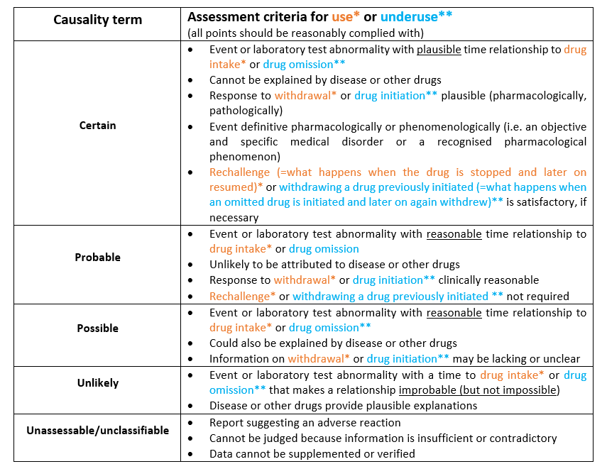

Why causality assessment?

An inherent problem in pharmacovigilance is that most case reports concern suspected adverse drug reactions. Adverse reactions are rarely specific for the drug, diagnostic tests are usually absent and a rechallenge is rarely ethically justified. In practice few adverse reactions are ‘certain’ or ‘unlikely’; most are somewhere in between these extremes, i.e. ‘possible’ or ‘probable’. In an attempt to solve this problem many systems have been developed for a structured and harmonised assessment of causality (1). None of these systems, however, have been shown to produce a precise and reliable quantitative estimation of relationship likelihood. Nevertheless, causality assessment has become a common routine procedure in pharmacovigilance. The advances and limitations of causality assessment are reviewed in Table 1⁽²⁾.

Table 1. Advances and limitations of standardised case causality assessment

What causality assessment can do | What causality assessment cannot do
Decrease disagreement between assessors | Give accurate quantitative measurement of
 | relationship likelihood
Classify relationship likelihood | Distinguish valid from invalid cases
Mark individual case reports | Prove the connection between drug and event
Improvement of scientific evaluation; | Quantify the contribution of a drug to the
educational | development of an adverse event
 | Change uncertainty into certainty

The WHO-UMC causality assessment system

The WHO-UMC system has been developed in consultation with the National Centres participating in the Programme for International Drug Monitoring and is meant as a practical tool for the assessment of case reports. It is basically a combined assessment taking into account the clinical-pharmacological aspects of the case history and the quality of the documentation of the observation. Since pharmacovigilance is particularly concerned with the detection of unknown and unexpected adverse reactions, other criteria such as previous knowledge and statistical chance play a less prominent role in the system. It is recognised that the semantics of the definitions are critical and that individual judgements may therefore differ. There are other algorithms that are either very complex or too specific for general use. This method gives guidance to the general arguments which should be used to select one category over another.

The various causality categories are listed in Table 2. The assessment criteria of the various categories are shown in a point-wise way, as has been developed for practical training during the UMC Training courses.

Table 2. WHO-UMC Causality Categories

Causality term | Assessment criteria*

Certain | • Event or laboratory test abnormality, with plausible time
Certain | relationship to drug intake
 | • Cannot be explained by disease or other drugs
 | • Response to withdrawal plausible (pharmacologically,
 | pathologically)
 | • Event definitive pharmacologically or phenomenologically (i.e. an
 | objective and specific medical disorder or a recognised
 | pharmacological phenomenon)
 | • Rechallenge satisfactory, if necessary
Probable/ | • Event or laboratory test abnormality, with reasonable time
Probable/ | relationship to drug intake
Likely | relationship to drug intake
Likely | • Unlikely to be attributed to disease or other drugs
 | • Response to withdrawal clinically reasonable
 | • Rechallenge not required
Possible | • Event or laboratory test abnormality, with reasonable time
Possible | relationship to drug intake
 | • Could also be explained by disease or other drugs
 | • Information on drug withdrawal may be lacking or unclear
Unlikely | • Event or laboratory test abnormality, with a time to drug intake
Unlikely | that makes a relationship improbable (but not impossible)
 | • Disease or other drugs provide plausible explanations
Conditional/ | • Event or laboratory test abnormality
Conditional/ | • More data for proper assessment needed, or
Unclassified | • More data for proper assessment needed, or
Unclassified | • Additional data under examination
Unassessable/ | • Report suggesting an adverse reaction
Unassessable/ | • Cannot be judged because information is insufficient or
Unclassifiable | • Cannot be judged because information is insufficient or
Unclassifiable | contradictory
 | • Data cannot be supplemented or verified
 | *All points should be reasonably complied with

The use of the WHO-UMC system

To illustrate how the system works, we suggest to first making a comparison of the criteria and wording of ‘Probable’ and Certain’. First of all there is one more criterion in the category ‘Certain’, the fourth: ‘Event definitive pharmacologically or phenomenologically’, i.e. an objective and specific medical disorder or a recognised pharmacological phenomenon (for instance ‘grey baby syndrome’ and chloramphenicol, or anaphylaxis immediately after the administration of a drug that had been given previously). This means that any other event is automatically excluded and can never qualify for ‘Certain’ (even in the case of a positive rechallenge observation). For ‘Certain’, rechallenge information with a satisfactory outcome is requested (i.e. what has happened when the drug was first stopped

and later on resumed), unless the evidence in the report is already convincing without a re-exposure.

For ‘Probable’, on the other hand, a rechallenge is not required. To qualify as ‘Certain’ the interval between the start of the drug and the onset of the event must be ‘plausible’; this means that there is in sufficient detail a positive argument in support of the view that the drug is causally involved, pharmacologically or pathologically. For ‘Probable’ the time relationship should be ‘reasonable’; this is a more neutral term covering everything that is not unreasonable. Also, with regard to the second criterion, ‘alternative causes’, the wording is different in ‘Probable’. For ‘Certain’ the occurrence of the event cannot be explained by any disease the patient is known to have or any other drug taken. For ‘Probable’, on the other hand, the event is ‘unlikely’ to be attributable to another cause. Also the dechallenge situations (i.e. what happened after stopping) are different. In a ‘Certain’ case report, the course of events constitutes a positive argument in favour of holding the suspected drug responsible, in pharmacological or pathological respects, whereas in a ‘Probable’ case it is sufficient if it is ‘clinically reasonable’ (i.e. not unreasonable).

The essential distinctions between ‘Probable’ and ‘Possible’ are that in the latter case there may be another equally likely explanation for the event and/or there is no information or uncertainty with regard to what has happened after stopping.

The criteria that may render the connection ‘Unlikely’ are firstly the time relationship is improbable (with the knowledge at the time), and/or another explanation is more likely. The term ‘Unclassified/Conditional’ is of a preliminary nature and is appropriate when, for a proper assessment, there is more data needed and such data are being sought, or are already under examination. Finally when the information in a report is incomplete or contradictory and cannot be complemented or verified, the verdict is ‘Unclassifiable’.

Since by far the most frequent categories in case reports are ‘Possible’ and ‘Probable’, the usual approach to using the system is to choose one of these categories (depending on the impression of the assessor) and to test if the various criteria fit with the content of the case report. If the report seems stronger one can go one step ‘higher’ (e.g. from ‘Possible’ to ‘Probable’), if the evidence seems weaker one should try a ‘lower’ category. To see if that category is the right one or if it does again not seem to fit, the next adjacent term is tried.

For drug-drug interactions the WHO-UMC system can be used by assessing the actor drug, which influences the kinetics or dynamics of the other drug (which has usually been taken over a longer period), in the medical context of the patient.

How does it work?

How the WHO-UMC causality assessment system can be used will be illustrated with the aid of a few real-life case reports. These will be made available on the UMC website in the near future.
- Meyboom RHB, Royer RJ. Causality Classification in Pharmacovigilance Centres in the European Community. Pharmacoepidemiology and Drug Safety 1992; 1:87-97.

- Meyboom RHB. Causal or Casual? The Role of Causality Assessment in Pharmacovigilance. Drug Safety 17(6): 374-389, 1997.

- Edwards IR, Biriell C. Harmonisation in Pharmacovigilance. Drug Safety 10(2): 93-102, 1994.

Summary description of Causality Assessment

Term | Description | Comment
Certain | A clinical event, including | It is recognized that this stringent definition
 | laboratory test abnormality, | will lead to very few reports meeting the
 | occurring in a plausible time | criteria, but this is useful because of the
 | relationship to drug | special value of such reports. It is considered
 | administration, and which | that time relationships between drug
 | cannot be explained by | administration and the onset and course of
 | concurrent disease or other | the adverse event are important in causality
 | drugs or chemicals. The | analysis. So also is the consideration of
 | response to withdrawal of the | confounding features, but due weight must
 | drug (dechallenge) should be | placed on the known pharmacological and
 | clinically plausible. The event | other characteristics of the drug product
 | must be definitive | being considered. Sometimes the clinical
 | pharmacologically or | phenomena described will also be sufficiently
 | phenomenologically, using a | specific to allow a confident causality
 | satisfactory rechallenge | assessment in the absence of confounding
 | procedure if necessary. | features and with appropriate time
 |  | relationships, e.g. penicillin anaphylaxis.
Probable/ Likely | A clinical event, including | This definition has less stringent wording than
 | laboratory test abnormality, | for "certain" and does not necessitate prior
 | with a reasonable time | knowledge of drug characteristics or clinical
 | sequence to administration of | adverse reaction phenomena. As stated no
 | the drug, unlikely to be | rechallenge information is needed, but
 | attributed to concurrent | confounding drug administration underlying
 | disease or other drugs or | disease must be absent.
 | chemicals, and which follows
 | a clinically reasonable
 | response on withdrawal
 | (dechallenge). Rechallenge
 | information is not required to
 | fulfil this definition.

 | Possible |  | A clinical event, including |  | This is the definition to be used when drug
 |  |  | laboratory test abnormality, |  | causality is one of other possible causes for
 |  |  | with a reasonable time |  | the described clinical event.
 |  |  | sequence to administration of
 |  |  | the drug, but which could also
 |  |  | be explained by concurrent
 |  |  | disease or other drugs or
 |  |  | chemicals. Information on
 |  |  | drug withdrawal may be
 |  |  | lacking or unclear.
 | Unlikely |  | A clinical event, including |  | This definition is intended to be used when
 |  |  | laboratory test abnormality, |  | the exclusion of drug causality of a clinical
 |  |  | with a temporal relationship to |  | event seems most plausible.
 |  |  | drug administration which
 |  |  | makes a causal relationship
 |  |  | improbable, and in which
 |  |  | other drugs, chemicals or underlying disease provide plausible explanations
Conditional/ |  | A clinical event, including
Unclassified |  | laboratory test abnormality,
 |  | reported as an adverse
 |  | reaction, about which more
 |  | data is essential for a proper
 |  | assessment or the additional
 |  | data are under examination.
Unassessible/ |  | A report suggesting an
Unclassifiable |  | adverse reaction which cannot
 |  | be judged because
 |  | information is insufficient or
 |  | contradictory, and which
 |  | cannot be supplemented or
 |  | verified.

HALLAS CRITERIA FOR ASSESSMENT OF ADE CONTRIBUTION TO HOSPITAL ADMISSION
1. Was the ADE listed as one of the primary reasons for admission?
- NO | - YES: Consider as a DRA (main reason)

Select YES if the ADE was the primary cause of admission and no other diseases or symptoms contributed significantly to the admission. This is considered as a DRA.
If NO, proceed to question 2.
2. Did the ADE worsen the reason for admission?
- Definitely/probably/more than likely NO: | - Definitely/probably/more than likely YES: Consider as a DRA (contributory reason)

Select YES if the ADE played definitely/probably/more than likely a substantial role in admission but other factors also contributed significantly.
If definitely/probably/more than likely NO, proceed to question 3.

3. Without occurrence of the ADE, would the patient have been admitted to hospital?
- Definitely/probably/more than likely YES:  Don’t consider as a DRA | - Definitely/probably/more than likely NO: Consider as a DRA

Select YES if the ADE played a minor or uncertain role and the patient would definitely/probably/more than likely have been admitted without occurrence of the ADE and other symptoms or circumstances were the reason for hospitalisation. This ADE shouldn’t be considered as a DRA.
Select NO if without occurrence of the ADE, the patient would definitely/probably/more than likely not have been admitted and consider this as a DRA.
- SCREENING FOR POTENTIAL ADVERSE DRUG EVENTS
9.4 Appendix 4: DRA case report form

Reviewers: Date: DD/MM/YY
DRA CASE REPORT FORM
- Identify potential ADE related to the main or contributory reason for admission using the trigger tool (Appendix 1)
Trigger | Description of the potential ADE  (potential ADE 1, 2, 3, 4 …) | Medication involved or omitted (ATC-code) | Evidence for potential ADE  (e.g. medication adjustment, lab values, documentation) | Other conditions that could have contributed to the event
☐Fall and/or fracture
☐Confusion/delirium
☐Acute renal impairment
☐Dehydration
☐Bleeding
☐Stroke
☐Thromboembolic event (DVT/PE)
☐(Recurrent) myocardial infarction or ischaemic disease
☐Heart failure exacerbation
☐COPD exacerbation

☐Uncontrolled (non-neuropathic) pain
☐Gastro-intestinal disorders (severe diarrhoea, vomiting)
☐Major constipation or faecal impaction
- Identify potential ADE related to the main or contributory reason for admission using the trigger tool (Appendix 1)
Trigger | Description of the potential ADE  (potential ADE 1, 2, 3, 4 …) | Medication involved or omitted | Evidence for potential ADE  (e.g. medication adjustment, lab values, documentation) | Other conditions that could have contributed to the event
☐INR > 5
☐Digoxin level > 2ng/ml
☐Hypoglycaemia
(BG < 4 mmol/L or 72 mg/dl)
☐Hyperglycaemia
(BG > 11 mmol/L or 198 mg/dl)
☐Hyperkalaemia
(K⁺> 5.5 mmol/L)
( K⁺ 5.5 mmol/L)
☐Hypokalaemia
(K⁺ < 3mmol/L)
(K⁺ < 3 mmol/L)
☐Hyponatraemia
(Na⁺ < 130 mmol/L)
(Na⁺ < 130 mmol/L)
☐WBC < 3000/mm³
☐Platelet count < 50 000/mm³
☐Neutrophils < 1.4 g/L
☐Antidote use or treatment that suggest a potential ADE
☐Mention of a (potential) ADE in the medical record
☐Abrupt medication stop within 24h of admission

- Identify potential ADE related to the main or contributory reason for admission using the screening questions (Appendix 1)
Non-triggered potential ADE | Description of the potential ADE | Medication involved or omitted | Evidence for potential ADE (e.g. medication adjustment, lab values, documentation) | Other conditions that could have contributed to the event
☐Adverse drug reaction (ADR)
Overuse
☐Drug without an indication
☐Too long duration of therapy
☐Therapeutic duplication
Underuse
☐Omission of indicated drug
☐Too short duration of therapy
☐Adherence concerns

Misuse
☐Wrong drug
☐Wrong dose (sub-or supratherapeutic)
☐Inappropriate monitoring
☐Clinically significant interactions
☐Inappropriate discontinuation (dose decrease/withdrawal) leading to withdrawal symptoms or disease exacerbation
☐Other (error in dispensing, preparation, administration)

- ADJUDICATION
- ADE causality assessment (potential ADE = confirmed ADE?) using WHO causality criteria in Appendix 2
Potential ADE 1:………………… | Potential ADE 2:………………… | Potential ADE 3:………………… | Potential ADE 4:………………… | Potential ADE 5:…………………
☐Certain  ☐Probable  ☐Possible  ☐Unlikely  ☐Unassessable | ☐Certain  ☐Probable  ☐Possible  ☐Unlikely  ☐Unassessable | ☐Certain  ☐Probable  ☐Possible  ☐Unlikely  ☐Unassessable | ☐Certain  ☐Probable  ☐Possible  ☐Unlikely  ☐Unassessable | ☐Certain  ☐Probable  ☐Possible  ☐Unlikely  ☐Unassessable

- Contribution of confirmed ADE to hospital admission (confirmed ADE = DRA?) using questions in Appendix 3
Did ADE 1 (if possible/probable/certain causal relationship) cause admission?  ☐Yes  ☐No | Did ADE 2 (if possible/probable/certain causal relationship) cause admission?  ☐Yes  ☐No |  | Did ADE 3 (if possible/probable/certain causal relationship) cause admission?  ☐Yes  ☐No |  | Did ADE 4 (if possible/probable/certain causal relationship) cause admission?  ☐Yes  ☐No |  | Did ADE 5 (if possible/probable/certain causal relationship) cause admission?  ☐Yes  ☐No
☐DRA = main reason: the ADE(s) was/were the main reason for admission; no other diseases or symptoms contributed significantly to the admission
☐DRA = contributory reason: the ADE(s) worsened the reason for admission or played a substantial role in the admission but other factors also contributed significantly
☐NO DRA: The ADE(s) played an uncertain or minor role in the admission and other symptoms or circumstances were the reason for admission
Description DRA (free text)
List of medications involved/omitted by importance |  | ☐Drug 1 |  | ☐Drug 2 |  | ☐Drug 3 |  | ☐Drug 4
Abbreviations: ADR = Adverse Drug Reaction, ADE = Adverse Drug Event, DRA = Drug-Related Admission, ME = Medication Error

vnkfvn

ADJUDICATION RULES
**The adjudication rules have been developed in agreement with all adjudication teams following a reliability study. These rules should be adhered to in order to minimise subjectivity and to ensure standardised adjudications of similar types of ADE or DRA. Additional rules might be developed during the OPERAM trial.
- Rule 1: Non-triggered event – Infection & chronic corticosteroid use
Consider admission for infection in a patient taking chronic systemic corticosteroids (at a dose of ≥ 10 mg prednisone or equivalent) or other immunosuppressive drugs as an ADE and DRA, at least as a very significant contributory reason for admission.
- Rule 2: Contributory reason for admission
Adhere to the Hallas criteria used in the adjudication guide; ADE that are contributory reasons for admission are also considered as DRA. A contributory reason for admission is any clinically significant contributory factor i.e. an event that worsened the main reason for admission or played a substantial role in the admission but other factors also contributed significantly.
E.g. a patient is admitted for urosepsis with associated hyperkalaemia and acute kidney injury (AKI). If the patient was taking also potassium tablets and a diuretic, these are two potential ADE (hyperkalaemia + potassium tablets; AKI + diuretic) that could have worsened the main reason for admission and this is therefore a DRA (contributory reason).
- Rule 3: Suspected adherence issues
Suspected adherence issues should be considered as underuse if either adherences issues are explicitly mentioned in the medical record or if the results from the Morisky (MMAS-8) questionnaire indicate low adherence (MMAS-8 score = 3-8).
- Rule 4: Underuse of statins
In patients > 85 years old or at the end-of-life (or with a heavy burden of multimorbidity and therefore short life expectancy), admission for an acute coronary syndrome or stroke with no statins in the medication history should not be considered as underuse, given limited evidence of benefit of statins above the age of 85. This is also specified in the trigger tool.

- Rule 5: Heart failure exacerbation & underuse
Example: a patient is admitted with heart failure exacerbation and was taking diuretics, ACE-inhibitors and β-blockers before admission and the MMAS-8 scale indicated that he was adherent. The patient was thus treated appropriately before admission but the dose of his diuretics and β-blocker was increased at discharge. An exacerbation of a chronic condition (with/without treatment modification at discharge) can in theory always be blamed on underuse but this is not correct. Therefore when adjudicating, always take into account underlying diseases and use the WHO UMC causality criteria to distinguish between disease-related or drug-related causes.

FREQUENTLY ASKED QUESTIONS
Why should I only include triggers up to 48 hours of admission?
Only triggers and potential ADE detected up to 48h of admission should be included for review, because only ADE that caused hospitalisation (and not any ADE occurring during hospitalisation) are of interest.
An example: a trigger hypoglycaemia that occurred on day 5 of admission is very unlikely to be the reason for admission and thus a DRA. Whereas a trigger hypoglycaemia on day 1 of admission could represent a DRA. Likewise, a diagnosis such as a COPD exacerbation that occurred on day 3 of admission unlikely represents a DRA, whereas COPD exacerbation as the admission diagnosis on day 1 could represent a DRA. The 48h cut-off is set to limit the number of irrelevant data to be reviewed.
What is the difference between a trigger and an ADE? For instance, when the INR > 5 in a patient on VKA, but there is no bleeding or any physical complication, is this considered as a positive trigger? What about glucose < 4 mmol/L but no clinical manifestation of hypoglycaemia?
ADE are defined as harm resulting from the use of a drug. The aim of the trigger tool is to screen for ADE that are potential DRA. If the patient has a high INR, but there is no bleeding, the trigger INR >5 is positive and should be recorded, but there is no harm and thus no ADE and DRA.
The same applies to a patient with a blood glucose level < 4 mmol/L. This is a positive trigger but some patients may have no symptoms at all. There is no injury in this case, so no ADE. Whereas if the patient experiences dizziness, syncope or glucose was administered, this would be considered as harm and a potential ADE.
The key for using a trigger tool is to screen for potential ADE. However, all potential ADE/positive triggers (=event AND a potential causative drug or cause of drug underuse) should be coded in the eCRF, regardless whether there is an ADE/DRA or not. This is very important to allow the determination of the predictive validity of the trigger tool.
What is the difference between a triggered and a non-triggered ADE?
During screening, you first use the trigger tool to screen for a potential ADE, this is a triggered event (e.g. hip fracture and use of medications that increase the risk of fall). Secondly, you use the screening questions to look for spontaneously detected potential ADE or non-triggered events (e.g. admission for infection and use of immunosuppressants).
When we developed the trigger tool, we selected the most common causes for DRA in older persons. However this is not a complete list. Therefore screening questions for non-triggered events may help in the detection of non-triggered ADE. As for the trigger tool, keep in mind that you are looking for non-triggered events that are related to the main or contributory reason for admission.
What is the difference between ADE causality assessment and assessment of ADE contribution to hospital admission?
ADE causality assessment is done for all potential ADE detected in the screening step (triggered or non-triggered) to evaluate whether the potential ADE is a confirmed ADE (possible, probable or certain causal relationship) and thus due to the drug rather than other conditions. Causality assessment is done using the WHO UMC criteria.
Assessment of ADE contribution to hospital admission is performed only when you found one or more confirmed ADE and this step evaluates whether the (group of) ADE(s) also was the main or contributory reason for admission and thus a DRA. Assessment of ADE contribution to admission is done using the Hallas criteria.
I found two potential ADE caused by the same drug, is this one or two potential ADE?
Two different potential ADE (or two different triggers) caused by the same drug, should be counted as two potential ADE e.g. a benzodiazepine causing a fall and confusion = 2 potential ADE.
What if there is one potential ADE that can be caused by two drugs, is it one or two potential ADE?
One potential ADE caused by multiple drugs should be counted as one ADE e.g. hip fracture attributed to a benzodiazepine, SSRI and underuse of vitamin D = 1 potential ADE.
What if there is more than one confirmed ADE? Should I perform assessment of ADE contribution to hospitalisation using the Hallas criteria for each separate ADE or for all ADE as a whole?
We believe that you should take into account all ADE as a whole when evaluating whether ADE where the main or contributory reason for admission. Sometimes it might be the whole ‘cocktail’ of ADE that contributed to hospitalisation, in complex multimorbidity cases. But in the case report form we ask you to determine the most likely drug involved.
I found a potential ADE caused by multiple drugs, should I perform causality assessment using the WHO UMC criteria for each individual drug or for the whole group of drugs?
If a potential ADE is caused by more than 1 drug (e.g. fall + benzodiazepine + an opiate + a drug causing orthostatic hypotension), causality should be assessed for the group of drugs and not for each drug individually.
However if you found another potential ADE (e.g. bleeding + anticoagulants), you should run another causality assessment for this potential ADE the “unit” of adjudication is thus per potential ADE.
Is a fall during admission a valid trigger?
Triggered and non-triggered events that occur up to 48h hours of admission are included in screening. However a fall during admission might be an ADE, but not a DRA. DRA are defined as hospitalisations because of an ADE and the fall should thus have occurred before hospitalisation.
Do hematomas fall under the trigger bleeding?
No, we only consider major bleeding and clinically relevant non-major bleeding as a positive trigger. The definitions are provided in the trigger tool.

