SUPPLEMENTARY RESULTS
Table S1. MRM parameters, regression equations, linearity (R²), limits of detection (LOD), limits of quantification (LOQ), and linear ranges for anthocyanin and polyphenol standards used for quantification and semi-quantification.
Reference Compound | Precursor | Production | Regression Equation | R² | Linear range | SNR | LOD* | LOQ†
Reference Compound | m/z | m/z | Regression Equation | R² | µg · mL⁻¹ | SNR | µg · mL⁻¹ | µg · mL⁻¹
Petunidin-3-rhamnoside | 479 | 317 | y = 1.630 × 10⁶x + 3539.7 | 0.9991 | 0─20 | 9276.1 | 9.70×10⁻⁶ | 0.02
Malvidin-3-glucoside | 493 | 331 | y = 2.473 × 10⁶x + 56989.6 | 0.9988 | 0─20 | 6538.2 | 1.38×10⁻⁵ | 0.23
Cyanidin-3-glucoside | 449 | 287 | y = 3.109 × 10⁶x + 457146.8 | 0.9996 | 0─20 | 1850 | 4.86×10⁻⁵ | 1.47
Pelargonidin-3-glucoside | 433 | 271 | y = 2.814 × 10⁶x + 7609.3 | 0.9974 | 0─20 | 7330.4 | 1.23×10⁻⁵ | 0.03
Rutin | 609 | 300 | y = 1.502 × 105x + 0 | 0.9924 | 0.01─5 | 58.8 | 5.10×10⁻⁵ | 0.01
Chlorogenic acid | 353 | 191 | y = 1.498 × 10⁵x + 283.9 | 0.9919 | 0.05─5 | 41.3 | 7.26×10⁻⁴ | 0.02
*LOD has been calculated using the lowest concentration on linear range (C) as (SNR/C) × 3.
† LOQ has been calculated as Interception^{xy}/Slope × 10.

Table S2 Physicochemical parameters in berry kefirs prepared from strawberry, blueberry, and blackberry, and in water kefir (control), before fermentation (J, juice); after fermentation with kefir grains (K) at 21 ± 1 °C for 48 h: and after refrigeration storage (RK) at 4 ± 1 °C for 7 days.
Parameters | Water |  |  | Strawberry |  |  | Blueberry |  |  | Blackberry
Parameters | J | K | RK | J | K | RK | J | K | RK | J | K | RK
pH | 5.2^{z} ± 0.1 | 3.6 ± 0.1* | 3.5 ± 0.1* | 3.6 ± 0.1 | 3.5 ± 0.0 | 3.6 ± 0.1 | 3.9 ± 0.1 | 3.4 ± 0.1* | 3.4 ± 0.0* | 3.4 ± 0.0 | 3.3 ± 0.0* | 3.4 ± 0.0#
TSS | 4.2 ± 0.3 | 4.2 ± 0.3 | 3.3 ± 0.5 | 7.0 ± 0.0 | 2.6 ± 0.1* | 2.5 ± 0.0* | 14.6 ± 0.2 | 11.8 ± 0.3* | 9.3 ± 0.5*# | 10.7 ± 0.3 | 6.9 ± 0.1* | 5.3 ± 0.3*#
L* | 43.7 ± 0.3 | 44.3 ± 0.6 | 44.6 ± 0.4 | 24.4 ± 0.3 | 26.1 ± 0.3* | 33.7 ± 1.5*# | 28.8 ± 0.4 | 26.5 ± 1.0* | 28.4 ± 1.7 | 22.3 ± 1.0 | 22.4 ± 0.6 | 24.2 ± 0.1#
h˚ | 178.48 ± 0.01 | 178.48 ± 0.02 | 178.49 ± 0.01 | 0.27 ± 0.01 | 0.46 ± 0.03* | 0.57 ± 0.04* | 0.31 ± 0.01 | 0.35 ± 0.01* | 0.27 ± 0.05 | 359.92 ± 0.01 | 359.85 ± 0.04 | 359.77 ± 0.05
C* | 10.5 ± 0.6 | 10.2 ± 0.6 | 9.6 ± 0.6 | 7.7 ± 0.2 | 8.9 ± 0.5 | 17.9 ± 2.5*# | 16.7 ± 0.2 | 9.5 ± 0.9* | 8.8 ± 1.6* | 3.7 ± 0.1 | 3.7 ± 0.5 | 3.3 ± 0.3
^{z} Means (n = 3 ± SEM). TSS: Total soluble solids; L* (lightness). Hue angle (h˚) = arctan (b*/a*). Chromaticity (C*) = (a*² + b*²)^{0.5}. Asterisks (*) denote significant differences (t-test; p < 0.05) with respect to the corresponding berry juice, while hash symbols (#) indicate significant differences between fermented beverage and refrigerated fermented beverage.

Table S3. Total anthocyanins, phenolic acids, flavonoids, and total sum of all the quantified phytochemicals in berry kefirs prepared from strawberry, blueberry, and blackberry, before fermentation (J, juice); after fermentation with kefir grains (K) at 21 ± 1 °C for 48 h; and after refrigeration storage (RK) at 4 ± 1 °C for 7 days.
Phytochemicals (μg/100 mL) | Fruits | J | K | RK
Total  anthocyanin | Strawberry | 2540.15^{z} ± 322.72 | 1829.91 ± 232.52 | 1041.66 ± 62.65
Total  anthocyanin | Blueberry | 615.89 ± 37.89 | 500.01 ± 4.54 | 459.42 ± 23.34
Total  anthocyanin | Blackberry | 2850.61 ± 93.27 | 1520.02 ± 86.48 | 996.09 ± 40.05
Total  phenolic acids | Strawberry | 4.42 ± 0.32 | 3.17 ± 0.28 | 1.47 ± 0.24
Total  phenolic acids | Blueberry | 3211.60 ± 212.49 | 2712.54 ± 104.75 | 2594.78 ± 85.92
Total  phenolic acids | Blackberry | 29.93 ± 1.81 | 28.29 ± 0.39 | 28.70 ± 0.47
Total flavonoids | Strawberry | ND | ND | ND
Total flavonoids | Blueberry | ND | ND | ND
Total flavonoids | Blackberry | 272.12 ± 9.77 | 140.62 ± 7.18 | 91.38 ± 3.70
Total polyphenols | Strawberry | 2544.90 ± 322.73 | 1833.08 ± 1.83 | 1043.13 ± 1.57
Total polyphenols | Blueberry | 3827.49 ± 250.36 | 3212.55 ± 106.09 | 3054.20 ± 88.19
Total polyphenols | Blackberry | 3152.67 ± 104.61 | 1688.94 ± 93.47 | 1116.17 ± 43.37
^{z}Means ± SEM (n = 3). ND: Not detected.

Table S4. Individual anthocyanins, phenolic acids, and flavonoids in berry kefirs prepared from strawberry, blueberry, and blackberry, before fermentation (J, juice); after fermentation with kefir grains (K) at 21 ± 1 °C for 48 h; and after refrigeration storage (RK) at 4 ± 1 °C for 7 days.

Phytochemicals  (μg/100 mL) | Strawberry
Phytochemicals  (μg/100 mL) | J | K | RK
Pe-3,7-diglu | 1.69^{z} ± 0.98 | 153.36 ± 15.82 | 125.60 ± 1.08
Pe-3-glu | 2475.41 ± 314.09ª | 1595.01 ± 208.20^{b} | 848.25 ± 4.77^{c}
Pe-3-rha-5-glu | 48.25 ± 8.08 | 73.38 ± 7.20 | 61.11 ± 0.46
5-car-pyr-Pe-3-gpy | 5.83 ± 1.61 | 16.30 ± 1.04 | 5.58 ± 0.03
Pe-3-(6-aceglu) | 0.49 ± 0.23 | 1.86 ± 0.32 | 1.12 ± 0.01
Cou-Hex | 4.31 ± 0.32 | 3.04 ± 0.28 | 1.35 ± 0.02
 | Blueberry
 | J | K | RK
Mv-ara 2 | 99.71 ± 13.14 | 73.43 ± 1.25 | 75.06 ± 0.77
Del-glu 1 | 104.73 ± 12.70 | 82.65 ± 4.48 | 81.14 ± 0.54
Mv-gal | 265.01 ± 8.35 | 217.76 ± 1.39 | 188.35 ± 0.68
Mv-ara 1 | 96.17 ± 3.93 | 75.32 ± 0.84 | 64.13 ± 0.44
Del-glu 2 | 39.05 ± 0.03 | 39.10 ± 0.15 | 39.01 ± 0.02
Cy-glu | 11.23 ± 0.24 | 11.75 ± 0.28 | 11.72 ± 0.02
ChlA | 3211.60 ± 212.49ª | 2712.54 ± 104.75^{b} | 2594.78 ± 8.59^{b}
 | Blackberry
 | J | K | RK
Cy-7-glu | 2788.03 ± 92.18ª | 1460.19 ± 80.88^{b} | 943.01 ± 3.88^{c}
Cy-3-ara | 47.73 ± 1.09 | 39.23 ± 3.89 | 32.42 ± 0.13
Cy-3-(6-maloglu) | 14.85 ± 0.18 | 20.61 ± 2.05 | 20.66 ± 0.03
Cou-hex | 11.73 ± 1.02 | 9.81 ± 0.55 | 10.07 ± 0.04
ChlA | 2.16 ± 0.41 | 3.26 ± 0.94 | 3.43 ± 0.09
Caf-hex | 16.05 ± 0.41 | 15.22 ± 0.09 | 15.20 ± 0.01
Tax-3-glu | 37.35 ± 1.05 | 21.15 ± 1.03 | 15.80 ± 0.06
Kam-3-glu | 234.77 ± 8.76ª | 119.47 ± 6.16^{b} | 75.58 ± 0.31^{b}
^{z}Means ± SEM (n = 3). Abbreviations: Pelargonidin (Pe), cyanidin (Cy), delphinidin (Del), malvidin (Mv), kaempferol (Kam), taxifolin (Tax), chlorogenic acid (ChlA), p-coumaroyl (Cou), caffeoyl hexoside (CafHex); glucoside (glu), rhamnoside (rha), galactoside (gal), arabinoside (ara), hexoside (Hex), acetyl (ace), malonyl (mal), diglu (diglucoside), gpy (glucopyranoside), and 5-car-pyr (pyruvyl or carboxypyranoyl group). Different letters denote significant differences (two-way ANOVA, Bonferroni p < 0.05).

Table S5. Pearson correlation (r) values among the main physicochemical parameters, total phytochemical compounds, and sensory parameters achieved of refrigerated fruit kefirs (strawberry, blueberry, and blackberry).

Parameters | TPC | Flavonoids | Lactic acid | Anthocyanins | Acetic acid | Aroma | Colour | Sugars | FRAP | Chroma | Organic acids | Phenolic acids | Flavour | Acceptability
TPC | 1.000 | 0.865 | 0.914 | 0.807 | 0.210 | 0.061 | 0.382 | 0.081 | -0.399 | -0.362 | -0.347 | -0.851 | -0.774 | -0.753
Flavonoids | 0.865 | 1.000 | 0.967 | 0.433 | -0.095 | 0.164 | 0.264 | 0.532 | 0.108 | -0.767 | -0.756 | -0.490 | -0.660 | -0.601
Lactic acid | 0.914 | 0.967 | 1.000 | 0.547 | 0.000 | 0.269 | 0.418 | 0.422 | 0.000 | -0.651 | -0.664 | -0.604 | -0.620 | -0.572
Anthocyanins | 0.807 | 0.433 | 0.547 | 1.000 | 0.426 | -0.203 | 0.284 | -0.401 | -0.825 | 0.221 | 0.227 | -0.969 | -0.715 | -0.738
Acetic acid | 0.210 | -0.095 | 0.000 | 0.426 | 1.000 | -0.223 | -0.064 | -0.384 | -0.520 | 0.373 | 0.523 | -0.397 | -0.235 | -0.324
Aroma | 0.061 | 0.164 | 0.269 | -0.203 | -0.223 | 1.000 | 0.858 | 0.254 | 0.267 | -0.197 | -0.420 | 0.123 | 0.565 | 0.598
Colour | 0.382 | 0.264 | 0.418 | 0.284 | -0.064 | 0.858 | 1.000 | -0.075 | -0.211 | 0.000 | -0.207 | -0.347 | 0.258 | 0.283
Sugars | 0.081 | 0.532 | 0.422 | -0.401 | -0.384 | 0.254 | -0.075 | 1.000 | 0.833 | -0.843 | -0.869 | 0.431 | 0.000 | 0.073
FRAP | -0.399 | 0.108 | 0.000 | -0.825 | -0.520 | 0.267 | -0.211 | 0.833 | 1.000 | -0.682 | -0.695 | 0.808 | 0.388 | 0.449
Chroma | -0.362 | -0.767 | -0.651 | 0.221 | 0.373 | -0.197 | 0.000 | -0.843 | -0.682 | 1.000 | 0.935 | -0.137 | 0.289 | 0.220
Organic acids | -0.347 | -0.756 | -0.664 | 0.227 | 0.523 | -0.420 | -0.207 | -0.869 | -0.695 | 0.935 | 1.000 | -0.163 | 0.129 | 0.000
Phenolic acids | -0.851 | -0.490 | -0.604 | -0.969 | -0.397 | 0.123 | -0.347 | 0.431 | 0.808 | -0.137 | -0.163 | 1.000 | 0.718 | 0.741
Flavour | -0.774 | -0.660 | -0.620 | -0.715 | -0.235 | 0.565 | 0.258 | 0.000 | 0.388 | 0.289 | 0.129 | 0.718 | 1.000 | 0.992
Acceptability | -0.753 | -0.601 | -0.572 | -0.738 | -0.324 | 0.598 | 0.283 | 0.073 | 0.449 | 0.220 | 0.000 | 0.741 | 0.992 | 1.000
Abbreviations: TPC, total phenolic content; FRAP, ferric reducing antioxidant power; Chroma, colour intensity parameter.

Table S6. Benjamini-Hochberg adjusted p-values derived from Pearson correlation analyses among the main physicochemical parameters, total phytochemical compounds, and sensory attributes of refrigerated strawberry, blueberry, and blackberry kefirs.

Parameter | TPC | Flavonols | Lactic acid | Anthocyanins | Acetic acid | Chroma | Organic acids |  | Phenolic acids | Flavour | Acceptability | Aroma | Colour | Sugars | FRAP
TPC | NA | 0.034 | 0.010 | 0.056 | 0.749 | 0.580 | 0.596 |  | 0.037 | 0.087 | 0.097 | 0.928 | 0.554 | 0.923 | 0.549
Flavonols | 0.034 | NA | 0.001 | 0.531 | 0.908 | 0.090 | 0.097 |  | 0.432 | 0.185 | 0.260 | 0.808 | 0.723 | 0.365 | 0.889
Lactic acid | 0.010 | 0.001 | NA | 0.342 | 0.940 | 0.195 | 0.185 |  | 0.260 | 0.243 | 0.306 | 0.723 | 0.531 | 0.531 | 0.940
Anthocyanins | 0.056 | 0.531 | 0.342 | NA | 0.531 | 0.749 | 0.749 |  | 0.001 | 0.125 | 0.106 | 0.749 | 0.709 | 0.549 | 0.047
Acetic acid | 0.749 | 0.908 | 0.940 | 0.531 | NA | 0.566 | 0.372 |  | 0.549 | 0.749 | 0.643 | 0.749 | 0.928 | 0.554 | 0.372
Chroma | 0.580 | 0.090 | 0.195 | 0.749 | 0.566 | NA | 0.005 |  | 0.856 | 0.709 | 0.749 | 0.753 | 0.940 | 0.040 | 0.162
Organic acids | 0.596 | 0.097 | 0.185 | 0.749 | 0.372 | 0.005 | NA |  | 0.808 | 0.864 | 0.940 | 0.531 | 0.749 | 0.034 | 0.150
Phenolic acids | 0.037 | 0.432 | 0.260 | 0.001 | 0.549 | 0.856 | 0.808 |  | NA | 0.125 | 0.106 | 0.866 | 0.596 | 0.531 | 0.056
Flavour | 0.087 | 0.185 | 0.243 | 0.125 | 0.749 | 0.709 | 0.864 |  | 0.125 | NA | 0.000 | 0.310 | 0.724 | 0.993 | 0.554
Acceptability | 0.097 | 0.260 | 0.306 | 0.106 | 0.643 | 0.749 | 0.940 |  | 0.106 | 0.000 | NA | 0.260 | 0.709 | 0.923 | 0.526
Aroma | 0.928 | 0.808 | 0.723 | 0.749 | 0.749 | 0.753 | 0.531 |  | 0.866 | 0.310 | 0.260 | NA | 0.035 | 0.724 | 0.723
Colour | 0.554 | 0.723 | 0.531 | 0.709 | 0.928 | 0.940 | 0.749 |  | 0.596 | 0.724 | 0.709 | 0.035 | NA | 0.923 | 0.749
Sugars | 0.923 | 0.365 | 0.531 | 0.549 | 0.554 | 0.040 | 0.034 |  | 0.531 | 0.993 | 0.923 | 0.724 | 0.923 | NA | 0.044
FRAP | 0.549 | 0.889 | 0.940 | 0.047 | 0.372 | 0.162 | 0.150 |  | 0.056 | 0.554 | 0.526 | 0.723 | 0.749 | 0.044 | NA
Abbreviations: TPC, total phenolic content; FRAP, ferric reducing antioxidant power; Chroma, colour intensity parameter. Significant correlations (p < 0.05) are shown in bold.

Table S7. Debiased Sparse Partial Correlation analysis showing degree and betweenness values of the main parameters as nodes within the kefir system.
Parameter | Degree | Betweenness
TPC | 5 | 6.67
Anthocyanins | 5 | 5.83
FRAP | 4 | 3.67
Phenolic acids | 4 | 3.33
Chroma | 3 | 2
Sugars | 3 | 0.5
Flavour | 3 | 0
Acceptability | 3 | 0
Lactic acid | 2 | 2

Degree cutoff: 2; Betweenness cutoff: 1; Adjust p-value < 0.05.
TPC, total phenolic content; FRAP, ferric reducing antioxidant power; Chroma, colour intensity parameter.

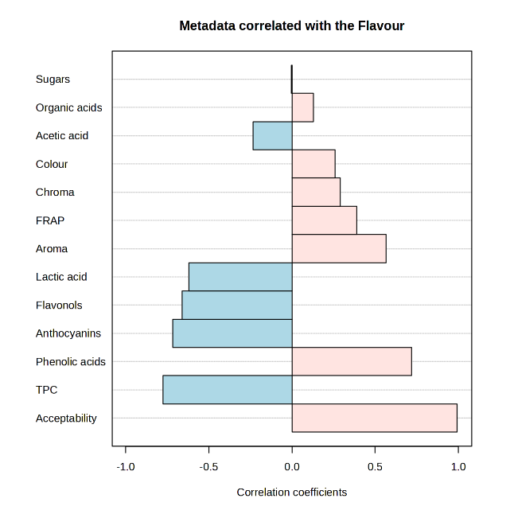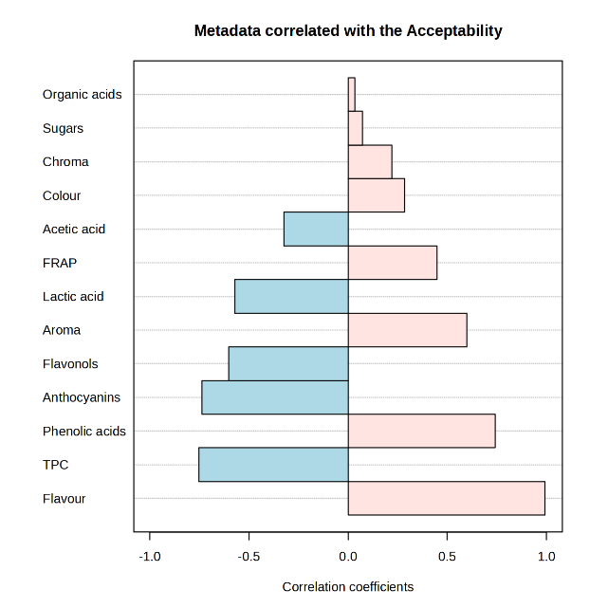
Figure S1. Pearson correlation (r) values between flavour and acceptability and the main physicochemical, phytochemical, and sensory parameters of refrigerated fruit kefirs (strawberry, blueberry, and blackberry).

Figure S2. Cell viability of HCT116-Dual cells assessed with the Sytox-Green probe. Optimisation assay evaluating different sample concentrations (5, 10, and 20%) of berry juices (J), berry kefirs (K), and refrigerated berry kefirs (RK) after 48 h of exposure. Water kefir was included as a fermentation control, and lysis buffer was used as a positive control for reduced cell viability.

