Table S1: Excluded studies

Study | Reason for exclusion
¹ | no ART restorations
² | no CT restorations
³ | not on older adults
⁴ | not on older adults
⁵ | not on older adults
⁶ | not on older adults
⁷ | no RCT
⁸ | same population as in ⁹ (which was included)

a)
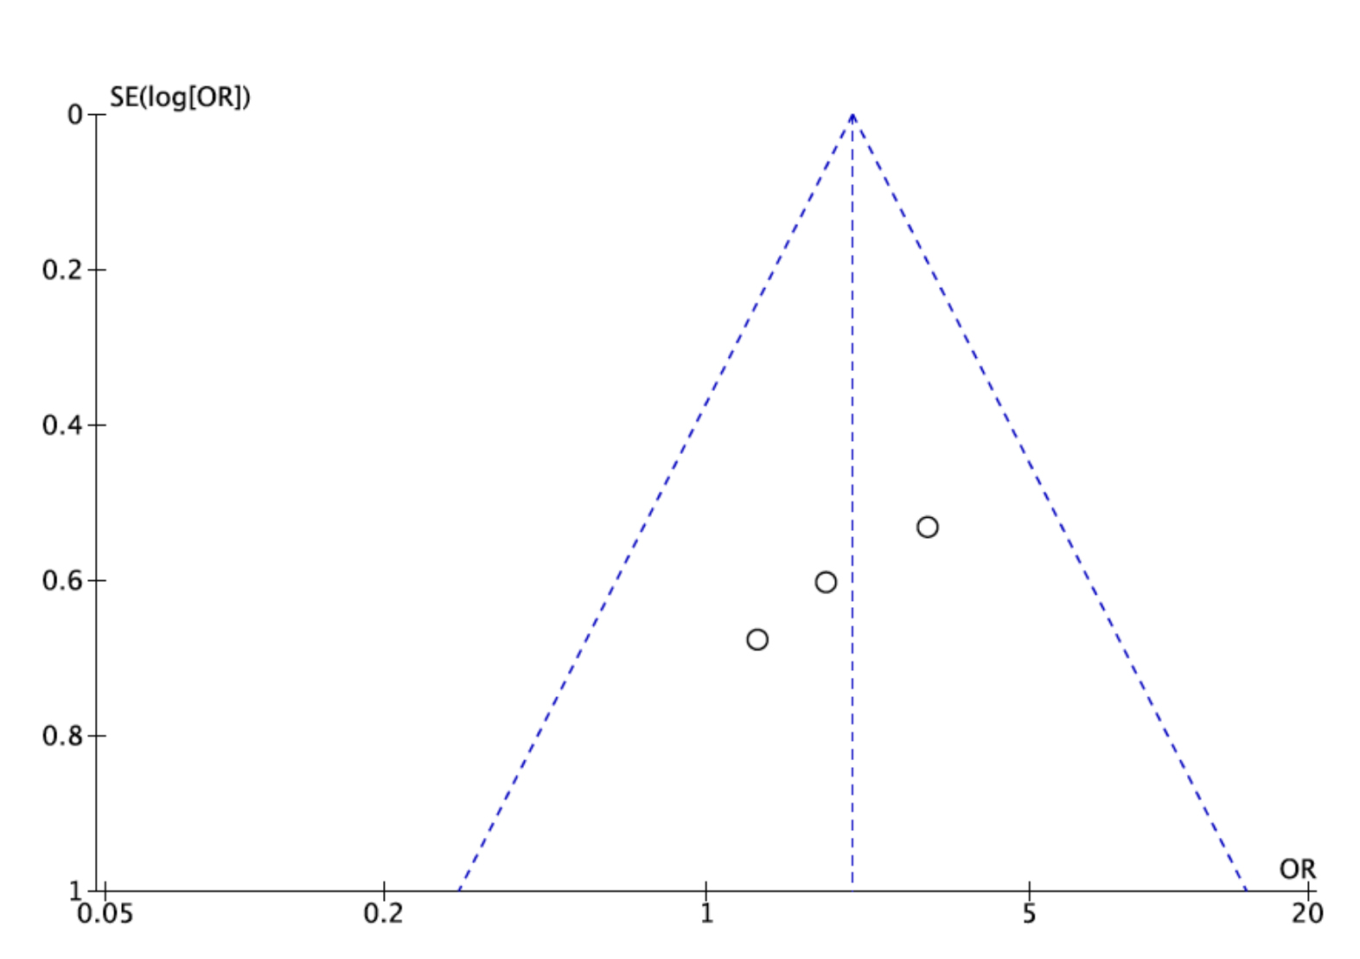
b)
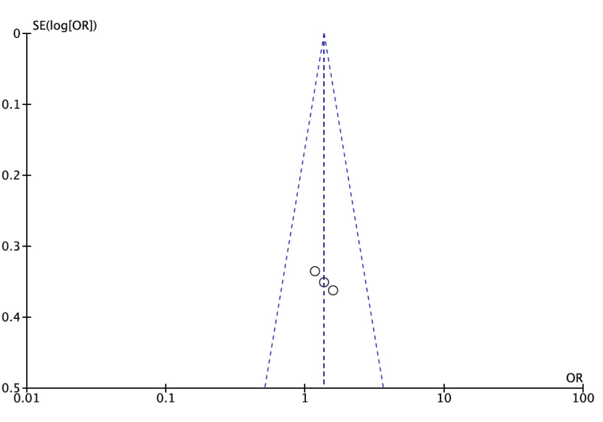

Figure S1: Funnel-plots for the meta-analysis of (a) per-protocol and (b) intention-to-treat scenario.

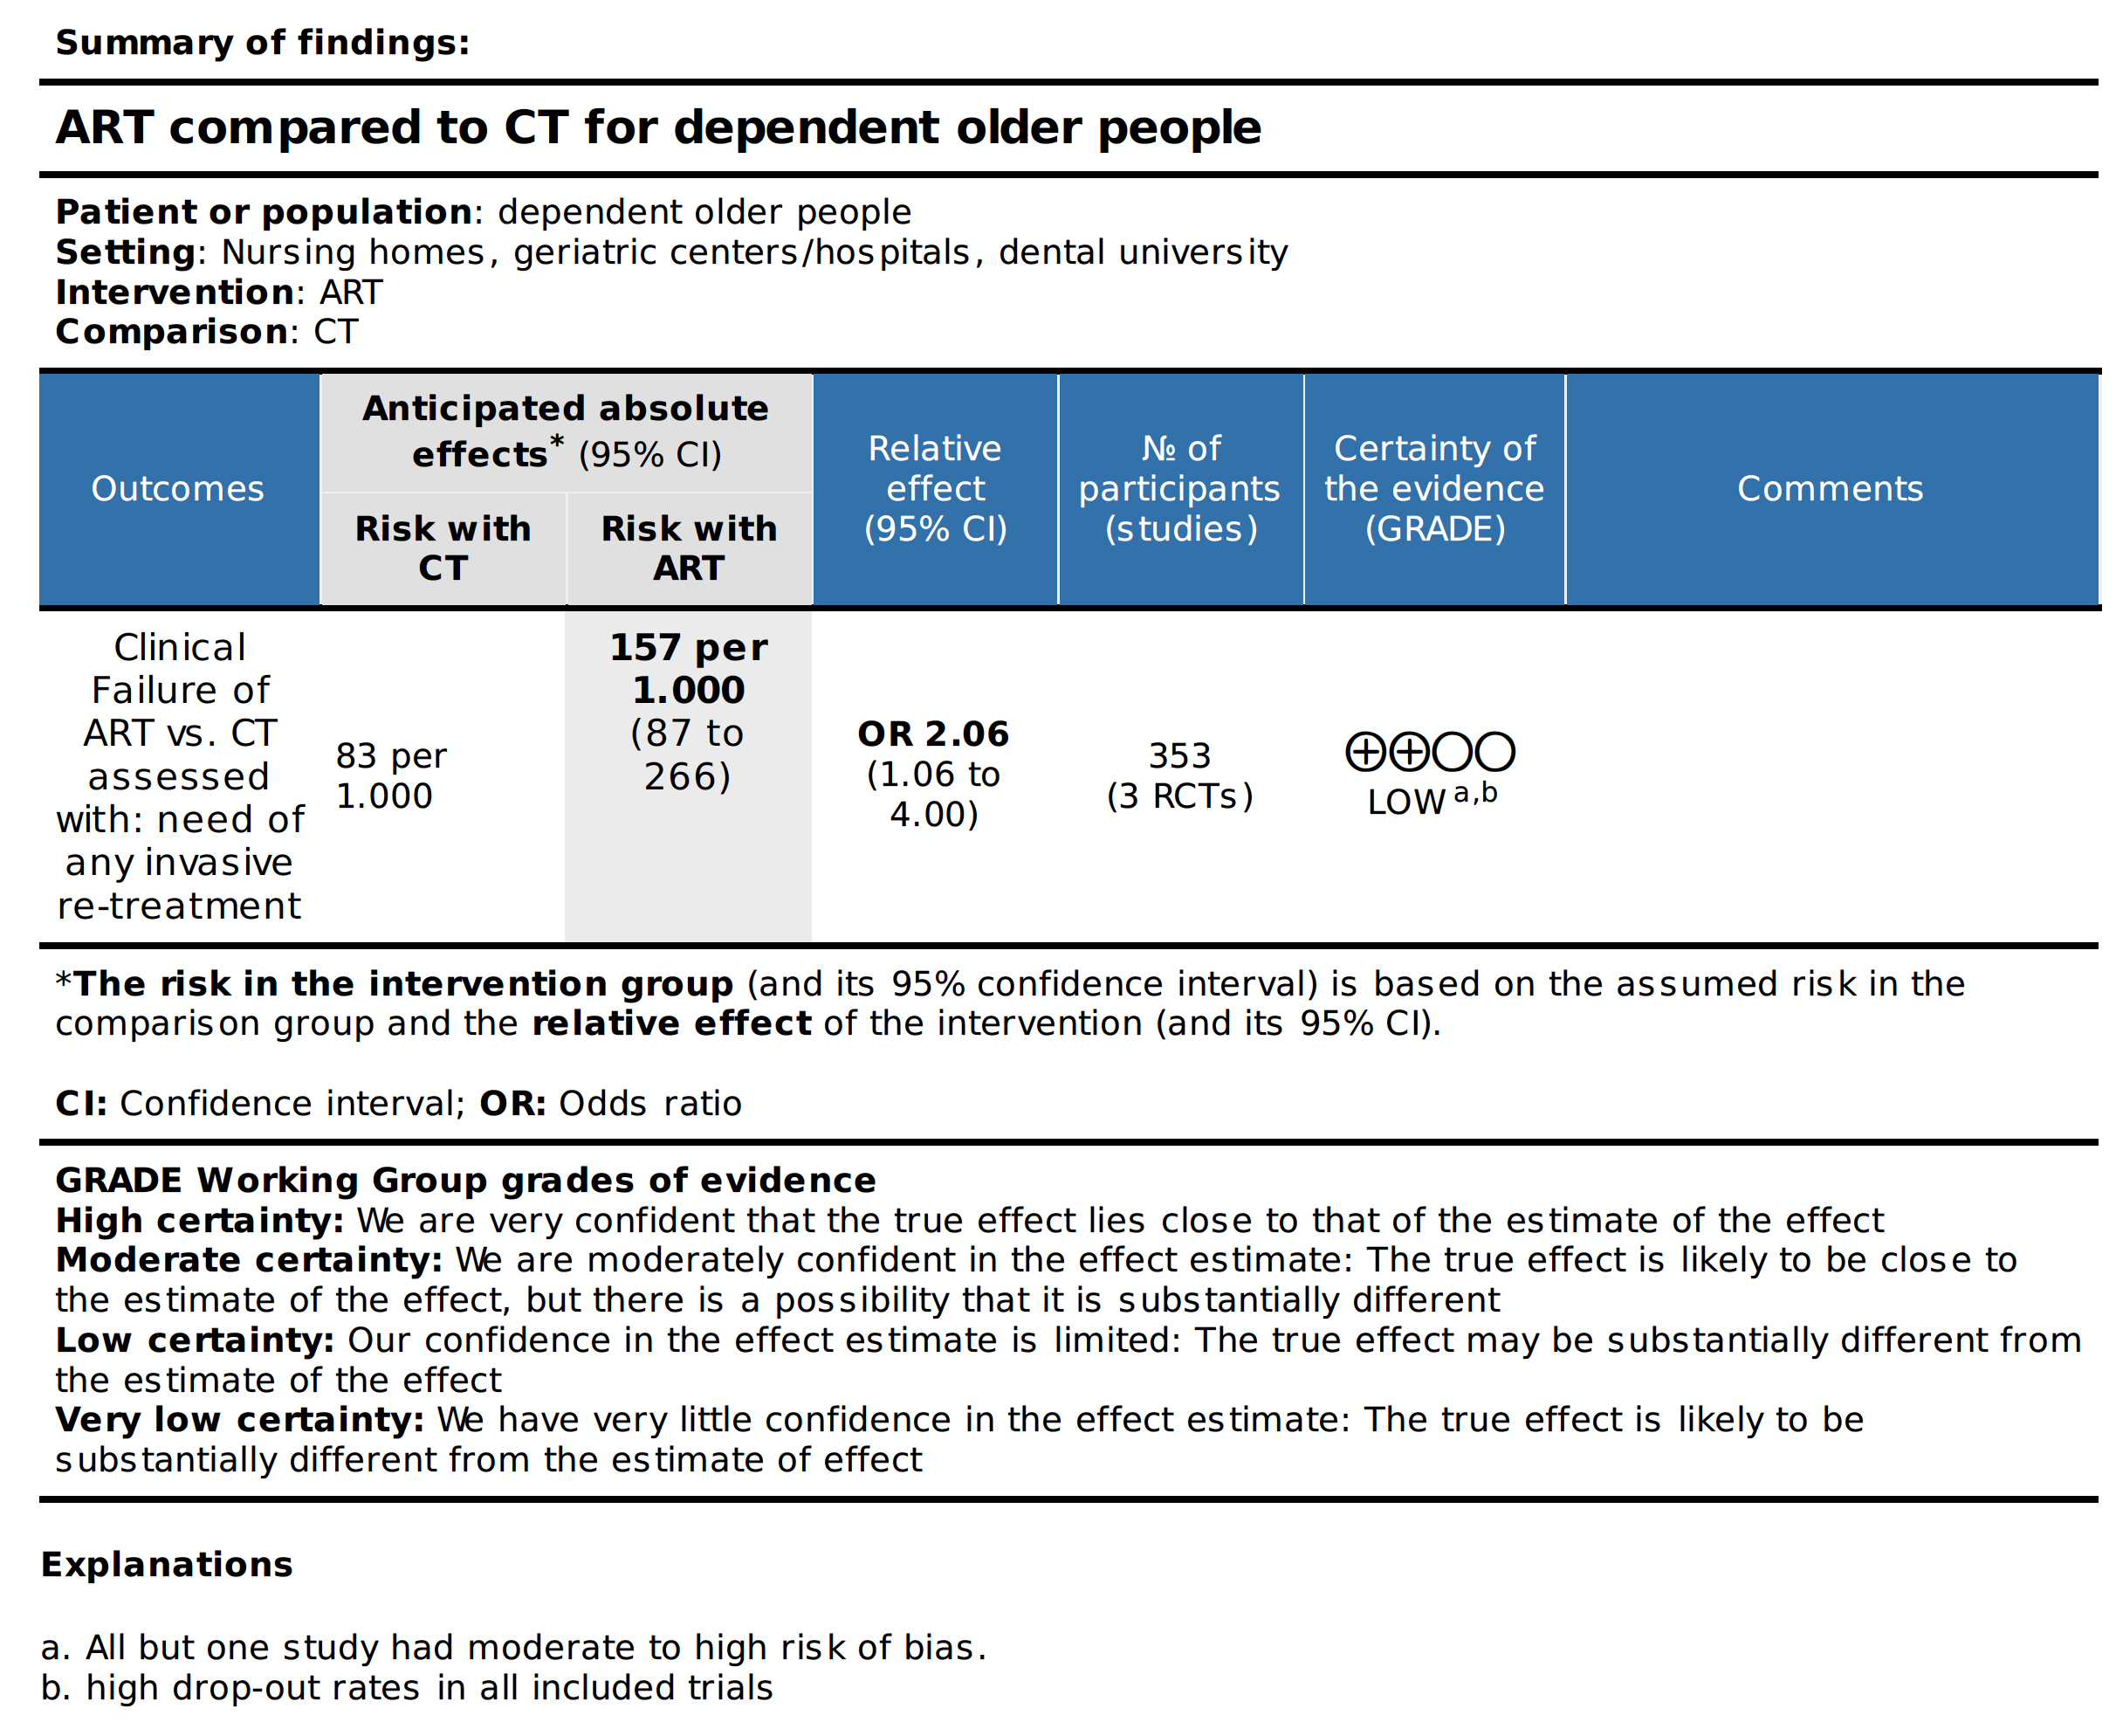
Figure S2: Summary of findings according to the GRADE assessment tool.

References
1. Levy SM, Jensen ME. A clinical evaluation of the restoration of root surface caries. Special care in dentistry : official publication of the American Association of Hospital Dentists, the Academy of Dentistry for the Handicapped, and the American Society for Geriatric Dentistry. Sep-Oct 1990;10(5):156-160.
2. Gil-Montoya JA, Mateos-Palacios R, Bravo M, Gonzalez-Moles MA, Pulgar R. Atraumatic restorative treatment and Carisolv use for root caries in the elderly: 2-year follow-up randomized clinical trial. Clinical oral investigations. May 2014;18(4):1089-1095.
3. Hu JY, Chen XC, Li YQ, Smales RJ, Yip KH. Radiation-induced root surface caries restored with glass-ionomer cement placed in conventional and ART cavity preparations: results at two years. Australian dental journal. Sep 2005;50(3):186-190.
4. De Moor RJ, Stassen IG, van 't Veldt Y, Torbeyns D, Hommez GM. Two-year clinical performance of glass ionomer and resin composite restorations in xerostomic head- and neck-irradiated cancer patients. Clinical oral investigations. Feb 2011;15(1):31-38.
5. McComb D, Erickson RL, Maxymiw WG, Wood RE. A clinical comparison of glass ionomer, resin-modified glass ionomer and resin composite restorations in the treatment of cervical caries in xerostomic head and neck radiation patients. Operative dentistry. Sep-Oct 2002;27(5):430-437.
6. Wood RE, Maxymiw WG, McComb D. A clinical comparison of glass ionomer (polyalkenoate) and silver amalgam restorations in the treatment of Class 5 caries in xerostomic head and neck cancer patients. Operative dentistry. May-Jun 1993;18(3):94-102.
7. Honkala S, Honkala E. Atraumatic dental treatment among Finnish elderly persons. Journal of oral rehabilitation. May 2002;29(5):435-440.
8. da Mata C, Allen PF, Cronin M, O'Mahony D, McKenna G, Woods N. Cost-effectiveness of ART restorations in elderly adults: a randomized clinical trial. Community dentistry and oral epidemiology. Feb 2014;42(1):79-87.
9. da Mata C, Allen PF, McKenna G, Cronin M, O'Mahony D, Woods N. Two-year survival of ART restorations placed in elderly patients: A randomised controlled clinical trial. Journal of dentistry. Apr 2015;43(4):405-411.

