Managing root caries with silver diamine fluoride, sodium fluoride and direct restorations: A cost-effectiveness analysis
Shijia Hu¹, Catherine Hsu Ling Hong¹, Xiaoli Gao^{1,2}, Hwee Lin Wee², Yi Wang², Bien Wen Pui Lai³, Shenna Yu-En Ho³, Patrick Finbarr Allen^{1,4}, Sharon Hui Xuan Tan^{1,2}
¹ Faculty of Dentistry, National University of Singapore, Singapore
² Saw Swee Hock School of Public Health, National University of Singapore, Singapore
³ National Dental Centre Singapore, Singapore
⁴ Restorative Dentistry, University of Cork, Ireland

Supplementary Figures and Tables

Supplementary Table S1: Deterministic sensitivity analysis
 |  |  |  | Caries |  |  |  | Extraction
 |  |  |  | Restoration vs SDF  Base ICER: -436 |  | NaF vs SDF  Base ICER: -71 |  | Restoration vs SDF  Base ICER: -371 |  | NaF vs SDF  Base ICER: -195
Parameter | Base case | LL | UL | LL_ICER | UL_ICER | LL_ICER | UL_ICER | LL_ICER | UL_ICER | LL_ICER | UL_ICER
teeth | 19 | 9.5 | 28.5 | -436 | -436 | -71 | -71 | -371 |  | -195 | -195
baseline caries prevalence | 0.3800 | 0.16 | 0.663 | -259 | -4686 | -68 | -73 | -425 | -318 | -220 | -174
probability of extraction | 0.0880 | 0.055 | 0.121 | -667 | -326 | -82 | -61 | -584 | -274 | -320 | -138
probability of caries arrest (SDF) | 0.61 | 0.305 | 0.915 | -111 | -14 | -73 | -70 | -240 | -57 | -208 | -192
probability of caries arrest (NaF) | 0.11 | 0.055 | 0.74 | -436 | -436 | -70 | -113 | -371 | -371 | -191 | 4804
probability of caries arrest (RMGIC) | 0.8750 | 0.773 | 0.977 | 289 | -226 | -71 | -70 | -643 | -318 | -200 | -190
baseline caries incidence | 0.1825 | 0.1322 | 0.2328 | -472 | -427 | -71 | -70 | -371 | -367 | -193 | -194
probability of caries prevented (SDF) | 0.6835 | 0.542 | 0.8251 | -203 | 330 | -71 | -70 | -352 | -407 | -187 | -204
probability of caries prevented (NaF) | 0.2886 | 0.14431067 | 0.43293201 | -436 | -436 | -70 | -70 | -371 | -371 | -196 | -195
cost of review | 55.00 | 25 |  | -436 |  | -71 |  | -371 |  | -195
cost of RMGIC | 120.00 | 60 | 250 | -376 | -564 | -31 | -156 | -320 | -481 | -86 | -432
cost of extraction | 100.00 | 40 | 200 | -430 | -445 | -67 | -77 | -366 | -379 | -184 | -213
cost of NaF | 6.40 |  | 52 |  | -436 |  | -127 |  | -371 |  | -350
cost of SDF | 4.80 |  | 6 |  | -512 |  | -65 |  | -436 |  | -179
blue--> favours traditional restorations (lower cost and more effective)
orange --> favours SDF (lower cost and more effective)
white --> restorations lower cost but less effective
green --> SDF lower cost but less effective

Supplementary Figure S1: Cost effectiveness acceptability curve (clinic-based model) for caries free tooth years
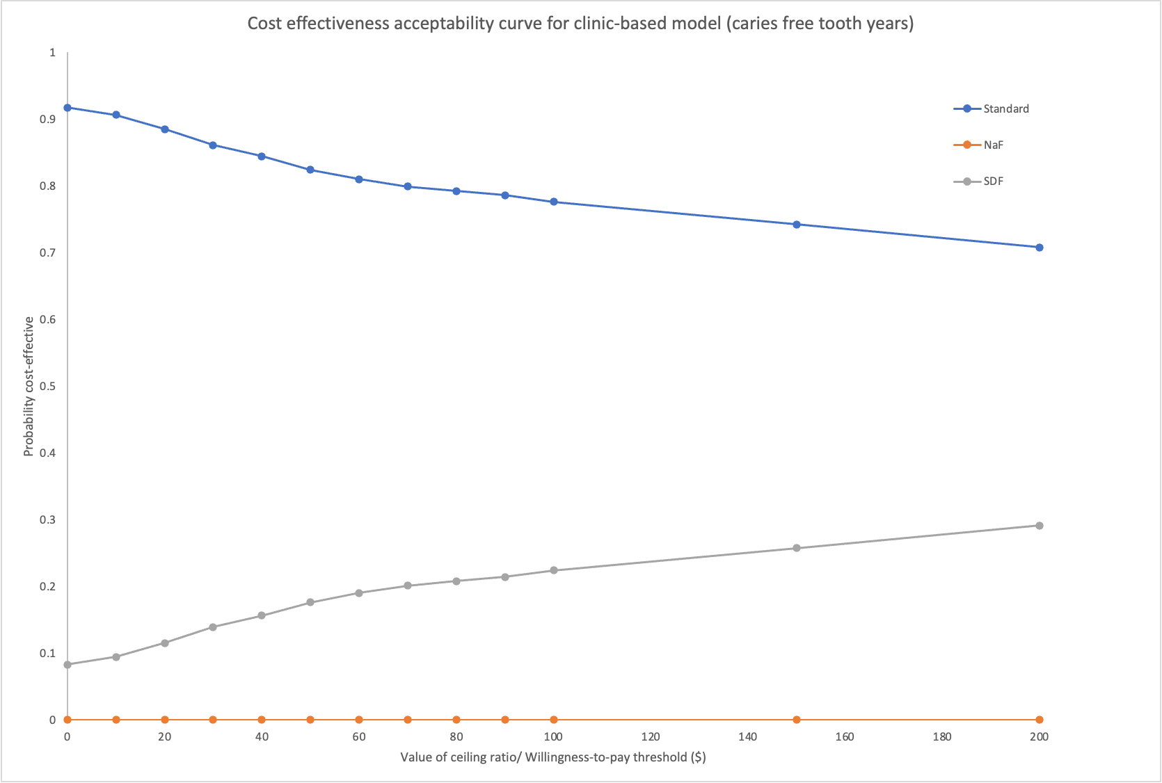
Supplementary Figure S2: Cost effectiveness acceptability curve (clinic-based model) for extraction free tooth years
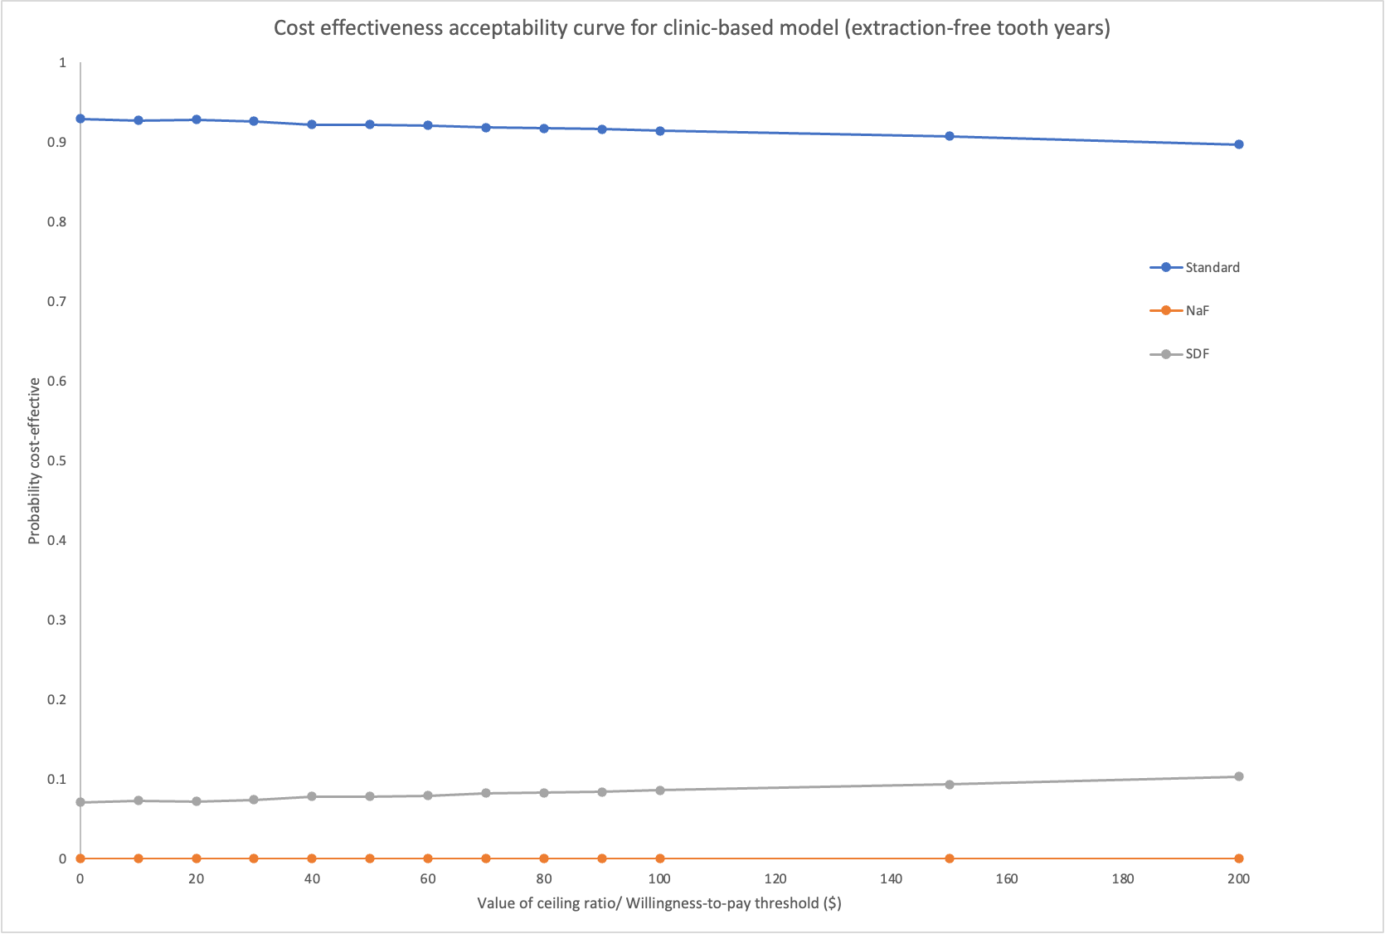
Supplementary Figure S3: Cost effectiveness acceptability curve (community-based model) for caries free tooth years
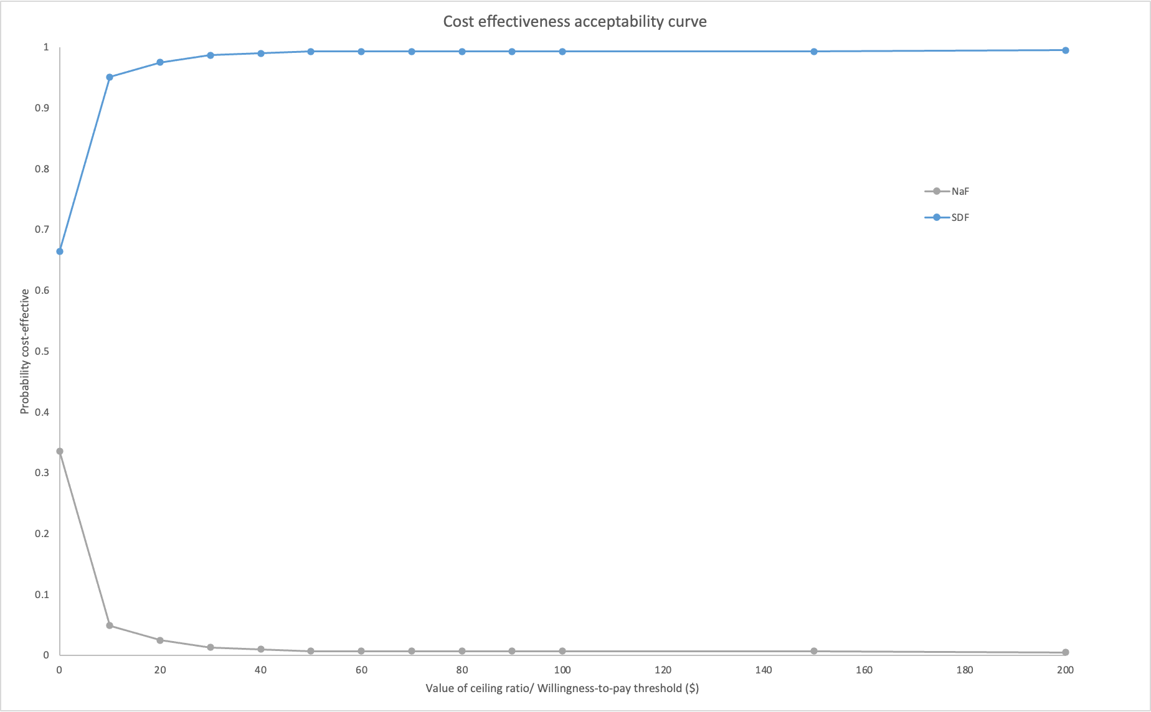

Supplementary Figure S4: Cost effectiveness acceptability curve (community-based model) for caries free tooth years
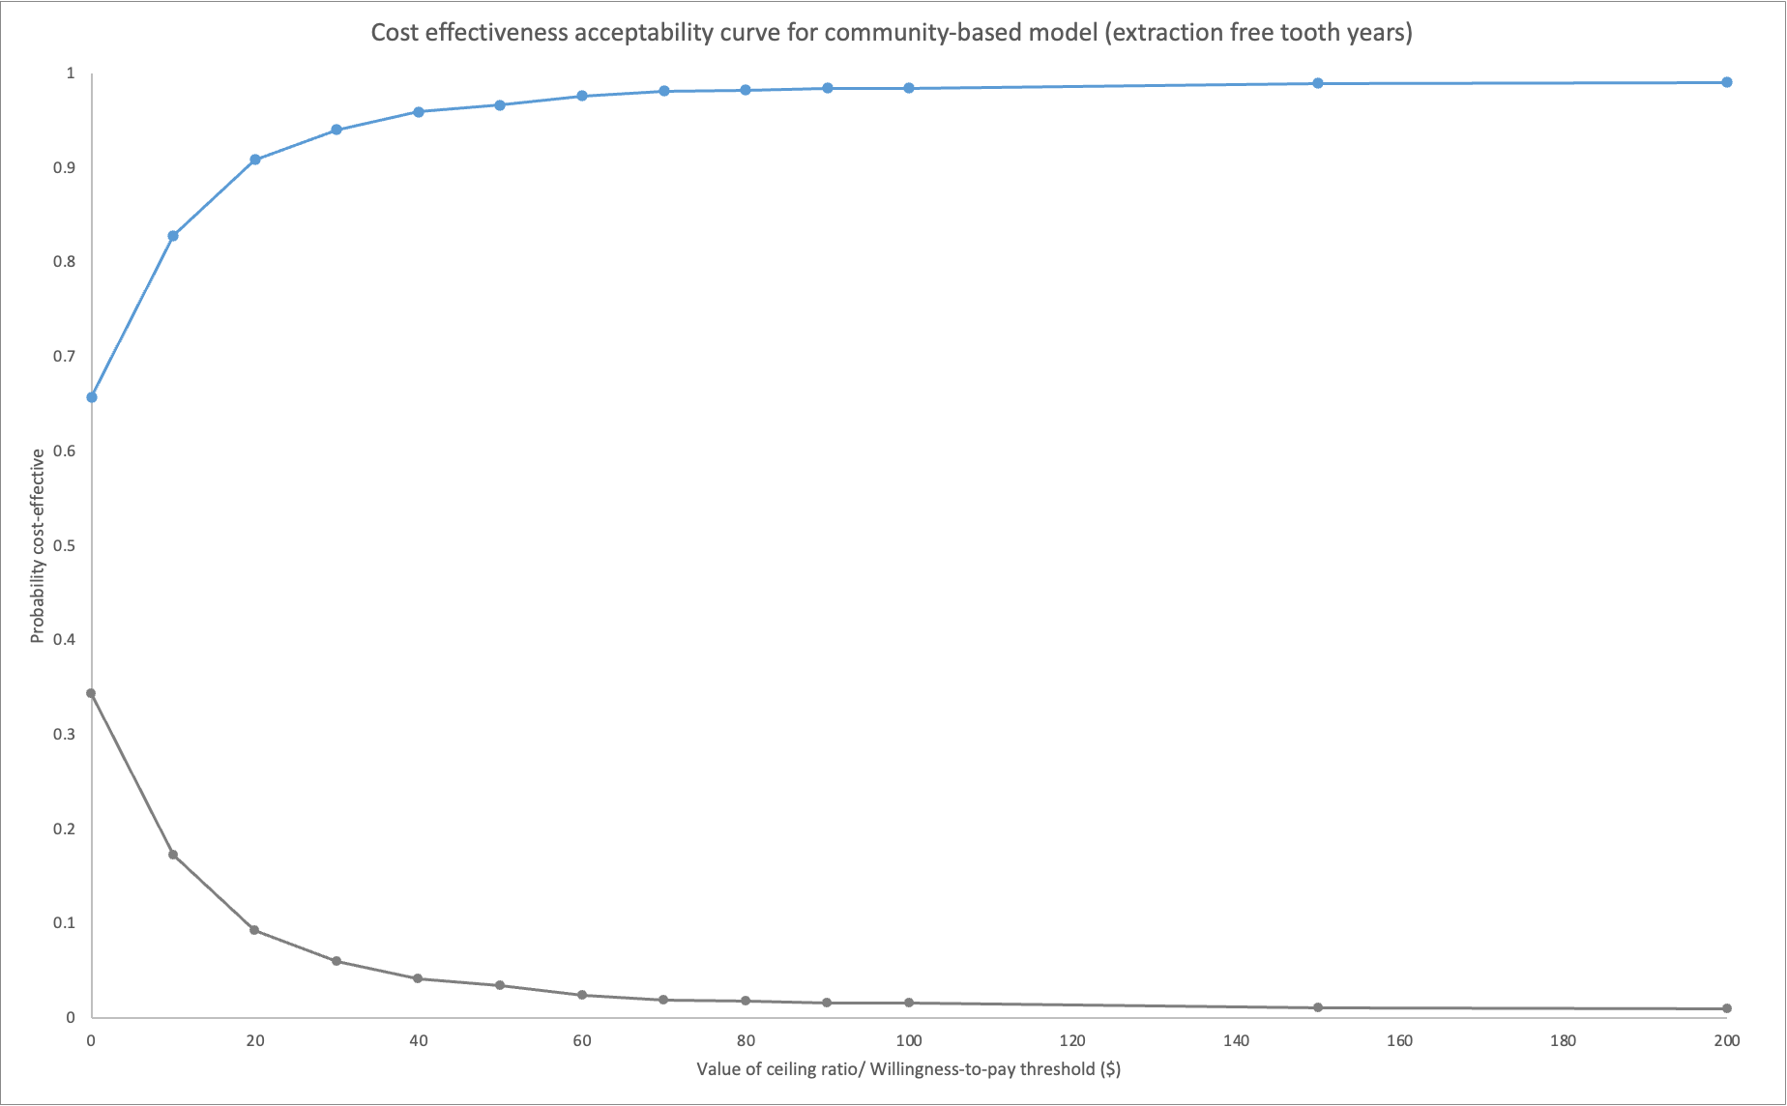

Supplementary Figure S5: Scatterplot (clinic model) for caries free tooth years
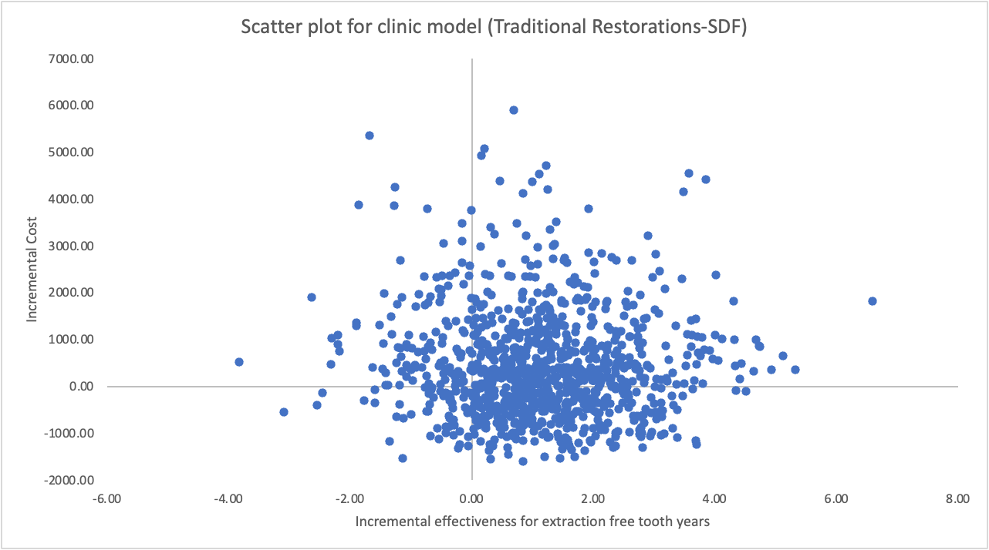
Supplementary Figure S6: Scatterplot (clinic model) for extraction free tooth years

Supplementary Figure S7: Scatterplot (community-based model) for caries free tooth years
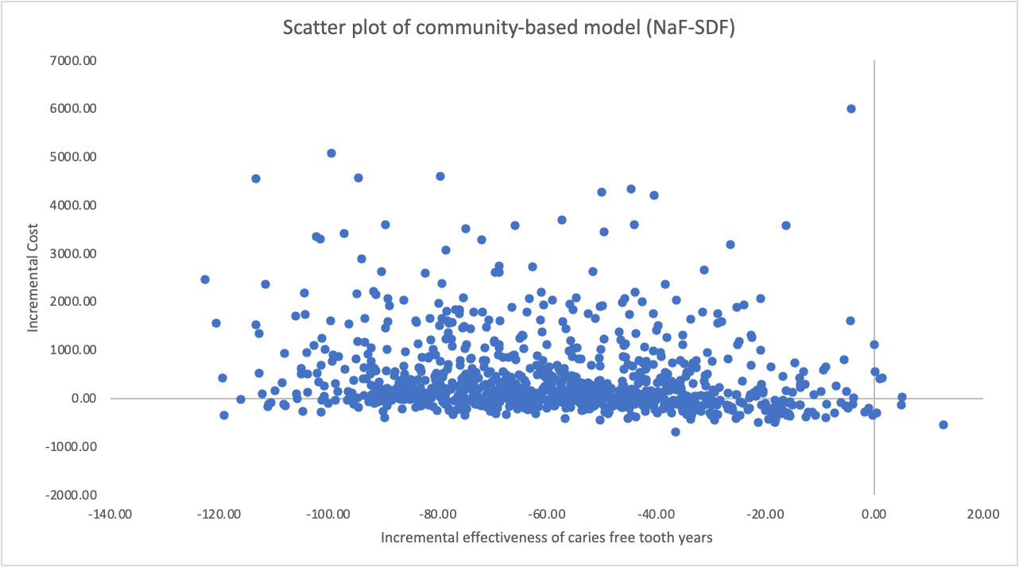

Supplementary Figure S8: Scatterplot (community-based model) for extraction free tooth years
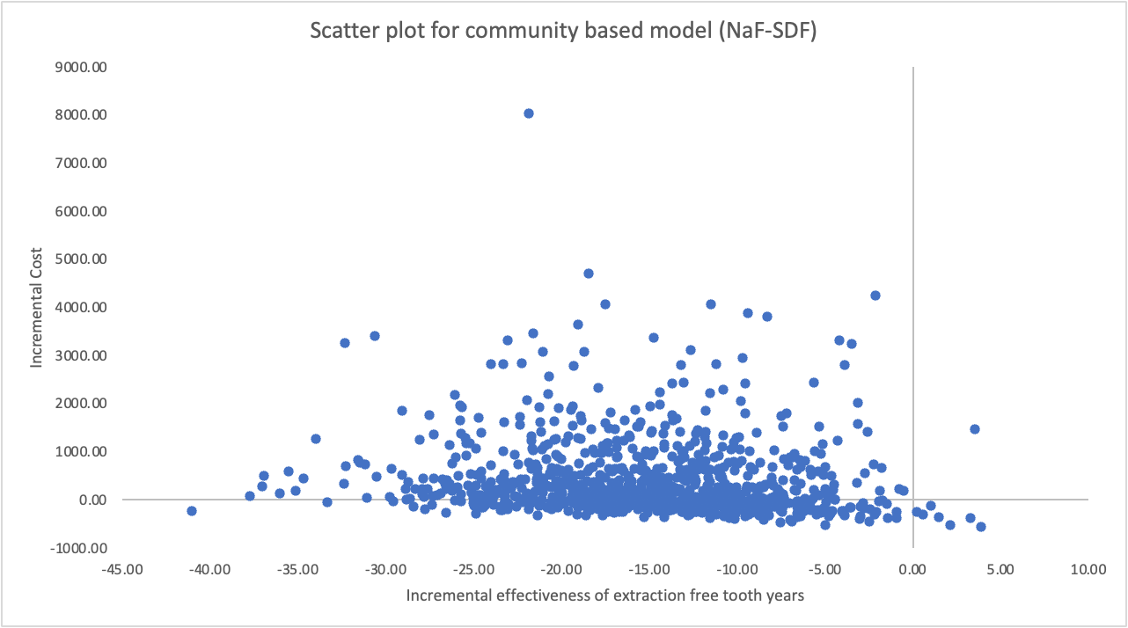

Supplementary Figure S9: Population EVPI as a function of WTP (clinic model, for caries free tooth years)
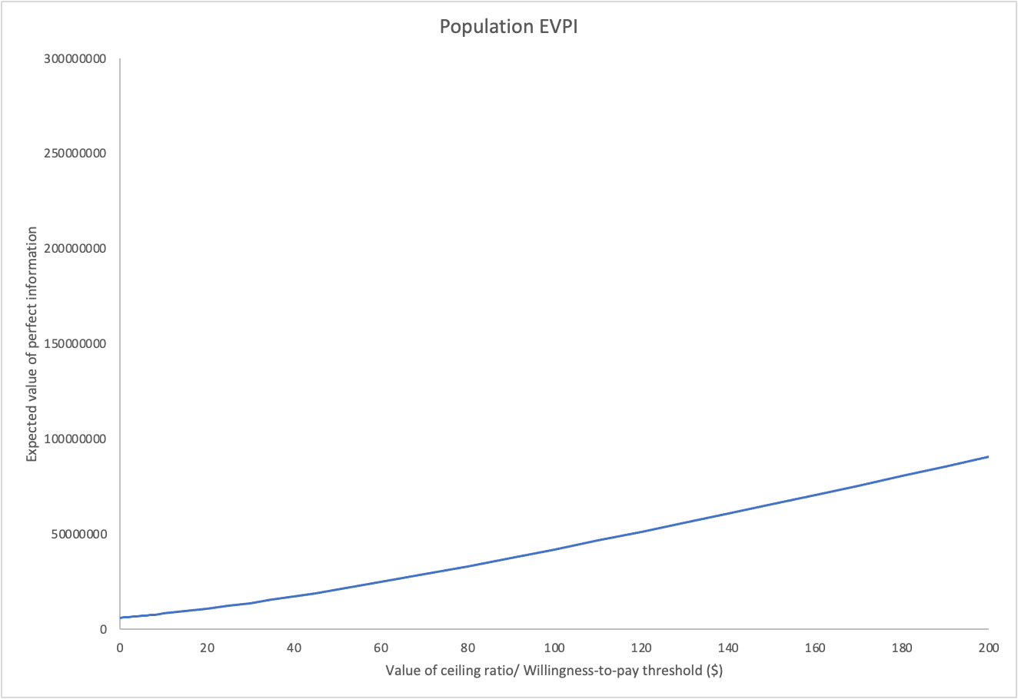
Supplementary Figure S10: Population EVPI as a function of WTP (community model, for caries free tooth years)

