Supporting Information

Synthesis and anticancer activity of novel bisindolylhydroxymaleimide derivatives with potent GSK-3 kinase inhibition.
Hannah J. Winfield, Michael M. Cahill, Kevin D. O’Shea, Larry T. Pierce, Thomas Robert ++, Sandrine Ruchaud ++, Stéphane Bach ++Pascal Marchand +++ and Florence O. McCarthy*

Contents
- Synthesis of selected compounds 2
- Table of results for Kinase screen at 10uM 6
- NCI One dose data 7
- NCI Five dose data 15 18
- NCI Five dose data 56 20
- Comparison of ¹H NMR data for bisindolyl maleic anhydrides 22
- ¹H and ¹³C NMR data for all compounds 23

1. Synthesis of selected compounds
2-(1-Methyl-1H-indol-3-yl)acetic acid (13)²⁶
A stirred suspension of sodium hydride (60 wt.% oil dispersion, 6.002 g, 150.1 mmol) in THF (150 mL) was cooled to 0 ºC in an ice bath. A solution of indole-3-acetic acid 12 (5.250 g, 30.0 mmol) in THF (50 mL) was then added. Following stirring for 30 minutes at 0 ºC, a solution of iodomethane (6.23 mL, 100.1 mmol) in THF (30 mL) was added to the reaction mixture in a dropwise manner. The mixture was allowed to warm slowly to room temperature and stirred for 16 hours. Methanol (5 mL) was then cautiously added to the mixture, followed by water (100 mL), in order to quench the reaction. Ether (100 mL) was added to the resulting clear yellow solution, after which the phases were separated. The aqueous phase was then acidified to pH 2 using 6M aqueous HCl and extracted with DCM (3 x 100 mL). The combined DCM extracts were dried over magnesium sulfate and concentrated to a volume of roughly 50 mL. Hexane was then added until a brownish solid precipitated out of solution. The crude solid was recrystallised from ethanol to give acetic acid 29 as a light brown solid (4.784 g, 84%): m.p. 126-128 ºC (lit.²⁶ 127-129 ºC); v_{max}/cm⁻¹ (KBr) 2930, 2676, 1698, 1547, 1474, 1412, 1305; δ_{H} (300 MHz, DMSO-d₆) 3.64 [2H, s, CH₂COOH], 3.75 [3H, s, NCH₃], 7.03 [1H, t, J 7.5, C-H₅], 7.15 [1H, t, J 7.6, C-H₆], 7.21 [1H, s, C-H₂], 7.40 [1H, d, J 8.2, C-H₇], 7.52 [1H, d, J 7.8, C-H₄], 12.17 (1H, bs, COOH]; δ_{C} (75 MHz, DMSO-d₆) 30.7 (CH₂, CH₂COOH), 32.2 (CH₃, NCH₃), 106.9 (C, aromatic C), 109.5 (CH, aromatic CH), 118.5 (CH, aromatic CH), 118.7 (CH, aromatic CH), 121.1 (CH, aromatic CH), 127.5 (C, aromatic C), 128.2 (CH, aromatic CH), 136.5 (C, aromatic C), 173.0 (C, C=O). m/z (ES+) 190.4 [M+H]⁺ (100%).
3-(1-Methyl-1H-indol-3-yl)-4-(1-methyl-1H-pyrrolo[2,3-b]pyridin-3-yl)-1H-pyrrole -2,5-dione (15)²⁷
To a stirred solution of 3-(1-methyl-1H-indol-3-yl)-4-(1-methyl-1H-pyrrolo[2,3-b]pyridin-3-yl)furan-2,5-dione 14 (0.801 g, 2.2 mmol) in DMF (10 mL) was added 1,1,1,3,3,3-hexamethyldisilazane (4.70 mL, 22.4 mmol), followed by methanol (0.45 mL, 11.2 mmol). The mixture was then stirred at room temperature for 24 hours. Water (100 mL) was added to the reaction mixture, which was then subsequently extracted with ethyl acetate (3 x 50 mL). The combined organic extracts were washed with water (4 x 100 mL) and brine (100 mL), then dried over magnesium sulfate. The solvent was removed under reduced pressure and the crude residue was subjected to flash column chromatography (hexane/ethyl acetate, 50:50) to yield pure maleimide 15 as a bright red solid (0.709 g, 88%): m.p. 238-239 ºC; v_{max}/cm⁻¹ (KBr) 3221, 3049, 1754, 1712, 1593, 1530, 1334, 1231; δ_{H} (300 MHz, CDCl₃) 3.85 [3H, s, NCH₃], 3.93 [3H, s, NCH₃], 6.68 [1H, q, J 8.0, 4.7, C-H_{5’}], 6.73 [1H, t, J 7.5, C-H₅], 6.81 [1H, d, J 7.7, C-H₇], 7.10 [1H, t, J 7.7, C-H₆], 7.23 [1H, dd, J 8.0, 1.6, C-H_{4’}], 7.29 [1H, d, J 8.3, C-H₄], 7.74 [1H, s, C-H₂], 7.82 [1H, s, C-H_{2’}], 8.23 [1H, dd, J 4.7, 1.5, C-H_{6’}], 8.35 [1H, bs, NH]; δ_{C} (75 MHz, CDCl₃) 31.8 (CH₃, NCH₃), 33.4 (CH₃, NCH₃), 104.2 (C, aromatic C), 105.3 (C, aromatic C), 109.5 (CH, aromatic CH), 116.1 (CH, aromatic CH), 118.9 (C, aromatic C), 120.3 (CH, aromatic CH), 122.0 (CH, aromatic CH), 122.4 (CH, aromatic CH), 125.9 (C, aromatic C), 126.5 (C, aromatic C), 128.1 (C, aromatic C), 130.4 (CH, aromatic CH), 132.7 (CH, aromatic CH), 133.0 (CH, aromatic CH), 136.9 (C, aromatic C), 143.4 (CH, aromatic CH), 147.7 (C, aromatic C), 172.3 (C, C=O), 172.4 (C, C=O). m/z (ES+) 357.2 [M+H]⁺ (100%); HRMS (ES+): Exact mass calculated for (C₂₁H₁₇N₄O₂)⁺ 357.1352. Found 357.1349.
Ethyl 2-oxo-2-(1H-pyrrolo[2,3-b]pyridin-3-yl)acetate (17)
7-Azaindole 16 (5.00 g, 42 mmol) was added to a suspension of aluminium trichloride (30.00 g, 225 mmol) in DCM (500 mL) and the resulting mixture was allowed to stir for 30 min at room temperature. After this time, ethyl chlorooxoacetate (24 mL, 215 mmol) was added dropwise over a 20 minutes with the resulting mixture left to stir vigorously at room temperature overnight. The reaction mixture was then poured over ice cold water and the layers were separated. The aqueous layer was washed with DCM (4 x 50 mL). Combined organic layers were then washed very carefully with ice-cold, saturated aqueous sodium bicarbonate solution (3 x 20 mL) and brine (1 x 100 mL) before being dried over anhydrous magnesium sulfate and concentrated under reduced pressure to yield a brown oil. Purification by flash column chromatography (60:40, Hexane/Ethyl Acetate) afforded the oxoacetate as a fluffy, light yellow solid (4.83 g, 22.1 mmol, 53%), m.p. 157 - 158°C; ν_{max}/cm⁻¹ (KBr) 3418, 1872, 1723, 1611, 1174; δ_{H} (400 MHz, DMSO-d₆) 1.35 (t, 3H, J = 7.1 Hz, OCH₂CH₃), 4.38 (q, 2H, J = 14.2, 7.1 Hz, OCH₂CH₃), 7.34 (dd, 1H, J = 7.9, 4.7 Hz, C-H₅), 8.40 (dd, 1H, J = 4.7, 1.6 Hz, C-H₆), 8.47 (dd, 1H, J = 7.9, 1.6 Hz, C-H₄), 8.57 (s, 1H, C-H₂); m/z (ES+) 219.3 [M+H]⁺ 100%.
Potassium 2-oxo-2-(1H-pyrrolo[2,3-b]pyridin-3-yl)acetate (18)
To a suspension of ethyl 2-oxo-2-(1H-pyrrolo[2,3-b]pyridin-3-yl)acetate 17 (4.83 g, 22.1 mmol) in a 1:1 solution of Water/MeOH was added potassium carbonate (5.67 g, 41.03 mmol). The resulting mixture was allowed to stir at room temperature for 5 hours before the product was isolated by vacuum filtration and the cake dried overnight to yield the glyoxylate salt as a brilliant white powder (3.53 g, 15.5 mmol, 70%), m.p. >250°C; ν_{max}/cm⁻¹ (KBr) 3244, 3061, 2530, 1980, 1860, 1780, 1634, 1455; δ_{H} (400 MHz, DMSO-d₆) 7.18 (q, 1H, J = 7.9, 4.5 Hz, C-H₅), 8.13 (s, 1H, C-H₂), 8.27 (dd, 1H, J = 4.7, 1.6 Hz, C-H₆), 8.42 (dd, 1H, J = 7.8, 1.6 Hz, C-H₄); m/z (ES-) 189.3 [M-H]⁻ 100%.
2-[1-(Phenylsulfonyl)-1H-indol-3-yl]acetic acid 19
To a stirred solution of indol-3-acetic acid 12 (20.011 g, 114 mmol) in THF (200 mL) under a nitrogen atmosphere at -70°C was added n-butyllithium (2.5 M in hexanes, 96 mL, 240 mmol) while maintaining the temperature below -70 °C. The mixture was stirred for 1 hour at this temperature before a solution of benzenesulfonyl chloride (14.6 mL, 20.2 g, 240 mmol) in THF (50 mL) was added slowly. Following addition, the reaction vessel was allowed to warm to room temperature over ~1 hour and stirred at this temperature for a further 16 hours. Water (10 mL) was then added to quench the reaction and the solvent was evaporated under reduced pressure. The residue was dissolved in ethyl acetate (200 mL) and the organic layer was then washed with 1 M aqueous HCl (100 mL × 2), followed by water (120 mL), before being dried over anhydrous magnesium sulfate and the solvent evaporated under reduced pressure to form a brown solid. Recrystallisation from ethyl acetate gave product as an off-white solid (32.210 g, 90%): m.p. 176-178 ºC; (Lit. 171-173 °C)⁴⁷; ν_{max}/cm⁻¹ (KBr) 3388, 3055, 1710, 1448, 1362, 1173; δ_{H} (300 MHz, DMSO-d₆) 3.71 [2H, s, CH₂], 7.26 [1H, t, J 7.5, C(6)-H], 7.36 [1H, ddd, J 7.5, 7.2, 1.1, C(5)-H], 7.53-7.61 [3H, m, C(3′, 5′, 7)-H], 7.69 [1H, m, C(4′)-H], 7.74 [1H, s, C(2)-H], 7.92-7.98 [3H, m, C(2′, 6′, 4)-H], 12.47 [1H, bs, OH]; m/z (ESI⁻) = 314.1 [(M-H)⁻ 100%].
2-(1H-Indol-3-yl)-2-oxoacetic acid 23
To a solution of indole (10.021 g, 85 mmol) in diethyl ether (150 mL) was added oxalyl chloride (11.0 mL, 16.3 g, 0.13 mol) dropwise over 10 minutes and the yellow suspension was allowed to stir for a further 30 minutes at room temperature. Saturated aqueous sodium bicarbonate (20 mL) was then added with caution and the biphasic mixture was stirred for 16 hours. The product was then collected using vacuum filtration, washed with diethyl ether and dried overnight at 40 °C to give a yellow solid (14.167 g, 88%): m.p. 193-196 °C; (Lit. 210 °C decomp.)⁴⁷; ν_{max}/cm⁻¹ (KBr) 3549, 3195, 1719, 1611, 1268; δ_{H} (300 MHz, DMSO-d₆) 7.26 [1H, ddd, J 9.1, 7.1, 1.7, C(5)-H], 7.29 [1H, ddd, J 9.3, 7.1, 1.9, C(6)-H], 7.52-7.58 [1H, m, C(7)-H], 8.14-8.20 [1H, m, C(4)-H], 8.42 [1H, d, J 3.3, C(2)-H], 12.36 (1H, bs, N-H); m/z (ESI⁺) = 190.3 [(M+H)⁺ 100%].
Potassium 2-(1H-indol-3-yl)-2-oxoacetate 24
A solution of 2-(1H-indol-3-yl)-2-oxoacetic acid 23 (14.205 g, 75 mmol) in ethanol (280 mL) was treated with potassium hydroxide (85 wt. %, 4.958 g, 75 mmol) and stirred at room temperature for 4 hours. The product was then collected using vacuum filtration and dried overnight at 40 °C to give a white solid (14.507 g, 85%): m.p. 291-293 °C (decomposition); ν_{max}/cm⁻¹ (KBr) 3649, 3392, 1632, 1614, 1114; δ_{H} (300 MHz, DMSO-d₆) 7.12 [1H, ddd, J 8.6, 7.1, 1.5, C(5)-H], 7.16 [1H, ddd, J 8.8, 7.1, 1.7, C(6)-H], 7.46 [1H, d, J 6.7, C(7)-H], 8.13 [1H, s, C(2)-H], 8.17 [1H, d, J 7.7, C(4)-H], 12.12 (1H, bs, N-H); m/z (ESI⁻) = 188.4 [(M)⁻ 70%].
3,4-Di(1H-indol-3-yl)furan-2,5-dione 26
A suspension of 3-(1-acetyl-1H-indol-3-yl)-4-[1-(phenylsulfonyl)-1H-indol-3-yl]furan-2,5-dione 25 (3.611 g, 7.1 mmol) in a mixture of methanol (100 mL) and water (25 mL) was treated with potassium hydroxide (85 wt. %, 2.774 g, 42 mmol) and the mixture was heated to reflux for 24 hours. The reaction mixture was allowed to cool to room temperature and the solvent evaporated under reduced pressure. The residue was acidified to pH 2 using 20% aqueous HCl and extracted using ethyl acetate (100 mL). The organic layer was washed once with 1 M aqueous HCl (50 mL), followed by water (2 × 50 mL) and brine (50 mL) before being dried over anhydrous magnesium sulfate, filtered and the solvent evaporated under reduced pressure to give a red foamy residue. The residue was dissolved in chloroform, allowed to crystallise and the red crystalline solid was collected by vacuum filtration (1.981 g, 85%): m.p. 227-229 °C; (Lit. 227-230 °C)⁴⁸; ν_{max}/cm⁻¹ (KBr) 3389, 1819, 1750, 1530, 1427, 1253; δ_{H} (300 MHz, DMSO-d₆) 6.71 [t, J 7.4, C(6, 6′)-H], 6.86 [d, J 7.9, C(7, 7′)-H], 7.04 [t, J 7.6, C(5, 5′)-H], 7.43 [d, J 8.2, C(4, 4′)-H], 7.85 [d, J 2.6, C(2, 2′)-H], 11.92 (2H, s, N(1, 1′)-H); m/z (ESI⁻) 327.4 [(M-H)⁻ 100%].
6,7,8,9,10,11-Hexahydro-5,21:12,17-dimethenodibenzo[i,o]furo[3,4-l][1,8]diazacyclohexadecine-18,20-dione 27
To a solution of 3,4-di(1H-indol-3-yl)furan-2,5-dione 26 (1.004 g, 3.0 mmol) in anhydrous DMF (150 mL) at 0 °C under a nitrogen atmosphere was added sodium hydride (60 wt. % oil dispersion, 0.270 g, 6.7 mmol) and the mixture was stirred for 40 minutes at this temperature. 1,6-Dibromohexane (0.50 mL, 0.79 g, 3.2 mmol) was then added to the dark blue mixture and the reaction was allowed to warm slowly to room temperature and stirred for 16 hours. At this point, the reaction mixture was poured into water (400 mL) and extracted with ethyl acetate (5 × 50 mL). The organic layer was washed with 1 M aqueous HCl (3 × 50 mL), followed by water (2 × 50 mL) before being dried over anhydrous magnesium sulfate, filtered and the solvent evaporated under reduced. The crude residue was purified using column chromatography on silica gel with 50:50 DCM/hexane to give desired compound as a reddish/purple solid (0.364 g, 29%): m.p. >300 °C; ν_{max}/cm⁻¹ (KBr) 3431, 2927, 1809, 1747, 1626, 1528, 1186, 735; δ_{H} (300 MHz, DMSO-d₆) 1.09 [4H, bs, C(8, 9)-H₂], 1.82 [4H, bs, C(7, 10)-H₂], 4.16-4.23 [4H, m, C(6, 11)-H₂], 7.15-7.28 [4H, m, C(2, 3, 14, 15)-H], 7.55 [2H, d, J 7.6, C(4, 13)-H], 7.57 [2H, s, C(22, 23)-H], 7.87 [2H, dd, J 7.1, 1.2, C(1, 16)-H]; δ_{c} (75 MHz, DMSO-d₆) 22.5 (2 × CH₂), 27.2 (2 × CH₂), 44.2 (2 × CH₂), 101.9 (2C, 2 × aromatic C), 110.7 (2CH, 2 × aromatic CH), 120.7 (2CH, 2 × aromatic CH), 121.3 (2CH, 2 × aromatic CH), 122.0 (2CH, 2 × aromatic CH), 126.4 (2C, 2 × aromatic C), 132.2 (2CH, 2 × aromatic CH), 132.5 (2C, 2 × aromatic C), 135.4 (2C, 2 × aromatic C), 165.5 (2 × C=O); m/z (ESI+) 411.2 [(M+H)⁺ 40%].
1-Methyl-1H-indole 31
To a stirred solution of indole (2.002 g, 17.1 mmol) in anhydrous DMF (90 mL) was added sodium hydride (60 wt. % oil dispersion, 1.367 g, 34.2 mmol) at 0 °C under nitrogen and the mixture was stirred for 30 minutes. Methyl iodide (1.80 mL, 4.10 g, 28.9 mmol) was then added before the mixture was allowed to warm to room temperature and stirred for a further 3 hours. Water (120 mL) was then cautiously added and the mixture was extracted with ethyl acetate (3 × 50 mL). The combined organic layers were washed with 1 M aqueous HCl (3 × 50 mL) followed by water (2 × 50 mL) before being dried over anhydrous magnesium sulfate, filtered and the solvent evaporated to give a pale yellow oil (2.137 g, 95%) which was used without further purification: ν_{max}/cm⁻¹ (NaCl) 3054, 2917, 1614, 1513, 1316, 1242; δ_{H} (300 MHz, CDCl₃) 3.78 [3H, s, N-CH₃], 6.48 [1H, dd, J 3.1, 0.8, C(3)-H], 7.03 [1H, d, J 3.1, C(2)-H], 7.10 [1H, ddd, J 8.0, 7.0, 1.1, C(5)-H], 7.22 [1H, ddd, J 8.0, 7.2, 1.1, C(6)-H], 7.32 [1H, dd, J 8.1, 0.7, C(7)-H], 7.63 [1H, dt, J 7.9, 0.9, C(4)-H]; m/z (ESI⁺) 132.2 [(M+H)⁺ 100%].
1-Isopropyl-1H-indole 32
To a stirred solution of indole (4.000 g, 34.1 mmol) in anhydrous DMF (70 mL), at 0 °C under nitrogen was added sodium hydride (60 wt. % oil dispersion, 2.728 g, 68.2 mmol) and the suspension was stirred for 30 minutes at this temperature. Isopropyl iodide (8.53 mL, 14.53 g, 85.4 mmol) was then added to the solution which was then allowed to warm to room temperature and stirred for 16 hours. Water (70 mL) was added and the mixture was extracted with ethyl acetate (25 mL × 2). The combined organic layers were washed using 1 M aqueous HCl (25 mL × 3) and water (25 mL × 2) before being dried over anhydrous magnesium sulfate, filtered and the solvent evaporated under reduced pressure. The crude product was then purified using column chromatography on silica gel with 10% ethyl acetate/hexane to give desired product as a pale yellow oil (3.220 g, 59%) which was used without further purification: ν_{max}/cm⁻¹ (NaCl) 2975, 1462, 1314, 1300, 1223, 739; δ_{H} (300 MHz, CDCl₃) 1.52 [6H, d, J 6.7, CH(CH₃)₂], 4.68 [1H, sept, J 6.7, CH(CH₃)₂], 6.51 [1H, dd, J 3.2, 0.6, C(3)-H], 7.09 [1H, ddd, J 8.0, 7.1, 1.1, C(5)-H], 7.19 [1H, ddd, J 8.3, 7.2, 1.2, C(6)-H], 7.22 [1H, d, J 3.2, C(2)-H], 7.38 [1H, dd, J 8.2, 0.6, C(7)-H], 7.63 [1H, dt, J 7.9, 1.0, C(4)-H]; m/z (ESI⁺) = 160.4 [(M+H)⁺, 100%].
2-(1-Methyl-1H-indol-3-yl)-2-oxoacetic acid 33
To a solution of 1-methyl-1H-indole 31 (4.503 g, 34.3 mmol) in diethyl ether (60 mL) was added oxalyl chloride (4.40 mL, 6.51 g, 51.5 mmol), dropwise, over 10 minutes. The yellow suspension was then stirred for a further 30 minutes at room temperature. Saturated sodium bicarbonate solution (10 mL) was added with caution and the biphasic mixture was stirred for 16 hours. The product was collected using vacuum filtration, washed with diethyl ether and dried overnight at 40 °C to give a pale yellow solid (5.158 g, 74%): m.p. 157-158 °C; ν_{max}/cm⁻¹ (KBr) 3249, 3145, 1754, 1619, 1521, 1308, 1210; δ_{H} (400 MHz, DMSO-d₆) 3.92 (s, CH₃), 7.32 [1H, ddd, J 8.4, 7.2, 1.1, C(5,)-H], 7.36 [1H, ddd, J 8.6, 7.2, 1.4, C(6)-H], 7.61 [1H, d, J 7.3, C(7)-H], 8.20 [1H, dd, J 7.0, 1.4, C(4)-H], 8.49 [1H, s, C(2)-H], 13.89 (1H, bs, COOH); m/z (ESI⁺) 204.3 [(M+H)⁺ 100%].
2-(1-Isopropyl-1H-indol-3-yl)-2-oxoacetic acid 34
To a solution of 1-isopropyl-1H-indole 32 (2.894 g, 18.0 mmol) in diethyl ether (50 mL) was added oxalyl chloride (2.33 mL, 3.45 g, 27.2 mmol) dropwise, over 10 minutes. The solution was then stirred for a further 30 minutes at rom temperature. Saturated aqueous sodium bicarbonate (10 mL) was then added with caution and the biphasic mixture was stirred for 16 hours. The layers were separated and the aqueous layer was extracted with ethyl acetate (2 × 15 mL). The combined organic layers were washed with water before being dried over anhydrous magnesium sulfate, filtered and the solvent evaporated under reduced pressure to give the desired product as a yellow solid (3.790 g, 90%): m.p. 113-115 °C; ν_{max}/cm⁻¹ (KBr) 3287, 2988, 1760, 1605, 1321, 1199, 740; δ_{H} (300 MHz, DMSO-d₆) 1.54 [6H, d, J 6.7, CH(CH₃)₂], 4.88 [1H, sept, J 6.7, CH(CH₃)₂], 7.31 [1H, ddd, J 8.5, 7.2, 1.4, C(5)-H], 7.35 [1H, ddd, J 8.6, 7.1, 1.6, C(6)-H], 7.72 [1H, d, J 7.4, C(7)-H], 8.22 [1H, d, J 6.8, C(4)-H], 8.42 [1H, s, C(2)-H]; δ_{c} (75 MHz, DMSO-d₆) 21.9 (2 × CH₃), 48.2 [CH(CH₃)₂], 111.4 (CH, aromatic CH), 111.6 (C, aromatic C), 121.4 (CH, aromatic CH), 123.1 (CH, aromatic CH), 123.7 (CH, aromatic CH), 126.3 (C, aromatic C), 136.1 (C, aromatic C), 136.5 (CH, aromatic CH), 165.2 (C=O), 180.3 (C=O); m/z (ESI⁺) 232.3 [(M+H)⁺, 100%]; HRMS (ESI+): Exact mass calculated for (C₁₃H₁₄NO₃)⁺ 232.0974. Found 232.0970.
Potassium 2-(1-methyl-1H-indol-3-yl)-2-oxoacetate 35
A solution of 2-(1-methyl-1H-indol-3-yl)-2-oxoacetic acid 33 (5.011 g, 24.6 mmol) in ethanol (120 mL) was treated with potassium hydroxide (85 wt. %, 1.620 g, 24.6 mmol) and stirred at room temperature for 4 hours. The product was then collected using vacuum filtration and dried overnight at 40 °C to give a white solid (5.646 g, 95%): m.p. >300 °C; ν_{max}/cm⁻¹ (KBr) 3420, 3047, 1623, 1520, 1361, 1204, 1084; δ_{H} (400 MHz, DMSO-d₆) 3.84 (1H, s, CH₃), 7.18 [1H, t, J 7.4, C(5)-H], 7.24 [1H, t, J 7.5, C(6)-H], 7.49 [1H, d, J 8.0, C(7)-H], 8.12 [1H, s, C(2)-H], 8.18 [1H, d, J 7.5, C(4)-H]; δ_{c} (75 MHz, DMSO-d₆) 32.9 (CH₃), 110.3 (CH, aromatic CH), 113.0 (C, aromatic C), 121.3 (CH, aromatic CH), 121.4 (CH, aromatic CH), 122.3 (CH, aromatic CH), 126.3 (C, aromatic C), 137.0 (C, aromatic C), 139.2 (CH, aromatic CH), 169.7 (C=O), 193.1 (C=O); m/z (ESI⁺) 204.3 [(M+2H)⁺ 20%]. HRMS (ESI⁺): Exact mass calculated for (C₁₁H₁₀NO₃)⁺ 204.0654. Found 204.0661.
3-(1-Methyl-1H-indol-3-yl)-4-[1-(phenylsulfonyl)-1H-indol-3-yl]furan-2,5-dione 37
A mixture of potassium 2-(1-methyl-1H-indol-3-yl)-2-oxoacetate 35 (4.605 g, 19 mmol) and 2-[1-(phenylsulfonyl)-1H-indol-3-yl]acetic acid 19 (6.002 g, 19 mmol) were suspended in acetic anhydride (30 mL) and heated to 80 °C for 24 hours. The resulting orange suspension was allowed to cool and the solvent evaporated under reduced pressure. The residue was washed with saturated aqueous sodium bicarbonate (60 mL) before being extracted into ethyl acetate (2 × 40 mL). The organic layer was washed with saturated aqueous sodium bicarbonate (4 × 30 mL), followed by water (40 mL), before being dried over anhydrous magnesium sulfate, filtered and the solvent evaporated under reduced pressure. The crude material was purified using column chromatography on silica gel with 20% ethyl acetate/hexane to give an orange foamy residue. The residue was dissolved in chloroform (20 mL) and diethyl ether was added until an orange solid precipitated which was collected by vacuum filtration (2.822 g, 31%): m.p. 185-187 °C; (Lit. >200 °C decomp.)⁴⁹; ν_{max}/cm⁻¹ (KBr) 3418, 2924, 1822, 1756, 1634, 1374, 1176; δ_{H} (300 MHz, DMSO-d₆) 3.92 (3H, s, CH₃), 6.16 [1H, t, J 7.6, C(6′)-H], 6.29 [1H, d, J 8.0, C(7′)-H], 6.92 [1H, ddd, J 7.9, 7.2, 0.7, C(6)-H], 6.98-7.05 [2H, m, C(5′, 7)-H], 7.26 [1H, ddd, J 8.4, 7.2, 1.3, C(5)-H], 7.45 [1H, d, J 8.2, C(4′)-H], 7.64-7.71 [2H, m, C(3′′,5′′)-H], 7.82 [1H, m, C(4′′)-H], 7.96 [1H, d, J 8.3, C(4)-H], 8.04-8.09 [2H, m, C(2′′,6′′)-H], 8.11 [1H, s, C(2′)-H], 8.21 [1H, s, C(2)-H]; m/z (ESI+) 483.1 [(M+H)+ 50%].
3-(1H-Indol-3-yl)-4-(1-methyl-1H-indol-3-yl)furan-2,5-dione 39
To a stirred suspension of 3-(1-methyl-1H-indol-3-yl)-4-(1-(phenylsulfonyl)-1H-indol-3-yl)furan-2,5-dione 37 (3.930 g, 8.1 mmol) in methanol (100 mL) and water (25 mL) was added potassium hydroxide (2.691 g, 41 mmol) and the resulting solution was heated to reflux for 24 hours. The reaction mixture was then cooled before the solvent was evaporated under reduced pressure. The residue was dissolved in water (40 mL) and acidified to pH 2 with 10% aqueous HCl before being extracted into ethyl acetate (2 × 40 mL). The organic layer was washed with water (3 × 30 mL), followed by brine (30 mL) before being dried over anhydrous magnesium sulfate, filtered and the solvent evaporated under reduced pressure giving a red solid (2.634 g, 95%): m.p. = 251-252 °C; (Lit. 246-248 °C)⁴⁹; ν_{max}/cm⁻¹ (KBr) 3372, 3037, 1819, 1747, 1529, 1248; δ_{H} (300 MHz, DMSO-d₆) 3.89 (3H, s, CH₃), 6.67-6.79 [3H, m, C(6, 6′, 7′)-H], 6.89 [1H, d, C(7)-H], 7.04 [1H, t, J 7.4, C(5)-H], 7.09 [1H, t, J 7.5, C(5′)-H], 7.43 [1H, d, J 8.2, C(4)-H], 7.49 [1H, d, J 8.3, C(4′)-H], 7.83 [1H, d, J 2.8, C(2)-H], 7.95 [1H, s, C(2′)-H], 11.93 (1H, bs, NH); m/z (ESI⁺) 343.2 [(M+H)⁺ 10%].
3,4-Bis(1-methyl-1H-indol-3-yl)furan-2,5-dione 41
To a solution of 3-(1H-indol-3-yl)-4-(1-methyl-1H-indol-3-yl)furan-2,5-dione 39 (0.301 g, 0.88 mmol) in anhydrous DMF (15 mL) under nitrogen was added sodium hydride (60 wt. % oil dispersion, 0.042 g, 1.1 mmol) and the mixture was allowed to stir for 40 minutes at room temperature. Iodomethane (0.08 mL, 0.18 g, 1.3 mmol) was then added and the reaction was stirred for a further 16 hours. Water (30 mL) was then added and the mixture was extracted with ethyl acetate (3 × 20 mL). The combined organic layers were then washed with 1 M aqueous HCl (2 × 20 mL), followed by water (20 mL) and brine (20 mL). Product was allowed to crystallise from the ethyl acetate solution to give desired product as a red solid (0.162 g). Excess solvent was removed from filtrate and the residue was purified using column chromatography on silica gel with 20% ethyl acetate/hexane to give additional product (0.087 g, combined yield 0.249 g, 80%): m.p. 177-178 °C; ν_{max}/cm⁻¹ (KBr) 2924, 2855, 1815, 1740, 1610, 1517, 1226, 735; δ_{H} (300 MHz, DMSO-d₆) 3.88 (6H, s, 2 × CH₃), 6.74 [2H, ddd, J 7.8, 7.0, 0.7, C(6, 6′)-H], 6.82 [2H, d, J 7.8, C(7, 7′)-H], 7.11 [2H, ddd, J 8.2, 7.0, 1.2, C(5, 5′)-H], 7.49 [2H, d, J 8.2, C(4, 4′)-H], 7.92 [2H, s, C(2, 2′)-H]; δ_{c} (75 MHz, DMSO-d₆) 33.0 (2 × CH₃), 104.0 (2C, 2 × aromatic C), 110.5 (2CH, 2 × aromatic CH), 120.0 (2CH, 2 × aromatic CH), 121.3 (2CH, 2 × aromatic CH), 122.2 (2CH, 2 × aromatic CH), 125.4 (2C, 2 × aromatic C), 127.3 (2C, 2 × aromatic C), 134.2 (2CH, 2 × aromatic CH), 136.7 (2C, 2 × aromatic C), 166.4 (2 × C=O); m/z (ESI+) 357.1 [(M+H)+ 100%].

Table 1 Kinase screen at 10μM (values quoted are the residual % activity)
Compound  Number | Hs HASPIN | Hs AURKB | Hs RIPK3 | Hs CDK2/ CyclinA | Hs CDK5/p25 | Hs CDK9/ CyclinT |  | Hs DYRK1A | Ssc GSK3α/β | Hs PIM1 | Ssc CK1δ/ε
15 | 101 | 84 | 79 | -3 | -1 | -10 | 30 |  | -21 | 1 | 76
22 | 98 | 61 | 102 | 85 | 87 | 89 | 73 |  | 45 | 16 | 41
47 | 112 | 79 | 100 | 77 | 66 | 19 | 46 |  | -18 | 8 | 40
48 | 118 | 84 | 100 | 83 | 82 | 38 | 81 |  | -13 | 33 | 104
49 | 133 | 98 | 102 | 64 | 76 | 20 | 81 |  | -12 | 30 | 77
50 | 114 | 71 | 105 | 64 | 49 | 17 | 24 |  | 8 | 52 | 88
51 | 103 | 71 | 106 | 36 | 34 | 15 | 22 |  | 2 | 64 | 80
52 | 123 | 147 | 97 | 71 | 71 | 44 | 73 |  | 2 | 24 | 72
53 | 127 | 95 | 103 | 23 | 34 | -7 | 54 |  | -16 | 28 | 98
54 | 114 | 95 | 107 | 70 | 73 | 5 | 75 |  | -20 | 33 | 107
55 | 134 | 97 | 108 | 89 | 91 | 87 | 107 |  | 48 | 68 | 103
56 | 99 | 75 | 109 | 78 | 75 | 55 | 38 |  | 5 | 78 | 67
57 | 113 | 63 | 100 | 66 | 60 | 19 | 24 |  | 8 | 53 | 83
58 | 134 | 83 | 100 | 36 | 46 | 9 | 9 |  | 11 | 54 | 108

NCI 60 Cell Line screen One Dose results 15

NCI 60 Cell Line screen One Dose results 47

NCI 60 Cell Line screen One Dose results 48

NCI 60 Cell Line screen One Dose results 50

NCI 60 Cell Line screen One Dose results 51
NCI 60 Cell Line screen One Dose results 52
NCI 60 Cell Line screen One Dose results 53

NCI 60 Cell Line screen One Dose results 55

NCI 60 Cell Line screen One Dose results 56

NCI 60 Cell Line screen One Dose results 57

NCI 60 Cell Line screen One Dose results 58

Graphical representation of the NCI 60 Cell Line screen Five Dose results 15

NCI 60 Cell Line screen Five Dose results 15

Graphical representation of the NCI 60 Cell Line screen Five Dose results 56

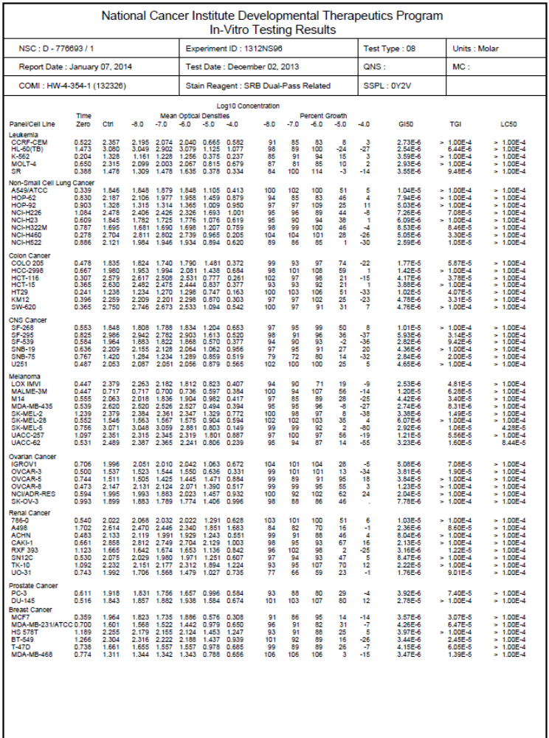
NCI 60 Cell Line screen Five Dose results 56

¹H and ¹³C NMR of selected compounds and ¹H NMR Comparison of bisindolyl maleic anhydrides
59
25
37
39
26

2-(1-Methyl-1H-indol-3-yl)acetic acid (13)⁴⁵

3-(1-Methyl-1H-indol-3-yl)-4-(1-methyl-1H-pyrrolo[2,3-b]pyridin-3-yl)furan -2,5-dione (14)
3-(1-Methyl-1H-indol-3-yl)-4-(1-methyl-1H-pyrrolo[2,3-b]pyridin-3-yl)-1H-pyrrole -2,5-dione (15)²⁷

Ethyl 2-oxo-2-(1H-pyrrolo[2,3-b]pyridin-3-yl)acetate (17)

Potassium 2-oxo-2-(1H-pyrrolo[2,3-b]pyridin-3-yl)acetate (18)

2-[1-(Phenylsulfonyl)-1H-indol-3-yl]acetic acid 19

3-(1-Acetyl-1H-pyrrolo[2,3-b]pyridin-3-yl)-4-(1-(phenylsulfonyl)-1H-indol-3-yl)furan-2,5-dione 20
3-(1H-Indol-3-yl)-4-(1H-pyrrolo[2,3-b]pyridin-3-yl)furan-2,5-dione 21

1-Hydroxy-3-(1H-indol-3-yl)-4-(1H-pyrrolo[2,3-b]pyridin-3-yl)-1H-pyrrole-2,5-dione 22

2-(1H-Indol-3-yl)-2-oxoacetic acid 23

Potassium 2-(1H-indol-3-yl)-2-oxoacetate 24

3-(1-Acetyl-1H-indol-3-yl)-4-[1-(phenylsulfonyl)-1H-indol-3-yl]furan-2,5-dione 25
3,4-Di(1H-indol-3-yl)furan-2,5-dione 26

6,7,8,9,10,11-Hexahydro-5,21:12,17-dimethenodibenzo[i,o]furo[3,4-l][1,8]diazacyclohexadecine-18,20-dione 27

6,6'-(3,3'-(2,5-Dioxo-2,5-dihydrofuran-3,4-diyl)bis(1H-indole-3,1-diyl))dihexanenitrile 28
6-{3-[4-(1H-Indol-3-yl)-2,5-dioxo-2,5-dihydrofuran-3-yl]-1H-indol-1-yl}hexanenitrile 29

6-{3-[4-(1H-Indol-3-yl)-2,5-dioxo-2,5-dihydrofuran-3-yl]-1H-indol-1-yl}hexanoic acid 30
1-Methyl-1H-indole 31

2-(1-Methyl-1H-indol-3-yl)-2-oxoacetic acid 33

Potassium 2-(1-methyl-1H-indol-3-yl)-2-oxoacetate 35

3-(1-Methyl-1H-indol-3-yl)-4-[1-(phenylsulfonyl)-1H-indol-3-yl]furan-2,5-dione 37

3-(1H-Indol-3-yl)-4-(1-methyl-1H-indol-3-yl)furan-2,5-dione 39
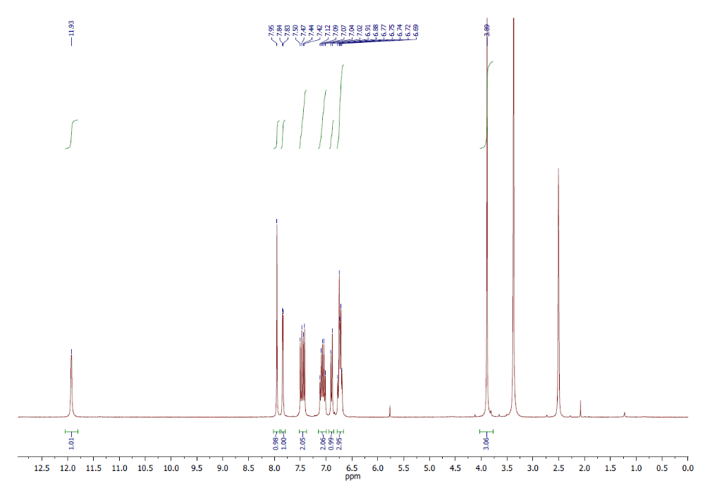

1-Isopropyl-1H-indole 32
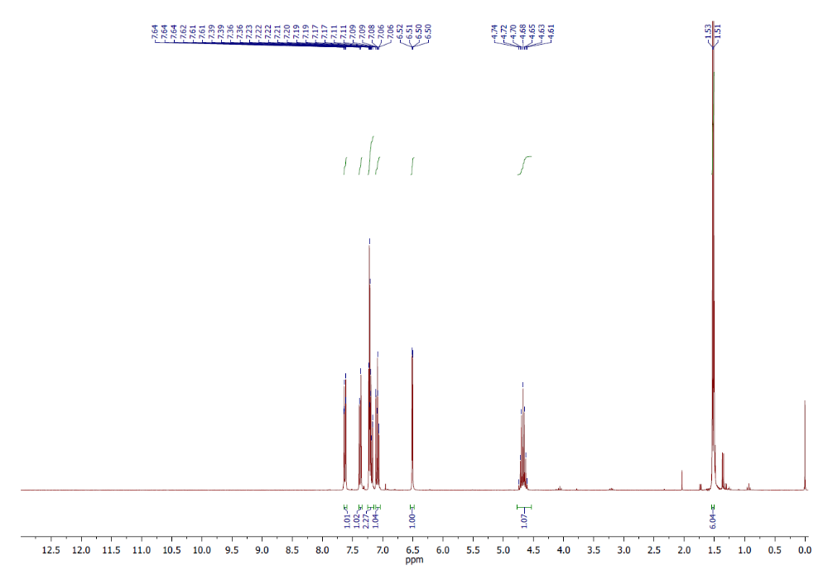

2-(1-Isopropyl-1H-indol-3-yl)-2-oxoacetic acid 34
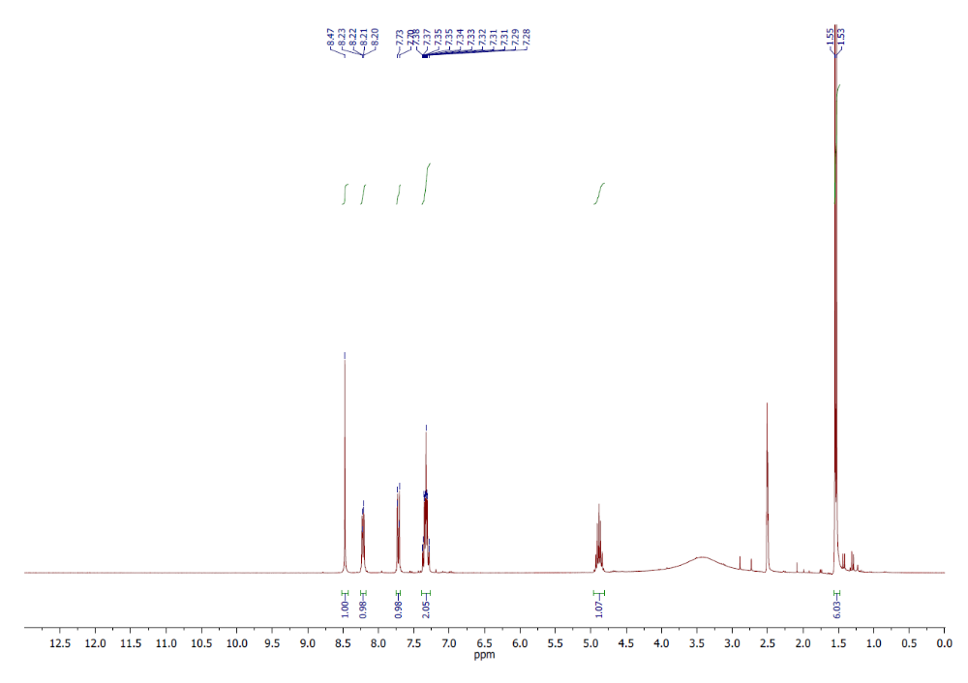
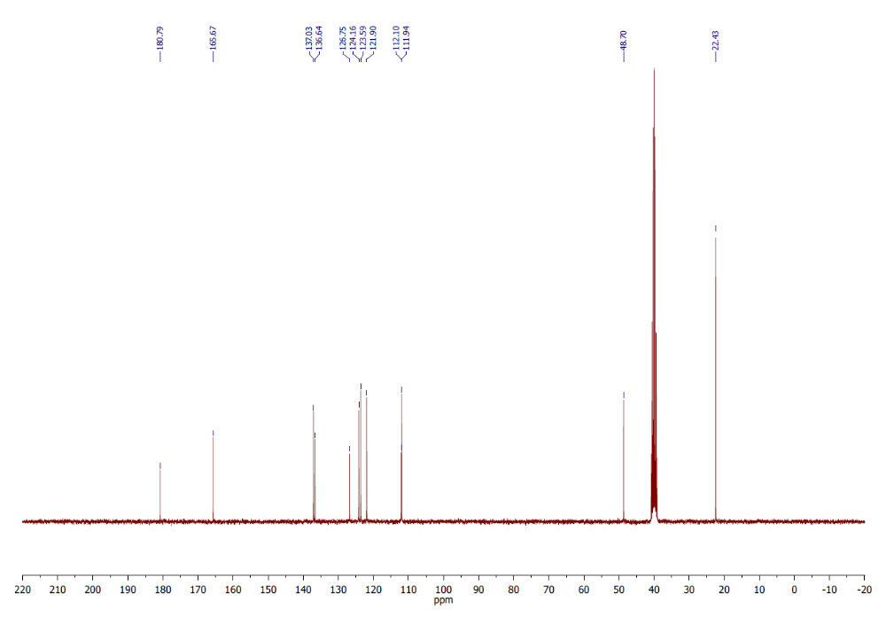

Potassium 2-(1-isopropyl-1H-indol-3-yl)-2-oxoacetate 36
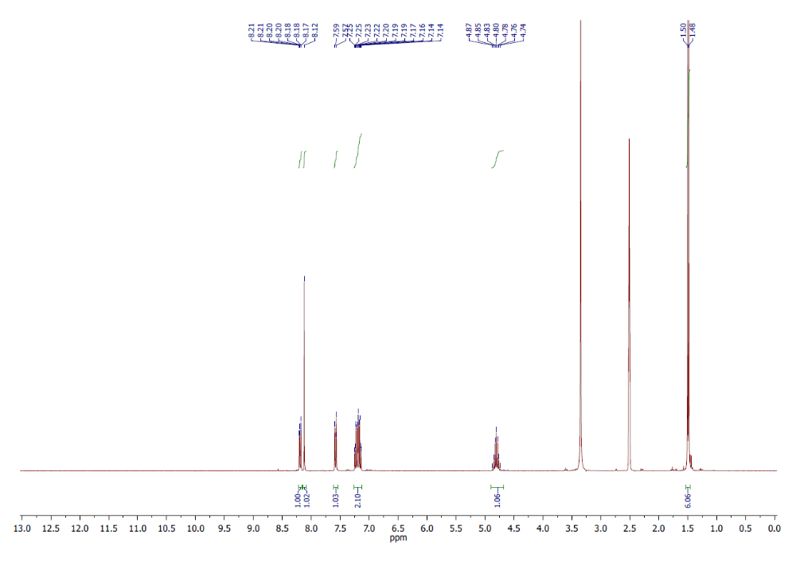
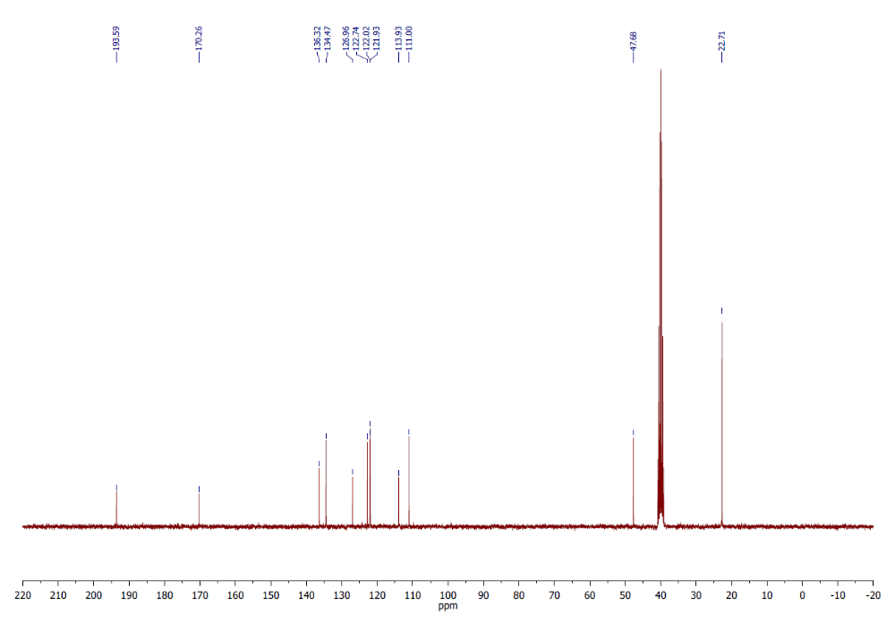

3-(1-Isopropyl-1H-indol-3-yl)-4-[1-(phenylsulfonyl)-1H-indol-3-yl]furan-2,5-dione 38
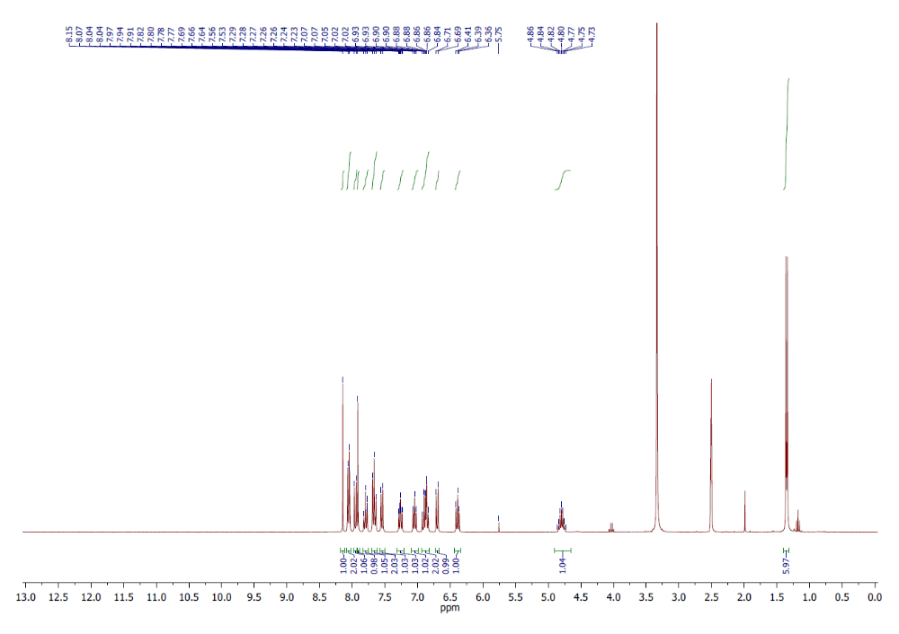
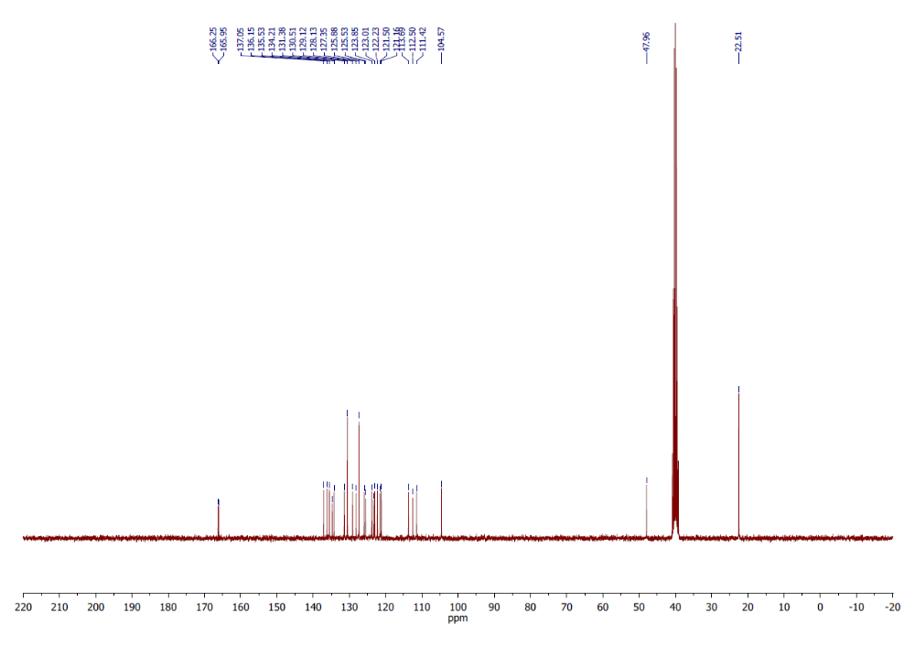

3-(1H-Indol-3-yl)-4-(1-isopropyl-1H-indol-3-yl)furan-2,5-dione 40
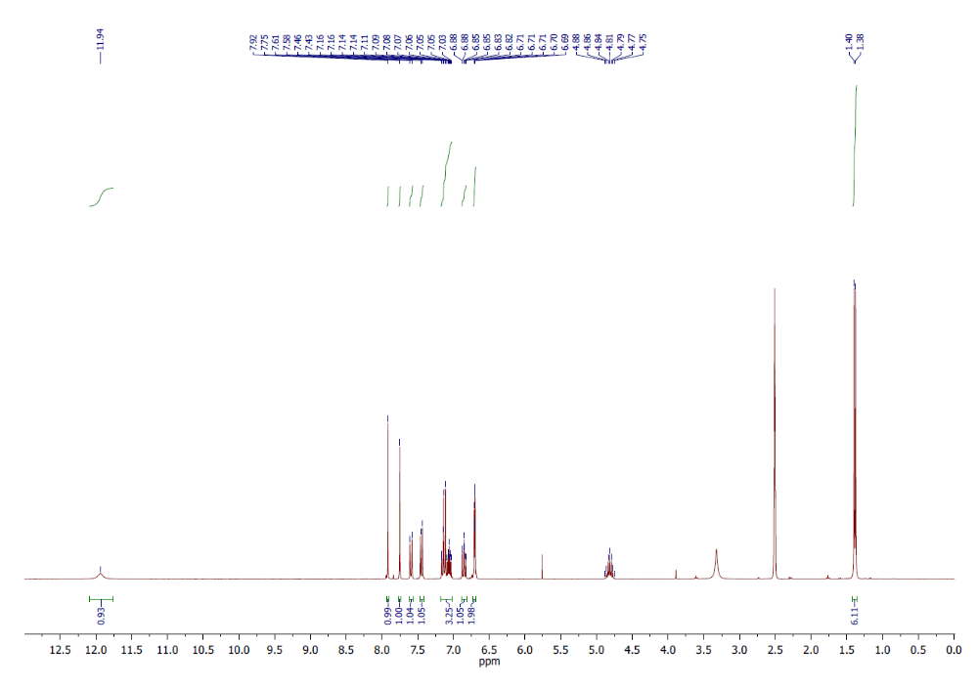
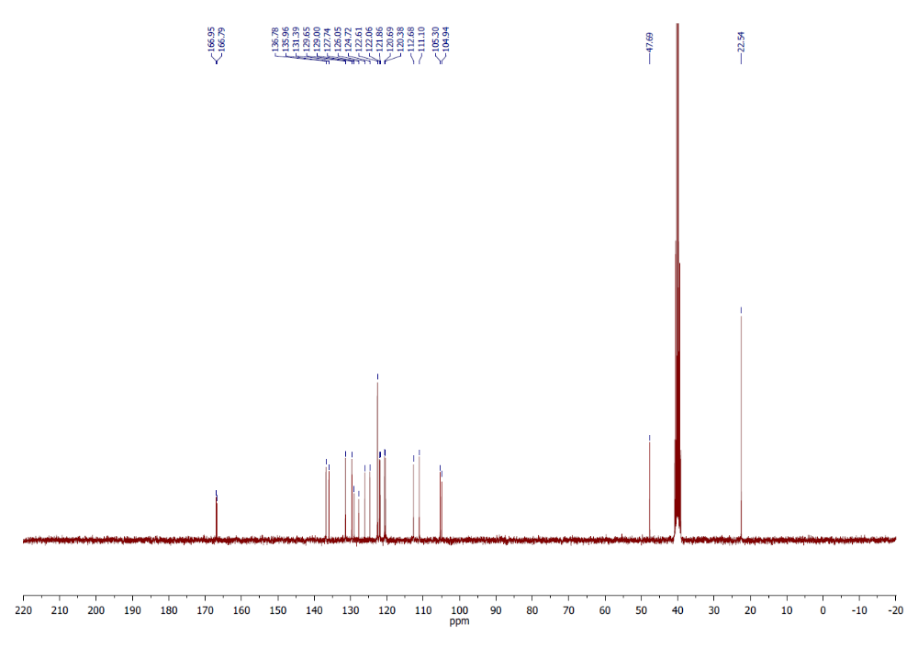

3,4-Bis(1-methyl-1H-indol-3-yl)furan-2,5-dione 41
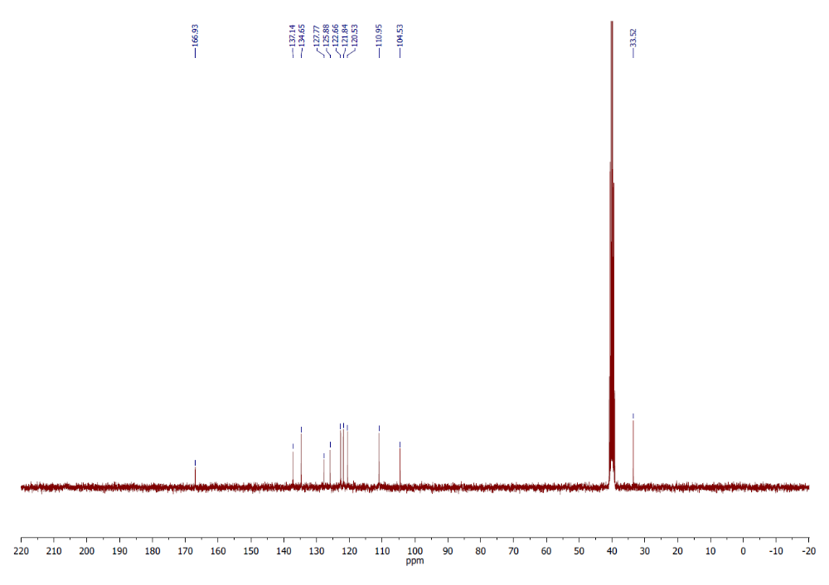

3-(1-Ethyl-1H-indol-3-yl)-4-(1-methyl-1H-indol-3-yl)furan-2,5-dione 42
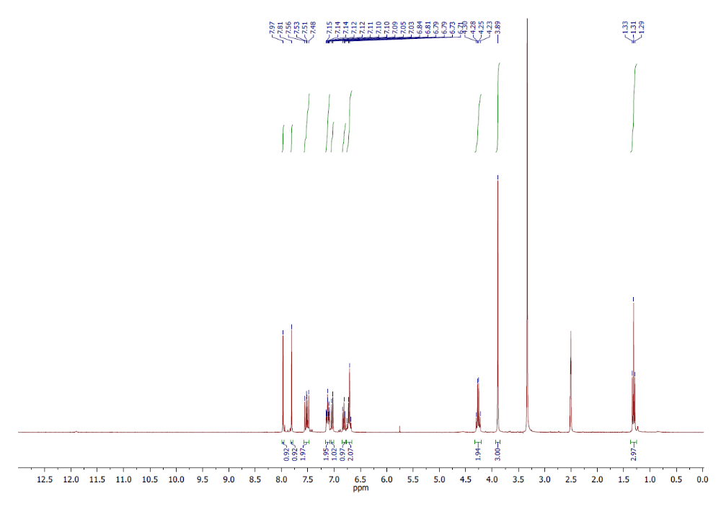
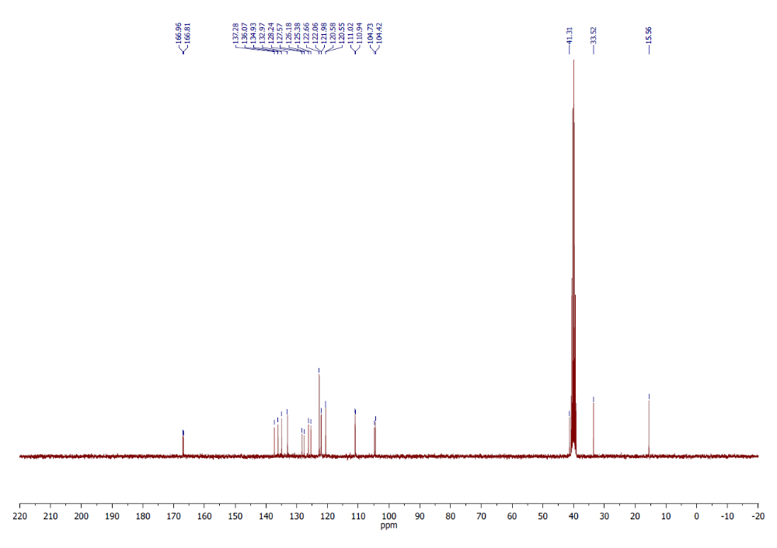

6-{3-[4-(1-Methyl-1H-indol-3-yl)-2,5-dioxo-2,5-dihydrofuran-3-yl]-1H-indol-1-
yl}hexanenitrile 43
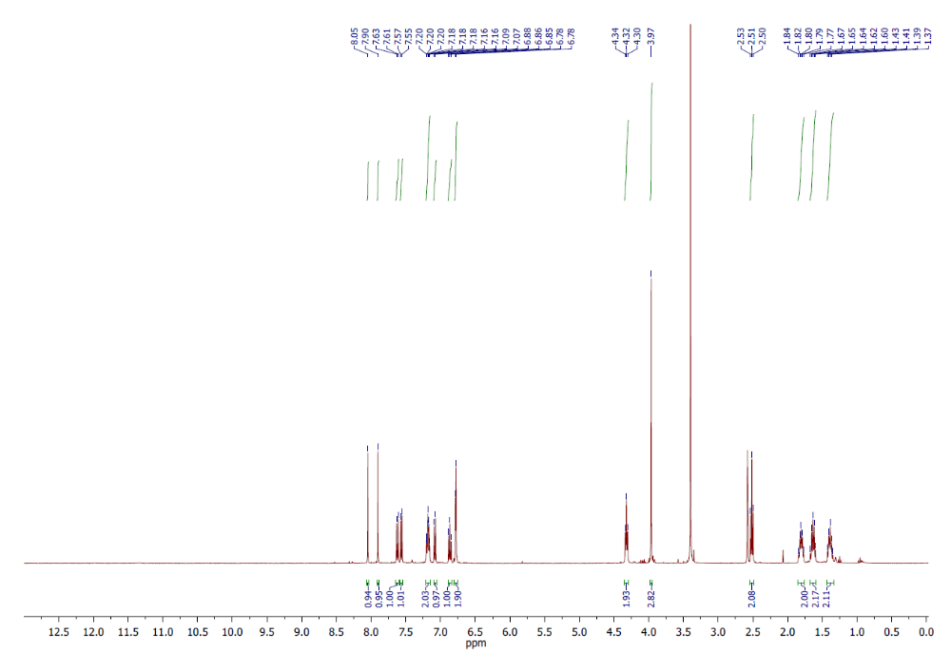
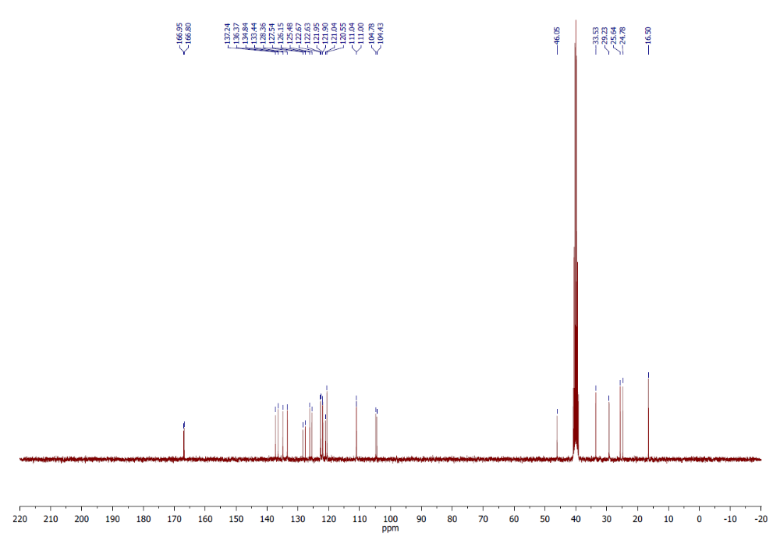
6-{3-[4-(1-Methyl-1H-indol-3-yl)-2,5-dioxo-2,5-dihydrofuran-3-yl]-1H-indol-1-yl}hexanoic acid 44
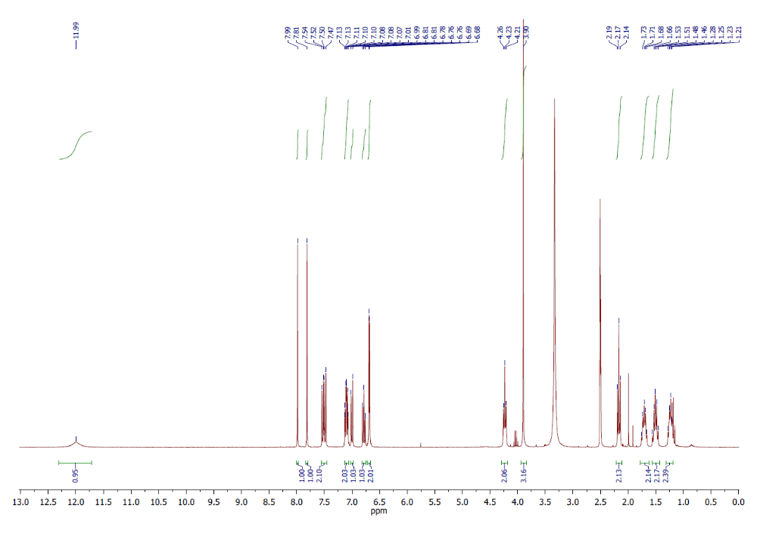
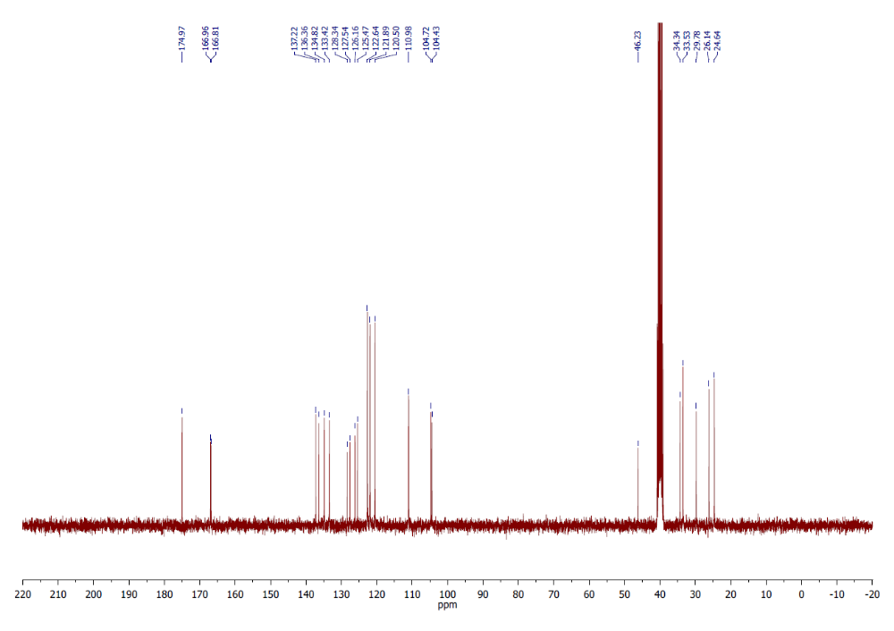
3-(1-Isopropyl-1H-indol-3-yl)-4-(1-methyl-1H-indol-3-yl)furan-2,5-dione 45
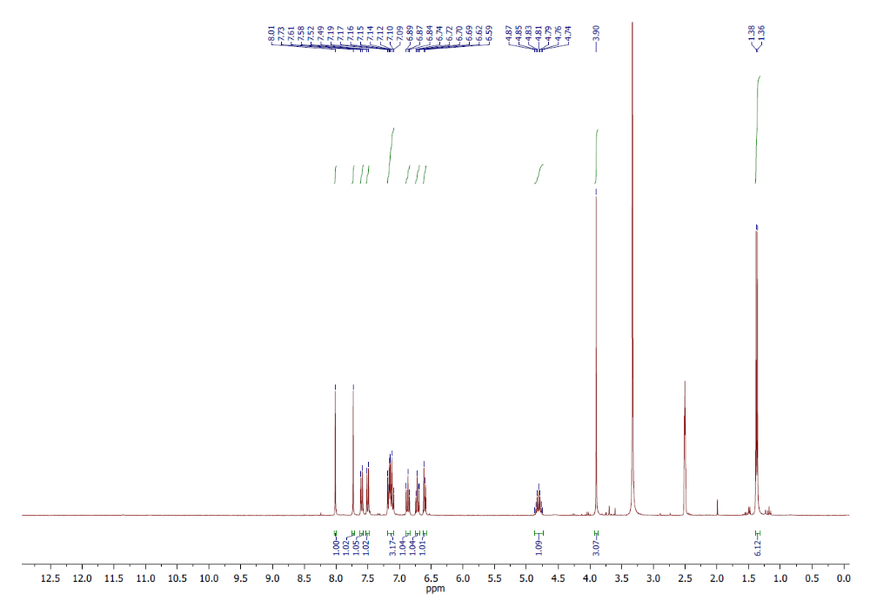
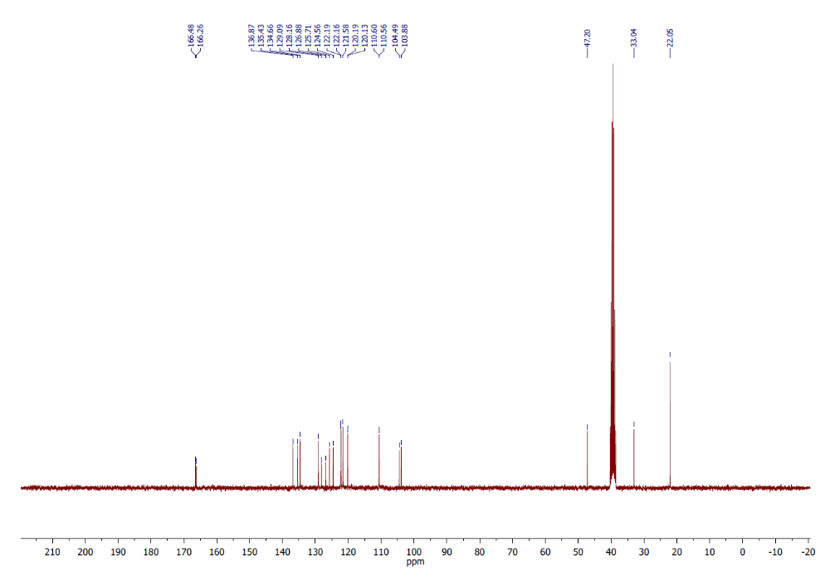

3-(1-Ethyl-1H-indol-3-yl)-4-(1-isopropyl-1H-indol-3-yl)furan-2,5-dione 46
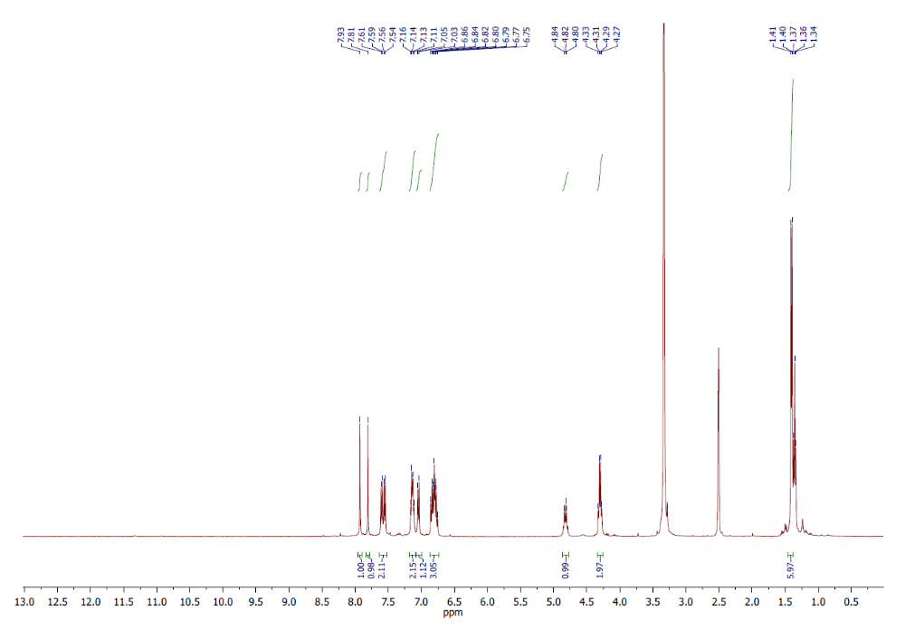

1-Hydroxy-3-(1H-indol-3-yl)-4-(1-methyl-1H-indol-3-yl)-1H-pyrrole-2,5-dione 47

1-Hydroxy-3,4-bis(1-methyl-1H-indol-3-yl)-1H-pyrrole-2,5-dione 48

3-(1-Ethyl-1H-indol-3-yl)-1-hydroxy-4-(1-methyl-1H-indol-3-yl)-1H-pyrrole-2,5-dione 49
6-{3-[1-Hydroxy-4-(1-methyl-1H-indol-3-yl)-2,5-dioxo-2,5-dihydro-1H-pyrrol-3-yl]-1H-indol-1-yl}hexanenitrile 50
6-{3-[1-Hydroxy-4-(1-methyl-1H-indol-3-yl)-2,5-dioxo-2,5-dihydro-1H-pyrrol-3-yl]-1H-indol-1-yl}hexanoic acid 51
1-Hydroxy-3-(1H-indol-3-yl)-4-(1-isopropyl-1H-indol-3-yl)-1H-pyrrole-2,5-dione 52

1-Hydroxy-3-(1-isopropyl-1H-indol-3-yl)-4-(1-methyl-1H-Indol-3-yl)-1H-pyrrole-2,5-dione 53
3-(1-Ethyl-1H-indol-3-yl)-1-hydroxy-4-(1-isopropyl-1H-indol-3-yl)-1H-pyrrole-2,5-dione 54
19-Hydroxy-6,7,8,9,10,11-hexahydro-5,21:12,17-dimetheno-18H-dibenzo[i,o]pyrrolo[3,4-l][1,8]diazacyclohexadecine-18,20(19H)-dione 55
6,6'-[3,3'-(1-Hydroxy-2,5-dioxo-2,5-dihydro-1H-pyrrole-3,4-diyl)bis(1H-indole-3,1-
diyl)]dihexanenitrile 56
6-{3-[1-Hydroxy-4-(1H-indol-3-yl)-2,5-dioxo-2,5-dihydro-1H-pyrrol-3-yl]-1Hindol-
1-yl}hexanoic acid 57
6,6'-[3,3'-(2,5-Dioxo-2,5-dihydro-1H-pyrrole-3,4-diyl)bis(1H-indole-3,1-diyl)]dihexanenitrile 58

