Post-glacial colonization of northern coastal habitat by bottlenose dolphins: A marine leading-edge expansion?
Electronic Supplementary Material
Milaja Nykänen, Kristin Kaschner, Willy Dabin, Andrew Brownlow, Nicholas J. Davison, Rob Deaville, Cristina Garilao, Kathleen Kesner-Reyes, M. Thomas P. Gilbert, Rod Penrose, Valentina Islas-Villanueva, Nathan Wales, Simon N. Ingram, Emer Rogan, Marie Louis, and Andrew D. Foote

Appendix S1. Whole mtDNA sequences/mitochondrial haplotypes downloaded from GenBank and used in the phylogenetic and coalescent analyses. Only the protein coding regions from these sequences were used in the estimation of time-calibrated phylogenies for delphinids and for the genus Tursiops. The numbers in brackets in the Tursiops spp. table indicate the number of samples found with the haplotype.
Delphinid phylogeny:
Species | Accession number | Reference
Cephalorhynchus heavisidii | JN632624 | Hassanin et al., 2012
Orcaella brevirostris | JF289177 | Vilstrup et al., 2011
Orcaella heinsohni | JF339977 | Vilstrup et al., 2011
Peponocephala electra | JF289175 | Vilstrup et al., 2011
Feresa attenuata | JF289171 | Vilstrup et al., 2011
Globicephala melas | JF339972 | Vilstrup et al., 2011
Globicephala macrorhynchus | JF339976 | Vilstrup et al., 2011
Pseudorca crassidens | JF289173 | Vilstrup et al., 2011
Grampus griseus | EU557095 | Xiong et al., 2009
Stenella attenuata | EU557096 | Xiong et al., 2009
Stenella coeruleoalba | EU557097 | Xiong et al., 2009
Delphinus capensis | EU557094 | Xiong et al., 2009
Sousa chinensis | EU557091 | Xiong et al., 2009
Tursiops truncatus | EU557093 | Xiong et al., 2009
Lagenorhynchus albirostris | NC005278 | Arnason et al., 2004
Orcinus orca, resident ecotype | GU187192 | Morin et al., 2010
Orcinus orca, transient ecotype | GU187173 | Morin et al., 2010
Steno bredanensis | JF339982 | Vilstrup et al., 2011

Genus Tursiops phylogeny:
Species | Haplotype name | Accession# | GenBank reference | Ecotype or population/sampling location | Ecotype reference
T. truncatus | EMED3 | KF570315 | Moura et al., 2013 | Coastal/Eastern Mediterranean | Natoli et al., 2005
T. truncatus | EMED4 | KF570316 | Moura et al., 2013 | Coastal/Eastern Mediterranean | Natoli et al., 2005
T. truncatus | EMED5 | KF570317 | Moura et al., 2013 | Coastal/Eastern Mediterranean | Natoli et al., 2005
T. truncatus | EMED1 | KF570318 | Moura et al., 2013 | Coastal/Eastern Mediterranean | Natoli et al., 2005
T. truncatus | EMED2 | KF570319 | Moura et al., 2013 | Coastal/Eastern Mediterranean | Natoli et al., 2005
T. truncatus | EMED10 | KF570320 | Moura et al., 2013 | Coastal/Eastern Mediterranean | Natoli et al., 2005
T. truncatus | EMED6 | KF570321 | Moura et al., 2013 | Coastal/Eastern Mediterranean | Natoli et al., 2005
T. truncatus | EMED9 | KF570322 | Moura et al., 2013 | Coastal/Eastern Mediterranean | Natoli et al., 2005
T. truncatus | EMED7 | KF570323 | Moura et al., 2013 | Coastal/Eastern Mediterranean | Natoli et al., 2005
T. truncatus | EMED8 | KF570324 | Moura et al., 2013 | Coastal/Eastern Mediterranean | Natoli et al., 2005
T. truncatus ponticus | BSEA2 | KF570325 | Moura et al., 2013 | Coastal/Black Sea | Natoli et al., 2005
T. truncatus ponticus | BSEA3 | KF570326 | Moura et al., 2013 | Coastal/Black Sea | Natoli et al., 2005
T. truncatus ponticus | BSEA1 | KF570327 | Moura et al., 2013 | Coastal/Black Sea | Natoli et al., 2005
T. truncatus ponticus | BSEA6 | KF570328 | Moura et al., 2013 | Coastal/Black Sea | Natoli et al., 2005
T. truncatus ponticus | BSEA7 | KF570329 | Moura et al., 2013 | Coastal/Black Sea | Natoli et al., 2005
T. truncatus ponticus | BSEA5 | KF570330 | Moura et al., 2013 | Coastal/Black Sea | Natoli et al., 2005
T. truncatus ponticus | BSEA4 | KF570331 | Moura et al., 2013 | Coastal/Black Sea | Natoli et al., 2005
T. truncatus ponticus | BSEA8 | KF570332 | Moura et al., 2013 | Coastal/Black Sea | Natoli et al., 2005
T. truncatus ponticus | BSEA9 | KF570333 | Moura et al., 2013 | Coastal/Black Sea | Natoli et al., 2005
T. truncatus ponticus | BSEA10 | KF570334 | Moura et al., 2013 | Coastal/Black Sea | Natoli et al., 2005
T. truncatus | WNAC11 | KF570370 | Moura et al., 2013 | Coastal/Northwest Atlantic | Hoelzel et al., 1998
T. truncatus | WNAC13 | KF570371 | Moura et al., 2013 | Coastal/Northwest Atlantic | Hoelzel et al., 1998
T. truncatus | WNAC14 | KF570372 | Moura et al., 2013 | Coastal/Northwest Atlantic | Hoelzel et al., 1998
T. truncatus | WNAC16 | KF570373 | Moura et al., 2013 | Coastal/Northwest Atlantic | Hoelzel et al., 1998
T. truncatus | WNAC19 | KF570374 | Moura et al., 2013 | Coastal/Northwest Atlantic | Hoelzel et al., 1998
T. truncatus | WNAC22 | KF570375 | Moura et al., 2013 | Coastal/Northwest Atlantic | Hoelzel et al., 1998
T. truncatus | WNAC23 | KF570376 | Moura et al., 2013 | Coastal/Northwest Atlantic | Hoelzel et al., 1998
T. truncatus | WNAC25 | KF570377 | Moura et al., 2013 | Coastal/Northwest Atlantic | Hoelzel et al., 1998
T. truncatus | WNAC8 | KF570378 | Moura et al., 2013 | Coastal/Northwest Atlantic | Hoelzel et al., 1998
T. aduncus | IPTA1 | KF570335 | Moura et al., 2013 | Coastal/Eastern Australia | Wang et al., 1999; Möller & Beheregaray, 2001
T. aduncus | IPTA2 | KF570336 | Moura et al., 2013 | Coastal/Eastern Australia | Wang et al., 1999; Möller & Beheregaray, 2001
T. aduncus | IPTA3 | KF570337 | Moura et al., 2013 | Coastal/Eastern Australia | Wang et al., 1999; Möller & Beheregaray, 2001
T. aduncus | IPTA4 | KF570338 | Moura et al., 2013 | Coastal/Eastern Australia | Wang et al., 1999; Möller & Beheregaray, 2001
T. aduncus | IPTA5 | KF570339 | Moura et al., 2013 | Coastal/Eastern Australia | Wang et al., 1999; Möller & Beheregaray, 2001
T. aduncus | IPTA6 | KF570340 | Moura et al., 2013 | Coastal/Eastern Australia | Wang et al., 1999; Möller & Beheregaray, 2001
T. aduncus | IPTA7 | KF570341 | Moura et al., 2013 | Coastal/Eastern Australia | Wang et al., 1999; Möller & Beheregaray, 2001
T. aduncus | IPTA8 | KF570344 | Moura et al., 2013 | Coastal/Eastern Australia | Wang et al., 1999; Möller & Beheregaray, 2001
T. aduncus | IPTA9 | KF570343 | Moura et al., 2013 | Coastal/Eastern Australia | Wang et al., 1999; Möller & Beheregaray, 2001
T. aduncus | IPTA10 | KF570342 | Moura et al., 2013 | Coastal/Eastern Australia | Wang et al., 1999; Möller & Beheregaray, 2001
T. aduncus | SA101 | KF570353 | Moura et al., 2013 | Coastal/South Africa | Natoli et al., 2004
T. aduncus | SA102 | KF570354 | Moura et al., 2013 | Coastal/South Africa | Natoli et al., 2004
T. aduncus | SA115 | KF570355 | Moura et al., 2013 | Coastal/South Africa | Natoli et al., 2004
T. aduncus | SA116 | KF570356 | Moura et al., 2013 | Coastal/South Africa | Natoli et al., 2004
T. aduncus | SA120 | KF570357 | Moura et al., 2013 | Coastal/South Africa | Natoli et al., 2004
T. aduncus | SA133 | KF570358 | Moura et al., 2013 | Coastal/South Africa | Natoli et al., 2004
T. aduncus | SA26 | KF570359 | Moura et al., 2013 | Coastal/South Africa | Natoli et al., 2004
T. aduncus | SA95 | KF570360 | Moura et al., 2013 | Coastal/South Africa | Natoli et al., 2004
T. aduncus | SA98 | KF570361 | Moura et al., 2013 | Coastal/South Africa | Natoli et al., 2004
T. aduncus | SA99 | KF570362 | Moura et al., 2013 | Coastal/South Africa | Natoli et al., 2004
T. australis | SABD1 | KF570364 | Moura et al., 2013 | Coastal/southern Australia | Charlton-Robb et al., 2006; Möller et al., 2008
T. australis | SABD2 | KF570365 | Moura et al., 2013 | Coastal/southern Australia | Charlton-Robb et al., 2006; Möller et al., 2008
T. australis | SABD3 | KF570366 | Moura et al., 2013 | Coastal/southern Australia | Charlton-Robb et al., 2006; Möller et al., 2008
T. australis | SABD4 | KF570369 | Moura et al., 2013 | Coastal/southern Australia | Charlton-Robb et al., 2006; Möller et al., 2008
T. australis | SABD5 | KF570367 | Moura et al., 2013 | Coastal/southern Australia | Charlton-Robb et al., 2006; Möller et al., 2008
T. australis | SABD6 | KF570368 | Moura et al., 2013 | Coastal/southern Australia | Charlton-Robb et al., 2006; Möller et al., 2008
T. australis | SABD7 | KF570363 | Moura et al., 2013 | Coastal/southern Australia | Charlton-Robb et al., 2006; Möller et al., 2008
T. truncatus | ENAC1 (N=5) | KT601188 | This study | Coastal North/Shannon Estuary, West Ireland, West Scotland | Mirimin et al., 2011; Louis et al., 2014; Islas-Villanueva, 2010; Nykänen et al., 2018
T. truncatus | ENAC2 (N=1) | KT601189 | This study | Coastal North/West Ireland | Mirimin et al., 2011; Nykänen et al., 2018
T. truncatus | ENAC3 (N=1) | KT601190 | This study | Coastal North/West Ireland | Mirimin et al., 2011; Nykänen et al., 2018
T. truncatus | ENAC4 (N=6) | KT601191 | This study | Coastal North/Shannon Estuary, West Ireland, East Scotland, France, Wales | Mirimin et al., 2011; Louis et al., 2014; Islas-Villanueva, 2010; Nykänen et al., 2018
T. truncatus | ENAC5 (N=1) | KT601192 | This study | Coastal North/France | Louis et al., 2014
T. truncatus | ENAC6 (N=2) | KT601193 | This study | Coastal South/France, England | Louis et al., 2014
T. truncatus | ENAC7 (N=1) | KT601194 | This study | Coastal South/France | Louis et al., 2014
T. truncatus | ENAC8 (N=1) | KT601195 | This study | Coastal North/France | Louis et al., 2014
T. truncatus | ENAC9 (N=1) | KT601196 | This study | Coastal South/France | Louis et al., 2014
T. truncatus | ENAP1 (N=1) | KT601197 | This study | Pelagic NEA/France | Louis et al., 2014
T. truncatus | ENAP2 (N=1) | KT601198 | This study | Pelagic NEA/France | Louis et al., 2014
T. truncatus | ENAP3 (N=1) | KT601199 | This study | Pelagic NEA/France | Louis et al., 2014
T. truncatus | ENAP4 (N=1) | KT601200 | This study | Pelagic NEA/France | Louis et al., 2014
T. truncatus | ENAP5 (N=1) | KT601201 | This study | Pelagic NEA/France | Louis et al., 2014
T. truncatus | ENAP6 (N=1) | KT601202 | This study | Pelagic NEA/France | Louis et al., 2014
T. truncatus | ENAP7 (N=1) | KT601203 | This study | Pelagic NEA/Ireland | Mirimin et al., 2011; Nykänen et al., 2018
T. truncatus | ENAP8 (N=1) | KT601204 | This study | Pelagic NEA/Ireland | Mirimin et al., 2011; Nykänen et al., 2018
T. truncatus | ENAP9 (N=1) | KT601205 | This study | Pelagic NEA/Wales | Islas-Villanueva, 2010
T. truncatus | ENAP10 (N=1) | KT601206 | This study | Pelagic NEA/Wales | Islas-Villanueva, 2010
T. truncatus | ENAP11 (N=1) | KT601207 | This study | Pelagic NEA/Wales | Louis et al., 2014; Islas-Villanueva, 2010

Appendix S2. Best partitioning schemes for nucleotide substitution models used in the construction of the delphinid and Tursiops sp. time-calibrated phylogenies.
Delphinids: All codon model
Partition |  | Best model |  | Subset partitions
p1 |  | HKY+I+G |  | atp6, atp8, cox2, cox3, cytb, nd1, nd2, nd3, nd4, nd4l, nd5
p2 |  | HKY+I+G |  | cox1
p3 |  | HKY+I+G |  | nd6
Delphinids: Third codon only model
Partition |  | Best model |  | Subset partitions
p1 |  | TrN+I+G |  | atp6, cox3, cytb, nd1, nd2, nd3, nd4, nd4l, nd5
p2 |  | TrN+G |  | atp8, cox1, cox2
p3 |  | TrN+G |  | nd6
Tursiops sp: All codon model
Partition |  | Best model |  | Subset partitions
p1 |  | HKY+I |  | atp6, atp8, cox2, cox3, cytb, nd1, nd2, nd3, nd4, nd4l, nd5
p2 |  | HKY+G |  | cox1
p3 |  | HKY+I |  | nd6
Tursiops sp: Third codon only model
Partition |  | Best model |  | Subset partitions
p1 |  | TrN+G |  | cox3, cytb, nd1, nd2, nd4, nd4l, nd5
p2 |  | TrN+I |  | atp6, atp8, cox1, cox2, nd3
p3 |  | TrN |  | nd6

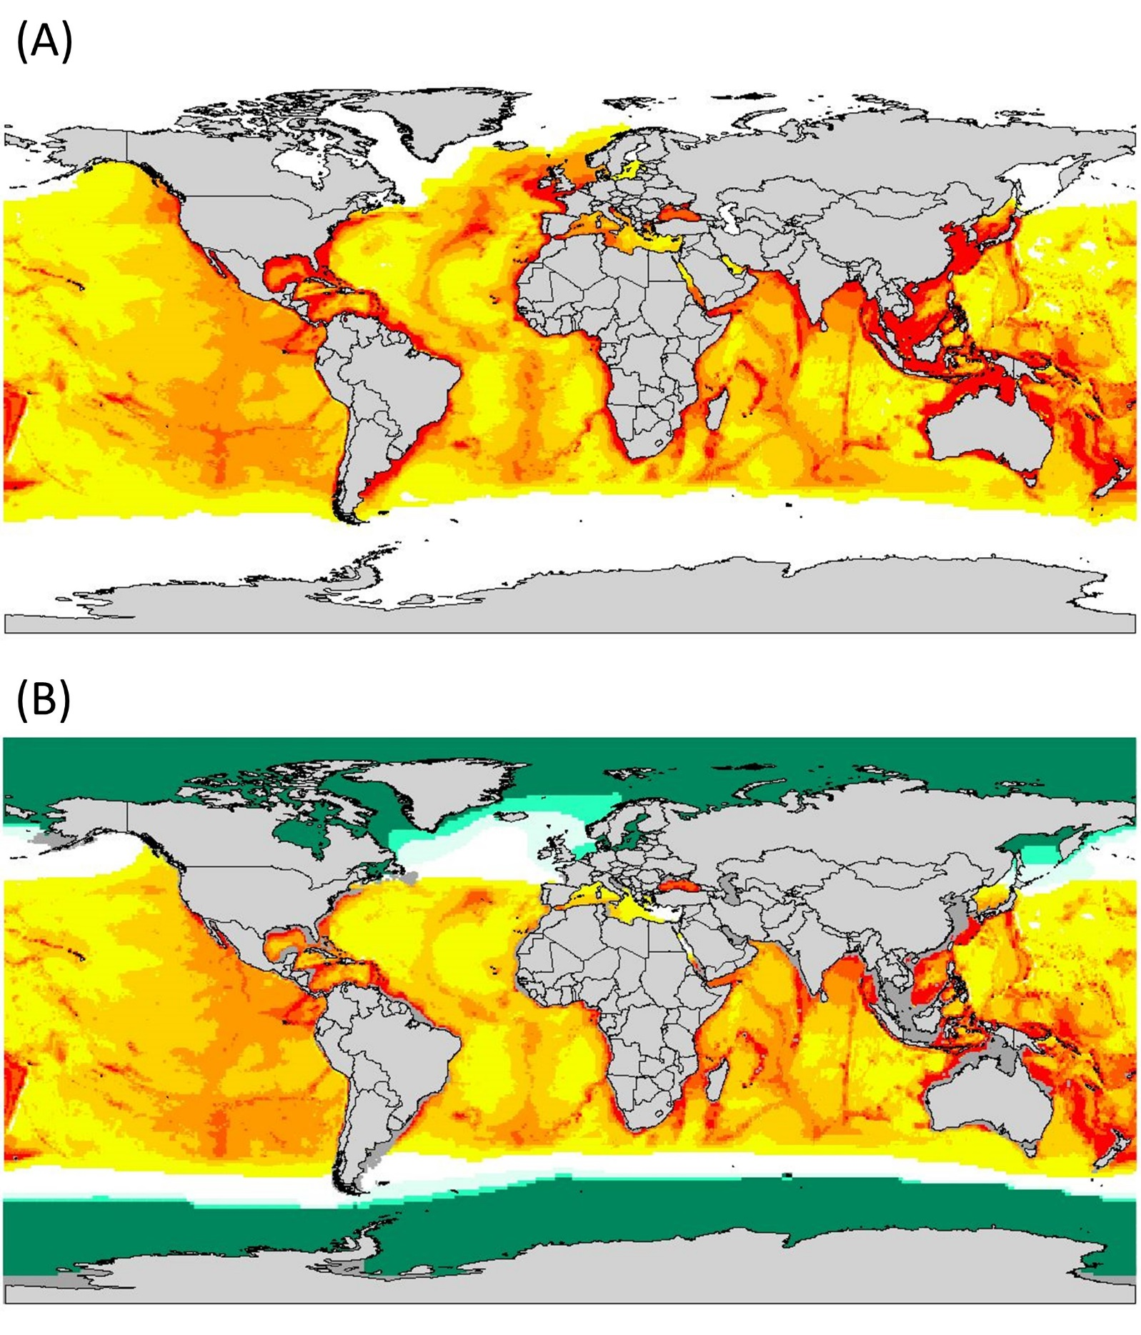

Appendix S3. AquaMaps world-wide suitable habitat map for T. truncatus for (a) the present day, and (b) the Last Glacial Maximum. White to red colors represent least to most suitable habitat, respectively, and land is shown in light gray. Dark green color in Fig. (b) represents areas with permanent ice sheet and light green color areas with >50% sea ice concentration.

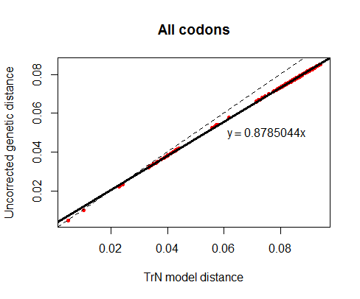
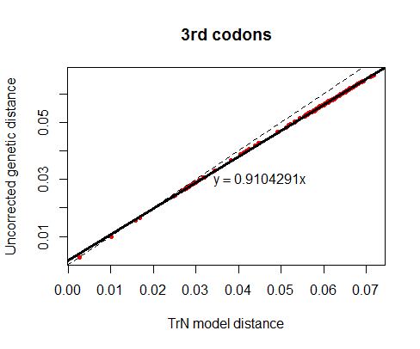

Appendix S4. Uncorrected and TrN model-corrected genetic distances in the aligment consisting of 13 protein coding mtDNA genes of 20 delphinids. Red dots are the data values and the solid line represents their correlation. Dashed line represents linear regression with a slope of 1.

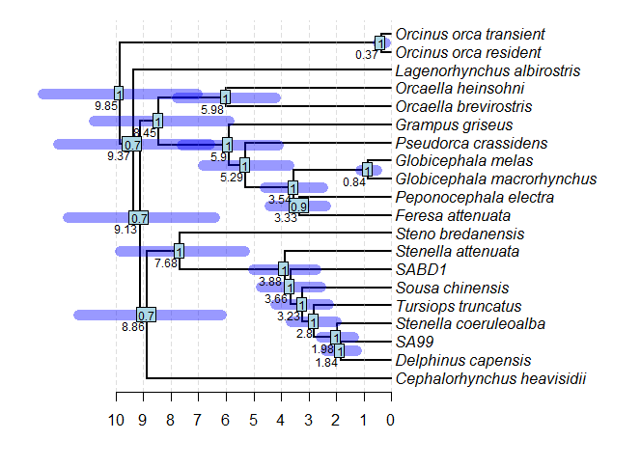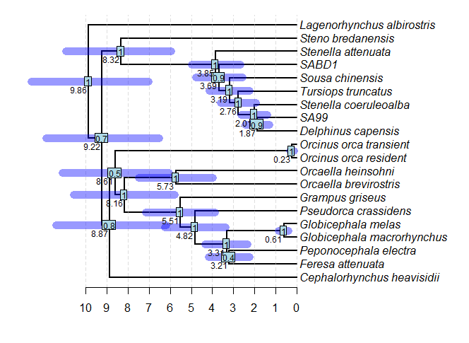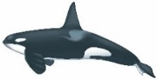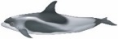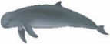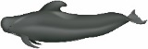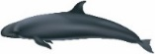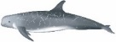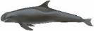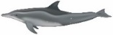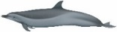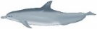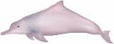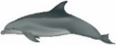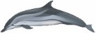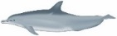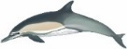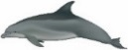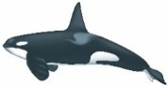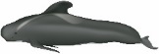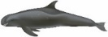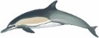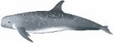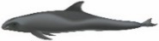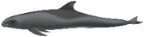
(A)
(B)
Myr
Myr

Appendix S5. Time-calibrated phylogenetic tree for delphinids inferred with StarBEAST2 strict clock model using 13 mitochondrial genes and including (A) all codon positions, and (B) only the third codon positions. The numbers in rectangles are node posterior probabilities, numbers below nodes the mean TMRCA, and the bars represent 95% HPDI in TMRCA. SABD1 and SA99 are the most divergent Tursiops haplotypes representing T. australis and T. aduncus haplotypes from South Australia and South Africa, respectively. Illustrations by Uko Gorter (http://ukogorter.com).
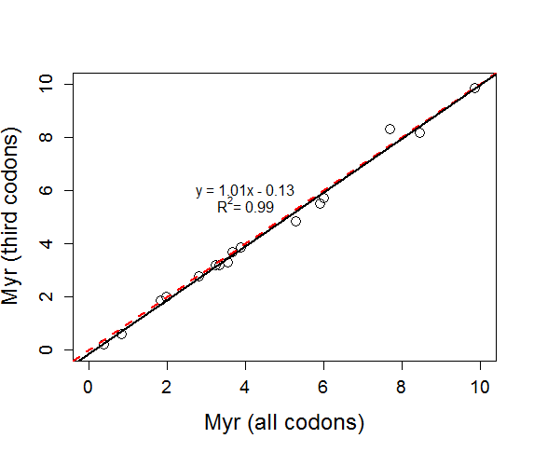

Appendix S6. Correlation of TMRCA (mean) of the common nodes inferred from two different BEAST2 models of delphinid time-calibrated phylogeny, a model including all codon positions and a model using only the third codon positions. The solid black line is fitted to the data, and the dashed red line represents perfect linear correlation with a slope of 1.

Appendix S7. The mean and Effective Sample Size (ESS) values for the different parameters in one run of the BEAST2 time-calibrated models for delphinids. The models were run with all codon positions and including only the third codon positions, both using a a strict clock.
All codon model |  |  |  | 3rd codon model
Statistic | Mean | ESS |  | Statistic | Mean | ESS
posterior | -43897.3 | 3276 |  | posterior | -23151.4 | 3249
likelihood | -43827.2 | 3563 |  | likelihood | -23044.3 | 2441
prior | -70.1 | 4348 |  | prior | -107.1 | 2539
treeLikelihood.atp6 | -2864.1 | 7353 |  | treeLikelihood.atp6_pos3 | -1434.6 | 2265
treeLikelihood.atp8 | -780.8 | 884 |  | treeLikelihood.atp8_pos3 | -391.8 | 1680
treeLikelihood.cox1 | -5340.5 | 5820 |  | treeLikelihood.cox1_pos3 | -3005.5 | 4141
treeLikelihood.cox2 | -2531.2 | 4681 |  | treeLikelihood.cox2_pos3 | -1357.1 | 3078
treeLikelihood.cox3 | -2835.7 | 3671 |  | treeLikelihood.cox3_pos3 | -1512.6 | 3019
treeLikelihood.cytb | -4482.6 | 1557 |  | treeLikelihood.cytb_pos3 | -2308.9 | 4368
treeLikelihood.nd1 | -3564.9 | 8629 |  | treeLikelihood.nd1_pos3 | -1873.1 | 6392
treeLikelihood.nd2 | -4189.5 | 8262 |  | treeLikelihood.nd2_pos3 | -2158.3 | 5069
treeLikelihood.nd3 | -1489.3 | 805 |  | treeLikelihood.nd3_pos3 | -758.1 | 5288
treeLikelihood.nd4 | -5244.0 | 6490 |  | treeLikelihood.nd4_pos3 | -2743.8 | 6143
treeLikelihood.nd4l | -1186.3 | 3252 |  | treeLikelihood.nd4l_pos3 | -573.4 | 3952
treeLikelihood.nd5 | -7345.2 | 2111 |  | treeLikelihood.nd5_pos3 | -3841.3 | 4088
treeLikelihood.nd6 | -1973.2 | 3415 |  | treeLikelihood.nd6_pos3 | -1085.9 | 1878
TreeHeight | 9.873 | 9001 |  | TreeHeight | 9.871 | 9001
kappa.1 | 43.627 | 5131 |  | kappa1.1 | 164.484 | 810
kappa.2 | 56.998 | 4669 |  | kappa1.2 | 107.570 | 1247
kappa.3 | 40.449 | 4330 |  | kappa1.3 | 49.071 | 1730
gammaShape.1 | 1.050 | 151 |  | kappa2.1 | 60.929 | 1424
gammaShape.2 | 0.628 | 426 |  | kappa2.2 | 58.129 | 1581
gammaShape.3 | 0.687 | 472 |  | kappa2.3 | 87.791 | 791
proportionInvariant.1 | 0.537 | 152 |  | proportionInvariant.1 | 0.077 | 2727
proportionInvariant.2 | 0.518 | 360 |  | gammaShape.1 | 3.515 | 3157
proportionInvariant.3 | 0.475 | 386 |  | gammaShape.2 | 1.163 | 5270
clockRate | 0.007 | 9001 |  | gammaShape.3 | 1.304 | 4056
CalibratedYuleModel | -41.426 | 9001 |  | clockRate | 0.017 | 8298
birthRateY | 0.075 | 9001 |  | CalibratedYuleModel | -41.325 | 8441
logP(mrca(root)) | -1.804 | 9001 |  | birthRateY | 0.082 | 8318
mrcatime(root) | 9.873 | 9001 |  | logP(mrca(root)) | -1.780 | 8528
 |  |  |  | mrcatime(root) | 9.871 | 9001
 |  |  |  | freqParameter.11 | 0.436 | 1135
 |  |  |  | freqParameter.12 | 0.333 | 1254
 |  |  |  | freqParameter.13 | 0.024 | 567
 |  |  |  | freqParameter.14 | 0.207 | 1890
 |  |  |  | freqParameter.21 | 0.421 | 1625
 |  |  |  | freqParameter.22 | 0.267 | 1903
 |  |  |  | freqParameter.23 | 0.050 | 987
 |  |  |  | freqParameter.24 | 0.261 | 1812
 |  |  |  | freqParameter.31 | 0.221 | 1674
 |  |  |  | freqParameter.32 | 0.032 | 579
 |  |  |  | freqParameter.33 | 0.239 | 1726
 |  |  |  | freqParameter.34 | 0.508 | 1289

Appendix S8. The mean and Effective Sample Size (ESS) for the different parameters in one run of the StarBEAST2 time-calibrated models for genus Tursiops. The models were run with all codon positions and including only the third codon positions, both using a a strict clock.
All codon model |  |  |  | 3rd codon model
Parameter | Mean | ESS |  | Parameter | Mean | ESS
posterior | -22073.5 | 3304 |  | posterior | -8807.4 | 3636
likelihood | -22162.6 | 7438 |  | likelihood | -8899.4 | 7238
prior | -11.517 | 2572 |  | prior | -34.2 | 2577
speciescoalescent | 100.6 | 4074 |  | speciescoalescent | 126.3 | 4545
TreeHeight.Species | 3.649 | 8899 |  | TreeHeight.Species | 3.670 | 8290
TreeHeight.t:all_codon_tree | 3.845 | 8854 |  | TreeHeight.t:tree | 3.807 | 8786
TreeLength.Species | 11.209 | 4928 |  | TreeLength.Species | 11.195 | 6404
treeLikelihood.atp6 | -1441.9 | 7567 |  | treeLikelihood.atp6_pos3 | -582.6 | 7775
treeLikelihood.atp8 | -355.4 | 7044 |  | treeLikelihood.atp8_pos3 | -167.0 | 6756
treeLikelihood.cox1 | -2845.1 | 8184 |  | treeLikelihood.cox1_pos3 | -1162.9 | 7452
treeLikelihood.cox2 | -1318.7 | 6659 |  | treeLikelihood.cox2_pos3 | -529.5 | 6822
treeLikelihood.cox3 | -1496.3 | 7264 |  | treeLikelihood.cox3_pos3 | -576.7 | 8002
treeLikelihood.cytb | -2299.1 | 7455 |  | treeLikelihood.cytb_pos3 | -910.2 | 7293
treeLikelihood.nd1 | -1862.7 | 8559 |  | treeLikelihood.nd1_pos3 | -700.8 | 6585
treeLikelihood.nd2 | -1984.9 | 5407 |  | treeLikelihood.nd2_pos3 | -782.9 | 7265
treeLikelihood.nd3 | -702.8 | 7521 |  | treeLikelihood.nd3_pos3 | -313.1 | 7454
treeLikelihood.nd4 | -2609.5 | 7964 |  | treeLikelihood.nd4_pos3 | -1028.2 | 7101
treeLikelihood.nd4l | -623.0 | 7060 |  | treeLikelihood.nd4l_pos3 | -252.8 | 7906
treeLikelihood.nd5 | -3620.9 | 6398 |  | treeLikelihood.nd5_pos3 | -1464.3 | 7281
treeLikelihood.nd6 | -1002.3 | 7114 |  | treeLikelihood.nd6_pos3 | -428.5 | 7983
strictClockRate.c:strict | 0.007 | 7827 |  | strictClockRate.c:strict | 0.017 | 8973
kappa.s:p1 | 47.112 | 8833 |  | kappa1.s:p1 | 226.7 | 7327
kappa.s:p2 | 77.472 | 8927 |  | kappa1.s:p2 | 112.7 | 7354
kappa.s:p3 | 40.724 | 8911 |  | kappa1.s:p3 | 19.867 | 8251
gammaShape.s:p2 | 0.081 | 8630 |  | kappa2.s:p1 | 65.249 | 7476
CalibratedYuleModel.t:Species | -3.202 | 2930 |  | kappa2.s:p2 | 47.706 | 7245
cySpeciationRate.t:Species | 2.120 | 329 |  | kappa2.s:p3 | 52.082 | 8382
proportionInvariant.s:p1 | 0.779 | 8795 |  | gammaShape.s:p1 | 1.322 | 8858
proportionInvariant.s:p3 | 0.774 | 8997 |  | proportionInvariant.s:p2 | 0.408 | 8445
logP(mrca(root_species)) | -0.782 | 9001 |  | CalibratedYuleModel.t:Species | -3.150 | 2014
mrcatime(root_species) | 3.649 | 8899 |  | cySpeciationRate.t:Species | 2.042 | 325
lwcrPopScale.Species | 0.090 | 2039 |  | logP(mrca(root_species)) | -0.829 | 9001
 |  |  |  | mrcatime(root_species) | 3.670 | 8290
 |  |  |  | lwcrPopScale.Species | 0.065 | 2575

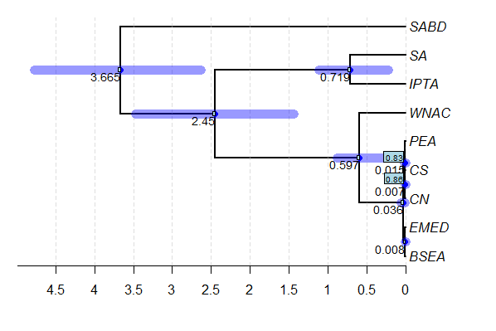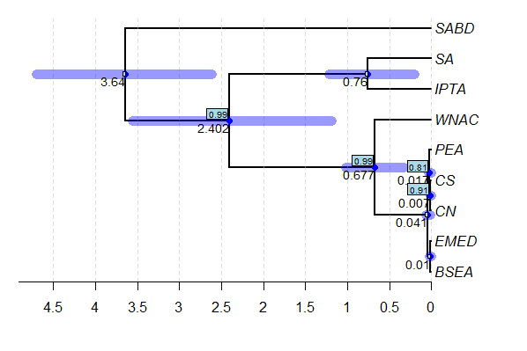
Myr
Myr
(A)
(B)

Appendix S9. Time-calibrated phylogenetic species tree for genus Tursiops inferred with StarBEAST2 using (A) all codon positions, and (B) only the third codon positions, from 13 mitochondrial protein coding genes. The numbers below nodes are mean divergence times, and the boxed numbers node posterior probabilities, if <1.0. The bars represent 95% HPDI. The tips represent current species/populations and their sampling locations: SABD – T. australis, South Australia, SA – T. aduncus, South Africa, IPTA – T. aduncus, Southeast Australia, WNAC – T. truncatus, coastal Northwest Atlantic, PEA – T. truncatus, pelagic Northeast Atlantic, CS – T. truncatus, Coastal South (Northeast Atlantic), CN – T. truncatus, Coastal North (Northeast Atlantic), EMED – T. truncatus, Eastern Mediterranean Sea, BSEA – T. truncatus ponticus, Black Sea.

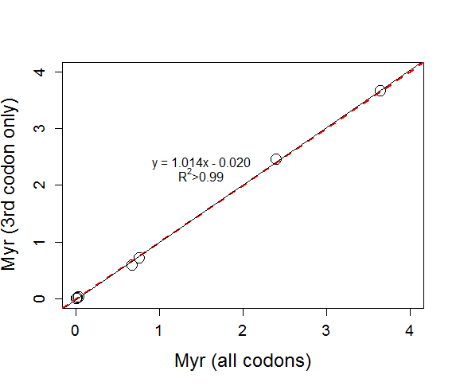

Appendix S10. Correlation of average TMRCA of the common nodes in Tursiops gene trees inferred using two different StarBEAST2 models, a model including all codon positions and a model using only the third codon positions. The solid black line is fitted to the data, and the dashed red line represents perfect linear correlation with a slope of 1.

Appendix S11. Effective population sizes (N_{e}) for each branch in the phylogenetic tree presented in Fig. 3 of the main article.
 | N_{e}
Branch | Start | End
PEA | 11614 | 20829
CS | 6571 | 11838
CN | 224 | 13300
EMED | 3424 | 15510
BSEA | 548 | 5214
PEA-CS-CN | 18057 | 23786
CS-CN | 12171 | 6795
EMED-BSEA | 17686 | 3971
Root | 14276 | 35743
Start/end: Effective population size (N_{e}) adjusted by the generation time, 21 years, at the start (older) and the end (more recent time) of the branch

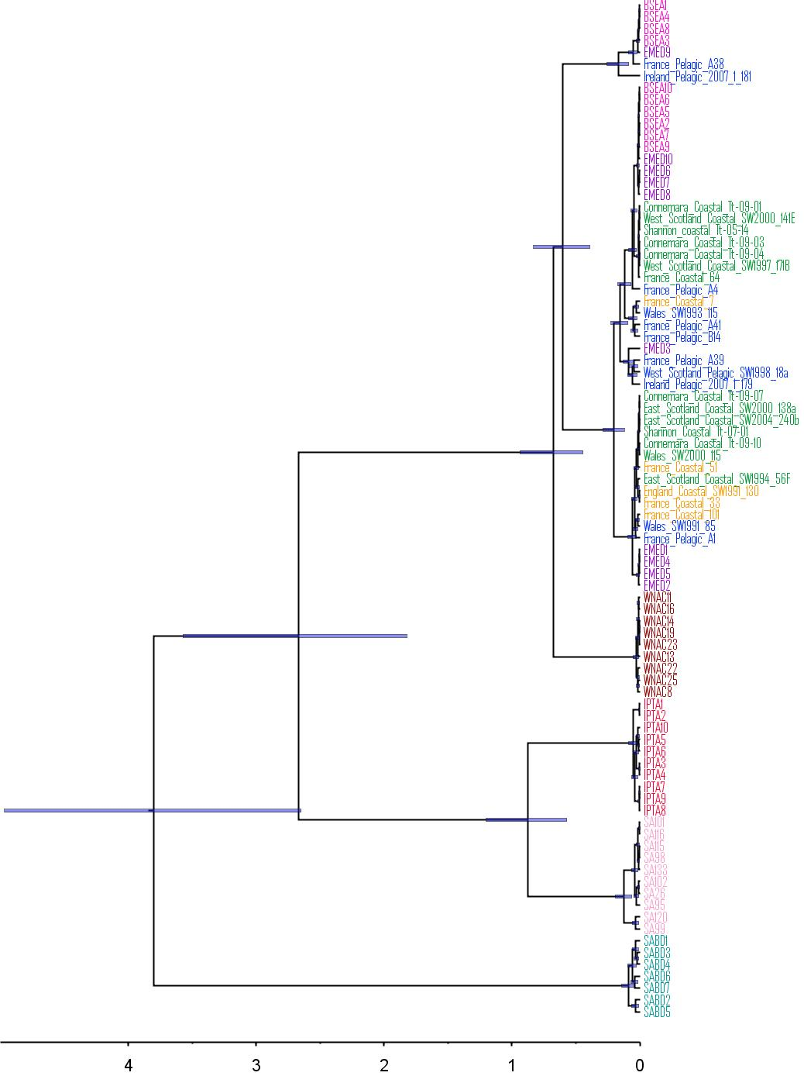
1.0
1.0
1.0
1.0
1.0
1.0
1.0
1.0
1.0
1.0
1.0
1.0
1.0
1.0
1.0
1.0
0.91
Myr

Appendix S12. Time-calibrated consensus gene tree of genus Tursiops inferred with StarBEAST2 using third codon positions from 13 mitochondrial genes. The tips of the tree are individual samples that have been coloured according to their species/population assignment based on nuclear markers. Pink – T. truncatus ponticus, Black Sea, purple – T. truncatus, Eastern Mediterranean, blue – T. truncatus, pelagic Atlantic, green – T. truncatus, Coastal North, orange – T. truncatus, Coastal South, burgundy – T. truncatus, Coastal NW Atlantic, red – T. aduncus, Southeast Australia, pink – T. aduncus, South Africa, turquoise – T. australis, South Australia. The numbers above nodes are node posterior probabilities for the main clades and the bars represent 95% HPDI.
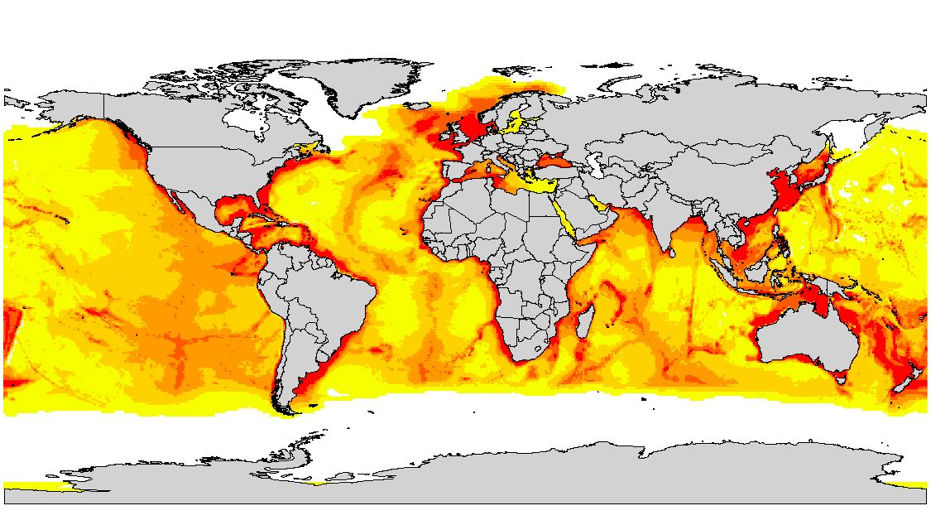

Appendix S13. AquaMaps suitable habitat map for T. truncatus for the year 2100. White to red colours represent least to most suitable habitat, respectively. Land is shown in light grey.

References
Arnason, U., Gullberg, A. & Janke, A. 2004. Mitogenomic analyses provide new insights into cetacean origin and evolution. Gene 333: 27–34.
Charlton-Robb, K., Taylor, A.C. & McKechnie, S.W.M. 2006. A note on divergent mtDNA lineages of bottlenose dolphins from coastal waters of southern Australia. J. Cetacean Res. Manag. 8: 173–179.
Hassanin, A., Delsuc, F., Ropiquet, A., Hammer, C., Jansen van Vuuren, B., Matthee, C., et al. 2012. Pattern and timing of diversification of Cetartiodactyla (Mammalia, Laurasiatheria), as revealed by a comprehensive analysis of mitochondrial genomes. C. R. Biol. 335: 32–50.
Hoelzel, A.R., Potter, C.W. & Best, P.B. 1998. Genetic differentiation between parapatric ‘nearshore’and ‘offshore’populations of the bottlenose dolphin. Proc. R. Soc. Lond. B Biol. Sci. 265: 1177–1183.
Islas-Villanueva, V. 2010. Genetic Characterisation and Social Structure of the East Scotland Population of Bottlenose Dolphins (Tursiops truncatus). University of St Andrews, St Andrews, Scotland.
Louis, M., Viricel, A., Lucas, T., Peltier, H., Alfonsi, E., Berrow, S., et al. 2014. Habitat-driven population structure of bottlenose dolphins, Tursiops truncatus , in the North-East Atlantic. Mol. Ecol. 23: 857–874.
Mirimin, L., Miller, R., Dillane, E., Berrow, S.D., Ingram, S., Cross, T.F., et al. 2011. Fine-scale population genetic structuring of bottlenose dolphins in Irish coastal waters: Population genetic structure of bottlenose dolphins. Anim. Conserv. 14: 342–353.
Möller, L.M. & Beheregaray, L.B. 2001. Coastal bottlenose dolphins from Southeastern Australia are Tursiops aduncus according to sequences of the mitochondrial DNA control region. Mar. Mammal Sci. 17: 249–263.
Möller, L.M., Bilgmann, K., Charlton-Robb, K. & Beheregaray, L. 2008. Multi-gene evidence for a new bottlenose dolphin species in southern Australia. Mol. Phylogenet. Evol. 49: 674–681.
Morin, P.A., Archer, F.I., Foote, A.D., Vilstrup, J., Allen, E.E., Wade, P., et al. 2010. Complete mitochondrial genome phylogeographic analysis of killer whales (Orcinus orca) indicates multiple species. Genome Res. 20: 908–916.
Moura, A.E., Nielsen, S.C.A., Vilstrup, J.T., Moreno-Mayar, J.V., Gilbert, M.T.P., Gray, H.W.I., et al. 2013. Recent Diversification of a Marine Genus (Tursiops spp.) Tracks Habitat Preference and Environmental Change. Syst. Biol. 62: 865–877.
Natoli, A., Birkun, A., Aguilar, A., Lopez, A. & Hoelzel, A.R. 2005. Habitat structure and the dispersal of male and female bottlenose dolphins (Tursiops truncatus). Proc. R. Soc. B Biol. Sci. 272: 1217–1226.
Natoli, A., Peddemors, V.M. & Hoelzel, A.R. 2004. Population structure and speciation in the genus Tursiops based on microsatellite and mitochondrial DNA analyses. J. Evol. Biol. 17: 363–375.
Nykänen, M., Dillane, E., Englund, A., Foote, A.D., Ingram, S.N., Louis, M., et al. 2018. Quantifying dispersal between marine protected areas by a highly mobile species, the bottlenose dolphin, Tursiops truncatus. Ecol. Evol., doi: 10.1002/ece3.4343.
Wang, J.Y., Chou, L.S. & White, B.N. 1999. Mitochondrial DNA analysis of sympatric morphotypes of bottlenose dolphins (genus : Tursiops) in Chinese waters. Mol. Ecol. 8: 1603–1612.
Xiong, Y., Brandley, M.C., Xu, S., Zhou, K. & Yang, G. 2009. Seven new dolphin mitochondrial genomes and a time-calibrated phylogeny of whales. BMC Evol. Biol. 9: 20.

