Supporting Information
Synthesis of a Diaryliodonium Salt and Its Use in the Direct Arylation of Indole: A Two-Step Experiment for the Organic Teaching Laboratory
Aisling M. Prendergastª, Rachel Shanahanª, Aobha Hickeyª, Francis Harringtonª, David Schönbauer,^{b} Peter A. Byrne^{a,c}, Michael Schnürch^{b} and Gerard P. McGlacken^{a,c}*
ªSchool of Chemistry and Analytical & Biological Chemistry Research Facility (ABCRF), University College Cork, College Road, Cork, Ireland
^{b}Institute of Applied Synthetic Chemistry, TU Wien, Getreidemarkt 9/163-OC, Vienna 1060, Austria
^{c}Solid State Pharmaceutical Centre, Cork, Ireland.
Contents
Student Instructions S2
Experimental Details S2
Hazards S4
General Experimental S5
Spectroscopic Details S5
Spectra S7
Instructors' Notes SError! Bookmark not defined.
Pedagogical Goals………………………………………………………………………………………………………S9
Learning Outcomes……………………………………………………………………………………………………S9
First Approach to Quantification of Achievement of Learning Outcomes…………………S10
Second Approach to Quantification of Achievement of Learning Outcomes………......S13
Pre-Experiment Assessment used in repetition 4 of the experiment (UCC 2019)……..S16
Post-Experiment Assessment used in repetition 4 of the experiment (UCC 2019)……S18
Pre-Experiment Assessment used in TUW 2019 and UCC 2018………………………………..S20
Post-Experiment Assessment used in TUW 2019 and UCC 2018……….……………………...S22
Student Report……………………………………………………………………………………………………......S23
Results of Post-experiment Survey…………………………………………………………………………………………….…..S27
Discussion on Mechanism………………………………………………………………………………………………………………S28
Further reactions………………………………………………………………………………………..………………………………….S28
References S28
Student Instructions

Experimental Details
Title:
Synthesis of a diaryliodonium salt and its application in a direct arylation reaction
Aims and Objectives:
The aim of this experiment is to (a) synthesise a diaryliodonium salt; (b) employ the diaryliodonium salt in a direct arylation reaction and (c) assess the success of the reaction, the regiospecificity of indole arylation and the purity of the product.
Background:
Cross-coupling reactions, such as the Suzuki-Miyaura reaction, using transition metal catalysts are among the most utilised methods for forming bonds between aromatic groups. However, these traditional reactions require both coupling partners to be activated, e.g. the Suzuki-Miyaura uses aryl boronic acids and aryl halides. The term direct arylation via C–H activation implies the formation of bonds between aromatic groups while avoiding the activation of one or both coupling partners, which reduces the amount of waste. Direct arylation has been a very popular area of research over the last decade. In this experiment, you will synthesise a diaryliodonium salt. You will then apply this as the activated coupling partner in a reaction with unactivated indole. The reaction utilises a palladium catalyst.
Session 1 (3 h):
Reaction 1: Synthesis of a diaryliodonium salt
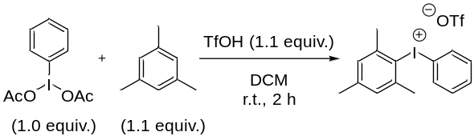
Add phenyliodo(III)diacetate (PIDA) (3.2 g, 10 mmol), mesitylene (1.5 mL, 11 mmol) and dry dichloromethane (20 mL) to a 100 mL round-bottomed flask. Using an ice bath, cool the mixture to 0 °C with stirring. Add trifluoromethanesulfonic acid (1 mL) slowly to the stirring solution. Once addition is complete, stir the mixture for 1 h. Remove the flask from the ice bath and stir at ambient temperature for a further 1 h. Concentrate the reaction mixture under reduced pressure to give a residue. Add diethyl ether (15 mL) to the residue and a solid should precipitate. Isolate the solid on a Büchner funnel and wash with diethyl ether (3 x 10 mL), or until the filtrate runs clear of coloured components. Spread the solid on a clock glass and leave open to air to dry until the next practical session.
The solid can also be dried in a glassware oven. To check for stability, the solid was stored in an oven at 65 °C for several days. After this time the sample was checked by ¹H NMR and was not degraded.
Session 2 (3 h):
Determine the weight of the diaryliodonium salt product. Yields can be expected in the range of 80-100% (actual yield range was 80-100% - some of these yields were inflated by improper drying). The product was analyzed by obtaining the melting point (lit.¹ 149-150 °C). ¹H NMR spectra were also recorded for some students. NMR samples were prepared by placing a small amount of product (small spatula tip, not weighed) in a sample vial and subsequently adding CDCl₃ (0.7 mL). The resulting solution was filtered through cotton wool (cotton wool placed in a Pasteur pipette) into an NMR tube.
Reaction 2: Direct arylation of indole
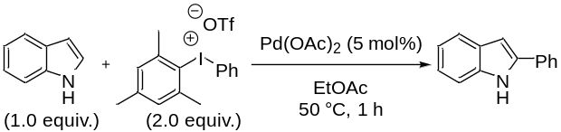
Add indole (0.3 g, 2.6 mmol), diaryliodonium salt (2.4 g, 5.1 mmol), Pd(OAc)₂ (29 mg, 0.13 mmol) and EtOAc (10 mL) to a 50 mL round-bottomed flask. Clamp the flask and heat to 50 °C with stirring. Stir the mixture at this temperature for 1 h. Perform TLC on a sample of the reaction mixture (R_{f} starting material 0.49, R_{f} product 0.53, 80:20 cyclohexane:EtOAc). Once the starting material is confirmed to be fully consumed, remove the flask from the heat and allow the mixture to cool to ambient temperature. Transfer the reaction mixture to a separating funnel and rinse the reaction vessel with EtOAc. Wash the combined organic components with saturated aqueous NaHCO₃ (15 mL) and brine (15 mL), dry over MgSO₄ and filter. Add celite (2 spoons) to the organic layers. Concentrate under reduced pressure to yield a dry, free-flowing powder. You may need to use your spatula to loosen the celite from the walls of the round-bottomed flask.
Session 3 (3 h):
Load the celite onto a column of silica (45 mL of dry silica was used), and elute the product with 95:5 cyclohexane:EtOAc (400 mL), collecting fractions of approx. 15 mL in test tubes. Concentrate the fractions containing the product (R_{f} product 0.16, 95:5 cyclohexane:EtOAc) under reduced pressure to yield a white solid, which is essentially pure product. A yield of approximately 40% can be expected (actual average yield was 51%). The product was analyzed by ¹H NMR spectroscopy to determine purity and regioselectivity.
NMR samples were prepared by placing a small amount of product (small spatula tip, not weighed) in a sample vial and subsequently adding CDCl₃ (0.7 mL). The resulting solution was filtered through cotton wool (cotton wool placed in a Pasteur pipette) into a NMR tube.
It should be emphasised to students that care must be taken to ensure complete removal of residual solvent.

Hazards
Cyclohexane: [110-82-7] Highly flammable liquid and vapour, may be fatal if swallowed and enters airways, causes skin irritation, may cause drowsiness or dizziness, very toxic to aquatic life with long lasting effects.
Phenyliodo(III)diacetate: [3240-34-4] Not considered a hazardous substance or mixture.
Mesitylene: [108-67-8] Flammable liquid and vapour, causes skin irritation, may cause respiratory irritation, toxic to aquatic life with long lasting effects.
Trifluoromethanesulfonic acid: [1493-13-6] Harmful if swallowed or in contact with skin, causes severe skin burns and eye damage.
Dichloromethane: [75-09-2] Causes skin irritation, causes serious eye irritation, may cause respiratory irritation, may cause drowsiness or dizziness, suspected of causing cancer, may cause damage to organs (Liver, Blood) through prolonged or repeated exposure if swallowed, may cause damage to organs (Central nervous system) through prolonged or repeated exposure if inhaled.
Diethyl ether: [60-29-7] Extremely flammable liquid and vapour, harmful if swallowed, may cause drowsiness or dizziness.
Diaryliodonium salt: [144930-50-7] Toxic if swallowed, causes skin irritation, causes serious eye irritation, may cause respiratory irritation.
Indole: [120-72-9] Harmful if swallowed, toxic in contact with skin, causes skin irritation, causes serious eye damage, may cause respiratory irritation, very toxic to aquatic life.
Palladium(II) acetate: [3375-31-3] Causes serious eye damage.
Ethyl acetate: [141-78-6] Highly flammable liquid and vapour, causes serious eye irritation, may cause drowsiness or dizziness.
Sodium bicarbonate: [144-55-8] Not considered a hazardous substance or mixture.
Chloroform-d: [865-49-6] Potential carcinogen, harmful if swallowed, causes skin irritation, causes serious eye irritation, toxic if inhaled, suspected of causing cancer, suspected of damaging the unborn child, causes damage to organs through prolonged or repeated exposure.
Please treat the isolated phenyl indole and all side/by-products as toxic and avoid contact with skin.

General Experimental
Dichloromethane was dried by storing it over activated 4Å molecular sieves overnight.
All other solvents and reagents were used as obtained from commercial sources and without purification. Wet flash column chromatography was carried out using silica gel 60, 0.040-0.063 μm (Merck). TLC was carried out on pre-coated silica gel plates (Merck 60 PF254). Visualisation was achieved by UV light. NMR spectra were run in CDCl₃ using TMS as the internal standard at 25 °C. ¹H NMR (300 MHz) spectra and ¹³C{¹H} NMR (75 MHz) were recorded on a Bruker Avance 300 NMR spectrometer, and ¹H NMR (400 MHz) spectra were recorded on a Bruker Avance 400 NMR spectrometer at University College Cork. Chemical shifts (δ_{H} and δ_{C}) are expressed as parts per million (ppm), positive shift being downfield from TMS; coupling constants (J) are expressed in hertz (Hz). Splitting patterns in ¹H NMR spectra are designated as s (singlet), bs (broad singlet), d (doublet), dd (doublet of doublets), ddd (doublet of doublet of doublets), t (triplet), q (quartet) and m (multiplet). For ¹³C NMR spectra, the number of attached protons for each signal was determined using the DEPT pulse sequence run in the DEPT-90 and DEPT-135 modes. LCMS were recorded on a Waters Quattro Micro triple quadrupole instrument in ESI mode using 50% acetonitrile-water containing 0.1% formic acid as eluent; samples were made up in acetonitrile or methanol. HRMS were recorded on a Waters LCT Premier Tof LC-MS instrument in ESI mode using 50% acetonitrile-water containing 0.1% formic acid as eluent; samples were made up in acetonitrile or methanol.

Spectroscopic Details
Mesityl(phenyl)iodonium trifluoromethanesulfonate¹
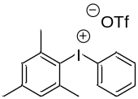
¹H NMR (300 MHz, CDCl₃) δ 7.70 (dd, J = 8.5, 1.0 Hz, 2H), 7.54 (t, J = 7.4 Hz, 1H), 7.40 (dd, J = 10.6, 4.8 Hz, 2H), 7.11 (s, 2H), 2.62 (s, 6H), 2.36 (s, 3H); ¹³C NMR (75 MHz) δ 144.5 (qC), 142.6 (2×qC), 133.0 (2×CH), 132.3 (2×CH), 131.8 (CH), 130.4 (2×CH), 120.3 (qC), 111.7 (qC), 27.1 (2×CH₃), 21.1 (CH₃); m/z (ES+): 323 ((M−OTf)⁺) 100%; m.p. (lit.¹ 149–150 °C) 138–142 °C.

2-phenyl-1H-indole²
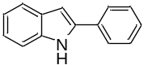
¹H NMR (300 MHz, CDCl₃) δ 8.29 (br s, 1H), 7.72 – 7.58 (m, 3H), 7.49 – 7.27 (m, 4H), 7.22 – 7.06 (m, 2H), 6.82 (dd, J = 2.1, 0.9 Hz, 1H); ¹³C NMR (75 MHz) δ 137.9 (qC), 136.9 (qC), 132.4 (qC), 129.3 (qC), 129.1 (2×CH), 127.7 (CH), 125.2 (2×CH), 122.4 (CH), 120.7 (CH), 120.3 (CH), 110.9 (CH), 100.0 (CH); m.p. (lit.³ 178–180 °C) 170–175 °C.
In terms of NMR signal assignments, students were expected to generate the above NMR data description as well as identify and explain key diagnostic signals including the alkyl signals and aromatic signals. Students were not expected to individually assign all aromatic signals. Students were typically able to perform this task. Some guidance was given by the instructor at the pre-laboratory talk.

Spectra
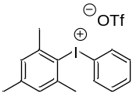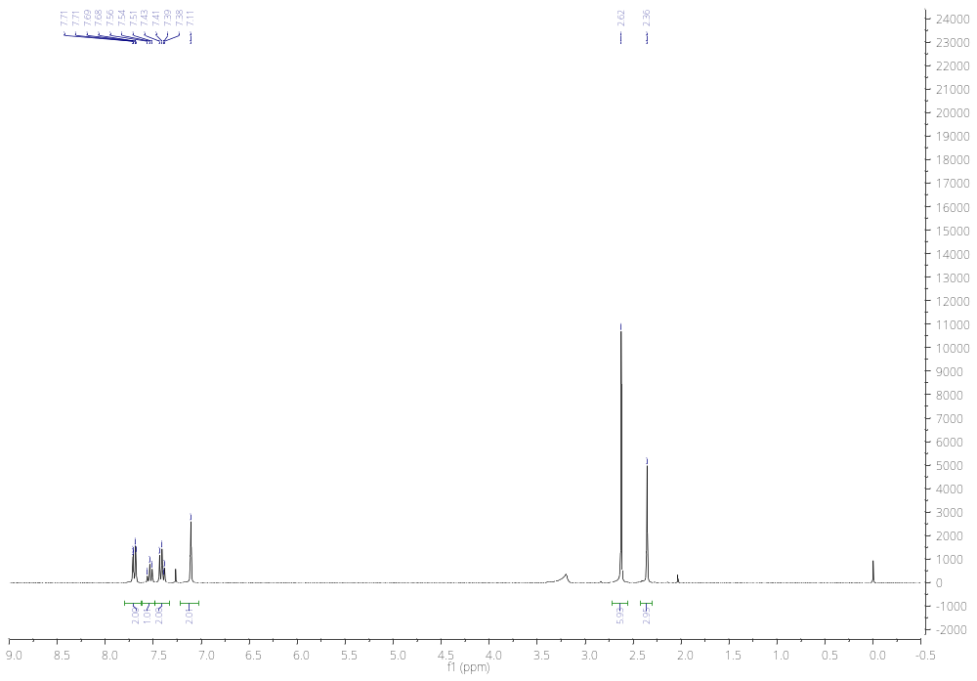
CH₃
2 x CH₃
Figure S1. ¹H NMR spectrum (CDCl₃, 300 MHz) of diaryliodonium salt.

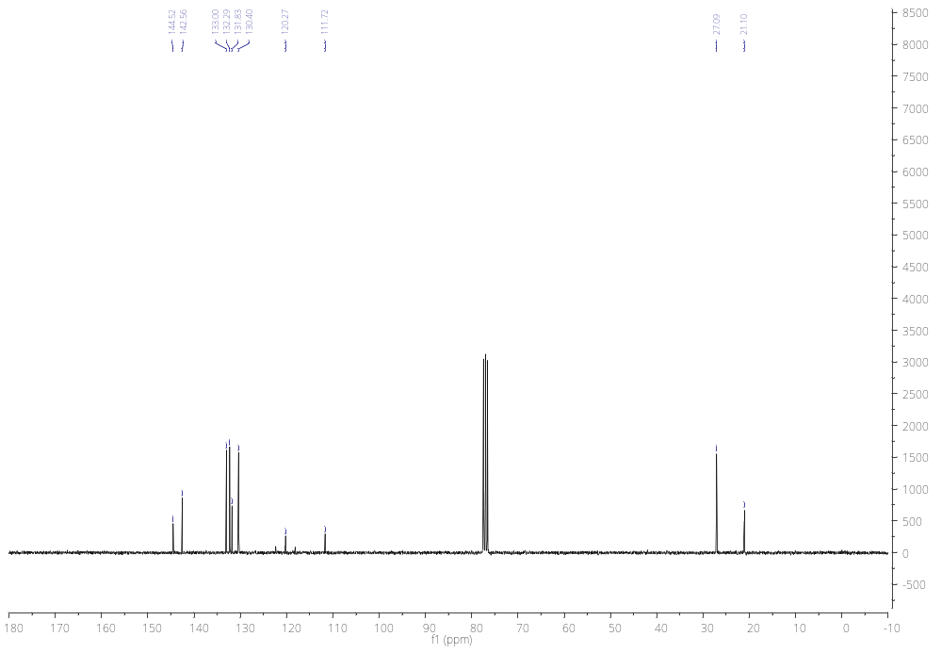
2 x CH₃
CH₃
Figure S2. ¹³C NMR spectrum (CDCl₃, 75 MHz) of diaryliodonium salt.

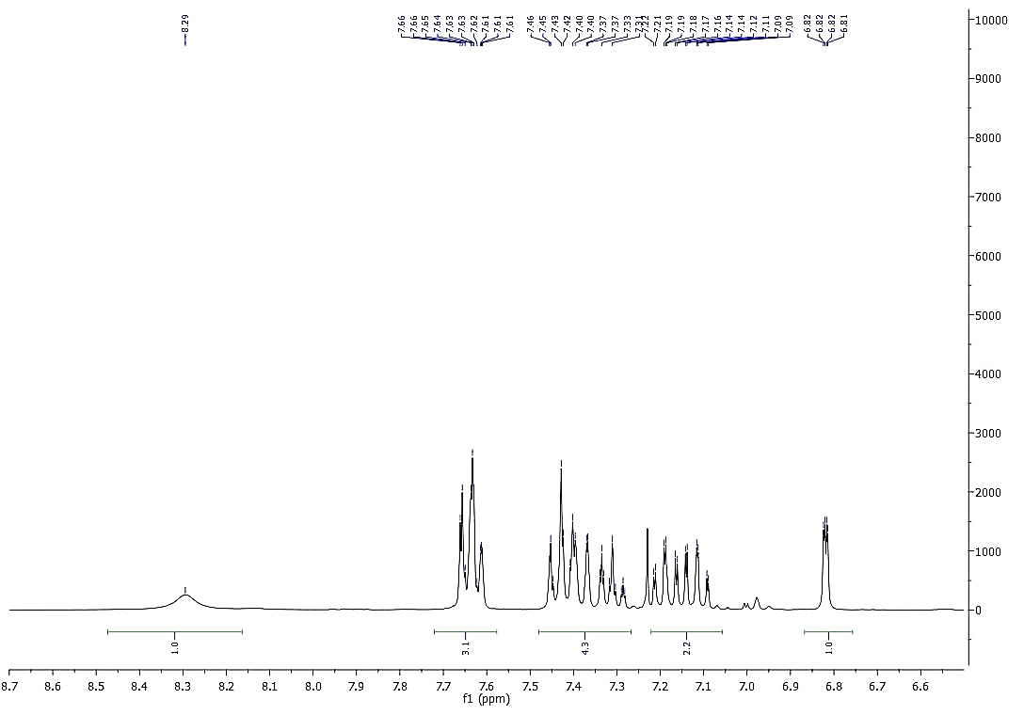
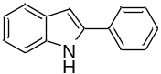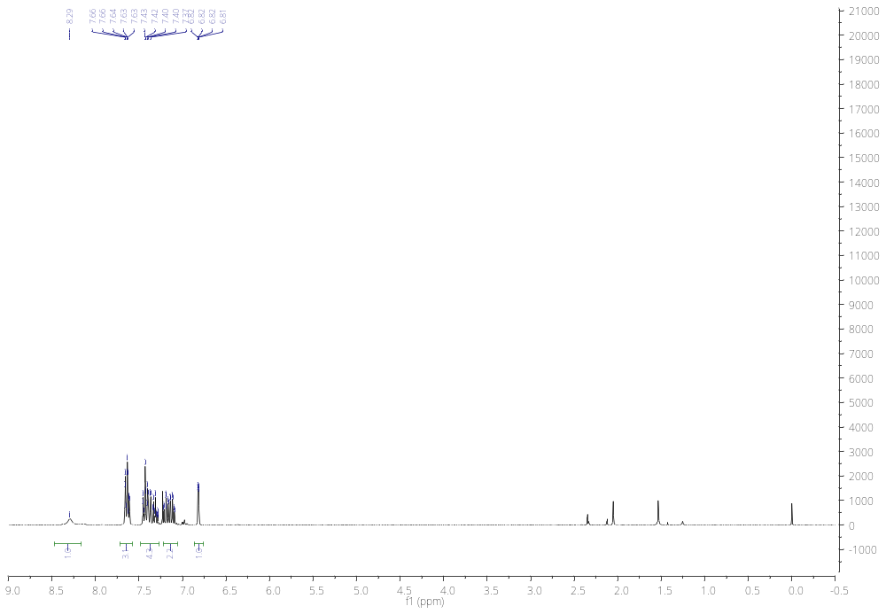
Figure S3. ¹H NMR spectrum (CDCl₃, 300 MHz) of 2-phenylindole.
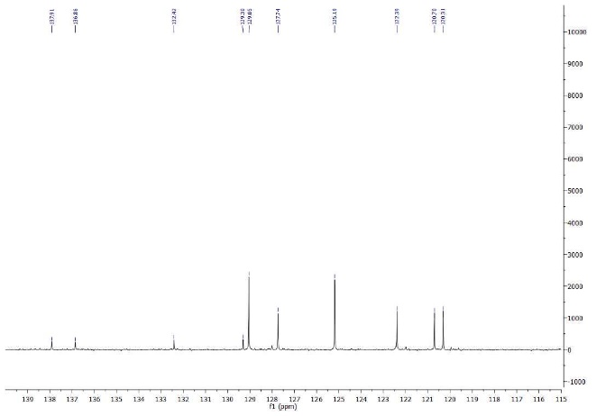
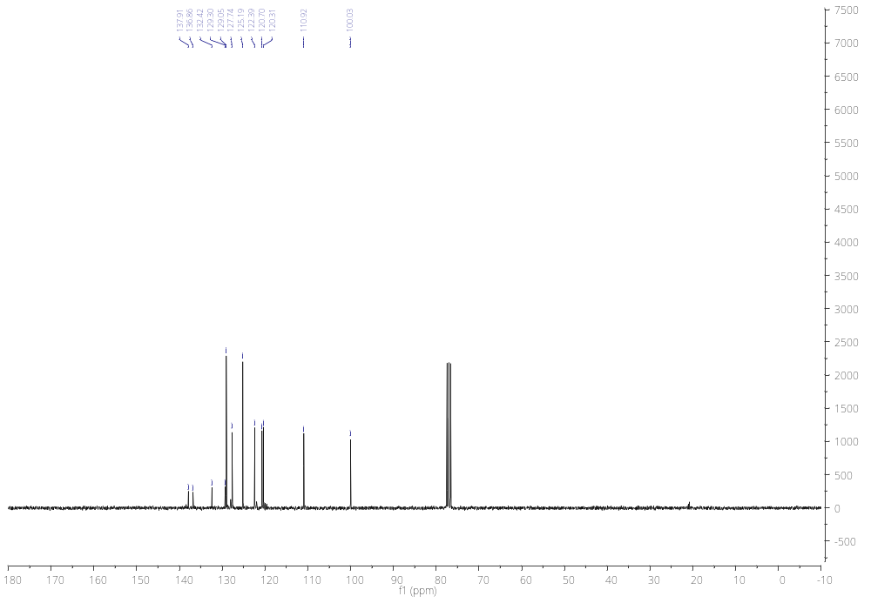
Figure S4. ¹³C NMR spectrum (CDCl₃, 75 MHz) of 2-phenylindole.

Instructors’ Notes
Pedagogical Goals
Our aim in running this experiment was to achieve the following pedagogical goals:
- To develop the students’ knowledge of transition-metal-catalyzed cross-coupling chemistry.
- To enhance the students’ facility in understanding the concept of catalysis.
- To introduce students to the potential benefits of realising cross-coupling transformations through C—H functionalisation or otherwise without pre-activation of one or more of the coupling partners.
- To improve the students’ abilities to analyze and interpret NMR spectra, and hence assign signals to structure(s) of starting materials, products and side-products.
- To ensure that students develop the skills necessary for multi-step syntheses and understand the necessity for these skills – good lab practice, ensuring high yield and purity of intermediate products.
- To develop students’ abilities to analyze unfamiliar problems and apply the knowledge they acquire through this experiment.
Learning Outcomes
Associated with the above pedagogical goals were a series of intended learning outcomes, which, if our pedagogical goals were fulfilled, should be achieved by participating students by the end of the experiment. Our aim was to ensure that upon completion of their experiment and associated work, each student should be able to achieve the following learning outcomes:
- Describe cross-coupling and direct arylation reactions (linked to pedagogical goals 1 and 2).
- Demonstrate an understanding of catalysis (linked to pedagogical goal 2).
- Explain the potential improvements that direct arylation by C—H functionalisation offers over traditional cross-coupling (linked to pedagogical goal 3).
- Demonstrate an ability to assign signals in NMR spectra to specific atoms/groups in a compound, and hence establish/confirm the structure of the compound (linked to pedagogical goal 4).
- Explain how one would tell that the starting material was consumed and the product formed using ¹H NMR spectroscopy (linked to pedagogical goal 4).
- Demonstrate an ability to distinguish between regioisomeric products using NMR spectroscopy (linked to pedagogical goal 4).
- Demonstrate an understanding of multi-step synthesis (linked to pedagogical goal 5).
- Analyze the reagents, catalyst(s) and reaction conditions used and evaluate how the reactions they had attempted could be improved, e.g. in terms of yield, “greenness”, prevention of contamination, etc. (linked to pedagogical goal 6).
- Analyze unfamiliar cross-coupling and direct arylation reactions, and predict the products that would be likely to form in such reactions (linked to pedagogical goal 6).
A detailed appraisal of the extent to which the pedagogical goals and learning outcomes were fulfilled is given in the main article. Additional material that was used to inform our appraisal is provided below.

First Approach to Quantification of Achievement of Learning Outcomes (UCC 2018, TUW 2019)
(i) Evaluation of Learning Outcomes 1-3 via Assessment Before and After Introductory Lectures
In two instances (UCC 2018 and TUW 2019) in which the experiment was run (involving a total of 17 students), participating students were introduced to the relevant background material (transition metal catalyzed cross-coupling, C—H functionalization) through delivery of 1 – 3 lectures on these topics prior to commencing their laboratory work.
The cohort of students involved in UCC in 2018 (9 students) were given a written assessment after the introductory lecture but in advance of carrying out the experiment. The 8 students involved in TUW in 2019 undertook this written assessment after having carried out the experiment. The questions included in this assessment are shown below, along with sample answers, and were designed to probe students’ abilities to do the following:
- Describe the essential features of cross-coupling and direct arylation reactions (relevant to learning outcome 1).
- Understand and explain the concept of catalysis, including how catalysts exert their effect(s) on the energetics of reactions, and the types of entities that play the roles of catalysts in different types of reactions (relevant to learning outcome 2).
- Explain the potential advantages of direct arylation versus “traditional” cross-coupling (relevant to learning outcome 3).
Through analysis of students’ answers to these questions in the written assessment, we were able to appraise the degree to which students achieved intended learning outcomes 1 – 3 (vide supra). The performance of the students in these written assessments is shown graphically in Figure S5, which indicates the percentage of students that correctly answered the questions relevant to learning outcomes 1 – 3.
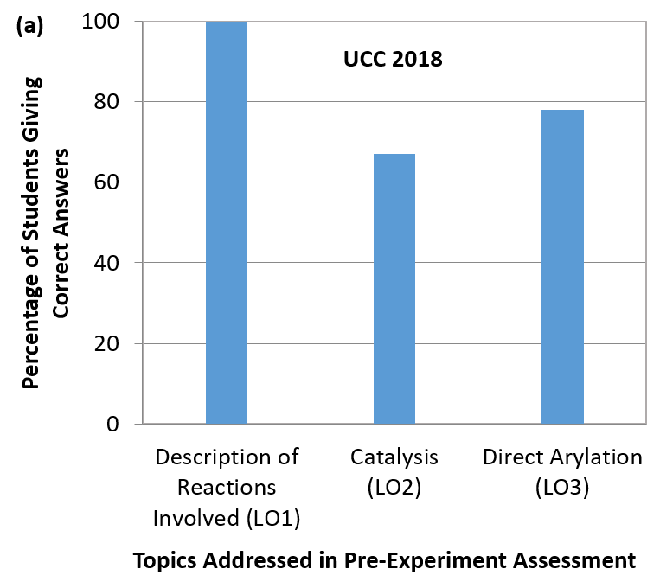
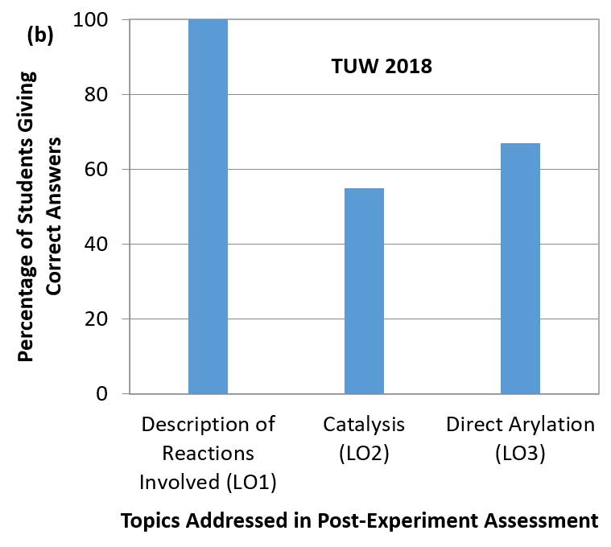
Figure S5. Percentage of participating students that gave correct answers to questions on topics of direct relevance to learning outcomes 1 – 3: (a) in post-lecture/pre-experiment assessment in UCC in 2018 (9 students), (b) in post-lecture/post-experiment assessment in TUW in 2019 (8 students).
As shown in Figure S5, all participating students (in UCC 2018 and TUW 2019 groups) were able to describe the essential features of cross-coupling and direct arylation reactions. About 67% of students in the UCC 2018 cohort gave good explanations of how catalysts exert their effect in chemical reactions and 78% also gave detailed descriptions of the drawbacks of traditional cross-coupling and potential advantages associated with direct arylation reactions (Figure 5a). As shown in Figure S5b, 55% of students from the TUW 2019 group gave answers indicating that they had fulfilled learning outcome 2 (on the concept of catalysis), and 67% showed that they had fulfilled learning outcome 3 (on cross-coupling and direct arylation).

(ii) Evaluation of Learning Outcomes 4 – 6 via a Pre-Experiment Lecture, the Experiment and a Post-Experiment Assessment
At UCC in 2018 and at TUW 2019, the 17 participating students answered post-experiment assessment questions as part of their written report (report template included in SI – see below). These questions required the students to do the following:
- Analyze and interpret ¹H NMR spectra of the products, and assign characteristic signals present in the ¹H NMR spectra to the desired 2-phenylindole product, and, if applicable, to any impurities present (relevant to learning outcome 4).
- Explain how ¹H NMR spectroscopy can be used to follow the progress of a chemical reaction such as the production of 2-phenylindole from indole and a diaryliodonium salt (relevant to learning outcome 5).
- Explain how ¹H NMR spectroscopy can be used to differentiate potential regioisomers of the arylindole product (relevant to learning outcome 6).
Analysis of students’ answers to the questions given in the post-experiment assessments allowed us to appraise the degree to which students achieved learning outcomes 4 – 6 (vide supra). In Figure S6 is shown a graphical representation of students’ performances in this assessment.
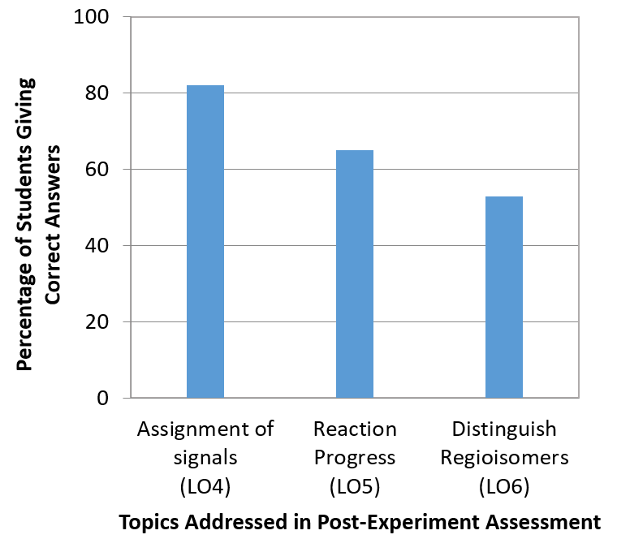
Figure S6. Percentage of participating students that gave correct answers to questions relevant to learning outcomes 4 – 6 in post-experiment assessment. The data were obtained from the cohorts of students that undertook the experiment in UCC in 2018 and TUW in 2019 (17 students in total).
As shown in Figure S6, students generally performed well on questions involving NMR spectroscopy, showing the ability to assign the signals of the 2-phenylindole product and diaryliodonium ion (achieved by 82% of students), and recognising that reaction progress could be monitored by observing the relative growth of the characteristic signals of the product while following the disappearance of signals characteristic of the iodonium salt (achieved by 65% of students). However, only 53% of students identified that NMR spectroscopy could also be used to establish the presence or otherwise of other potential regioisomers that could in principle be produced by direct arylation processes.
Based on the data represented in Figure S5 and S6 (and the associated discussion above), we conclude that learning outcomes 1 – 6 were achieved by at least 50% of the participating students, and that learning outcomes 1 – 5 were fulfilled by 65% of students or more.
Although the above data allowed us to effectively appraise students’ achievement of intended learning outcomes 1 – 6, we felt that a number of improvements to our assessment methods were possible which would significantly benefit our evaluation. For example, our initial approach to the assessments did not provide us with information on the students’ level of knowledge of the relevant topics prior to engaging in the experiment and the pre-experiment lecture(s). It also did not allow us to explicitly evaluate the extent to which students in the TUW 2019 and UCC 2018 cohorts succeeded in achieving learning outcomes 7 – 9 (vide supra). The alternative approach we adopted, with a different group of students, is described in the main article (“Appraisal of achievement of pedagogical goals and learning outcomes”). Further discussion on the fulfilment of the learning outcomes by the students in this subsequent group, using our alternative assessment approach, are given in the next section of the SI.
Second Approach to Quantification of Achievement of Learning Outcomes (UCC 2019) – Further Information
Information on our second approach to quantification of the achievement of learning outcomes by the fourth group of students that undertook the experiment (17 students, all of whom were 3rd year undergraduates from UCC) is given in the main article in the “Appraisal of achievement of pedagogical goals and learning outcomes” section. In the following section, we discuss in more detail the answers given by participants to pre- and post-experiment assessment questions. The questions included in these assessments are shown below. We analyzed students’ answers to determine whether or not they had achieved the intended learning outcomes.
In advance of the experiment, almost all of the 17 participating students could not adequately explain how and why catalysts exert their effect on reactions in a general sense (based on answers to pre-experiment question 1 – see below). Their answers to pre-experiment assessment questions 2 and 6 indicated that almost none of the students had any familiarity with cross-coupling chemistry (this was verified during the introductory talks – students generally indicated that they had not heard of “cross-coupling”, “Suzuki reactions” or “Heck reactions”). Naturally, therefore, the students were not well placed in advance of the practical to elaborate on the potential advantages offered by direct arylation over cross-coupling.
By the end of the experiment, 60% of the students were able to elaborate on how catalysts exert their effect by providing different reaction pathways to products in which the Gibbs energies of activation are generally much lower than is the case for the corresponding uncatalyzed reactions (based on answers to post-experiment question 1). For this question, we would regard an ideal answer as one containing a Gibbs energy profile diagram illustrating the material discussed. At this point, all of the students involved demonstrated an ability to discuss the reactions in involved in the two-step experiment, based on the content of the discussion sections of their written reports and answers to post-experiment questions 2, 6 and 13 (fulfillment of learning outcome 1). They also all included material in the discussion sections of their reports on suitable catalysts for cross-coupling reactions and direct arylation reactions. 88% of participating students were able to point out potential benefits of realising transformations by direct arylation rather than by “traditional” cross-coupling in their answers to post-experiment assessment question 2 (fulfilment of learning outcome 3). However, most students’ answers did also indicate that they had not fully grasped that non-functionalized starting materials are more likely to be readily available, and that use of readily available starting materials is inherently desirable.
Based on the above, we conclude that students’ knowledge of cross-coupling chemistry and of the potential benefits of direct arylation has been well developed, while their familiarity with the concept of catalysis was significantly improved. We thus consider that learning outcomes 1 – 3 were fulfilled by most students.
The students were required (with guidance from laboratory demonstrators, where necessary) to analyze ¹H NMR spectra of (i) the diaryliodonium salt, (ii) the indole starting material, and (iii) the product(s) of the direct arylation reactions isolated after column chromatography. Students’ success in establishing that they had isolated the desired 2-phenylindole product after column chromatography was evaluated by reference to their written reports and answers to questions in the post-experiment assessment.
In our first approach to assessment, students’ prior knowledge of ¹H NMR spectroscopy was not investigated in the pre-experiment assessment. In order to give us a measure of prior knowledge, we decided to include a question on the topic in the pre-experiment assessment administered to students in UCC in 2019. Students’ answers demonstrated that prior to the experiment, they had limited understanding of how ¹H NMR spectroscopy could be used to establish the progress of a reaction or the purity of a product (based on answers to pre-experiment question 5).
Based on their answers to post-experiment questions 5, 8 and 9, 73% of the students demonstrated that they recognized that ¹H NMR spectroscopy could be used to distinguish between regioisomeric products and hence follow the progress of a reaction by establishing the relative concentrations of all compounds present (products, starting materials, side-products), but were not all necessarily able to assign characteristic signals to specific compounds in the spectra analyzed. 53% of students did demonstrate the ability to analyze their spectra and assign diagnostic signals of the diaryliodonium salt and the 2-phenylindole product (relevant to learning outcome 4), based on their written reports. 76% of students recognized the potential for formation of regioisomer(s) of the product, and were able to use their spectra to rule out the occurrence of this (learning outcomes 5 and 6).
Because our first approach to assessment, used in earlier iterations of the experiment, did not assess the students’ awareness of the importance of good lab practice other than on some aspects related to personal protective equipment and safety, we decided to include an additional question on this topic in the pre- and post-experiment assessments carried out in UCC in 2019. We noted that, prior to the experiment, only 18% of the 17 students in this cohort demonstrated an appreciation of the reasons why it is important to exercise due care in the execution of experimental work to maximize the yield and purity of intermediate products (in this case the iodonium salt) leading to the final product (based on answers to pre-experiment question 3). These students did generally exhibit a good understanding of the need for specific types of personal protective equipment appropriate to the laboratory undertaking at hand in advance of the experiment.
After conducting their practical work and reflecting on the topics raised in the pre-practical assessment and introductory talk, students’ input in the discussion sections of their written reports and answers to post-experiment assessment question 3 indicated a good understanding of the skills and approach necessary for multi-step synthesis (based on material from all participating students from both years and both universities). All participating students recognised the importance of proper use of personal protective equipment. They also all recognised that ensuring adequate purity of intermediate products (e.g. the iodonium salt) has immediate consequences in the success of the subsequent synthetic steps, and that losses in yield in one or more steps contribute to a diminished overall yield of the final product. 82% of students were able to apply what they had learnt in this context to the experiment they had carried out, reflecting on means through which the yield and purity of their product could be improved were they to repeat the experiment (fulfilment of learning outcome 7).
Several questions of relevance to learning outcome 8 were posed to students in the post-experiment assessment. Students’ prior knowledge of the topics in question were not assessed in advance of the experiment, as we did not anticipate that students would have experience of this high level learning outcome. These questions related to analysing the reactions they had carried out in order to improve their performance were they to repeat the experiment.
60% of students recognised that the product yield could be improved by increasing reaction time and/or temperature, altering concentrations of reactants, based on their answers to post-experiment question 7. Students also made the reasonable suggestion that increasing catalyst loadings could lead to improved yields.
All students recognised that modification of diaryliodonium salt to increase the steric bulk of the “non-transferring group” would bias the reaction towards transfer of the less bulky phenyl group based on answers to questions 11 and 14.
Based on answers to post-experiment questions 12 and 13, 82% of students were able to recognise potential impurities that could be present alongside the desired product – e.g. the starting materials, other possible direct arylation products, and solvent(s). These students also suggested at least one means by which the presence of these could be avoided by employing conditions that result in improved conversion/yield (covered in question 7) or by prolonged evaporation of solvent under vacuum, respectively. 30% of students recognised that a consequence of employing a diarryliodonium salt with a very bulky “non-transferring group” would result in reduced formation of side-products (potential contaminants).
Some aspects of the method reported herein for synthesis of 2-arylindoles by direct arylation make it more environmentally friendly than a synthesis using traditional cross-coupling methodology – e.g. lower temperature, use of ethyl acetate as solvent, no requirement for additional ligands, direct use of readily-available indole as a coupling partner without the requirement for prior derivatisation. However, there are some drawbacks to the method which mean that the “greenness” of the method is somewhat compromised e.g. the generation of an entire equivalent of aryl iodide as a by-product. Based on students’ answers to post-experiment questions 2 and 15, 53% were able to recognise and analyze the beneficial aspects and drawbacks of direct arylation reactions of the type concerned in this experiment (given above).
Question 6 of the pre- and post-experiment assessments required students to identify products that would be formed (from specific starting materials) in Suzuki-Miyaura and direct arylation reactions, and to identify suitable catalysts to employ in these reactions. Only one student was able to answer this question correctly in the pre-experiment assessment. In the post-experiment assessment, the answers given by all participating students demonstrated that they could predict the products formed in such reactions and identify suitable catalysts to employ, despite not having been familiar with these types of reaction in advance of the experiment. Hence, all of the participating students achieved learning outcome 9.

Pre-Experiment Assessment used in repetition 4 of the experiment UCC 2019 (relevant to Figures 3 and 4 in Main Article)
- Define the term ‘catalyst’.
__________________________________________________________________________________
- What are the advantages of direct arylation methodology over traditional cross-coupling methods?
__________________________________________________________________________________
_________________________________________
- In carrying out a multi-step synthesis, what are the consequences of the manner in which the first steps are carried out for the result of the overall process?
___________________________________________________________________________________________________________________________
- How could you separate two (or more) compounds of similar polarity?
__________________________________________________________________________________
- How could you use NMR spectroscopy to determine a) the progress of a reaction and b) the purity of a final product?
___________________________________________________________________________________________________________________________

- Identify the catalysts required and products formed in the following reactions:
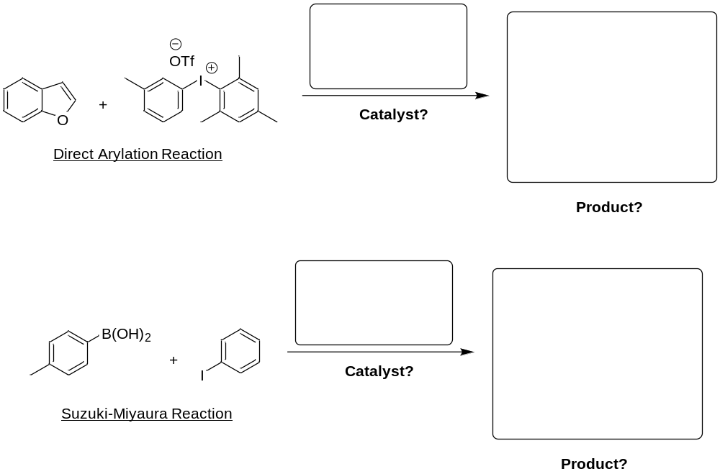

- What does TLC stand for?
_________________________________________

- What does PPE stand for? Give examples of PPE you might need for this experiment.
__________________________________________________________________________________

- Draw the structures of indole and 2-phenylindole.

- Most reactions involving indole occur at the C-3 position. Why is that the case?
__________________________________________________________________________________

Post-Experiment Assessment used in repetition 4 of the experiment (UCC 2019)
Answers to the following questions were included in the laboratory reports of the participating students:
- Define the term ‘catalyst’.
- What are the advantages of direct arylation methodology over traditional cross-coupling methods?
- In carrying out a multi-step synthesis, what are the consequences of the manner in which the first steps are carried out for the result of the overall process?
- How could you separate two (or more) compounds of similar polarity?
- How could you use NMR spectroscopy to determine a) the progress of a reaction and b) the purity of a final product?
- Identify the catalysts required and products formed in the following reactions:
- What change in conditions would you make in future, should you find that the reaction had not gone to completion?
- Explain how you would determine the regiospecificity of the direct arylation reaction.
- How can you predict which regioisomer (C-2/C-3) is which, using ¹H-NMR and ¹³C-NMR spectroscopy?
- Why must all of your sample be soluble in the solvent for NMR spectroscopy to properly assess the purity of your sample?
- What change could be made to the diaryliodonium salt to ensure the desired aryl group is transferred?
- What potential contaminants could be present in your product? How could these be avoided in the future?
- In addition to the major product, what other direct arylation products are possible?
- Should migration of the mesityl group occur when using a particular substrate, what changes could you make to the iodonium salt structure to ensure the desired product is formed in greater amount?
- Give an overall assessment of the ‘greenness’ of your experiments.

Pre-Experiment Assessment used in TUW 2019 and UCC 2018
Questions
- The Nobel Prize in Chemistry in 2010 was awarded to Richard F. Heck, Akira Suzuki and Ei-ichi Negishi. What contribution were they awarded for?
- What are the main drawbacks of traditional cross-coupling compared to direct arylation methodology?
- What are the main advantages of direct arylation chemistry?
- Name a biologically active molecule that contains an indole core.
- What is a catalyst?
- What is TLC?
- Draw the full molecular structure of TfO⁻.
- What is PPE? What PPE is required to be worn at all times during this practical?
- Which solvents may only be handled in a fume cupboard? What other risks are associated with this practical?
- What spectroscopic experiment would you use to distinguish between CH, CH₂ and CH₃ peaks in a ¹³C NMR spectrum?
Example Answers
- Richard F. Heck, Akira Suzuki and Ei-ichi Negishi were awarded the Nobel Prize in Chemistry “for palladium-catalyzed cross-couplings in organic synthesis”.
- It is time-consuming and costly to pre-activate the coupling partners. The process is wasteful in terms of additional reagents and purifications. Also, the side products of the reactions, such as tin-based residues from the Stille reaction, are toxic.
- The C–H group does not need to be preactivated, and the production of waste from the reaction is minimized. Also, a diverse variety of products can be made from a single substrate via selective activation of the different C–H bonds in the molecule.
- Serotonin.
- A catalyst is a substance that increases the rate of a chemical reaction, usually by forming a reactive intermediate which reduces the overall activation energy of the reaction.
- TLC is a chromatographic technique used to separate non-volatile mixtures. It is performed on plates, usually made of aluminium foil which is coated in a thin layer of silica gel (stationary phase). After the sample has been applied to the plate, the solvent mixture (mobile phase) is drawn up the plate via capillary action. Since the solubility of different analytes in the mobile phase causes them to ascend the stationary phase at difference rates, separation is achieved.
- 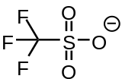
- PPE is personal protective equipment. For this practical, a lab coat, gloves and safety glasses must be worn at all times. In addition, long hair must be securely tied back.
- Diethyl ether, chloroform-d and dichloromethane must be used in the fumehood only. Mesitylene, diethyl ether and ethyl acetate are flammable and can cause irritation and dizziness. Trifluoromethanesulfonic acid is corrosive and must be handled with extreme care. All solid reagents can cause irritation, so care must be taken to minimize the amount of dust.
- DEPT90 and DEPT135 experiments. DEPT135 allows one to distinguish CH and CH₃ from CH₂ peaks, and DEPT90 will only show CH peaks.

Post-Experiment Assessment used in TUW 2019 and UCC 2018
Answers to the following questions were included in the laboratory reports of the participating students:
- Explain your understanding of the term catalysis.
- Explain the ¹H NMR spectrum generated for the diaryliodonium salt.
- Explain the ¹H NMR spectrum generated for the arylated indole product.
- Explain how you determined if the direct arylation reaction had progressed to completion.
- Explain how you determined the regiospecificity of the direct arylation reaction.
- What change could be made to the diaryliodonium salt to improve the regiospecificity?
- Did you isolate a pure sample of the product? What potential contaminants could be present? (Draw using pen and paper provided)
- In addition to the major product, what other arylation products are possible? (Draw using pen and paper provided)

Student Report
Students in UCC completed a report based on a template which was provided to them. Students completed the lab reports during the practical session. The template is provided overleaf.
Students in TUW were required to write a protocol on the sequence describing the experimental work, recording observations not reported in the literature procedure and analysis of the spectral data of their products.

Synthesis of a diaryliodonium salt and its application in a direct arylation reaction

Name:

Date:

Objectives

Experimental Procedure/ Observations (Concise account written scientifically)

Experimental Procedure/ Observations continued

DATA SHEET
Diaryliodonium salt

Physical Appearance:

Mass of diaryliodonium salt:

% yield of diaryliodonium salt:

Melting Point of diaryliodonium salt:

2-Phenylindole

Physical Appearance:

Mass of purified 2-phenylindole:

% yield of 2-phenylindole salt:

If required use other side of sheet for calculations

Discussion/Conclusions

Results of Post-Experiment Survey
Subsequent to completing the experiment and post-experiment assessment, the participating students in UCC were asked to anonymously complete a feedback form to describe their experience of undertaking this laboratory experiment. The results were overwhelmingly positive. 100% of students at UCC said that the experience was enjoyable, and that the experiment increased their interest in, and knowledge of, organic chemistry and C—H functionalization. Students also reported that they:
- Could describe the reaction types used in the experiment (100%).
- Demonstrated an understanding of multi-step synthesis (100%).
- Understood the potential improvements offered by direct arylation via C-H functionalization over traditional cross-coupling (100%).
- Understood how to determine if starting material is consumed and if product is formed using ¹H NMR spectroscopy (100%).
- Had a better understanding of catalysis (89%).
- Had a better understanding of how to assign a structure using NMR data (78%).
- Understood how to distinguish between regioisomeric products using NMR data (89%).

Discussion on Mechanism
It should be noted that a number of complex and diverse mechanisms are plausible (e.g. Heck-like, Concerted Metalation Deprotonation (CMD), Electrophilic Aromatic Substitution (EAS)-like, Pd(II)/Pd(IV)-mediated etc). While beyond the scope of this paper, the reader is directed to a number of interesting papers on related systems.⁴⁻⁷

Further reactions
The product indole can be carried on in further well-known synthetic steps such as (EAS, N-protection, N-arylation, N-alkylation, N-amide formation etc).

References

1. Reay, A. J.; Williams, T. J.; Fairlamb, I. J. Org. Biomol. Chem. 2015, 13, 8298-8309.
2. Peña‐López, M.; Neumann, H.; Beller, M. Chem. Eur. J. 2014, 20, 1818-1824.
3. Jang, Y. H.; Youn, S. W. Org. Lett. 2014, 16, 3720-3723.
4. Lane, B. S., Brown, M. A., Sames, D. J. Am. Chem. Soc. 2005, 127, 8050-8057.
5. Deprez, N. R.; Sanford, M. S. J. Am. Chem. Soc. 2009, 131, 11234-11241.
6. Lapointe, D.; Fagnou, K. Chem. Lett., 2010, 39, 1119-1126.
7. Colletto, C.; Islam, S.; Juliá-Hernández, F.; Larrosa, I.; J. Am. Chem. Soc., 2016, 138, 1677-1683

