Supplementary Materials

Acute Stress Increases Monocyte Levels and Modulates Receptor Expression in Healthy Females

Marcel van de Wouw¹, Marzia Sichetti², Caitriona M. Long-Smith¹, Nathaniel L. Ritz¹, Gerard Moloney^{1,3}, Anne Marie Cusack¹, Kirsten Berding¹, Timothy G. Dinan^{1,4}, John F. Cryan^{1,3}

¹APC Microbiome Ireland, University College Cork, Cork, Ireland
²Unit of Biochemical Sciences and Health, Department of Pharmaceutical Sciences, University of Perugia, Italy
³Department of Anatomy and Neuroscience, University College Cork, Cork, Ireland
⁴Department of Psychiatry and Neurobehavioral Science, University College Cork, Cork, Ireland

Corresponding author:
J.F. Cryan: APC Microbiome Ireland; Department of Anatomy and Neuroscience, University College Cork, Cork, Ireland. Email: j.cryan@ucc.ie.

sFigure 1. Changes in total monocytes and comparisons between stress-induced changes in monocytes subtypes.

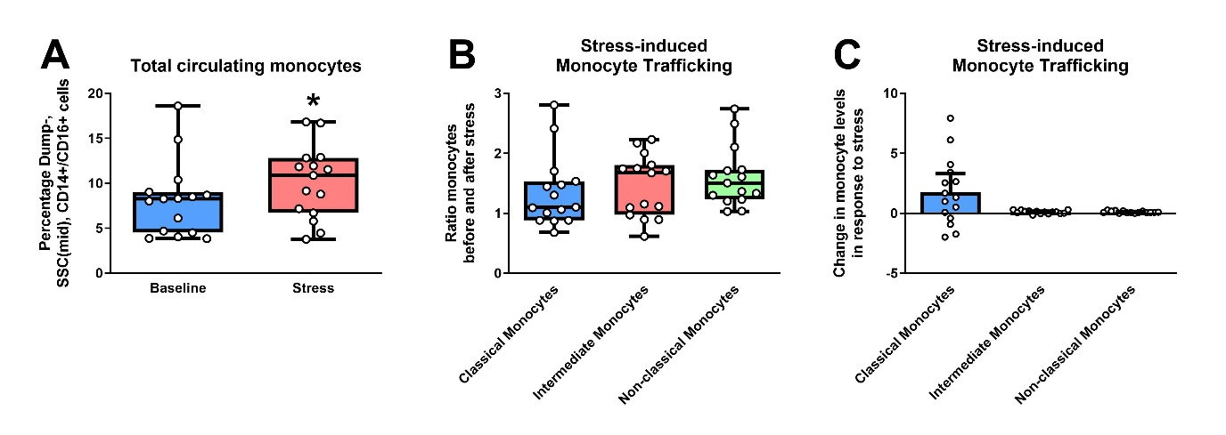
Acute stress increased total circulating monocyte levels (Z = -2.499, p = 0.012) (sFigure 1A). Acute stress did not impact one specific monocyte subtype preferentially over another one (sFigure 1B), even though the absolute stress-induced changes in monocyte levels were more prominent in classical monocytes (sFigure 1C). This was attributed to higher levels of classical monocytes being present in the blood, compared to intermediate and non-classical monocytes. Statistical significance is depicted as *P < 0.05. Data are depicted as box plots or bar plots with individual data points.
sFigure 2. Significant stress-induced changes in receptor expression in intermediate and non-classical monocytes.

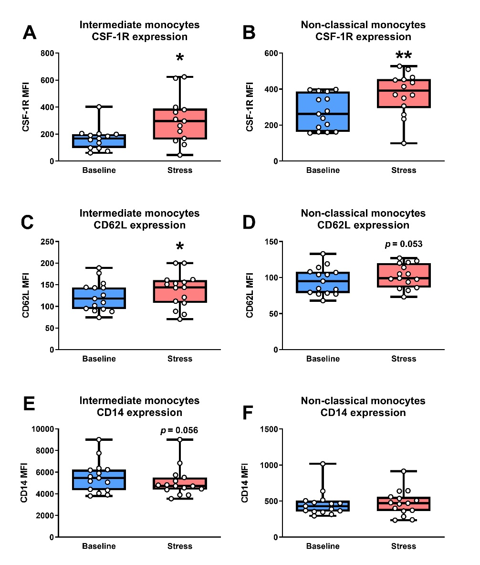

Acute stress-induced changes in CSF-1R, CD62L and CD14 receptor expression were measured by median fluorescent intensity (MFI) and assessed using the non-parametric Wilcoxon signed-rank test. Stress increased CSF-1R receptor expression (Z = -2.970, p = 0.003; Z = -2.700, p = 0.007, respectively) (sFigure 2A, B) as well as CD62L receptor expression in intermediate and non-classical monocytes (Z = -2.102, p = 0.036; Z = -1.931, p = 0.053, respectively) (sFigure 2C, D). Finally, stress induced a trend towards decreased CD14 expression in intermediate monocytes, but not non-classical monocytes (Z = -1.915, p = 0.056) (sFigure 2E, F). Statistical significance is depicted as *P < 0.05 and **P < 0.01. Data are depicted as box plots with individual datapoints.

sFigure 3. Acute stress-induced changes in monocyte levels and receptors do not show a strong correlation with each other.

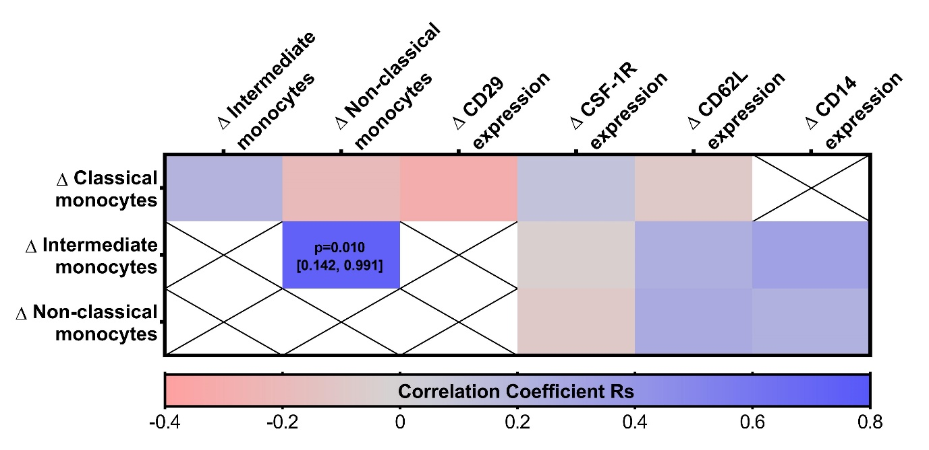
The difference between pre- and post-stress (Delta, Δ) from parameters that were significantly affected by acute stress were calculated, after which they were correlated using non-parametric Spearman correlations. The only significant correlation was between Δ Intermediate monocytes and Δ Non-classical monocytes (p=0.010, 95% CI: [0.142, 0.991]). Crossed out cells depict data that were either unaffected by acute stress or correlations between the same parameters. The correlations between Δ monocyte levels and Δ receptor expression were performed for receptors on the respective monocyte subtypes (i.e., Δ classical monocytes were correlated with Δ CD62L on classical monocytes, while Δ intermediate monocytes were correlated with Δ CD62L on intermediate monocytes).

sTable 1. Antibodies used for flow cytometry.

Marker | Conjugation | Product information | Volume per sample (µL)
Monocyte panel 1
FVS780 | R780/60 | BD Biosciences, 565388 | /
DUMP – CD3 | VioBright FITC | Miltenyi Biotec, 130-113-128 | 2
DUMP – CD19 | VioBright FITC | Miltenyi Biotec, 130-113-173 | 5
DUMP – CD56 | VioBright FITC | Miltenyi Biotec, 130-113-309 | 2
CD14 | PerCP-Cy5.5 | BioLegend, 301824 | 5
CD16 | APC | Miltenyi Biotec, 130-113-389 | 2
CD62L | BV510 | BioLegend, 304844 | 5
CD192 (CCR2) | BV605 | BioLegend, 357214 | 5
CX3CR1 | BV786 | BD Biosciences, 744489 | 2
Monocyte panel 2
FVS780 | R780/60 | BD Biosciences, 565388 | /
DUMP – CD3 | VioBright FITC | Miltenyi Biotec, 130-113-128 | 2
DUMP – CD19 | VioBright FITC | Miltenyi Biotec, 130-113-173 | 5
DUMP – CD56 | VioBright FITC | Miltenyi Biotec, 130-113-309 | 2
CD14 | PerCP-Cy5.5 | BioLegend, 301824 | 5
CD16 | APC | Miltenyi Biotec, 130-113-389 | 2
CD11b | BV421 | BioLegend, 301324 | 5
CD115 (CSF-1R) | BV510 | BD Biosciences, 743141 | 2
CD163 | BV605 | BD Biosciences, 744488 | 2
CD29 (ITGB1) | BV786 | BD Biosciences, 564815 | 5

