Supplementary data for:

Assessment of pretreatment and digestion temperature on anaerobic digestion of whiskey byproducts and microbial taxonomy
Xihui Kang^{1,3}, Richen Lin^{1,3}*, Lianhua Li², Benteng Wu^{1,3}, Chen Deng^{1,3}, Richard O’Shea^{1,3}, Yongming Sun², Jerry D Murphy^{1,3}
¹ MaREI Centre, Environmental Research Institute, University College Cork, Cork, Ireland
² Guangzhou Institute of Energy Conversion, Chinese Academy of Sciences, Guangzhou 510640, PR China
³ School of Engineering, University College Cork, Cork, Ireland

* Corresponding author:
Dr Richen Lin
MaREI Centre, Environmental Research Institute, University College Cork, Ireland. Tel.: +353 (0)21 490 1948.
Email: richen.lin@ucc.ie

Table S1. Substrates used for mesophilic and thermophilic anaerobic digestion of whiskey byproducts mixture.
Sample (unit) | Mixture for mesophilic digestion | Mixture for thermophilic digestion
Draff (g, wwt) | 5.76 | 5.61
Thin stillage (g, wwt) | 39.79 | 38.74
Thick stillage (g, wwt) | 34.20 | 33.30
pH value of mixture | 3.82 | 3.85
NH₃-N (mg/L) | 80.0±56.6 | 90.0±42.4
Soluble COD (g/L) | 32.5±0.1 | 32.8±0.0
Draff, thin stillage and thick stillage used for generating whiskey byproducts are the same in this study. However, as the VS content of the inoculum used for mesophilic and thermophilic anaerobic digestion is different, in order to satisfy the VS ratio of inoculum to substrate (2:1), the amount of respective sample added in mesophilic and thermophilic digester is adjusted accordingly. For each bottle with 400 mL of working volume, the amount of each sample is added as shown in Table S1.

Figure S1. COD (A) and NH₃-N (B) concentration of untreated and pretreated whiskey byproducts mixture. R, S and A indicate raw material (no pretreatment), steam-treated sample and acid-treated sample, respectively.

Noticing that the NH₃-N concentration on day 0 from the digesters of untreated and steam pretreated samples was obviously different from that of acid-treated samples (Fig 3B), which ideally should be similar, we tested the samples with different strategies; this includes adjusting the pH of untreated and pretreated samples (without mixing with the inoculum) to the digestion pH, diluting the effluent on day 0 at different times (such as 100 and 200 times). However, results (Fig S1(B)) showed that the pH adjustment of the samples and different dilution times of the effluent had little effects on the NH₃-N concentration. Therefore, the difference of NH₃-N concentration on day 0 could be attributed to interaction between the samples and inoculum as the samples are rather ready to degrade.

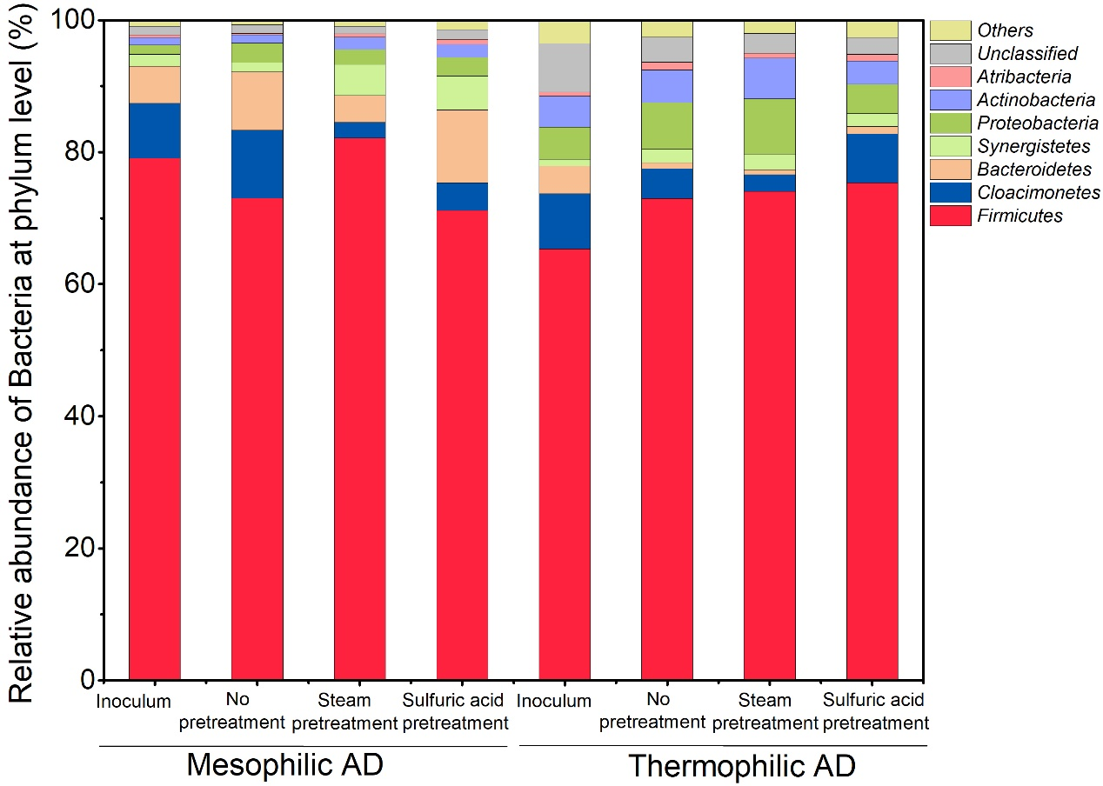
Figure S2. Taxonomic classification of the bacteria communities at the phylum level under mesophilic and thermophilic anaerobic digestion (AD).

