Supporting Information/Appendices

Pediocin PA-1 production by Pediococcus pentosaceus ET34 using non-detoxified hemicellulosic hydrolysate obtained from hydrothermal pretreatment of sugarcane bagasse
Taís Mayumi Kuniyoshi^{a†}, Carlos Miguel Nóbrega Mendonça^{a†}, Viviane Borges Vieiraª, Diogo Robl^{b}, Bernadette Dora Gombossy de Melo Franco^{c}, Svetoslav Dimitrov Todorov^{de}, ﻿Elisabetta Tomé^{f}, Paula Mary O’Connor^{g,h}, Attilio Converti^{i}, Welington Luiz Araujo^{j}, Lívia Paula Silva Palmeiras Vasconcellos^{k}, Alessandro de Mello Varani^{l}, Paul David Cotter^{g,h,m}, Sarita Cândida Rabelo^{n}, Ricardo Pinheiro de Souza Oliveira^{a*}

ªDepartment of Biochemical and Pharmaceutical Technology, Schoool of Pharmaceutical Sciences, University of São Paulo, 05508-000 São Paulo, Brazil.
^{b}CICECO – Aveiro Institute of Materials, Department of Chemistry, University of Aveiro, 3810-193 Aveiro, Portugal.
^{c}Department of Microbiology, Immunology and Parasitology, Federal University of Santa Catarina (UFSC), 88040-900 Santa Catarina, Brazil.
^{d}FoRC (Food Research Center), Food and Experimental Nutrition Department, School of Pharmaceutical Sciences, University of São Paulo, São Paulo 05508-900, Brazil.
^{e}Food and Experimental Nutrition Department, School of Pharmaceutical Sciences, University of São Paulo, São Paulo 05508-900, Brazil.
^{f}ProBacLab, Advanced Convergence, Handong Global University, Pohang, Gyeongbuk 37554, South Korea.
^{g}Instituto de Ciencias y Tecnología de Alimentos. Escuela de Biología. Universidad Central de Venezuela. Apartado 47.097 – Caracas 1041 A, Venezuela.
^{h}Food Bioscience Department Teagasc Food Research Centre, Moorepark, Fermoy, Cork, T12 YN60 Ireland.
^{i}APC Microbiome Ireland, University College Cork, Cork, Ireland.
^{j}Microbiology Department - Biomedical Sciences Institute, University of São Paulo, São Paulo 05508-900, Brazil.
^{k}Brazilian Biorenewables National Laboratory (LNBR), National Research Center for Energy and Materials (CNPEM), Campinas, Brazil.
^{l}Department of Technology, School of Agricultural and Veterinary Sciences, Faculdade de Ciências Agrarias e Veterinária, São Paulo State University, Brazil
^{m} School of Microbiology, University College Cork, Cork, Ireland.
^{n}Department of Bioprocess and Biotechnology, College of Agricultural Sciences, São Paulo State University, 18610-034, São Paulo, Brazil.

†Tais M. Kuniyoshi and Carlos M. N. Mendonça shared first co-author
*Corresponding author: rpsolive@usp.br

Appendices

Figure A1:

Fig. A1. Schematic diagram of the hemicellulosic hydrolysate production from hydrothermal pretreatment of sugarcane bagasse.
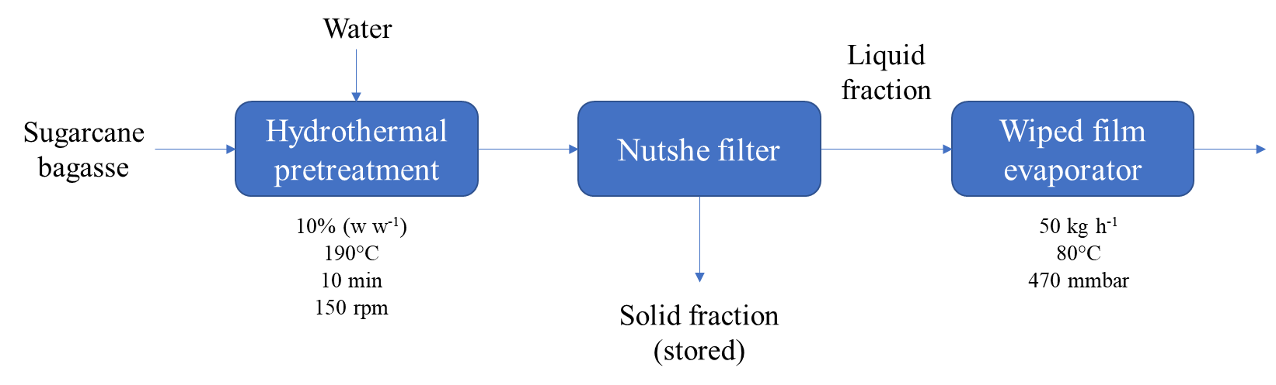

Table A1:

Table A2:

Table A3:

