Supplementary results
Supplementary Result S1: High-Quality MAV Recovery Trends Across Fermented Food Metagenomes in the Fermented Food-Associated Virome Catalogue
Firstly, we compared MAV recovery rates across cFMD metagenomes and observed that viral sequences were undetectable in the majority of them (n=3,045) (Figure S1A). A comparison between metagenomes with successful MAV recovery and those without revealed significant differences associated with sequencing depth, sequencing platform, and DNA extraction method (Figure S1). Specifically, metagenomes with MAV recovery demonstrated a significantly higher median number of reads (Mann-Whitney test, p < 0.001) (Figure S1A).
To further explore the sequencing depth patterns, we generated a scatter plot using log-log scaling (Figure S1B) to depict the relationship between the number of MAVs (y-axis, log scale) and the number of reads (x-axis, log scale) across metagenomes. Each blue point on the plot represents a metagenome, with the point size corresponding to the number of "High Quality or greater" MAVs. The green linear regression line fitted over the data reveals a modest positive trend, with a correlation strength of R = 0.16 and a weak relationship indicated by the equation y = -0.47 + 0.1x and R² = 0.023. This suggests that while an increase in read counts is associated with a higher number of contigs, the relationship is not strong (Figure S1B).
The variation in point sizes, which represent MAV quality, highlights that larger bubbles—indicating high-quality MAVs—are predominantly found in metagenomes with read counts exceeding 3 × 10⁷. Nonetheless, smaller but still noteworthy bubbles at lower read depths (below 3 × 10⁷) suggest that MAV recovery is still possible, though less frequent, at lower sequencing depths (Figure S1B).

Supplementary Result S2: Characterization of MAV Taxonomy and Host Range in Fermented Food Systems
To investigate the taxonomic diversity of metagenome-assembled viruses (MAVs) from fermented foods, we combined gene-sharing network analysis with vConTACT3 and hallmark gene-based classification using the INPHARED database via Pharokka. Pharokka assigned taxonomic classifications to 32% of MAVs, indicating sizeable homology to known viruses in INPHARED.
To assess taxonomic consistency, we compared predictions from Pharokka with vConTACT-derived classifications. Among MAVs classified by both tools, concordance at the phylum and class levels reached ~89%, reflecting strong agreement at higher taxonomic ranks. At the highest taxonomic level, 3,033 MAVs were classified within the realm Duplodnaviria, 30 MAVs were assigned to Monodnaviria, and 382 MAVs remained unclassified at the realm level despite being integrated into gene-sharing networks. All Duplodnaviria-classified MAVs were further assigned to the phylum Uroviricota and class Caudoviricetes.
To gain deeper insight into the potential prokaryotic hosts of the MAVs, we applied iPHoP v1.3.3, a two-step host prediction framework that integrates multiple homology- and composition-based approaches. A custom host database was constructed by supplementing the default iPHoP Aug_2023_pub_rw database with 4,356 dereplicated metagenome-assembled genomes (MAGs) recovered from the same fermented food samples using the iphop add_to_db function. MAGs were taxonomically classified using GTDB-tk and integrated into the iPHoP phylogenetic framework, where they were clustered with existing reference genomes at 95% average nucleotide identity (ANI). For each species cluster, a representative genome was selected for use in host prediction algorithms. This approach enabled host prediction for MAVs infecting fermented food-associated bacteria not well-represented in standard reference databases.
Of the 3,445 MAVs analysed, 2,530 (73%) were confidently assigned to bacterial hosts, while 25 MAVs (0.7%) were linked to archaeal hosts. The remaining 890 MAVs (26%) could not be classified at the domain level. At the phylum level, host predictions were dominated by Bacillota (1,783 MAVs; 52%) and Pseudomonadota (633 MAVs; 18%), with smaller contributions from Actinomycetota (83 MAVs), Bacteroidota (5), and other less represented phyla. Archaeal MAVs were affiliated primarily with Halobacteriota (3 MAVs) and Thermoproteota (22 MAVs), though these were rare.
At the class level, Bacilli accounted for the majority of host assignments (1,783 MAVs), followed by Gammaproteobacteria (358 MAVs), Alphaproteobacteria (277), and Actinomycetia (80). Archaeal host predictions were largely confined to Halobacteria (3 MAVs) and Halanaerobiia (1 MAV).
At the order level, Lactobacillales was the most frequently assigned host order (1,621 MAVs), in line with the known abundance of lactic acid bacteria (LAB) in fermented food environments. Other common orders included Pseudomonadales (182 MAVs), Enterobacterales (145), Actinomycetales (66), and Bacillales (39). Archaeal hosts were assigned to Halobacteriales and Halanaerobiales, but only infrequently.
At the family level, predicted bacterial hosts were led by Lactobacillaceae (978 MAVs), Streptococcaceae (608), Enterobacteriaceae (139), and Pseudomonadaceae (86). Several other LAB-associated families were also represented, including Leuconostocaceae, Carnobacteriaceae (10 MAVs), Lactococcaceae, and Pediococcaceae. Archaeal host families included Halobacteriaceae and Haloferacaceae, although these were only rarely detected (Figure 3B). At the genus level, host associations were detected for over 200 genera. Lactic acid bacteria (LAB) were dominant among identified hosts, with Lactococcus accounting for the highest number of MAVs (343), followed by Lacticaseibacillus (178), Lactobacillus (156), Lentilactobacillus (156), and Leuconostoc (82). Other LAB genera such as Fructilactobacillus, Limosilactobacillus, and Levilactobacillus also contributed notably. Within the Proteobacteria, commonly detected host genera included Pseudomonas (87 MAVs spanning multiple clusters), Klebsiella (58), Enterobacter (42), and Citrobacter (34). A small number of archaeal hosts were also identified, with Natrinema among the few confidently assigned genera.
Of the MAVs with confident host predictions, 1,545 were linked to novel host MAGs from our study, representing putative novel bacterial and archaeal species not present in existing reference databases. These novel host species spanned 68 distinct genera across 2 archaeal phyla (24 MAVs total) and 4 bacterial phyla (1,521 MAVs). Within Archaea, 23 MAVs were predicted to infect unclassified Thermoproteota and 1 MAV targeted Halarchaeum (Halobacteriota). Bacterial hosts were dominated by Bacillota (1,038 MAVs across 28 genera) and Pseudomonadota (457 MAVs across 32 genera), with smaller representation from Actinomycetota (61 MAVs, 7 genera) and Bacteroidota (3 MAVs, 1 genus).
Within Bacillota, the order Lactobacillales overwhelmingly dominated with 971 MAVs distributed across two major families: Lactobacillaceae (651 MAVs across 18 genera) and Streptococcaceae (240 MAVs across 3 genera). The five most abundant novel host genera—all from Lactobacillales—were Liquorilactobacillus (229 MAVs), Streptococcus (207 MAVs), Lentilactobacillus (206 MAVs), Lactococcus (205 MAVs), and Lacticaseibacillus (193 MAVs), collectively accounting for 67% of all novel host predictions. Other notable Lactobacillaceae genera included Leuconostoc (78 MAVs), Lactiplantibacillus (36 MAVs), Pediococcus (24 MAVs), and Lactobacillus sensu stricto (23 MAVs). Outside Lactobacillales, Staphylococcus (75 MAVs) and Bacillus (52 MAVs) were the most prominent host genera.
Within Pseudomonadota, Alphaproteobacteria accounted for 272 MAVs across 10 genera, with Acetobacteraceae strongly dominating: Acetobacter (173 MAVs), Gluconobacter (61 MAVs), Gluconobacter_A (12 MAVs), and Komagataeibacter (12 MAVs). Gammaproteobacteria contributed 382 MAVs across 22 genera, with the most abundant being Pseudomonas (195 MAVs, Pseudomonadaceae) and Acinetobacter (75 MAVs, Moraxellaceae). Enterobacteriaceae was particularly diverse with 11 genera represented, including Hafnia (18 MAVs), Escherichia (12 MAVs), Klebsiella (11 MAVs), Serratia (9 MAVs), and Vibrio (9 MAVs from Vibrionaceae).
To investigate the taxonomic diversity of metagenome-assembled viruses (MAVs) from fermented foods, we combined gene-sharing network analysis with vConTACT3 and hallmark gene-based classification using the INPHARED database via Pharokka. Pharokka assigned taxonomic classifications to 32% of MAVs, indicating sizeable homology to known viruses in INPHARED. To assess taxonomic consistency, we compared predictions from Pharokka with vConTACT-derived classifications. Among MAVs classified by both tools, concordance at the phylum and class levels reached ~89%, reflecting strong agreement at higher taxonomic ranks. At the highest taxonomic level, 3,029 MAVs were classified within the realm Duplodnaviria, 30 MAVs were assigned to Monodnaviria, and 381 MAVs remained unclassified at the realm level despite being integrated into gene-sharing networks. All Duplodnaviria-classified MAVs were further assigned to the phylum Uroviricota and class Caudoviricetes. These MAVs grouped both recognised and putatively novel viral orders. The majority of genomes were assigned to highly expanded novel Caudoviricetes lineages, most notably novel_order_32 (n = 671), novel_order_31 (n = 379), novel_order_30 (n = 237), novel_order_34 (n = 201), and novel_order_57 (n = 164). Several additional clusters also contained more than 100 genomes, including novel_order_106 (n = 112), novel_order_129 (n = 101), and novel_order_45 (n = 104).
Although most orders were represented by only a few genomes, this subset of large clusters reflects deep underlying genomic diversity within the fermented-food virome (Figure 3A). A small number of MAVs were placed into recognised viral orders such as Kirjokansivirales (n = 2), Petitvirales (n = 7), Tubulavirales (n = 7), and Thumleimavirales (n = 1), indicating that only a minor fraction of the fermented-food viral community overlaps with currently defined viral taxonomy. To contextualize the novelty of fermented food viruses, we compared the FVGC against all high-confidence IMG/VR v4 UViGs at 95% ANI. The majority of MAVs (85%) showed no detectable matches, confirming substantial novel viral diversity in fermented foods. Among the 15% with matches (n = 513), IMG/VR ecosystem annotations were distributed across Host-associated (n = 234), Engineered (n = 92), Environmental (n = 14), and Unclassified (n = 173) categories. Host-associated annotations were dominated by human-derived sequences (n = 199), primarily from the digestive system, with 170 hits originating from large intestine samples. Smaller numbers of matches were assigned to plants (n = 16), other mammals (n = 8), and microbial hosts (n = 8). Notably, food-related annotations fell entirely within the Engineered category.

Supplementary figures
Figure S1. Overview of the Fermented Food Metagenomes Analyzed by Food Category and Country of Origin. The panels are described as follows: A Number of metagenomes (Y-axis) categorized by food type, sourced either from ■ ‘cFMD’ or ■ ‘Future release’. B Number of metagenomes (Y-axis) categorized by specific food types, with data similarly sourced from ■ ‘cFMD’ or ■ ‘Future release’. C Distribution of fermented food metagenomes (X-axis) across different countries (Y-axis), with bars colored according to their origin: either from ■ ‘cFMD’ or ■ ‘Future release’. D Summary description of the types of metagenomes analyzed across different fermented food categories, along with the number of metagenomes and the average (Mean ± SD) number of metagenomic reads per metagenome.

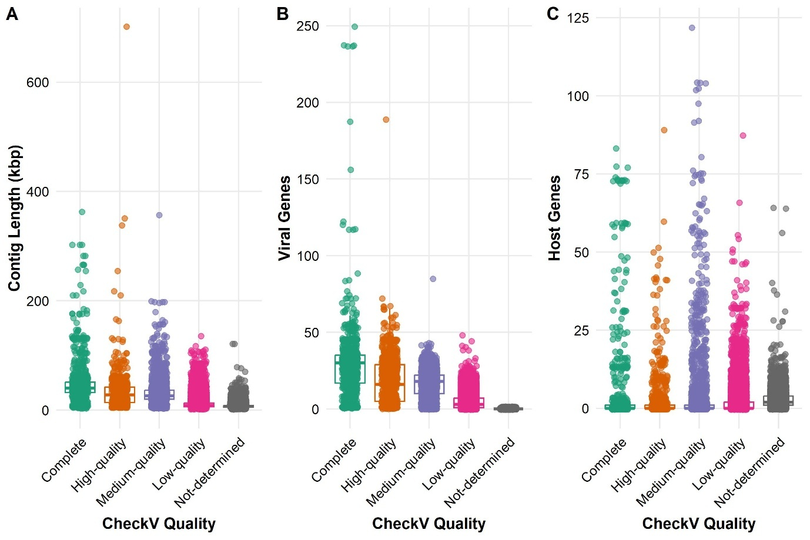

Figure S2. A–C show box plots of viral contig length (A), number of viral genes (B), and number of host genes (C), grouped by CheckV genome completeness levels (Complete, High-quality, Medium-quality, Low-quality, and Not determined). Each box represents the interquartile range, with the central line indicating the median and whiskers extending to 1.5 times the interquartile range; individual data points are overlaid using jitter for visual clarity.

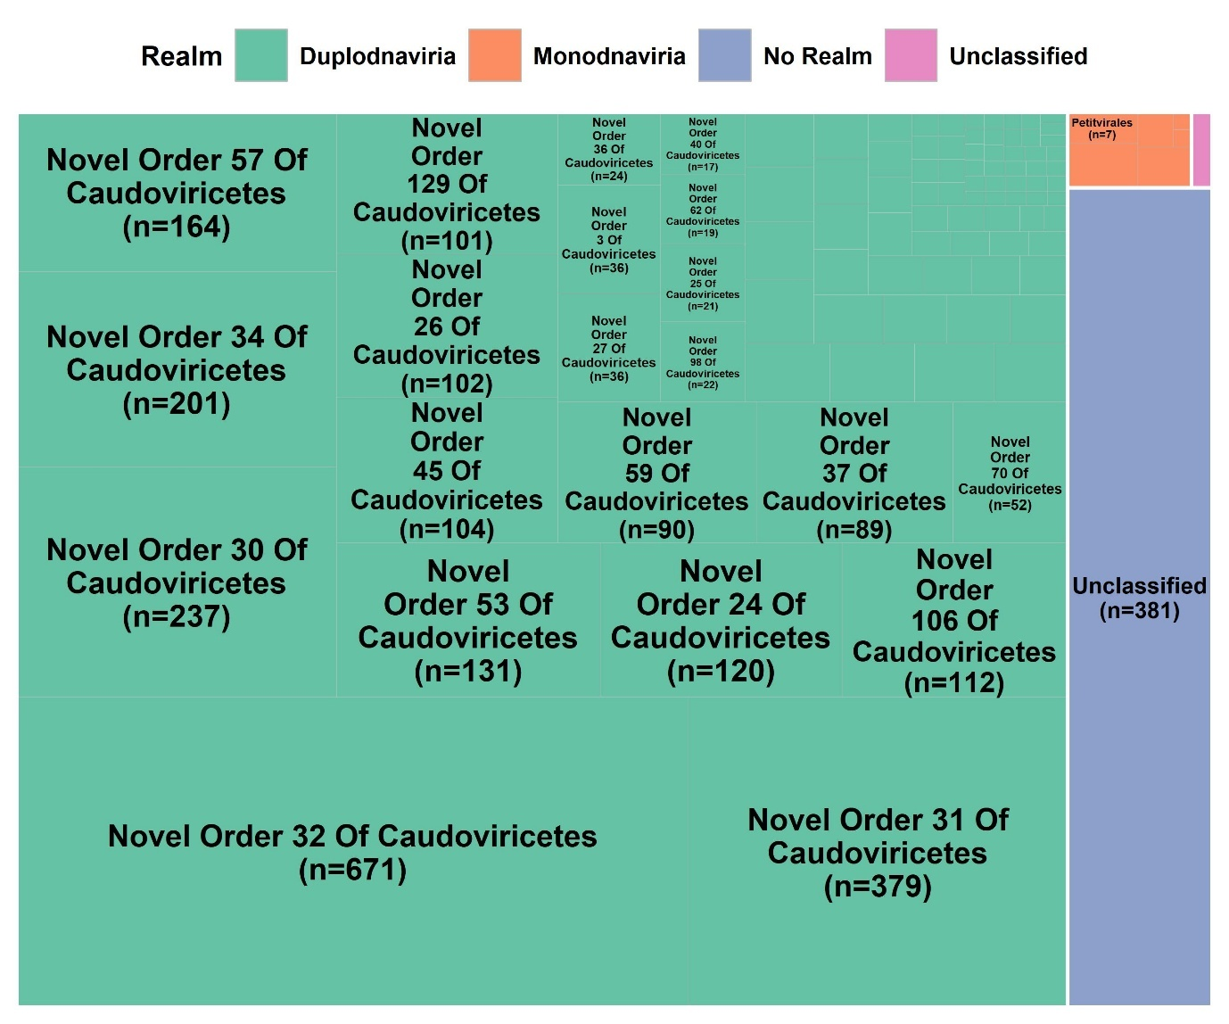
Figure S3. Treemap illustrating the distribution of MAVs across viral orders. The size of each tile is proportional to the number of MAVs assigned to each order. Tile colours represent broader viral realms. Taxonomic resolution at the order level was chosen due to the high proportion of MAVs affiliated with novel proposed viral orders.

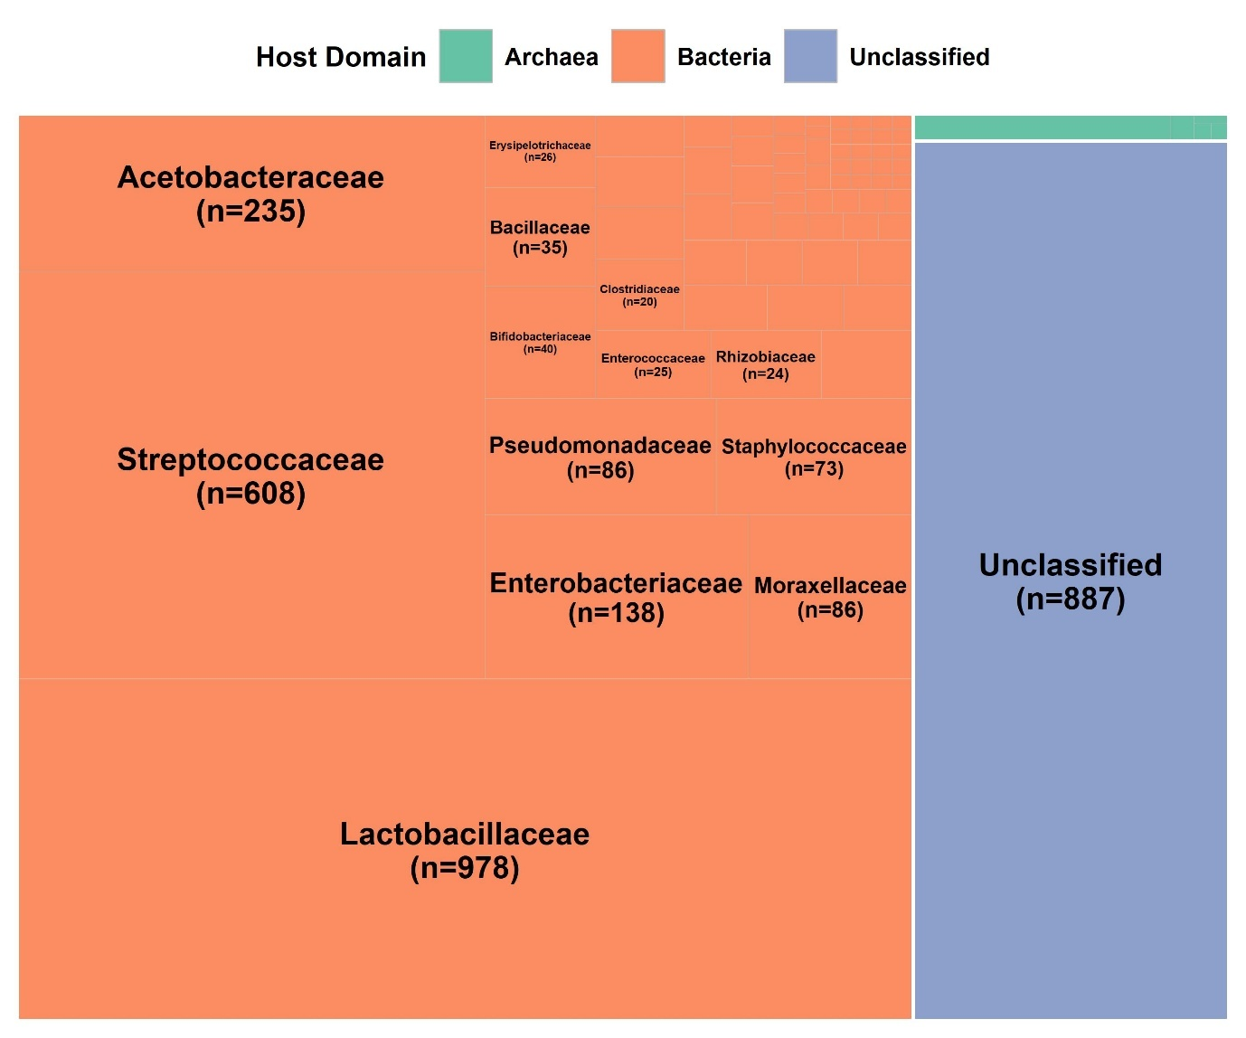
Figure S4. Treemap showing predicted host associations of MAVs at the host family level. Tile area corresponds to the number of MAVs predicted to infect each host family, while tile colours indicate the host domain classification: Bacteria, Archaea, or Eukaryota.

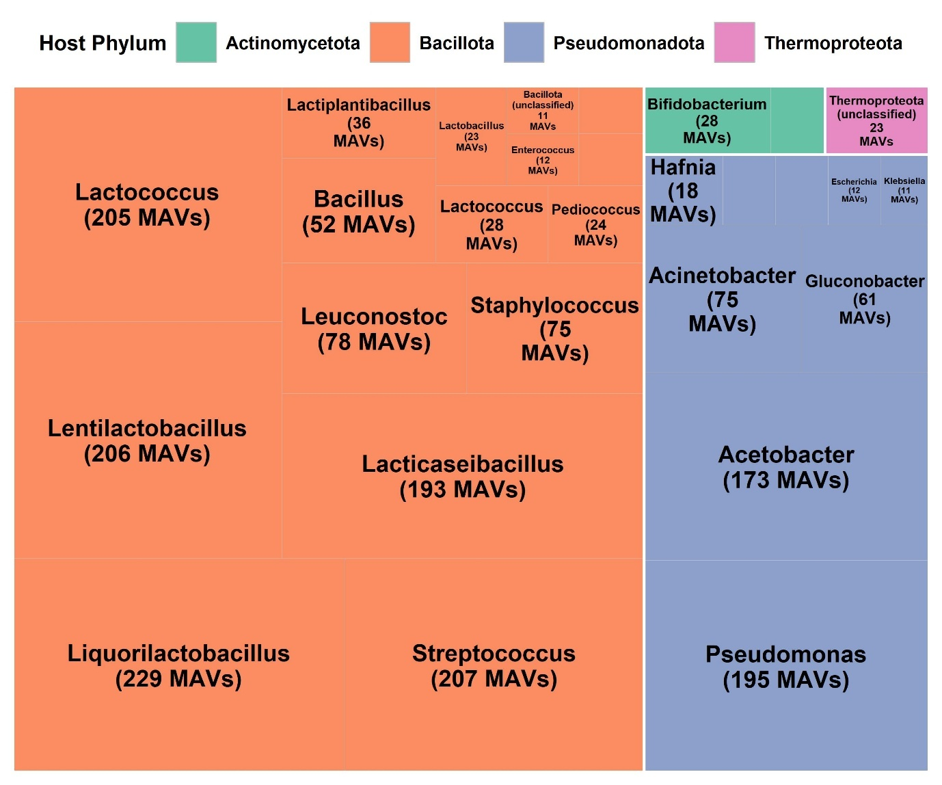
Figure S5. Treemap visualization showing the distribution of 1,545 MAVs linked to novel bacterial and archaeal host species (MAGs with <95% ANI to reference genomes) recovered from fermented food metagenomes. Box size represents the number of MAVs associated with each host genus. Colors indicate host phylum. Only genera with ≥10 MAV associations are shown for clarity.

