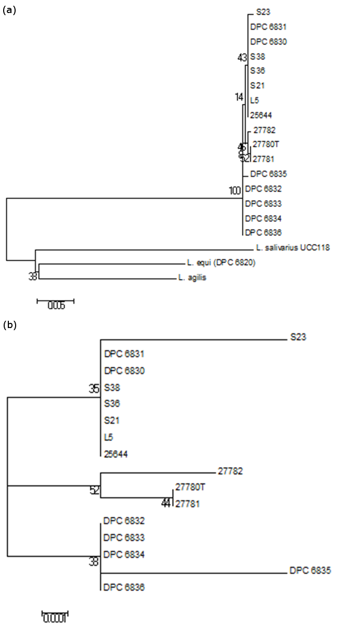
Additional file 2 Neighbour joining phylogenetic tree based upon (a) 16S rRNA genes sequences of L. ruminis isolates and selected other Lactobacillus salivarius clade species. (b) Neighbour joining phylogenetic tree for the L. ruminis isolates alone.

