Strain Differences in Behaviour and Immunity in Aged Mice: Relevance to Autism

4.6: Supplementary data
sFigure 1. Gating strategy for CD4+ and CD8+ cells in C57bl/6 mice. CD4+ and CD8+ cells were quantified in blood and mesenteric lymph nodes. First, cells were selected based on FSC-Height and SSC-Height, after which cells were selected based on CD4 and CD8 receptor expression.

sFigure 2. Gating strategy for T regulatory cells (Treg) in C57bl/6 mice. Treg cells were quantified in blood and mesenteric lymph nodes. First, cells were selected based on FSC-Height and SSC-Height, after which T helper cells were selected based on CD4 receptor expression. Treg cells were subsequently selected based on CD25 and FoxP3 expression. Finally, Treg cells were investigated for their origin (i.e. thymus or non-thymus), based on helios expression.

sFigure 3. Gating strategy for dendritic cells in C57bl/6 mice. Dendritic cells were quantified in mesenteric lymph nodes. First, cells were selected based on FSC-Height and SSC-Height, after which dendritic were selected based on CD11c and MHC-II receptor expression.

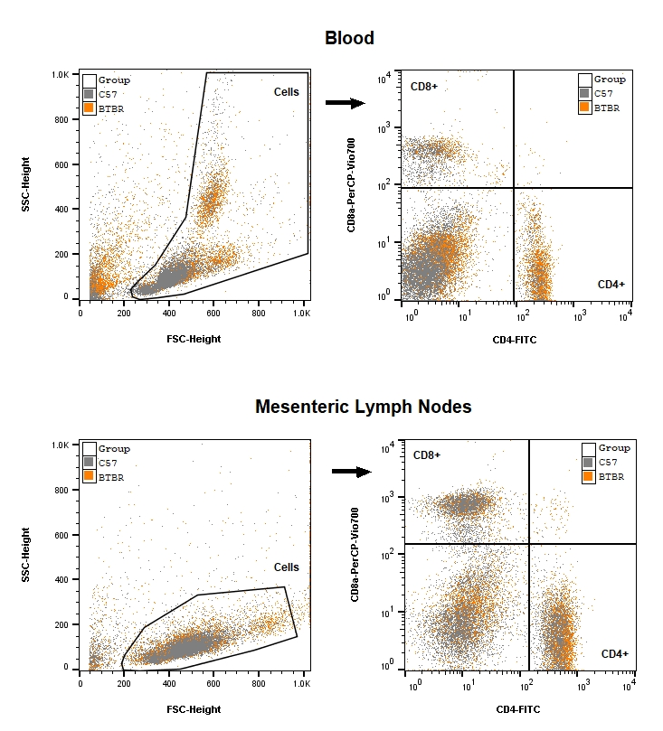

sFigure 4. Gating strategy for CD4+ and CD8+ cells in BTBR mice. CD4+ and CD8+ cells were quantified in blood and mesenteric lymph nodes. First, cells were selected based on FSC-Height and SSC-Height, after which cells were selected based on CD4 and CD8 receptor expression.

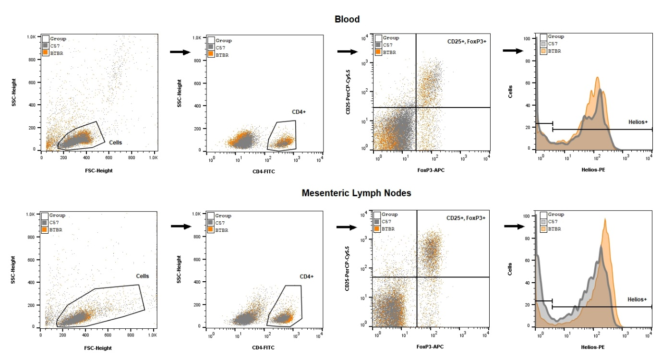

sFigure 5. Gating strategy for T regulatory cells (Treg) in BTBR mice. Treg cells were quantified in blood and mesenteric lymph nodes. First, cells were selected based on FSC-Height and SSC-Height, after which T helper cells were selected based on CD4 receptor expression. Treg cells were subsequently selected based on CD25 and FoxP3 expression. Finally, Treg cells were investigated for their origin (i.e. thymus or non-thymus), based on helios expression.
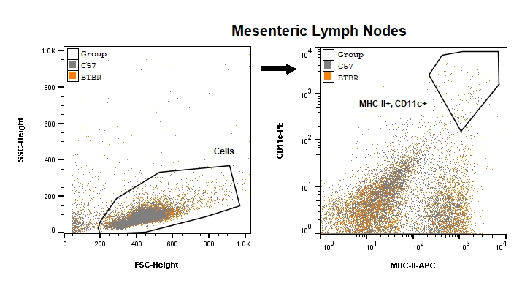
sFigure 6. Gating strategy for dendritic cells in BTBR mice. Dendritic cells were quantified in mesenteric lymph nodes. First, cells were selected based on FSC-Height and SSC-Height, after which dendritic were selected based on CD11c and MHC-II receptor expression.

