Supplementary Material

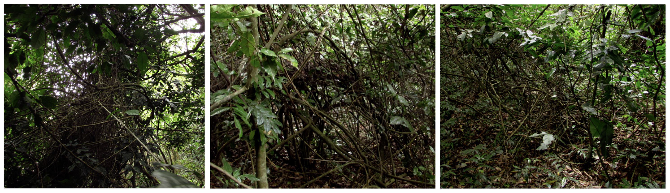
Figure S1 Example of bundles found in different sampling plots; these were found on six of the 40 sampled plots. Lianas in bundles were excluded from further analysis due to the difficulty of determining suitable measurement points; photography by TGL.

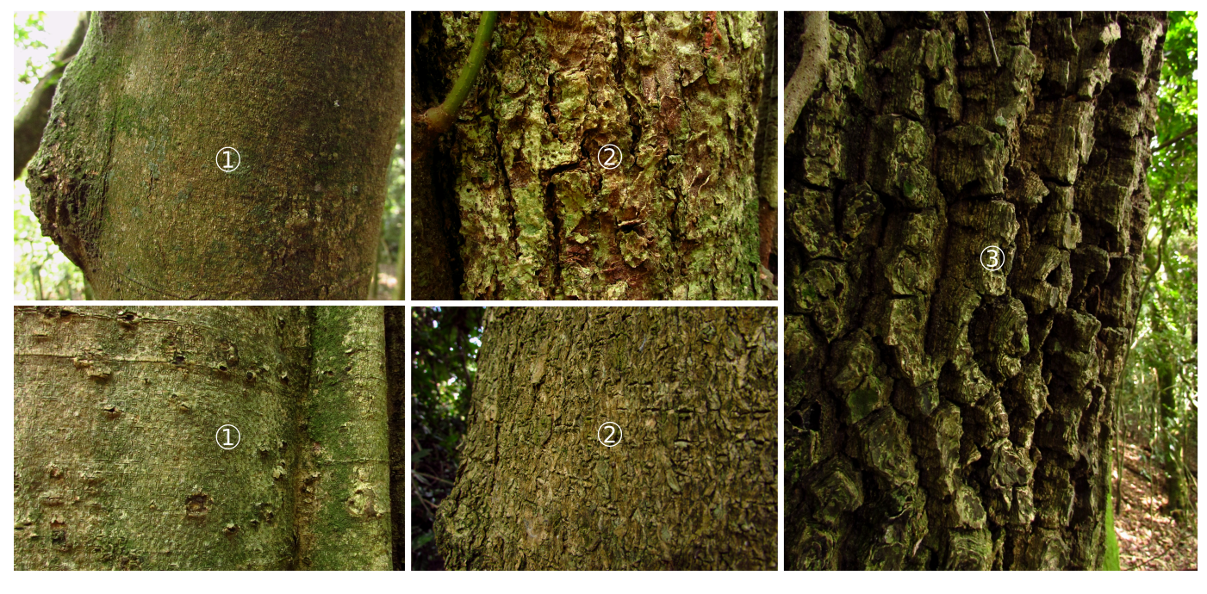
Figure S2 Detail of bark roughness classification for example trees in the study plots; taxonomic information was not available. 1 corresponds to smooth: minor to absent ridges on the bark, 2 corresponds to rough: some ridges on the bark, and 3 to extremely rough: deep ridges on the bark; photography by TGL.

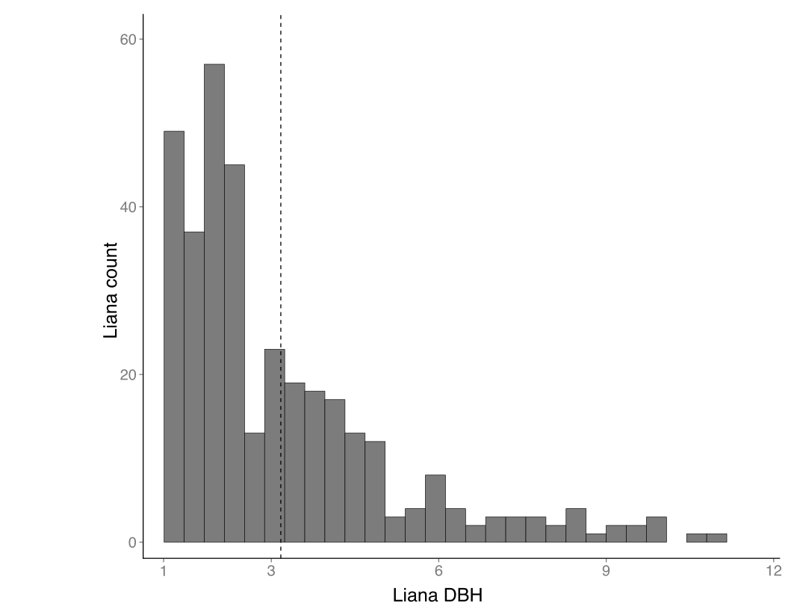
Figure S3 Distribution of lianas per DBH class; A total of 347 lianas with DBH superior to 1cm were surveyed, 91% presented DBH lower than 5 cm, with an average DBH of 3.15cm (dashed vertical line). Maximum liana DBH recorded was 10.9 cm.
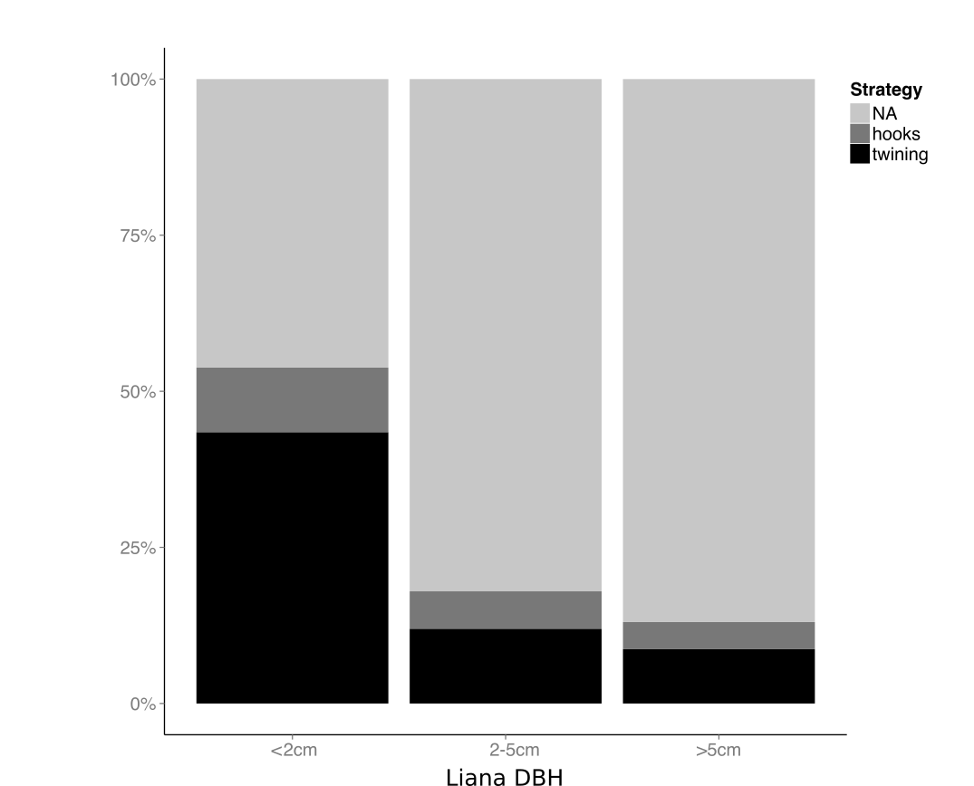
Figure S4 Liana climbing strategy per liana size; 192 lianas (38.2%) presented a recognizable climbing strategy. For the remaining, climbing strategy could not be assessed from the ground level (NA; light grey). The most common strategy was stem twining (black), followed by hooks (dark grey).

